Data supplement
Table 2: Health Related Quality of Life domains (QLQ-C30 & BR23-module) per subgroup

Subdomain | Thresholds for clinical importance [56] | Overall | Excellent HRQoL |  | Psychosocial concerns | Poor HRQoL with severe limitations in functioning
Subdomain | Thresholds for clinical importance [56] | N = 2,1811 | N = 1,1731 |  | N = 7231 | N = 2851
Quality of Life total |  | 75.19 (17.92) | 85.49 (11.48) |  | 67.70 (13.97) | 51.75 (17.08)
Physical Functioning | 83 | 89.07 (15.01) | 96.08 (7.15) |  | 86.34 (13.06) | 67.15 (19.49)
Role Functioning | 58 | 80.90 (25.12) | 95.99 (9.62) |  | 72.20 (20.89) | 40.88 (24.72)
Emotional Functioning | 71 | 72.26 (21.12) | 82.79 (14.04) |  | 63.54 (19.46) | 51.07 (23.34)
Cognitive Functioning | 75 | 81.71 (21.79) | 93.36 (11.88) |  | 74.78 (18.72) | 51.35 (23.72)
Social Functioning | 58 | 82.87 (22.46) | 96.15 (9.32) |  | 74.83 (18.45) | 48.60 (23.98)
Fatigue | 61 | 71.62 (23.75) | 86.03 (13.18) |  | 64.08 (15.95) | 31.44 (18.60)
Nausea/Vomiting | 92 | 94.89 (11.85) | 98.76 (4.88) |  | 94.47 (10.20) | 80.00 (20.74)
Pain | 75 | 81.71 (22.00) | 92.63 (11.70) |  | 77.34 (18.15) | 47.89 (25.01)
Dyspnea | 83 | 88.58 (19.49) | 95.08 (12.53) |  | 86.08 (19.84) | 68.19 (25.67)
Sleep Disturbances | 50 | 68.75 (28.08) | 80.28 (21.23) |  | 58.92 (27.38) | 46.20 (31.37)
Appetite Loss | 50 | 90.17 (19.28) | 96.96 (9.70) |  | 86.95 (20.77) | 70.41 (27.58)
Constipation | 50 | 89.38 (20.83) | 94.66 (14.31) |  | 87.64 (21.44) | 72.05 (29.90)
Diarrhea | 83 | 92.31 (17.70) | 95.82 (12.41) |  | 91.01 (18.67) | 81.17 (26.54)
Financial Impact | 83 | 92.47 (18.36) | 97.64 (9.50) |  | 89.53 (20.30) | 78.60 (29.04)
Systemic Therapy Side Effects |  | 86.34 (14.76) | 93.33 (8.13) |  | 83.04 (12.38) | 65.89 (18.97)
Upset by Hair Loss |  | 21.72 (25.49) | 16.23 (20.07) |  | 24.48 (27.09) | 37.31 (32.74)
Arm Symptoms |  | 88.98 (16.33) | 94.30 (10.68) |  | 86.48 (16.32) | 73.41 (22.90)
Breast Symptoms |  | 81.42 (17.69) | 87.76 (12.57) |  | 76.76 (17.88) | 67.15 (22.60)
Body Image |  | 84.00 (21.05) | 93.42 (11.16) |  | 76.00 (22.63) | 65.54 (26.69)
Future Perspective |  | 54.84 (27.63) | 65.02 (23.19) |  | 45.55 (27.51) | 36.49 (27.01)
Sexual Functioning |  | 20.76 (20.55) | 23.57 (21.27) |  | 18.42 (19.18) | 15.09 (19.03)
Sexual Enjoyment |  | 42.30 (28.64) | 46.21 (28.45) |  | 39.51 (28.70) | 33.33 (26.39)
 | 1 Mean (SD)
NB: All scores are transformed into 0 = low quality of life or high symptom burden, 100 = high quality of life or low symptom burden.

Table 3: Goodness of fit indices for 1 – 7 classes at baseline
Model Classes AIC BIC Entropy prob_min prob_max n_min n_max BLRT_p
1 1 373636.26 373889.94 1.00 1.00 1.00 1.00 1.00 0.01
1 2 364515.83 364901.87 0.94 0.97 0.99 0.27 0.73 0.01
1 3 362142.40 362660.79 0.91 0.93 0.97 0.12 0.56 0.01
1 4 361857.98 362508.73 0.82 0.82 0.96 0.11 0.40 0.01
1 5 360869.13 361652.23 0.83 0.72 0.95 0.05 0.33 0.01
1 6 360144.70 361060.16 0.84 0.73 0.97 0.05 0.32 0.01
1 7 359738.37 360786.19 0.83 0.73 0.98 0.04 0.31 0.01

Table 4 Odds ratios and 95% confidence intervals of factors associated with different subgroups
Covariate | Cluster Psychosocial Concerns |  |  | 95% CI | p-value |  | Cluster Poor HRQoL |  |  | 95% CI | p-value
Covariate | (OR) |  |  | 95% CI |  |  | (OR) |  |  | 95% CI | p-value
Intercept (ref = Excellent HrQoL) | 0.88 |  |  | [0.32 - 2.42] | 0.50 |  | 1.07 |  |  | [0.58 - 1.97] | 0.049
Cardiac history | 0.95 |  |  | [0.64 - 1.41] | 0.860 |  | 1.07 |  |  | [0.72 - 1.59] | 0.340
Stroke | 2.76 |  |  | [0.44 - 17.28] | 0.550 |  | 1.90 |  |  | [0.4 - 9.02] | 0.720
Hypertension | 1.15 |  |  | [0.87 - 1.52] | 0.140 |  | 1.16 |  |  | [0.58 - 2.32] | 0.055
Respiratory diseases | 0.89 |  |  | [0.64 - 1.24] | 0.015 |  | 1.17 |  |  | [0.87 - 1.57] | 0.015
Diabetes | 0.70 |  |  | [0.45 - 1.08] | 0.230 |  | 0.68 |  |  | [0.39 - 1.18] | 0.280
Stomach ulcer | 1.36 |  |  | [0.15 - 12.3] | 0.960 |  | 2.62 |  |  | [0.36 - 19] | 1.000
Kidney diseases | 0.82 |  |  | [0.41 - 1.63] | 0.360 |  | 0.79 |  |  | [0.33 - 1.88] | 0.430
Liver diseases | 1.29 |  |  | [0.67 - 2.47] | 0.340 |  | 0.75 |  |  | [0.32 - 1.75] | 0.420
Blood diseases | 1.34 |  |  | [0.87 - 2.06] | 0.011 |  | 1.83 |  |  | [1.23 - 2.73] | 0.411
Thyroid diseases | 1.19 |  |  | [0.81 - 1.74] | 0.180 |  | 1.13 |  |  | [0.77 - 1.66] | 0.200
Depression | 2.58 |  |  | [0.37 - 2.91] | 0.040 |  | 2.59 |  |  | [1.09 - 3.32] | <0.001
Arthritis | 0.97 |  |  | [0.73 - 1.29] | 0.130 |  | 1.04 |  |  | [0.78 - 1.39] | 0.140
Back pain | 0.59 |  |  | [0.47 - 0.74] | 0.001 |  | 1.12 |  |  | [0.9 - 1.39] | 0.110
Rheumatic arthritis | 0.89 |  |  | [0.54 - 1.47] | 0.250 |  | 1.37 |  |  | [0.89 - 2.11] | 0.220
Multiple comorbidities (>3) | 3.80 |  |  | [2.85 – 6.85] | <0.001 |  | 5.61 |  |  | [3.10 – 8.23] | <0.001
(ref = none)
Marital status | 1.00 |  |  | [0.92 – 1.08] | 0.400 |  | 3.98 |  |  | [2.81 – 5.87] | 0.042
(ref = married or living together)
Socio-economic status | 1.00 |  |  | [0.91 – 1.12] | 0.400 |  | 1.98 |  |  | [1.03 – 9.87] | 0.039
(ref = lower than average)
Education status | 1.17 |  |  | [1.05 - 1.3] | 0.056 |  | 0.92 |  |  | [0.82 - 1.95] | 0.057
(ref = university degree )
Age (years) | 1.00 |  |  | [0.99 - 1.01] | 0.820 |  | 1.00 |  |  | [0.99 - 1] | 0.670
Smoking | 1.00 |  |  | [0.91 - 1.1] | 0.490 |  | 1.11 |  |  | [1 - 1.23] | 0.050
Alcohol use | 0.94 |  |  | [0.79 - 1.1] | 0.350 |  | 0.91 |  |  | [0.76 - 1.09] | 0.370
WHO status | 1.08 |  |  | [0.91 - 1.29] | 0.300 |  | 1.06 |  |  | [0.87 - 1.29] | 0.620
BMI | 0.98 |  |  | [0.96 - 0.99] | 0.019 |  | 2.68 |  |  | [2.66 - 2.99] | 0.020
Menopausal status | 1.09 |  |  | [0.91 - 1.3] | 0.085 |  | 2.77 |  |  | [2.65 - 2.91] | <0.001
Neo-adjuvant chemotherapy | 1.69 |  |  | [1.56 - 1.98] | 0.012 |  | 1.16 |  |  | [0.90 - 1.56] | 0.128
Adjuvant chemotherapy | 1.72 |  |  | [1.54 - 1.96] | 0.014 |  | 1.19 |  |  | [0.92 - 1.54] | 0.140
Adjuvant immunotherapy | 1.19 |  |  | [0.81 - 1.76] | 0.200 |  | 1.37 |  |  | [0.88 - 2.13] | 0.310
Adjuvant hormonal therapy | 0.78 |  |  | [0.63 - 0.96] | 0.013 |  | 0.97 |  |  | [0.75 - 1.25] | 0.800
Adjuvant radiotherapy | 1.16 |  |  | [0.95 - 1.42] | 0.100 |  | 0.90 |  |  | [0.71 - 1.14] | 0.470
Type of surgery | 1.15 |  |  | [0.88 - 1.5] | 0.360 |  | 1.20 |  |  | [0.92 - 1.57] | 0.360
(ref = axillary dissection)
Her2-status | 0.87 |  |  | [0.66 - 1.15] | 0.310 |  | 0.91 |  |  | [0.62 - 1.33] | 0.600
PR-status | 1.20 |  |  | [0.92 - 1.57] | 0.034 |  | 1.47 |  |  | [1.09 - 1.99] | 0.008
ER-status | 0.73 |  |  | [0.54 - 0.99] | 0.040 |  | 1.01 |  |  | [0.74 - 1.39] | 0.930
Hormone Receptor Status | 0.83 |  |  | [0.69 - 1.01] | 0.037 |  | 0.92 |  |  | [0.76 - 1.12] | 0.036
(ref = negative)
T | 1.05 |  |  | [0.91 - 1.2] | 0.520 |  | 1.05 |  |  | [0.91 - 1.21] | 0.540
N | 0.79 |  |  | [0.41 - 1.53] | 0.570 |  | 0.57 |  |  | [0.41 - 1.53] | 0.591
Grade |  | 1.15 | [0.88 - 1.17] |  |  | 0.580 |  | 1.05 | [0.91 - 1.19] |  | 0.590
Covariates in bold indicate a significant |  | association.

Table 5 Odds ratios and 95% confidence intervals of factors associated with transition
 | Transition from Excellent HRQoL Psychosocial concerns |  |  | Transition from Psychosocial concerns Low HRQoL
Variable | OR | 95 CI% | p-value | OR | 95 CI% | p-value
Intercept | 0.0001 | 0.00001-0.0003 | < 0.001 | 0.0002 | (0.00001-0.001) | < 0.001
Cardiac history | 1.32 | 0.64-2.72 | 0.47 | 1.18 | (0.49-2.84) | 0.70
Stroke | 9.14 | 0.62-14.48 | 0.16 | 5.22 | (0.19-13.63) | 0.21
Hypertension | 0.79 | (0.45-1.39) | 0.42 | 0.89 | (0.50-1.58) | 0.70
Respiratory diseases | 0.80 | (0.44-1.46) | 0.48 | 1.19 | (0.65-2.17) | 0.60
Diabetes | 2.31 | (0.77-6.89) | 0.14 | 1.07 | (0.32-3.61) | 0.91
Stomach ulcer | 3.84 | (0.15-9.75) | 0.42 | 13.36 | (0.44-12.84) | 0.021
Kidney diseases | 0.63 | (0.15-2.66) | 0.52 | 2.38 | (0.69-8.18) | 0.16
Liver diseases | 2.70 | (0.004-18.65) | 0.72 | 1.39 | (0.01-14.19) | 0.87
Blood diseases | 1.12 | (0.51-2.46) | 0.78 | 1.21 | (0.55-2.69) | 0.63
Thyroid diseases | 2.06 | (0.99-4.29) | 0.053 | 1.51 | (0.69-3.32) | 0.30
Depression | 4.94 | (2.31-10.58) | <0.001 | 4.62 | (1.94-11.00) | <0.001
Arthritis | 0.62 | (0.37-1.04) | 0.071 | 0.77 | (0.44-1.35) | 0.38
Back pain | 2.00 | (1.32-3.03) | <0.001 | 1.66 | (1.04-2.66) | 0.036
Rheumatic arthritis | 2.87 | (0.96-8.58) | 0.058 | 2.88 | (0.96-8.64) | 0.057
Marital status  (ref = married/living together) | 0.88 | (0.70-1.10) | 0.25 | 0.85 | (0.67-1.07) | 0.15
Education status  (ref = university degree) | 0.87 | (0.71-1.07) | 0.20 | 0.77 | (0.61-0.96) | 0.024
Age | 0.99 | (0.97-1.01) | 0.31 | 0.99 | (0.97-1.02) | 0.61
Smoking | 1.07 | (0.89-1.28) | 0.50 | 1.06 | (0.86-1.31) | 0.55
Alcohol use | 1.10 | (0.79-1.53) | 0.58 | 1.25 | (0.89-1.76) | 0.20
WHO status | 0.97 | (0.72-1.30) | 0.82 | 1.05 | (0.78-1.41) | 0.76
BMI | 1.00 | (0.97-1.03) | 0.93 | 1.00 | (0.96-1.04) | 0.84
Menopausal status | 0.86 | (0.63-1.17) | 0.33 | 0.64 | (0.45-0.91) | 0.011
Adjuvant chemotherapy | 1.27 | (0.72-2.24) | 0.42 | 1.22 | (0.70-2.12) | 0.51
Neo adjuvant chemotherapy | 0.96 | (0.65-1.43) | 0.86 | 0.84 | (0.53-1.33) | 0.48
Adjuvant immunotherapy | 0.70 | (0.36-1.38) | 0.31 | 0.79 | (0.22-2.82) | 0.72
Adjuvant hormonal therapy | 0.83 | (0.56-1.24) | 0.38 | 1.08 | (0.68-1.71) | 0.76
Adjuvant radiotherapy | 1.07 | (0.72-1.60) | 0.74 | 0.89 | (0.57-1.40) | 0.63
Type of surgery  (ref = axillary dissection) | 0.79 | (0.54-1.16) | 0.20 | 0.86 | (0.58-1.28) | 0.48
Her2neu-status | 1.47 | (0.88-2.46) | 0.14 | 1.06 | (0.33-3.43) | 0.92
PR-status | 1.12 | (0.66-1.89) | 0.67 | 1.04 | (0.58-1.88) | 0.89
ER-status | 1.07 | (0.60-1.92) | 0.81 | 2.82 | (1.55-5.12) | < 0.001
Hormone receptor status  (ref = negative) | 1.17 | (0.83-1.65) | 0.36 | 1.03 | (0.73-1.45) | 0.89
T | 0.91 | (0.65-1.29) | 0.63 | 0.94 | (0.65-1.36) | 0.76
N | 1.29 | (0.95-1.76) | 0.10 | 1.39 | (1.02-1.89) | 0.037
M | 0.62 | (0.13-2.95) | 0.57 | 1.01 | (0.19-5.39) | 0.99
Grade | 1.26 | (0.72-2.19) | 0.43 | 0.87 | (0.47-1.61) | 0.64
Socio-economic status | 0.66 | (0.19-2.31) | 0.80 | 1.56 | (0.46-5.26) | 0.79
(ref = lower than average)
Amount of comorbidities | 1.06 | (0.90-1.25) | 0.52 | 1.08 | (0.95-1.24) | 0.26

Network analysis
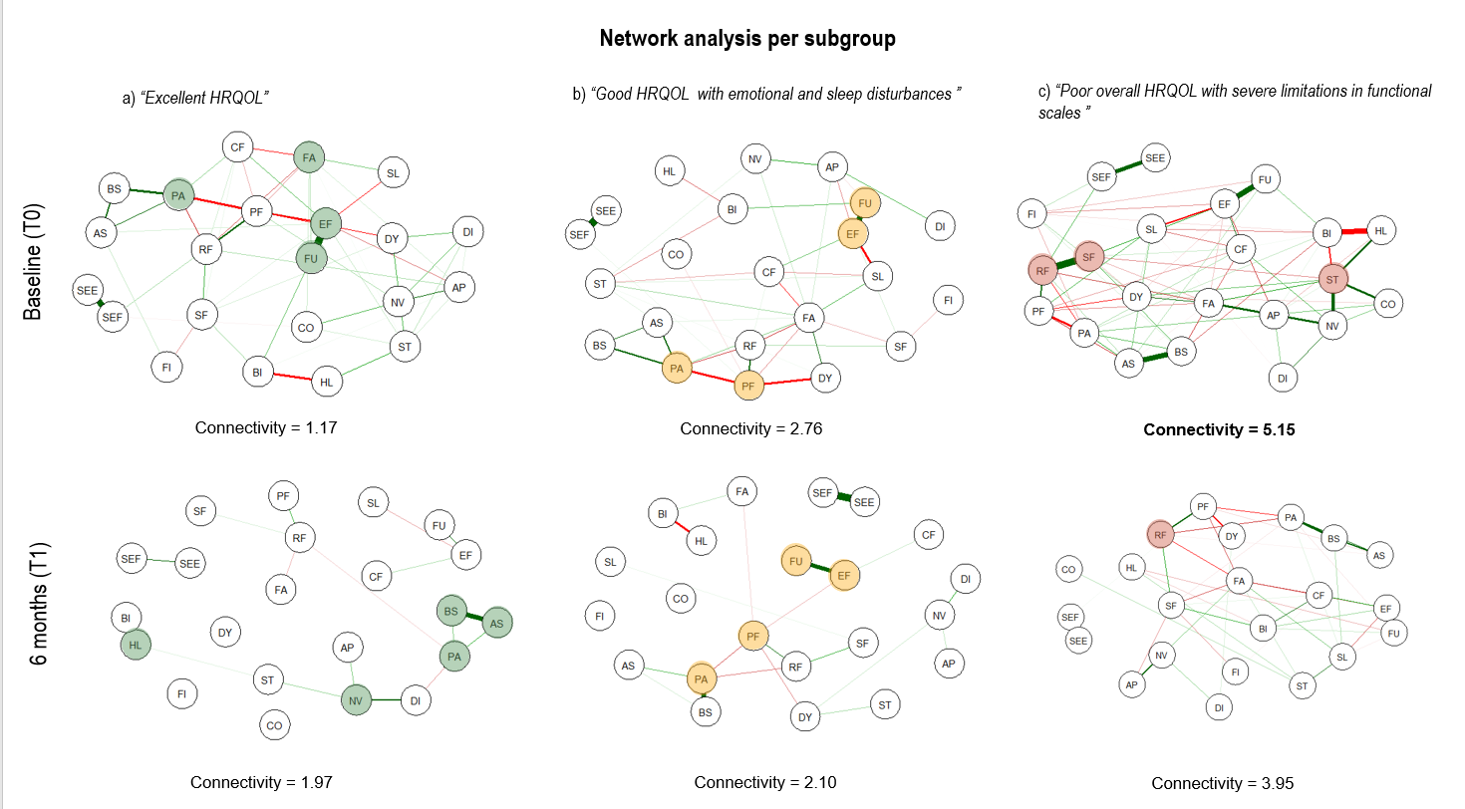

Figure 6: Overview of network structures per subgroup
Interpretation: Networks constructed at baseline (T0) and after 6 months (T1). Networks constructed via graphical LASSO visualizing the regularized partial correlations between items in different subgroups. Green edges represent positive partial correlations and red edges negative ones. Thicker and more saturated edges represent stronger partial correlations. Edges with absolute weight above 0.05 are displayed. The distance between two nodes reflects the absolute edge weight between them (Fruchterman–Reingold layout). Highlighted symptoms represent the symptoms with the highest strength.
Legend: Green = Excellent HRQOL, yellow = Good HRQoL with Psychosocial concerns, red = Poor HRQoL with severe limitations in functioning domains;
Abbreviations: QL = Quality of life total, PF = Physical Functioning, RF = Role Functioning, EF = Emotional Functioning, CF = Cognitive Functioning, SF = Social Functioning, FA = Fatigue, NV = Nausea/Vomiting, PA = Pain, DY = Dyspnoea, SL = Sleep Disturbances, AP = Appetite Loss, CO = Constipation, DI = Diarrhoea, FI = Financial Impact; ST = Systemic Therapy Side Effects/Hormonal Symptoms, HL= Hair Loss, AS = Arm Symptoms, BS = Breast Symptoms, BI= Body Image, FU = Future Perspective, SEF = Sexual Functioning, SEE = Sexual Enjoyment.

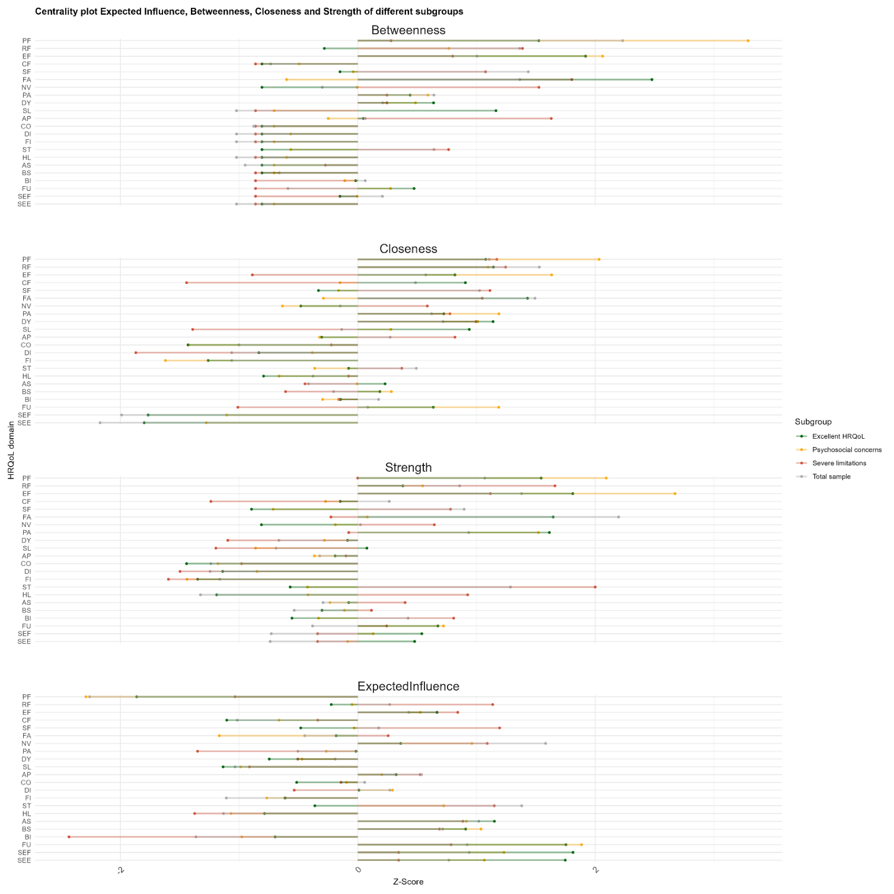
Figure 7: Centrality measures (betweenness, closeness, strength, expected influence) per subgroup.
Legend: Green = Excellent HRQOL, yellow = Good HRQoL with Psychosocial concerns, red = Poor HRQoL with severe limitations in functioning domains;
Items in bold indicate a significant difference. Betweenness, closeness, strength and expected influence are displayed by Z-scores.
Abbreviations: QL = Quality of life total, PF = Physical Functioning, RF = Role Functioning, EF = Emotional Functioning, CF = Cognitive Functioning, SF = Social Functioning, FA = Fatigue, NV = Nausea/Vomiting, PA = Pain, DY = Dyspnoea, SL = Sleep Disturbances, AP = Appetite Loss, CO = Constipation, DI = Diarrhoea, FI = Financial Impact; ST = Systemic Therapy Side Effects/Hormonal symptoms, HL= Hair Loss, AS = Arm Symptoms, BS = Breast Symptoms, BI= Body Image, FU = Future Perspective, SEF = Sexual Functioning, SEE = Sexual Enjoyment.
Supplement: Outcomes of Independent groups Gaussian network comparison test
1..Severe limitations vs Excellent HRQoL-subgroup
INDEPENDENT GROUPS GAUSSIAN NETWORK COMPARISON TEST

P-VALUE CORRECTION: none
NETWORK INVARIANCE TEST
Test statistic M: 4.0340572
p-value 0.0001218781

GLOBAL STRENGTH INVARIANCE TEST
Global strength per group: 5.153191 1.975892
Test statistic S: 0.282299
p-value 0.0170999001

CENTRALITY INVARIANCE TEST
Nodes tested: PF RF EF CF SF FA NV PA DY SL AP CO DI FI ST HL AS BS BI FU SEF SEE
Centralities tested: strength betweenness closeness
Test statistics C:
strength betweenness closeness
PF 0.710925190 71 7.354960e-04
RF 0.327069699 -14 5.414891e-04
EF 0.527924757 43 NA
CF 0.404875300 3 NA
SF 0.309849692 20 5.853334e-04
FA 0.836349860 78 1.132135e-03
NV -0.009749133 -13 -3.516644e-04
PA 0.417214811 -19 -1.413547e-04
DY 0.442267457 39 NA
SL 0.412332876 29 NA
AP 0.320512385 19 -1.135134e-04
CO 0.136689405 0 NA
DI -0.041070991 -34 -8.045480e-04
FI 0.111453585 0 NA
ST 0.371686685 -18 -1.144942e-04
HL -0.227809504 -11 2.068155e-04
AS 0.026234339 -11 -1.662847e-04
BS 0.072370897 9 5.157345e-05
BI 0.102723817 24 6.036792e-04
FU 0.464981050 40 NA
SEF 0.341708475 20 NA
SEE 0.296057188 0 NA

p-values:
strength betweenness closeness
PF 0.000999001 0.000999001 0.056943057
RF 0.007992008 0.338661339 0.177822178
EF 0.000999001 0.000999001 NA
CF 0.004995005 0.868131868 NA
SF 0.026973027 0.152847153 0.225774226
FA 0.000999001 0.000999001 0.003996004
NV 0.977022977 0.677322677 0.665334665
PA 0.004995005 0.068931069 0.916083916
DY 0.001998002 0.000999001 NA
SL 0.004995005 0.000999001 NA
AP 0.109890110 0.268731269 0.851148851
CO 0.392607393 1.000000000 NA
DI 0.804195804 0.019980020 0.135864136
FI 0.569430569 1.000000000 NA
ST 0.013986014 0.222777223 0.916083916
HL 0.147852148 0.025974026 0.881118881
AS 0.853146853 0.370629371 0.841158841
BS 0.563436563 0.313686314 0.969030969
BI 0.520479520 0.005994006 0.670329670
FU 0.004995005 0.000999001 0.01498501
SEF 0.001998002 0.000999001 NA
SEE 0.022977023 1.000000000 NA

2.Psychosocial concerns vs Excellent HRQoL-subgroup

INDEPENDENT GROUPS GAUSSIAN NETWORK COMPARISON TEST
P-VALUE CORRECTION: none
NETWORK INVARIANCE TEST
Test statistic M: 0.2116146
p-value 0.0999001

GLOBAL STRENGTH INVARIANCE TEST
Global strength per group: 2.763135 1.174892
Test statistic S: 0.6606957
p-value 0.01658342

CENTRALITY INVARIANCE TEST
Nodes tested: PF RF EF CF SF FA NV PA DY SL AP CO DI FI ST HL AS BS BI FU SEF SEE
Centralities tested: strength betweenness closeness
Test statistics C:
strength betweenness closeness
PF 0.265418603 21 -9.050364e-05
RF -0.091090227 16 -1.187260e-04
EF 0.392322730 40 2.253604e-04
CF 0.151514574 9 2.305729e-04
SF -0.058675828 4 -2.919156e-04
FA 0.041378350 -30 -1.541668e-04
NV 0.081106520 -7 1.741438e-04
PA -0.007073412 7 -2.429520e-05
DY 0.051526010 0 -4.224923e-06
SL 0.070073511 0 4.669747e-04
AP 0.105670315 0 3.195572e-04
CO 0.069933541 0 NA
DI 0.042428653 15 2.553996e-04
FI 0.012037237 0 NA
ST 0.107927774 53 -6.003717e-06
HL 0.040547938 7 1.501294e-04
AS 0.106643766 0 -2.201338e-05
BS -0.055904472 0 -1.338178e-04
BI -0.048363994 -10 1.091483e-04
FU 0.157083979 17 2.264139e-04
SEF -0.043076074 20 NA
SEE -0.070038110 0 NA

p-values:
strength betweenness closeness
PF 0.032967033 0.634365634 0.8641359
RF 0.556443556 0.439560440 0.7762238
EF 0.006993007 0.107892108 0.5674326
CF 0.385614386 0.095904096 0.5034965
SF 0.646353646 0.620379620 0.3656344
FA 0.726273726 0.197802198 0.7362637
NV 0.380619381 0.803196803 0.6663337
PA 0.947052947 0.840159840 0.9470529
DY 0.573426573 1.000000000 0.9900100
SL 0.457542458 1.000000000 0.2097902
AP 0.222777223 1.000000000 0.4435564
CO 0.465534466 1.000000000 NA
DI 0.662337662 0.038961039 0.4155844
FI 0.902097902 1.000000000 NA
ST 0.217782218 0.001998002 0.9900100
HL 0.761238761 0.328671329 0.7422577
AS 0.253746254 1.000000000 0.9610390
BS 0.497502498 1.000000000 0.6953047
BI 0.764235764 0.556443556 0.8531469
FU 0.273726274 0.348651349 0.5274725
SEF 0.513486513 0.053946054 NA
SEE 0.326673327 1.000000000 NA

3. Psychosocial concerns vs Excellent HRQoL-subgroup
P-VALUE CORRECTION: none
NETWORK INVARIANCE TEST
Test statistic M: 0.2115587
p-value 0.1038961
GLOBAL STRENGTH INVARIANCE TEST
Global strength per group: 3.988824 2.324266
Test statistic S: 1.664559
p-value 0.4175824
CENTRALITY INVARIANCE TEST
Nodes tested: PF RF EF CF SF FA NV PA DY SL AP CO DI FI ST HL AS BS BI FU SEF SEE
Centralities tested: strength betweenness closeness
Test statistics C:
strength betweenness closeness
PF 0.57730752 81 0.0016706854
RF 0.04260999 -23 0.0012776851
EF 0.54727904 31 0.0017742422
CF 0.25980438 6 0.0011148517
SF -0.09727850 -37 0.0007781484
FA 0.19759713 -74 0.0007340620
NV 0.02743241 -49 0.0006526222
PA 0.47112003 5 0.0013760332
DY 0.23907229 2 0.0012746638
SL 0.13436805 0 0.0012840849
AP 0.09015965 -59 0.0007507204
CO 0.04113467 0 0.0004311166
DI 0.17683935 4 0.0010747840
FI 0.06968372 0 NA
ST -0.19961544 -43 0.0007920721
HL -0.05670591 3 0.0007273635
AS 0.05087729 -17 0.0010439964
BS 0.11318887 0 0.0011842130
BI -0.02297737 17 0.0008885383
FU 0.26598462 28 0.0016074083
SEF 0.22251464 20 NA
SEE 0.17872086 0 NA

p-values:
strength betweenness closeness
PF 0.001998002 0.000999001 0.03796204
RF 0.766233766 0.380619381 0.09690310
EF 0.034965035 0.004995005 NA
CF 0.151848152 0.849150849 0.09290709
SF 0.700299700 0.105894106 0.22577423
FA 0.358641359 0.024975025 0.33166833
NV 0.900099900 0.012987013 0.24875125
PA 0.005994006 0.607392607 0.04795205
DY 0.227772228 0.953046953 0.08091908
SL 0.471528472 1.000000000 NA
AP 0.693306693 0.003996004 0.25774226
CO 0.809190809 1.000000000 NA
DI 0.329670330 0.044955045 NA
FI 0.774225774 1.000000000 NA
ST 0.527472527 0.086913087 0.23376623
HL 0.752247752 0.886113886 NA
AS 0.847152847 0.183816184 0.04995005
BS 0.492507493 1.000000000 0.02697303
BI 0.935064935 0.055944056 NA
FU 0.038961039 0.006993007 NA
SEF 0.101898102 0.559440559 NA
SEE 0.120879121 1.000000000 NA
> summary(NCT_2_3)

Network comparison test

P-VALUE CORRECTION: none

NETWORK INVARIANCE TEST
Test statistic M: 0.2794973
p-value 0.008991009

GLOBAL STRENGTH INVARIANCE TEST
Global strength per group: 2.324266 3.739907
Test statistic S: 1.415642
p-value 0.000999001
CENTRALITY INVARIANCE TEST
Nodes tested: PF RF EF CF SF FA NV PA DY SL AP CO DI FI ST HL AS BS BI FU SEF SEE
Centralities tested: strength betweenness closeness
Test statistics C:
strength betweenness closeness
PF -0.470831868 -38 -5.991970e-04
RF 0.007146584 49 -6.094858e-04
EF -0.381774498 -35 -7.873181e-04
CF -0.259754101 0 -8.861932e-04
SF 0.173074298 36 -1.751430e-04
FA -0.523103726 -23 -7.231283e-04
NV 0.136507931 69 -1.979761e-04
PA -0.496247990 -6 -5.423894e-04
DY -0.254545094 -12 -6.410940e-04
SL -0.303899208 -60 -8.896924e-04
AP -0.099623252 46 -2.215807e-04
CO 0.061031690 0 -1.265055e-05
DI -0.074863477 0 -4.086513e-04
FI -0.041106195 0 NA
ST 0.262203800 47 -3.492759e-04
HL 0.257200602 0 -1.881763e-04
AS -0.058816663 17 -5.494604e-04
BS -0.046634833 0 -5.573693e-04
BI 0.101147923 -24 -3.977089e-04
FU -0.245970983 -39 -7.474542e-04
SEF -0.292926700 -20 NA
SEE -0.279497271 0 NA

p-values:
strength betweenness closeness
PF 0.000999001 0.058941059 0.108891109
RF 0.940059940 0.006993007 0.075924076
EF 0.000999001 0.010989011 0.011988012
CF 0.043956044 1.000000000 0.009990010
SF 0.119880120 0.047952048 0.635364635
FA 0.000999001 0.158841159 0.032967033
NV 0.239760240 0.000999001 0.541458541
PA 0.000999001 0.672327672 0.097902098
DY 0.031968032 0.161838162 0.033966034
SL 0.001998002 0.000999001 0.003996004
AP 0.405594406 0.015984016 0.536463536
CO 0.589410589 1.000000000 0.976023976
DI 0.508491508 1.000000000 0.281718282
FI 0.728271728 1.000000000 NA
ST 0.045954046 0.000999001 0.334665335
HL 0.010989011 1.000000000 0.522477522
AS 0.655344655 0.097902098 0.115884116
BS 0.683316683 1.000000000 0.059940060
BI 0.463536464 0.063936064 0.268731269
FU 0.007992008 0.001998002 0.004995005
SEF 0.000999001 0.062937063 NA
SEE 0.000999001 1.000000000 NA
> summary(NCT_1_3)
INDEPENDENT GROUPS GAUSSIAN NETWORK COMPARISON TEST

P-VALUE CORRECTION: none

NETWORK INVARIANCE TEST
Test statistic M: 0.1496325
p-value 0.1418581

GLOBAL STRENGTH INVARIANCE TEST
Global strength per group: 3.988824 3.739907
Test statistic S: 0.2489171
p-value 0.6793207

EDGE INVARIANCE TEST

CENTRALITY INVARIANCE TEST
Nodes tested: PF RF EF CF SF FA NV PA DY SL AP CO DI FI ST HL AS BS BI FU SEF SEE
Centralities tested: strength betweenness closeness
Test statistics C:
strength betweenness closeness
PF 1.064756e-01 43 0.0010714884
RF 4.975657e-02 26 0.0006681993
EF 1.655045e-01 -4 0.0009869241
CF 5.027725e-05 6 0.0002286585
SF 7.579580e-02 -1 0.0006030054
FA -3.255066e-01 -97 0.0000109337
NV 1.639403e-01 20 0.0004546462
PA -2.512796e-02 -1 0.0008336437
DY -1.547281e-02 -10 0.0006335699
SL -1.695312e-01 -60 0.0003943925
AP -9.463603e-03 -13 0.0005291397
CO 1.021664e-01 0 0.0004184661
DI 1.019759e-01 4 0.0006661327
FI 2.857752e-02 0 0.0002891261
ST 6.258836e-02 4 0.0004427963
HL 2.004947e-01 3 0.0005391873
AS -7.939371e-03 0 0.0004945360
BS 6.655404e-02 0 0.0006268437
BI 7.817055e-02 -7 0.0004908294
FU 2.001363e-02 -11 0.0008599542
SEF -7.041206e-02 0 0.0006558126
SEE -1.007764e-01 0 0.0005957185

p-values:
strength betweenness closeness
PF 0.368631369 0.017982018 0.01598402
RF 0.489510490 0.292707293 0.13886114
EF 0.157842158 0.761238761 0.01398601
CF 1.000000000 0.405594406 0.41258741
SF 0.427572428 0.974025974 0.09490509
FA 0.003996004 0.000999001 0.97802198
NV 0.234765235 0.059940060 0.13586414
PA 0.752247752 0.955044955 0.02397602
DY 0.880119880 0.521478521 0.10089910
SL 0.046953047 0.000999001 0.17982018
AP 0.934065934 0.324675325 0.12087912
CO 0.364635365 1.000000000 0.30369630
DI 0.387612388 0.187812188 0.13186813
FI 0.780219780 1.000000000 0.46253746
ST 0.693306693 0.819180819 0.21778222
HL 0.007992008 0.032967033 0.08291708
AS 0.957042957 1.000000000 0.07792208
BS 0.487512488 1.000000000 0.02597403
BI 0.535464535 0.469530470 0.13786214
FU 0.812187812 0.062937063 0.01498501
SEF 0.383616384 1.000000000 NA
SEE 0.191808192 1.000000000 NA

