Identification of chemotherapeutic dihydromyricetin with enhanced anti-tumor activity and biosafety for muscle invasive bladder cancer
Zijian Wang^{a,b,c,1}, Zicheng Guo^{d,1}, Wenjie You^{a,1}, Wang Wangª, Fenfang Zhouª, Renjie Zhangª, Zhiwen Heª, Hongbo Chen^{d,}, and Xinghuan Wang^{a,b,}*

Correspondence: wangxinghuan@whu.edu.cn
ª Department of Urology, Zhongnan Hospital of Wuhan University, Wuhan 430071, P. R. China
^{b} Cancer Precision Diagnosis and Treatment and Translational Medicine, Hubei Engineering Research Center, Zhongnan Hospital of Wuhan University, Wuhan 430071, P. R. China
^{c} Department of Biomedical Engineering, Hubei Province Key Laboratory of Allergy and Immune Related Disease, Wuhan University School of Basic Medical Sciences, Wuhan 430071, P. R. China
^{d} Department of Urology, The Central Hospital of Enshi Tujia and Miao Autonomous Prefecture, Enshi 445000, P. R. China.

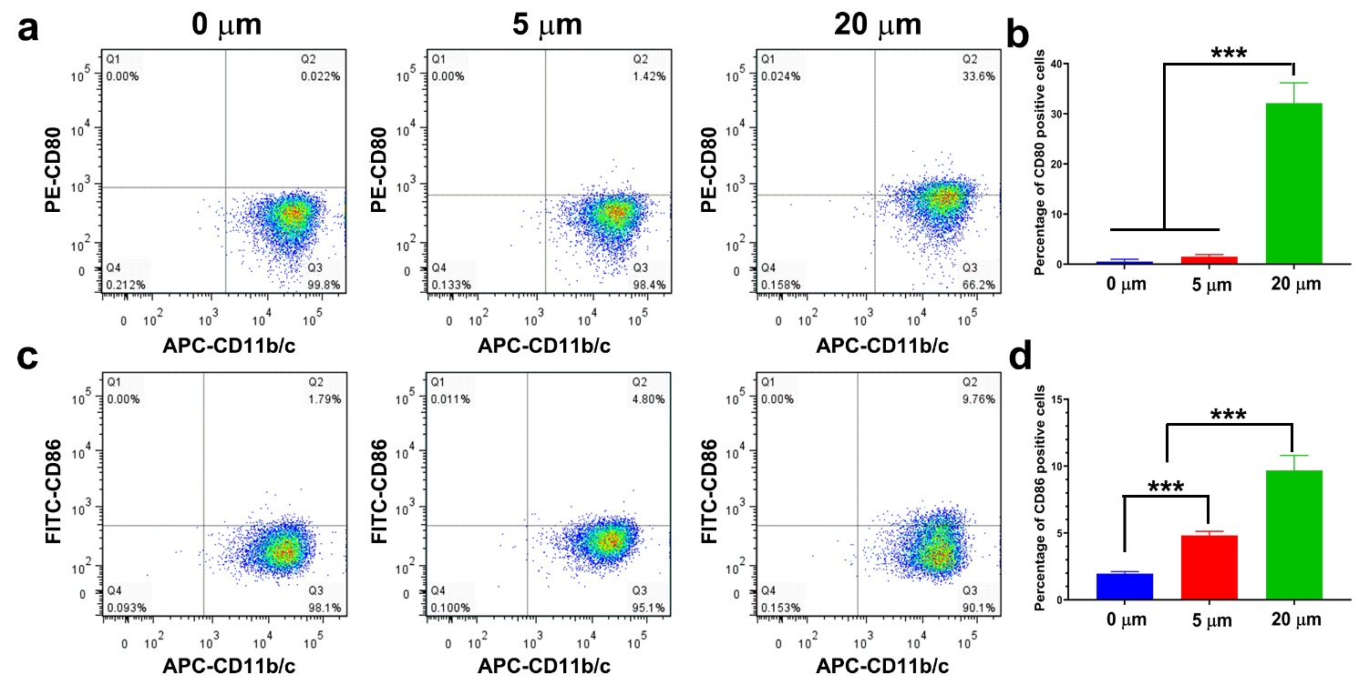

Fig. S1. Dihydromyricetin (DHM) motivated macrophage polarization in vitro. (a, c) Representative flow cytometry images of CD80 and CD86 staining after DHM chemotherapy; (b, d) Quantitative results of CD80 and CD86 positively stained cells. ***P < 0.001.

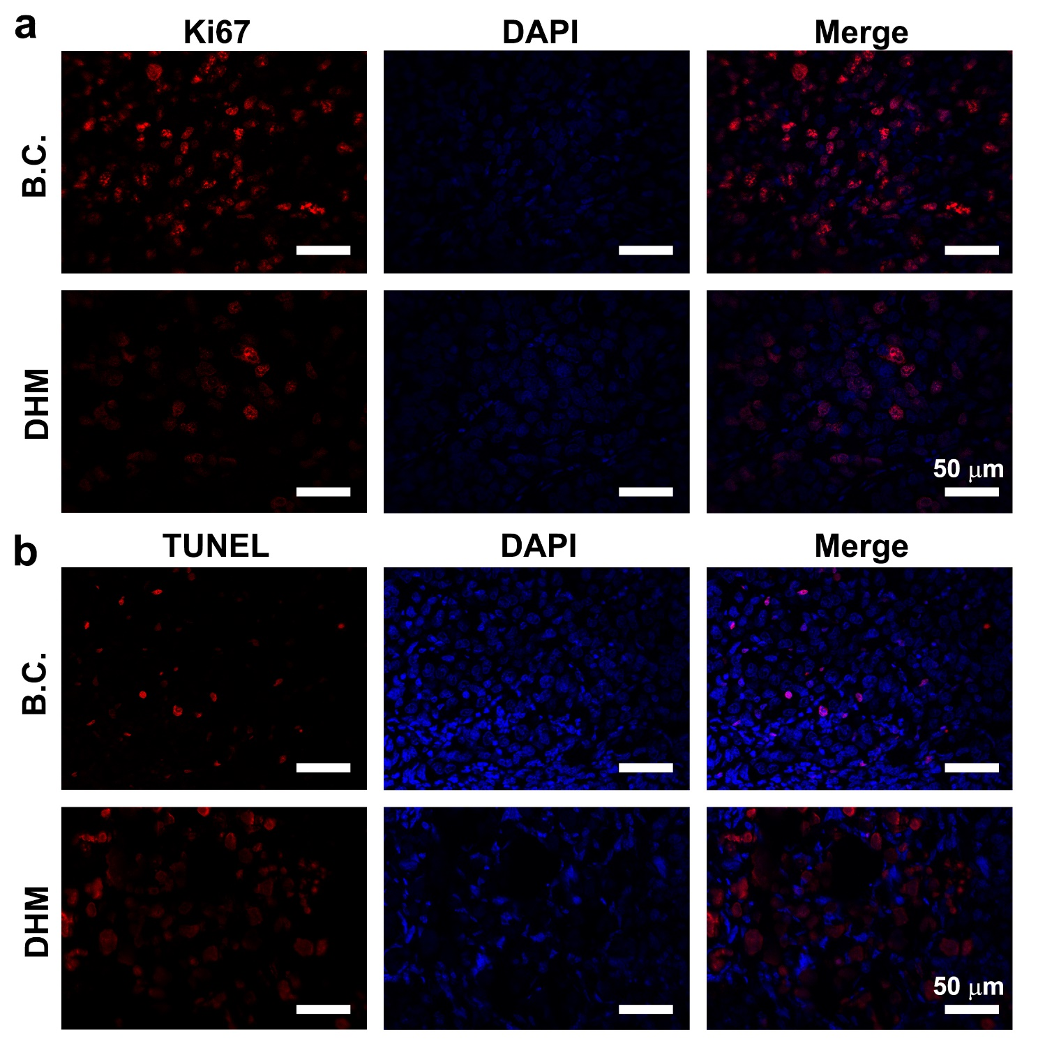
Fig. S2. Dihydromyricetin (DHM) inhibited proliferation and promoted apoptosis of BCa in vivo xenografts. (a) Representative Ki67 staining images of the tumor samples. Scale Bar: 50 µm. (b) Representative TUNEL staining images of the tumor samples. Scale Bar: 50 µm.

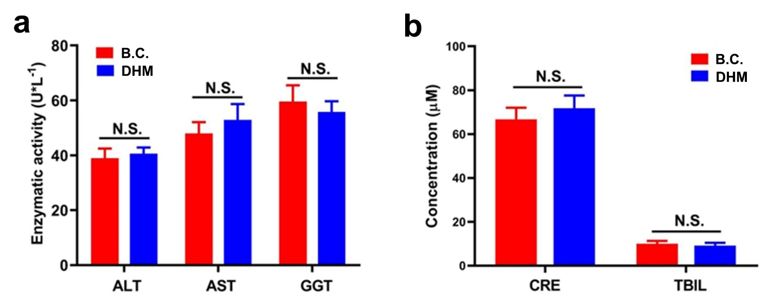
Fig. S3. Dihydromyricetin (DHM) possessed remarkable in vivo hemocompatibility. (a) Quantitative results of enzymatic activity of ALT, AST and GGT. (b) Representative results of the concentration of CRE and TBIL. N.S. represented P>0.05.

Table S1. Primer sequences used for qRT-PCR
Primer name | sequences 5’-3’ | Tm
GAPDH-F | TGTGGGCATCAATGGATTTGG | 60.9 ºC
GAPDH-R | ACACCATGTATTCCGGGTCAAT | 61.4 ºC
CDK2-F | TGTTTAACGACTTTGGACCGC | 61.1 ºC
CDK2-R | CCATCTCCTCTATGACTGACAGC | 61.5 ºC
CDK4-F | GGGGACCTAGAGCAACTTACT | 60.3 ºC
CDK4-R | CAGCGCAGTCCTTCCAAAT | 60.4 ºC
Cyclin E1-F | TCGCATCAAACTCTCTGGCTA | 60.9 ºC
Cyclin E1-R | TGAGCGACTAAACTCACCACT | 60.8 ºC
Cyclin D1-F | GCTGCGAAGTGGAAACCATC | 61.6 ºC
Cyclin D1-R | CCTCCTTCTGCACACATTTGAA | 60.8 ºC
P53-F | AACTGCGGGACGAGACAGA | 62.9 ºC
P53-R | AGCTTCAAGAGCGACAAGTTTT | 60.7 ºC
Vimentin-F | GCCCTAGACGAACTGGGTC | 61.4 ºC
Vimentin-R | GGCTGCAACTGCCTAATGAG | 61.1 ºC
E-cadherin-F | CGAGAGCTACACGTTCACGG | 62.6 ºC
E-cadherin-R | GGGTGTCGAGGGAAAAATAGG | 60.1 ºC
N-cadherin-F | TTTGATGGAGGTCTCCTAACACC | 61.3 ºC
N-cadherin-R | ACGTTTAACACGTTGGAAATGTG | 60.2 ºC
Snail-F | TGTGACAAGGAATATGTGAGCC | 60.0 ºC
Snail-R | TGAGCCCTCAGATTTGACCT | 61.5 ºC
Caspase 3-F | AGAGGGGATCGTTGTAGAAGTC | 60.6℃
Caspase 3-R | ACAGTCCAGTTCTGTACCACG | 61.4℃
Caspase 6-F | GAGCACGTTGGATATGATGGTG | 61.1℃
Caspase 6-R | GGTCCACTTACATCCTCGATCTA | 60.4℃
Caspase 9-F | ATGTCGGACTACGAGAACGAT | 60.4℃
Caspase 9-R | TGATGCGTGAGGGGTCGAT | 63.0℃

Table S2. List of primary antibodies and secondary antibodies
name | species | dilution | resources
GAPDH | Mouse | 1:1000 | Abcam, USA, Cat. # ab181602
CDK2 | Rabbit | 1:1000 | Abcam, USA, Cat. # ab32147
CDK4 | Rabbit | 1:1000 | Abcam, USA, Cat. #ab108357
Cyclin D1 | Rabbit | 1:1000 | Abcam, USA, Cat. #ab16663
Ki67 | Rabbit | 1:100 | Abcam, USA, Cat. # ab15580
E-cadherin | Rabbit | 1:1000 | Abcam, USA, Cat. #ab194982
N-cadherin | Rabbit | 1:1000 | Abcam, USA, Cat. #ab18203
Snail | Rabbit | 1:1000 | Abcam, USA, Cat. #ab229701
Vimentin | Rabbit | 1:1000 | Abcam, USA, Cat. #ab93547
Caspase 3 | Rabbit | 1:1000 | Abcam, USA, Cat. #ab51772
Caspase 6 | Rabbit | 1:1000 | Abcam, USA, Cat. #ab32053
Caspase 9 | Rabbit | 1:1000 | Abcam, USA, Cat. #ab219590
Anti-Mouse-IgG (H+L)-HRP | Goat | 1:10000 | Sungene Biotech, China, Cat. #LK2003
Anti-Rabbit-IgG(H+L)-HRP | Goat | 1:10000 | Sungene Biotech, China, Cat. #LK2001

