SUPPLEMENTAL ONLINE CONTENT
Genomic relationship between polycystic ovary syndrome and bipolar disorder
Piotr Jaholkowski¹, Markos Tesfaye^{1,2,3}#, Vera Fominykh¹#, Pravesh Parekh^{1,4}, Erik D Wiström¹, Nadine Parker¹, Elise Koch¹, Anna E. Bauer^{5,6}, Pawel Trzaskoma⁷, Jaroslav Rokicki^{8,9}, Shahram Bahrami¹, Zillur Rahman¹, Oleksandr Frei^{1,10}, Srdjan Djurovic^{1,11}, Anders M. Dale⁴, Alexey A. Shadrin^{1,12}, Kevin S. O’Connell¹, Ole A. Andreassen^{1,12}
¹ Center for Precision Psychiatry, Division of Mental Health and Addiction, Oslo University Hospital, and Institute of Clinical Medicine, University of Oslo, Oslo, Norway;
² Department of Psychiatry and Behavioral Sciences, SUNY Downstate Health Sciences University, Brooklyn, NY, USA.
³ Institute for Genomics in Health, SUNY Downstate Health Sciences University, Brooklyn, NY, USA.
⁴ J. Craig Venter Institute, La Jolla, California, USA
⁵ Department of Psychiatry, University of North Carolina at Chapel Hill, NC, USA
⁶ Department of Molecular Genetics and Microbiology, Duke University, Durham, NC, USA
⁷ National Institute of Arthritis and Musculoskeletal and Skin Diseases, National Institutes of Health, Bethesda, MD, USA.
⁸ Centre of Research and Education in Forensic Psychiatry (SIFER), Oslo University Hospital, Oslo, Norway
⁹ Department of Electronic Systems, Vilnius Gediminas Technical University, Vilnius, Lithuania
¹⁰ Center for Bioinformatics, Department of Informatics, University of Oslo, Oslo, Norway;
¹¹ Department of Medical Genetics, Oslo University Hospital and University of Oslo, Oslo, Norway;
¹² KG Jebsen Centre for Neurodevelopmental Disorders, University of Oslo and Oslo University Hospital, Oslo, Norway
# equal contribution
Corresponding Authors:
Piotr Jaholkowski, MD, PhD (p.p.jaholkowski@medisin.uio,no), and Ole A. Andreassen, MD, PhD (ole.andreassen@medisin.uio.no), Center for Precision Psychiatry, Division of Mental Health and Addiction, Oslo University Hospital, and Institute of Clinical Medicine, University of Oslo, Ullevål, Kirkeveien 166, 0424 Oslo, Norway.

Table of contents

Supplementary Figure 1 ………………………………………………………………….…….3
Supplementary Figure 2 ………………………………………………………………….…….3
Supplementary Figure 3 ………………………………………………………………….…….4
Supplementary Figure 4 ………………………………………………………………….…….5
Supplementary Figure 5 …………………………………………………………………….….6
Supplementary Figure 6 ………………………………………………………………………..6
Supplementary Figure 7 …………………………………………………………………..…....7
Supplementary Figure 8 …………………………………………………………………..……8
Supplementary Figure 9 …………………………………………………………………..……9

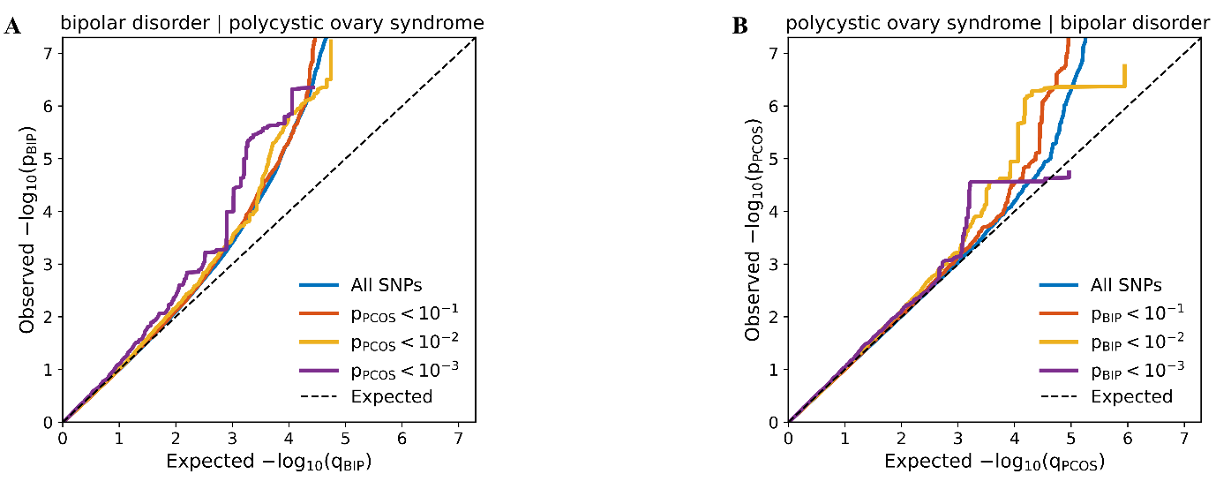
Supplementary Figure 1. (A-B) Conditional QQ plots illustrating cross-phenotype polygenic enrichment between bipolar disorder (BIP) and polycystic ovary syndrome (PCOS). (A) BIP trait is conditioned on PCOS (B) PCOS is conditioned on BIP.

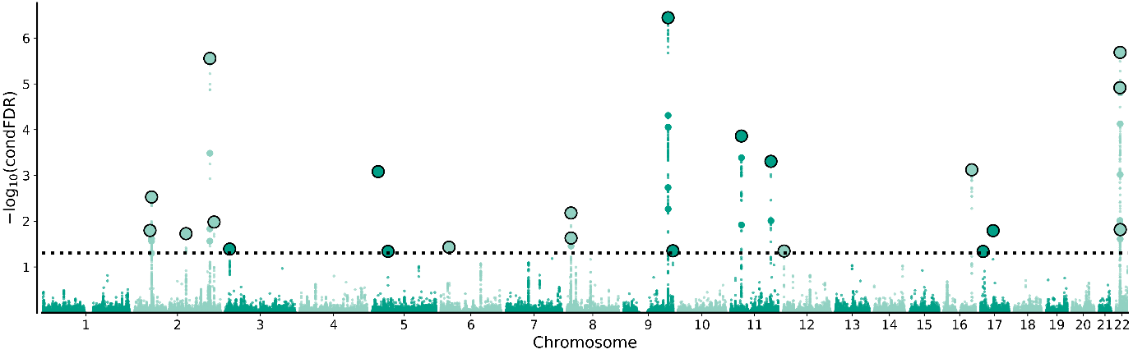

Supplementary Figure 2. "Conditional FDR Manhattan plot" of conditional -log10 (FDR) values for polycystic ovary syndrome conditioned on bipolar disorder. Chromosomal position is presented along the x-axis. SNPs with conditional FDR < .05 are shown with larger points. A black line around the large points indicates the most significant SNP in each LD block.

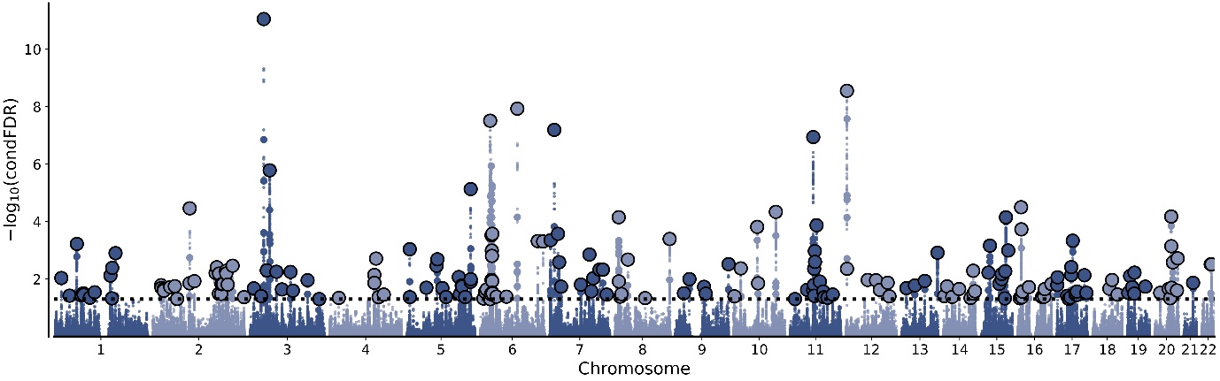
Supplementary Figure 3. "Conditional FDR Manhattan plot" of conditional -log10 (FDR) values for bipolar disorder conditioned on polycystic ovary syndrome. Chromosomal position is presented along the x-axis. SNPs with conditional FDR < .05 are shown with larger points. A black line around the large points indicates the most significant SNP in each LD block.

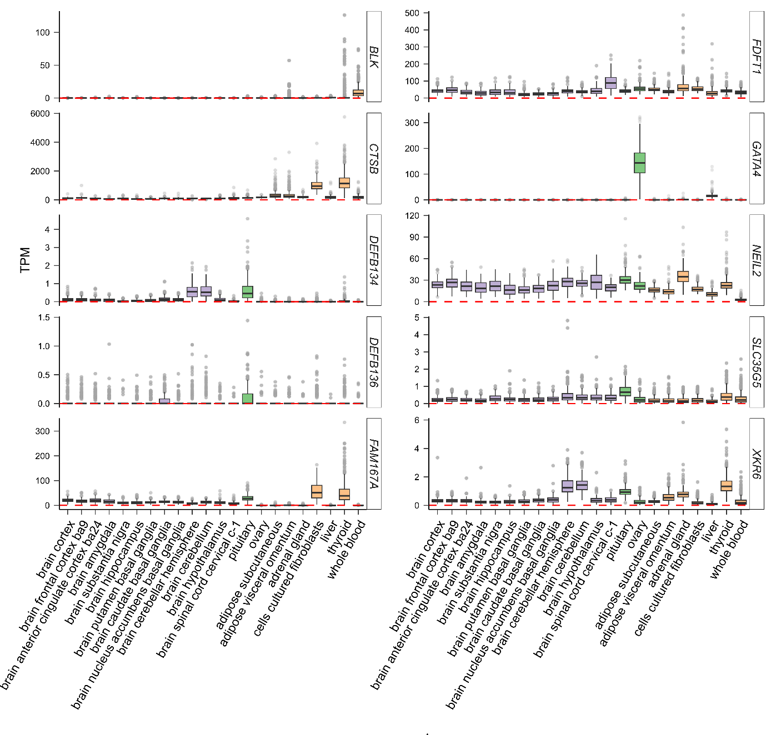Supplementary Figure 4 Tissue expression of genes mapped for locus identified on chromosome 8:11455262 (rs34876360) based on the Genotype-Tissue Expression (GTEx) dataset. Expression values are shown in transcripts per million (TPM). Isoformes were collapsed into a signle gene. No normalization or thresholds procedures applied.

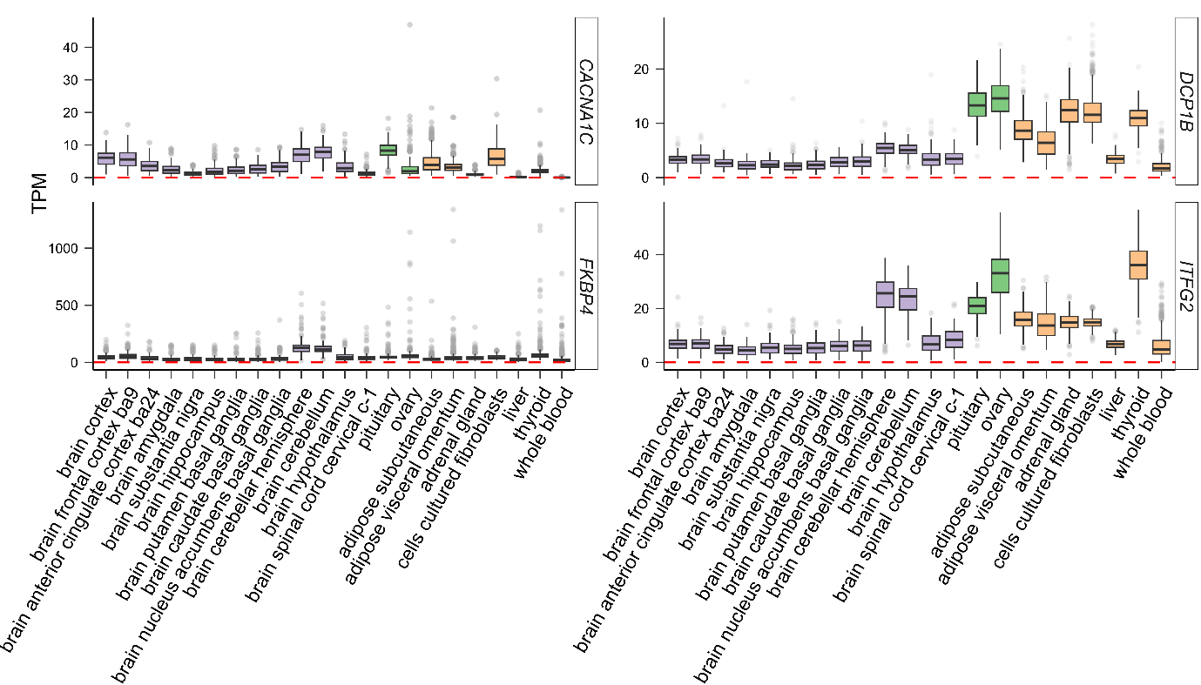
Supplementary Figure 5. Tissue expression of genes mapped for locus identified on chromosome 12:2499849 (rs740417) based on the Genotype-Tissue Expression (GTEx) dataset. Expression values are shown in transcripts per million (TPM). Isoformes were collapsed into a signle gene. No normalization or thresholds procedures applied.

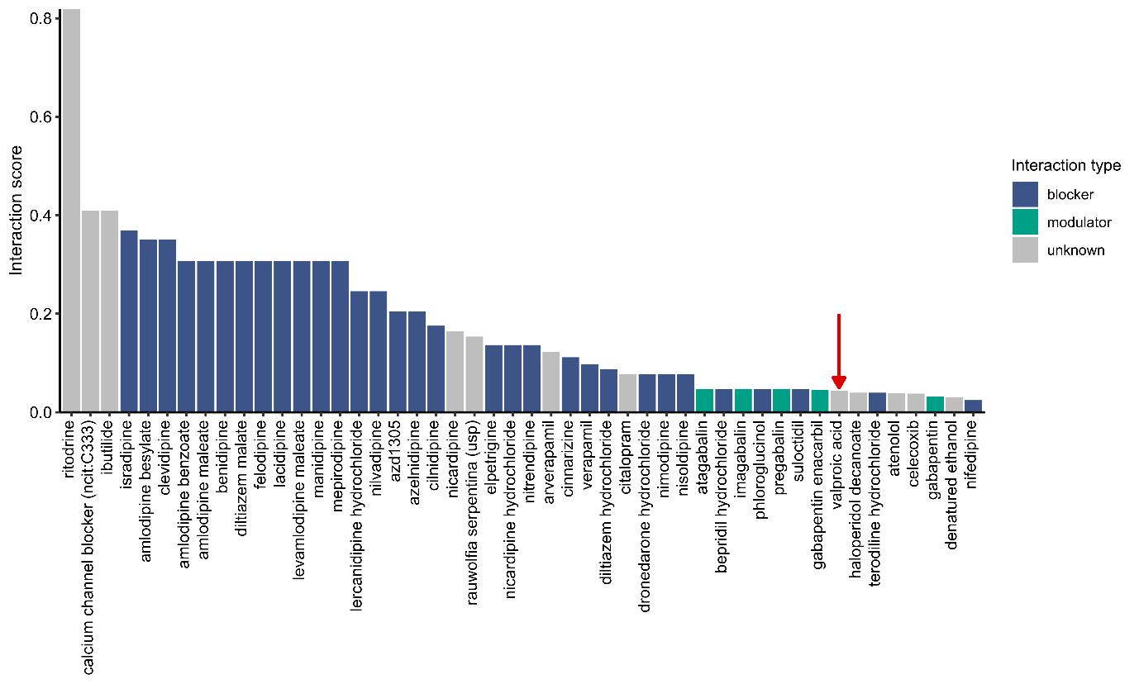
Supplementary Figure 6. Analysis of the drug-gene interaction database (DGIdb) for CACNA1C. The height of each bar illustrates the strength of the interaction (interaction score), while the colors denote the types of interactions. A red arrow highlights the presence of valproic acid.
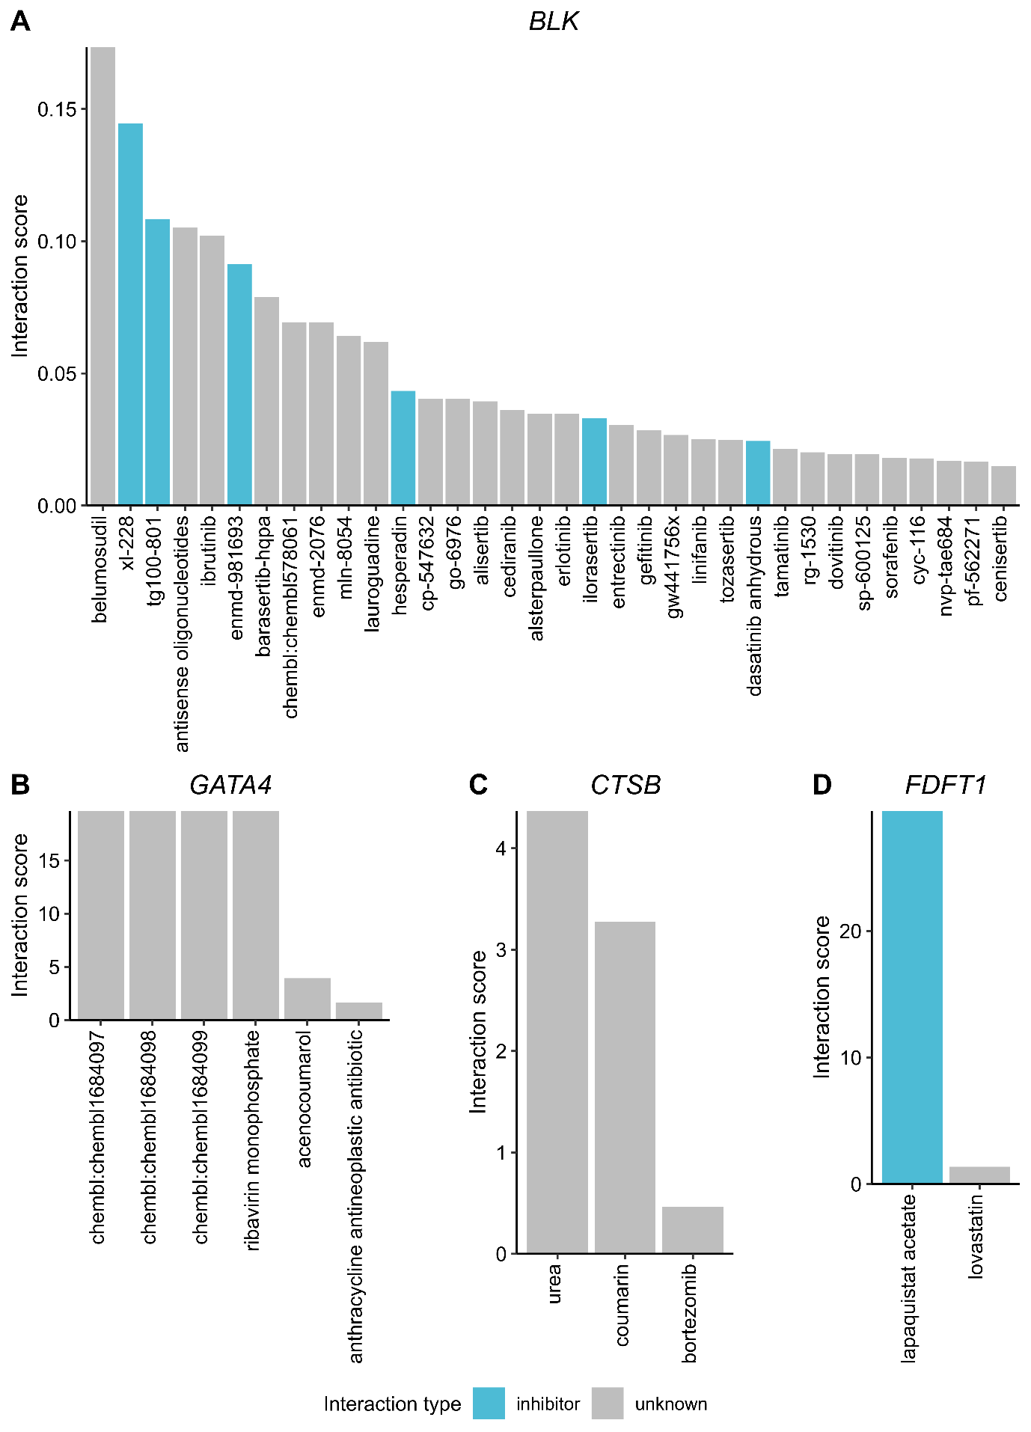Supplementary Figure 7. Analysis of the drug-gene interaction database (DGIdb) for genes mapped to the locus shared between PCOS and BIP and located on chromosome 8:11455262 (rs34876360). A) BLK, B) GATA4, C) CTSB, D) FDFT1. The height of each bar illustrates the strength of the interaction (interaction score), while the colors denote the types of interactions.
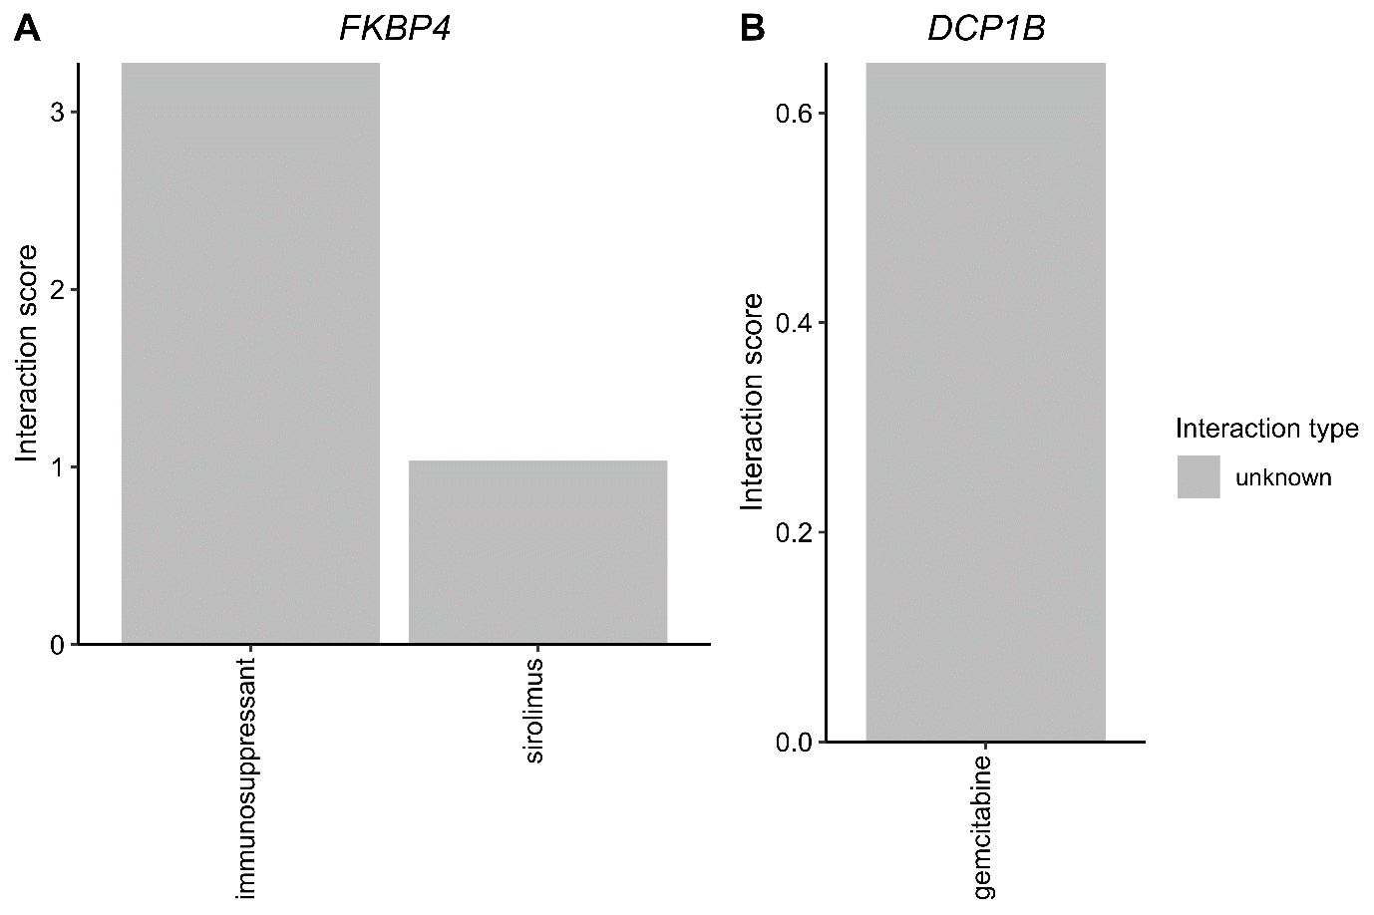
Supplementary Figure 8. Analysis of the drug-gene interaction database (DGIdb) for genes mapped to the locus shared between PCOS and BIP and located on chromosome 12. A) FKBP4, B) DCP1B. The height of each bar illustrates the trength of the interaction (interaction score), while the colors denote the types of interactions.

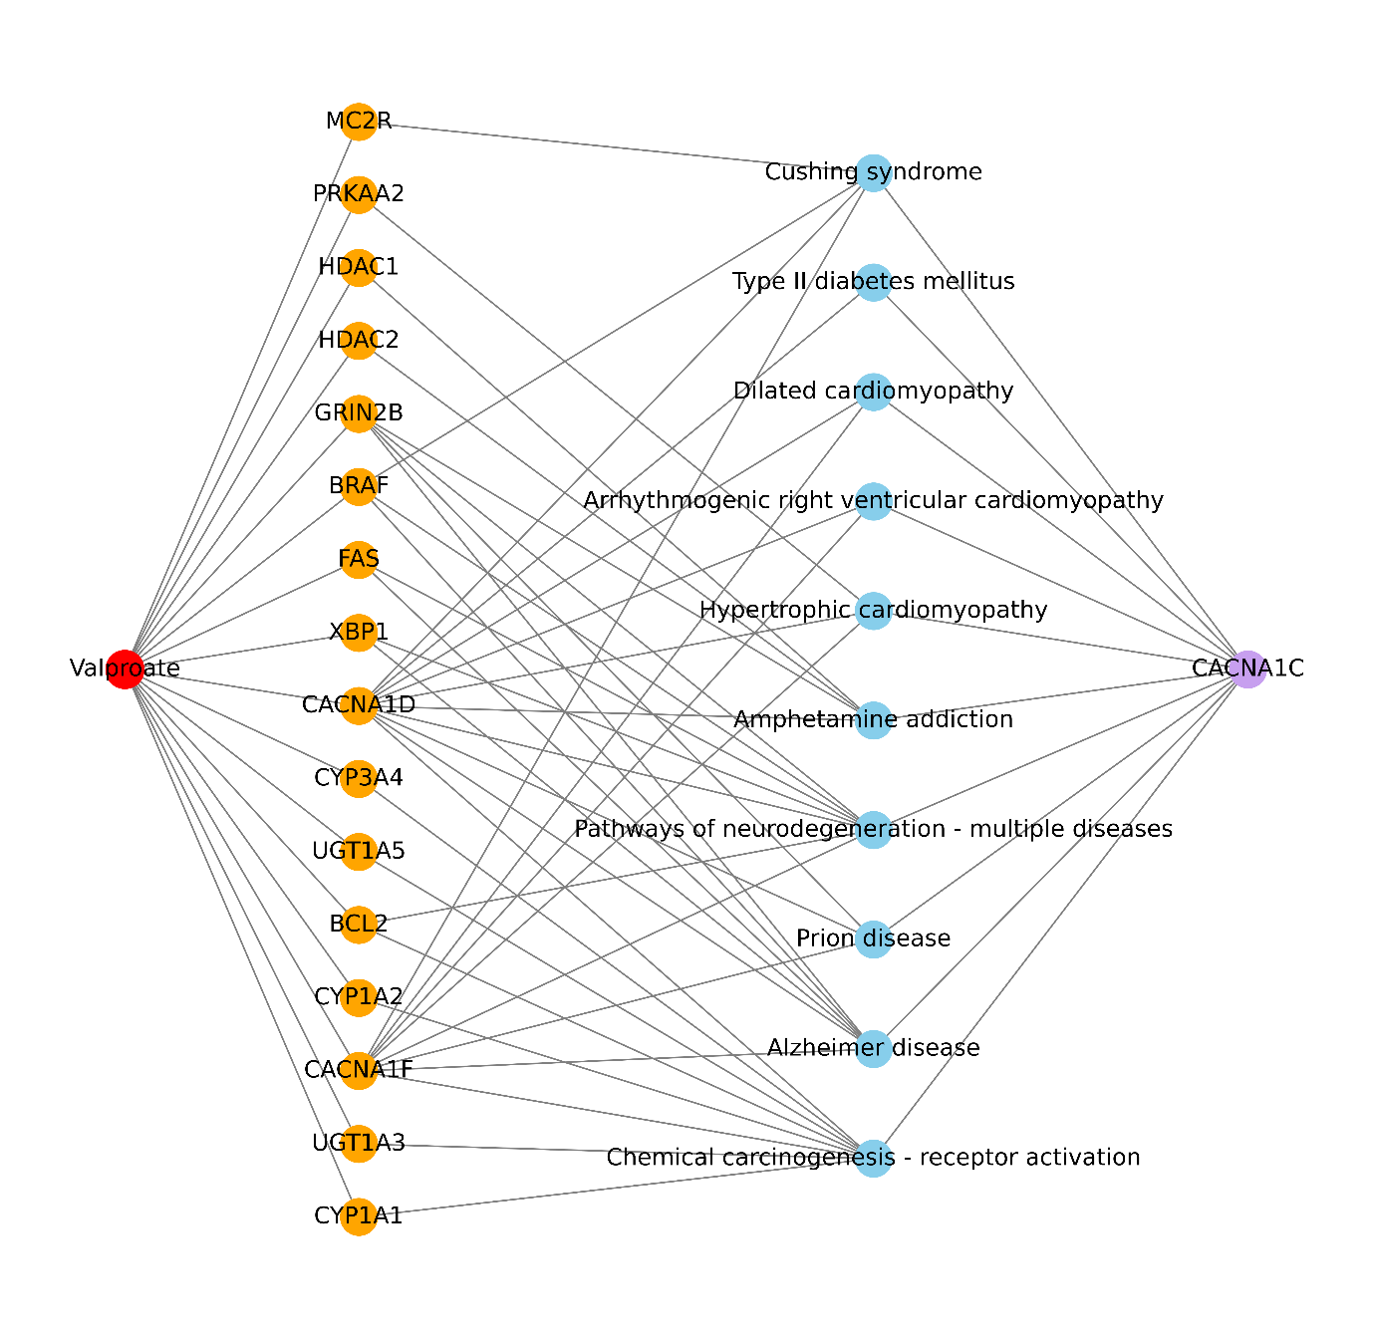
Supplementary Figure 9. The network depicts human diseases pathways encompassing CACNA1C and genes modified by VPA. To enable the above analyses, we removed CACNA1C from the list of genes affected by VPA.

