SUPPLEMENTARY MATERIAL
EUCLIDEAN SPACE POINTS WITH AN EXAMPLE:

The user-defined Euclidean space points are obtained from the sequences (2), (4), (5), (6), (7), and (8) from the manuscript. These points obtained are shown in Table 1. By observing the points from Table 1, it is sure that the points are not limited to the region of the host image. To bring all the ESP in the region of the host image further processing is required on the points of Table 1.

Table 1User defined Euclidean Space points from GS and AS
$$x_{11}$$ | 1 | 2 | 4 | 8 | 16 | 32 | 64 | 128 | 256 | 512
$$y_{11}$$ | 1 | 3 | 5 | 7 | 9 | 11 | 13 | 15 | 17 | 19
$$x_{12}$$ | 19 | 38 | 76 | 152 | 304 | 608 | 1216 | 2432 | 4864 | 9728
$$y_{12}$$ | 19 | 57 | 95 | 133 | 171 | 209 | 247 | 285 | 323 | 361
$$x_{13}$$ | 2 | 5 | 9 | 15 | 25 | 43 | 77 | 143 | 273 | 531
$$y_{13}$$ | 1 | 6 | 20 | 56 | 144 | 352 | 832 | 1920 | 4352 | 9728

The points in Table 1 obtained from the above procedure are above the size of the host image, so applying modulus on the points equal to the size of the image, let the size of the host image is M X N, then applying modulus M on the y – coordinates and modulus N on the x – coordinates results in Table 2. Where the set of values in the x – coordinates are $\left\{X_{11}, X_{12}, and X_{13}\right\}$ and the set values of y – coordinates are $\left\{Y_{11}, Y_{12} and Y_{13}\right\}$

Table 2 Euclidean Space Points with mod 256
$$x_{11}$$ | 1 | 2 | 4 | 8 | 16 | 32 | 64 | 128 | 0 | 0
$$y_{11}$$ | 1 | 3 | 5 | 7 | 9 | 11 | 13 | 15 | 17 | 19
$$x_{12}$$ | 19 | 38 | 76 | 152 | 48 | 96 | 192 | 128 | 0 | 0
$$y_{12}$$ | 19 | 57 | 95 | 133 | 171 | 209 | 247 | 29 | 67 | 105
$$x_{13}$$ | 2 | 5 | 9 | 15 | 25 | 43 | 77 | 143 | 17 | 19
$$y_{13}$$ | 1 | 6 | 20 | 56 | 144 | 96 | 64 | 128 | 0 | 0

In Table 2, there are redundant values in x and y coordinates, so the redundant values are removed, the point at (0, 0) is also removed since practically there will be no (0, 0) point. Thus the user-defined Euclidean Space points are generated, in which the watermark is to be embedded and it is tabulated in Table 3.

Table 3 Set of location points in the defined Euclidean Space without redundant location points
S.No | 1 | 2 | 3 | 4 | 5 | 6 | 7 | 8 | 9 | 10 | 11 | 12 | 13
X - coordinate point | 77 | 43 | 25 | 48 | 15 | 128 | 19 | 96 | 9 | 17 | 192 | 5 | 152
Y - coordinate point | 247 | 209 | 171 | 144 | 133 | 128 | 105 | 96 | 95 | 67 | 64 | 57 | 56
S.No | 14 | 15 | 16 | 17 | 18 | 19 | 20 | 21 | 22 | 23 | 24 | 25 | 26
X - coordinate point | 143 | 76 | 2 | 128 | 64 | 32 | 16 | 8 | 38 | 4 | 2 | 1 | 19
Y – coordinate point | 29 | 20 | 19 | 15 | 13 | 11 | 9 | 7 | 6 | 5 | 3 | 1 | 1

The location points at which the watermark needs to be embedded are defined using Geometric Sequence and Arithmetic Sequence from discrete mathematics.

All the visual metrics of the standard images are calculated and tabulated in Table 4.

Table 4 Full Reference Quality Metric of the Proposed Watermarking Scheme
Host Image (Grayscale) | No. of Bit Plane | Quality Metrics with Watermarked Image and Host image with Logo1 of size  (32 x 32) |  |  |  | Quality Metrics with Watermarked Image and Host image with Logo1 of size  (64 x 64)
Host Image (Grayscale) | No. of Bit Plane | PSNR1 | SSIM1 | CORR1 | BER1 | PSNR2 | SSIM2 | CORR2 | BER2
Cameraman.tif  (512 x 512) |  | 75.06526 | 0.999975 | 1 | 531 | 69.21565 | 0.999909 | 0.999999 | 2042
Cameraman.tif  (512 x 512) |  | 66.79804 | 0.99984 | 0.999998 | 1030 | 60.76588 | 0.999381 | 0.999993 | 4093
Cameraman.tif  (512 x 512) |  | 59.91196 | 0.99924 | 0.999991 | 1517 | 53.81084 | 0.997052 | 0.999965 | 6094
Cameraman.tif  (512 x 512) |  | 53.06582 | 0.996968 | 0.999958 | 2042 | 47.34002 | 0.988576 | 0.999844 | 8170
Cameraman.tif  (512 x 512) |  | 46.49699 | 0.991222 | 0.999811 | 2538 | 41.42625 | 0.967699 | 0.999391 | 10078
Cameraman.tif  (512 x 512) |  | 41.63231 | 0.980827 | 0.999419 | 3057 | 35.04568 | 0.918361 | 0.997355 | 12236
Cameraman.tif  (512 x 512) |  | 35.34495 | 0.969547 | 0.997542 | 3484 | 29.59993 | 0.863789 | 0.99081 | 13935
Cameraman.tif  (512 x 512) |  | 29.57427 | 0.953757 | 0.990769 | 4077 | 22.88145 | 0.784885 | 0.957799 | 16367
Lena.tif  (256 x 256) |  | 69.26269 | 0.999945 | 0.999998 | 505 | 63.24424 | 0.999799 | 0.999993 | 2019
Lena.tif  (256 x 256) |  | 60.54257 | 0.999604 | 0.999987 | 1057 | 54.71107 | 0.998619 | 0.999952 | 4101
Lena.tif  (256 x 256) |  | 53.62271 | 0.998152 | 0.999938 | 1572 | 47.76818 | 0.99337 | 0.999763 | 6133
Lena.tif  (256 x 256) |  | 47.10477 | 0.993097 | 0.999724 | 2093 | 41.252 | 0.973086 | 0.998939 | 8182
Lena.tif  (256 x 256) |  | 40.70534 | 0.979431 | 0.998794 | 2613 | 35.06196 | 0.919163 | 0.995606 | 10172
Lena.tif  (256 x 256) |  | 35.50254 | 0.957789 | 0.996018 | 3118 | 28.74699 | 0.813117 | 0.981788 | 12357
Lena.tif  (256 x 256) |  | 29.63214 | 0.936863 | 0.985012 | 3546 | 22.4722 | 0.678674 | 0.92968 | 14513
Lena.tif  (256 x 256) |  | 23.57659 | 0.906672 | 0.941705 | 4116 | 17.67182 | 0.52421 | 0.807855 | 16443
Lena.tif  (512 x 512) |  | 75.35264 | 0.99998 | 1 | 497 | 69.2864 | 0.999927 | 0.999998 | 2009
Lena.tif  (512 x 512) |  | 66.72312 | 0.999857 | 0.999997 | 1025 | 60.78568 | 0.999498 | 0.999988 | 4060
Lena.tif  (512 x 512) |  | 59.82153 | 0.999321 | 0.999985 | 1530 | 53.8746 | 0.997616 | 0.999942 | 6040
Lena.tif  (512 x 512) |  | 53.43817 | 0.997413 | 0.999936 | 1998 | 47.30472 | 0.990156 | 0.999736 | 8089
Lena.tif  (512 x 512) |  | 47.00038 | 0.992003 | 0.999717 | 2485 | 40.89298 | 0.968077 | 0.998846 | 10144
Lena.tif  (512 x 512) |  | 41.24524 | 0.981044 | 0.998935 | 3063 | 35.02336 | 0.927769 | 0.995573 | 12147
Lena.tif  (512 x 512) |  | 35.7359 | 0.970984 | 0.996236 | 3477 | 28.92583 | 0.869957 | 0.982379 | 14054
Lena.tif  (512 x 512) |  | 29.30951 | 0.95395 | 0.983633 | 4077 | 23.57285 | 0.783081 | 0.941654 | 16240
Mandril.tif  Or  Baboon.tif  Size  (512 x 512) |  | 75.41424 | 0.999996 | 0.999999 | 490 | 69.12306 | 0.999981 | 0.999998 | 2086
Mandril.tif  Or  Baboon.tif  Size  (512 x 512) |  | 66.71714 | 0.999965 | 0.999996 | 1022 | 60.70792 | 0.999869 | 0.999983 | 4153
Mandril.tif  Or  Baboon.tif  Size  (512 x 512) |  | 59.67984 | 0.999821 | 0.999978 | 1541 | 53.81231 | 0.999368 | 0.999915 | 6148
Mandril.tif  Or  Baboon.tif  Size  (512 x 512) |  | 53.26289 | 0.999309 | 0.999904 | 2052 | 47.17325 | 0.997192 | 0.999609 | 8287
Mandril.tif  Or  Baboon.tif  Size  (512 x 512) |  | 46.96927 | 0.997398 | 0.999591 | 2585 | 40.90526 | 0.989376 | 0.998349 | 10388
Mandril.tif  Or  Baboon.tif  Size  (512 x 512) |  | 40.9448 | 0.992715 | 0.998364 | 3092 | 34.6527 | 0.966631 | 0.993086 | 12515
Mandril.tif  Or  Baboon.tif  Size  (512 x 512) |  | 35.01301 | 0.983867 | 0.993653 | 3584 | 28.94451 | 0.92678 | 0.975164 | 14436
Mandril.tif  Or  Baboon.tif  Size  (512 x 512) |  | 29.79673 | 0.969529 | 0.979156 | 4087 | 23.57042 | 0.848187 | 0.918315 | 16539
Pepper.tif  (512 x 512) |  | 74.84208 | 0.999987 | 1 | 559 | 69.07338 | 0.999948 | 0.999999 | 2110
Pepper.tif  (512 x 512) |  | 66.61194 | 0.999916 | 0.999998 | 1103 | 60.72715 | 0.999635 | 0.99999 | 4157
Pepper.tif  (512 x 512) |  | 59.85738 | 0.999614 | 0.999988 | 1581 | 53.84677 | 0.998267 | 0.999954 | 6206
Pepper.tif  (512 x 512) |  | 53.27755 | 0.998369 | 0.999947 | 2091 | 47.24961 | 0.992356 | 0.999788 | 8215
Pepper.tif  (512 x 512) |  | 47.01924 | 0.994492 | 0.999776 | 2616 | 41.1299 | 0.974396 | 0.999132 | 10239
Pepper.tif  (512 x 512) |  | 40.58276 | 0.986214 | 0.999016 | 3161 | 35.00273 | 0.934817 | 0.996449 | 12348
Pepper.tif  (512 x 512) |  | 35.22015 | 0.974184 | 0.996629 | 3654 | 29.34631 | 0.876489 | 0.987146 | 14261
Pepper.tif  (512 x 512) |  | 29.5508 | 0.962241 | 0.98764 | 4139 | 23.29504 | 0.791611 | 0.949616 | 16453
Pirate.tif  Or  Man.tif  (512 x 512) |  | 75.04079 | 0.999984 | 1 | 534 | 69.26914 | 0.999954 | 0.999998 | 2017
Pirate.tif  Or  Man.tif  (512 x 512) |  | 66.9079 | 0.999896 | 0.999997 | 1026 | 60.77714 | 0.999677 | 0.999988 | 4080
Pirate.tif  Or  Man.tif  (512 x 512) |  | 59.763 | 0.999479 | 0.999985 | 1531 | 53.71708 | 0.998371 | 0.999939 | 6118
Pirate.tif  Or  Man.tif  (512 x 512) |  | 53.57336 | 0.998029 | 0.999937 | 2036 | 47.43345 | 0.993598 | 0.999741 | 8141
Pirate.tif  Or  Man.tif  (512 x 512) |  | 46.82183 | 0.993294 | 0.999702 | 2594 | 41.28261 | 0.979147 | 0.998934 | 10125
Pirate.tif  Or  Man.tif  (512 x 512) |  | 41.30781 | 0.985325 | 0.998942 | 3077 | 35.1639 | 0.941204 | 0.995669 | 12162
Pirate.tif  Or  Man.tif  (512 x 512) |  | 35.03105 | 0.973011 | 0.995537 | 3550 | 29.41455 | 0.887945 | 0.98401 | 13983
Pirate.tif  Or  Man.tif  (512 x 512) |  | 29.64896 | 0.961214 | 0.984709 | 4072 | 23.44456 | 0.810617 | 0.93897 | 16170
Walkbridge.tif  (512 x 512) |  | 74.99227 | 0.999994 | 1 | 540 | 69.22843 | 0.999981 | 0.999999 | 2036
Walkbridge.tif  (512 x 512) |  | 66.50012 | 0.999959 | 0.999998 | 1089 | 60.7677 | 0.999869 | 0.999991 | 4089
Walkbridge.tif  (512 x 512) |  | 59.73079 | 0.999817 | 0.999988 | 1589 | 53.79702 | 0.999356 | 0.999954 | 6117
Walkbridge.tif  (512 x 512) |  | 53.43868 | 0.999246 | 0.99995 | 2093 | 47.37594 | 0.997294 | 0.999798 | 8161
Walkbridge.tif  (512 x 512) |  | 47.03578 | 0.997243 | 0.999782 | 2620 | 41.11909 | 0.989833 | 0.999149 | 10210
Walkbridge.tif  (512 x 512) |  | 41.18573 | 0.991841 | 0.999161 | 3120 | 35.12241 | 0.96794 | 0.996623 | 12228
Walkbridge.tif  (512 x 512) |  | 34.50797 | 0.981372 | 0.99611 | 3679 | 28.64439 | 0.919921 | 0.985237 | 14463
Walkbridge.tif  (512 x 512) |  | 29.09677 | 0.967586 | 0.986565 | 4215 | 23.39313 | 0.853938 | 0.951678 | 16434
Woman_blonde.tif  (512 x 512) |  | 75.62303 | 0.999985 | 1 | 467 | 69.33641 | 0.999946 | 0.999998 | 1986
Woman_blonde.tif  (512 x 512) |  | 67.2498 | 0.999895 | 0.999997 | 931 | 60.79026 | 0.999621 | 0.999985 | 4033
Woman_blonde.tif  (512 x 512) |  | 60.22454 | 0.999485 | 0.999983 | 1404 | 53.73504 | 0.998103 | 0.999924 | 6091
Woman_blonde.tif  (512 x 512) |  | 53.69901 | 0.997868 | 0.999923 | 1859 | 47.42008 | 0.992529 | 0.999673 | 8060
Woman_blonde.tif  (512 x 512) |  | 47.8876 | 0.993271 | 0.999706 | 2361 | 41.23677 | 0.97472 | 0.998646 | 10121
Woman_blonde.tif  (512 x 512) |  | 41.83672 | 0.984178 | 0.998814 | 2761 | 35.42343 | 0.936146 | 0.99484 | 11947
Woman_blonde.tif  (512 x 512) |  | 35.77751 | 0.970275 | 0.995279 | 3318 | 29.04233 | 0.873008 | 0.978603 | 14115
Woman_blonde.tif  (512 x 512) |  | 30.26954 | 0.958998 | 0.983302 | 3717 | 24.13207 | 0.794348 | 0.935889 | 15881
Woman_blackhair  .tif  (512 x 512) |  | 75.20657 | 0.999975 | 1 | 514 | 69.14602 | 0.999921 | 0.999999 | 2075
Woman_blackhair  .tif  (512 x 512) |  | 66.58053 | 0.999818 | 0.999998 | 1050 | 60.61153 | 0.999444 | 0.999993 | 4173
Woman_blackhair  .tif  (512 x 512) |  | 59.65436 | 0.999156 | 0.999991 | 1568 | 53.67495 | 0.997335 | 0.999963 | 6241
Woman_blackhair  .tif  (512 x 512) |  | 53.35568 | 0.996898 | 0.999961 | 2064 | 47.16447 | 0.989253 | 0.999836 | 8318
Woman_blackhair  .tif  (512 x 512) |  | 47.36629 | 0.990833 | 0.999843 | 2576 | 41.29264 | 0.967816 | 0.999366 | 10347
Woman_blackhair  .tif  (512 x 512) |  | 40.56533 | 0.978986 | 0.999251 | 3166 | 34.54217 | 0.913793 | 0.997024 | 12644
Woman_blackhair  .tif  (512 x 512) |  | 35.3095 | 0.965351 | 0.997491 | 3645 | 29.40354 | 0.847039 | 0.990314 | 14525
Woman_blackhair  .tif  (512 x 512) |  | 29.5351 | 0.955055 | 0.990563 | 4099 | 23.48225 | 0.783808 | 0.962831 | 16356
Whitepage.tif  (512 x 512) |  | 74.29531 | 0.999964 | NaN | 634 | 68.3091 | 0.999854 | NaN | 2516
Whitepage.tif  (512 x 512) |  | 64.75289 | 0.999684 | NaN | 1268 | 58.76667 | 0.998701 | NaN | 5032
Whitepage.tif  (512 x 512) |  | 57.39335 | 0.998384 | NaN | 1902 | 51.40714 | 0.993292 | NaN | 7548
Whitepage.tif  (512 x 512) |  | 50.77349 | 0.99402 | NaN | 2536 | 44.78727 | 0.974487 | NaN | 10064
Whitepage.tif  (512 x 512) |  | 44.46808 | 0.984659 | NaN | 3170 | 38.48186 | 0.931571 | NaN | 12580
Whitepage.tif  (512 x 512) |  | 38.3085 | 0.97229 | NaN | 3804 | 32.32229 | 0.871206 | NaN | 15096
Whitepage.tif  (512 x 512) |  | 32.21924 | 0.960388 | NaN | 4438 | 26.23302 | 0.810844 | NaN | 17612
Whitepage.tif  (512 x 512) |  | 26.16451 | 0.950251 | NaN | 5072 | 20.17829 | 0.758603 | NaN | 20128
Blackpage.tif  (512 x 512) |  | 76.40556 | 0.999958 | NaN | 390 | 70.32963 | 0.999827 | NaN | 1580
Blackpage.tif  (512 x 512) |  | 66.86313 | 0.999629 | NaN | 780 | 60.78721 | 0.998478 | NaN | 3160
Blackpage.tif  (512 x 512) |  | 59.5036 | 0.998154 | NaN | 1170 | 53.42767 | 0.992511 | NaN | 4740
Blackpage.tif  (512 x 512) |  | 52.88373 | 0.993635 | NaN | 1560 | 46.80781 | 0.974293 | NaN | 6320
Blackpage.tif  (512 x 512) |  | 46.57832 | 0.985201 | NaN | 1950 | 40.5024 | 0.939217 | NaN | 7900
Blackpage.tif  (512 x 512) |  | 40.41875 | 0.975375 | NaN | 2340 | 34.34282 | 0.896106 | NaN | 9480
Blackpage.tif  (512 x 512) |  | 34.32948 | 0.966521 | NaN | 2730 | 28.25356 | 0.85496 | NaN | 11060
Blackpage.tif  (512 x 512) |  | 28.27475 | 0.959053 | NaN | 3120 | 22.19883 | 0.818323 | NaN | 12640
NaN* - It is 0/0 from whitepage.tif and blackpage.tif. (Discussions): Homogenous images tend to have high correlation value.

Table 5. Histogram of I, F_WI and Difference of Histogram of I and F_WI
Histogram of Input Image | Histogram of Output Image from Facebook | Difference Histogram of Input Image
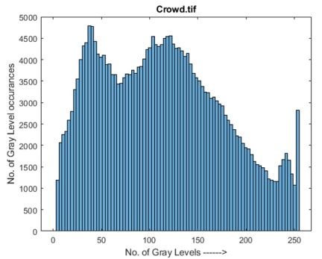 | 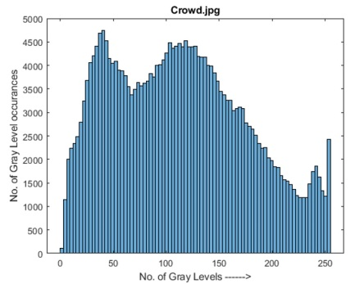 | 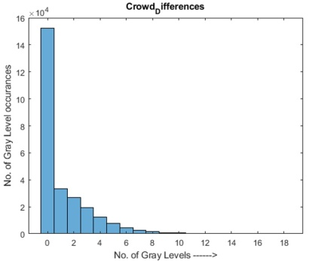
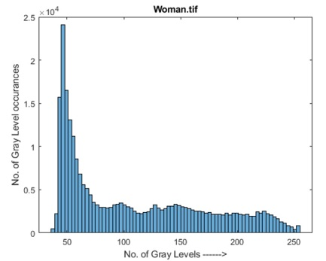 | 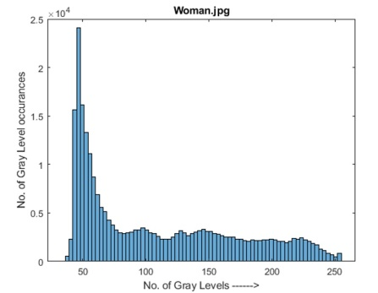 | 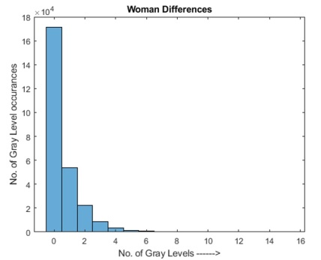
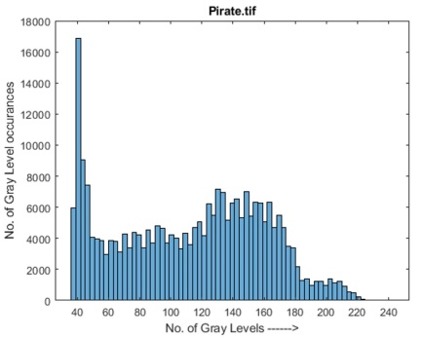 | 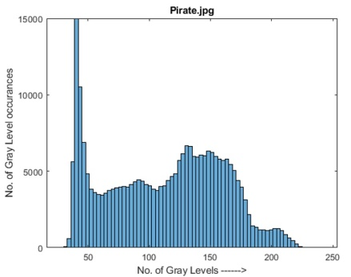 | 