Appendix.

Methodology

Animals
BALB/c mice (Envigo) were transported to the University of Helsinki biosafety level 3 (BSL-3) facility and acclimatized to individually ventilated biocontainment cages (ISOcage; Scanbur) for seven days with ad libitum water and food (rodent pellets). After the acclimatization period, the animals were placed under isoflurane anesthesia and inoculated intranasally with 20 µl of virus dilution. Immediately following the inoculation, the isoflurane was switched off and the animals were held in an upright position for a few seconds to allow the liquid to flush downwards in the nasal cavity. The wellbeing of the animals was carefully observed throughout the experiment for signs of illness, but none of the mice showed any clinical symptoms. Euthanasia was performed under terminal isoflurane anesthesia with cervical dislocation. Experimental procedures were approved by the Animal Experimental Board of Finland (license number ESAVI/28687/2020).
Viruses
The wt and beta variant SARS-CoV-2 viruses were isolated in a BSL-3 laboratory as described in (1, 2).
RNA isolation and RT-PCR
Following euthanasia and dissections, RNA extractions from lung tissues were performed using Trizol (ThermoScientific) according to the manufacturers’ instructions. Isolated RNA was directly subjected to one-step RT-qPCR analysis based on a previously described protocol for RdRp (2) and for E and subE genes (3) with TaqMan fast virus 1-step master mix (Thermo Scientific) using AriaMx instrumentation (Agilent). The actin RT-qPCR is described in (4).
Sequencing
Isolated RNA from lung tissues were used for sequencing the SARS-CoV-2 beta variant with Illumina NovaSeq platform in-house within the Department of Virology in the University of Helsinki

Histology and immunohistochemistry
The left lung and remaining thoracic organs were trimmed and routinely paraffin wax embedded. Coronal sections (1-2 mm) of the nose were prepared using a diamond saw (Exakt 300; Exakt), followed by gently decalcification in RDF (Biosystems) for 5 days at RT and on a shaker, followed by paraffin wax embedding. Consecutive sections (3–5 µm) were prepared and routinely stained with hematoxylin-eosin (HE) or subjected to IHC for the detection of SARS-CoV-2 antigen in tissues as previously described (5). IHC was performed in an autostainer (Agilent) using a rabbit polyclonal anti-SARS-CoV nucleoprotein antibody (Rockland, 200-402-A50) and the horseradish peroxidase (HRP) method. Briefly, sections were deparaffinized and rehydrated through graded alcohol. Antigen retrieval was achieved by 20 min incubation in citrate buffer (pH 6.0) at 98 °C in a pressure cooker. This was followed by incubation with the primary antibody (diluted 1:3,000 in dilution buffer; Dako) overnight at 4 ⁰C, a 10 min incubation at room temperature (RT) with peroxidase blocking buffer (Agilent) and a 30 min incubation at RT with Envision+System HRP Rabbit (Agilent). The reaction was visualized with diaminobenzidin (DAB; Dako) for 10 min at RT. After counterstaining with hematoxylin for 2 s, sections were dehydrated and placed on a coverslip with Tissue-Tek Film (Sysmex, Kobe, Japan).
References

1. Cantuti-Castelvetri L, Ojha R, Pedro LD, Djannatian M, Franz J, Kuivanen S, van der Meer F, Kallio K, Kaya T, Anastasina M, Smura T, Levanov L, Szirovicza L, Tobi A, Kallio-Kokko H, Österlund P, Joensuu M, Meunier FA, Butcher SJ, Winkler MS, Mollenhauer B, Helenius A, Gokce O, Teesalu T, Hepojoki J, Vapalahti O, Stadelmann C, Balistreri G, Simons M. Neuropilin-1 facilitates SARS-CoV-2 cell entry and infectivity. Science. 2020 Nov 13;370(6518):856-860
2. Virtanen J, Uusitalo R, Korhonen EM, et al. Kinetics of Neutralizing Antibodies of COVID-19 Patients Tested Using Clinical D614G, B.1.1.7, and B 1.351 Isolates in Microneutralization Assays. Viruses. 2021;13(6):996.
3. Dagotto G, Mercado NB, Martinez DR, Hou YJ, Nkolola JP, Carnahan RH, et al. Comparison of Subgenomic and Total RNA in SARS-CoV-2 Challenged Rhesus Macaques. J Virol. 2021;95(8).
4. Zivcec M, Safronetz D, Haddock E, Feldmann H, Ebihara H. Validation of assays to monitor immune responses in the Syrian golden hamster (Mesocricetus auratus). J Immunol Methods. 2011;368(1-2):24-35.
5.Clark JJ, Penrice-Randal R, Sharma P, Kipar A, Dong X, Pennington SH, et al. Sequential infection with influenza A virus followed by severe acute respiratory syndrome coronavirus 2 (SARS-CoV-2) leads to more severe disease and encephalitis in a mouse model of COVID-19. bioRxiv. 2021:2020.10.13.334532.
Supplemental Material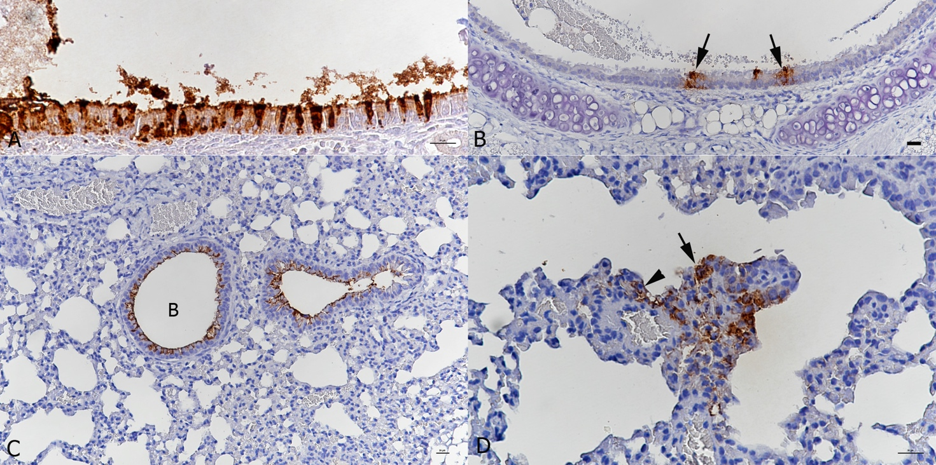
Supplemental Figure S1. BALB-C mouse, male. Two days post intranasal infection with 6 x 10³ PFU of beta variant SARS-CoV-2. A. Nose with focal extensive viral antigen expression in ciliated epithelial cells. Bar = 20 µm. B. Trachea with small patches of positive epithelial cells (arrows). Bar = 20 µm. Bar = 20 µm. C. Lung with viral antigen deposition along the luminal surface of the bronchiolar epithelial cells. B: bronchiole. D. Lung. Small focal area with viral antigen expression in type I (arrowhead) and type II (arrow) alveolar epithelial cells. Bar = 10 µm. Immunohistochemistry, hematoxylin counterstain.

