The role of the Helmholtz potential on electrocatalytic activity
Supplementary Information
Arsène Chemin
0000-0003-2338-1523
Univ. Lyon, Université Claude Bernard Lyon 1, CNRS, UMR5306, Institut Lumière Matière, Villeurbanne, F-69100, France
arsene.chemin@univ-lyon1.fr
Louis Godeffroy
0009-0003-2763-0408
Helmholtz-Zentrum Berlin für Materialien und Energy GmbH Nanoscale Solid-Liquid Interfaces Albert-Einstein Str. 15 Berlin Germany
louis.godeffroy@helmholtz-berlin.de
David Amans
0000-0001-7553-2907
Univ. Lyon, Université Claude Bernard Lyon 1, CNRS, UMR5306, Institut Lumière Matière, Villeurbanne, F-69100, France
david.amans@univ-lyon1.fr
Tristan Petit
0000-0002-6504-072X
Helmholtz-Zentrum Berlin für Materialien und Energy GmbH Nanoscale Solid-Liquid Interfaces Albert-Einstein Str. 15 Berlin Germany
tristan.petit@helmholtz-berlin.de

Supplementary Note 1: HER Overpotential as a function of the Helmholtz potential
In the specific case of HER, the extended Butler–Volmer equation (Eq. 1) can be rewritten:
$$\frac{j}{j_{0}}={r_{H_{2}}e}^{\frac{Fη}{RT}}-r_{H+}e^{-\frac{Fη}{RT}}, r_{H+}=\frac{{\left[H^{+}\right]}_{surf}}{{\left[H^{+}\right]}_{bulk}}=e^{-\frac{qV_{H}}{k_{B}T}}, r_{H_{2}}= \frac{{\left[H_{2}\right]}_{surf}}{{\left[H_{2}\right]}_{bulk}} (S1.1)$$
For a target current density $j=-0.005$ A/cm², and an exchange current density $j_{0}$ = 10 A/cm² deduced from data fitting in Figure 1, equation S4.1 can be inverted to compute the overpotential $η$ as a function of the Helmholtz potential $V_{H}$, accounting for both cathodic and anodic currents. By setting $X=e^{-\frac{Fη}{RT}}$, Equation S1.1 reduces to solving a second-degree polynomial.
$$0=-r_{H+}X^{2}-\frac{j}{j_{0}}X+r_{H_{2}}, (S1.2)$$
The polynomial admits a physically meaningful solution:
$$X=e^{-\frac{Fη}{RT}}= \frac{1}{2r_{H+}}\left(\sqrt{{\left(\frac{j}{j_{0}}\right)}^{2}+4r_{H+}r_{H_{2}}} - \frac{j}{j_{0}}\right), (S1.3)$$
We still need to discuss the values of $r_{H+}$ and $r_{H2}$. In the article, we introduce a relationship between $r_{H+}$ and Helmholtz potential $V_{H}$, i.e. $r_{H+}∝exp⁡\left(-\frac{qV_{H}}{k_{B}T}\right)$. Nevertheless, at low Helmholtz potential $V_{H}$, it is necessary to introduce a cutoff for $r_{H+}$, reflecting the limitation imposed by diffusion. In other words, the surface concentration of $H^{+}$ is not expected to exceed the bulk concentration due to its consumption during the reaction at the surface of the electrode. The local pH cannot be lower than the bulk pH of 13 used in these experiments. When decreasing the limit surface concentration of H⁺ from pH=13 to pH=14, the saturation overpotential for negative Helmholtz potential increases as shown by the red curve compared to the black curve in Fig. S1.
For $r_{H_{2}}$, a first approach consists in taking a value of 1, considering that the continuous production of $H_{2}$ leads to saturation of dissolved $H_{2}$ in the solution, with ${\left[H_{2}\right]}_{surf}={\left[H_{2}\right]}_{bulk}={\left[H_{2}\right]}_{sat}= 7.8×{10}^{-4}$ mol/L considering the $H_{2}$ solubility in water at 1 atm and 25°C (Henry coefficient $7.8 ×{10}^{-6}$ mol/m³/pa). In any case, the $H_{2}$ concentration is not expected to depend on $V_{H}$. From Equation S1.3, we can evaluate the $V_{H}$ value from which the oxidation reaction has to be taken into account. This corresponds to the $V_{H}$ value at which the two terms inside the square root in Equation S1.3 become equal, i.e. ${\left(\frac{j}{j_{0}}\right)}^{2}=4r_{H+}r_{H_{2}}$. It occurs for $V_{H}=0.43$ V, as shown in Fig. 1 and in black in Fig. S1.
We assume $r_{H_{2}}=1,$ but, at equilibrium, an $H_{2}$ concentration gradient can be assumed to result from its accumulation close to the interface. Assuming a $H_{2}$current density $j_{H_{2}}=\frac{1}{2}\left|j\right|$ at the electrode surface, resulting from its production, one can derive the concentration gradient $\left[H_{2}\right]\left(z\right)$, with $z$ being the distance from the electrode into the electrolyte. We assume a planar interface which is a reasonable approximation given the characteristic distance involved. The stationary solution $0=\frac{∂\left[H_{2}\right]}{∂t}\left(z,t\right)$ implies that $j_{H_{2}}\left(z\right)=j_{H_{2}}\left(0\right)=\frac{1}{2}\left|j\right|$ close to the surface, since $\frac{∂\left[H_{2}\right]}{∂t}\left(z,t\right)=-\frac{∂j_{H_{2}}}{∂z}\left(z,t\right)$. Solving the Fick law, $j_{H_{2}}(z)=-D\frac{∂\left[H_{2}\right]}{∂z}\left(z\right)$, with $D=4.5×{10}^{-9}$ m²/s the diffusion coefficient of $H_{2}$ in water, it follows that $\left[H_{2}\right]\left(z\right)=-\frac{\left|j\right|}{2D}z+cst.$ At a distance L, corresponding to the slipping plane, $\left[H_{2}\right]\left(z\right)$ reaches a constant due to the stirring of the solution. One can assume $\left[H_{2}\right]\left(L\right)={\left[H_{2}\right]}_{sat}$, with $L$ taken as 1 nm at molar ionic strength. It follows that $\left[H_{2}\right]\left(z\right)=\frac{\left|j\right|}{2D}\left(L-z\right)+{\left[H_{2}\right]}_{sat}$, and then
$$r_{H_{2}}= \frac{{\left[H_{2}\right]}_{surf}}{{\left[H_{2}\right]}_{bulk}}=\frac{\left[H_{2}\right]\left(0\right)}{{\left[H_{2}\right]}_{sat}}=\frac{\left|j\right|L}{2D{\left[H_{2}\right]}_{sat}}+1, (S1.4)$$
This leads to $r_{H_{2}}=8.1$. The increase in $H_{2}$ concentration near the electrode leads to a slight rise in the overpotential compared to the case $r_{H_{2}}=1$ as shown in Fig. S1 (blue curve versus black curve). For overpotential small enough so the H₂ oxidation reaction becomes significant, the higher surface concentration of H₂ enhances the reaction rate, which in turn must be balanced by a larger overpotential.
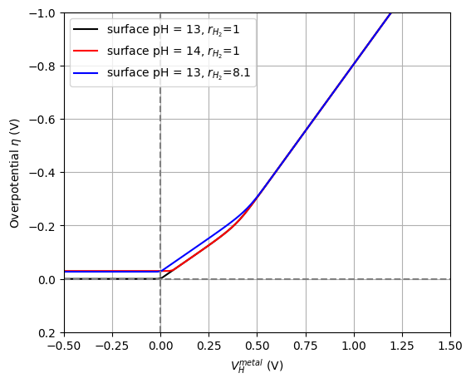
Figure S1: Variations of the HER overpotential as a function of the Helmholtz potential depending on the pH at the surface of the electrode as well as the surface versus bulk ratio of H₂( $r_{H_{2}}).$

Supplementary Note 2: Continuity of the electric displacement at the surface of a semiconductor electrode
When a semiconductor electrode is put in contact with a metal, having a difference of potential $Δϕ_{SC}$, charge transfers form a SCR with a thickness $W_{SC}$ that can be calculated simply as
$$W_{SC}=\sqrt{\frac{2ϵ_{0} ϵ_{r}^{SC}}{qN_{D} } Δϕ_{SC} } \left(S2.1\right)$$
with $ϵ_{r}^{SC}$ and $ϵ_{0}$ the relative permittivity of the semiconductor and of the vacuum, respectively, and $N_{D}$ the density of charge carriers.
Considering the continuity of the electric displacement at the interface, the Helmholtz potential can be derived as:
$$V_{H}=\frac{ϵ_{r}^{SC}}{ϵ_{r}^{HL} } \frac{W_{HL}}{W_{SC}} Δϕ_{SC}, (S2.2)$$
with $ϵ_{r}^{SC}$ and $ϵ_{r}^{HL}$ the relative permittivity of the semiconductor and the Helmholtz layer, respectively, and $W_{HL}$ the width of the Helmholtz layer. The relative permittivity of the electrolyte remains close to that of water ($ϵ_{r}^{HL}∼80$) even if it decreases with increasing ion concentration³², so that $ϵ_{r}^{SC}<ϵ_{r}^{HL}$ and $W_{SC}>>W_{HL}$ for a classical semiconductor in concentrated electrolyte (>0.1 M). Interestingly, $V_{H}$ is therefore negligible for semiconductors.
In equation (S2.2), surface charges are not explicitly considered, which may seem surprising as surface states and defect often trap charges and ions can absorb. This omission is justified by the fact that the potential drop is attributed to the charge distribution within the Helmholtz layer, which inherently includes any surface charges. Alternatively, since the Helmholtz layer is extremely thin at high ionic strength, its total charge can be effectively treated as a surface charge. The results presented here remain unchanged whether one interprets the effect as the energy required for a reactant to adsorb or desorb from a charged surface, or as the energy needed to overcome the potential barrier across the Helmholtz layer.

Supplementary Note 3: Derivation of the evolution of the potential in a semiconductor thin film
The evolution of the potential $ϕ(x)$ in the semiconductor is given by the Poisson equation with a uniform charge density $qN_{D}$​ as described as:
$$\frac{d^{2} ϕ}{dx^{2} }=-\frac{qN_{D}}{ϵ_{0} ϵ_{r}^{SC} } (S3.1)$$
Solving this equation considering $ϕ(x=0)=WF/q$​ and $ϕ(x=d)=-μ/q-V_{H}$, leads to:
$$ϕ\left(x\right)=-\frac{qN_{D}}{2ϵ_{0} ϵ_{r}^{SC} }x^{2}+C_{1} x+WF/q (S3.2)$$
with:
$$C_{1}=\frac{qN_{D}}{2ϵ_{0} ϵ_{r}^{SC} } d-\frac{μ+WF+qV_{H}}{qd} (S3.3)$$
At the interface between the electrolyte and the semiconductor, the continuity of the electric displacement gives:
$$ϵ_{0} ϵ_{r}^{SC} \left(-\frac{qN_{D}}{ϵ_{0} ϵ_{r}^{SC} } d+C_{1} \right)=ϵ_{0} ϵ_{r}^{HL} \frac{V_{H}}{W_{HL}}. (S3.4)$$
Combining both equation leads to an expression of the Helmholtz potential:
$$qV_{H}=\frac{1-{\left(\frac{d}{W_{SC}}\right)}^{2}}{1+\frac{ϵ_{r}^{HL}}{ϵ_{r}^{SC} } \frac{d}{W_{HL}} } \left[-μ-WF\right], (S3.5)$$
where
$$W_{SC}=\sqrt{\frac{2ϵ_{0} ϵ_{r}^{SC}}{q^{2} N_{D} } \left[-μ-WF\right]} (S3.6)$$
would be the width of the SCR for the potential difference $-(μ+WF)/q$ defined when $V_{H}=0$. Note that $\left[-μ-WF\right]$ is only positive in the limit of the model $WF< -μ$ .
Compared to eq. 3, a dependence of the Helmholtz potential linear with the difference $-μ-WF$ similar to the one derived for metal is observed, except that the coefficient $κ$ tends to zero as d approaches the value $W_{SC}$.

Supplementary Note 4: Consideration on the resistivity of the semiconducting thin film
The presence of the thin hydroxyl layer can introduce an additional resistive component to the system, effectively behaving as a series resistor and contributing to the observed increase of $η$ by:
$$η_{R}=\frac{j}{qμ_{n} N_{D} } d. (S4)$$
with $j$ the current density and $μ_{n}$ the charge mobility. As discussed previously, increasing the density of charge carrier and decreasing the thickness can help to mitigate this potential drop. But this overpotential remains negligible even for low amount of charge carriers and large current densities relevant for industrial application, and thickness of hundreds of nanometers.

Supplementary Note 5: Modulation of the HER overpotential on Pt(111) surface by a thin metal hydroxide layer
The high WF of Pt(111) results in a negative Helmholtz potential when in contact with an aqueous electrolyte (Fig. S2a). Although this negative Helmholtz potential does not reduce the proton concentration at the electrode surface, it introduces an energetic penalty associated with charge transfer across the two-dimensional interfacial water network, as previously described by Koper and co-workers⁸, leading to an overpotential of 0.19 V⁵.
Depositing a thin semiconductor layer can mitigate the Helmholtz potential, provided the Fermi level of the system drops below the n-type dopant states, enabling the accumulation of positive trapped charges. This effect is observed for Ni(OH)₂, Co(OH)₂, and FeOOH (see Fig. S2b–d). However, the concentration of surface charge carriers can vary depending on the ionization energy of the material, which dictates the Fermi level position relative to the valence band maximum (VBM).
A high density of charge carriers is critical, as the exchange current in semiconducting materials is directly proportional to the number of available carriers at the surface. In Ni(OH)₂ and Co(OH)₂, the Fermi level lies below the VBM, establishing a deep depletion layer. Deep depletion condition is achieved when its ionization energy is lower than both the metal WF and the chemical potential of the electrolyte. Under these conditions, the system behaves similarly to a metal, with both mobile charges, ensuring a good charge exchange, and immobile (trapped) charges contributing to the compensation of the Helmholtz potential. This leads to a notable reduction in overpotential, as illustrated in Fig. S2e.
In contrast, for FeOOH, the Fermi level remains within the bandgap, which limits the accumulation of surface charge carriers. As a result, the overpotential is even higher than that of the bare Pt surface, likely due to both less favorable catalytic properties and a reduced carrier density. As such, most of the reaction occurs on the bare Pt surface, whose active surface area is decreased by the presence of FeOOH.
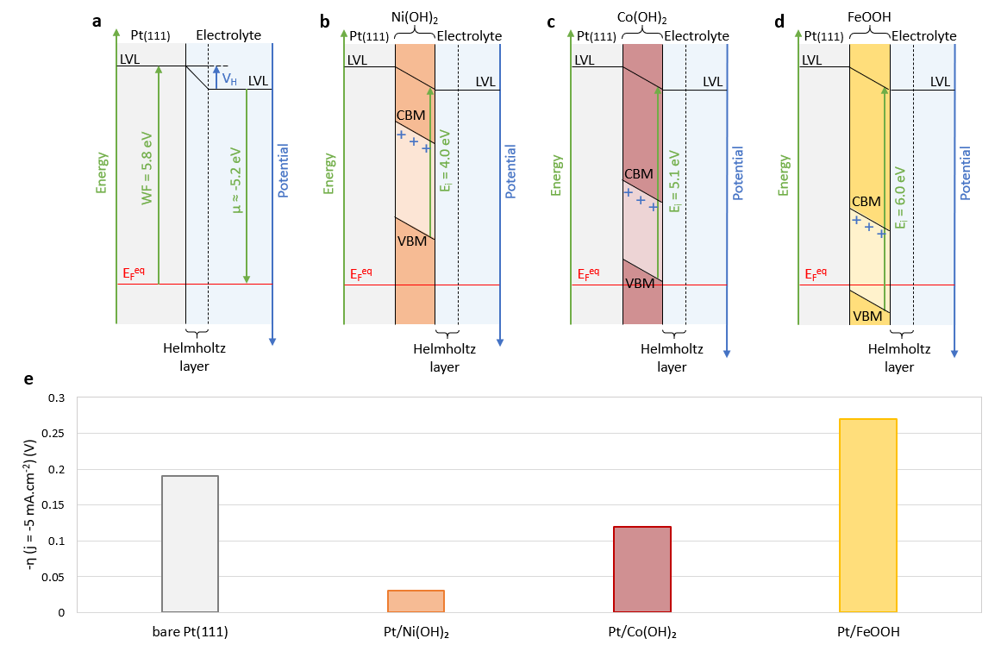
Figure S2: Modulation of the HER overpotential on Pt(111) surface by a thin metal hydroxide layer. Band alignment and interfacial equilibrium for a Pt(111) surface (a) bare, covered with a thin film of (b) Ni(OH)₂, (c) Co(OH)₂, and (d) FeOOH. Trapped charges from n-type dopants are indicated by blue “+” signs. (e) HER overpotential values of these surfaces measured at -5 mA cm⁻² in 0.1 M KOH, taken from ref. ⁵. The WF value of Pt(111) was taken from ref. ²⁰. The electronic properties of 2D Ni(OH)₂, 2D Co(OH)₂ and nanosized FeOOH were taken from refs. ^{26,27}, ref. ²⁸ and ref. ²⁹, respectively. The bandgap energy of 2D Co(OH)₂ was extrapolated from the Tauc plots based on ref. ²⁷. In the case of nanosized FeOOH, the γ/δ polymorphs were considered. All values are summarized in Supplementary Table 3.

Supplementary Table 1: HER overpotential for metal electrodes
HER overpotential values, measured at -5 mA cm⁻² in 0.1 M HClO₄ and 0.1 M KOH, were taken from Danilovic et al³ and Dadallagei et al¹⁸. WF values were taken from Sheng et al¹⁹. The polycrystalline materials were considered.
Metal | WF (eV) | -$η_{HClO_{4}}$ (V)³ | -$η_{KOH}$ (V)³ | -$η_{KOH}$ (V)¹⁸
Cu | 4.51 | 0.42 | 0.53 | 0.60
Ag | 4.39 | 0.40 | 0.60 | 0.64
Au | 5.30 | 0.33 | 0.62 | 0.63
Ru | 4.71 | 0.18 | 0.24 | /
Ir | 5.28 | 0.02 | 0.04 | /
Pt | 5.30 | 0.02 | 0.11 | 0.07
V | 4.10 | 0.73 | 0.78 | /
Ti | 3.87 | 0.87 | 0.98 | /
Ni | 5.06 | 0.27 | 0.31 | 0.33
W | 4.56 | / | / | 0.44
Co | 4.71 | / | / | 0.36
Fe | 4.55 | / | / | 0.35
Pd | 5.17 | / | / | 0.31

Supplementary Table 2: HER overpotential for metal electrodes covered by a thin film of nickel hydroxide
HER overpotential values, measured at -5 mA cm⁻² in 0.1 M KOH, were taken from Danilovic et al³. WF values were taken from Sheng et al¹⁹. The polycrystalline materials were considered.
Metal | WF (eV) | -$η_{bare}$ (V) | -$η_{Ni(OH)2 }$ (V)
Cu | 4.51 | 0.53 | 0.44
Ag | 4.39 | 0.60 | 0.42
Au | 5.30 | 0.62 | 0.38
Ru | 4.71 | 0.24 | 0.22
Ir | 5.28 | 0.04 | 0.02
Pt | 5.30 | 0.11 | 0.04
V | 4.10 | 0.78 | 0.56
Ti | 3.87 | 0.98 | 0.60
Ni | 5.06 | 0.31 | 0.24

Supplementary Table 3: HER overpotential for Pt(111) electrodes covered by a thin film of hydroxide
HER overpotential values, measured at -5 mA cm⁻² in 0.1 M KOH, were taken from Subbaraman et al.⁵. The WF value of Pt(111), 5.84 eV, was taken from Sheng et al.¹⁹. The electronic properties of 2D Ni(OH)₂, 2D Co(OH)₂ and nanosized FeOOH were taken from refs. ^{26,27}, ref. ²⁸ and ref. ²⁹, respectively. The bandgap energy of 2D Co(OH)₂ was extrapolated from the Tauc plots based on Ping et al. ²⁷. In the case of nanosized FeOOH, the γ/δ polymorphs were considered.
Hydroxide | Bandgap (eV) | EA (eV) | $E_{i}$ (eV) | -$η$ (V)
Ni(OH)₂ | 2.54 | 1.47 | 4.01 | 0.03
Co(OH)₂ | 2.20 | 2.93 | 5.13 | 0.12
FeOOH | / | / | 6.00 | 0.27

References
1. Roger, I., Shipman, M. A. & Symes, M. D. Earth-abundant catalysts for electrochemical and photoelectrochemical water splitting. Nature Reviews Chemistry 1, 1–13 (2017).
2. Subbaraman, R. et al. Enhancing hydrogen evolution activity in water splitting by tailoring Li+-Ni(OH)2-Pt interfaces. Science 334, 1256–1260 (2011).
3. Danilovic, N. et al. Enhancing the alkaline hydrogen evolution reaction activity through the bifunctionality of Ni(OH)₂/metal catalysts. Angewandte Chemie - International Edition 51, 12495–12498 (2012).
4. Strmcnik, D. et al. Improving the hydrogen oxidation reaction rate by promotion of hydroxyl adsorption. Nature Chemistry 5, 300–306 (2013).
5. Subbaraman, R. et al. Trends in activity for the water electrolyser reactions on 3d M(Ni,Co,Fe,Mn) hydr(oxy)oxide catalysts. Nature Materials 11, 550–557 (2012).
6. Liu, M. et al. Dynamic modulation of electron redistribution at the heterogeneous interface nickel hydroxides/platinum boosts acidic oxygen reduction reaction. Nature Communications 16, 1–10 (2025).
7. Zeng, Z., Chang, K. C., Kubal, J., Markovic, N. M. & Greeley, J. Stabilization of ultrathin (hydroxy)oxide films on transition metal substrates for electrochemical energy conversion. Nature Energy 2, 1–9 (2017).
8. Ledezma-Yanez, I. et al. Interfacial water reorganization as a pH-dependent descriptor of the hydrogen evolution rate on platinum electrodes. Nature Energy 2, 1–7 (2017).
9. Sarabia, F. J., Sebastián-Pascual, P., Koper, M. T. M., Climent, V. & Feliu, J. M. Effect of the Interfacial Water Structure on the Hydrogen Evolution Reaction on Pt(111) Modified with Different Nickel Hydroxide Coverages in Alkaline Media. ACS Applied Materials and Interfaces 11, 613–623 (2019).
10. García-Aráez, N., Climent, V. & Feliu, J. M. Evidence of water reorientation on model electrocatalytic surfaces from nanosecond-laser-pulsed experiments. Journal of the American Chemical Society 130, 3824–3833 (2008).
11. Trasatti, S. Work function, electronegativity, and electrochemical behaviour of metals: III. Electrolytic hydrogen evolution in acid solutions. Journal of Electroanalytical Chemistry and Interfacial Electrochemistry 39, 163–184 (1972).
12. Kim, M. et al. Acidic Hydrogen Evolution Electrocatalysis at High-Entropy Alloys Correlates with its Composition-Dependent Potential of Zero Charge. Angewandte Chemie International Edition 62, e202310069 (2023).
13. Buckley, D. N. & Leddy, J. The Butler-Volmer Equation Revisited: Effect of Metal Work Function on Electron Transfer Kinetics. Journal of The Electrochemical Society 171, 116503 (2024).
14. The quest for correlations. Nature Catalysis 7, 111 (2024).
15. Bard, A. J., Faulkner, L. R. & White, H. S. Electrochemical methods: fundamentals and applications. 1044 (John Wiley & Sons, Ltd., 2022).
16. Morrison, S. R. Electrochemistry at Semiconductor and Oxidized Metal Electrodes. 416 (Springer-Verlag New York Inc., 2011).
17. Ooka, H., Huang, J. & Exner, K. S. The Sabatier Principle in Electrocatalysis: Basics, Limitations, and Extensions. Frontiers in Energy Research 9, 654460 (2021).
18. Dadallagei, K. S. R. et al. New Perspectives from Classical Transition State Theory: The Hydrogen Evolution Reaction on Metal Electrodes. Journal of The Electrochemical Society 170, 086508 (2023).
19. Sheng, W., Myint, M., Chen, J. G. & Yan, Y. Correlating the hydrogen evolution reaction activity in alkaline electrolytes with the hydrogen binding energy on monometallic surfaces. Energy & Environmental Science 6, 1509–1512 (2013).
20. Kawano, H. Effective Work Functions of the Elements: Database, Most probable value, Previously recommended value, Polycrystalline thermionic contrast, Change at critical temperature, Anisotropic dependence sequence, Particle size dependence. Progress in Surface Science 97, 100583 (2022).
21. Ganassin, A. et al. On the pH Dependence of the Potential of Maximum Entropy of Ir(111) Electrodes. Scientific Reports 7, 1246 (2017).
22. Sauvé, E. R. et al. Open circuit potential decay transients quantify interfacial pH swings during high current density hydrogen electrocatalysis. Joule 8, 728–745 (2024).
23. Hinnemann, B. et al. Biomimetic hydrogen evolution: MoS₂ nanoparticles as catalyst for hydrogen evolution. Journal of the American Chemical Society 127, 5308–5309 (2005).
24. Chemin, A. et al. Surface-Mediated Charge Transfer of Photogenerated Carriers in Diamond. Small Methods 7, 2300423 (2023).
25. Chemin, A. et al. Modulating Surface Redox Reactions and Solvated Electron Emission on Boron-Doped Diamond by (Photo)Electrochemistry. PRX Energy (2025), https://doi.org/10.1103/zhcb-13pn.
26. Kim, S. I., Thiyagarajan, P. & Jang, J. H. Great improvement in pseudocapacitor properties of nickel hydroxide via simple gold deposition. Nanoscale 6, 11646–11652 (2014).
27. Ping, L. et al. Synthesis of 2D layered transition metal (Ni, Co) hydroxides via edge-on condensation. Scientific Reports 14, 1–9 (2024).
28. Suksomboon, M., Kongsawatvoragul, K., Duangdangchote, S. & Sawangphruk, M. Reducing the Energy Band Gap of Cobalt Hydroxide Nanosheets with Silver Atoms and Enhancing Their Electrical Conductivity with Silver Nanoparticles. ACS Omega 6, 20804–20811 (2021).
29. Ali, F. M., Hmadeh, M., O’Brien, P. G., Perovic, D. D. & Ozin, G. A. Photocatalytic Properties of All Four Polymorphs of Nanostructured Iron Oxyhydroxides. ChemNanoMat 2, 1047–1054 (2016).
30. Schindler, P., Antoniuk, E. R., Cheon, G., Zhu, Y. & Reed, E. J. Discovery of Stable Surfaces with Extreme Work Functions by High-Throughput Density Functional Theory and Machine Learning. Advanced Functional Materials 34, 2401764 (2024).
31. Sui, Y. & Ji, X. Anticatalytic Strategies to Suppress Water Electrolysis in Aqueous Batteries. Chemical Reviews 121, 6654–6695 (2021).
32. Shilov, I. Y. & Lyashchenko, A. K. The Role of Concentration Dependent Static Permittivity of Electrolyte Solutions in the Debye-Hückel Theory. Journal of Physical Chemistry B 119, 10087–10095 (2015).

