Supplementary File 2:
Breakpoint clustering analysis for random distribution of recombination events across the CHIKV-E2 glycoprotein:
The breakpoint clustering test results show no evidence of non-random recombination breakpoint distribution across the CHIKV-E2 glycoprotein. The comparison indicated no significant difference in breakpoint frequency. In one comparison, no breakpoints were detected in intergenic regions while eight were found in ORFs, and in the reverse comparison, eight breakpoints occurred in intergenic regions with none in ORFs. The calculated breakpoint rates per 100 nucleotides differed numerically between categories but were not statistically significant, with p-values equal to or approaching 1.0. Similarly, comparisons between CHIKV-E2 glycoprotein ends and middle regions at varying proportions (end 50% vs middle 50%, end 25% vs middle 75%, and end 10% vs middle 90%) did not reveal significant clustering. Breakpoint counts and rates showed minor numerical differences between ends and middle sections, but all p-values exceeded 0.05, indicating no statistically significant bias toward either region (Figure S1).
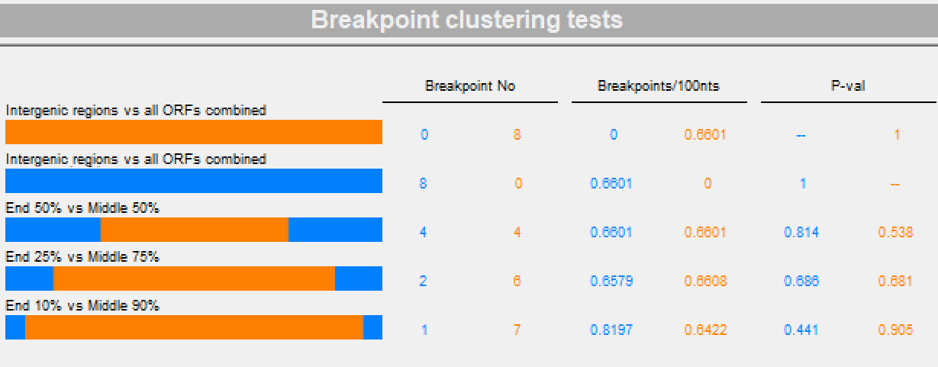
Figure S1: Breakpoint clustering tests. Bars represent breakpoint counts in each region, with corresponding breakpoint rates per 100 nucleotides and p-values indicating statistical significance. No significant clustering of breakpoints was detected in any comparison (all p > 0.05).
Probability plot of recombination signals across the CHIKV-E2 glycoprotein alignment:
The recombination signal analysis across the CHIKV-E2 glycoprotein alignment showed no strong evidence of localized recombination hotspots. Throughout the alignment, the log-transformed p-value difference remained largely within the non-significant threshold range, as indicated by the shaded central band. Only minor fluctuations were observed, and these did not exceed the thresholds indicative of statistically significant recombination. This pattern suggests that recombination events, if present, are either infrequent or evenly distributed across the CHIKV-E2 glycoprotein, with no clustering in specific nucleotide regions. The overall uniformity of the recombination probability profile supports the conclusion that the analyzed sequences do not exhibit strong positional biases for recombination breakpoints.
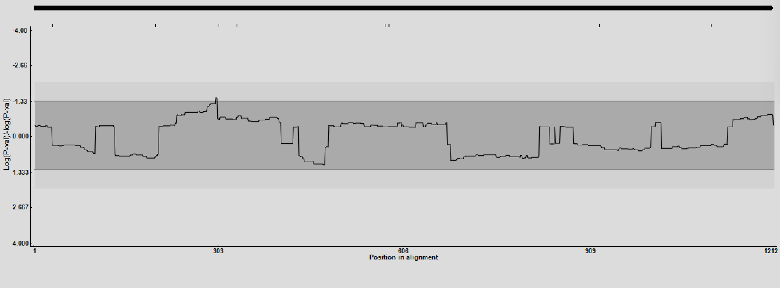
Figure S2: Sliding window analysis of recombination signal significance along the CHIKV-E2 glycoprotein alignment. The y-axis shows log-transformed p-values, and the x-axis represents nucleotide positions in the alignment. The shaded region denotes the non-significant threshold range, while values outside this region indicate potential recombination signals.

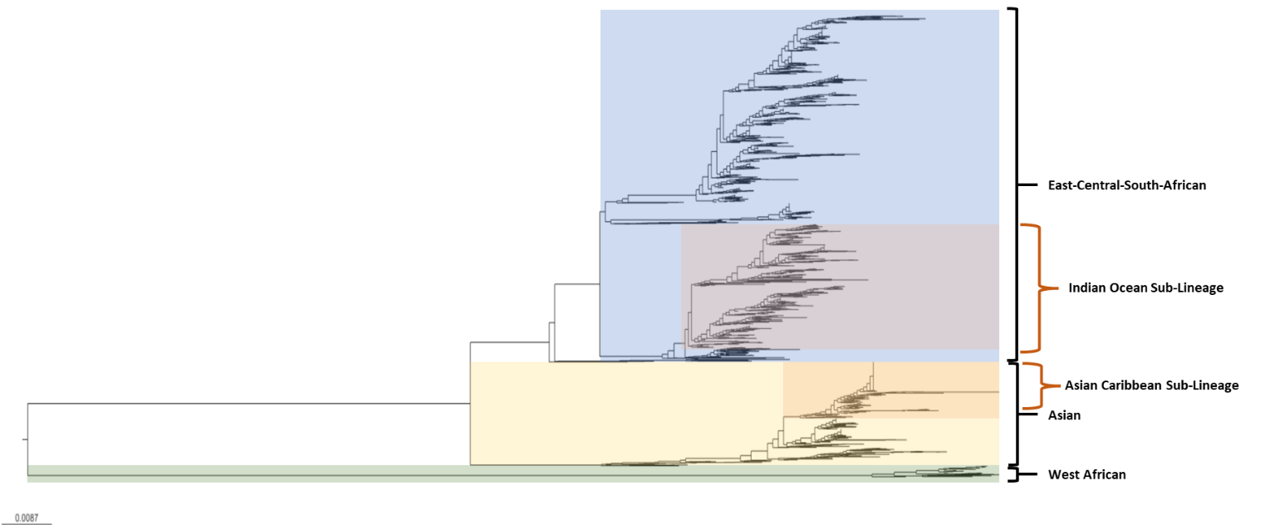
Figure S3: Phylogenetic analysis of CHIKV-E2 glycoprotein for lineages and sub-lineages determination

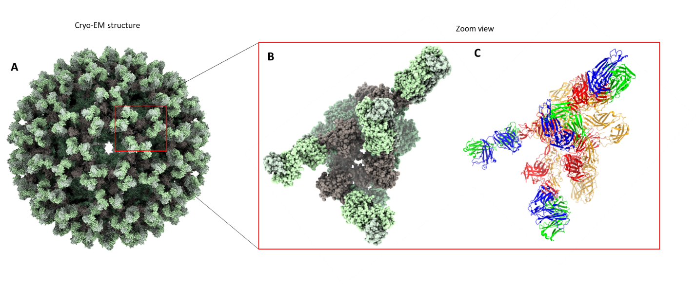
Figure S4: A: Electron cryo-microscopy structure of Chikungunya virus in complex with the neutralizing antibody Fab CHK-265 (PDB ID: 5ANY). B: Asymmetric unit of the cryo-EM structure showing the virus-Fab CHK-265 complex. C: Ribbon representation of the four major four major E1, E2, and FAB-chains within the asymmetric unit of the CHIKV-E2-Fab CHK-265 complex. Each chain is distinctly colored to highlight structural domains and facilitate comparison. Colors represent the following chains: Orange — E1 chains (A, C, E, G); Red — E2 chains (B, D, F, H); Blue, Fab CHK-265 heavy chains (I, J, K, L); Green, Fab light chains (M, N, O, P).

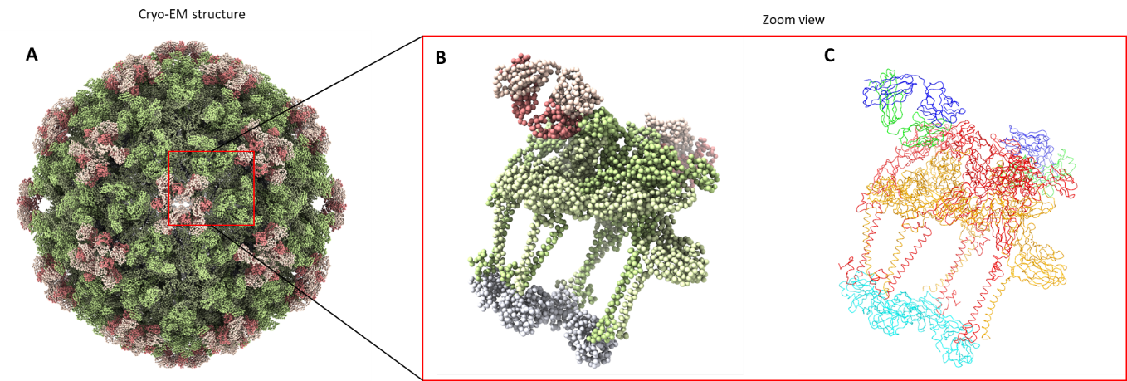
Figure S5: A: Electron cryo-microscopy structure of Chikungunya virus in complex with the neutralizing antibody Fab CHK-263 (PDB ID: 7CVZ). B: Asymmetric unit of the cryo-EM structure showing the virus-Fab CHK-263 complex. C: Ribbon representation of the four major E1, E2, Capsid protein, and FAB-chains within the asymmetric unit of the CHIKV-E2-Fab CHK-263 complex. Each chain is distinctly colored to highlight structural domains and facilitate comparison. Colors represent the following chains: Orange — E1 chains (A, D, G, J); Red — E2 chains (B, E, H, K); Cyan — Capsid chains (C, F, I, L), and Blue, Fab CHK-263 heavy chains (O, Q); Green, Fab light chains (P, R).

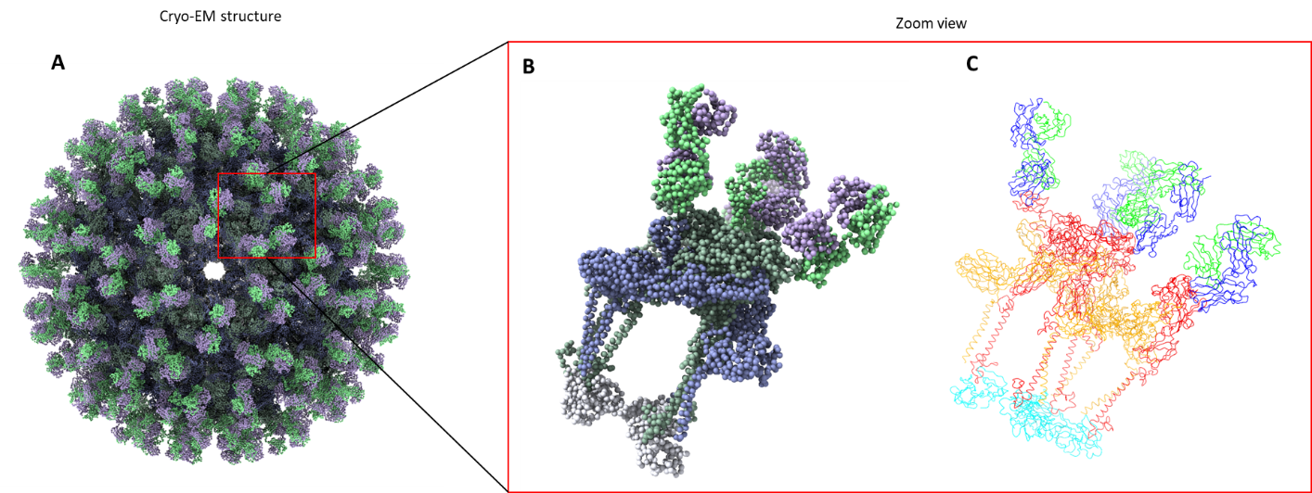
Figure S6: A: Electron cryo-microscopy structure of Chikungunya virus in complex with the neutralizing antibody Fab CHK-124 (PDB ID: 7CVY). B: Asymmetric unit of the cryo-EM structure showing the virus-Fab CHK-124 complex. C: Ribbon representation of the four major E1, E2, Capsid protein, and FAB-chains within the asymmetric unit of the CHIKV-E2-Fab CHK-124 complex. Each chain is distinctly colored to highlight structural domains and facilitate comparison. Colors represent the following chains: Orange — E1 chains (A, F, K, P); Red — E2 chains (B, G, L, Q); Cyan — Capsid chains (C, H, M, R), and Blue, Fab CHK-124 heavy chains (D, I, N, S); Green, Fab light chains (E, J, O, T).

Table S1: Lineage-specific and shared polymorphisms in the CHIKV E2 gene across ECSA, Asian, and West African lineages.
Lineage | Shared polymorphisms | Lineage specific polymorphisms
ECSA Lineage | T2I, T2L, T2V, T2A, K3R, D4E, N5H, F6L, F6S, N6T, A11V, T12I, H18P, H18Q, H18R, I37L, I37V, D60G, W64R, I74L, I74M, I74T, I74V, G82R, F84L, F84S, R86K, T92A, T92M, T92S, V113A, T116I, H123P, H123T, D132N, K149E, K149R, P152L, P152T, N160T, S182L, S185A, S185Y, G186S, T191I, T191S, S194C, S194G, Q195R, G205D, G205S, N207D, N207H, N207T, L210I, L210Q, L210T, I217V, K221R, A227T, A227V, K233E, K233R, K234R, Y237C, A246D, L248F, L248P, I255V, H256Y, I257V, T277A, T277M, T277S, G279E, G279R, I284T, I284V, L286V, C288Y, S299K, S299N, Q307L, Q307R, Q307S, H313P, H313Y, L319I, L319V, V328A, A344T, H351E, H351N, H351Q, H351R, H351Y, H353Q, H353R, H353Y, L357Q, L357R, V368A, V370I, V371M, S375T, I377T, I377V, S380A, V382M, M384T, M384V, R395I, R395N, A406T, A406Y, V408I | V8A, R13K, P12Q, C19G, C19R, G23A, G23E, H26Y, V32I, A33V, L34I, R36H, N39S, T42I, T45R, L46Q, K47H, K47N, I48L, V50I, L52F, I54L, G55R, I56L, I56T, G57K, G57Q, G57R, S61G, S61N, H62Y, D63G, K66E, Y69H, Y69I, N72S, N72T, H73Y, A76T, A78T, G79E, A81V, V85A, T87S, S88L, A89S, P90L, P90S, M97T, A103T, K107R, G108R, T110I, T110S, L111M, L111V, S118G, R119S, R119W, K120M, K120N, K120S, I121F, I121L, I121M, I121N, I121S, I121T, I121V, S122G, S122Q, S122R, T126M, P128S, H130R, H131L, H131Y, V135A, V135G, V135M, H142Y, S143A, S143Y, Q146H, Q146R, E150D, L151M, T155S, Q158H, Q158R, A162V, A164I, A164T, E165D, H170N, M171V, D174G, R178H, T179A, L180I, L181M, L181T, L181V, Q184R, K189T, V197A, V197E, R198Q, N202D, N202I, N202S, I211T, T213I, T213R, D214N, V216E, V216M, N218G, N218S, N219S, V222I, H226Y, A228E, A228T, V229I, N231D, N238S, P240L, L241S, V242G, N245S, E247A, K252H, K252Q, P260L, P260S, A262V, V264A, T265I, M267R, M267V, A271V, R272G, N273I, T275P, K280R, N281K, Q282K, L294F, Y297C, Y297F, E303K, P304S, P304T, N305H, Y306S, E308H, E308K, E308Q, E309Q, T312A, T312M, E316G, E316K, V318A, V318M, W330C, G331D, N333K, E334G, E334V, P335L, K337E, K337R, Q341H, S343P, G346S, G350S, P352V, E361G, M366I, M366K, M366T, M366V, S372A, A374V, F376C, A385T, V386A, G387W, C389Y, M390I, M390V, P404T, G405R, G405S, G405T, T407A, P409A, P409L, P409S, S413G, S413N, I415L, I415M, I415T, I415V, C416G
Asian Lineage | T2I, T2L, T2V, T2A, K3R, D4N, D4E, N5H, N5R, F6L, A11V, T12I, H18R, I37V, W64R, I74M, G82R, L83I, F84L, F84I, R86K, V113A, T116I, H123L, H123R, D132N, H147Y, K149R, P152S, N160T, S182L, S185C, G186S, T191A, S194G, S194N, K200R, N207S, L210S, L210V, I217V, K221G, K221R, A227V, K233E, Y237D, Y237F, A246D, A246V, L248A, L248F, L248I, L248S, I255L, I255V, I257T, T277M, G279E, I284T, L286S, Y288H, S299N, Q307H, Q307R, H313L, H313R, L319I, V328I, A344T, H351R, H351Y, H353A, H353E, L357E, L357Q, V368A, V370A, V371L, S375L, I377V, V382M, M384A, M384V, A406T, V408I | D21V, P27S, T94I, F115L, P134L, K140R, Y156H, V157A, V157T, S159N, E166D, I167M, I167T, I167V, S206L, E208D, V268G, K314R, V317I, T320A, T320I, V321G, E354D, I356F, I356Y, Y358S, V373A, C391Y, I397L, L412V
West African Lineage | T2I, N5H, F6Y, N7D, T92M, H147Q, Q195R, K200R, G205S, K221I, A227V, K234N, L248F, H313Y, S380T, R395G | D60G, P133S, N187S, K270R, M285L, V369I

Table S2: Percentage identity of predicted epitopes sequences within the E2 gene
Epitope sequence | Percent of protein sequence matches at identity <= 100%
 | All Lineages | ECSA | Asian | West African
HAAVTNHKKWQYNSPLVPRNAELGDRKGKIHIPFPLANVTCR | 29.42% (798/2712) | 36.05% (734/2036) | 0.33% (2/611) | 95.38% (62/65)
RNMGEEPNYQEEWVMHKK | 28.32% (768/2712) | 37.72% (768/2036) | 0.00% (0/611) | 0.00% (0/65)
VTYGKNQVIMLLYPD | 92.81% (2517/2712) | 94.65% (1927/2036) | 96.56% (590/611) | 0.00% (0/65)
NVYKATRPY | 99.15% (2689/2712) | 99.21% (2020/2036) | 99.02% (605/611) | 98.46% (64/65)
PKGETLTVGFTDSRK | 71.09% (1928/2712) | 91.50% (1863/2036) | 0.00% (0/611) | 100.00% (65/65)
IILYYYELY | 99.04% (2686/2712) | 99.41% (2024/2036) | 97.71% (597/611) | 100.00% (65/65)
ELYPTMTVVVVSVAT | 28.47% (772/2712) | 37.92% (772/2036) | 0.00% (0/611) | 0.00% (0/65)
SPLVPRNAEL | 67.51% (1831/2712) | 85.51% (1741/2036) | 4.26% (26/611) | 98.46% (64/65)
VPKARNPTV | 98.16% (2662/2712) | 97.89% (1993/2036) | 99.84% (610/611) | 90.77% (59/65)
IILYYYELYPTMT | 98.53% (2672/2712) | 98.72% (2010/2036) | 97.71% (597/611) | 100.00% (65/65)
MLLYPDHPTL | 99.48% (2698/2712) | 99.90% (2034/2036) | 98.36% (601/611) | 96.92% (63/65)
DNFNVYKATRPYLAHCPD | 76.95% (2087/2712) | 87.77% (1787/2036) | 38.95% (238/611) | 95.38% (62/65)
TKDNFNVYKATRPYLAHC | 76.18% (2066/2712) | 87.33% (1778/2036) | 37.64% (230/611) | 89.23% (58/65)
EIRLTVPTEGLEVTW | 22.20% (602/2712) | 0.00% (0/2036) | 98.53% (602/611) | 0.00% (0/65)
MSQQSGNVKITVNSQ | 22.16% (601/2712) | 0.00% (0/2036) | 98.36% (601/611) | 0.00% (0/65)
VPTEGLEVTWGNNEP | 99.71% (2704/2712) | 99.66% (2029/2036) | 99.84% (610/611) | 100.00% (65/65)
MTVVVVSVATFILLS | 28.24% (766/2712) | 37.62% (766/2036) | 0.00% (0/611) | 0.00% (0/65)
ATRPYLAHCP | 99.00% (2685/2712) | 99.02% (2016/2036) | 98.85% (604/611) | 100.00% (65/65)
GNNEPYKYWP | 99.67% (2703/2712) | 99.56% (2027/2036) | 100.00% (611/611) | 100.00% (65/65)
KVDQCHAAVT | 92.26% (2502/2712) | 93.66% (1907/2036) | 97.38% (595/611) | 0.00% (0/65)
CTITGTMGHF | 99.67% (2703/2712) | 99.75% (2031/2036) | 99.51% (608/611) | 98.46% (64/65)
HPTLLSYRNM | 99.08% (2687/2712) | 98.82% (2012/2036) | 99.84% (610/611) | 100.00% (65/65)
HPHEIILY | 98.08% (2660/2712) | 98.23% (2000/2036) | 97.38% (595/611) | 100.00% (65/65)
PKGETLTVGF | 97.82% (2653/2712) | 97.74% (1990/2036) | 97.87% (598/611) | 100.00% (65/65)
QYNSPLVPRN | 99.59% (2701/2712) | 99.56% (2027/2036) | 99.67% (609/611) | 100.00% (65/65)
ARNPTVTYGKNQVIM | 91.67% (2486/2712) | 92.63% (1886/2036) | 98.20% (600/611) | 0.00% (0/65)
ARNPTVTYGK | 97.94% (2656/2712) | 97.59% (1987/2036) | 98.85% (604/611) | 100.00% (65/65)
LEVTWGNNEP | 99.74% (2705/2712) | 99.71% (2030/2036) | 99.84% (610/611) | 100.00% (65/65)
HAAVTNHKKWQYNSPLVP | 95.10% (2579/2712) | 94.16% (1917/2036) | 98.04% (599/611) | 96.92% (63/65)
SHDWTKLRYM | 99.41% (2696/2712) | 99.31% (2022/2036) | 99.67% (609/611) | 100.00% (65/65)
IGREKFHSRP | 97.20% (2636/2712) | 99.66% (2029/2036) | 99.35% (607/611) | 0.00% (0/65)
RTSAPCTITGTMGHF | 99.23% (2691/2712) | 99.17% (2019/2036) | 99.51% (608/611) | 98.46% (64/65)
RTSAPCTITG | 99.26% (2692/2712) | 99.21% (2020/2036) | 99.51% (608/611) | 98.46% (64/65)
KIDQCHAAVTNHKKW | 2.47% (67/2712) | 0.54% (11/2036) | 0.00% (0/611) | 86.15% (56/65)
ISHSCTHPFH | 95.65% (2594/2712) | 97.79% (1991/2036) | 98.69% (603/611) | 0.00% (0/65)
DCGEGHSCHS | 99.82% (2707/2712) | 99.85% (2033/2036) | 99.67% (609/611) | 100.00% (65/65)
VPRNAELGDRQGKIHIPF | 5.01% (136/2712) | 6.68% (136/2036) | 0.00% (0/611) | 0.00% (0/65)
IQVSLQIGIKTDDSHDWT | 97.05% (2632/2712) | 96.22% (1959/2036) | 99.67% (609/611) | 98.46% (64/65)
AELGDRKGKI | 61.43% (1666/2712) | 78.59% (1600/2036) | 0.33% (2/611) | 98.46% (64/65)
RKGKIHIPFPLANVT | 38.46% (1043/2712) | 47.45% (966/2036) | 1.96% (12/611) | 100.00% (65/65)
RKGKIHIPFP | 72.27% (1960/2712) | 92.49% (1883/2036) | 1.96% (12/611) | 100.00% (65/65)
ATDGTLKIQVSLQIG | 98.86% (2681/2712) | 98.48% (2005/2036) | 100.00% (611/611) | 100.00% (65/65)
CITPYELTPGATVPF | 99.04% (2686/2712) | 98.92% (2014/2036) | 99.35% (607/611) | 100.00% (65/65)
CRVPKARNPT | 97.49% (2644/2712) | 97.00% (1975/2036) | 99.84% (610/611) | 90.77% (59/65)
THPFHHDPPVIGREK | 96.42% (2615/2712) | 98.62% (2008/2036) | 99.35% (607/611) | 0.00% (0/65)
TDSRKISHSC | 69.51% (1885/2712) | 92.58% (1885/2036) | 0.00% (0/611) | 0.00% (0/65)
IKTDDSHDWT | 98.01% (2658/2712) | 97.50% (1985/2036) | 99.67% (609/611) | 98.46% (64/65)
PDRTLMSQQS | 95.13% (2580/2712) | 96.86% (1972/2036) | 99.51% (608/611) | 0.00% (0/65)
PPVIGREKFHSRP | 97.05% (2632/2712) | 99.51% (2026/2036) | 99.18% (606/611) | 0.00% (0/65)
LLYPDHPTLLSYRNM | 98.67% (2676/2712) | 98.77% (2011/2036) | 98.20% (600/611) | 100.00% (65/65)
LPCSTYVQST | 76.47% (2074/2712) | 98.67% (2009/2036) | 0.00% (0/611) | 100.00% (65/65)
NQVIMLLYPDHPTLL | 93.18% (2527/2712) | 94.79% (1930/2036) | 97.71% (597/611) | 0.00% (0/65)
SYRNMGEEPN | 96.31% (2612/2712) | 98.33% (2002/2036) | 99.84% (610/611) | 0.00% (0/65)
ILARCPKGET | 58.33% (1582/2712) | 44.50% (906/2036) | 100.00% (611/611) | 100.00% (65/65)
LAHCPDCGEGHSCHS | 99.52% (2699/2712) | 99.51% (2026/2036) | 99.51% (608/611) | 100.00% (65/65)
SYRNMGEEPNYQEEW | 93.99% (2549/2712) | 97.64% (1988/2036) | 91.82% (561/611) | 0.00% (0/65)
HIPFPLANV | 65.93% (1788/2712) | 54.67% (1113/2036) | 99.84% (610/611) | 100.00% (65/65)
HAAVTNHKKWQYNSP | 95.13% (2580/2712) | 94.20% (1918/2036) | 98.04% (599/611) | 96.92% (63/65)
HAAVTNHKKW | 95.32% (2585/2712) | 94.35% (1921/2036) | 98.36% (601/611) | 96.92% (63/65)
HPHEIILYYYELYPT | 97.90% (2655/2712) | 97.99% (1995/2036) | 97.38% (595/611) | 100.00% (65/65)
HSCHSPVALE | 97.42% (2642/2712) | 99.80% (2032/2036) | 99.84% (610/611) | 0.00% (0/65)
EVVLTVPTEG | 74.30% (2015/2712) | 98.97% (2015/2036) | 0.00% (0/611) | 0.00% (0/65)
PVALERIRNE | 97.16% (2635/2712) | 99.46% (2025/2036) | 99.84% (610/611) | 0.00% (0/65)
LLYPDHPTLL | 99.56% (2700/2712) | 99.90% (2034/2036) | 98.36% (601/611) | 100.00% (65/65)
YQEEWVMHKK | 28.50% (773/2712) | 37.97% (773/2036) | 0.00% (0/611) | 0.00% (0/65)
VPTEGLEVTW | 99.85% (2708/2712) | 99.85% (2033/2036) | 99.84% (610/611) | 100.00% (65/65)
ADAERAGLFV | 88.86% (2410/2712) | 88.90% (1810/2036) | 98.20% (600/611) | 0.00% (0/65)
LVPRNAELGD | 67.55% (1832/2712) | 85.56% (1742/2036) | 4.26% (26/611) | 98.46% (64/65)
NQVIMLLYPD | 93.18% (2527/2712) | 94.79% (1930/2036) | 97.71% (597/611) | 0.00% (0/65)
LTVGFTDSRKISHSC | 69.40% (1882/2712) | 92.44% (1882/2036) | 0.00% (0/611) | 0.00% (0/65)
MPPDTPDRTL | 98.86% (2681/2712) | 98.48% (2005/2036) | 100.00% (611/611) | 100.00% (65/65)
ATTEEIEVHMPPDTPDRT | 72.27% (1960/2712) | 96.27% (1960/2036) | 0.00% (0/611) | 0.00% (0/65)
CTITGTMGHFILARC | 59.59% (1616/2712) | 46.37% (944/2036) | 99.51% (608/611) | 98.46% (64/65)
FHSRPQHGKE | 72.71% (1972/2712) | 94.01% (1914/2036) | 0.16% (1/611) | 87.69% (57/65)
TTTDKVINNC | 57.49% (1559/2712) | 43.42% (884/2036) | 99.84% (610/611) | 100.00% (65/65)
TVNGQTVRYK | 76.40% (2072/2712) | 98.48% (2005/2036) | 0.65% (4/611) | 96.92% (63/65)
ATDGTLKIQV | 99.63% (2702/2712) | 99.51% (2026/2036) | 100.00% (611/611) | 100.00% (65/65)
SLQIGIKTDD | 97.68% (2649/2712) | 96.95% (1974/2036) | 100.00% (611/611) | 98.46% (64/65)
ILYYYELYPTMTVVV | 80.01% (2170/2712) | 98.48% (2005/2036) | 27.00% (165/611) | 0.00% (0/65)
TMGHFILARCPKGET | 58.30% (1581/2712) | 44.45% (905/2036) | 100.00% (611/611) | 100.00% (65/65)
TMGHFILARC | 59.81% (1622/2712) | 46.46% (946/2036) | 100.00% (611/611) | 100.00% (65/65)
TDSRKISHSCTHPFH | 69.40% (1882/2712) | 92.44% (1882/2036) | 0.00% (0/611) | 0.00% (0/65)
TVRYKCNCGG | 67.44% (1829/2712) | 86.84% (1768/2036) | 0.00% (0/611) | 93.85% (61/65)
ITTDKVINNCKIDQC | 0.07% (2/2712) | 0.10% (2/2036) | 0.00% (0/611) | 0.00% (0/65)
KLRYMDNHMPADAER | 54.35% (1474/2712) | 42.44% (864/2036) | 99.84% (610/611) | 0.00% (0/65)
KLRYMDNHMP | 55.75% (1512/2712) | 44.30% (902/2036) | 99.84% (610/611) | 0.00% (0/65)
GNVKITVNGQTVRYKCNC | 76.14% (2065/2712) | 98.18% (1999/2036) | 0.65% (4/611) | 95.38% (62/65)
VPKARNPTVTYGKNQVIM | 91.63% (2485/2712) | 92.63% (1886/2036) | 98.04% (599/611) | 0.00% (0/65)
PTVTYGKNQ | 96.02% (2604/2712) | 95.04% (1935/2036) | 98.85% (604/611) | 100.00% (65/65)
GNVKITVNSQTVRYK | 22.46% (609/2712) | 0.25% (5/2036) | 98.85% (604/611) | 0.00% (0/65)
GNVKITVNGQ | 76.70% (2080/2712) | 98.82% (2012/2036) | 0.82% (5/611) | 96.92% (63/65)
LEVTWGNNEPYKYWP | 99.59% (2701/2712) | 99.51% (2026/2036) | 99.84% (610/611) | 100.00% (65/65)
MSQQSGNVKI | 96.09% (2606/2712) | 98.18% (1999/2036) | 99.35% (607/611) | 0.00% (0/65)
QHGKELPCST | 72.79% (1974/2712) | 94.11% (1916/2036) | 0.16% (1/611) | 87.69% (57/65)
LTVGFTDSRK | 72.60% (1969/2712) | 93.52% (1904/2036) | 0.00% (0/611) | 100.00% (65/65)
VPRNAELGDRKGKIHIPF | 61.17% (1659/2712) | 78.24% (1593/2036) | 0.33% (2/611) | 98.46% (64/65)
AATTEEIEVH | 73.34% (1989/2712) | 97.69% (1989/2036) | 0.00% (0/611) | 0.00% (0/65)
RIRNEATDGT | 99.59% (2701/2712) | 99.51% (2026/2036) | 99.84% (610/611) | 100.00% (65/65)
GTAHGHPHEIILYYY | 98.01% (2658/2712) | 98.13% (1998/2036) | 97.38% (595/611) | 100.00% (65/65)
HDPPVIGREK | 97.16% (2635/2712) | 99.61% (2028/2036) | 99.35% (607/611) | 0.00% (0/65)
EPYKYWPQL | 97.31% (2639/2712) | 99.61% (2028/2036) | 100.00% (611/611) | 0.00% (0/65)
KVDQCHAAVTNHKKW | 91.70% (2487/2712) | 93.32% (1900/2036) | 96.07% (587/611) | 0.00% (0/65)
LAHCPDCGEG | 99.59% (2701/2712) | 99.56% (2027/2036) | 99.67% (609/611) | 100.00% (65/65)
CNCGGSNEGL | 62.87% (1705/2712) | 80.70% (1643/2036) | 0.00% (0/611) | 95.38% (62/65)
MCMCARRRCITPYELTPG | 94.54% (2564/2712) | 96.07% (1956/2036) | 99.51% (608/611) | 0.00% (0/65)
TVNGQTVRY | 76.47% (2074/2712) | 98.48% (2005/2036) | 0.82% (5/611) | 98.46% (64/65)
ADAERAGLFVRTSAP | 88.42% (2398/2712) | 88.31% (1798/2036) | 98.20% (600/611) | 0.00% (0/65)
AGLFVRTSAP | 92.48% (2508/2712) | 93.71% (1908/2036) | 98.20% (600/611) | 0.00% (0/65)
PTEGLEVTWGNNEPYKYWPQLSTNGT | 96.35% (2613/2712) | 98.43% (2004/2036) | 99.67% (609/611) | 0.00% (0/65)
VINNCKVDQCHAAVT | 91.08% (2470/2712) | 92.14% (1876/2036) | 97.22% (594/611) | 0.00% (0/65)
VTHKKEIRLTVPTEG | 22.01% (597/2712) | 0.00% (0/2036) | 97.71% (597/611) | 0.00% (0/65)
VMHKKEVVLT | 28.47% (772/2712) | 37.92% (772/2036) | 0.00% (0/611) | 0.00% (0/65)
NHKKWQYNSPLVPRN | 99.00% (2685/2712) | 99.21% (2020/2036) | 98.36% (601/611) | 98.46% (64/65)
MVGMAAGMCMCARRR | 26.44% (717/2712) | 35.22% (717/2036) | 0.00% (0/611) | 0.00% (0/65)
NNEPYKYWPQ | 99.67% (2703/2712) | 99.56% (2027/2036) | 100.00% (611/611) | 100.00% (65/65)
HPFHHDPPV | 97.12% (2634/2712) | 99.46% (2025/2036) | 99.67% (609/611) | 0.00% (0/65)
LANVTCRVPKARNPT | 63.53% (1723/2712) | 51.77% (1054/2036) | 99.84% (610/611) | 90.77% (59/65)
LKIQVSLQIG | 98.93% (2683/2712) | 98.58% (2007/2036) | 100.00% (611/611) | 100.00% (65/65)
HIPFPLANVT | 65.89% (1787/2712) | 54.62% (1112/2036) | 99.84% (610/611) | 100.00% (65/65)
SHDWTKLRYMDNHMP | 55.42% (1503/2712) | 43.96% (895/2036) | 99.51% (608/611) | 0.00% (0/65)
SNEGLTTTDK | 31.49% (854/2712) | 37.13% (756/2036) | 5.40% (33/611) | 100.00% (65/65)
EIEVHMPPDT | 99.67% (2703/2712) | 99.75% (2031/2036) | 99.35% (607/611) | 100.00% (65/65)
VTYGKNQVIM | 93.25% (2529/2712) | 94.74% (1929/2036) | 98.20% (600/611) | 0.00% (0/65)
VSVATFILLSMVGMA | 28.32% (768/2712) | 37.72% (768/2036) | 0.00% (0/611) | 0.00% (0/65)
VINNCKVDQC | 91.45% (2480/2712) | 92.63% (1886/2036) | 97.22% (594/611) | 0.00% (0/65)
CTITGTMGHFILARC | 59.59% (1616/2712) | 46.37% (944/2036) | 99.51% (608/611) | 98.46% (64/65)
DNHMPADAER | 54.46% (1477/2712) | 42.58% (867/2036) | 99.84% (610/611) | 0.00% (0/65)
THPFHHDPPV | 96.50% (2617/2712) | 98.62% (2008/2036) | 99.67% (609/611) | 0.00% (0/65)
TTTDKVINNCKVDQC | 50.26% (1363/2712) | 37.77% (769/2036) | 97.22% (594/611) | 0.00% (0/65)
LLSMVGMAAGMCMCARRRCITPYELTPGATVPFL | 26.22% (711/2712) | 34.92% (711/2036) | 0.00% (0/611) | 0.00% (0/65)
IGREKFHSRPQHGKE | 70.61% (1915/2712) | 94.01% (1914/2036) | 0.16% (1/611) | 0.00% (0/65)
LANVTCRVPK | 65.08% (1765/2712) | 53.83% (1096/2036) | 99.84% (610/611) | 90.77% (59/65)
GEEPNYQEEW | 94.91% (2574/2712) | 98.82% (2012/2036) | 91.98% (562/611) | 0.00% (0/65)
NHKKWQYNSP | 99.23% (2691/2712) | 99.51% (2026/2036) | 98.36% (601/611) | 98.46% (64/65)
YVQSTAATTE | 73.34% (1989/2712) | 97.69% (1989/2036) | 0.00% (0/611) | 0.00% (0/65)
GNVKITVNGQTVRYK | 76.29% (2069/2712) | 98.38% (2003/2036) | 0.65% (4/611) | 95.38% (62/65)
HIPFPLANVTCRVPK | 64.97% (1762/2712) | 53.73% (1094/2036) | 99.67% (609/611) | 90.77% (59/65)
HDPPVIGREKFHSRP | 96.83% (2626/2712) | 99.26% (2021/2036) | 99.02% (605/611) | 0.00% (0/65)
HPTLLSYRNMGEEPN | 96.31% (2612/2712) | 98.33% (2002/2036) | 99.84% (610/611) | 0.00% (0/65)
HAAVTNHKKWQYNSPLVPRNAELGDRQGKIHIPF | 5.01% (136/2712) | 6.68% (136/2036) | 0.00% (0/611) | 0.00% (0/65)
GETLTVGFTDSRKISHSC | 67.96% (1843/2712) | 90.52% (1843/2036) | 0.00% (0/611) | 0.00% (0/65)
ATDGTLKIQVSLQIG | 98.86% (2681/2712) | 98.48% (2005/2036) | 100.00% (611/611) | 100.00% (65/65)
CARRRCITPYELTPG | 99.37% (2695/2712) | 99.36% (2023/2036) | 99.51% (608/611) | 98.46% (64/65)
FNVYKATRPY | 99.00% (2685/2712) | 99.07% (2017/2036) | 98.85% (604/611) | 98.46% (64/65)
FNVYKATRPYLAHCP | 98.71% (2677/2712) | 98.72% (2010/2036) | 98.69% (603/611) | 98.46% (64/65)
TRPYLAHCPDCGEGHSC | 99.08% (2687/2712) | 99.07% (2017/2036) | 99.02% (605/611) | 100.00% (65/65)

