Supplementary Information for
Climate-driven silicate weathering and biogeochemical coupling in black soil

Chengcheng Zhang ¹, Zhongxiu Sun ^{1,*}, Yinying Jiang ², Siyi Duan ¹, Qiubing Wang ¹ &
Weiwen Qiu ³

- College of Land and Environment, Shenyang Agricultural University, Shenyang 110866, Liaoning Province, China.
- Shenyang Institute of Technology, Shenyang 113122, China.
- New Zealand Institute for Bioeconomy Science Limited, Private Bag 3230, Hamilton 3240, New Zealand.

*Correspondence: zhongxiusun@syau.edu.cn (Sun, Z.X.); Tel.: +86 15734005989

Supplementary Note 1. Determination of the soil major elemental composition
The major elemental composition was determined using fused bead X-ray fluorescence spectrometry⁵⁵. The major element compositions were determined by X-ray fluorescence (XRF-1800; SHIMADZU) on fused glasses and inductively coupled plasma mass spectrometry (PlasmaQuant MS; Analytikjena) after acid digestion of samples in Teflon bombs, at Createch Testing Tianjin Technology Co., Ltd. Loss on ignition was measured after heating to 1000℃ for 3h in a muffle furnace. The precision of the XRF analyses is within ±2% for the oxides greater than 0.5 wt.% and within ±5% for the oxides greater than 0.1 wt.%. Sample powders (about 50 mg) were dissolved in teflon bombs using a HF+HNO₃ mixture for 48h at about 190℃. The solution was evaporated to incipient dryness, dissolved by concentrated HNO₃ and evaporated at 150℃ to dispel the fluorides. The samples were diluted to about 100g for analysis after redissolved in 30% HNO₃ overnight. An internal standard solution containing the element Rh was used to monitor signal drift during analysis. Analytical results for USGS standards indicated that the uncertainties for most elements were within 5%.
Supplementary Note 2. Determination of soil chronology
Soil chronology was established through optically stimulated luminescence (OSL) dating (Supplementary Note 2)⁵⁶. In a laboratory darkroom (under weak red ambient lighting with a central wavelength of 660 nm), the outer 2–3 cm layer of the sample—which may have been exposed or contaminated during sampling or transportation—is removed. Approximately 50 g of material is then taken from the inner unexposed portion for moisture content and radionuclide concentration testing. An additional 100 g of unexposed sample is extracted from the inner part for equivalent dose measurement. In the darkroom, carbonates and organic materials are removed from the sample using HCl and H₂O₂, respectively. The sample is then rinsed with pure water, dried, and specific particle size fractions are extracted. After magnetic separation, target minerals are isolated using heavy liquid. The target minerals are subsequently etched with HF or H₂SiF₆, rinsed, and dried before measurement.
A Danish RISØ TL/OSL-DA-20C/D luminescence reader is used. The system is equipped with an LED light source emitting red light at 830±10 nm and blue light at 470±30 nm. The heating system can reach a maximum temperature of 700 °C at ramp rates ranging from 0.1 to 10 K/s. The maximum vacuum level of the vacuum system is 20 μm Hg. The photon counting system has a gain of 5×10⁷, a frequency range of 0–10 MHz, and a discrimination threshold adjustable from 0.1 to 1.1 V. The irradiation source is a ⁹⁰Sr/⁹⁰Y beta source with an activity of 2.96×10⁹ Bq.
The equivalent dose (Dₑ) measurement is then conducted according to the following procedure.
Procedure | Operation | Explain
1 | Irradiate with regenerative dose Dᵢ (i=0,1,2,3…) | i=0 corresponds to the natural dose
2 | Preheat for 10 s | To remove unstable signals
3 | Stimulate with blue light for 40 s at 125 °C | Obtain the luminescence signal Lₓ
4 | Irradiate with test dose Dₜ | To correct for sensitivity changes
5 | Preheat for 10 s | To remove unstable signals from the test dose
6 | Stimulate with blue light for 40 s at 125 °C | Obtain the test dose luminescence signal Tₓ
7 | Return to Step 1 | Repeat Steps 1–6 to construct the dose-response curve
Then, the environmental dose rate (Dr) is determined. The mass concentrations of U, Th, and K are measured using ICP-MS/OES. The moisture content is calculated as the mass percentage of water relative to the dry sample. The environmental dose rate is derived by correcting for sample moisture content, cosmic ray contribution, mineral type, and grain size.
Finally, soil chronology is calculated using the following formula.
$$\text{Soil chronology}\text{ (A)=}\frac{\text{E}\text{quivalent dose}\text{ (De)}}{\text{E}\text{nvironmental dose rate}\text{ (Dr)}}$$
Supplementary Note 3. Determinations of different silicon fractions
Soil samples passed through a 20−mesh sieve were subjected to sequential Si extraction to quantify Si fractions, following the method of Georgiadis et al. (2013)⁵⁷. The summary steps are as follows.
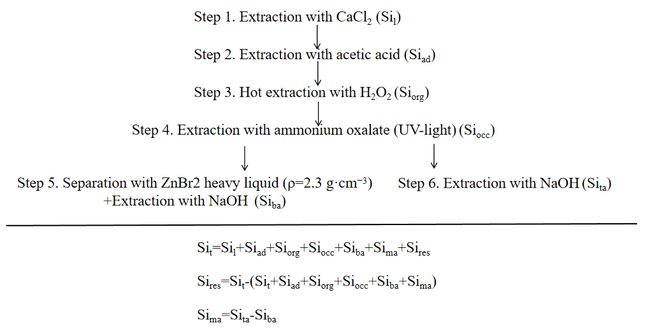
The extraction is run with four replicates until step 4. From this step on, the four replicates are divided in two by two for different subsequent treatments. The extracts of each extraction step are centrifuged and filtered. The soil samples are rinsed with distilled water between two extraction steps to remove the extractant of the previous step. Specific steps are as follows.
Si from the mobile silica fraction (Si_{l}) supposed to be dissolved in the soil solution is extracted with 0.01 M CaCl₂-solution using a soil to solution ratio of 1:5, usually 1 g soil and 5 ml solution. The samples are shaken slowly on a horizontal shaker for 24 h, only for 1 min/h in order to accelerate the extraction but at the same time avoid Si abrasion from mineral grains.
Si from the adsorbed silica fraction (Si_{ad}) is obtained by extraction with 0.01 M acetic acid using a soil to solution ratio of 1:10. This means that after the first step the samples are rinsed with distilled water, and then 10 ml of the extractant is added to each sample. The samples are then shaken for 24 h.
Oxidation with H₂O₂ at 85 °C releases Si from SOM (Si_{org}). The samples are treated with 20 ml 17.5% H₂O₂, manually shaken 4–6 times and kept for 1 h at room temperature. Then, 10 ml of 35% H₂O₂ are added, and the samples are kept in a water bath at 85 °C, until the reaction is completed.
Si occluded in pedogenic oxides and hydroxides (Si_{occ}) is extracted with 0.2 M ammonium oxalate and 0.2 M oxalic acid under UV-light. First, the extractant is applied at daylight and room temperature for 8 h, using a soil to solution ratio of 1:50. Then, the suspensions are irradiated with UV light overnight (with a distance between the sample and the UV lamp of approx. 20 cm). During the whole time the samples are shaken horizontally for 8 h.
Then the four replicates are divided into two by two.
Two replicates are subjected to bio-opal separation with ZnBr₂ heavy liquid (ρ=2.3 g·cm⁻³), The obtained bio-opal is then extracted with 0.2 M sodium hydroxide solution for 168 h at room temperature, using a sample to solution ratio of 1:400, and preferably shaking slowly end-over-end over the whole time. In this step biogenic amorphous silica is obtained (Si_{ba}).
The two other replicates are directly subjected to extraction with 0.2 M NaOH solution in the same way as described in step 5. This step provides the amount of total (minerogenic and biogenic) amorphous silica (Si_{ta}).

