Evaluation of toxicity and apoptotic effects of copper nanoparticles in combination with imatinib on chronic myeloid leukemia cells

Mohammad Ebrahimi Torkamani¹, Mahshid Mohammadian^{2*}, Farzaneh Kefayatirad³, Safiyeh Aghazadeh⁴, Mohammad Taghi Goodarzi^{1*}

¹ Department of Biochemistry, Sha.C., Islamic Azad University, Shahrood, Iran
² Department of clinical biochemistry, School of medicine, Urmia university of medical sciences, Urmia, Iran
³ Department of Biochemistry, Dorevitch Pathology, Heidelberg, VIC 3084, Australia
⁴ Department of Basic Sciences, Faculty of Veterinary Medicine, Urmia University, Urmia, Iran

*Corresponding authors:
Mohammad Taghi Goodarzi, Department of Biochemistry, Sha.C., Islamic Azad University, Shahrood, Iran. Tel: +982332390077, Email: mt.goodarzi@iau.ac.ir ORCID: 0000-0002-5546-5812
Mahshid Mohammadian, Department of clinical biochemistry, School of medicine, Urmia university of medical sciences, Urmia, Iran. Tel: +982332390077, Email: Biochem426@gmail.com

Running Title: toxicity and apoptotic effects of copper nanoparticles in combination with imatinib

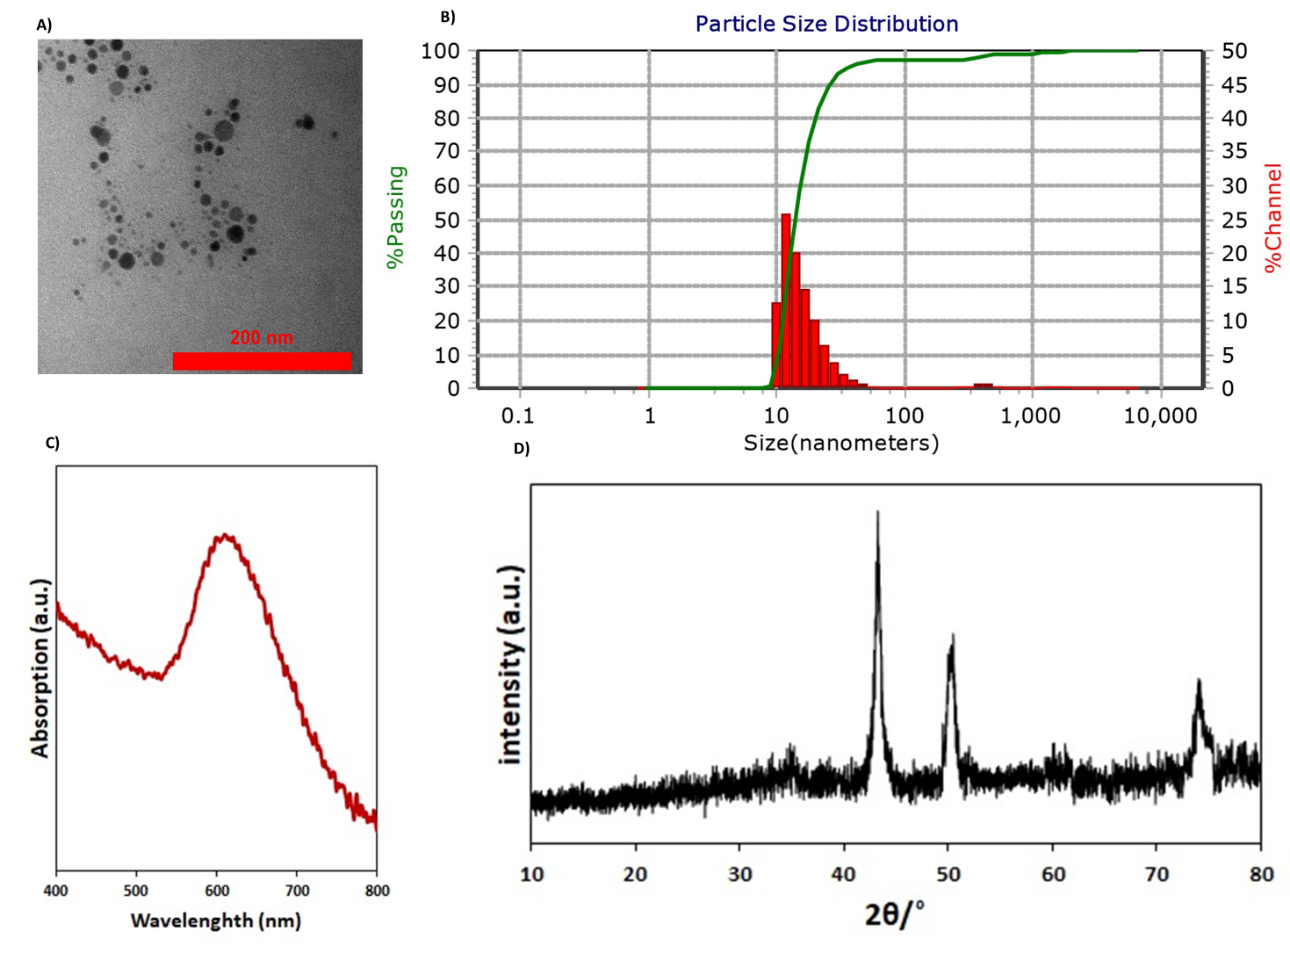
Supplementary Figure S1. Physicochemical characterization of CuNPs. (A)TEM image showing predominantly spherical CuNPs with variable size distribution. (B) DLS profile indicating an average particle size of ~40 nm, with a distribution range of 20–50 nm. (C) UV–VIS absorption spectrum exhibiting a strong SPR band at ~600 nm, confirming the formation of metallic CuNPs. (D) XRD pattern demonstrating crystalline structure and high phase purity of CuNPs. CuNPs, copper nanoparticles; TEM, transmission electron microscopy; DLS, dynamic light scattering; UV–VIS, ultraviolet–visible spectroscopy; SPR, surface plasmon resonance; XRD, X-ray diffraction.

