Supporting information
Bharat Kumar^{a, b*}
Table S1: Weight fraction of micron sized CuO and copper oxalate in nano-micron composites of CuO
S. No. | Compounds | Weight of CuO(g) | Weight of copper oxalate (g)
1 | Pure micron | 2 | 0
2 | 20 % nano-micron composites | 1.6 | 0.4
3 | 40 % nano-micron composites | 1.2 | 0.8
4 | 50 % nano-micron composites | 1.0 | 1.0
5 | 60 % nano-micron composites | 0.8 | 1.2
6 | 80 % nano-micron composites | 0.4 | 1.6
7 | Pure nano | 0 | 2

Figure S1: FESEM micrograph of (a, b) pure micron and (c, d) pure nano sized CuO.

Figure S2: FESEM micrograph of nano-micron composites of CuO
(a) 20 % (b) 40 % (c) 50 % (d) 60 %

Figure S3: Diffuse reflectance spectra of CuO composites

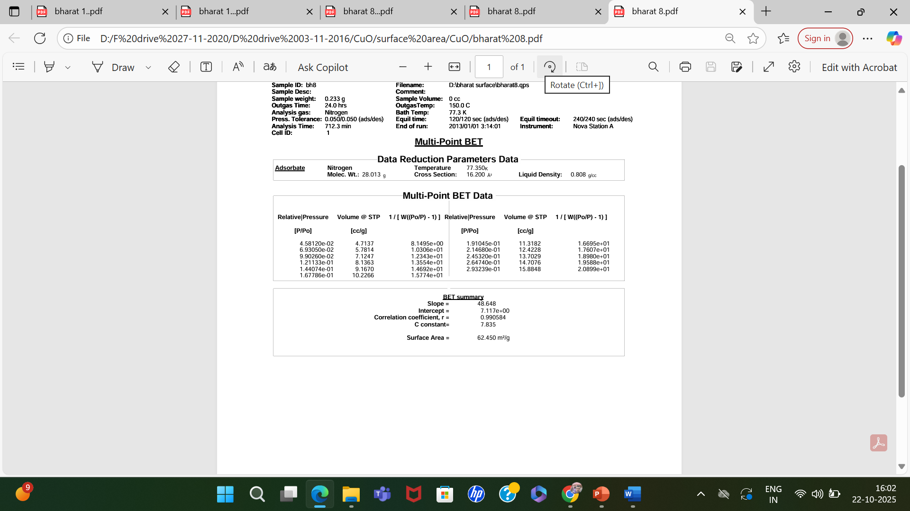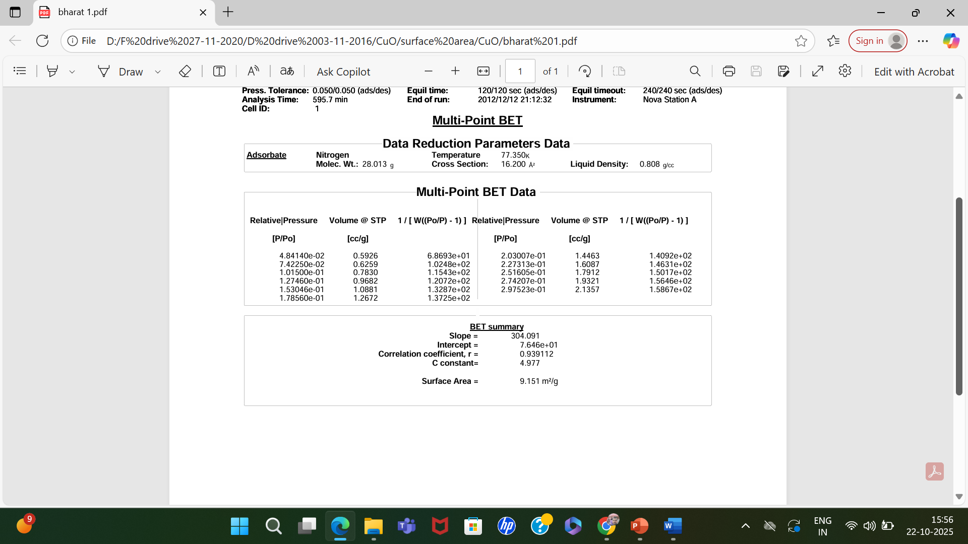
Pure Micron
Pure Nano

Figure S4: Hydrogen evolves during HER (bubble in red circle) respectively

Figure S4: BET analysis of N₂ adsorption-desorption isotherm of pure micron and pure
nano CuO particles.

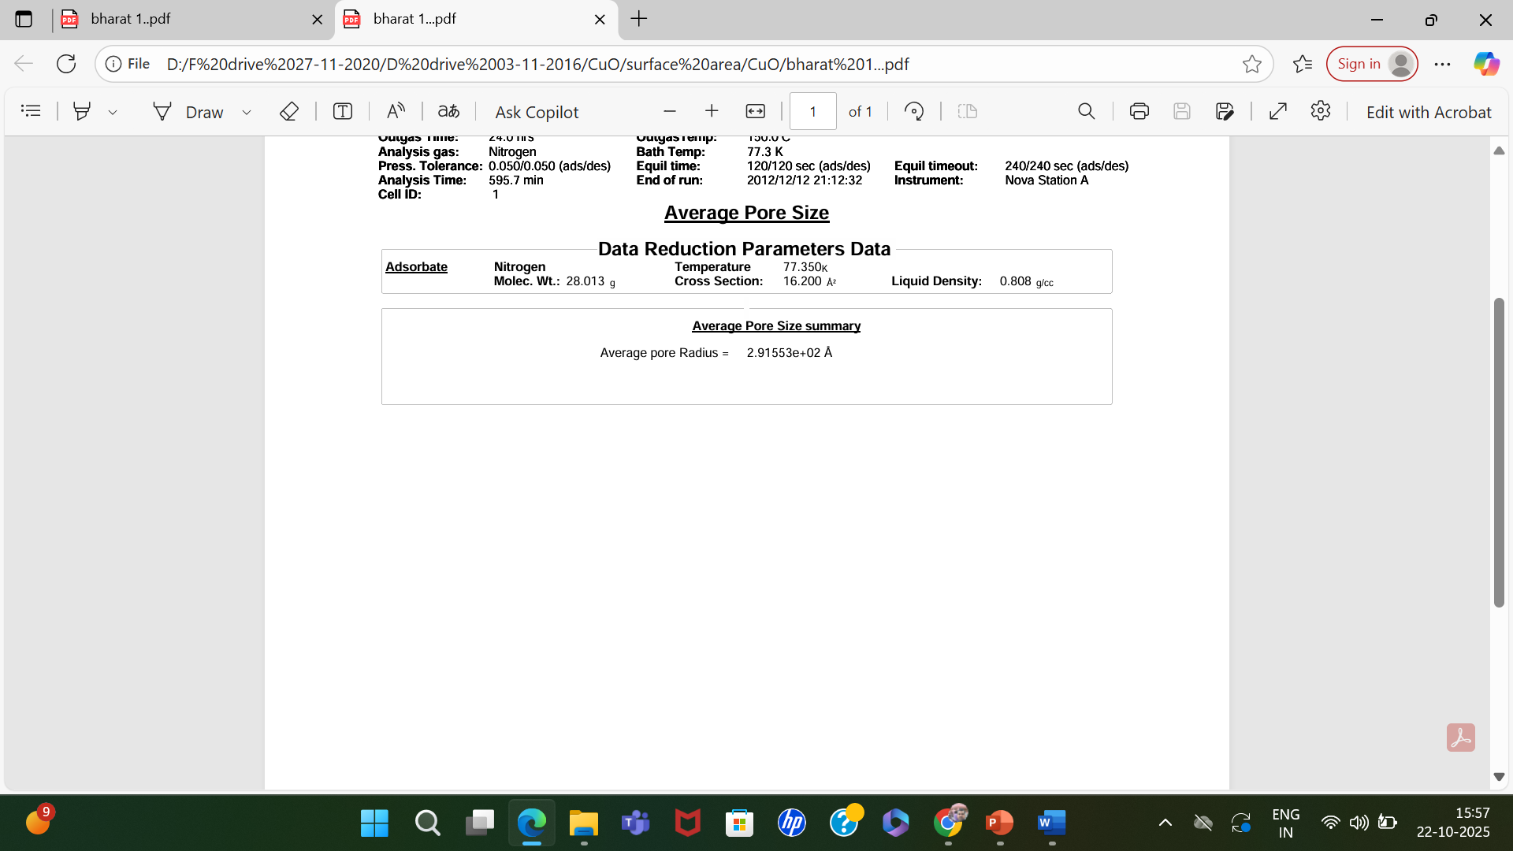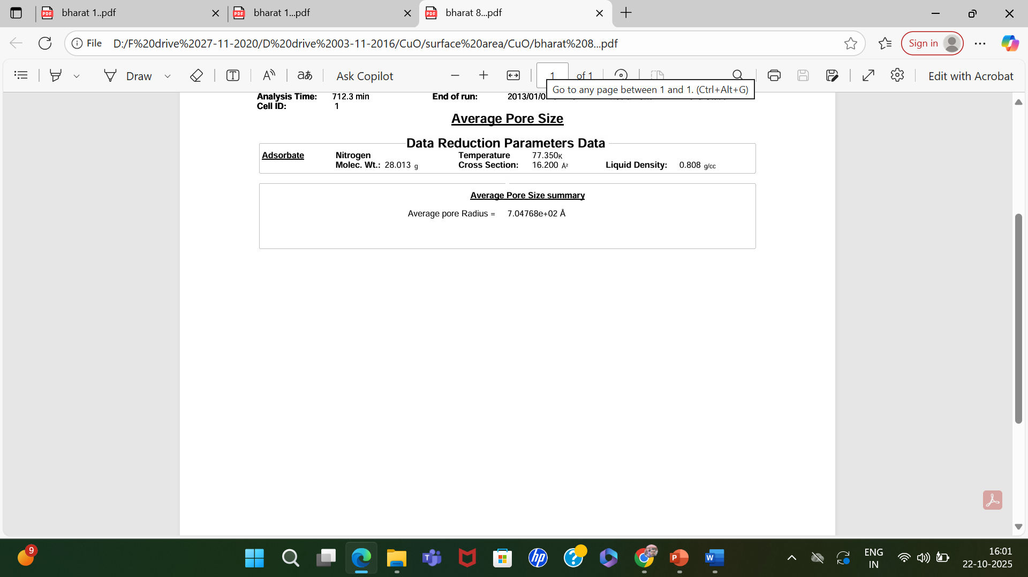
Pure Micron
Pure Nano

Figure S5: average pore size of pure micron and pure nano CuO particles.

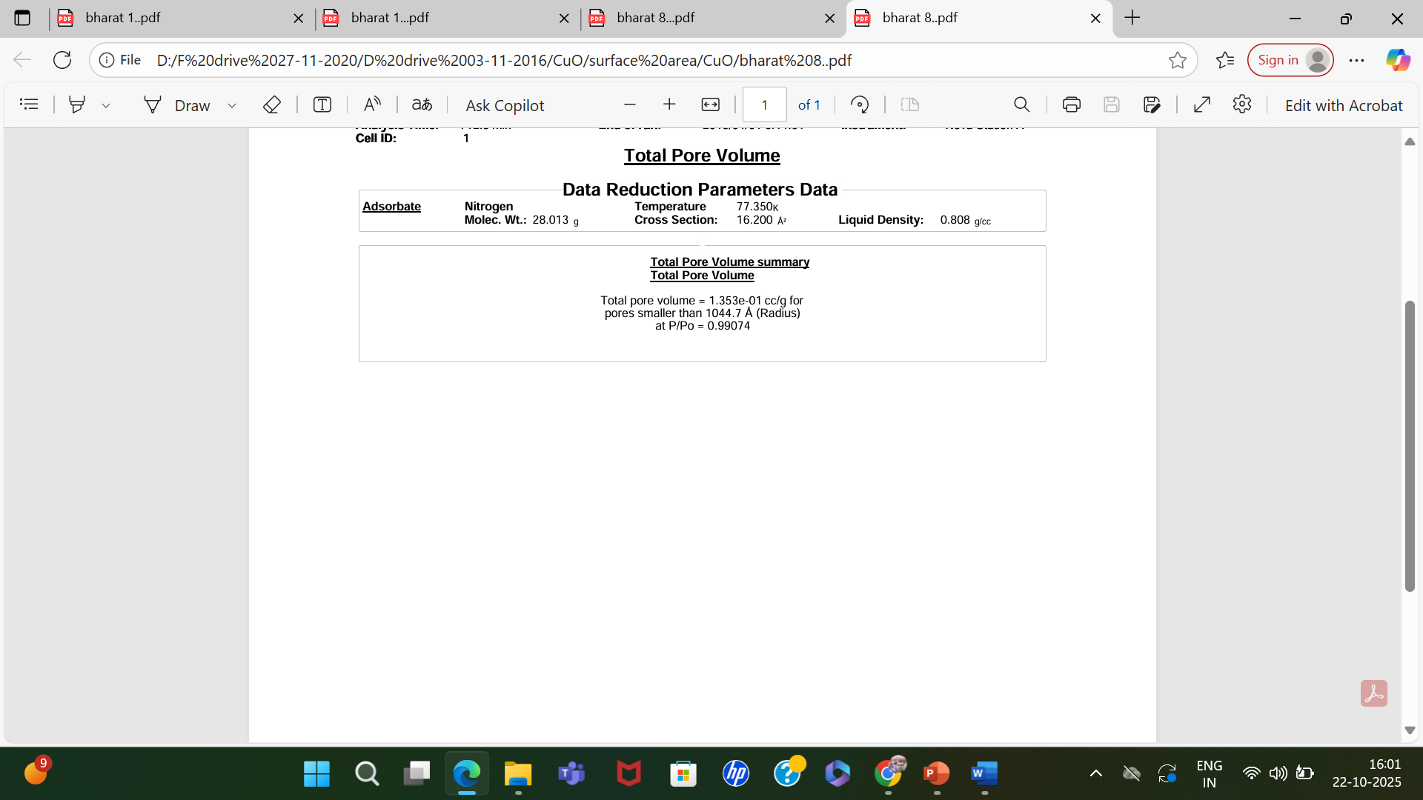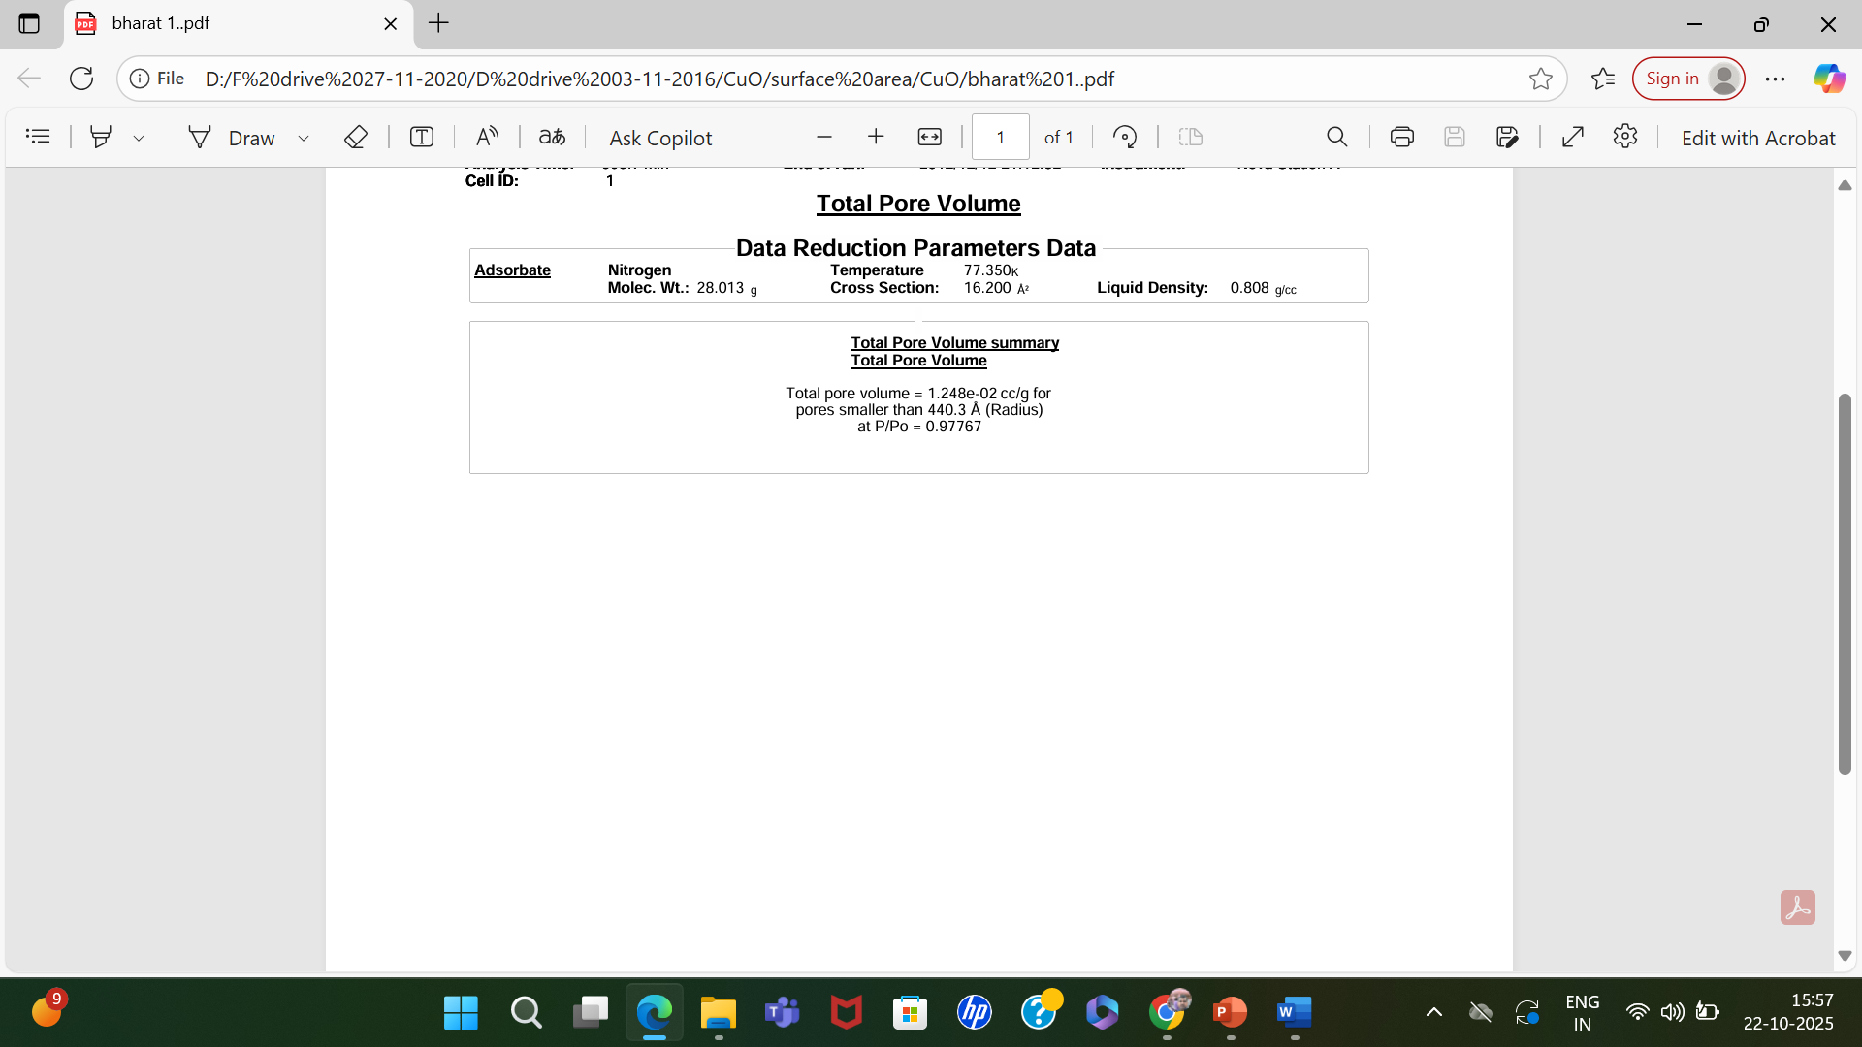
Pure Micron
Pure Nano

Figure S6: Total pore volume of pure micron and pure nano CuO particles.

Figure S7: Stability of current density obtained by pure CuO nanoparticles

Figure S8: Comparison of Powder X-ray diffraction pattern of pure nano size CuO before
and after HER

Figure S9: Hydrogen evolves during HER (bubble in red circle)

Conversion Formula from Ag/AgCl to Reversible Hygrogen Electrode (RHE)
E_{RHE} = E_{Ag/AgCl} + 0.197 + 0.0591 x pH
Where E_{RHE} = Potential versus RHE
E_{Ag/AgCl} measured potential = -1.3 V
Standard potential difference between Ag/AgCl and SHE at 25 °C = 0.197 V
0.0591 × pH = correction term for solution pH
For 0.5 M KOH, pH = 13.7

E_{RHE} = -1.3 + 0.197 + 0.0591 x 13.7
= -1.3 + 0.197 + 0.8097
= - 1.3 + 1.0067
= - 0.293 V
E_{RHE} = -0.293 V

