Electrochemotherapy in Basal & Squamous Cell Carcinoma of Head & Neck; A Prospective Study
Farrokh Heidari^{1.6,#}, Mahdis Bayat ^{1,2,3,#}, Alireza Namvari^{1,4}, Seyyed Mojtaba Yazdanparast^{1,2}, Sepideh Mansouri^{1,4}, Farshid Rostami Pouria^{1,2} , Amirhossein ghabasiah⁶ , Navid Manoochehri^{1,2}, Negar Hemmati^{1,2}, Sama Mansouri^{1,4}, Nasim Sharghi¹, S. M. Sadegh Mousavi-kiasary^{1,2}, Omid Nabavian⁴, Habibollah Mahmoodzadeh^{8,4}, Niloufar Shabani³, Farbood farahbakhsh⁶, Seyed Hadi Samimi Ardestani⁶, Alireza Mohamadian¹, Seyede Misha Seyednia⁷, Baran Mehdizadeh⁵, Seyed Rouhollah Miri^{1,4,8*}, Ebrahim Karimi^{1.6*} , Mohammad Abdolahad^{1,2,3}*
- Cancer Electronics Research Center, University of Tehran and Tehran University of Medical Sciences Imam Khomeini Hospital, Tehran 14197-33141, Iran
- Nano Bioelectronics Devices Lab, Cancer Electronics Research Group, School of Electrical and Computer Engineering, University of Tehran, Tehran, Iran
- Faculty of Medicine, Shahid Beheshti University of Medical Sciences, Tehran, Iran
- Cancer Institute, Imam-Khomeini Hospital, Tehran University of Medical Sciences, Tehran 14166-34793, Iran
- School of Medicine, Tehran University of Medical Sciences, Tehran, Iran
- Otorhinolaryngology Research Center, AmirAlam Hospital, Tehran University of Medical Sciences, Tehran, Iran
- Anesthesiology and intensive care, Amir-Alam Hospital, Tehran University of Medical Sciences, Tehran, Iran
- Department of Surgical Oncology, Tehran University of Medical Science, Tehran 14176-14411, Iran
- General surgery department, Amir-Alam hospital, Tehran University of Medical Sciences, Tehran, Iran
#Authors with the same contribution.
* Corresponding authors:
- Mohammad Abdolahad: Full Professor, Director of Nanobioelectronics Devices Lab (NBEL), School of Electrical and Computer Engineering, University of Tehran. Adjunct Professor, Cancer Institute, Tehran University of Medical Sciences. E-mail: m.abdolahad@ut.ac.ir, abdolahad@tums.ac.ir (ORCID: 0000-0002-1091-3095). Tel: +989122079914
  - Ebrahim Karimi, Associate Professor, Otorhinolaryngology Research Center, AmirAlam Hospital, Tehran University of Medical Sciences, Tehran, Iran. E-mail: Farrokh.heidari@yahoo.com, (ORCID: 0000-0002-6904-5691)
  - S. R. Miri, Associate professor, Dean Cancer Institute, Tehran University of Medical Sciences. S.r.miri@tums.ac.ir

1. Various Probes of ECT

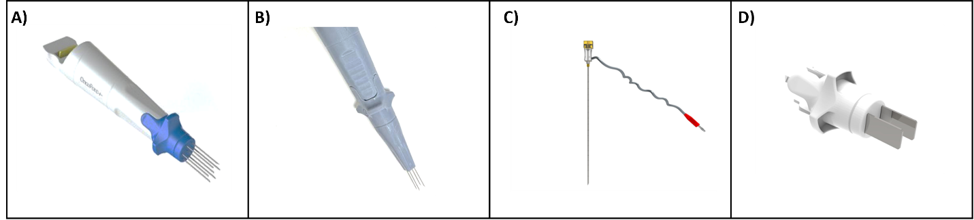
Figure S1- A) A hexagonal needle electrode, B) A square array electrode, C) A single needle electrode, D) A plate electrode.

