Supplementary Information

Reducing False Negatives in Gastroesophageal Reflux Disease Diagnosis Using Multi-feature Anomaly Detection on pH-Impedance Signals

Songho Lee¹, Junhyeong Lee¹, Donggeun Park¹, Sang Kil Lee², Kyoung G. Lee^{3*}, Hee Man Kim^{4*}, and Seunghwa Ryu^{1*}

Affiliations
¹Department of Mechanical Engineering, Korea Advanced Institute of Science and Technology (KAIST), Daejeon 34141, Republic of Korea
²Department of Internal Medicine, Yonsei Institute of Gastroenterology, Severance Hospital, Yonsei University College of Medicine, Seoul, 03722, Republic of Korea
³ Center for NanoBio Development, National NanoFab Center, 291 Daehak-ro, Yuseong-gu, Daejeon, 34141 Republic of Korea
⁴Cancer Prevention Center, Yonsei Cancer Center, Yonsei University of College of Medicine, Seoul 03722, Republic of Korea

* Corresponding authors:
Seunghwa Ryu, Ph.D.
Department of Mechanical Engineering, Korea Advanced Institute of Science and Technology (KAIST)
291, Daehak-ro, Yuseong-gu, Daejeon, Republic of Korea
E-mail: ryush@kaist.ac.kr
Hee Man Kim, M.D., Ph.D.
Cancer Prevention Center, Yonsei Cancer Center, Yonsei University of College of Medicine
50-1 Yonsei-ro, Seodaemun-gu, Seoul, 03722, Republic of Korea
E-mail: loverkorea2009@gmail.com
Kyoung G. Lee, Ph.D.
Center for NanoBio Development, National NanoFab Center
291 Daehak-ro, Yuseong-gu, Daejeon, 34141 Republic of Korea
E-mail: kglee@nnfc.re.kr

S1. Feature-wise analysis of pH signals using min-max cases
To understand how each extracted feature manifests in esophageal pH monitoring, we analyzed representative cases with minimum and maximum values for each metric. Fig. S1 and Fig. S2 present the corresponding pH signal across eight key features: acid exposure time (AET), kurtosis, peak to peak, skewness, mean, variance, impulse factor, and crest factor. For each feature, one sample with the minimum value and another with the maximum value was selected. The AET and DMS for each case are annotated in the figure titles. These examples provide insight into how signal morphology changes across different clinical contexts.
Among the features, AET is a domain feature established in clinical practice. In our dataset, the AET ranged from 0.000 (normal) to 89.274 (severely abnormal). pH signals in high-AET cases exhibit frequent and prolonged drops below the pH threshold of 4, indicating pathological acid reflux. In contrast, signals with minimal AET remain stable and far above the threshold. Kurtosis ranged from -1.562 to 38.107. Low kurtosis reflected stable pH profiles, whereas high kurtosis indicated infrequent but sharp acid spikes showing suggestive of episodic reflux events not captured by AET alone. The peak to peak metric ranged from 2.0 to 11.090. Greater peak to peak values were associated with volatile signal patterns and substantial pH fluctuations. Similarly, skewness values ranged from -5.593 to 2.429. Negative skewness typically emerged in stable pH signals, while positive skewness indicated asymmetric acid exposure patterns. The mean pH value ranged from 2.154 to 8.485. Lower mean values often corresponded with high AET and high DMS scores, reinforcing its relevance in identifying abnormal cases. Variance ranged from 0.095 to 4.983. This feature directly reflected variability in pH, with larger values indicative of unstable signals. Impulse factor and crest factor, which measure signal sharpness and peak prominence, showed smaller spreads but also tended to increase in high-reflux cases.
From a clinical perspective, these findings support the utility of extracted features beyond AET. For most features, such as kurtosis, variance, and peak to peak, higher values aligned with abnormal reflux activity. Mean value, on the other hand, showed an inverse pattern: lower values indicated abnormality.
Consequently, this min-max analysis highlights the complementary value of statistical and waveform-derived features in GERD diagnosis. By capturing signal patterns that AET alone may miss, such features enhance the interpretability and sensitivity of reflux detection. Their integration may contribute to more precise, feature-rich diagnostic frameworks for patients presenting with borderline or atypical symptoms.

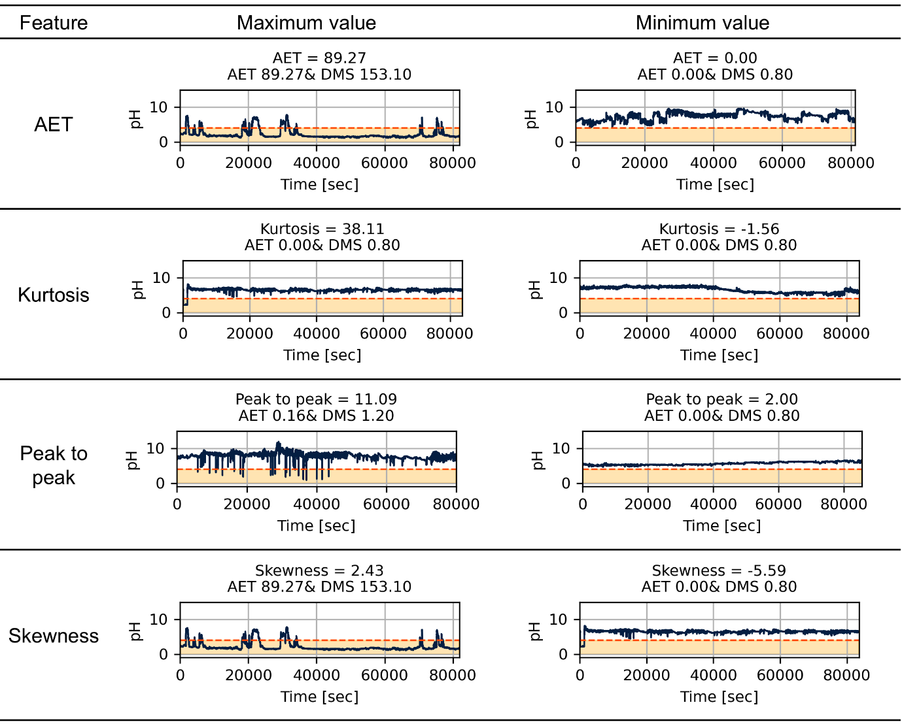
Fig. S1 Representative examples of esophageal pH signals illustrating the maximum and minimum values of extracted features (Part 1). Signals corresponding to the maximum and minimum values of AET, kurtosis, peak to peak, and skewness. Orange shaded regions indicate pH ≤4, and dashed lines indicate the critical threshold (pH 4).

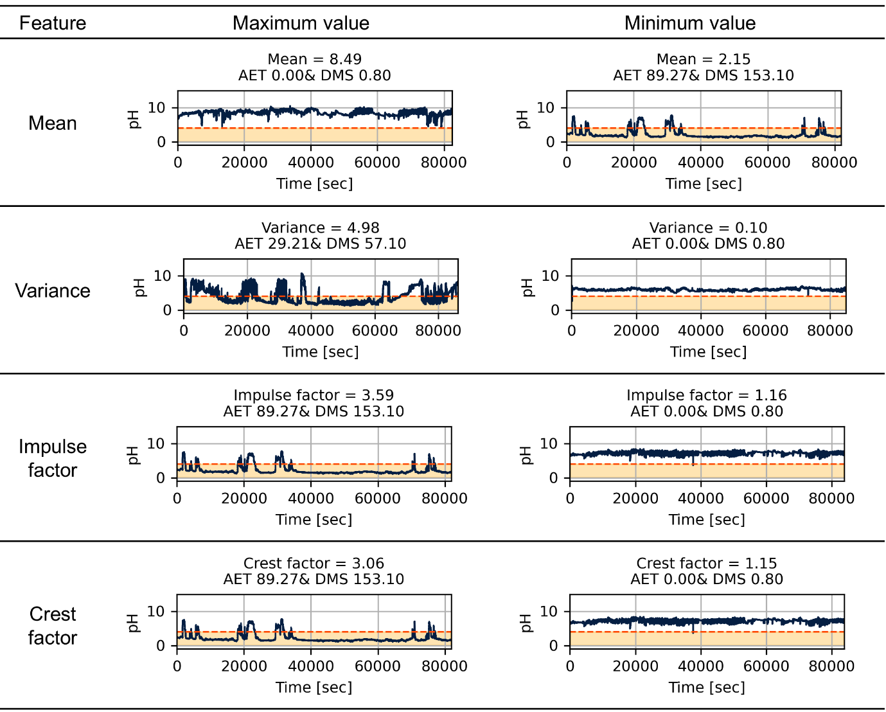
Fig. S2 Representative examples of esophageal pH signals illustrating the maximum and minimum values of extracted features (Continued, Part 2). Signals corresponding to the maximum and minimum values of mean, variance, impulse factor, and crest factor. Orange shaded regions indicate pH ≤4, and dashed lines indicate the critical threshold (pH 4).

S2. Results of hyperparameter tuning of support vector data description (SVDD) model
The hyperparameter optimization results for the SVDD model, obtained via Bayesian optimization (BO), are presented in Fig. S3. The optimization process comprised a total of 520 iterations: an initial phase of 20 points generated through Latin hypercube sampling (LHS) to ensure comprehensive coverage of the hyperparameter space, followed by 500 iterations where new points were proposed based on the expected improvement (EI) acquisition function.
Fig. S3A illustrates the progression of the $F_{3}$​ score throughout the optimization process. A rapid improvement is observed during the initial LHS phase, with the score gradually converging to a stable maximum in subsequent iterations. The highest $F_{3}$​ score achieved was approximately 0.912. Fig. S3B depicts the distribution of evaluated hyperparameter combinations, highlighting both the initial LHS points and those suggested by the BO process. The optimal hyperparameters identified were $ν=0.843$ and $s=2.625$, distinctly marked in the parameter space. Figs. S3C, D provide detailed trajectories of the $ν$ and $s$ parameters, respectively, over the course of the optimization. These plots show the convergence of hyperparameters toward optimal values that enhance model performance.
The optimal hyperparameters of the SVDD model closely matched those of the One-Class Support Vector Machine (OCSVM) model, with $ν=0.833$ and $s=2.500$. While strict mathematical equivalence between SVDD and OCSVM requires that all input data be normalized to unit norm¹, this condition was not enforced in our case. Nevertheless, the consistency in results can be attributed to the use of the same dataset, the same Gaussian kernel, and optimization under the same performance metric (i.e., the $F_{3}$​ score). These shared conditions likely led both models to converge toward similar decision boundaries in the feature space.

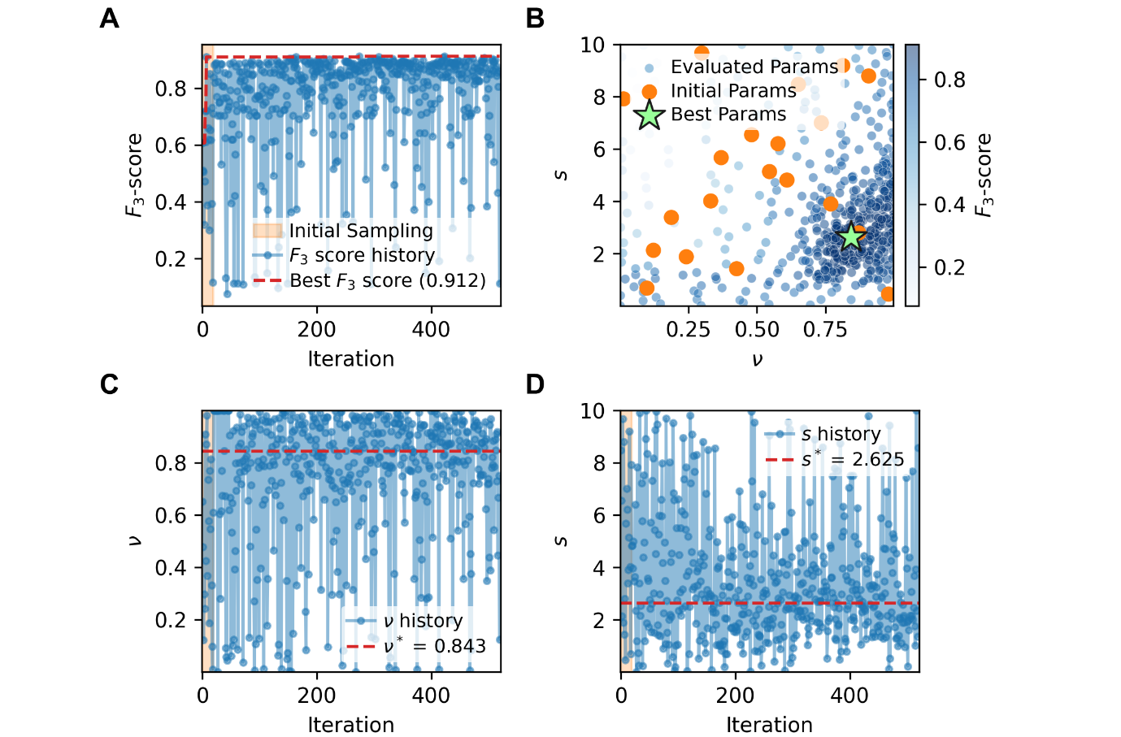
Fig. S3 hyperparameter optimization results using BO in SVDD. A Evolution of the $F_{3}$​ score across BO iterations, with the best score (0.912) highlighted. B Visualization of the explored hyperparameter space ($ν$ and $s$), showing initial parameters (orange), evaluated parameters (blue), and the optimal set (green star). C Convergence history of the hyperparameter $ν$, with the optimal value identified as $ν^{*}=0.843$. D Convergence history of the hyperparameter $s$, with the optimal value identified as $s^{*}=2.625$.

S3. Diagnosis results and interpretation of representative cases on SVDD
To validate the SVDD based anomaly detection (AD) framework, diagnostic outcomes obtained from the SVDD model were compared against those from conventional AET-based classification. Results from the SVDD model, analogous to those from the one-class support vector machine (OCSVM) analysis detailed in the main manuscript, are presented comprehensively in Fig. S4.
In Fig. S4A, the SVDD-based AD outcomes were visualized through the same two-dimensional principal component analysis (PCA) projection in the main text. Each patient was represented by a single data point, with background colors indicating anomaly scores derived from the SVDD model. Blue shades signifying normality and red shades indicating anomalous classifications. It was observed that normal patients generally formed a distinct cluster in the central region, whereas anomalous patients exhibited dispersion toward regions with lower anomaly scores. Triangles marked cases identified as anomalous by both conventional AET thresholds and SVDD, while squares highlighted additional anomalies uniquely detected by the SVDD model. The classification results of the SVDD model on this test data are identical to those of the OCSVM model presented in the main text, with only slight differences in the anomaly scores due to differences in the model calculation.
In Figs. S4B-E, detailed diagnostic summaries of four representative cases were presented. Each panel consisted of three distinct components: conventional classification based on AET values, proposed model classification derived from SVDD anomaly scores, and supplementary clinical metrics including the DMS or total reflux episode count. Furthermore, a Shapley additive explanations (SHAP) analysis was provided on the right side of each panel to elucidate the feature-wise contributions influencing the SVDD model's predictions.
Across all four representative cases, the SVDD model produced classification results fully consistent with those of the OCSVM model presented in the main text. Patients a and b were correctly classified as a true positive and true negative, respectively, while patients c and d, misclassified as normal by the AET threshold, were successfully detected as anomalies by the SVDD model. In both potential false-negative cases, the anomaly predictions were supported by SHAP contributions from features such as peak to peak, kurtosis, and variance, with clinical documentation (e.g., high DMS or total reflux counts) indicating underlying weak acid reflux. Overall, these findings confirm that both SVDD and OCSVM effectively identify subtle reflux patterns, including weak acid reflux cases that are typically missed by conventional metrics like AET or DMS alone.

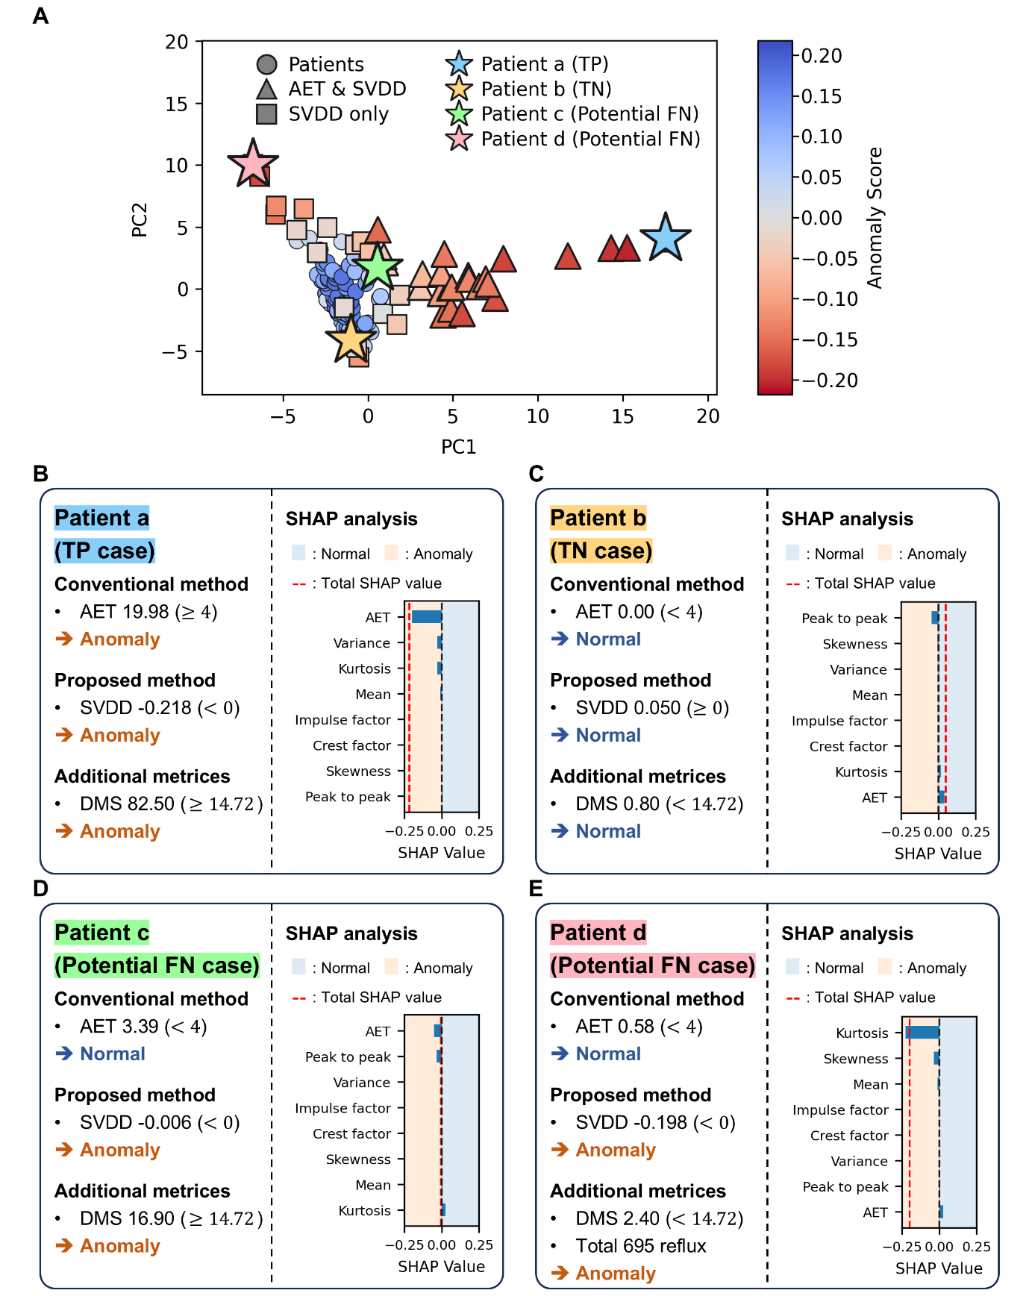
Fig. S4 Comparison of diagnostic outcomes and SHAP-based interpretation of representative patient cases. A Principal component visualization of SVDD anomaly detection versus AET classification, with stars marking four representative patients (a-d). B Patient a (TP): Both AET and SVDD detect anomaly, C Patient b (TN): Both AET and SVDD detect normal, D Patient c (Potential FN): Missed by AET but detected as anomaly by SVDD. E Patient d (Potential FN): Missed by AET but detected as anomaly by SVDD.

S4. Additional potential FN cases
This section presents two additional cases classified as normal by conventional methods (AET and DMS) but identified as anomalous by the proposed AD framework. These cases highlight the limitations of current diagnostic thresholds and underscore the value of integrating data-driven features to detect subtle or borderline abnormal patterns.

Case 1
AD Results: Figs. S5A, B show the raw signals and corresponding SHAP values for the first additional case. In Fig. S5A, the pH signal intermittently approaches or dips below the critical threshold of 4 (orange dashed line), suggesting potential episodes of acid reflux. However, both AET (0.746%) and DMS (4.70) fall below the clinical thresholds (AET < 4%, DMS < 14.72), and the sample was therefore labeled as normal. The proposed models, however, classified this case as anomalous, with anomaly scores of -0.010 (OCSVM) and -0.019 (SVDD), both below zero, indicating an anomaly. As illustrated in Fig. S5B, peak to peak and mean were the primary contributors to the anomaly classification, showing negative SHAP contributions. In contrast, the AET value had a positive contribution.
Clinical Implications: According to clinical reports from the Severance hospital of Yonsei University, this patient experienced 109 total reflux episodes: 34 acid-related and 75 non-acid-related. This pattern is indicative of weak acid reflux. Furthermore, the baseline pH signal appeared elevated (approximately 1-2 units higher than typical), raising the possibility of sensor displacement or proximal migration. A follow-up examination is therefore recommended.

Case 2
AD Results: The second additional case is visualized in Figs. S5C, D. In Fig. S5C, the pH signal occasionally dips below pH 4, and both AET (3.197%) and DMS (9.20) remain below their respective thresholds, resulting in a normal label by conventional standards. However, this sample lies near the diagnostic cutoff and was flagged as anomalous by the proposed model, with anomaly scores of -0.017 (OCSVM) and -0.032 (SVDD), both below zero, indicating anomaly. In Fig. S5D, AET made the most substantial negative contribution to the anomaly classification. Skewness and kurtosis also contributed notably, indicating sharp fluctuations in the pH signal.
Clinical Implications: This patient experienced 77 reflux episodes in total, with 52 acid-related and 25 non-acid-related. Based on this reflux profile and model interpretation, this case can be classified as weak acid reflux missed by conventional AET/DMS criteria but successfully detected by the proposed AD framework.

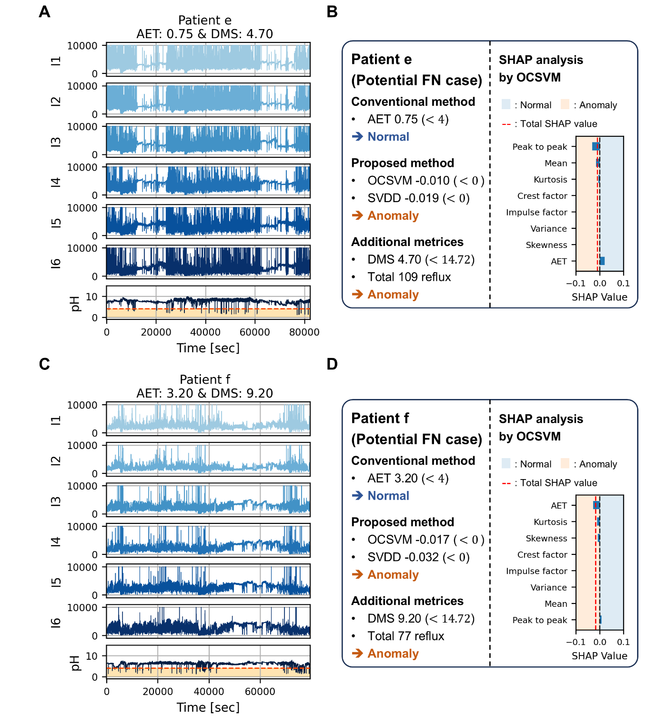
Fig. S5 Additional potential FN cases detected by ML-based anomaly detection with SHAP interpretation. A Raw MII-pH signals (I1-I6 and pH), Patient e. B Case-wise diagnostic summary and SHAP explanation (AET, OCSVM/SVDD, DMS, total reflux), Patient e. C Raw MII-pH signals (I1-I6 and pH), Patient f. D Case-wise diagnostic summary and SHAP explanation (AET, OCSVM/SVDD, DMS, total reflux), Patient f.

References
1. Tax, D. M. J. & Duin, R. P. W. Support Vector Data Description. vol. 54 (2004).

