Supplementary Materials for:
Cross-species mapping of psychedelic gene expression reveals links to the 5HT2A receptor, cortical layers, and human accelerated regions
Authors:
Patrick A. McConnell², Jackson Raffety¹, Andrew Li¹, Eric Steinberg¹, Syed Rahim¹, Christian Valtierra¹, Adam Gazzaley¹, Robin Carhart-Harris¹, Lorenzo Pasquini^{1, 2,} *
Content:
- Supplementary Figures: 2
- Supplementary Tables: 5
- Supplementary Appendix: 2
- Supplementary Data: 1

Supplementary Figures, Legends, and Tables:
Gene lists | Number of unique genes | Source
Brain-expressed genes | 15,633 | Allen Human Brain Atlas
HAR genes | 2,164 | Doan et al. 2019
Genes changing expression under acute psychedelic administration in animal models | 56 | Benekareddy et al. 2012; Desouza et al. 2021; Fadahunsi et al. 2022; Gewirtz et al. 2002; González-Maeso et al. 2003, 2007; Jefsen et al. 2021; Lerer et al. 2024; Martin et al. 2016; Nichols et al. 2002, 2003, 2004; Santini et al. 2014; Tilakaratne et al. 1996; Vaidya et al. 1997
Subacute changes in gene expression after psychedelic administration in animal models | 104 | Donovan et al. 2021; Nardou et al. 2023
Supplementary Table S1. Raw numbers of gene lists involved in the analyses and their sources.

Schaeffer labels
- 112: 7Networks_RH_Vis_12
- 117: 7Networks_RH_SomMot_2
- 121: 7Networks_RH_SomMot_6
- 129: 7Networks_RH_SomMot_14
- 143: 7Networks_RH_DorsAttn_Post_9
- 150: 7Networks_RH_SalVentAttn_TempOccPar_3
- 174: 7Networks_RH_Cont_PFCl_5
- 175: 7Networks_RH_Cont_PFCl_6
- 176: 7Networks_RH_Cont_PFCl_7
- 181: 7Networks_RH_Cont_PFCmp_2
- 188: 7Networks_RH_Default_Temp_4
Supplementary Table S2. List of Schaeffer parcels missing gene expression data. Con: control; Default_Temp: default mode temporal; DorsAttn_Post: posterior dorsal attention; Cont_PFCl: control prefrontal cortex lateral; Cont_PFCmp: control prefrontal cortex medial; RH: right hemisphere; SalVentAttn_TempOccPar: temporo-occipital-parietal salience ventral attention; SomMot: somatomotor; Vis: visual

List of GCEP_{AHBA}
APOO, AR, ARC, ARRDC2, ATF3, ATF4, BDNF, CDH19, CEBPB, CEBPD, CLK1, COL5A1, COQ10B, CYB561A3, DIO2, DLG4, DUSP1, EGR1, EGR2, EGR3, EGR4, ETS1, FOS, FOSL1, GAD1, GPR26, GRM2, HOMER1, HRH1, HTR2A, JUNB, LRRTM4, LYN, MAPK3, NEGR1, NELFB, NFKBIA, NPTN, NR4A1, NR4A3, PER1, PTGS2, PVALB, S100A10, SGK1, SLC17A6, SLC6A1, SST, STYK1, TIA1, USP53
Supplementary Table S3. List of GCEP_{AHBA}. Genes in bold also overlapped with HAR_{AHBA} genes.

List of acute GCEP not present in the AHBA
GLUT4, N10, IL6, ILAD1, NGFLC
Supplementary Table S4. List of acute GCEP not present in the AHBA.

List of GCEP_{AHBA} in Clusters 1-3
Cluster 1: ARRDC2, ATF3, CDH19, CLK1, CYB561A3, FOS, GRM2, SGK1
Cluster 2: APOO, AR, ARC, ATF4, CEBPB, CEBPD, COL5A1, DUSP1, EGR1, EGR2, ETS1, OSL1, GAD1, HTR2A, JUNB, LRRTM4, NEGR1, NELFB, NFKBIA, NPTN, NR4A1, PER1, PTGS2, PVALB, SLC17A6, SLC6A1, TIA1, USP53
Cluster 3: BDNF, COQ10B, DIO2, DLG4, EGR3, EGR4, GPR26, HOMER1, HRH1, LYN, MAPK3, NR4A3, S100A10, SST, STYK1
Supplementary Table S5. GCEP_{AHBA} in Clusters 1-3.

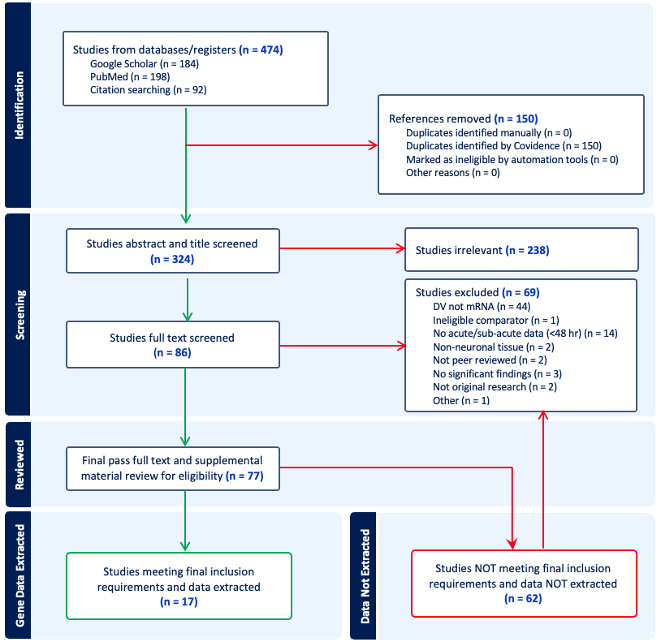
Supplementary Figure S1. Prisma flowchart.

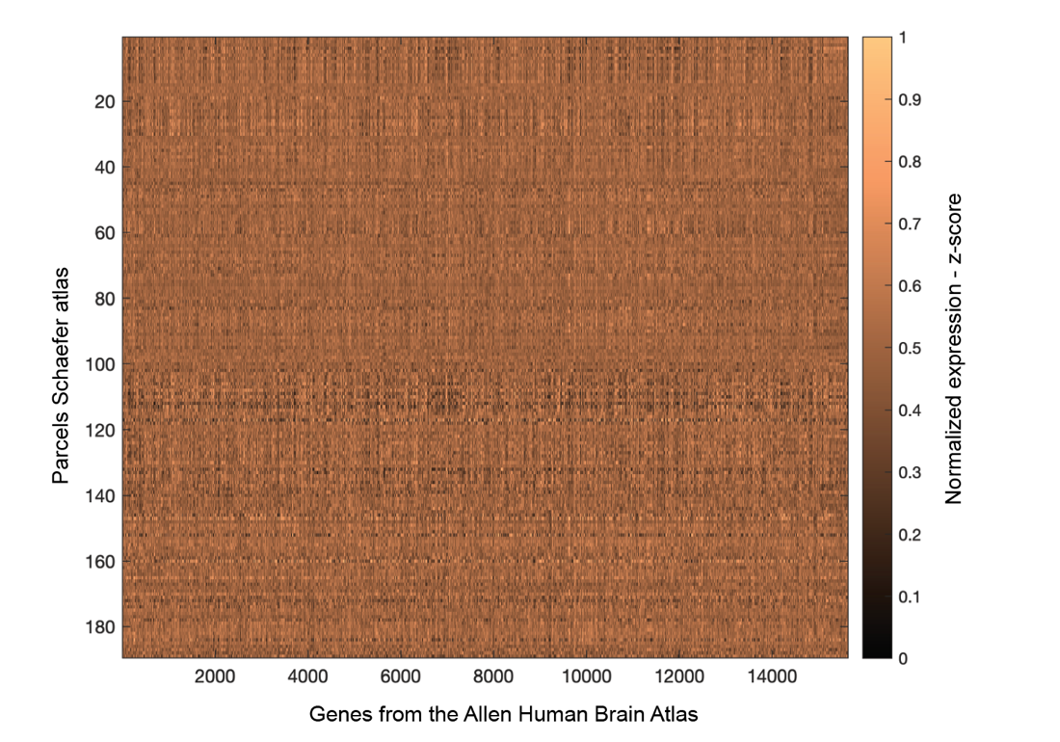
Supplementary Figure S2. Standardized expression of genes from the Allen Human Brain Atlas across parcels of the Schaefer atlas. Warm colors reflect higher expression, cold colors lower expression. Color-bar reflects standardized z-scores.

Supplementary Appendix S1: Search Terms and Screening Tool
Search terms used in PubMed and Google Scholar:
- ("hallucinogens" OR psychedelic OR psilocybin OR "lysergic acid diethylamide" OR LSD OR DMT OR dimethyltryptamine OR "5-HT2A agonist" OR "serotonin 2A receptor agonist") AND ("gene expression" OR "gene expression profiling" OR transcriptome OR transcriptomics OR "RNA sequencing" OR "differential gene expression") AND ("brain" OR "brain tissue" OR "cerebral cortex" OR hippocampus OR "prefrontal cortex") AND (acute OR "single dose" OR "short-term")
- (“gene expression” OR transcriptome OR transcriptomics) AND ("hallucinogen" OR psychedelic) AND (“psilocybin” OR "lysergic acid diethylamide" OR ”LSD” OR “DMT” OR “dimethyltryptamine” OR “mescaline” OR “DOI” OR “ayahuasca”) AND (“brain” OR neural OR “neuron” OR “cortical” OR “cortex” OR “cell culture”)
- (gene expression) AND (5-HT2A) AND (psychedelic OR hallucinogen)
Screening tool:
- Is the title in English?
  - No, stop screening
  - Yes, continue screening
- Does the abstract indicate it is an original research article?
  - No, stop screening
    - E.g., review, secondary analysis
  - Yes, continue screening
- Does the abstract indicate gene expression was quantified in neuronal cell tissue or animal brain models?
  - No, stop screening
    - E.g., organ other than brain was studies in rodent model
  - Yes, continue screening
- Does the abstract indicate the use of a non-classical serotonergic psychedelic?
  - Yes, stop screening
    - E.g., MDMA, ibogaine
  - No, continue screening
- Does the abstract indicate more than two administrations of a psychedelic?
  - Yes, stop screening
    - E.g., multiple dosing over several weeks
  - No, continue screening
- Where gene list described in the articles publicly available?
  - No, article included
    - E.g., organ other than brain was studies in rodent model
  - Yes, article included

Supplementary Appendix S2: abagen code and report
Abagen Code:
$ abagen --output-file Schaeffer_200.csv Schaeffer_200.nii.gz
Abagen Report:
Regional microarray expression data were obtained from 6 post-mortem brains (1 female, ages 24.0--57.0, 42.50 +/- 13.38) provided by the Allen Human Brain Atlas (AHBA, https://human.brain-map.org; [H2012N]). Data were processed with the abagen toolbox (version 0.1.3; https://github.com/rmarkello/abagen) using a 200-region volumetric atlas in MNI space.
First, microarray probes were reannotated using data provided by [A2019N]; probes not matched to a valid Entrez ID were discarded. Next, probes were filtered based on their expression intensity relative to background noise [Q2002N], such that probes with intensity less than the background in >=50.00% of samples across donors were discarded, yielding 31,569 probes. When multiple probes indexed the expression of the same gene, we selected and used the probe with the most consistent pattern of regional variation across donors (i.e., differential stability; [H2015N]), calculated with:
$$ΔS\left(p\right)= \frac{1}{\left(\begin{matrix}N \\ 2\end{matrix}\right)} \sum_{i=1}^{N-1}{\sum_{j=i+1}^{N}{ρ\left[B_{i}\left(p\right),\right]B_{j}\left(p\right)}}$$
Where $ρ$ is Spearman's rank correlation of the expression of a single probe, p, across regions in two donors B_{i} and B_{j} and N is the total number of donors. Here, regions correspond to the structural designations provided in the ontology from the AHBA
The MNI coordinates of tissue samples were updated to those generated via non-linear registration using the Advanced Normalization Tools (ANTs; https://github.com/chrisfilo/alleninf). Samples were assigned to brain regions in the provided atlas if their MNI coordinates were within 2 mm of a given parcel. All tissue samples not assigned to a brain region in the provided atlas were discarded.
Inter-subject variation was addressed by normalizing tissue sample expression values across genes using a robust sigmoid function [F2013J]:
$$ΔS\left(p\right)= \frac{1}{\left(\begin{matrix}N \\ 2\end{matrix}\right)} \sum_{i=1}^{N-1}{\sum_{j=i+1}^{N}{ρ\left[B_{i}\left(p\right),\right]B_{j}\left(p\right)}}$$
where $〈x〉$ is the median and ${IQR}_{z}$is the normalized interquartile range of the expression of a single tissue sample across genes. Normalized expression values were then rescaled to the unit interval:
$$x_{scaled}= \frac{x_{norm}-min\left(x_{norm}\right)}{max\left(x_{norm}\right)-min\left(x_{norm}\right)}$$

Gene expression values were then normalized across tissue samples using an identical procedure. Samples assigned to the same brain region were averaged separately for each donor and then across donors, yielding a regional expression matrix with 200 rows, corresponding to brain regions, and 15,633 columns, corresponding to the retained genes.
REFERENCES:
[A2019N]: Arnatkevic̆iūtė, A., Fulcher, B. D., & Fornito, A. (2019). A practical guide to linking brain-wide gene expression and neuroimaging data. Neuroimage, 189, 353-367.
[F2013J]: Fulcher, B. D., Little, M. A., & Jones, N. S. (2013). Highly comparative time-series analysis: the empirical structure of time series and their methods. Journal of the Royal Society Interface, 10(83), 20130048.
[H2012N]: Hawrylycz, M. J., Lein, E. S., Guillozet-Bongaarts, A. L., Shen, E. H., Ng, L., Miller, J. A., ... & Jones, A. R. (2012). An anatomically comprehensive atlas of the adult human brain transcriptome. Nature, 489(7416), 391-399.
[H2015N]: Hawrylycz, M., Miller, J. A., Menon, V., Feng, D., Dolbeare, T., Guillozet-Bongaarts, A. L., ... & Lein, E. (2015). Canonical genetic signatures of the adult human brain. Nature Neuroscience, 18(12), 1832.
[Q2002N]: Quackenbush, J. (2002). Microarray data normalization and transformation. Nature Genetics, 32(4), 496-501.

