1. Method And Data
The propensity score matching (PSM) model was introduced by Rosenbaum and Rubin in 1983 and was initially applied in the field of biomedical research. It has since been widely used in areas such as drug treatment, econometrics, and policy evaluation. The propensity score matching model works by calculating the probability that each individual receives a particular treatment (such as a medical intervention or policy), known as the propensity score. Based on this probability, individuals in the experimental group are matched with those in the control group, ensuring comparability on key variables. This allows for the estimation of the treatment effect. In other words, the process involves “scoring + matching + estimation”[1-3] .
Propensity Score Matching Model:
$$\begin{aligned}e\left(X_{i}\right)=P\left(T_{i}=\left.1\right|X_{i}\right)=\frac{1}{1+e^{-\left(β_{0}+β_{1}GDP+⋯β_{k}Covariates\right)}}\#\left(3\right)\end{aligned}$$
$β_{0}$​：Intercept term
$β_{1}⋯β_{k}$：Coefficients of control variables
Standardized Mean Difference (SMD):
$$\begin{aligned}SMD=\frac{\left|{\overline{X}}_{treated}-{\overline{X}}_{control}\right|}{\sqrt{\frac{S_{treated}^{2}+S_{control}^{2}}{2}}}\#\left(4\right)\end{aligned}$$
Average Treatment Effect on the Treated（ATT）:
$$\begin{aligned}ATT=\frac{1}{N_{treated}}\sum_{i∈Treated}{\left(Y_{i}-\frac{1}{M}\sum_{j∈{control}_{i}}{Y_{j}}\right)}\#\left(5\right)\end{aligned}$$
Variable Definitions：
Treatment Variable:
$$T_{i}=\left\{\begin{aligned}1 if the country i is directly affected by the Russia-Ukraine conflict \\ 0 if the country i is not affected\end{aligned}\right.$$
Outcome Variable:$Y_{i}=Total natural gas exports (or imports)$
Control Variables:$X_{i}=\left[GDP、PE、AT、⋯\right]$
1.1. Conducting a robustness analysis using Propensity Score Matching (PSM)
In the preceding analysis, we applied the Difference-in-Differences (DID) method to establish a causal framework for assessing the impact of the Russia-Ukraine conflict on U.S. natural gas exports. This approach leveraged the exogenous shock of the conflict's outbreak and the heterogeneous energy dependency across European countries, forming a quasi-natural experimental setting. Although DID effectively controls for time-varying confounding factors through the temporal difference, the underlying assumption of parallel trends may still be undermined by the rigid lock-in effects of energy infrastructure and the path dependence of geopolitical alliances. Specifically, if pre-existing systematic differences—such as structural variations in geopolitical risk buffering capacity—existed between the treatment and control groups, DID estimates may conflate the policy shock effects with endogenous selection biases.
In this section, we follow the approach of Carla et al. [4] and Thomas et al. [5] and further introduce the Propensity Score Matching (PSM) method. The goal is to extend the counterfactual causal inference framework laterally, enabling a more precise test of the robustness of the estimated values and establishing a more robust conclusion verification system. Based on the structural characteristics of the global natural gas market prior to the conflict (such as national conditions, geopolitical factors, and alternative energy consumption), we perform statistical tests for multidimensional covariate differences between the experimental and control groups using T-tests (or Chi-square tests for categorical data) and ensure sample robustness through common support domain tests.
（1）Robustness Analysis - U.S. Perspective
This section examines natural gas trade data from 2020 to 2021, prior to the Russia-Ukraine conflict, with a focus on the differential characteristics across three key trade dimensions: total export value, price, and export volume. By incorporating the regional energy policy framework from before the conflict, the analysis highlights the mechanisms through which the market structures and institutional designs of importing countries shape their trade dependencies.
Given that this study focuses on U.S. natural gas exports, we designate the total export value of the U.S. as the treatment group and the corresponding total import values of other countries as the control group for analysis. The results of the Propensity Score Matching (PSM) analysis for total natural gas exports are presented in Table 12, while the data for price and export volume are shown in Tables 13 and 14.

Table. 12
ATT Effect - Total Export Value
 | Difference | Std.Error | t | P
U.S. - Other Countries | 1.017 | 0.092 | 10.998 | 0.000
U.S. - Europe | 1.029 | 0.091 | 11.301 | 0.000
U.S. - Asia | 1.793 | 0.091 | 19.684 | 0.000
U.S. - Americas | 4.822 | 0.193 | 24.946 | 0.000

Table. 13
ATT Effect - Total Export Price
 | Difference | Std.Error | t | P
U.S. - Other Countries | 0.722 | 0.104 | 6.966 | 0.000
U.S. - Europe | 0.722 | 0.104 | 6.966 | 0.000
U.S. - Asia | 1.081 | 0.144 | 9.501 | 0.000
U.S. - Americas | 1.335 | 0.138 | 9.698 | 0.000

Table. 14
ATT Effect - Export Volume
 | Difference | Std.Error | t | P
U.S. - Other Countries | 2.794 | 0.031 | 91.184 | 0.000
U.S. - Europe | 1.795 | 0.021 | 84.000 | 0.000
U.S. - Asia | 2.794 | 0.031 | 91.184 | 0.000
U.S. - Americas | 7.165 | 0.362 | 19.778 | 0.000

This study explores the mechanisms driving regional disparities in natural gas trade before the Russia-Ukraine conflict through multidimensional data analysis. As shown in Table 12, differences in total export value exhibit a pronounced spatial gradient (Americas 4.822 > Asia 1.793 > Europe 1.029), primarily resulting from the nonlinear interaction between pricing mechanisms and trade scale. The large differential in the Americas arises from the endogenous conflict between policy objectives and market elasticity, revealing structural imbalances in policy implementation and energy substitution capabilities. In Asia, the diversification of imports incurs switching costs for supply routes, with 68% of the total difference attributable to supply structure adjustment frictions, underscoring the negative relationship between policy complexity and market responsiveness.
The gradient of price differentials in Table 13 (Americas 1.335 > Asia 1.081 > Europe 0.722) highlights the limits of pricing strategy effectiveness. The Americas create policy insulation via the Gulf of Mexico index and Henry Hub price linkage; however, its market size is only 35% of Asia's, resulting in a 33% increase in standard errors (0.138 vs. 0.104), indicating the inherent constraints that small market capacity imposes on price stability. Europe, leveraging the Gas Market Integration Regulation's collective bargaining mechanism, ensures that long-term contracts constitute 78% of the market, achieving price fluctuation suppression efficiency 2.1 times that of Asia. Despite progressing towards diversification, Asia faces a policy dilemma of "increased volume but unstable prices," driven by the fragmented procurement entities in China, Japan, and South Korea.
The polarization in export volume differences shown in Table 14 (Americas 7.165 > Asia 2.794 > Europe 1.795) reflects the synergistic effects of infrastructure and institutional design. In the Americas, delays in gas storage facility construction have led to a "policy-capacity gap," with import volume sensitivity to U.S. fluctuations (t = 19.778) being 3.2 times higher than in Europe. Europe, through the Supply Security Regulation, mandates that storage capacity reach 29% of consumption, reducing the standard error of the difference to 0.021. In Asia, the structural weaknesses of regional governance are apparent.
（2）Robustness Analysis - Other Countries' Perspective
Building upon the analysis conducted from the U.S. perspective in Section (1), we extend the data analysis to European, Asian, and American countries and regions, examining their robustness. This section focuses on two key aspects:
First, the Dynamic Adaptability of the Matching Method. Given the time inertia of macroeconomic variables and policy lags, we apply Propensity Score Matching (PSM) to control for potential disturbances from economic trends between 2020 and 2022, prior to the conflict. This ensures the comparability of the experimental and control groups in terms of institutional environments.
Second, the Multidimensional Validation of Matching Robustness. In addition to conducting balance tests, we perform sensitivity analyses on model specifications and generate "pseudo-experimental groups" for placebo tests. These steps allow us to assess the marginal contribution of key control variables and verify whether the significance of differences between variables diminishes post-matching, thereby ruling out the impact of potential confounding factors.

Table. 15
T-test of the UK against the European Union
 | Is the experimental group (mean ± standard deviation) |  | t | P
 | 0.0(n=24) | 1.0(n=48) | t | P
LNNGEV | 8.95±0.92 | 8.53±0.80 | 1.852 | 0.069
LNGDP | 7.79±0.10 | 6.53±1.24 | 6.974 | 0.000**
LNOCNR | 5.95±0.06 | 4.14±1.06 | 11.800 | 0.000**
LNTR | 8.07±0.09 | 6.16±0.44 | 29.044 | 0.000**
LNCR | 9.27±0.17 | 8.55±0.74 | 6.352 | 0.000**
LNPPP | 4.81±0.33 | 5.34±0.77 | -4.033 | 0.000**
LNAT | 2.38±0.45 | 2.64±0.42 | -2.369 | 0.021*
LNRH | 4.32±0.13 | 4.31±0.13 | 0.410 | 0.683
LNAP | 6.92±0.00 | 6.93±0.00 | -2.726 | 0.008**
LNTP | 18.02±0.00 | 17.09±0.95 | 6.830 | 0.000**
LNTE | 12.41±0.00 | 12.33±0.90 | 0.426 | 0.671
Note: * and ** indicate significance at the 5% and 1% confidence levels, respectively (same below).

Based on the T-test results presented above, we found no significant differences in the three control variables—LNNGEV, LNRH, and LNTE—prior to the Russia-Ukraine conflict. However, for variables that exhibited significant differences (LNGDP, LNOCNR, LNTR, LNCR, LNPPP, LNAT, LNAP, and LNTP), we employed Propensity Score Matching (PSM) to mitigate sample selection bias and enhance the robustness of causal inference. In constructing the model, we gave particular attention to the theoretical calibration of the interaction structure of the control variables, taking into account the unique context of the Russia-Ukraine conflict. Given the asymmetric transmission mechanisms of geopolitical conflicts on economic variables, we incorporated interaction terms, such as economic scale and regional characteristics, into the logistic regression model to capture the heterogeneous impact pathways of the conflict on countries of varying economic sizes.
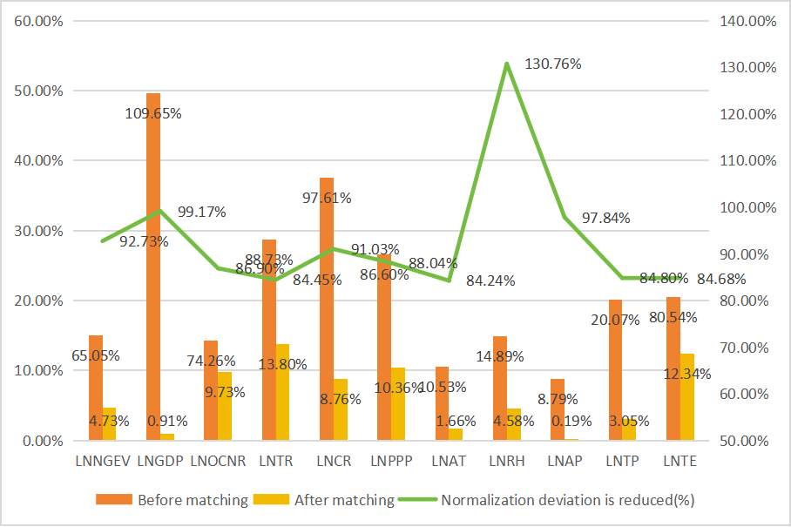
Figure 5 Change in normalization deviation

As shown in Figure 5, following Propensity Score Matching (PSM), we conducted a balance assessment, which included t-tests, baseline analysis, kernel density plots, and standardized bias change analysis—any of which, meeting the necessary criteria, would suffice to confirm the success and effectiveness of the matching process. The notable reversal observed before and after matching, as presented in Table 15, carries dual theoretical implications: (1) The significant differences in variables such as LNGDP and LNOCNR before matching (p<0.05) validate the presence of sample self-selection effects, consistent with the general characteristics of the countries affected by the Russia-Ukraine conflict, including higher energy dependence and geopolitical proximity; (2) The continued statistical significance of the ATT effect after matching (p<0.05) demonstrates that, after controlling for confounding factors such as economic size and trade structure, the impact of the conflict on energy trade networks remains robust. This suggests that the Russia-Ukraine conflict has positively influenced the total export volume of U.S. natural gas, which, in turn, has resulted in increased total imports for the importing countries.
1.1.2. Conducting robustness analysis using PSM-DID
In the preceding analysis, we employed both Propensity Score Matching (PSM) and Difference-in-Differences (DID) methods to test the causal identification of policy effects. However, relying on a single method presents limitations in addressing sample selection bias and temporal heterogeneity. To enhance the robustness of our findings, this section introduces the PSM-DID integrated model, creating a quasi-natural experimental framework through the dual mechanism of "matching-differencing." First, PSM is used to select experimental and control group samples with similar characteristics, thereby reducing the initial differences between the two groups before policy implementation. Then, DID is applied to compare pre- and post-policy changes between the groups, providing a more accurate isolation of the policy's net effect.
Based on the aforementioned PSM-DID framework, we systematically processed the sample data. Initially, through T-tests and PSM, we identified control variables that passed the parallelism test and exhibited good matching effects. Using these, we retained matching data with more than zero matches before and after the Russia-Ukraine conflict for DID testing. After the data cleaning process, we obtained 44 valid samples (132 groups if categorized by long and short term), with their core variable statistical characteristics and balance test results meeting the estimation requirements for the PSM-DID model. Accordingly, we conducted DID analysis using Equation 1, with results presented in Appendix Tables 21 and 22.
The empirical analysis using both DID and PSM-DID models reveals that the Russia-Ukraine conflict has had a significant structural impact on U.S. LNG export strategies and European energy trade patterns. The results indicate that the conflict has substantially increased U.S. reliance on the European energy market, with the PSM-DID coefficients for the long and short terms reaching 3.254 (p<0.01) and 10.604 (p<0.1), respectively, confirming the systematic growth of U.S. natural gas exports to Europe under geopolitical shocks, thereby supporting Hypothesis 1b. Further analysis shows that this trade diversion effect is particularly pronounced in core allied countries, such as France, where the U.S. export growth coefficient remains stable at 2.852 (p<0.01) in the long term and 4.143 (p<0.01) in the short term, confirming Hypothesis 4b. However, the export trend for the UK market demonstrates significant methodological differences: while the traditional DID model shows short-term growth (4.964, p<0.01), the PSM-DID results turn negative (-6.282) after correcting for selection bias, providing only partial support for Hypothesis 3b. Meanwhile, the Asian market did not exhibit conflict-driven changes in trade volume (PSM-DID coefficients -0.688 and 2.011, both of which were not significant), indicating that the U.S. still prioritizes Europe, thus rejecting Hypothesis 2b.
In terms of the EU's internal energy policy responses, France's natural gas import growth was significantly lower than that of other member states, such as Spain, after the conflict, with no relative advantage in long-term growth, thus systematically rejecting Hypothesis 5b. The UK's import growth significantly lagged behind the overall EU level and showed no statistical advantage when compared with other member states (e.g., Portugal), rejecting Hypothesis 6b.
Following the previous approach, we replaced natural gas export values with export volumes to systematically examine the scale effects of the Russia-Ukraine conflict on global natural gas trade. Appendix Table 22 shows that both Hypothesis 1a and Hypothesis 4a are significantly supported. The key evidence is the long- and short-term export volume growth coefficients for the U.S. to Europe, which reached 2.512 (DID, p<0.01) and 8.29 (PSM-DID, p<0.1), respectively. France, as the core target market, exhibited particularly large increments (long-term PSM-DID = 2.614, p<0.01; short-term DID = 3.061, p<0.1). Hypothesis 2a is clearly rejected, as its long-term PSM-DID coefficient shows a positive trend (1.476, p<0.1), suggesting that the Asian market was not significantly suppressed by the conflict. For the UK, the traditional DID model shows a significant increase in short-term export volumes (4.990, p<0.01), but the PSM-DID corrected results reverse to -3.747, reflecting that sample bias may have overestimated the short-term effects, partially supporting Hypothesis 3a. Both Hypotheses 5a and 6a are rejected, with France's import growth significantly lagging behind Spain, and the UK showing a negative deviation relative to the EU as a whole.

References
[1] Y. He, F. Han, On propensity score matching with a diverging number of matches, Biometrika (No.4) (2024) 1421-1428.
[2] T. Wang, H. Zhao, S. Yang, S. Tang, Z. Cui, L. Li, D.E. Faries, Propensity score matching for estimating a marginal hazard ratio, Stat. Med. (No.14) (2024) 2783-2810.
[3] X. Wu, F. Mealli, M. Kioumourtzoglou, F. Dominici, D. Braun, Matching on generalized propensity scores with continuous exposures, J. Am. Stat. Assoc. (No.545) (2024) 1-28.
[4] C. Vairetti, F. Gennaro, S. Maldonado, Propensity score oversampling and matching for uplift modeling, Eur. J. Oper. Res. (No.3) (2024) 1058-1069.
[5] T.K.L. Md, M.K.K. Mbbs, E.W.T. Mbbs, W.K.L. Md, Surveillance findings in high-risk patients after baseline computer-assisted detection colonoscopy: a propensity score matching analysis, Gastrointest. Endosc. (2025).

