Multimodal sensing platform based on MnO₂ nanozyme and carbon dots for colorimetric and fluorescent detection of peroxynitrite
Man Duª, Shuang Houª, Xinyue Yangª, Yue Zhang^{a,}*, Haijun Lvª, Yaran Zhouª, Shuang Zong^{b,}**, Haiwen Song^{c,}***
ªCollege of Chemical and Pharmaceutical Engineering, Hebei University of Science and Technology, Shijiazhuang 050018, P. R. China;
^{b}Department of Chemical and Environmental Engineering, Hebei Chemical & Pharmaceutical College, Shijiazhuang 050026, P.R. China.
^{c}Hebei Lansheng Biotechnology Co., LTD., Shijiazhuang 052260, P. R. China.
*Corresponding author
**Corresponding author
***Corresponding author
E-mail addresses: yuezhang@hebust.edu.cn (Yue Zhang), ynszong@hebcpc.edu.cn (Shuang Zong), haiwen1230@yeah.net (Haiwen Song)

Contents
Table S1. Comparison of fluorescent probes for ONOO⁻. 1
Preparation of peroxynitrite (ONOO⁻) 4
Fig. S1 XRD pattern of CDs. 5
Fig. S2 TEM images of MnO₂ NSs. 5
Fig. S3 TEM images of CDs. 6
Fig. S4 Fluorescence decay curves of CDs solution in the presence and absence of oxTMB solution. 7
Fig. S5 Fluorescence decay curves of CDs solution in the presence and absence of ONOO⁻ solution. 7
Table S2. The kinetic parameters for oxidase-like activity of MnO₂ NSs and other nanozymes. 8
Fig. S6 Cytotoxicity assays of CDs at different concentrations for HUVEC cells. 9
References 10

Table S1. Comparison of fluorescent probes for ONOO⁻.
No. | Probes | Structure | λ_{ex}/λ_{em} (nm) | Linear range | LOD | Application |  | Ref.
1 | K-ONOO |  | 405/570,678 | 0-15 μM | 212 nM | Cells  Zebrafish imaging | [1]
2 | GOl-ONOO |  | 420/600 | 8-40 μM | 250 nM | Cells | [2]
3 | DCM-ONOO |  | 520/685 | 0-20 μM | 96 nM | Cells  Mouse imaging | [3]
4 | MAR |  | 323/408 | 0-15 μM | 6.97 nM | Cells | [4]
5 | WND-1 |  | 420/527 | 0-100 μM | 930 nM | Cells  Zebrafish imaging | [5]
6 | MULTI-ONOO- |  | 410/706 | 0-20 μM | 11.6 nM | Cells  Mouse imaging | [6]
7 | NIR-VO |  | 540/686 | 0-50 μM | 1.44 nM | Cells  Zebrafish imaging  Mouse imaging | [7]
8 | TR-ONOO- |  | 390/490 | 0-100 μM | 520 nM | Cells | [8]
9 | GYP |  | 457/656 | 0-15 μM | 270 nM | Cells  Mouse imaging | [9]]
10 | - |  | 380/545，435 | 0-20 μM | 320 nM | Cells  Zebrafish imaging | [10]
11 | TCPB |  | 362/460 | 0-14 μM | 1590 nM | Cells  Mouse imaging | [11]
12 | MeOTPE-NO₂ |  | 380/505 | 0-200 μM | 35.1 nM | Cells  Mouse imaging | [12]
13 | NAP-ONOO |  | 460/560 | 0-100 μM | - | Cells  Mouse imaging  Zebrafish imaging | [13]
14 | HN-ONOO |  | 360/542 | 0-125 μM | 1117 nM | Cells  Mouse imaging | [14]
15 | AcA-MO |  | 650/739 | 0-1 μM | 17.5 nM | Cells  Zebrafish imaging  Mouse imaging | [15]
16 | PC-CDs | - | 365/450,645 | 0-100 μM | 500 nM | Serum samples | [16]
17 | CDs | - | 488/560 | 0-7 μM  7.5-10 μM | 200 nM | Cells  Mouse imaging | [17]]
18 | C-dots-TPP | - | 420/575 | 0.2-1 μM | 13.5 nM | Cells | [[18]]
19 | PN-CDs | - | 340/406 | 1-60 μM | 380 nM | Cells | [19]
20 | Trp-CD | - | 370/457 | 2.5-25 μM | 1500 nM | Serum samples | [20]
21 | CSU-FT | - | 405/706 | 0-20 μM | 11.7 nM | Cells  Mouse imaging | [21]
22 | Rhb-ONOO | - | 580/628 | 0-1 μM | 33 nM | Cells  Mouse imaging | [22]
23 | TMB+MnO₂ NSs  CDs  TMB+MnO₂ NSs+CDs | - | 350/446  360/480 | 1-70 μM  0.3-55 μM  0.3-45 μM | 28.73 nM  25.47 nM  40.17 nM | Test strip  Smartphone software  Serum samples  Cells | This work

Preparation of peroxynitrite (ONOO⁻)
According to the literature [23], ONOO⁻ were prepared with slight modifications. Hydrochloric acid (0.7 M) and hydrogen peroxide (0.6 M) were sequentially added to a reaction flask pre-cooled to 0 °C, followed by continuous stirring for 30 min. Subsequently, a mixed solution of sodium hydroxide (1.5 M) and sodium nitrite (0.6 M) was slowly added into the aforementioned reaction flask, and a pale yellow peroxynitrite (ONOO⁻) solution was immediately generated. After the preparation was completed, the obtained ONOO⁻ solution was transferred to a container and stored in a refrigerator at -18 °C away from light for subsequent experimental use.

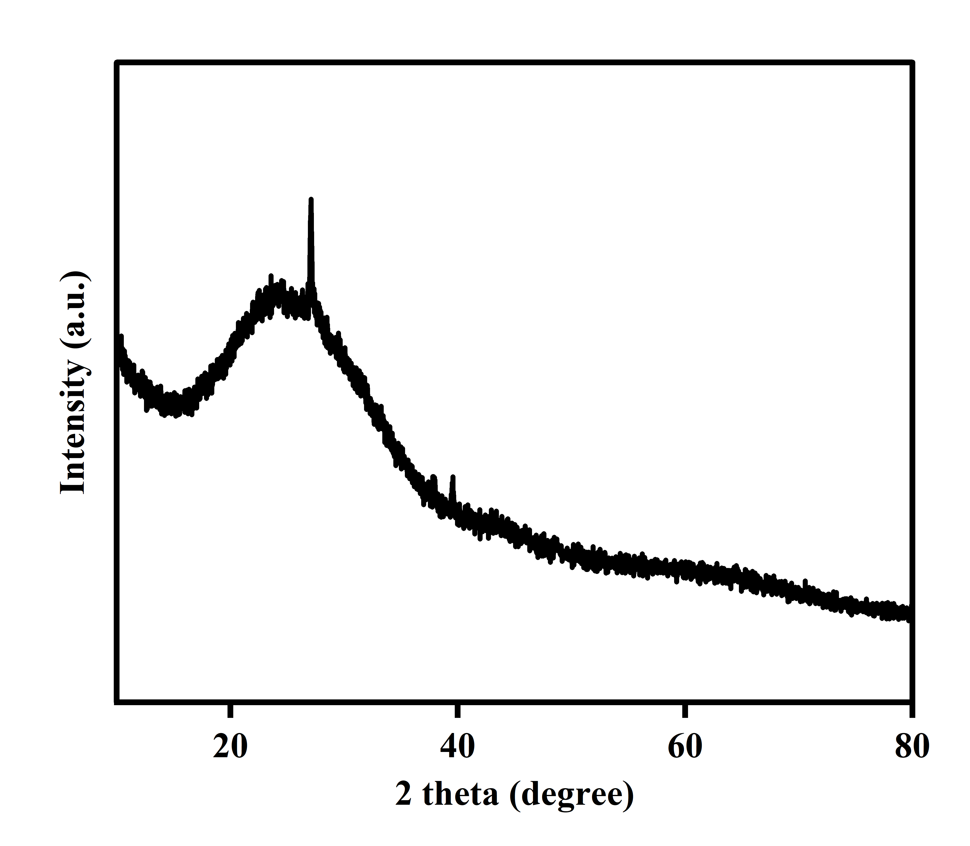

Fig. S1 XRD pattern of CDs.

Fig. S2 TEM images of MnO₂ NSs.

Fig. S3 TEM images of CDs.

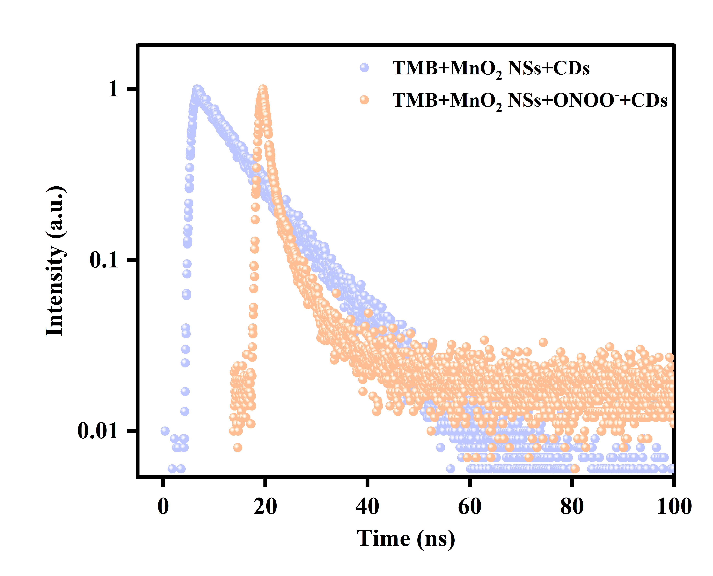

Fig. S4 Fluorescence decay curves of CDs solution in the presence and absence of oxTMB solution.
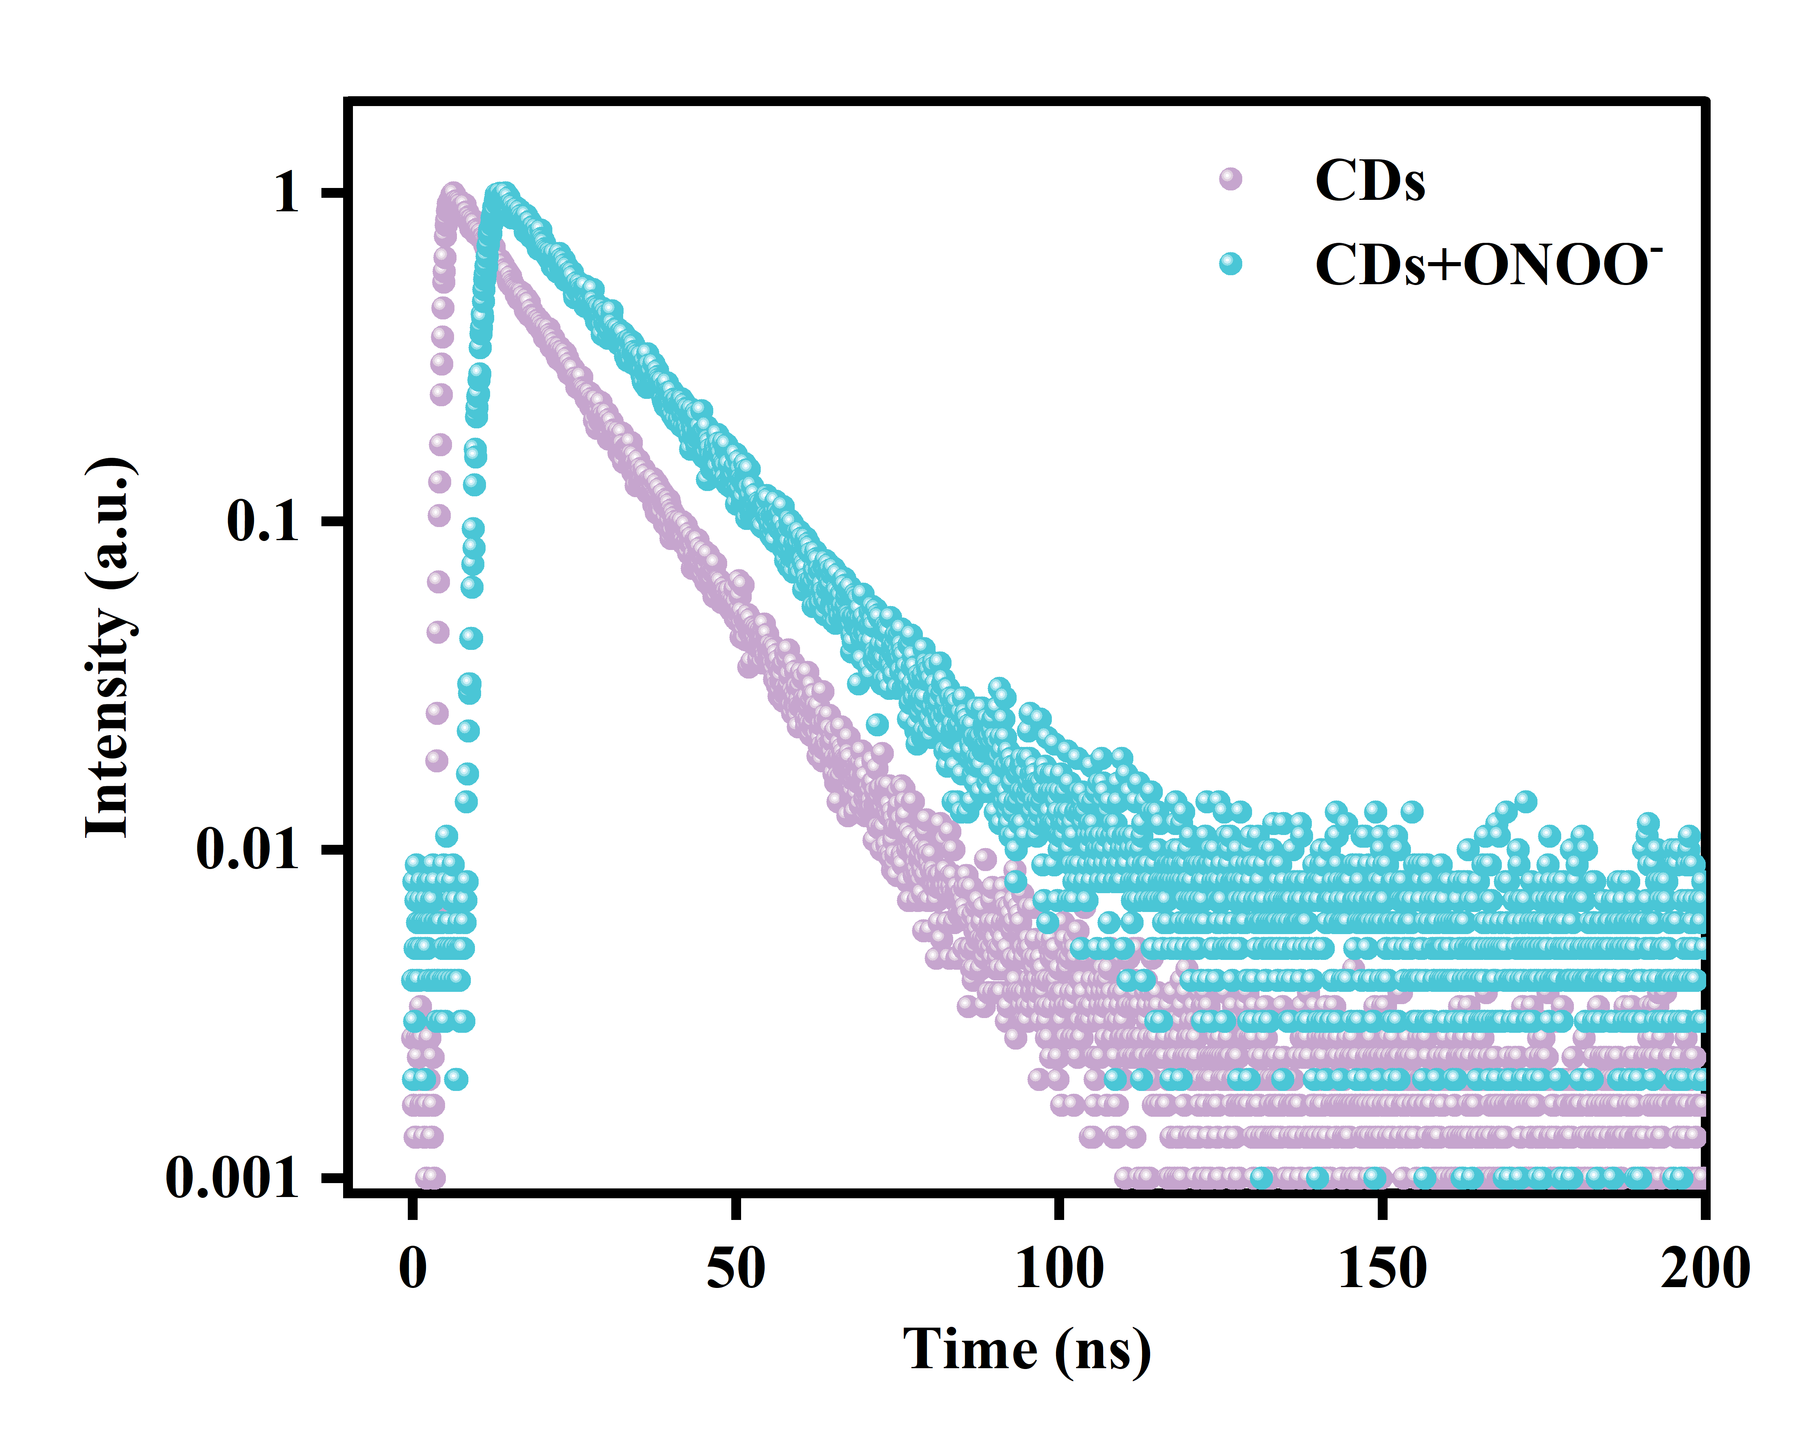

Fig. S5 Fluorescence decay curves of CDs solution in the presence and absence of ONOO- solution.

Table S2. The kinetic parameters for oxidase-like activity of MnO₂ NSs and other nanozymes.
Nanozymes | Substrate | K_{m} (mM) | V_{max} (10⁻⁷ M/s) | Refs
MnO₂ nanozyme | TMB | 0.298 | 1.37 | [24]
Mn₃O₄ NFs | TMB | 13.2 | 0.135 | [25]
OV-Mn₃O₄ NFs | TMB | 1.66 | 0.397 | [25]
MnO₂@ZIF-67 | TMB | 2.325 | 0.5875 | [26]
MnO₂@ZIF-67@MAA | TMB | 1.722 | 0.393 | [26]
MnO₂ NS | TMB | 0.0198 | 5.534 | [27]
Pt/MnO₂/GO | TMB | 0.41 | 7.12 | [28]
MnO₂ NFs | TMB | 0.121 | 0.665 | [29]
CoNCN | TMB | 0.53 | 3.24 | [30]
AgNPs@COF-TD | TMB | 0.26 | 0.298 | [31]
MnO₂ NSs | TMB | 0.3293 | 2.5058 | This work

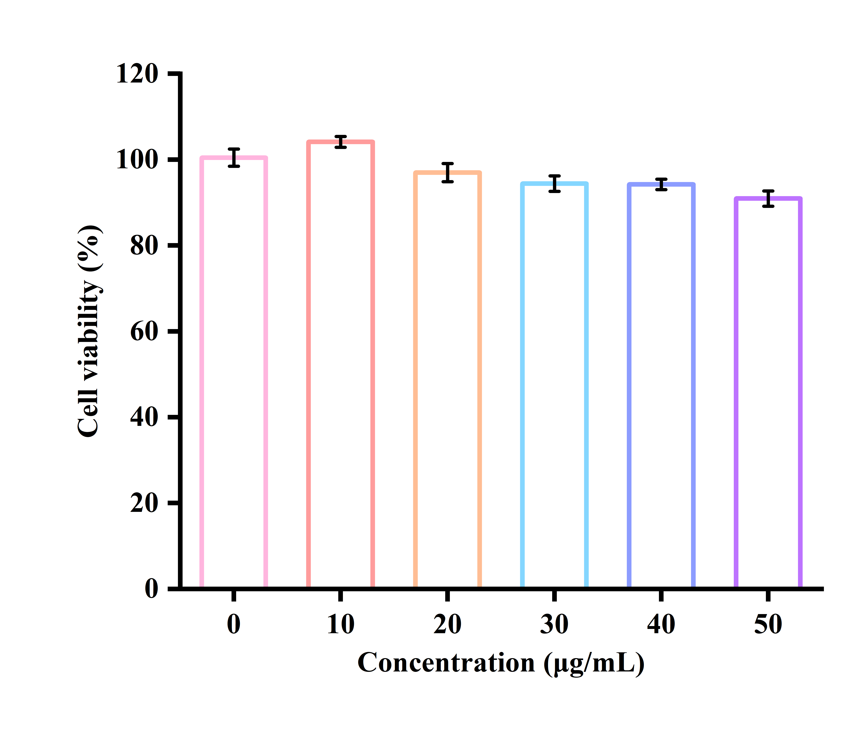

Fig. S6 Cytotoxicity assays of CDs at different concentrations for HUVEC cells.

References
- Kang H, Shu W, Yu J, Gao MX, Han RB, Jing J, Zhang RB, Zhang XL (2022) A near-infrared fluorescent probe for ratiometric imaging peroxynitrite in Parkinson's disease model. Sens Actuators B Chem 359:131393. https://doi.org/10.1016/j.snb.2022.131393
- Li JS, Tang J, Yang XP, Xie PY, Liu JF, Zhang D, Ye Y (2022) A novel aggregation-induced emission fluorescent probe to visualize peroxynitrite levels during Golgi stress. Sens Actuators B Chem 358:131513. https://doi.org/10.1016/j.snb.2022.131513
- Luo XZ, Cheng ZY, Wang R, Yu FB (2021) Indication of dynamic peroxynitrite fluctuations in the rat epilepsy model with a near-infrared two-photon fluorescent probe. Anal chem 93:2490-2499. https://doi.org/10.1021/acs.analchem.0c04529
- Jiang HQ, Shi LL, Wang WX, Yang Y, Fang M, Zhu WJ, Li C (2025) A bifunctional AIEgen fluorescent probe for detection viscosity and ONOO⁻ in living cells. J Mol Struct 1329:141381. https://doi.org/10.1016/j.molstruc.2025.141381
- Liu YY, Ma YY, Lin WY (2022) Construction of a bi-functional ratiometric fluorescent probe for detection of endoplasmic reticulum viscosity and ONOO⁻ in cells and zebrafish. Sens Actuators B Chem 373:132742. https://doi.org/10.1016/j.snb.2022.132742
- Xu WZ, Yang QM, Zeng JQ, Tan LB, Zhou LY, Peng LP, Zhou YZ, Xie C, Luo K, Zhang Z (2022) A biomarker (ONOO⁻)-activated multicolor fluorescent probe for early detection and assessment of arthritis. Sens Actuators B Chem 359:131565. https://doi.org/10.1016/j.snb.2022.131565
- Zhan JT, Huang HW, Quan W, Lin WY (2025) Innovative two-dimensional fluorescent probe of viscosity and ONOO⁻ for high-throughput screening of antioxidant drugs and its application in epilepsy. Sens Actuators B Chem 440:137887. https://doi.org/10.1016/j.snb.2025.137887
- Yan HL, Xu XJ, Li JS, Xie PY, Cao WB, Yang XP, Ye Y (2023) A novel fluorescence-on fluorescent probe for ONOO⁻ detection in HeLa cells. J Photochem Photobiol A 440:114638. https://doi.org/10.1016/j.jphotochem.2023.114638
- Lu GY, Fan HE, Wang KD, Tian GN, Chen CY, Wang Y, Wang L, Fan XJ (2024) A novel fluorescent probe for the detection of peroxynitrite and its application in mice epileptic brain model. Talanta 267:125157. https://doi.org/10.1016/j.talanta.2023.125157
- Zeng XD, Chen X, Chen J, Ma MS, Jin H, Yu SH, Liu ZG (2023) A simple highly selective ratiometric fluorescent probe for detection of peroxynitrite and its bioimaging applications. Dyes Pigm 210:110993. https://doi.org/10.1016/j.dyepig.2022.110993
- Zhang ZC, Li CC, Niu JT, Luo HT, Wang FY, Tan Y, Wang CF, Wu XH, Liu XY, Zhang XL, Kang YF (2026) A NIR dual-channel fluorescent probe for detecting viscosity and ONOO⁻ in vitro and vivo. Spectrochim Acta Part A 344:126760. https://doi.org/10.1016/j.saa.2025.126760
- Yan M, Yu MM, Wang ZK, Yu FB, Fang WW (2025) An ɑ-ketoamide-based fluorescent probe via aggregation induced emission for ONOO⁻ detection in vivo. Talanta 293:128064. https://doi.org/10.1016/j.talanta.2025.128064
- Fan CL, Ma KF, Chi WJ, LiMeng YW, Dong QX, Gao YA, Zeng CK, Meng WS, Shu W, Zeng CY (2025) An innovative fluorescent probe for monitoring of ONOO⁻ in multiple liver-injury models. Talanta 283:127194. https://doi.org/10.1016/j.talanta.2024.127194
- Wei LC, Zhang P, Yu T, Ren NX, Chen J, Yang FT, Shu W (2024) A highly sensitive and specific fluorescent probe for detecting ONOO⁻ in liver-injured cells and tissues. Microchem J 205:111209. https://doi.org/10.1016/j.microc.2024.111209
- Zhu YX, Liu CY, Rong XD, Zhu YX, Wen HY, Zheng M, Sheng WL, Huang SY, Zhu BC (2025) A novel acridine-based mitochondria-targeted near-infrared fluorescent probe for the detection of HOCl/ONOO⁻ in vivo. Sens Actuators B Chem 442:138143. https://doi.org/10.1016/j.snb.2025.138143
- Shao JJ, Sun S, Zhan D, Pan LP, Min GZ, Li XB, Huang KL, Chen W, Yang LK, Liu XY, Lin NB (2022) Phycocyanin-carbon dots nanoprobe for the ratiometric fluorescence determination of peroxynitrite. Spectrochim Acta Part A 275:121177. https://doi.org/10.1016/j.saa.2022.121177
- Liu HF, Liu JB, Zhang S, Chen Y, Zhang JL, Sun YQ, Zheng ZY, Hu S, Li ZH, Tang WX (2023) Spying on the peroxynitrite fluctuation during hearing loss enabled by rationally designed fluorescent carbon dots. Chem Eng J 452:139024. https://doi.org/10.1016/j.cej.2022.139024
- Wu XX, Sun S, Wang YH, Zhu JL, Jiang K, Leng YM, Shu QH, Lin HW (2017) A fluorescent carbon-dots-based mitochondria-targetable nanoprobe for peroxynitrite sensing in living cells. Biosens Bioelectron 90:501-507. https://doi.org/10.1016/j.bios.2016.10.060
- Gong YQ, Yu B, Yang W, Zhang XL (2016) Phosphorus, and nitrogen co-doped carbon dots as a fluorescent probe for real-time measurement of reactive oxygen and nitrogen species inside macrophages. Biosens Bioelectron 79:822-828. https://doi.org/10.1016/j.bios.2016.01.022
- Simões EFC, Esteves da Silva JCG, Leitão JMM (2014) Carbon dots from tryptophan doped glucose for peroxynitrite sensing. Anal Chim Acta 852:174-180. https://doi.org/10.1016/j.aca.2014.08.050
- Xu WZ, Tan LB, Zeng JQ, Yang QM, Zhou YZ, Zhou LY (2022) Molecular engineering for construction of a novel ONOO⁻- activated multicolor fluorescent nanoprobe for early diagnosis and assessing treatment of arthritis in vivo. Biosens Bioelectron 209:114242. https://doi.org/10.1016/j.bios.2022.114242
- Ou PH, Ran HY, Ye XP, Wang JY, Pang ML, Zhao LL, Chen MZ, Li X, Ma YP, Wang P, Chen J, Luo Q, Peng YB (2023) A robust high selectivity fluorescence turn-on nanoprobe for peroxynitrite detection in inflammatory cells and mice. Spectrochim Acta Part A 291:122381. https://doi.org/10.1016/j.saa.2023.122381
- Peng T, Yang D (2010) HKGreen-3: a rhodol-based fluorescent probe for peroxynitrite. Org Lett 12:4932-4935. https://doi.org/10.1021/ol102182j
- Liang N, Ge XY, Zhao Y, Xia L, Song ZL, Kong RM, Qu FL (2023) Promoting sensitive colorimetric detection of hydroquinone and Hg²⁺ via ZIF-8 dispersion enhanced oxidase-mimicking activity of MnO₂ nanozyme. J Hazard Mater 454:131455. https://doi.org/10.1016/j.jhazmat.2023.131455
- Lu WH, Chen J, Kong LS, Zhu F, Feng ZY, Zhan JH (2021) Oxygen vacancies modulation Mn₃O₄ nanozyme with enhanced oxidase-mimicking performance for l-cysteine detection. Sens Actuators B Chem 333:129560. https://doi.org/10.1016/j.snb.2021.129560
- Cui YH, Zhao N, Wang SH, Yan HY, Han DD (2025) Colorimetric detection of tetracycline by enhancing peroxidase-like activity of polymerized MnO₂@ZIF-67 nanocomposites. Biosens Bioelectron 287:117726. https://doi.org/10.1016/j.bios.2025.117726
- Zhang YY, Zhao TF, Zhao B, Sun B, Zhang XH, Gu YW, Zhang QF, Li M (2024) Development of MnO₂ nanosheets nanozyme-based colorimetric and photothermal dual-signal platform for monitoring alkaline phosphatase activity. Microchem J 207:111656. https://doi.org/10.1016/j.microc.2024.111656
- Yi ZH, Ren YS, Li Y, Li YN, Long F, Zhu AN (2023) Rational design of three-in-one Pt/MnO₂/GO hybrid nanozyme with enhanced catalytic performance for colorimetric detection of ascorbic acid and cysteine. Talanta 265:124839. https://doi.org/10.1016/j.talanta.2023.124839
- Yue XY, Hao CX, Fu L, Wu CY, Bai YH (2025) Smartphone-assisted colorimetric sensing hydrogels based on MnO₂ NFs nanozyme for highly sensitive and rapid detection of tert-butylhydroquinone in edible oils. Food Chem 492:145264. https://doi.org/10.1016/j.foodchem.2025.145264
- Li Y, Lu YW, Zhang XD, Cao HY, Huang YM (2022) Cobalt-embedded nitrogen-doped carbon nanosheets with enhanced oxidase-like activity for detecting perfluorooctane sulfonate. Microchem J 181:107814. https://doi.org/10.1016/j.microc.2022.107814
- Jia ZX, Shi DP, Wang JB, Lin XC (2024) Covalent organic frameworks surface-anchored with silver nanoparticles for colorimetric detection of dopamine based on its oxidase-mimicking activity. Microchem J 200:110428. https://doi.org/10.1016/j.microc.2024.110428

