Newly-engineered angiopoietin-1 as a cell-priming agent for vasculogenesis
Jeehoon Kang, Hyun Ju Seo, et al.

Contents
Supplementary Figures

Supplementary Figure 1.
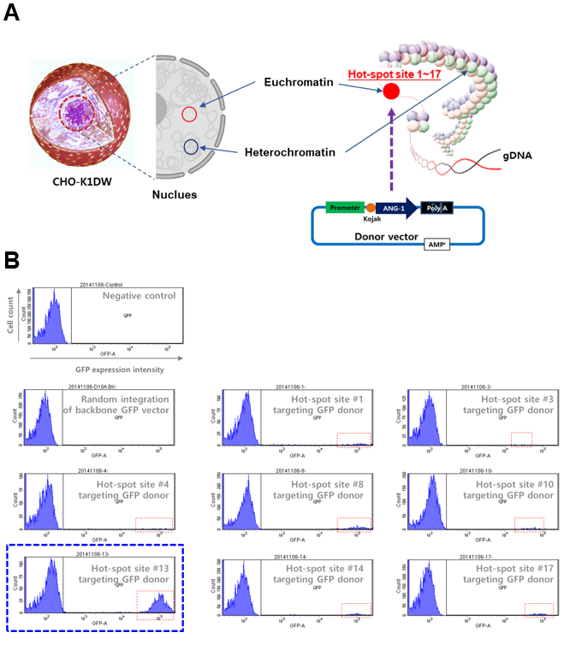
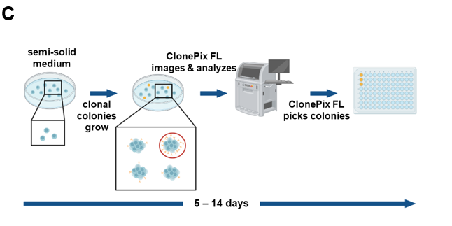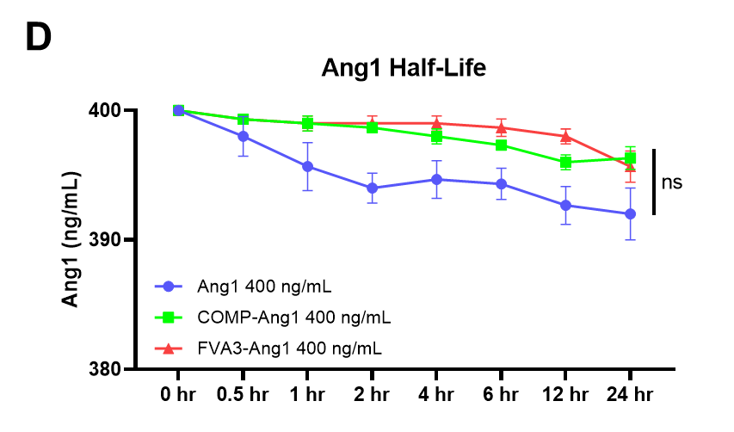

(A) Schematic representation of CRISPR-Cas9D10A mediated integration of the Ang1 expression vector into the Hot-spot site of CHO-K1DW cells. (B) Flow cytometry analysis to identify the optimal Hot-spot site (#13) for GFP expression. (C) Schematic representation of Ang1 expressing cell line generation and clonal selection. Ang1 expressing cell colonies were selected using the ClonePix FL system. (D) Time-course analysis of Ang1 protein degradation in HUVEC culture medium, showing half-life measurements for three variants at 400 ng/mL determined by ELISA quantification.

Supplementary figure 2.
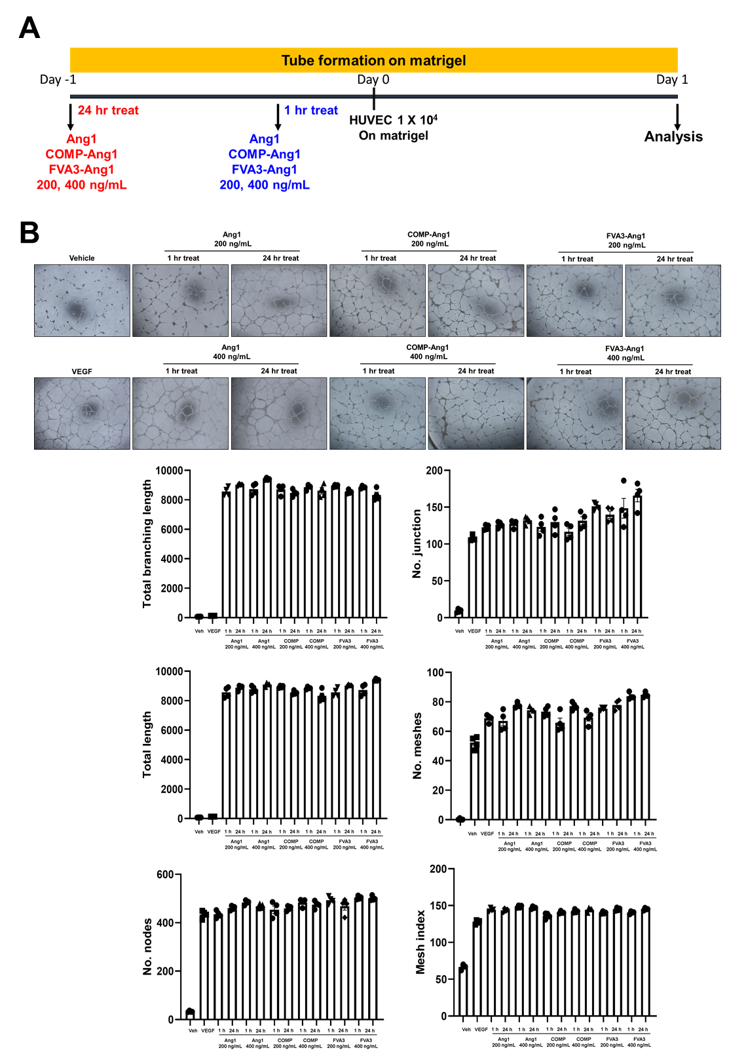
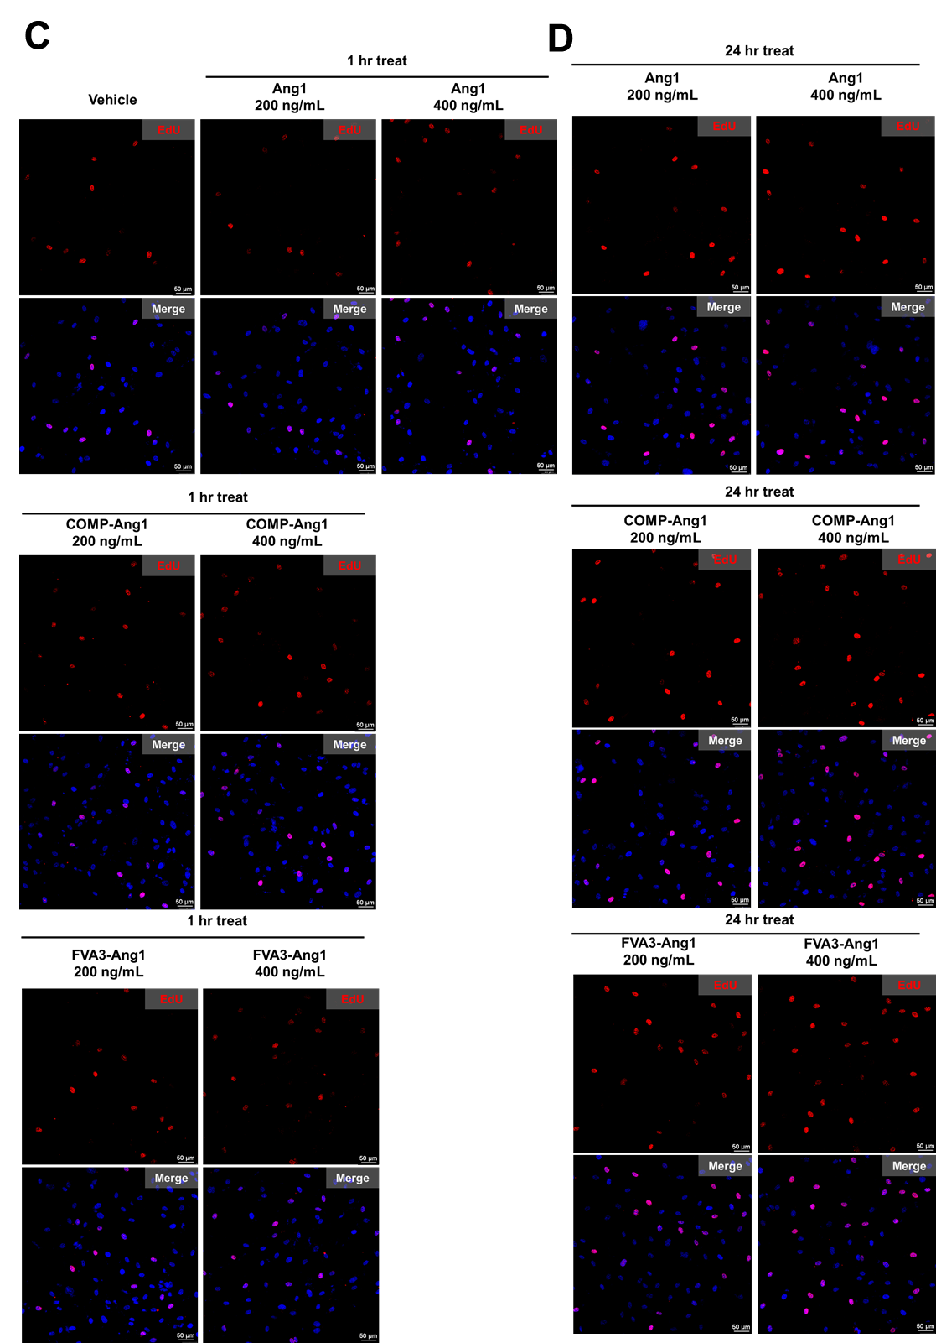
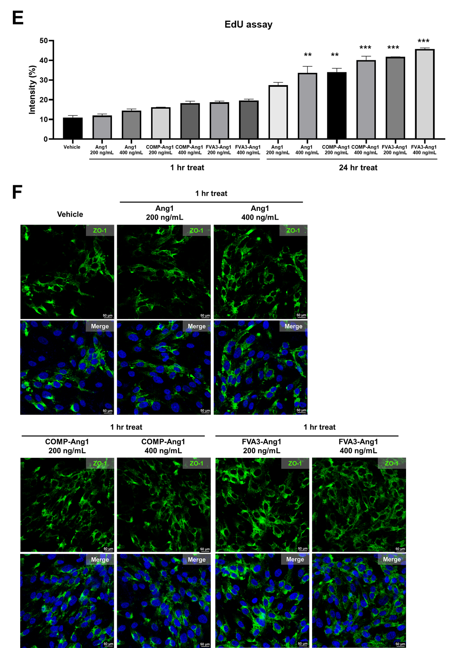
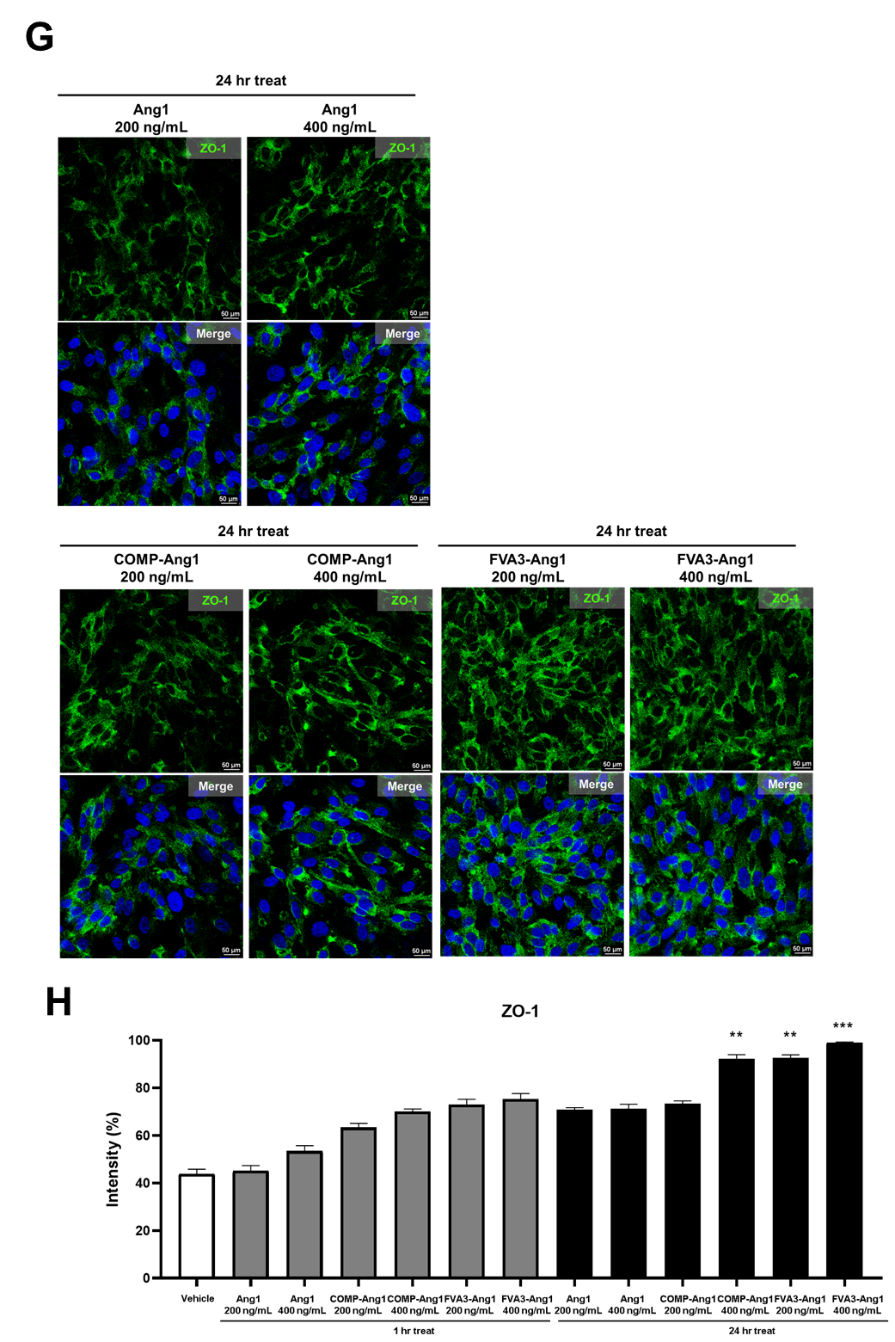
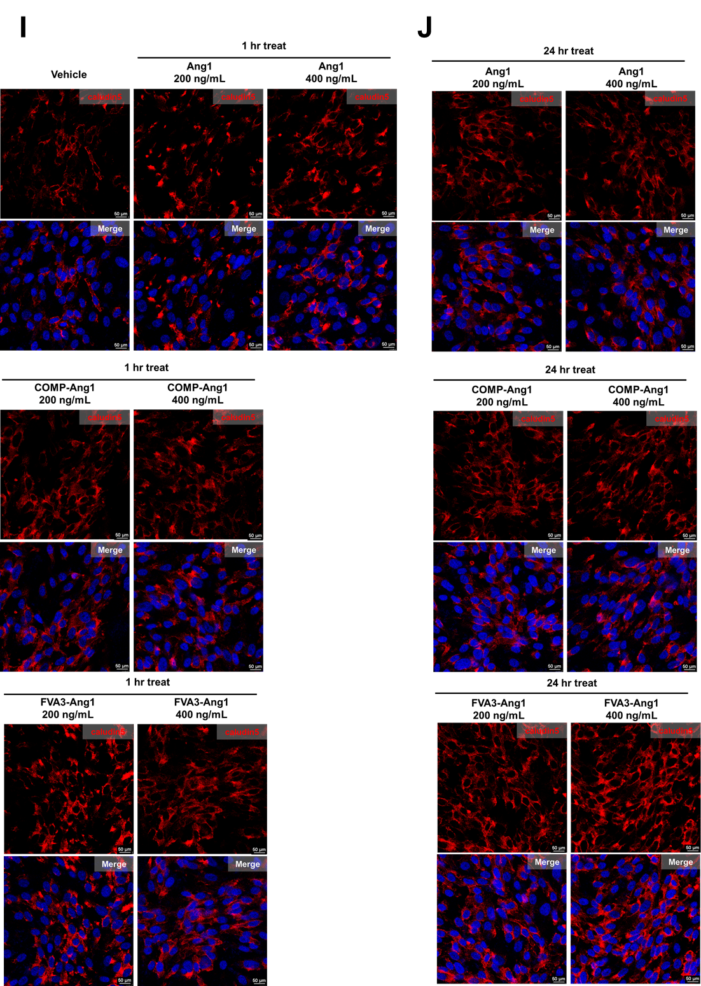
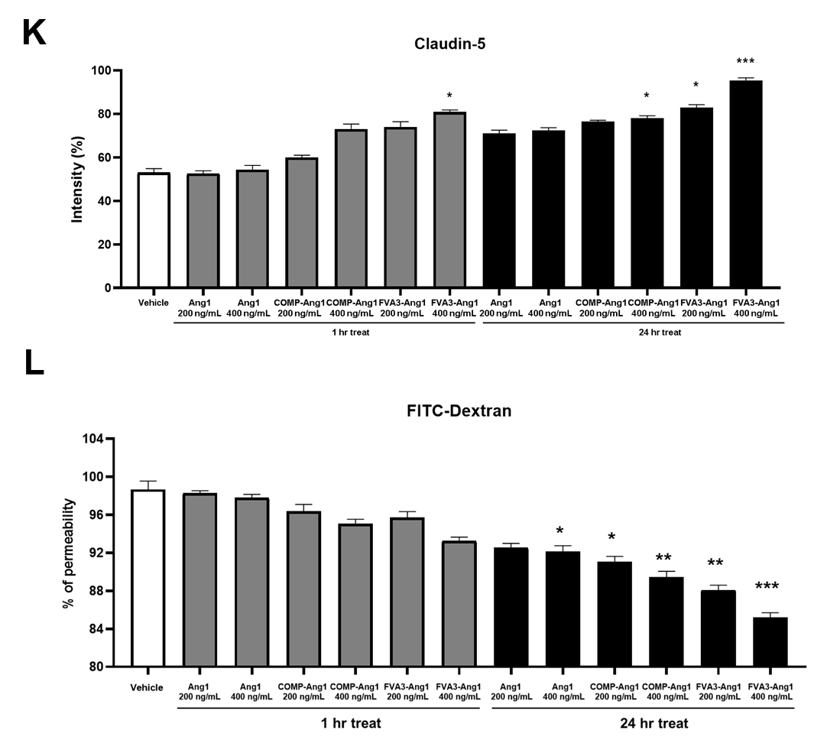
(A) Tube formation analysis was performed to confirm the angiogenic potential induced by Ang1 priming. HUVECs were treated with Ang1 or COMP-Ang1 or FVA3-Ang1 at concentrations of 200 ng/mL or 400 ng/mL, for 1 hour or 24 hours. (B) A Matrigel tube formation was observed at both concentrations of 200 ng/mL and 400 ng/mL of naïve Ang1, COMP-Ang1, and FVA3-Ang1(n=4), with no difference in the treatment duration and concentration (*: p<0.05, **: p<0.001 using Mann-Whitney test, Mean ± SEM). (C) EdU proliferation assay in HUVECs following 1 hour treatment with native Ang1, COMP-Ang1, and FVA3-Ang1. (D) EdU proliferation assay in HUVECs following 24 hours treatment with native Ang1, COMP-Ang1, and FVA3-Ang1. (E) Quantification of proliferating HUVECs after 1 and 24 hours treatment with three Ang1 variants. Statistical analysis by two-way ANOVA (n=3). (F) ZO-1 immunofluorescence staining showing endothelial barrier integrity in HUVECs after 1 hour of treatment with three Ang1 variants. (G) ZO-1 immunofluorescence staining showing endothelial barrier integrity in HUVECs after 24 hours of treatment with three Ang1 variants. (H) Quantification of tight junction integrity by ZO-1 in HUVECs at 1 and 24 hours after treatment with three Ang1 variants compared to control groups. Statistical analysis by two-way ANOVA (n=3). (I) Claudin-5 immunofluorescence staining showing endothelial barrier integrity in HUVECs after 1 hour of treatment with three Ang1 variants. (J) Claudin-5 immunofluorescence staining showing endothelial barrier integrity in HUVECs after 24 hours of treatment with three Ang1 variants. (K) Quantification of tight junction integrity by Claudin-5 in HUVECs at 1 and 24 hours after treatment with three Ang1 variants compared to control groups. Statistical analysis by two-way ANOVA (n=3). (L) ITC-dextran permeability assay measuring tight junction barrier function in HUVECs at 1 and 24 h after treatment with three Ang1 variants. Statistical analysis by two-way ANOVA (n=3).

Supplementary Figure 3.
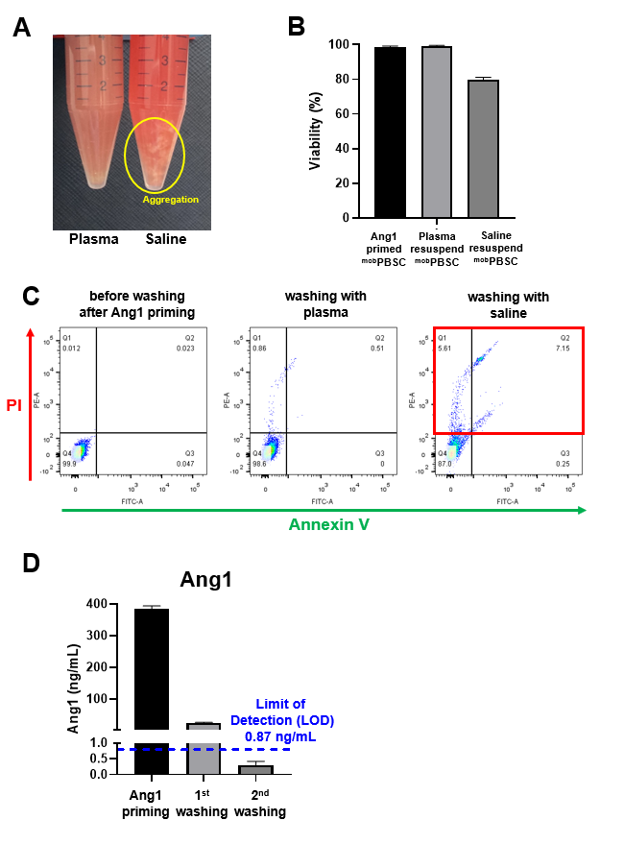
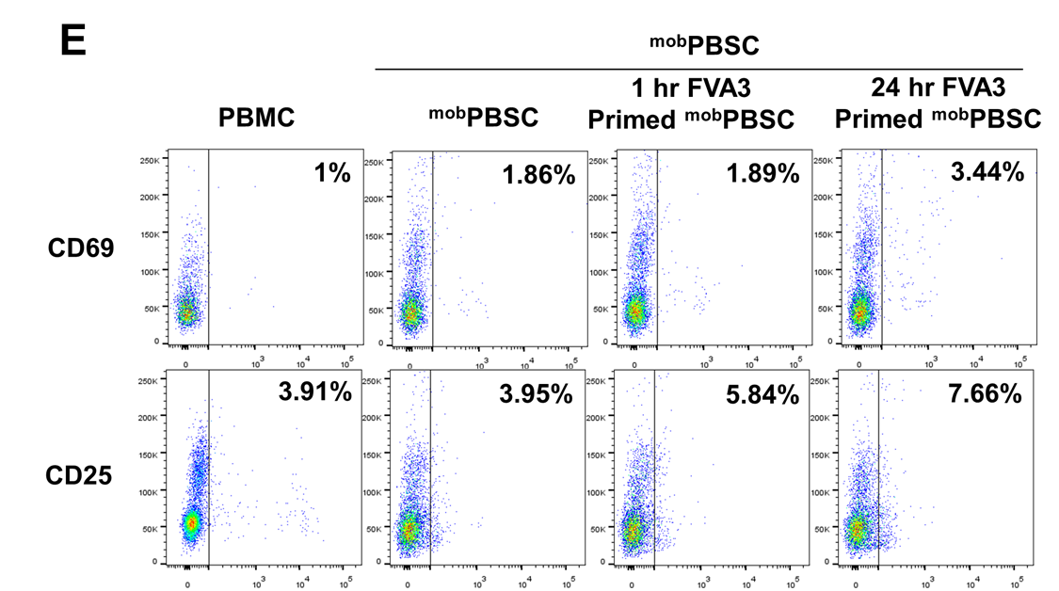
(A) Comparative images of the solution for formulating 1-hour FVA3-Ang1 primed ^{mob}PBSC, comparing plasma and saline for suspension. Aggregation was observed when resuspended in saline. (B) Cell viability test when resuspended in plasma or saline. ^{mob}PBSC immediately after FVA3-Ang1 priming served as a control. (C) Flow cytometry analysis of ^{mob}PBSC for apoptosis and necrosis markers, after washing with plasma or saline. ^{mob}PBSCs immediately after FVA3-Ang1 priming served as a control. (D) ELISA analysis of residual FVA3-Ang1 levels in ^{mob}PBSC after washing. After two washes with plasma, residual FVA3-Ang1 was below the detection limit (0.87 ng/mL). (E) Flow cytometry analysis for T cells activation in FVA3-Ang1 priming cells compared with control, as assessed by CD69 and CD25.

Supplementary Figure 4.
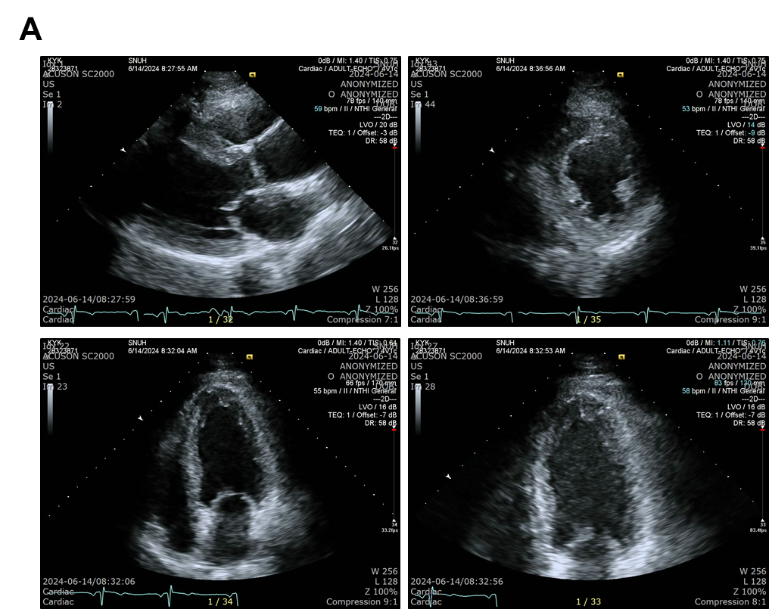
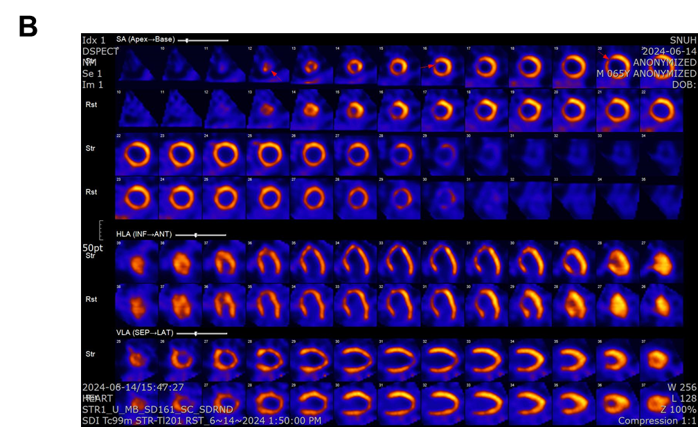
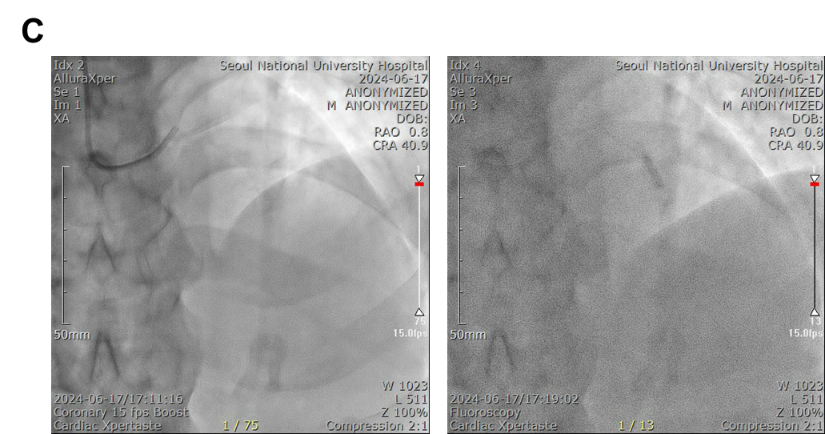
(A) Echocardiography performed 3 days prior to the MAGIC cell 6 procedure, demonstrating a left ventricular ejection fraction (EF) of 55% with focal akinesia in the mid-septal region. (B) Myocardial SPECT performed 3 days prior to the MAGIC cell 6 procedure, showing a moderate-to-severe stress perfusion defect, partially reversible at rest, in the apex, apical septal, and mid anteroseptal wall (LAD territory). (C) MAGIC Cell-6 infusion procedure. Successful wiring to the LAD was followed by introduction of a 3.0 × 12 mm Emerge balloon. A total of 2 × 10⁹ MAGIC Cells-6 (8 mL) were infused in three intervals of 20 seconds each (3 mL, 3 mL, and 2 mL).

