Supporting Material

Class-II dihydroorotate dehydrogenases from three phylogenetically distant fungi support anaerobic pyrimidine biosynthesis

Jonna Bouwknegt¹, Charlotte C. Koster¹, Aurin M. Vos², Raúl A. Ortiz-Merino¹, Mats Wassink¹, Marijke A. H. Luttik¹, Marcel van den Broek¹, Peter L. Hagedoorn¹ and Jack T. Pronk¹*
¹Department of Biotechnology, Delft University of Technology, van der Maasweg 9, 2629 HZ Delft, the Netherlands
²Wageningen Plant Research, Wageningen University and Research, Droevendaalsesteeg 1, 6708 PB Wageningen, the Netherlands

*Corresponding author: Jack T. Pronk, e-mail j.t.pronk@tudelft.nl, tel +31 15 2782416

This PDF file contains:
Figures S1-S4
Tables S1-S6

Additional files:
Additional file 1: Protein sequences Ura9 orthologs
Additional file 2: Protein IDs Ura9 orthologs
Additional file 3: Raw phylogenetic tree
Additional file 4: Codon-optimized protein sequences
Additional file 6: Plasmid and strain construction

Supporting Figures

Figure S1. Anaerobic growth of S. cerevisiae ura1Δ strains expressing heterologous URA9 genes. The native URA1 gene of S. cerevisiae was replaced by URA9 orthologs of O. parapolymorpha (Op) or D. bruxellensis (Db). Growth on medium with uracil (SMUD+ura) is indicated by closed circles, and on medium without uracil (SMUD) by open circles. A: S. cerevisiae IMI447 (ura1ΔOpURA9) and B: S. cerevisiae IMI439 (ura1ΔDbURA9). Both strains were transferred to fresh SMUD after 76 h. Specific growth rate of strain IMI439 was measured after the transfer (Additional file 4; Table S1). Optical densities are presented as average and mean deviation of data from duplicate cultures.

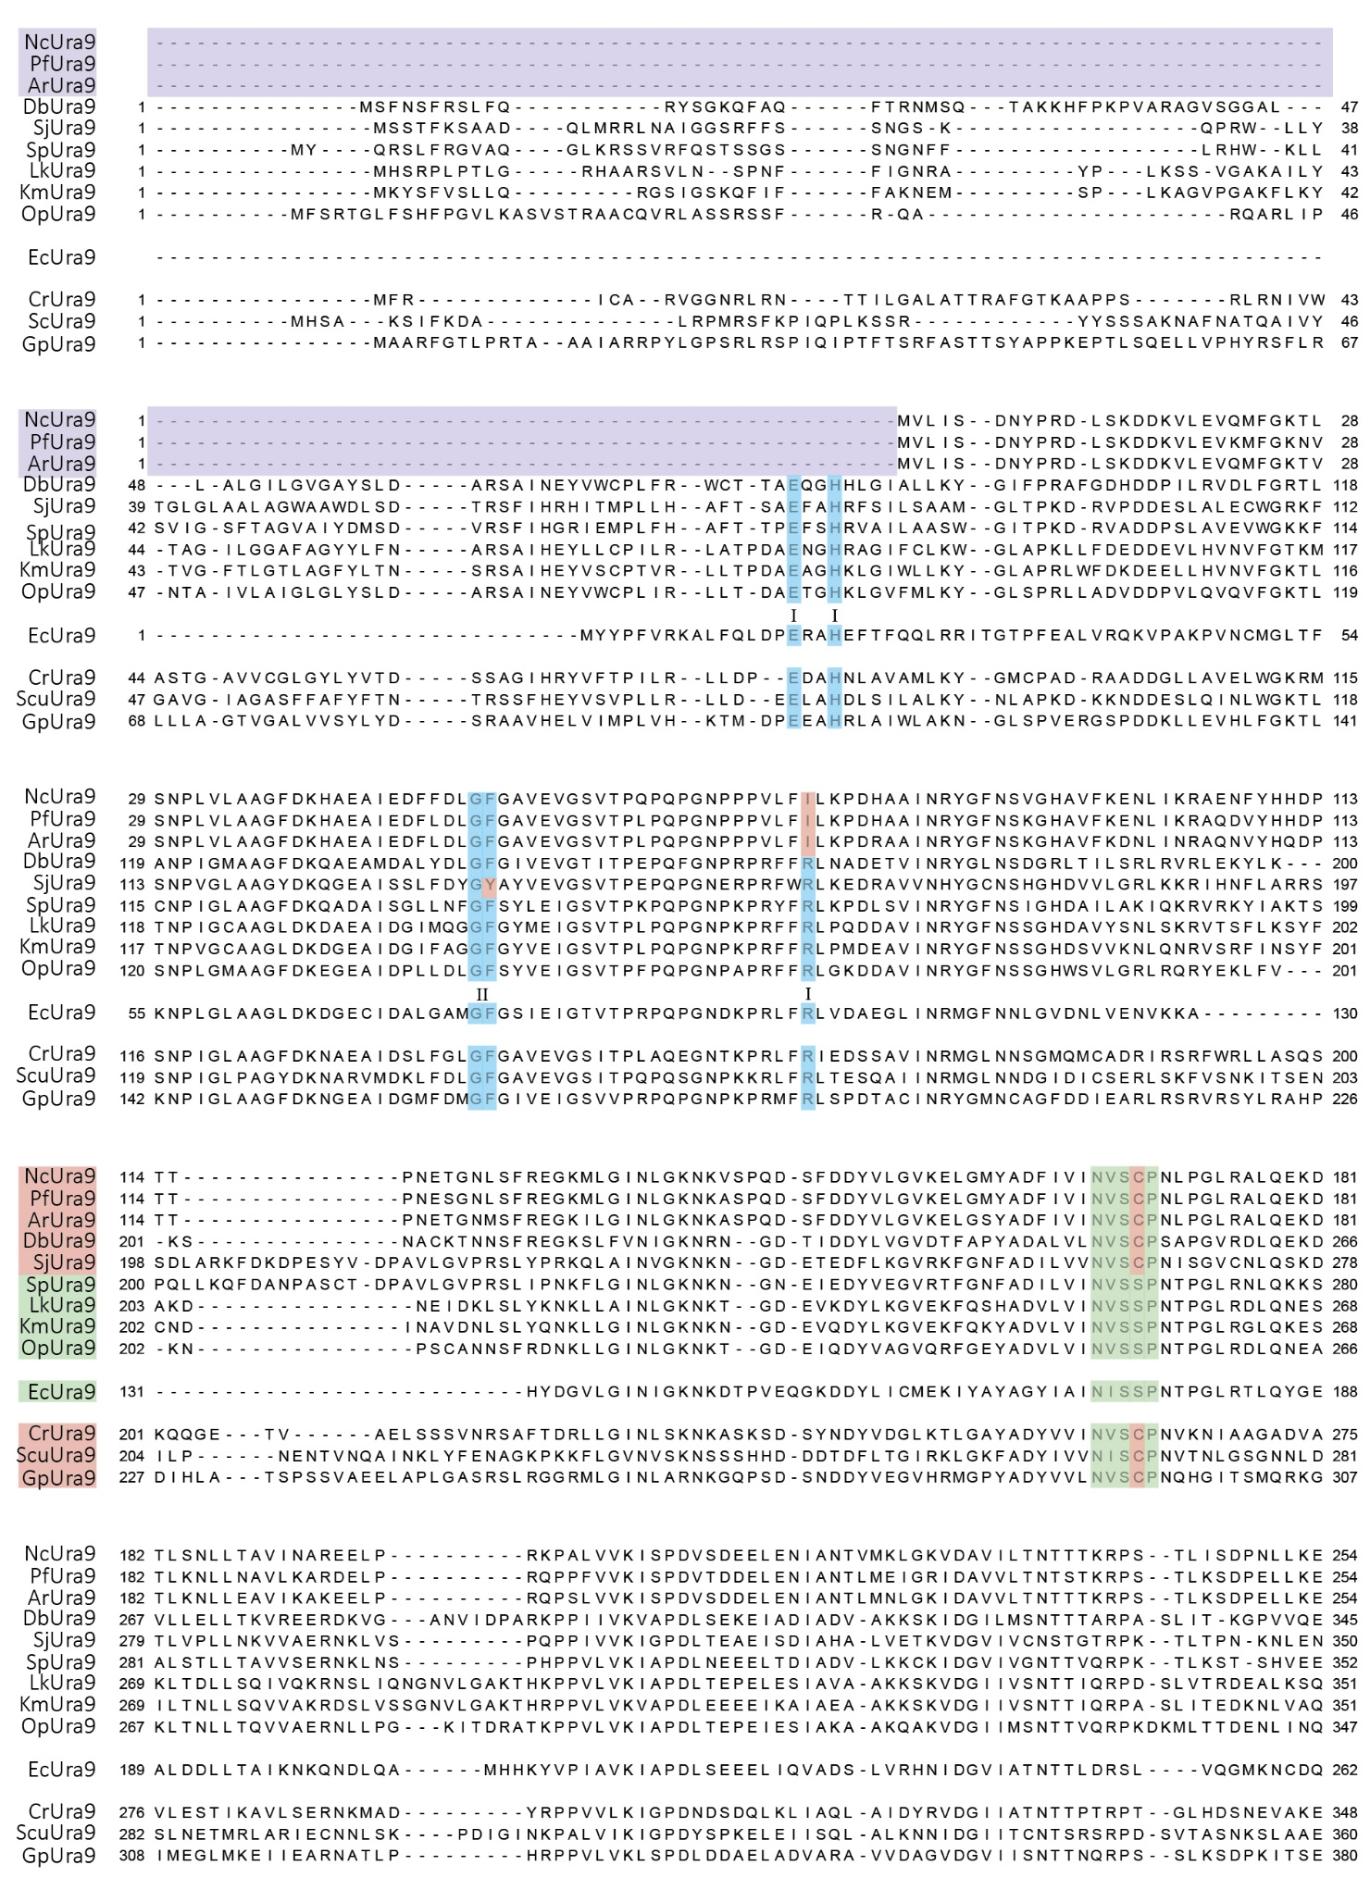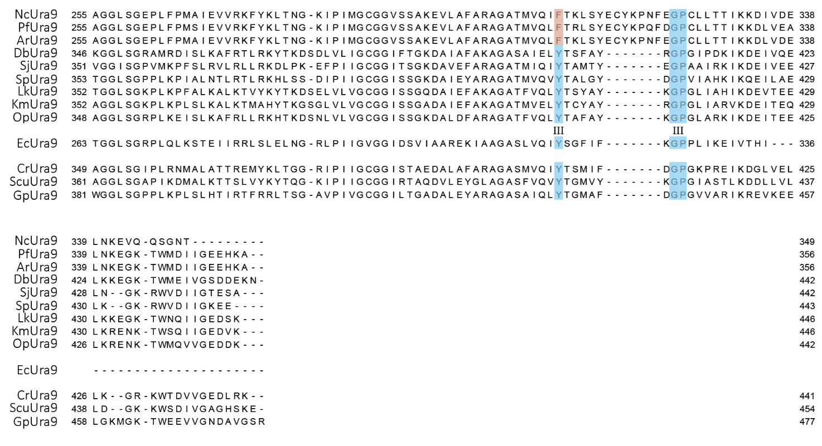Figure S2. Multiple sequence alignment of Ura9 proteins.
Canonical Class-II DHOD protein sequences of Sch. pombe (SpUra3), L. kluyveri (LkUra9), O. parapolymorpha (OpUra9), K. marxianus (KmUra9), E. coli (EcUra9), sequences of Ura9 orthologs of the facultatively anaerobic yeasts D. bruxellensis (DbUra9) and Sch. japonicus (SjUra9), of the Neocallimastigomycetes A. robustus (ArUra9), N. californiae (NcUra9) and P. finnis (PfUra9) and of the fungi Coemansia reversa (CmUra9), Smittium culicis (ScuUra9) and Gonopodya prolifera (GpUra9) were subjected to a multiple sequence alignment in Clustal Omega (default settings). The purple bar indicates an N-terminal truncation of sequences from Neocallimastigomycetes. The conserved active site (NVSSP) is presented in green. Amino acids proposed to be involved in quinone binding (I), stabilizing (II), and entry into the pocket (III) by Sousa et al. [1] are shown in blue. Amino acids indicated in red represent deviations from conserved amino acids in canonical Ura9 sequences.

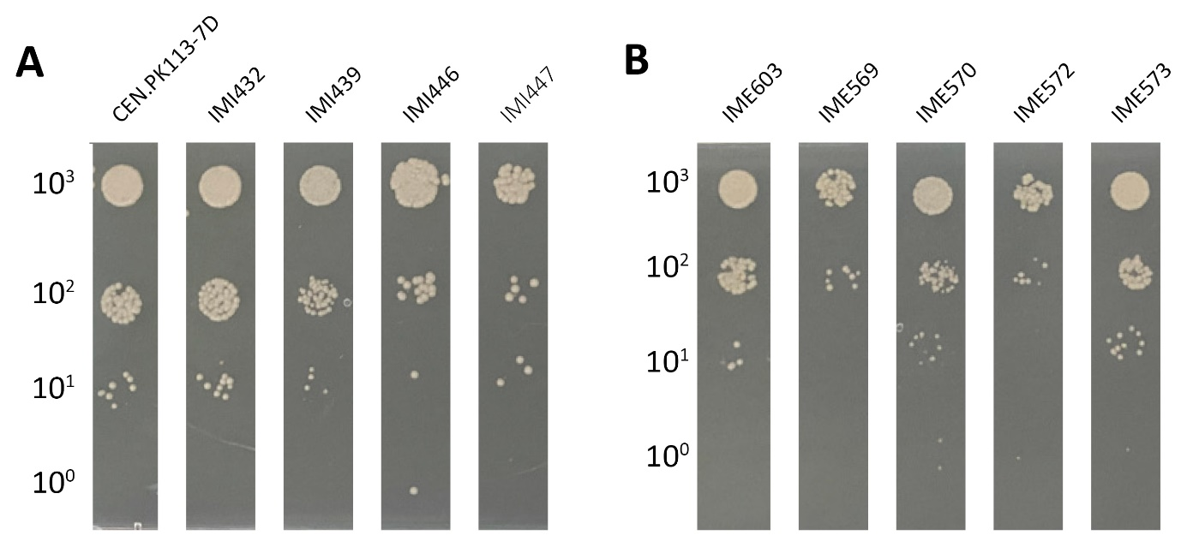

Figure S3. Growth on non-fermentable carbon sources of S. cerevisiae strains expressing heterologous URA9 genes.
The native URA1 gene of S. cerevisiae (ScURA1) was either replaced by a single expression cassette for an URA9 ortholog of A. robustus (Ar), D. bruxellensis (Db), K. marcianus (Km) or
O. parapolymorpha (Op), or expression cassettes introduced on multicopy plasmids (mc). Synthetic medium with ethanol and glycerol (SMEG) plates were incubated aerobically for 12 d at 20 °C. A: Strains with single-copy DHOD genes: CEN.PK113-7D (ScURA1; reference); IMI432 (ura1Δ::Arura9), IMI439 (ura1Δ::DbURA9), IMI446 (ura1Δ::KmURA9) and IMI447 (ura1Δ::OpURA9). B: Strains carrying multicopy plasmids: IME603 (mcScURA1), IME569 (ura1Δ mcArura9), IME570 (ura1Δ mcDbURA9), IME572 (ura1Δ mcKmURA9) and IME573 (ura1Δ mcOpURA9).
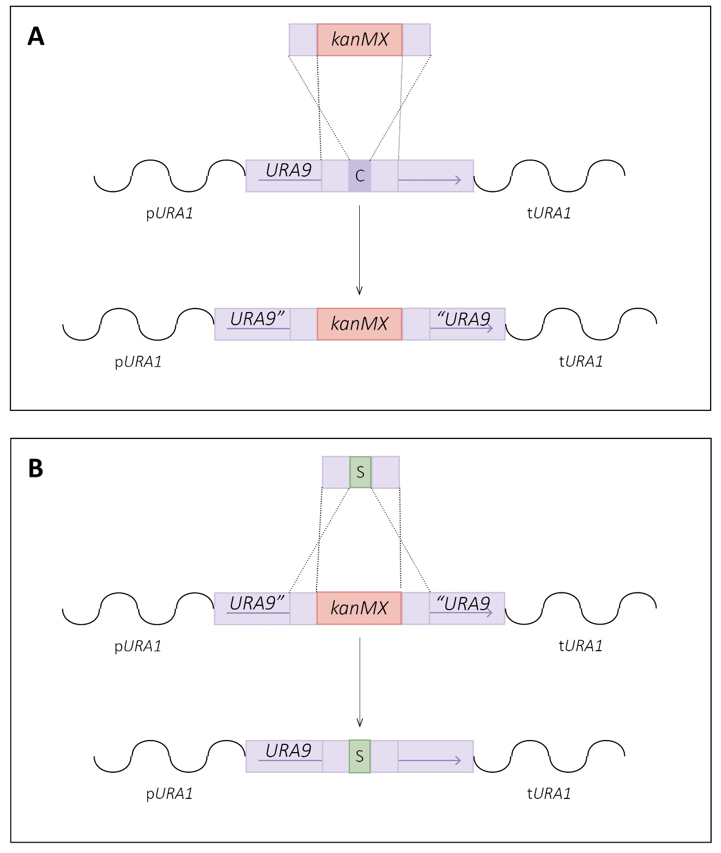

Figure S4. Introduction of point mutations in URA9 genes integrated in S. cerevisiae.
Point mutations were introduced in two rounds of transformation, A: In a first transformation, the codon of interest (purple C) in the integrated URA9 gene (purple) was targeted with a gRNA to introduce a Cas9 induced double-strand break. A repair fragment encompassing a kanMX marker gene (red) flanked with 60 bp sequences homologous to sequences up- and downstream of the codon of interest was integrated at the site of the double-strand break, resulting in a strain in which the codon of interest was replaced by the kanMX marker. B: After verification of correct integration of the kanMX marker, it was targeted with a specific gRNA in a subsequent round of transformation. A 120 bp repair oligonucleotide homologous to the URA9-gene and carrying the mutated codon of interest (green S) was supplied. Homologous recombination resulted in a strain with a URA9 gene that contained a single-nucleotide mutation.

Supporting Tables

Table S1. Maximum specific growth rates under aerobic and anaerobic conditions for URA1- and URA9-expressing strains.
Specific growth rates were determined from at least five points in the exponential phase and presented as average ± mean deviation of measurements on duplicate cultures. Absence of exponential growth is indicated as n.g.; while n.a. indicates that the corresponding experiments was not performed.
Strain | Relevant genotype | Parental strain | Maximum specific growth rate μ (h⁻¹)
 |  |  | Aerobic |  |  |  | Anaerobic
 |  |  | SMUD |  | SMUD-ura |  | SMUD |  | SMUD-ura
Reference strains
CEN.PK113-7D | URA1 |  | 0.350±0.004 |  | 0.357±0.003 |  | 0.236±0.013 |  | 0.247±0.011
IMK824 | ura1Δ | IMX585 (SpCas9) | n.g |  | 0.298±0.002 |  | n.g. |  | 0.256±0.009
URA9-expressing strains
IMI432 | ura1Δ::Arura9 | IMX585 | 0.338±0.002 |  | 0.349±0.000 |  | 0.246±0.006 |  | 0.254±.010
IMI439 | ura1Δ::DbURA9 | IMX585 | 0.342±0.004 |  | 0.343±0.002 |  | 0.206±0.006* |  | 0.250±.007
IMI452 | ura1Δ::SjURA9 | IMX585 | 0.167±0.002 |  | 0.171±0.000 |  | 0.120±0.000 |  | 0.143±0.000
IMI462 | ura1Δ::SjURA9 | IMX2600 (SpCas9) | 0.189±0.003 |  | 0.192±0.002 |  | 0.147±0.021 |  | 0.153±0.023
IMI446 | ura1Δ::KmURA9 | IMX585 | 0.342±0.001 |  | 0.348±0.001 |  | n.g. |  | 0.250±0.000
IMI447 | ura1Δ::OpURA9 | IMX585 | 0.352±.0.001 |  | 0.348±0.003 |  | n.g. |  | 0.250±0.006
DHOD genes expressed from a multicopy plasmid
IME569 | 2mμ Arura9 | IMK824 | 0.194±0.003 |  | 0.273±0.004 |  | n.a. |  | n.a.
IME570 | 2mμ DbURA9 | IMK824 | 0.208±0.002 |  | 0.283±0.007 |  | n.a. |  | n.a.
IME571 | 2mμ SjURA9 | IMK824 | 0.185±0.000 |  | 0.195±0.005 |  | n.a. |  | n.a.
IME572 | 2mμ KmURA9 | IMK824 | 0.267±0.004 |  | 0.306±0.001 |  | n.a. |  | n.a.
IME573 | 2mμ OpURA9 | IMK824 | 0.196±0.004 |  | 0.273±0.004 |  | n.a. |  | n.a.
IME603 | 2mμ ScURA1 | CEN.PK113-5 (ura3-52) | 0.242±0.005 |  | 0.267±0.009 |  | n.a. |  | n.a.
Strains expressing mutated DHOD genes
IMG005 | ura1Δ::KmURA9^{S263C} | IMI447 | 0.341±0.001 |  | 0.345±0.004 |  | n.g. |  | 0.244±0.002
IMG007 | ura1Δ:: Arura9^{C168S} | IMI432 | 0.322±0.005 |  | 0.350±0.004 |  | 0.240±0.003 |  | 0.244±0.001
IMG008 | ura1Δ::SjURA9^{C265S} | IMI452 | 0.086±0.000 |  | 0.181±0.001 |  | n.g. |  | 0.127±0.002
Selection strain
IMS1206 | ura1Δ | IME571 | n.a. | 0.172±.001 |  | n.a. |  | n.a.
IMS1167 | ura1Δ::DbURA9 | IMI439 | n.a. | n.a. |  | 0.219±0.002 |  | 0.239±0.003
IMS1168 | ura1Δ::DbURA9 | IMI439 | n.a. | n.a. |  | 0.206±0.003 |  | 0.226±.0.003
IMS1169 | ura1Δ::DbURA9 | IMI439 | n.a. | n.a. |  | 0.206±0.008 |  | 0.232±0.001
IMS1170 | ura1Δ::DbURA9 | IMI439 | n.a. | n.a. |  | 0.191±0.012 |  | 0.201±0.004
*Maximum specific growth rate was calculated from the second transfer (Figure S1).

Table S2. Dihydroorotate activities of ArUra9 with various electron acceptors, measured in cell extracts of S. cerevisiae IME569.
Activities were determined in 0.1 M potassium phosphate buffer (pH 7.5) at 30 °C, by measuring orotate formation at 300 nm. Reactions were started with the addition of dihydroorotate. Activities represent the average and mean deviation of results obtained with two separately prepared cell extracts. Reduction potentials were retrieved from Schafer and Buettner [2]. PMS; phenazine methosulfate, DHAP; dihydroxyacetone phosphate.
Electron acceptor | Reduction potential  (V) | Activity  (U∙mg_{protein}⁻¹)
- | - | 0.008±0.001
DHAP | -0.29 | 0.008±0.001
FAD | -0.219 | 0.148±0.032
FMN | -0.219 | 0.126±0.012
Acetaldehyde | -0.197 | 0.014±0.008
Pyruvate | -0.183 | 0.008±0.002
Oxaloacetate | -0.166 | 0.008±0.001

Table S3. Sequence similarities of sequences in proteomes of (facultative) anaerobic fungi with those of the fumarate reductases Frd1 and Osm1 of S. cerevisiae.
Amino-acid sequences of Frd1 (GenBank accession number; EIW10990.1) and Osm1 (EIW09573.1) of S. cerevisiae CEN.PK113-7D (taxid 889517) were used as query. Results with an E-value below E⁻⁵⁰ are shown. Localization of predicted proteins was predicted using WoLF PSORT [3] for fungal sequences and the highest scoring cellular component (mitochondria, cytosol, or other) is presented. The proteome of P. finnis yielded a partial protein sequence (ORX41846.1) whose localization could not be predicted (n.a.).
Subject proteome | Resulting GenBank  accession | Query coverage  (%) |  | E-value |  | Identity  (%) |  | Predicted localization
 | Protein query | Frds1 | Osm1 | Frds1 | Osm1 | Frds1 | Osm1
A. robustus | ORX80473.1  ORX87251.1 | 97  98 | 91  95 | 6∙10⁻⁹⁹  6∙10⁻⁸⁴ | 3∙10⁻¹⁰²  1∙10⁻⁸¹ | 40.99  35.86 | 41.54  33.58 | Cytosol  Other
P. finnis | ORX59854.1  ORX41846.1 | 97  98 | 91  92 | 1∙10⁻⁹⁶  2∙10⁻⁸⁸ | 2∙10⁻¹⁰²  3∙10⁻⁹⁰ | 40.00  37.30 | 42.03  36.96 | Cytosol  n.a.
N. californiae | ORY20775.1  ORY34386.1 | 98  97 | 91  92 | 9∙10⁻¹⁰⁰  3∙10⁻⁸⁶ | 1∙10⁻¹⁰³  4∙10⁻⁸⁶ | 40.93  36.86 | 41.85  35.98 | Cytosol  Other
Sch. japonicus | XP_002171497.1 | 99 | 91 | 9∙10⁻⁹⁹ | 2∙10⁻⁹⁶ | 39.63 | 38.63 | Mitochondria
D. bruxellensis | KAF6005858.1  VUG19043.1  XP_041138004.1 | 97  97  97 | 92  98  92 | 8∙10⁻¹⁰⁴  2∙10⁻¹⁰³  4∙10⁻¹⁰³ | 2∙10⁻⁹²  5∙10⁻⁹⁴  4∙10⁻⁹² | 41.61  41.61  41.61 | 39.09  38.13  38.89 | Mitochondria  Mitochondria  Mitochondria

Table S4. S. cerevisiae strains used in this study
Strain | Relevant genotype | Parental strain | Reference
CEN.PK113-7D | MATa TRP1 LEU2 HIS3 URA3 | - | [4]
CEN.PK113-5D | MATa TRP1 LEU2 HIS3 ura3-52 | CEN.PK113-7D | [4]
IMX585 | MATa TRP1 LEU2 HIS3 URA3 can1Δ::Spcas9-natNT2 | CEN.PK113-7D | [5]
IMX2600 | MATa TRP1 LEU2 HIS3 URA3 can1Δ::Spcas9-natNT2 | CEN.PK113-7D | [6]
IMX581 | MATa TRP1 LEU2 HIS3 ura3-52 can1Δ::Spcas9-natNT2 | CEN.PK113-5D | [5]
IMK242 | MATa TRP1 LEU2 HIS3 URA3 rip1Δ::loxP-kanMX-loxP | CEN.PK113-7D | [7]
IMK824 | MATa TRP1 LEU2 HIS3 URA3 can1Δ::Spcas9-natNT2 ura1Δ | IMX585 | This study
IMK976 | MATa TRP1 LEU2 HIS3 ura3-52 can1Δ::Spcas9-natNT2 leu2Δ ura1Δ | IMX581 | This study
IMI432 | MATa TRP1 LEU2 HIS3 URA3 can1Δ::Spcas9-natNT2 ura1Δ::Arura9 | IMX585 | This study
IMI439 | MATa TRP1 LEU2 HIS3 URA3 can1Δ::Spcas9-natNT2 ura1Δ::DbURA9 | IMX585 | This study
IMI446 | MATa TRP1 LEU2 HIS3 URA3 can1Δ::Spcas9-natNT2 ura1Δ::KmURA9 | IMX585 | This study
IMI447 | MATa TRP1 LEU2 HIS3 URA3 can1Δ::Spcas9-natNT2 ura1Δ::OpURA9 | IMX585 | This study
IMI452 | MATa TRP1 LEU2 HIS3 URA3 can1Δ::Spcas9-natNT2 ura1Δ::SjURA9 | IMX585 | This study
IMI462 | MATa TRP1 LEU2 HIS3 URA3 can1Δ::Spcas9-natNT2 ura1Δ::SjURA9 | IMX2600 | This study
IME569 | MATa TRP1 LEU2 HIS3 URA3 can1Δ::Spcas9-natNT2 ura1Δ pUDE696 | IMK824 | This study
IME570 | MATa TRP1 LEU2 HIS3 URA3 can1Δ::Spcas9-natNT2 ura1Δ pUDE738 | IMK824 | This study
IME571 | MATa TRP1 LEU2 HIS3 URA3 can1Δ::Spcas9-natNT2 ura1Δ pUDE815 | IMK824 | This study
IME572 | MATa TRP1 LEU2 HIS3 URA3 can1Δ::Spcas9-natNT2 ura1Δ pUDE756 | IMK824 | This study
IME573 | MATa TRP1 LEU2 HIS3 URA3 can1Δ::Spcas9-natNT2 ura1Δ pUDE809 | IMK824 | This study
IME600 | MATa TRP1 LEU2 HIS3 ura3-52 can1Δ::cas9-SpnatNT2 leu2Δ ura1Δ pUDC286 pUDE849 | IMK976 | This study
IME601 | MATa TRP1 LEU2 HIS3 ura3-52 can1Δ::Spcas9-natNT2 leu2Δ ura1Δ pUDC286 pUDE1008 | IMK976 | This study
IME602 | MATa TRP1 LEU2 HIS3 ura3-52 can1Δ::Spcas9-natNT2 leu2Δ ura1Δ pUDC286 pUDE1009 | IMK976 | This study
IME603 | MATa TRP1 LEU2 HIS3 URA3 can1Δ::cas9-SpnatNT2 ura1Δ pUDE1069 | IIMK824 | This study
IME604 | MATa TRP1 LEU2 HIS3 ura3-52 can1Δ::Spcas9-natNT2 leu2Δ ura1Δ pUDC286 pUDE1011 | IMK976 | This study
IMX2165 | MATa TRP1 LEU2 HIS3 URA3 can1Δ::Spcas9-natNT2 ura1Δ::SjURA9’-kanMX-‘SjURA9 | IMI452 | This study
IMX2203 | MATa TRP1 LEU2 HIS3 URA3 can1Δ::Spcas9-natNT2 ura1Δ::KmURA9’-kanMX-‘KmURA9 | IMI446 | This study
IMX2209 | MATa TRP1 LEU2 HIS3 URA3 can1Δ::Spcas9-natNT2 ura1Δ::Arura9’-kanMX-‘Arura9 | IMI432 | This study
IMG005 | MATa TRP1 LEU2 HIS3 URA3 can1Δ::Spcas9-natNT2 ura1Δ::KmURA9^{S263C} | IMX2203 | This study
IMG007 | MATa TRP1 LEU2 HIS3 URA3 can1Δ::Spcas9-natNT2 ura1Δ::Arura9^{C168S} | IMX2209 | This study
IMG008 | MATa TRP1 LEU2 HIS3 URA3 can1Δ::Spcas9-natNT2 ura1Δ::SjURA9^{C265S} | IMX2165 | This study
IMS1167 | Single colony isolate 1.1 of IMI439 anaerobically evolved for growth on SMUD | IMI439 | This study
IMS1168 | Single colony isolate of 1.2 IMI439 anaerobically evolved for growth on SMUD | IMI439 | This study
IMS1169 | Single colony isolate of 2.1 IMI439 anaerobically evolved for growth on SMUD | IMI439 | This study
IMS1170 | Single colony isolate of 2.2 IMI439 anaerobically evolved for growth on SMUD | IMI439 | This study
IMS1206 | Single colony isolate of IME573 selected for plasmid removal | IME573 | This study

Table S5. Oligonucleotides used in this study
Number | Sequence 5’ → 3’
580 | GAATGTAAGCGTGACATAAC
1552 | TAGGATGAGTAGCAGCACGTTC
1720 | CAATTCAGCGCAGTCACG
1935 | ATCCGTACTCCTGATGATGC
2897 | CCAGTGCTGCAATGATACC
2898 | TATTGACGCCGGGCAAGAG
3452 | GACGGACTTCAGCAATGGCATTC
4369 | TGGGCATGTACGGGTTACAG
5719 | CGAATACCGCTTCCACAAAC
5720 | GTTTGTGGAAGCGGTATTCG
6005 | GATCATTTATCTTTCACTGCGGAGAAG
6006 | GTTTTAGAGCTAGAAATAGCAAGTTAAAATAAGGCTAGTC
7823 | ATCCGTCGAAACTAAGTTCTGG
7998 | AAGCTTATCGATACCGTCGACC
9595 | TGTAATATCTTAATGCTAAA
11334 | TGCGCATGTTTCGGCGTTCGAAACTTCTCCGCAGTGAAAGATAAATGATCGGTACAGAATTACAAAAAGAGTTTTAGAGCTAGAAATAGCAAGTTAAAATAAGGCTAGTCCGTTATCAAC
11335 | GTTGATAACGGACTAGCCTTATTTTAACTTGCTATTTCTAGCTCTAAAACTCTTTTTGTAATTCTGTACCGATCATTTATCTTTCACTGCGGAGAAGTTTCGAACGCCGAAACATGCGCA
11336 | TAGACGTTTCAAATAGATATACACAATTACTCAAAAAAAAATTGAACTTCCGTACCAAACTTATCGGAATTTGAAGAACTATGATGGGACAAGTTATGGAAGAGTGTTAAGATTCGTATG
11337 | CATACGAATCTTAACACTCTTCCATAACTTGTCCCATCATAGTTCTTCAAATTCCGATAAGTTTGGTACGGAAGTTCAATTTTTTTTTGAGTAATTGTGTATATCTATTTGAAACGTCTA
11338 | TTTTCTTCACCGGGCTTTGC
11353 | GATGCCAATTGCGAATGCACTC
11634 | GTGAGCAAGGGCGAGGAG
11798 | CGACGGATTCTAGAACTAGTGGGTCTCATATGGTTTTGATCTC
11799 | GAATGCCTTAGTCATGCCAACCCGGTCTCAGGATTTAAGCCTTGTGTTC
11802 | TAGACGTTTCAAATAGATATACACAATTACTCAAAAAAAAATTGAACTTCCGTACCAAACCGCGTGTGGAAGAACGATTACAACAGG
11803 | CATACGAATCTTAACACTCTTCCATAACTTGTCCCATCATAGTTCTTCAAATTCCGATAAGCTGGAGCTCAGTTTATCATTATC
11808 | CAGCGTAAGAACCCAATTCC
12367 | AGAACTTAGTTTCGACGGATGCGGTACCATGTCTTTCAAC
12368 | TCGACGGTATCGATAAGCTTTGCTCCGAGCTCTTAGTTC
12375 | CACGATCTTCGGCATTCGCCGAAAATTTTTCAAGATGCCCATCACCAAAAAATAAAAAAAGCGATCGCGTGTGGAAGAAC
12376 | CATACGAATCTTAACACTCTTCCATAACTTGTCCCATCATAGTTCTTCAAATTCCGATAAGCTGGAGCTCAGTTTATCATTATC
12665 | GCGTTTGACACACGTTCGATGCTACCTGTTCCATCAGTGTTTATGCCATTTGAGCCCTGGACACACCGAGATTCATCAAC
12735 | AGGCAACTTGACACCAAGAG
12743 | TGCGCATGTTTCGGCGTTCGAAACTTCTCCGCAGTGAAAGATAAATGATCACCGGATTCAGTCGTCACTCAGTTTTAGAGCTAGAAATAGCAAGTTAAAATAAG
12744 | TGCGCATGTTTCGGCGTTCGAAACTTCTCCGCAGTGAAAGATAAATGATCAGACCTGAAATCAAAGTTATGTTTTAGAGCTAGAAATAGCAAGTTAAAATAAG
12842 | GGAGCAGATGGACAAGAAAC
13277 | TGCGCATGTTTCGGCGTTCGAAACTTCTCCGCAGTGAAAGATAAATGATCCTTTTGGAAGTTAAAGACATGTTTTAGAGCTAGAAATAGCAAGTTAAAATAAG
13278 | TTGAACATAAATAATATCACTCTAACACTTATTAGGAAACCGAAAGGAGCAATAACAAACGTTTGTTTTTCGTCCTCGAAAACTACATCTTTATTGTCTATTTGTTTCACCCTTATTTTG
13279 | CAAAATAAGGGTGAAACAAATAGACAATAAAGATGTAGTTTTCGAGGACGAAAAACAAACGTTTGTTATTGCTCCTTTCGGTTTCCTAATAAGTGTTAGAGTGATATTATTTATGTTCAA
13674 | TGCGCATGTTTCGGCGTTCGAAACTTCTCCGCAGTGAAAGATAAATGATCGTTTCTTGTCCAAACTTGCCGTTTTAGAGCTAGAAATAGCAAGTTAAAATAAG
13715 | TGCGCATGTTTCGGCGTTCGAAACTTCTCCGCAGTGAAAGATAAATGATCGTTTCTTGCCCAAACATTTCGTTTTAGAGCTAGAAATAGCAAGTTAAAATAAG
13800 | AGAACTTAGTTTCGACGGATCCATGTCCTCTACTTTTAAGTCCGC
13801 | TCGACGGTATCGATAAGCTTGCTCTTAAGCAGATTCGGTGCC
13802 | AACTTCAACGTAGGCGTAACC
13811 | CGCATATACCTTTTTCAACTGAAAAATTGGGAGAAAAAGGAAAGGTGAGAGCGCCGGAACGATATTTGTACATAAACTTTATAAATGAAATTCATAATAGAAACGACACGAAATTACAAA
13812 | TTTGTAATTTCGTGTCGTTTCTATTATGAATTTCATTTATAAAGTTTATGTACAAATATCGTTCCGGCGCTCTCACCTTTCCTTTTTCTCCCAATTTTTCAGTTGAAAAAGGTATATGCG
14345 | AATTGAAGGCGGACCACTACC
14439 | GGGCGCTATCGCACAGAATC
14440 | ACTGAAGAGGAGGTCGACTACG
14480 | TTGTTCGTACTTCCTTCTGAGCAG
14708 | AGAACTTAGTTTCGACGGATGTAGTTGCATGTCCATTGGAAAG
14709 | TCGACGGTATCGATAAGCTTTCTTATTTGACGTCTTCTCC
14710 | AGAACTTAGTTTCGACGGATATGTTTTCCCGAACAGGTCTC
14711 | TCGACGGTATCGATAAGCTTCTATTTATCGTCCTCGCCAACTAC
14759 | GAACCGGTATTCTTCTCTTGG
14760 | CCAATTGCGAATGCACTCAC
14872 | CCCACGCATGTATCTATCTC
14873 | ACTTGCCAGGTTTGAGAG
14873 | ACTTGCCAGGTTTGAGAG
14874 | CTTGGCAATTCTTCCTTAGC
14875 | CGATGATTGGTGGCTTTC
14876 | AGATTGAACGCTGACGAAAC
14877 | TCGGTGAAGAACACAAGG
14878 | CTCTTGGGTAGTTGTCAGAG
15067 | TGCGCATGTTTCGGCGTTCGAAACTTCTCCGCAGTGAAAGATAAATGATCTGATTATAATACCATTTAGGGTTTTAGAGCTAGAAATAGCAAGTTAAAATAAGGCTAGTCCGTTATCAAC
15597 | TTAAGCCTTGTGTTCTTCACCGATGATG
15598 | ATGGTTTTGATCTCTGACAACTAC
15645 | TGAAGTGGTGGCCTAACTACGG
15651 | AATATTTTAGTAGCTCGTTACAGTCCG
15834 | ACGTTTTGGGTGTTAAGGAATTGGGTTCTTACGCTGACTTCATCGTTATCAACGTTTCTTCTCCAAACTTGCCAGGTTTGAGAGCTTTGCAAGAAAAGGACACTTTGAAGAACTTGTTGG
15835 | CCAACAAGTTCTTCAAAGTGTCCTTTTCTTGCAAAGCTCTCAAACCTGGCAAGTTTGGAGAAGAAACGTTGATAACGATGAAGTCAGCGTAAGAACCCAATTCCTTAACACCCAAAACGT
15836 | TGCGCATGTTTCGGCGTTCGAAACTTCTCCGCAGTGAAAGATAAATGATCGTTTCCTCTCCAAACACACCGTTTTAGAGCTAGAAATAGCAAGTTAAAATAAG
15837 | CAGGACTACTTGAAAGGTGTTGAAAAATTCCAGAAATATGCAGATGTGCTAGTGATTAACCATGGGTAAGGAAAAGACTC
15838 | GCGACCACCTGACTCAAAAGATTAGTTAAAATCGATTCCTTCTGCAAGCCTCTGAGTCCACAAGTTCTTGAAAACAAGAATC
15847 | GCAACAACTTTGTTCAACAGGGGAACCAAAGTATCCTTAGATTGCAAGTTGCAGACACCACATGGGTAAGGAAAAGACTC
15848 | GAGGATTTCTTGAAAGGTGTTAGAAAATTCGGTAACTTCGCCGATATCTTGGTTGTTAATCAAGTTCTTGAAAACAAGAATC
15851 | GACGACTACGTTTTGGGTGTTAAGGAATTGGGTTCTTACGCTGACTTCATCGTTATCAACCATGGGTAAGGAAAAGACTC
15852 | TTGATAACAGCTTCCAACAAGTTCTTCAAAGTGTCCTTTTCTTGCAAAGCTCTCAAACCTCAAGTTCTTGAAAACAAGAATC
16360 | GGTCTCATATGTTGTCTTTGAGACAATCTATCAGATTCTTCAAGCCAGCTACTAGAACTTTGTGTTCTTCTAGATACTTGTTGGGTTCTTGAGACC
16361 | GGTCTCAAGAACCCAACAAGTATCTAGAAGAACACAAAGTTCTAGTAGCTGGCTTGAAGAATCTGATAGATTGTCTCAAAGACAACATATGAGACC
16368 | CTTGAAAGGTGTTGAAAAATTCCAGAAATATGCAGATGTGCTAGTGATTAACGTTTCCTGTCCAAACACACCTGGACTCAGAGGCTTGCAGAAGGAATCGATTTTAACTAATCTTTTGAG
16369 | CTCAAAAGATTAGTTAAAATCGATTCCTTCTGCAAGCCTCTGAGTCCAGGTGTGTTTGGACAGGAAACGTTAATCACTAGCACATCTGCATATTTCTGGAATTTTTCAACACCTTTCAAG
16370 | ACAGGGGAACCAAAGTATCCTTAGATTGCAAGTTGCAGACACCAGAAATGTTTGGGGAAGAAACATTAACAACCAAGATATCGGCGAAGTTACCGAATTTTCTAACACCTTTCAAGAAAT
16371 | ATTTCTTGAAAGGTGTTAGAAAATTCGGTAACTTCGCCGATATCTTGGTTGTTAATGTTTCTTCCCCAAACATTTCTGGTGTCTGCAACTTGCAATCTAAGGATACTTTGGTTCCCCTGT
16436 | AGAACGGTGACGAAGTACAG
16438 | GGTAACTTCGCCGATATCTTGG
16439 | CAAGTCGAGGTCTGCGATTC
16441 | AGAACGGTGACGAAGTACAG
16443 | CTTGAGCGACGAGATTCTTG
16443 | CTTGAGCGACGAGATTCTTG
16445 | GAGTCACAGATCCGATTTCC
16449 | CCATTGCCAAGGCTGCGAAG
16451 | CAGCCTGGTTGATGAGGTTC
16454 | GCACCAGCTCTAGCAAATTC
16455 | CGGTCAAATCTGGACCAATC
16456 | GTTACCTGGTTGTGGTTCTG
16458 | TACGCCTACGTTGAAGTTGG
17291 | CTTCCGAAAATGCAACGCGAGGCCGCAAATTAAAGCCTTCGAG
17292 | CTCGCGTTGCATTTTCGGAAG
17293 | CTTTTTACGGTTCCTGGCCTCACGCCCTCCAACGAAGC
17294 | GCACGTGACTGCGCTGAATTGCAAAAGCTGGAGCTCAGTTTATC
17296 | AGCTCCTCGCCCTTGCTCACTTTATCGTCCTCGCCAACTAC
17298 | AGCTCCTCGCCCTTGCTCACAGCCTTGTGTTCTTCACC
17299 | AGCTCCTCGCCCTTGCTCACGTTCTTTTCGTCGTCAGAACC
17300 | AGCTCCTCGCCCTTGCTCACAGCAGATTCGGTGCC
17683 | GCTTACATTCACGCCCTCCC
17697 | AGAACTTAGTTTCGACGGATCATGACAGCCAGTTTAACTACC
17698 | TCGACGGTATCGATAAGCTTTTAAATGCTGTTCAACTTCCC

Table S6. Plasmids used in this study
Plasmid | Relevant characteristics | Reference
pMEL13 | AmpR kanMX gRNA-CAN1.Y 2μm | [5]
pROS12 | AmpR hygB gRNA-CAN1.Y 2μm gRNA-ADE2.Y | [5]
pROS13 | AmpR kanMX gRNA-CAN1.Y 2μm gRNA-ADE2.Y | [5]
pROS14 | AmpR KlLEU2 gRNA-CAN1.Y 2μm gRNA-ADE2.Y | [5]
pYTK002 | ConLS CamR (type 1) | [8]
pYTK009 | pTDH3 CamR (type 2) | [8]
pYTK033 | tADH1 CamR (type 4) | [8]
pYTK046 | mRuby2 CamR (type 3b) | [8]
pYTK047 | E. coli GFP-dropout (type 234r) | [8]
pYTK067 | ConRI (type 5) | [8]
pYTK074 | URA3 (type 6) | [8]
pYTK081 | CEN6/ARS (type 7) | [8]
pYTK089 | AmpR-ColE (type 8a) | [8]
pUDC071 | AmpR URA3 pARO10-eGFP-tCYC1 2μm | [9]
pUDC286 | AmpR URA3 pTDH3-(ScCOX4 MTS)-mRuby2-tADH1 2μm | This study
pUD538 | CamR URA3 GFP-dropout CEN6/ARS | This study
pUD650 | AmpR Arura9 | Ordered from GeneArt
pUD707 | AmpR DbURA9 | Ordered from GeneArt
pUD764 | AmpR SjURA9 | Ordered from GeneArt
pUDR348 | AmpR kanMX gRNA-URA1 2μm gRNA-URA1 | This study
pUDR499 | AmpR kanMX gRNA-Arura9- 2μm gRNA-Arura9 | This study
pUDR501 | AmpR kanMX gRNA-SjURA9- 2μm gRNA-SjURA9 | This study
pUDR602 | AmpR kanMX gRNA-KmURA9- 2μm gRNA-KmURA9 | This study
pUDR605 | AmpR hugB gRNA-kanMX- 2μm gRNA-kanMX | This study
pUDR721 | AmpR kanMX gRNA-LEU2 2μm gRNA-URA11 | This study
pUDE63 | AmpR URA3 pTDH3-pgmB-tCYC1 2μm | [10]
pUDE696 | AmpR URA3 pTDH3-Arura9-tCYC1 2μm | This study
pUDE738 | AmpR URA3 pTDH3-DbURA9-tCYC1 2μm | This study
pUDE756 | AmpR URA3 pTDH3-KmURA9-tCYC1 2μm | This study
pUDE809 | AmpR URA3 pTDH3-OpURA9-tCYC1 2μm | This study
pUDE815 | AmpR URA3 pTDH3-SjURA9-tCYC1 2μm | This study
pUDE849 | AmpR LEU2 pTDH3-Arura9-eGFP-tCYC1 2μm | This study
pUDE1008 | AmpR LEU2 pTDH3-DbURA9-eGFP-tCYC1 2μm | This study
pUDE1009 | AmpR LEU2 pTDH3-SjURA9-eGFP-tCYC1 2μm | This study
pUDE1011 | AmpR LEU2 pTDH3-OpURA9-eGFP-tCYC1 2μm | This study
pUDE1069 | AmpR URA3 pTDH3-ScURA1-tCYC1 2μm | This study

References
1. Sousa FM, Refojo PN, Pereira MM. Investigating the amino acid sequences of membrane bound dihydroorotate:quinone oxidoreductases (DHOQOs): Structural and functional implications. Biochim Biophys Acta - Bioenerg. 2021;1862:148321.
2. Schafer FQ, Buettner GR. Redox state and redox environment in biology. In: Forman HJ, Fukuto J, Torres M, editors. Signal transduction by reactive oxygen and nitrogen species: pathways and chemical principles. Dordrecht: Springer Netherlands; 2003. p. 1–14.
3. Horton P, Park KJ, Obayashi T, Fujita N, Harada H, Adams-Collier CJ, Nakai K. WoLF PSORT: Protein localization predictor. Nucleic Acids Res. 2007;35:585–7.
4. Entian KD, Kötter P. Yeast genetic strain and plasmid collections. In: Stansfield, I. , and Stark MJR, editor. Methods in microbiology: Yeast gene analysis. Amsterdam: Academic Press; 2007. p. 629–66.
5. Mans R, van Rossum HM, Wijsman M, Backx A, Kuijpers NGA, van den Broek M, Daran-Lapujade P, Pronk JT, van Maris AJA, Daran J-MG. CRISPR/Cas9: a molecular Swiss army knife for simultaneous introduction of multiple genetic modifications in Saccharomyces cerevisiae. FEMS Yeast Res. 2015;15:fov004.
6. Bouwknegt J, Wiersma SJ, Ortiz-Merino RA, Doornnebal ESR, Buitenhuis P, Giera M, Muller C, Pronk JT. A squalene-hopene cyclase in Schizosaccharomyces japonicus represents a eukaryotic adaptation to sterol‐independent anaerobic growth. BioRXiv [preprint]. 2021;
7. Perez-Samper G, Cerulus B, Jariani A, Vermeersch L, Simancas NB, Bisschops MMM, van den Brink J, Solis-Escalante D, Gallone B, De Maeyer D, van Bael E, Wenseleers T, Michiels J, Marchal K, Daran-Lapujade P, Verstrepen KJ. The crabtree effect shapes the Saccharomyces cerevisiae lag phase during the switch between different carbon sources. MBio. 2018;9:1–18.
8. Lee ME, DeLoache WC, Cervantes B, Dueber JE. A highly characterized yeast toolkit for modular, multipart assembly. ACS Synth Biol. 2015;4:975–86.
9. Romagnoli G, Knijnenburg TA, Litti G, Louis EJ, Pronk JT, Daran J-M. Deletion of the Saccharomyces cerevisiae ARO8 gene, encoding an aromatic amino acid transaminase, enhancesphenylethanol production from glucose. Yeast. 2015;32:29–45.
10. de Kok S, Yilmaz D, Suir E, Pronk JT, Daran JM, van Maris AJA. Increasing free-energy (ATP) conservation in maltose-grown Saccharomyces cerevisiae by expression of a heterologous maltose phosphorylase. Metab Eng. 2011;13:518–26.

