Supplements for:
Size-fractionated PM-bound Metals and Associated Health Risks in the Densely Populated Megacity of Southern Vietnam: A Preliminary Investigation.
Le Quoc Hau^{1,2}, Nguyen Duy Dat³, Nhung Thi-Tuyet Hoang³, Giang Tien Nguyen³, Perapong Tekasakula^{4,5}, Racha Dejchanchaiwonga^{4,6}, Ly Sy Phu Nguyen^{1,2*}.

¹ Faculty of Environment, University of Science, Ho Chi Minh City, Viet Nam
² Vietnam National University, Ho Chi Minh City, Viet Nam
³ Faculty of Chemical and Food Technology, HCM University of Technology and Education, No. 01 Vo Van Ngan, Thu Duc Ward, Ho Chi Minh City, Viet Nam.
⁴Air Pollution and Health Effect Research Center, Prince of Songkla University, Hat Yai, Songkhla, Thailand
⁵Department of Mechanical and Mechatronics Engineering, Faculty of Engineering, Prince of Songkla University, Hat Yai, Songkhla, Thailand
⁶Department of Chemical Engineering, Faculty of Engineering, Prince of Songkla University, Hat Yai, Songkhla, Thailand
* Corresponding author email: Ly Sy Phu Nguyen (nlsphu@hcmus.edu.vn)

Table S1. Blank levels (mean ± S.D.) of selected HMs in this study.
Heavy metal | Concentration (µg L⁻¹)
Al | 0.34 ± 0.11
Fe | 0.1 ± 0.04
Mn | 0.53 ± 0.14
Ni | 0.5 ± 0.22
Cu | 0.26 ± 0.05
Zn | 0.15 ± 0.08
Pb | 0.5 ± 0.26
Cd | 0.04 ± 0.02

Table S2. Recommended values in equations of the daily exposure in calculation (USEPA 2009).
Parameter | Definition (unit) | Values-adult | Values-children
ET | exposure time (hours day⁻¹) | 24 | 24
EF | exposure frequency (days year⁻¹) | 350 | 350
ED | exposure duration (year) | 24 | 6
AT | averaging time (hour) | ED×365×24 (non-carcinogens), 75×365×24 (carcinogens)

Table S3. The RfC, IUR for selected elements via inhalation (USEPA 2022).
Metals | IUR_{j} | RfC_{j}
Al | − | 5.0 10⁻³
Mn  (non-diet) | − | 5.0 10⁻⁵
Ni  (Subsulfide) | 4.8 10⁻⁴ | 1.4 10⁻⁵
Pb  (acetate) | 8.0 10⁻⁵ | −
Cd  (diet) | 1.8 10⁻³ | 1.0 10⁻⁵

Table S4. Summary of metal concentrations in PM (ng m⁻³) at some urban sites worldwide.
City | PM | Al | Fe | Mn | Ni | Cu | Zn | Pb | Cd | Reference
HCMC, Vietnam | PM_{2.5} | 350 | 298 | 10.3 | 2.70 | 12 | 528 | 17 | 0.40 | This Study
HCMC, Vietnam | PM₁₀ | 1197 | 666 | 16.9 | 4.18 | 18 | 678 | 21 | 0.48 | This Study
Hai Phong, Vietnam | PM₁₀ | 1543 | 828 | 44.6 | 4.69 | 48.2 | 145 | 56.0 | 1.46 | Chifflet et al., 2018
HCMC, Vietnam | PM₁₀ | 5144 | 1573 | 45.5 | 6.20 | 16.1 | - | 44.1 | - | Truong et al., 2022
HCMC, Vietnam | PM₂ | 33.2 | 45.7 | 5.26 | 0.91 | 4.47 | 189 | 19.6 | 0.44 | Hien et al., 2022*
BHC, Vietnam | PM_{2.5} | 590 | 380 | 40 | 60 | 380 | 660 | 80 | 15.5 | Bui et al., 2023
Seoul, Korea | PM_{2.5} | 899 | 263 | - | - | 9.26 | 57.3 | 12.9 | 0.45 | Shim et al., 2021
Fuxin, China | PM_{2.5} | - | - | 18.7 | 6.1 | 14 | 294 | 66.4 | 1.9 | Zhao et al., 2024
Zhejiang, China | PM_{2.5} | 48.1 | - | 24.2 | 4.67 | - | - | 29.3 | 4.36 | Guo et al., 2022
Xiamen, China | PM_{2.5} | 402 | 332 | 16.4 | 12.5 | 11.1 | 90.1 | 18.5 | 0.55 | Wu et al., 2022
Xiamen, China | PM₁₀ | 863 | 693 | 26.3 | 14.9 | 14.8 | 110 | 20.3 | 0.61 | Wu et al., 2022
Beijing, China | PM₁₀ | 1520 | 2200 | 65 | 2.4 | 28 | 165 | 39 | - | Rai et al., 2021
Delhi, India | PM₁₀ | 3100 | 3300 | 79 | 4.9 | 128 | 780 | 480 | - | Rai et al., 2021
Krakow, Poland | PM₁₀ | 146 | 1830 | 28 | 1.73 | 29 | 168 | 33 | - | Rai et al., 2021
Los Angeles, US | PM_{2.5} | 115 | 251 | 4.1 | 0.7 | 12.8 | 11.5 | 2.2 | 0.06 | Oroumiyeh et al., 2022
Los Angeles, US | PM₁₀ | 298 | 361 | 4.8 | 0.6 | 12.1 | 9.2 | 0.9 | 0.02 | Oroumiyeh et al., 2022
*Soluble

Table S5. Summary of non-carcinogenic and carcinogenic risks for selected elements via inhalation.
Metals | PM | HQ_{j} |  | CR_{j}
Metals | PM | Adult | Children | Adult | Children
Al | PM_{2.5} | 0.067 | 0.268 | - | -
Al | PM₁₀ | 0.230 | 0.919 | - | -
Mn (non-diet) | PM_{2.5} | 0.197 | 0.787 | - | -
Mn (non-diet) | PM₁₀ | 0.324 | 1.29 | - | -
Ni (Subsulfide) | PM_{2.5} | 0.185 | 0.739 | 1.24 10⁻⁶ | 4.97 10⁻⁶
Ni (Subsulfide) | PM₁₀ | 0.286 | 1.14 | 1.92 10⁻⁶ | 7.69 10⁻⁶
Pb (acetate) | PM_{2.5} | - | - | 1.32 10⁻⁶ | 5.29 10⁻⁶
Pb (acetate) | PM₁₀ | - | - | 2.56 10⁻⁷ | 6.56 10⁻⁶
Cd (diet) | PM_{2.5} | 0.039 | 0.155 | 6.97 10⁻⁷ | 2.79 10⁻⁶
Cd (diet) | PM₁₀ | 0.046 | 0.182 | 8.21 10⁻⁷ | 3.28 10⁻⁶
Total | PM_{2.5} | 0.49 | 1.95 | 3.26 10⁻⁶ | 1.31 10⁻⁵
Total | PM₁₀ | 0.88 | 3.54 | 3.00 10⁻⁶ | 1.75 10⁻⁵

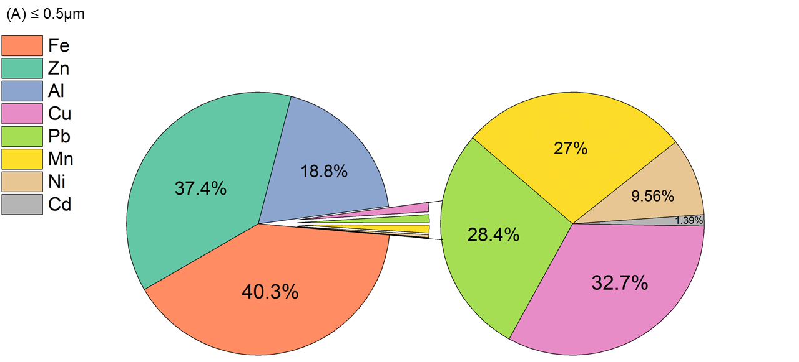
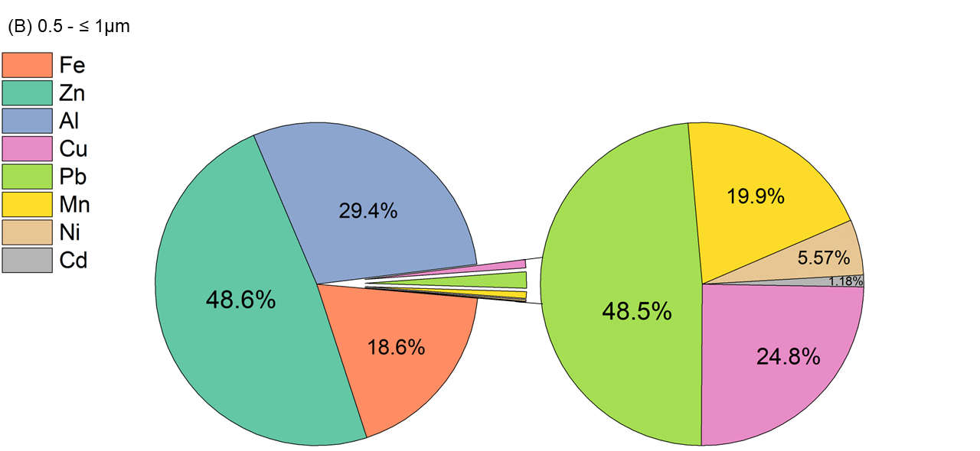
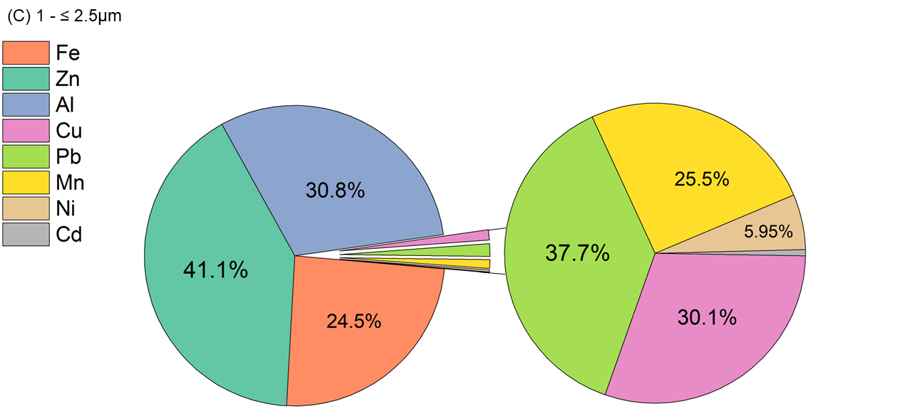
Fig. S1. Distribution of heavy metals (%) in (A) PM_{<0.5}, (B) PM_{0.5-1}, (C) PM_{1-2.5}, (D) PM_{2.5-10}, and (E) PM_{>10}.

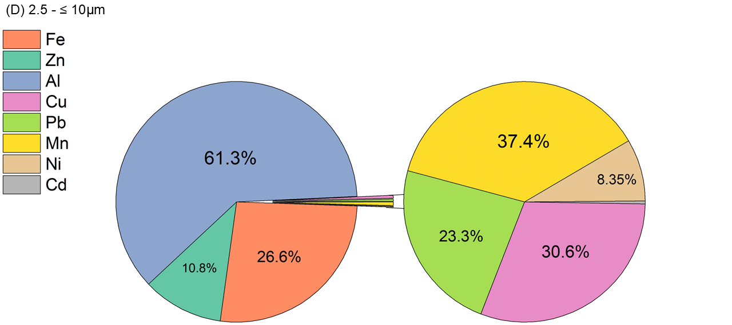
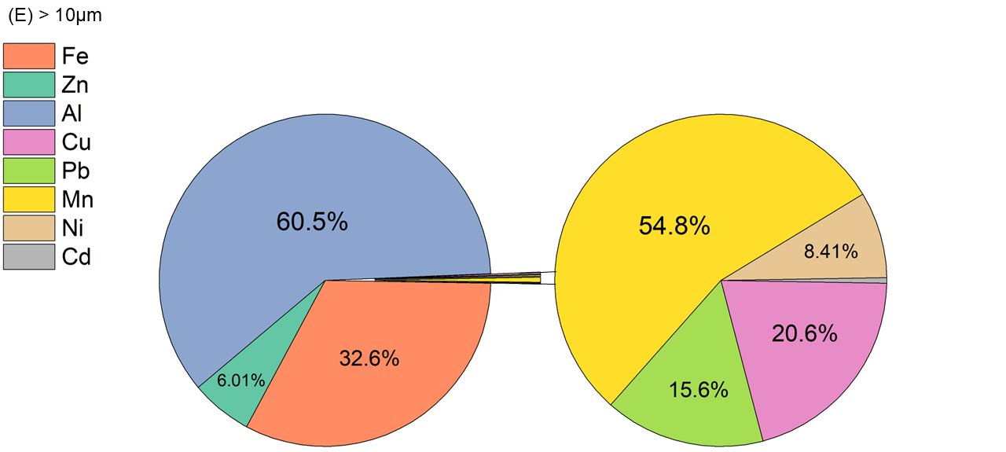
Fig. S1. Continued.

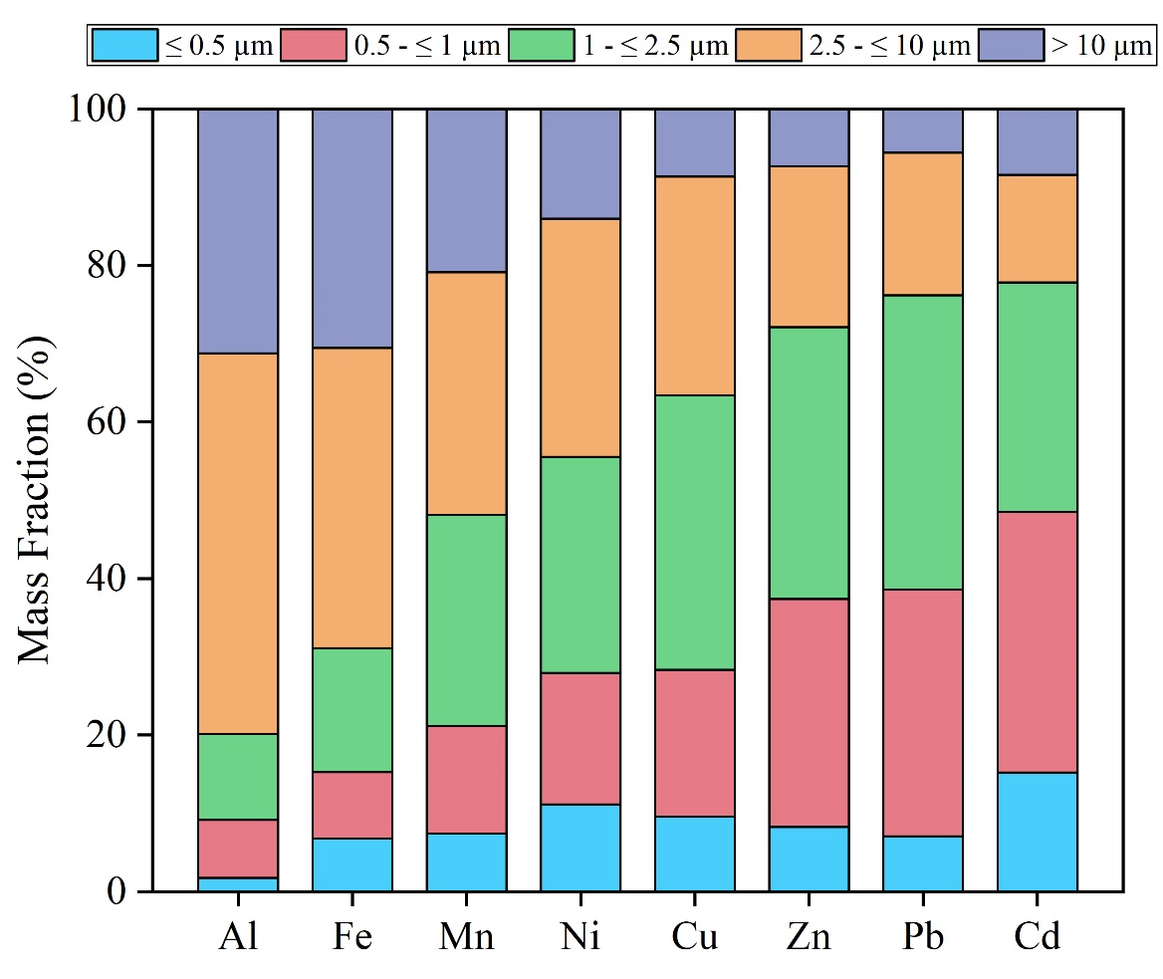
Fig. S2. Fractional mass (%) of metals in PM_{<0.5}, PM_{0.5-1}, PM_{1-2.5}, PM_{2.5-10}, and PM_{>10}.

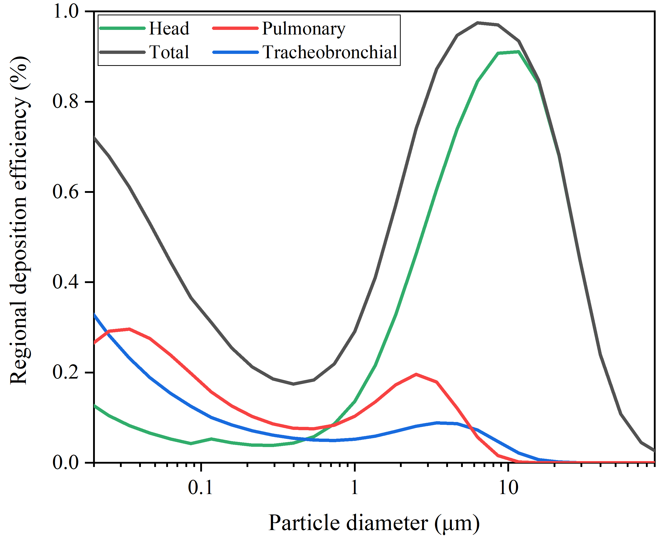
Fig. S3. Deposition efficiencies of particles by the MPPD models in HCMC.

Reference
Bui DL, Le Hoang A, Ngo QK, Nghiem XT (2023) Chemical characterization, source apportionment, and health risk assessment nexus of PM2.5-bound major heavy metals in Bien Hoa city, southern Vietnam. Atmosp Environ X 17:100209. https://doi.org/10.1016/j.aeaoa.2023.100209
Chifflet, S. Amouroux, D. Bérail, S. Barre, J. Van, T.C. Baltrons, O. Brune, J. Dufour, A. Guinot, B. Mari, X. (2018). Origins and discrimination between local and regional atmospheric pollution in Haiphong (Vietnam), based on metal (loid) concentrations and lead isotopic ratios in PM10. Environ. Sci. Pollut. Res Int. 25, 26653–26668. https://doi.org/10.1007/s11356-018-2722-7
Guo F, Tang M, Wang X, Yu Z, Wei F, Zhang X, Chen K (2022) Characteristics, sources, and health risks of trace metals in PM2. 5. Atmospheric Environment, 289, 119314. https://doi.org/10.1016/j.atmosenv.2022.119314
Hien TT, Chi NDT, Huy DH, Le HA, Oram DE, Forster GL, Baker AR (2022) Soluble trace metals associated with atmospheric fine particulate matter in the two most populous cities in Vietnam. Atmospheric Environment: X, 15, 100178. https://doi.org/10.1016/j.aeaoa.2022.100178
Oroumiyeh F, Jerrett M, Del Rosario I, Lipsitt J, Liu J, Paulson SE, Zhu Y (2022) Elemental composition of fine and coarse particles across the greater Los Angeles area: Spatial variation and contributing sources. Environmental Pollution, 292, 118356. https://doi.org/10.1016/j.envpol.2021.118356
Rai P, Slowik JG, Furger M, El Haddad I, Visser S, Tong Y, Prévôt A S (2020) Highly time-resolved measurements of element concentrations in PM 10 and PM 2.5: comparison of Delhi, Beijing, London, and Krakow. Atmospheric Chemistry and Physics Discussions, 2020, 1-18. https://doi.org/10.5194/acp-21-717-2021
Shim I, Kim W, Kim H, Lim YM, Shin H, Park KS, Yu SD (2021) Comparative cytotoxicity study of PM2. 5 and TSP collected from urban areas. Toxics, 9(7), 167. https://doi.org/10.3390/toxics9070167
Truong MT, Nguyen LSP, Hien TT, Pham TDH, Do TTL (2022) Source apportionment and risk estimation of heavy metals in PM10 at a Southern Vietnam megacity. Aerosol and Air Quality Research, 22(8), 220094. https://doi.org/10.4209/aaqr.220094
USEPA (2009) Risk Assessment Guidance for Superfund (RAGS), Volume I: Human Health Evaluation Manual (Part E, Supplemental Guidance for Dermal Risk Assessment). Office of Superfund Remediation and Technology Innovation U.S. Environmental Protection Agency, Washington, DC https://www.epa.gov/sites/default/files/2015-09/documents/part_e_final_revision_10-03-07.pdf.
USEPA (2022) User's guide/technical background document for US EPA region 9's RSL (regional screening levels) tables. https://www.epa.gov/risk/regional-screening-levelsrsls-generic-tables.
Wu SP, Li X, Xiao SH, Zhang J, Schwab JJ (2022) Solubility of aerosol minor and trace metals in Xiamen Island, Southeast China: Size distribution, health risk and dry deposition. Science of The Total Environment, 844, 157100. https://doi.org/10.1016/j.scitotenv.2022.157100
Zhao X, Shen Z, Han F, Bharti B, Feng S, Du J, Li Y (2024) Pollution characteristics and health risk assessment of heavy metals in PM_{2.5} in Fuxin, China. Environmental Geochemistry and Health, 46(12), 511. https://doi.org/10.1007/s10653-024-02275-x

