Supplementary Information

Rejuvenation of Mechanical Fatigue Resistance in Two-dimensional Ferroelectric CuInP₂S₆ by Reversing Ionic Motion

Xiqi Wu^{1†}, Shuai Han^{2†}, Zhaoheng Zhang^{1†}, Yafei Wang¹, Jiahao Li¹, Zhao Zhang¹, Dong Wang¹, Xinshuai Peng¹, Yixuan She¹, Xiang Gao¹, Chongjian Zhou^{2*}, Guorui Wang^{1*}, Zhong Zhang^{1*}

¹CAS Key Laboratory of Mechanical Behavior and Design of Materials, Department of Modern Mechanics, University of Science and Technology of China, Hefei 230027, China
²State Key Laboratory of Solidiﬁcation Processing and Key Laboratory of Radiation Detection Materials and Devices, Ministry of Industry and Information, Technology Northwestern Polytechnical University, Xi’an 710072, China

*Address correspondence to: cjzhou@nwpu.edu.cn (C.J.Z), wgrui@ustc.edu.cn (G.R.W), zhongzhang@ustc.edu.cn (Z.Z)

Note 1. Structural and Mechanical Characterization of CIPS
Note 1.1 Atomic structure
CuInP₂S₆ (CIPS) is a room-temperature layered van der Waals ferroelectric material with a Curie temperature of about 315 K. The side view and top view of its crystal structure are shown in Figs. S1a-b, where Cu ions, In ions and P-P pairs are filled in the octahedral framework composed of sulfur atoms and the positions of Cu ions and P-P pairs between adjacent layers are exchanged completely in a CIPS unit cell. Moreover, the positions of Cu ions can shift along the direction of external electric field, imparting its distinctive ionic conductivity. The ferroelectric polarization originates from the asymmetry of lattice flipping due to the different positions of Cu ions in each layer. Figure S1c shows the high-resolution TEM image of CIPS, where the well-defined lattice stripes with interplane spacing of 0.528 nm and 0.310 nm are observed, corresponding respectively to the (110) and (200) crystal plane. The selected area electron diffraction (SAED) pattern in Fig. S1c shows that CIPS is referred to a trigonal phase.

Note 1.2 Raman characterization
The crystal structures of CIPS are characterized in detail by Raman spectroscopy (RENISHAW confocal Raman microscope). The Raman spectra of both pristine and fatigued CIPS samples are acquired using a 532 nm laser, as illustrated in Fig. S2a, from which we can extract Raman peak positions and analyze the corresponding lattice vibration states. The peaks around 100 cm⁻¹ are assigned to the vibration of Cu⁺ and In³⁺, wherein the lower and higher frequency peaks correspond to vibrations from Cu-S and In-S bonds, respectively. The peaks between 100 cm⁻¹ and 350 cm⁻¹ are associated with the deformation of sulfur octahedron and the displacement of P and S atoms. The peak around 320 cm⁻¹ is due to the lattice distortion of S₆ cage caused by Cu⁺ occupation¹. The dominant Raman feature at 370 cm⁻¹ is associated with vibrational modes involving P-P bond stretching and out-of-plane atomic displacements².
A comparative analysis of the Raman spectral features is presented in Fig. S2b, demonstrating the distinct changes induced by the aggregation process of Cu ions. Through peak deconvolution analysis, significant spectral modifications are observed at 100 cm⁻¹, 325 cm⁻¹, and 375 cm⁻¹, which can be primarily attributed to the structural alterations induced by Cu ion migration, including chemical bond cleavage, lattice distortion, and out-of-plane atomic displacements.

Note 1.3 The Young’s modulus and fracture strength of CIPS
AFM-based nanoindentation method is employed to measure the Young’s modulus of CIPS, which is modeled as clamped circular membranes with a central point loading. The force-displacement relation can be described by Eq. (S1)^{3, 4}, where the deformation is dominated by stretching, similar to membrane behavior.
$$\begin{aligned}F=\left[\frac{4πEt^{3}}{3\left(1-ν^{2}\right)}+T\right]\frac{δ_{t}}{a}+E\left(ξ^{3}ta\right){\left(\frac{δ_{t}}{a}\right)}^{3}\#\left(S1\right)\end{aligned}$$
where $F$ is the applied force, $E$ is Young’s modulus,$t$ is thickness of CIPS membrane, T is the pre-tension, $δ_{t}$ is the displacement (indentation depth),$a$ is the hole radius, and $ξ=1/{\left(1.049-0.15ν-0.16ν^{2}\right)}$ is a function of Poisson ratio $ν$.
In our experiments, the CIPS film is less than 10 nm which can be deemed as membrane structure and $δ_{t}≫t$, so the bending contribution can be ignored. The gold-assisted exfoliation technique is employed to transfer the sample onto a patterned silicon oxide substrate containing 2 μm apertures, creating a free-standing suspended structure as shown in Fig. S3a. The insets show the schematic of AFM-based nanoindentation method with cone shaped diamond probes (Fig. S4) and the flat surface morphology of CIPS. By capturing the force and deflection of the suspended film and fitting the stretch-dominated stage using a cubic formula (Fig. S3b), the in-plane Young's moduli across various thicknesses can be determined, averaged as $97.1±7.2 GPa$. This is consistent with the value predicted by density functional theory (DFT) calculations (Fig. S5). Besides, the Young's moduli exhibit thickness independence allowing the evaluation of stress level in CIPS during subsequent fatigue testing.
The fatigue load was determined by the fracture force (${\overline{F}}_{fracture}$) identified as the maximum value in the force-displacement (F-δ) curve (Fig. S3b). In the case of a circular membrane exhibiting linear elastic behavior, constrained by fixed boundary conditions along its entire circumference and subjected to a central point indentation, its in-plane fracture strength is obtained by:
$\begin{aligned}σ=\sqrt{{{\overline{F}}_{fracture}E}/{\left(4πRt\right)}}\#\left(S2\right)\end{aligned}$
where $σ$ is the fracture strength, ${\overline{F}}_{fracture}$ is the breaking force, and $R$ is the tip radius. The fracture strength is estimated to be $7.6±0.8 GPa$ as presented in Fig. S3d. Notably, both the modulus and fracture strength of CIPS are substantially lower than those of well-studied two-dimensional materials (e.g. graphene, hBN and MoS₂)⁴. This disparity is likely attributed to the nature of the intra-layer bonding in CIPS, which includes Cu–S and In–S bonds with pronounced ionic character—particularly due to electrostatic interactions between Cu⁺ and S²⁻ ions—rendering these bonds generally weaker than purely covalent ones³. Additionally, the mobility of Cu⁺ within the CIPS layer induces dynamic fluctuations in local bond lengths and bond angles, further weakening the intra-layer mechanical stiffness. Prior to fatigue evaluation, quantitative pre-characterization of mechanical integrity is conducted through AFM-based nanoindentation as shown in Fig. S6. The results show a consistent fracture force of approximately 700 nN for nanosheets of 10 nm thickness.

Note 2. Fatigue Testing of CIPS
Note 2.1 Resonant frequency calculation
The fundamental resonant frequency of the circular membrane with fully clamped boundary conditions is calculated by⁶ .
$$\begin{aligned}f_{1}=\frac{2.405\sqrt{T/ρ}}{2πa}\#\left(S3\right)\end{aligned}$$
where $T$ is the film tension, $ρ$ is the area density, and $a$ is the film radius. The pre-tension can be quantified based on Eq. (S1), approximated as $0.45 N/m$, and the area density is $3.45×{10}^{-5} kg/m^{2}$, giving rise to a first mode resonant frequency of CIPS of $f_{1}≈43.72 GHz$, which significantly exceeds the fundamental frequency of the cantilever (100 kHz). Furthermore, the application of a central preload to the membrane induces a significant increase in its resonant frequency. This configuration guarantees continuous contact between the tip and the sample throughout fatigue testing.

Note 2.2 Interpretation of S-N curve
In fatigue tests with constant stress amplitude, the relationship between the stress amplitude and the number of load cycles to failure ($N_{f}$) is described by the empirical Basquin model⁵ as follows:
$$\begin{aligned}σ_{a}=σ_{f}^{'}{\left(N_{f}\right)}^{b}\#\left(S4\right)\end{aligned}$$
where the stress amplitude and mean stress are defined as:
$$\begin{aligned}σ_{a}=\frac{σ_{max}-σ_{min}}{2}, σ_{m}=\frac{σ_{max}+σ_{min}}{2} \#\left(S5\right)\end{aligned}$$
$σ_{f}^{'}$ is the fatigue strength coefficient which is very close to the breaking strength, b is the fatigue strength index or Basquin index. However, the empirical fatigue life description above applies specifically to cases where the mean stress of the fatigue cycle is zero. When the mean stress is $σ_{m}$, the following Basquin correction formula^{6, 7} must be applied for accurate calculation:
$$\begin{aligned}σ_{a}=\left(σ_{f}^{'}-σ_{m}\right){\left(N_{f}\right)}^{b}\#\left(S6\right)\end{aligned}$$
According to $σ_{m}=\sqrt{\frac{F_{dc}}{{\overline{F}}_{fracture}}}σ_{f}^{'}$, it can be derived:
$$\begin{aligned}\frac{F_{dc}}{{\overline{F}}_{fracture}}={\left(1-\frac{σ_{a}}{σ_{f}^{'}{\left(N_{f}\right)}^{b}}\right)}^{2}\#\left(S7\right)\end{aligned}$$
By fitting the experimental data, the following empirical formula is obtained:
$$\begin{aligned}\frac{F_{dc}}{{\overline{F}}_{fracture}}={\left(1-\frac{0.008828}{{\left(N_{f}\right)}^{-0.17184}}\right)}^{2}\#\left(S8\right)\end{aligned}$$
The value of $b≈0.17$ means the fatigue behavior of CIPS exhibits high sensitivity to variations in stress amplitude.

Note 3. Estimation of Flexoelectric Field
Note 3.1 Stress distribution in deflected CIPS film
To estimate the stress levels in CIPS under fatigue loading, a model was constructed by COMSOL Multiphysics with the solid mechanic module using typical experimental conditions (membrane diameter: 2 μm; membrane thickness:10 nm; tip radius: 20 nm; $F_{fracture}=700 nN$; Young’s modulus: 97.08 GPa; cyclic amplitude: 5 nm). The mesh model is established using free tetrahedrons and fixed boundary conditions are set to simulate the deformation of the CIPS film at different loading depths.
Figure S8a presents a representative deformation diagram, and the relationship between the force and the maximum in-plane stress as a function of the indentation depth is obtained by finite element calculation in Fig. S8b. The maximum in-plane stress and stress amplitude of the tip under various $F_{dc}/{\overline{F}}_{fracture}$ can be further deduced in Fig. S8c. Notably, unlike graphene⁸, the stress amplitude does not exhibit a gradual decrease with increasing $F_{dc}$, primarily due to the nonlinear effects induced by the thickness of CIPS film.

Note 3.2 Flexoelectric field
To determine the abnormal arrangement of Cu ions due to the tip loading, it is necessary to study the deformation ability of the suspended film under nanoindentation. As shown in Fig. S8d, at the load of 30%${\overline{F}}_{fracture}$, the deformation profile of CIPS (red dots) can be perfectly fitted by the Gaussian-type function:
$$\begin{aligned}z\left(x\right)=a_{1}e^{-{\left(\frac{\left(x-b_{1}\right)}{c_{1}}\right)}^{2}}+a_{2}e^{-{\left(\frac{\left(x-b_{2}\right)}{c_{2}}\right)}^{2}}\#\left(S9\right)\end{aligned}$$
where $a_{1}$,$b_{1}$,$c_{1}$,$a_{2}, b_{2}, c_{2}$ are fitting parameters.
To gain a more thorough understanding, a detailed analysis of the flexoelectric field distribution is conducted. For a thin sheet with a thickness of $t$, when a downward bending deformation occurs, its upper and lower surfaces are subjected to compressive stress and tensile stress respectively as the inset in Fig. S8b. Thus, the strain gradient can be described in terms of curvature:
$$\begin{aligned}\frac{∂μ}{∂z}=\frac{μ_{1}-μ_{2}}{t}=\frac{\frac{\left(R+\frac{t}{2}\right)\frac{l_{0}}{R}-l_{0}}{l_{0}}-\frac{\left(R-\frac{t}{2}\right)\frac{l_{0}}{R}-l_{0}}{l_{0}}}{t}=\frac{1}{R}=k\#（S10）\end{aligned}$$
where k represents the curvature, $μ_{1}$ and $μ_{2}$ are the length of the tensile and compressive surface respectively, $R$ is the radius of curvature, and $l_{0}$ is the length of the neutral plane. In flexoelectronics, we can use the following formula to characterize both the magnitude and direction of the curvature.
$$\begin{aligned}k=\frac{z^{''}\left(x\right)}{{\left(1+z^{'}{\left(x\right)}^{2}\right)}^{3/2}}\#\left(S11\right)\end{aligned}$$
where z(x) represents the topography height. Integrating Eq. (S9) into Eq. (S11), the curvature of the suspended CIPS film is obtained as shown in Fig. S8d, which can be divided into upward convex and downward concave parts, corresponding to the upward and downward flexoelectric field respectively.

Note 4. Molecular Dynamics Simulations
Note 4.1 DeepMD
The Deep Potential-Smooth Edition scheme was implemented in the DeepMD-kit package⁹, to build a deep neural network (DNN) potential to represent the free energy surface of CIPS. This model consists of two neural networks: the embedding and the fitting one. Both networks use the ResNet architecture. We used three hidden layers with (30, 60, 120) nodes/layer and a matrix size of 16 for the embedding network, and four hidden layers with 240 nodes/layer for the fitting network. The cutoff radius was set to 6.5 Å and the descriptors decay smoothly from 6.0 Å to 6.5 Å. The networks were trained with the ADAM optimizer, with an exponentially decaying learning rate from 1.0×10⁻³ to 1.0×10⁻⁸.
The following loss function was minimized during training:
$$\begin{aligned}L\left(α_{E},α_{f},α_{ξ}\right)=α_{E}∆E^{2}+\frac{α_{f}}{3N}\sum_{i}{∆F_{i}^{2}}+\frac{α_{ξ}}{9}{\left\|∆ξ\right\|}^{2}\#\left(S12\right)\end{aligned}$$
where $α_{E},α_{f},α_{ξ}$are the energy, force, and the virial tensor prefactors, respectively. ∆ denotes the difference between the DeePMD prediction of the energy, forces and virials and the training data, N is the number of atoms, E is the energy per atom, $F_{i}$ is the force on atom i, and $ξ=-\frac{1}{2}\sum_{i}{R_{i}⨂F_{i}}$ is the virial tensor. The hyperparameters of the energy, force, and virial terms in the loss function changed from 0.02 to 2, from 1000 to 1, and from 0.02 to 2 respectively. A small training step of 400,000 was used for the active learning process, which was increased to 800,000 for training the final DNN potential.

Note 4.2 Mean square displacement (MSD)
To characterize the diffusion behavior of Cu, In, P and S atoms at the interface, we employed the MSD command in LAMMPS to compute the mean square displacement (MSDs).
$$\begin{aligned}MSD=〈{\left|r\left(t\right)-r\left(0\right)\right|}^{2}〉\#\left(S13\right)\end{aligned}$$
The output is a four-component vector: The first three entries correspond to the squared displacements along the x, y, and z directions (summed and averaged over atoms in the selected group), while the fourth entry represents the total square displacement. To avoid artifacts arising from the translational motion of fractured segments along the y-axis, only the x and z components were used in the MSD evaluation.

Note 4.3 Diffusion coefficient (D_{MSD})
To further quantify and compare the migration capability of each atomic species, diffusion coefficients (D_{MSD}) were derived from the MSD curves according to the Einstein relation¹⁰:
$$\begin{aligned}D_{MSD}=\lim_{t→∞}{\frac{1}{2d}\frac{d}{dt}MSD\left(t\right)}\#\left(S14\right)\end{aligned}$$
where d represents the dimensionality of the system (d = 2 for in-plane motion and d = 1 for out-of-plane motion). Specifically, MSD trajectories of all atoms were extracted from MD simulations and averaged over multiple time origins to enhance statistical accuracy. To remove the influence of initial non-equilibrium dynamics, only the equilibrium portion of the trajectory was considered. A linear regression was then performed over the final 0.5 ns of the equilibrium phase, during which the MSD curves exhibited a robust linear dependence on time. The fitted slopes yielded the in-plane (D∥) and out-of-plane (𝐷⊥) diffusion coefficients for each element. This protocol ensures that the obtained coefficients reflect the long-time diffusive dynamics rather than transient vibrational fluctuations.

Note 5. Predicting Extended Fatigue Life
We estimate the extended fatigue life along Route II in Fig. 4b, where ion migration modulates cluster size (Fig. S13). The pristine CIPS sample exhibits a fatigue lifetime of ~4.2×10⁸ cycles at 100 kHz (τ₀~70 minutes) under $50\%{\overline{F}}_{fracture}$ (step I, Fig. 4b). Pausing the test at mid-life (τ₁=τ₀/2) reveals a prominent Cu⁺ ion aggregation at the hole center with diameter D_{τ1} (step II, Fig. S13b). Keeping the tip in contact and applying +5 V for 10 s reduces the cluster to a residual diameter D_{R} (Fig. S13c), limited by partial passivation from surface oxidation. Resuming mechanical cycling thereafter yields a fatigue life comparable to the pristine case, consistent with a reversible ionic process.
Assuming a linear relation between the aggregation size at any time τ ($D_{τ}$) and the fatigue time,
$$\begin{aligned}D_{τ}=\frac{τ}{τ_{0}}D_{F}\#\left(S15\right)\end{aligned}$$
where $D_{F}$ is the cluster diameter at final failure without recovery, the regulated failure life ($τ_{F}$) hinges on the residual protrusion size D_{R}. Therefore, the reduction in fatigue life ($τ_{loss}$) after each electrical recovery can be expressed as:
$$\begin{aligned}τ_{loss}=\frac{D_{R}}{D_{F}}τ_{0}\#\left(S16\right)\end{aligned}$$
If the electric field is applied every τ₁ (e.g., τ₁=τ₀/2), the total lifetime after N recovery cycles is
$$\begin{aligned}τ_{F}=τ_{0}+N(τ_{1}-τ_{loss})=(1-N\frac{D_{R}}{D_{F}}) τ_{0}+Nτ_{1}\#\left(S17\right)\end{aligned}$$
where $ND_{R}≤D_{F}$. Using $τ_{1}=τ_{0}$/2, $D_{R}=20.2$nm, and $D_{F}$= 364.6 nm (Fig. S13) gives $τ_{loss}≈0.055τ_{0}$. With $N=\left\lfloor D_{F}/D_{R}\right\rfloor =18$, Eq. (S17) yields $τ_{F}≈9τ_{0}$.

Figures
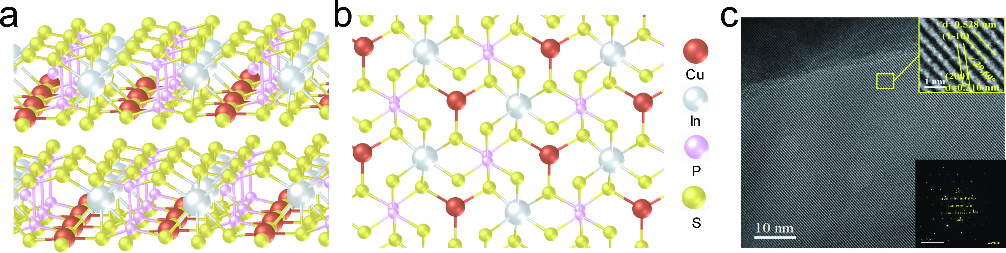
Supplementary Fig. S1. Atomic structure of CIPS. a, Side view of CIPS. b, Top view of CIPS. c, High-resolution transmission electron microscopy (HRTEM) and selected area electron diffraction (SAED) of CIPS flake.

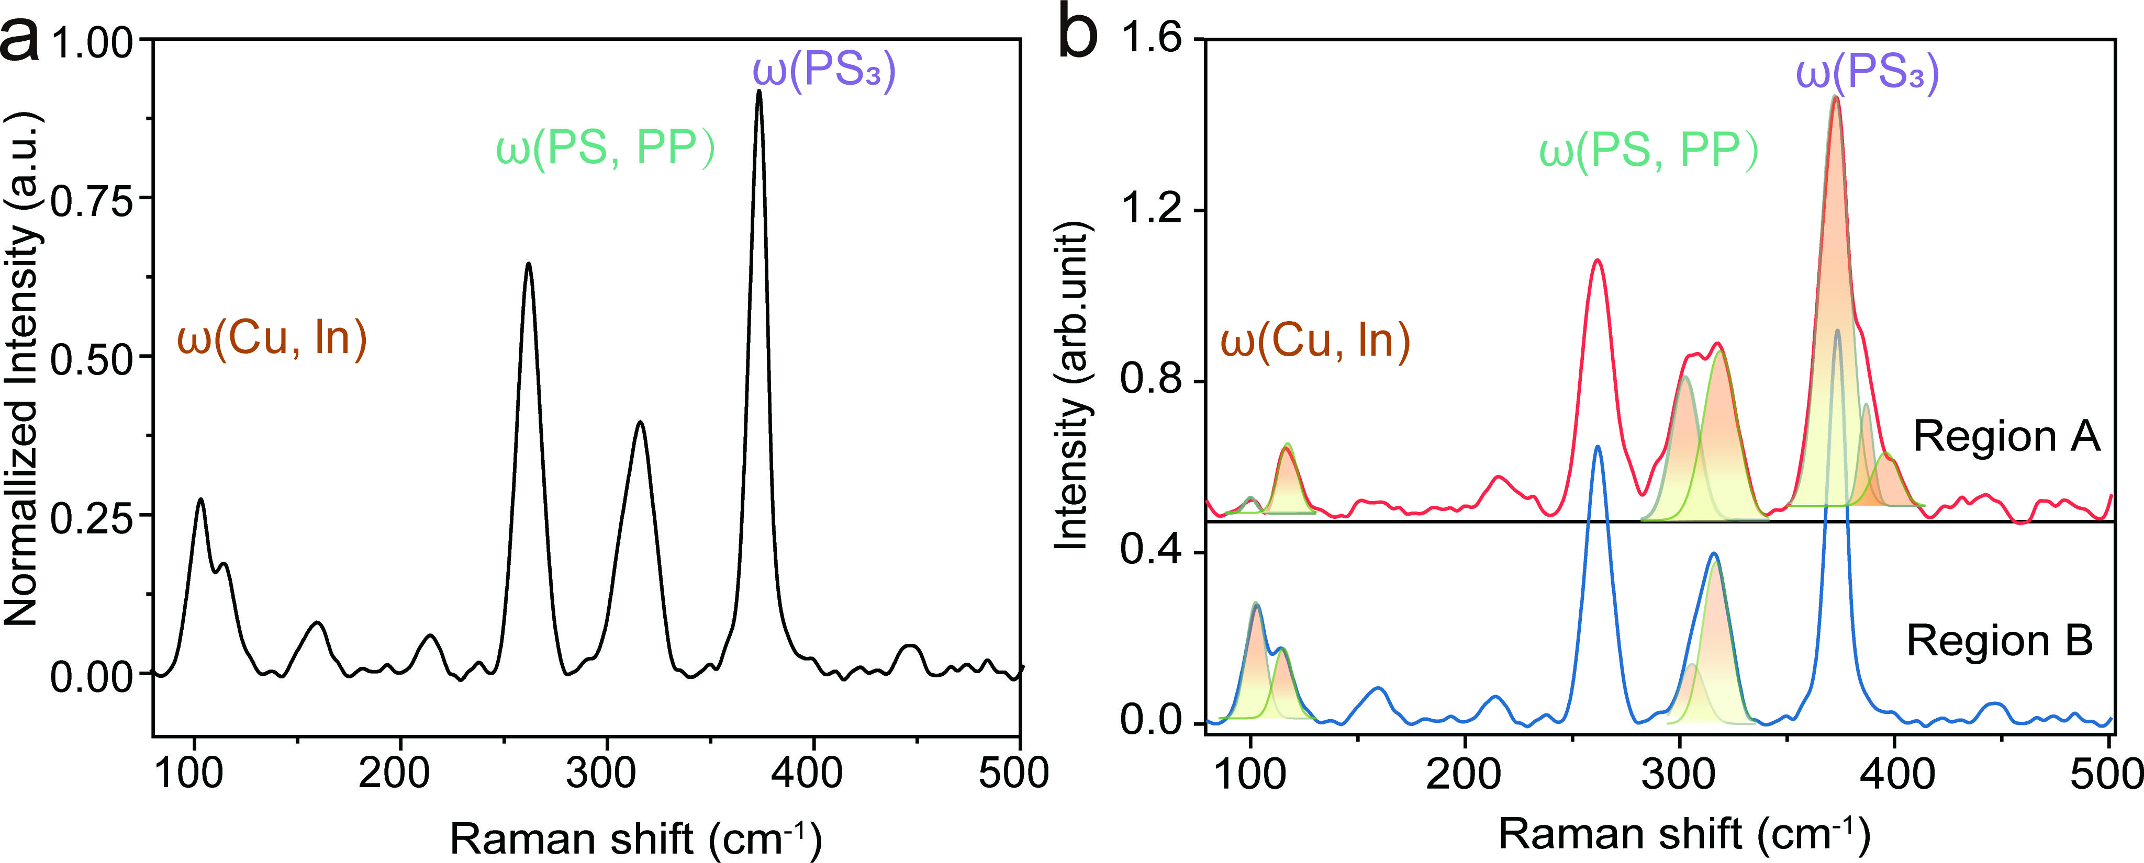
Supplementary Fig. S2. Raman characterization of CIPS. a, Characteristic Raman peaks of pristine CIPS samples. b, Interpretation of Raman peaks before (Region B) and after (Region A) Cu⁺ aggregation.
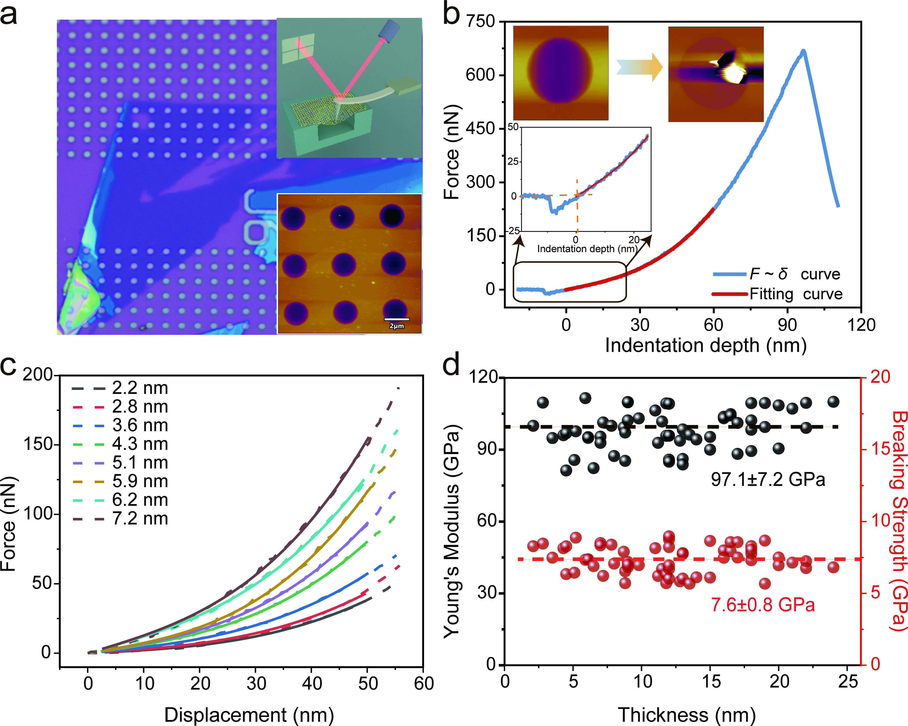
Supplementary Fig. S3. Young’s modulus and fracture strength of CIPS. a, Optical image of exfoliated CIPS sample suspended over circular holes. The insets show the corresponding topography images and the schematic of AFM-based nanoindentation. b, Force-indentation depth curves. The inset displays the surface morphology before and after nanoindentation test. c, Curve fitting for CIPS flakes with various thicknesses. d, Measurements of Young’s modulus and fracture strength with thickness independence.

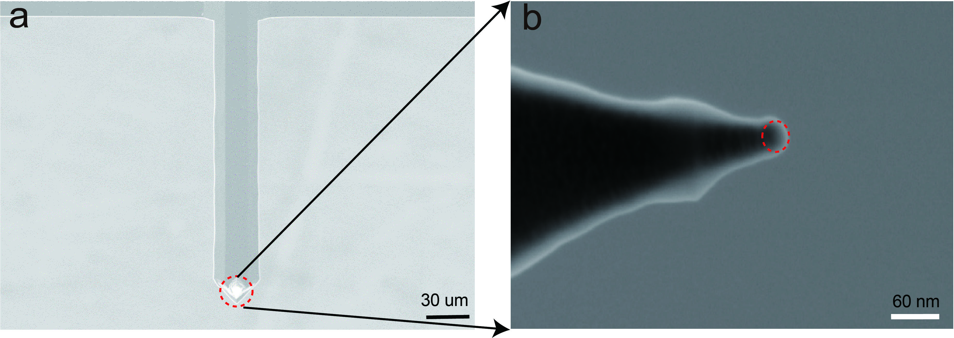
Supplementary Fig. S4. SEM image of the Adama FM-LC probe. a, SEM image of the AFM probe. b, Magnified image of the tip.

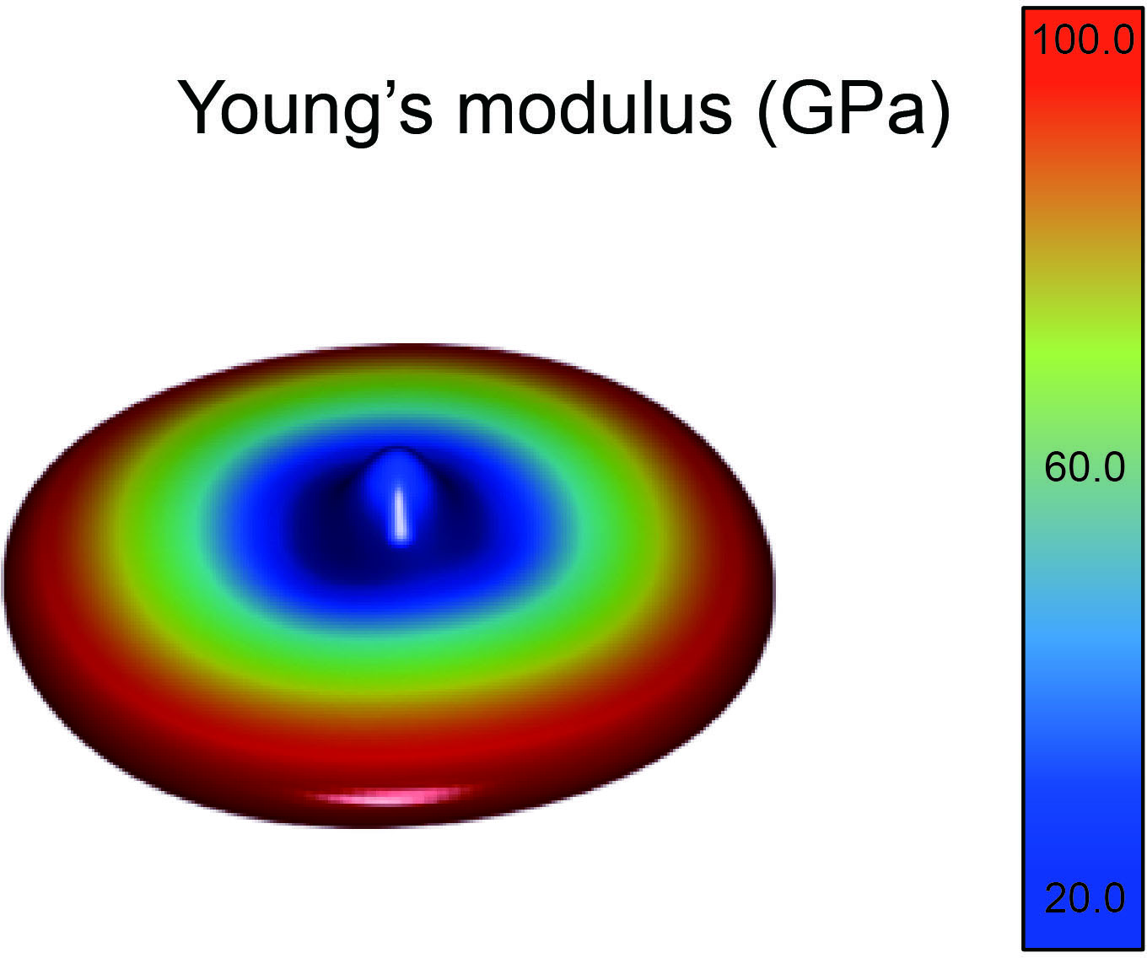

Supplementary Fig. S5. Young’s modulus calculated by density function theory (DFT) simulation.

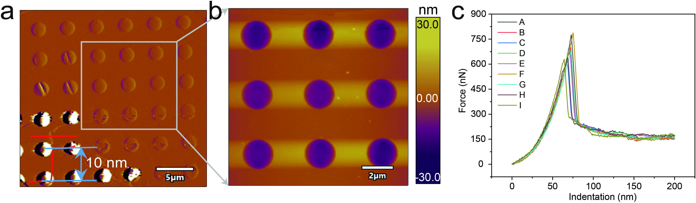

Supplementary Fig. S6. Statistics of the fracture force of suspended films. a, Thickness measurement of suspended CIPS films. b, Surface morphology characterization of CIPS samples for fatigue testing. c, Statistics of fracture force of tested CIPS samples.

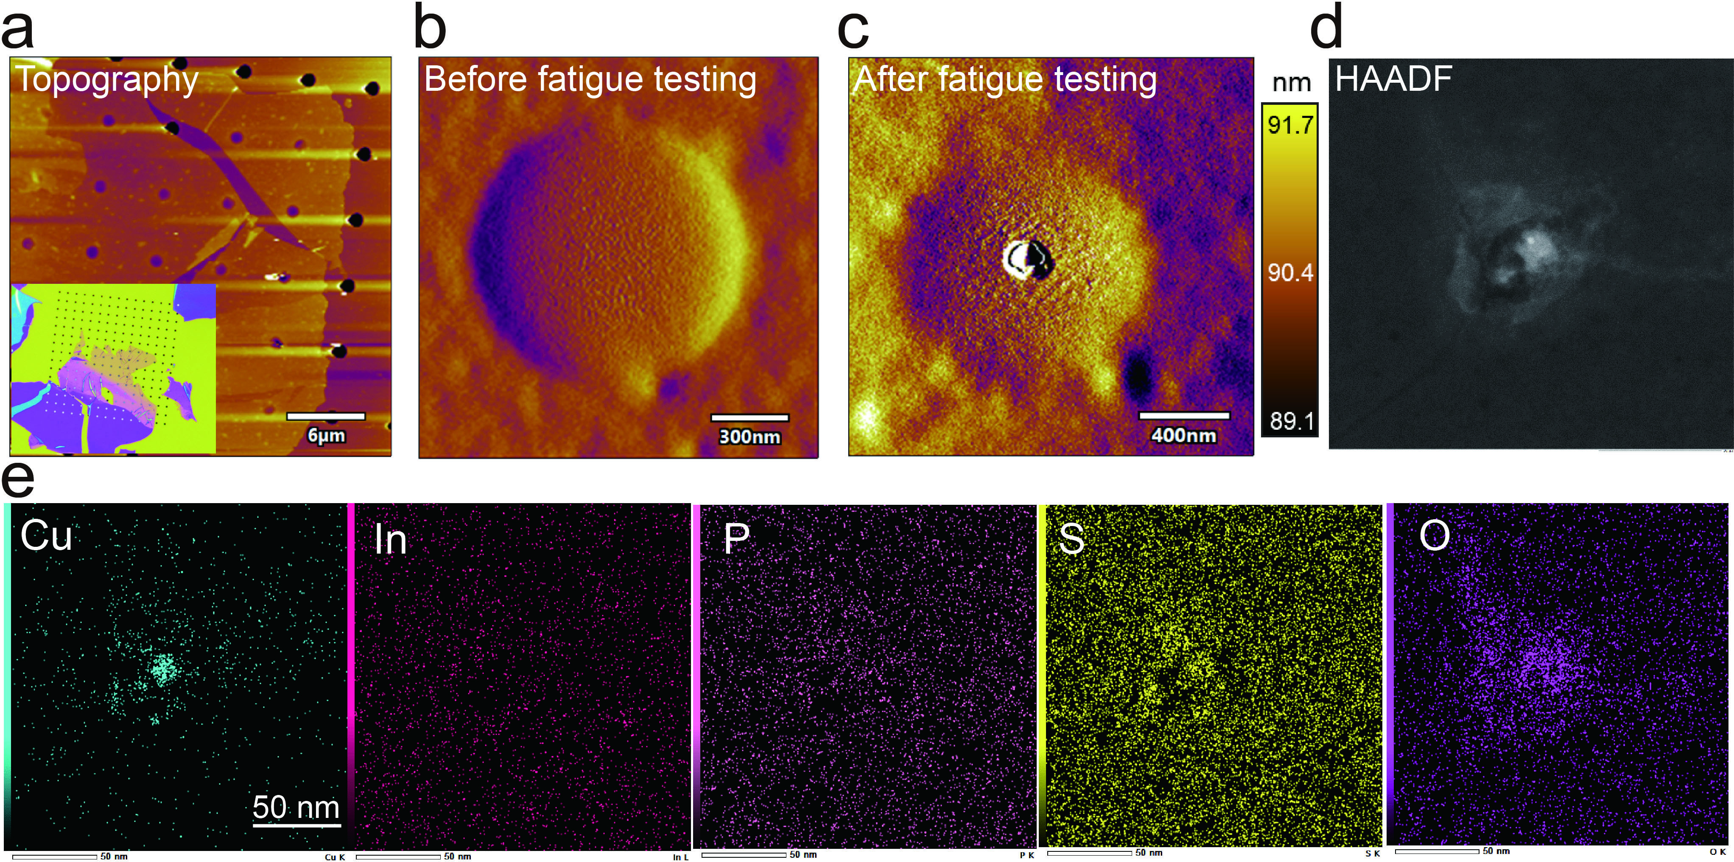
Supplementary Fig. S7. TEM and EDS characterization of Cu⁺ aggregation. a, CIPS flakes placed on the silicon nitride substrate. The inset shows the corresponding optical image. b, Surface morphology of suspended CIPS sample. c, Cu⁺ ion aggregation after fatigue testing. d, High resolution TEM image of the surface protrusion area. e, Energy-dispersive spectroscopy (EDS) elemental mapping of surface protrusion area.

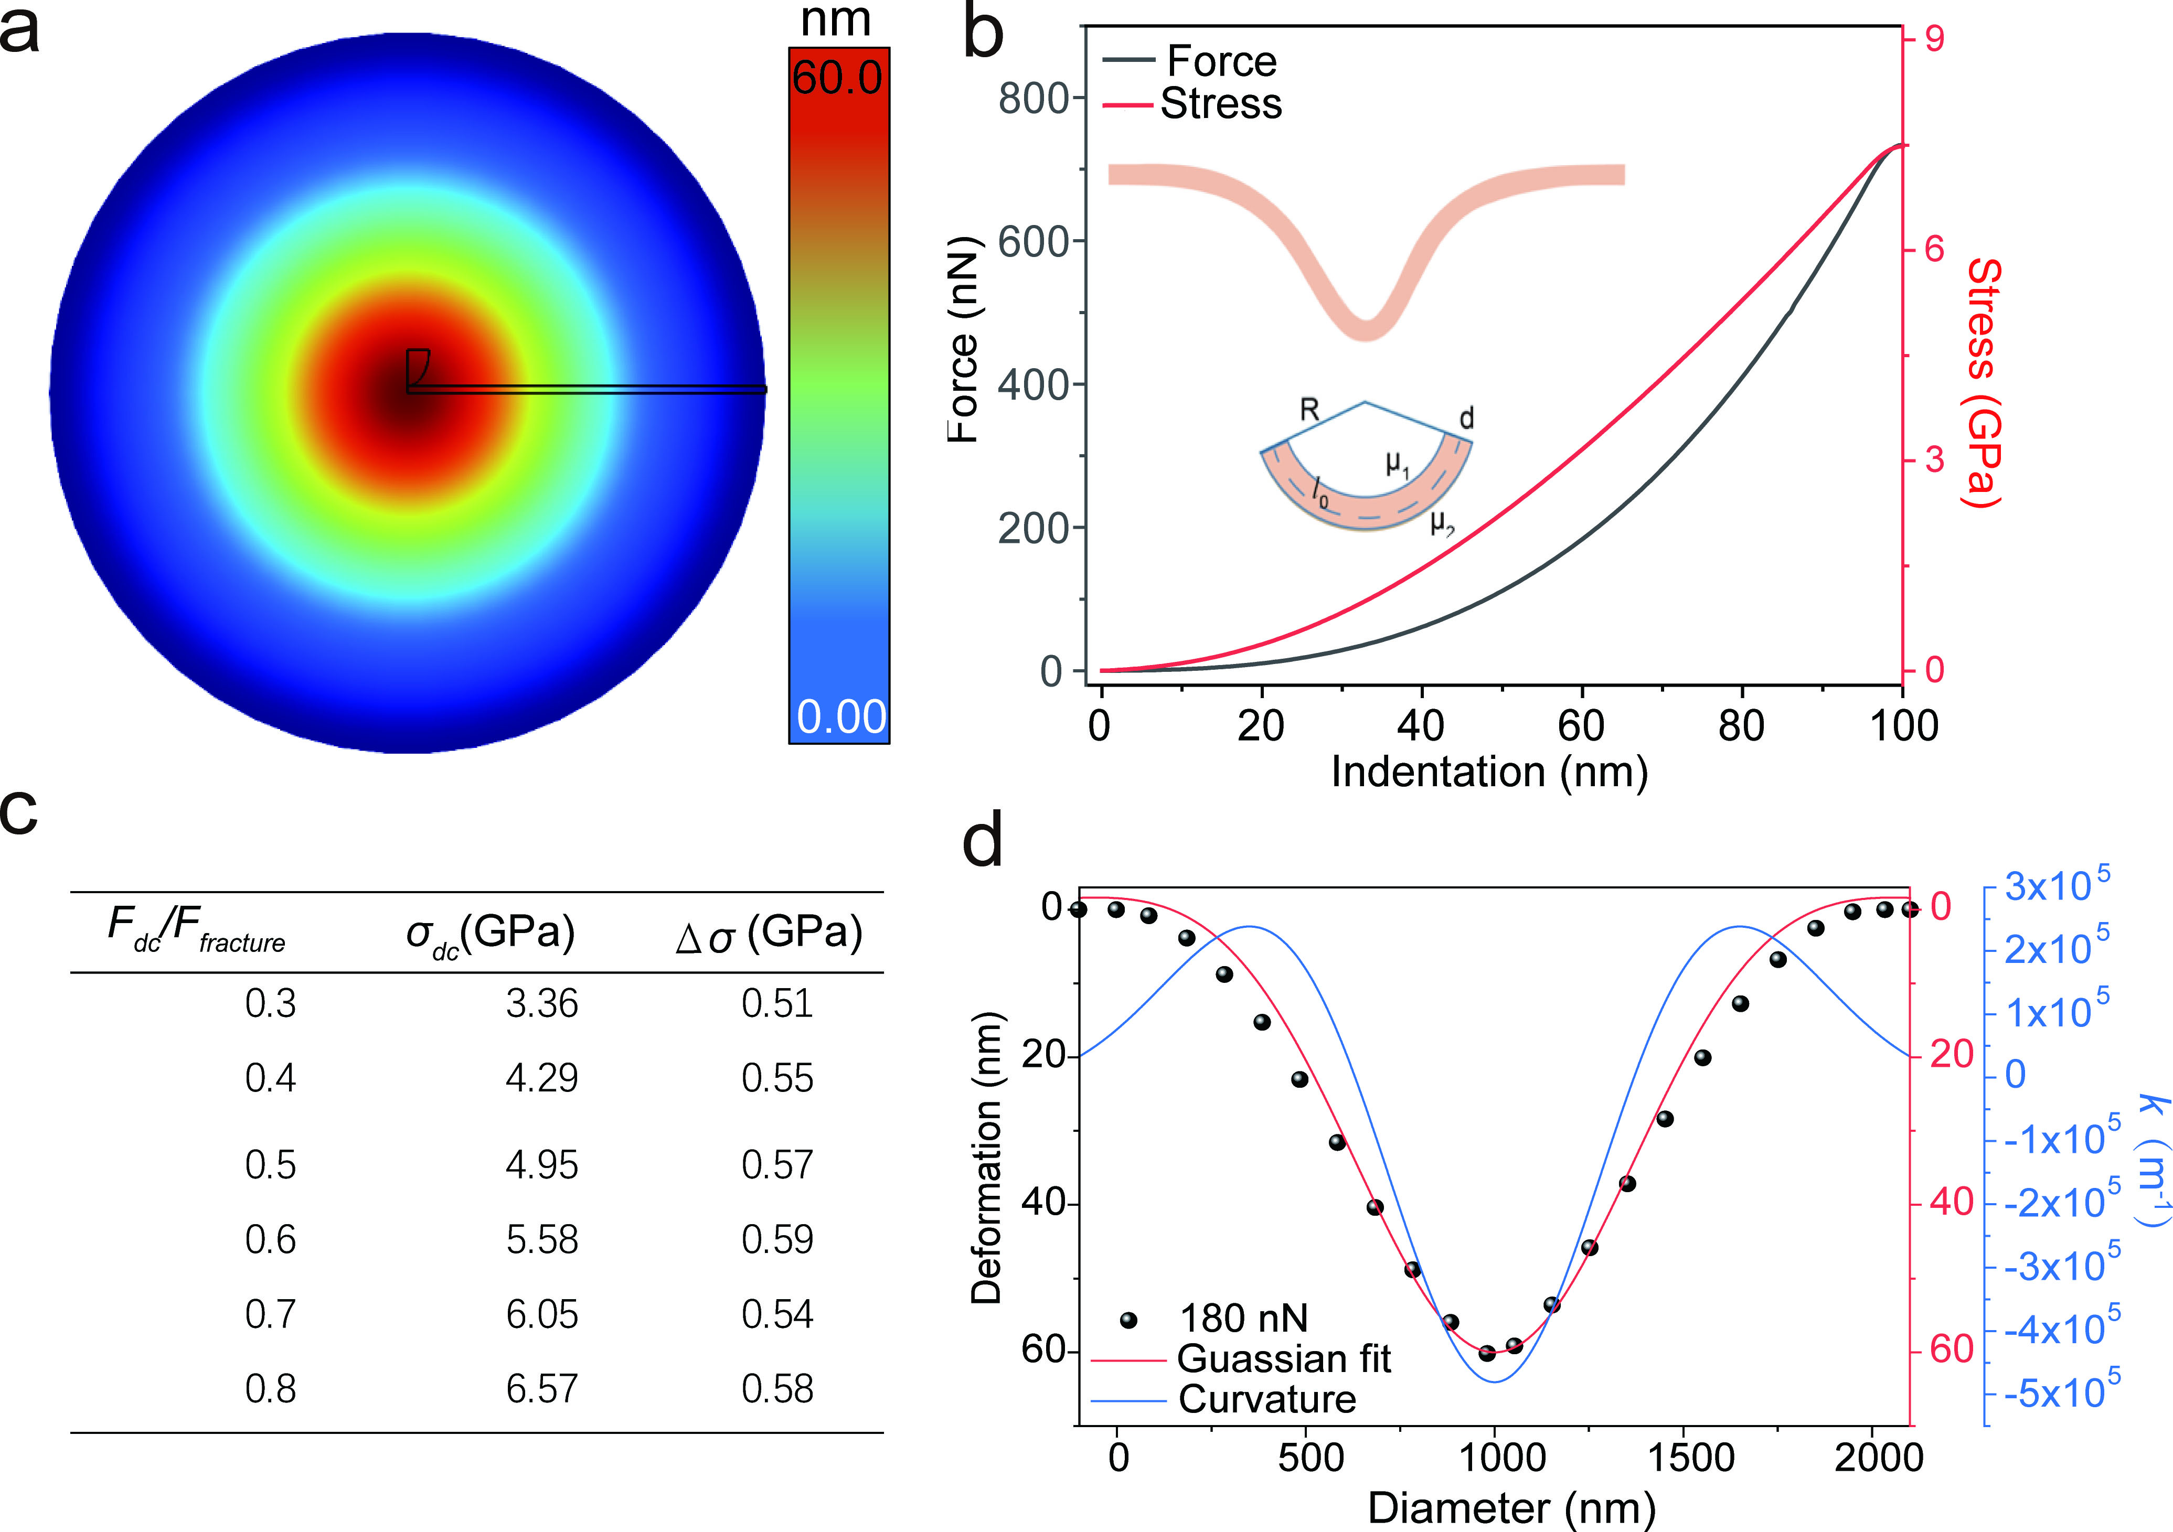
Supplementary Fig. S8. Finite element calculation of flexoelectric field. a, Contour of out-of-plane deformation of the suspended film. b, Maximum in-plane stress and force at the center as a function of indentation depth. c, Summary of mean stress and cyclic stress at different F_{DC} for an oscillation amplitude of 5 nm. d, Gaussian fitting of the deflection profile and the corresponding curvature of the suspended film.

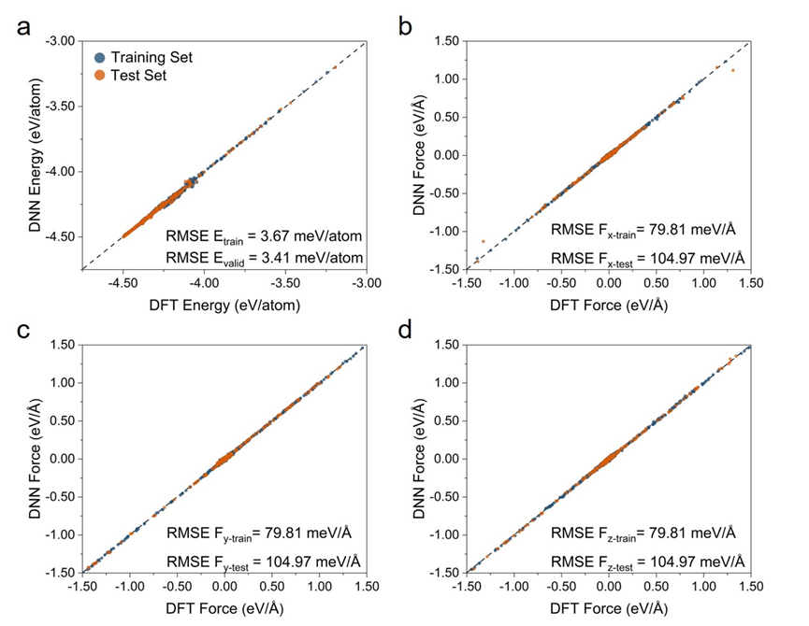
Supplementary Fig. S9. Performance of the DNN potential. Parity plots comparing (a) total energies and (b–d) atomic forces along x, y, z directions predicted by DFT (reference) and by the final DNN potential for the training set (blue dots) and test set (orange dots). The black dashed lines indicate perfect agreement.
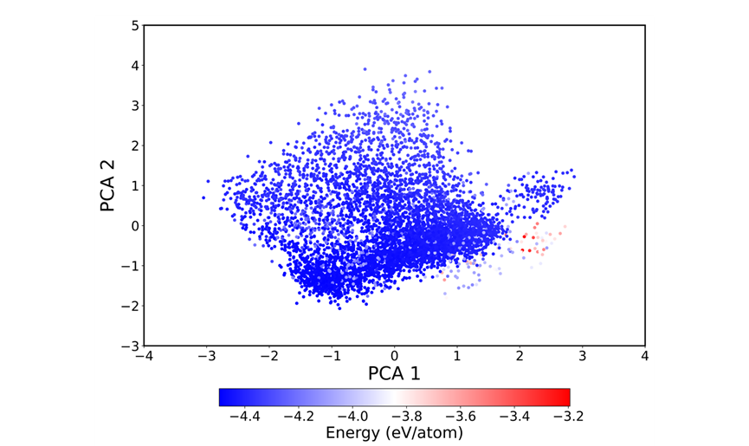
Supplementary Fig. S10. Coverage of the training set in descriptor space. Principal component analysis (PCA) was performed based on the Smooth Overlap of Atomic Positions (SOAP) descriptors for all training configurations. Points are colored by energy from −4.5 to −3.2 eV atom⁻¹. SOAP features and the PCA were computed with the open-source Automated Simulations and Analysis Package (ASAP).

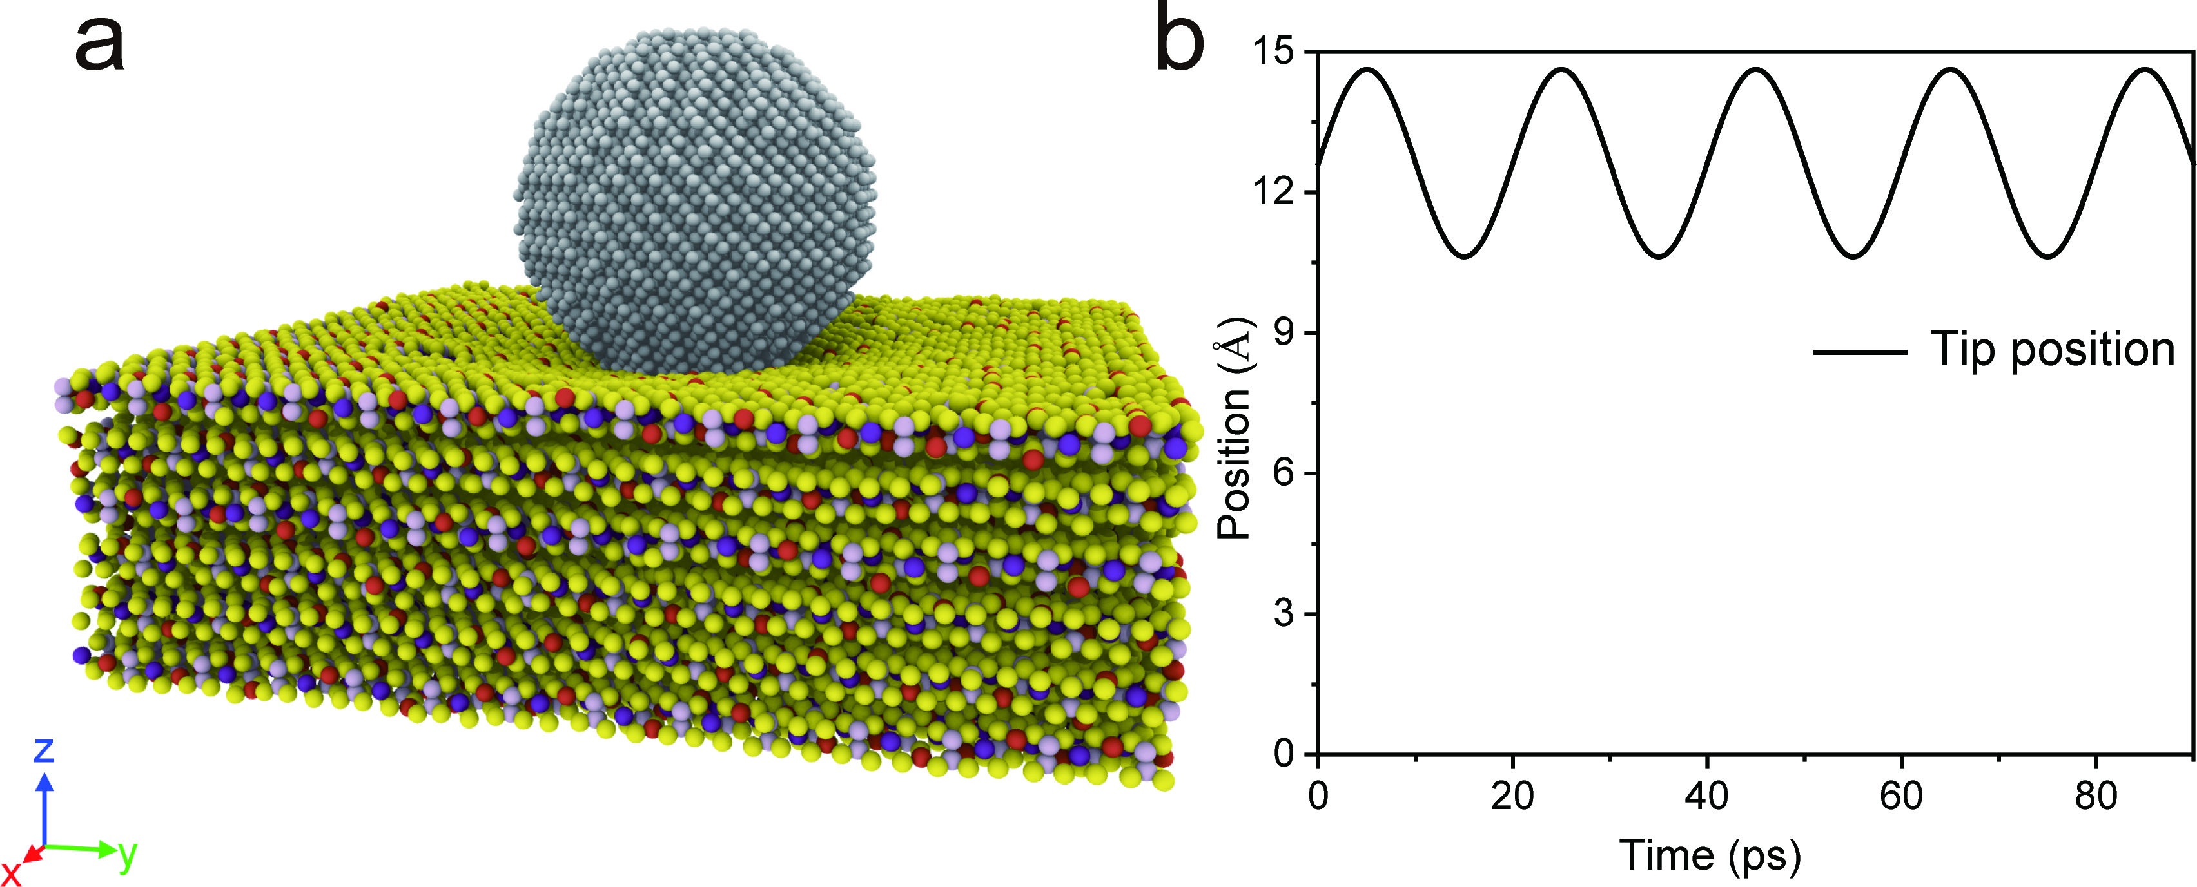
Supplementary Fig. S11. Molecular dynamics simulation. a, The schematic of dynamic indentation setup. b, The variation of indentation depth as a function of time.

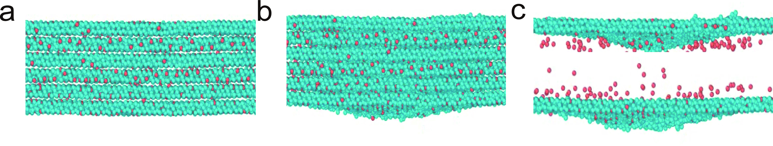
Supplementary Fig. S12. Indentation process in MD simulation. a, Initial state and b, deformed state of CIPS under indentation load. c, Cu⁺ ion migration for the top and bottom layers after 2 ns of cyclic loading.

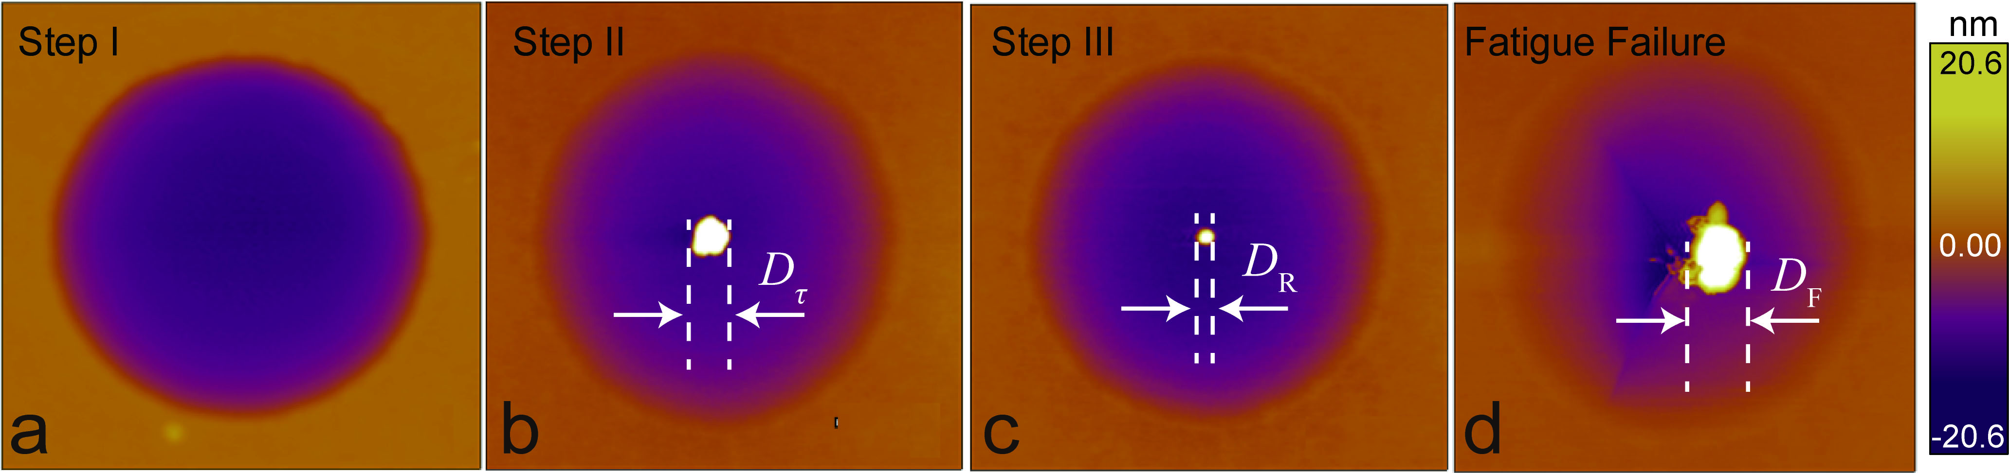
Supplementary Fig. S13. Modulation of Cu⁺ ion aggregation by electric field. a, The initial state of suspended CIPS film. b, The Cu⁺ ion aggregation after mechanical fatigue testing for 30 minutes, showing a diameter of $D_{τ}$. c, The shrinkage of Cu⁺ cluster down to $D_{R}$ under +5 V voltage for 10 s. d, Final fatigue failure of CIPS flakes featuring Cu⁺ ion aggregation with size of $D_{F}$.

Reference
1. Vysochanskii YM, Stephanovich V, Molnar A, Cajipe V, Bourdon X. Raman spectroscopy study of the ferrielectric-paraelectric transition in layered CuInP₂S₆. Phys. Rev. B 58, 9119 (1998).
2. Rao R, Selhorst R, Conner BS, Susner MA. Ferrielectric-paraelectric phase transitions in layered CuInP₂S₆ and CuInP₂S₆-In_{4/3}P₂S₆ heterostructures: A Raman spectroscopy and x-ray diffraction study. Phys. Rev. Mater. 6, 045001 (2022).
3. Ruedenberg K. The physical nature of the chemical bond. Rev. Mod. Phys. 34, 326 (1962).
4. Wang G, et al. Recent advances in the mechanics of 2D materials. Int. J. Extreme. Manuf. 5, 032002 (2023).
5. OH B. The exponential law of endurance tests. Proc. Am. Soc. Test. Mater. 10625-10630 (1910).
6. Suresh S. Fatigue of materials. Cambridge university press (1998).
7. Morrow J. Fatigue properties of metals. Fatigue design handbook 4, 21-30 (1968).
8. Cui T, et al. Fatigue of graphene. Nat. Mater. 19, 405-411 (2020).
9. Wang H, Zhang L, Han J. DeePMD-kit: A deep learning package for many-body potential energy representation and molecular dynamics. Comput. Phys. Commun. 228, 178-184 (2018).
10. Einstein A. Investigations on the Theory of the Brownian Movement. Courier Corporation (1956).

