Copper-catalyzed decarboxylation of α,α-difluoroarylacetic acid
with 1,2,4-triazine-3,5(2H,4H)-dione

Yiwen Huo ^{a, 1}, Rongfei Liu ^{a, 1}, Yue Liu^{b, 1}, Qinjiang Zhouª, Yanna Lv^{a,} *, Jinxing Hu^{a,} *

ª School of Pharmacy, Shandong Second Medical University, Weifang, Shandong, 261053, PR China.
^{b} School of Basic Medical Sciences, Shandong Second Medical University, Weifang, Shandong, 261053, PR China.
*Corresponding author.
- mail address: lynlyna@163.com (Y. Lv), jinxinghu2013@sdsmu.edu.cn (J. Hu).
¹ these authors contributed equally to this work

General experimental procedure
In a Schlenk tube, 1,2,4-triazine-3,5(2H,4H)-dione (1, 0.5 mmol), α,α-difluoroarylacetic acid (2, 0.75 mmol), CuI (20 mol%), NaHCO₃ (1.0 mmol), (NH₄)₂S₂O₈ (2.0 mmol), and DMSO (2.0 mL) were sequentially added, and the mixture was purged with nitrogen. The reaction mixture was then heated to 60°C and maintained at this temperature for 4 h, with the progress of the reaction monitored by TLC. Upon completion of the reaction, water was added to the mixture, which was subsequently extracted with dichloromethane (30 mL) and washed with saturated sodium chloride solution (10 mL × 3). The organic layer was dried over anhydrous Na₂SO₄ and concentrated under vacuum. The residue was purified by silica gel column chromatography using a petroleum ether/ethyl acetate eluent to yield the desired 6-substituted 1,2,4-triazine-3,5(2H,4H)-dione (3).

6-(difluoro(phenyl)methyl)-2,4-dimethyl-1,2,4-triazine-3,5(2H,4H)-dione (3a)
Yield: 86% ; White solid; m. p. 100.7-102.1℃. ¹H NMR (400 MHz, CDCl₃) δ 7.63 (d, J = 5.9 Hz, 2H), 7.46 (s, 3H), 3.70 (s, 3H), 3.31 (s, 3H). ¹³C NMR (101 MHz, CDCl₃) δ 153.24, 148.93, 137.24, 136.93, 136.63, 134.55, 134.29, 134.02, 130.52, 128.37, 125.91, 125.85, 125.79, 119.09, 116.64, 114.19, 40.16, 27.29. ¹⁹F NMR (376 MHz, CDCl₃) δ -98.04. HRMS (ESI-Q-TOF, m/z) calcd for C₁₂H₁₁N₃O₂F₂Na [M+Na]⁺: 290.0717, found [M+Na]⁺: 290.0714.

2,4-di(but-2-yn-1-yl)-6-(difluoro(phenyl)methyl)-1,2,4-triazine-3,5(2H,4H)-dione (3b)
Yield: 38% ; White solid; m.p.113.6-115.0℃. ¹H NMR (400 MHz, CDCl₃) δ 7.65 (d, J = 6.7 Hz, 2H), 7.45 (d, J = 5.9 Hz, 3H), 4.74 (s, 2H), 4.58 (s, 2H), 1.84 (s, 3H), 1.76 (s, 3H). ¹³C NMR (101 MHz, CDCl₃) δ 152.05, 147.39, 138.06, 137.75, 137.44, 134.37, 134.11, 133.85, 130.55, 128.36, 126.05, 125.99, 125.94, 119.02, 116.57, 114.11, 82.37, 79.95, 71.57, 71.31, 42.75, 30.75, 3.64. ¹⁹F NMR (376 MHz, CDCl₃) δ -97.84. HRMS (ESI-Q-TOF, m/z) calcd for C₁₈H₁₅N₃O₂F₂Na [M+Na]⁺: 366.1030, found [M+Na]⁺: 366.1034.

Diethyl 2,2'-(6-(difluoro(phenyl)methyl)-3,5-dioxo-1,2,4-triazine-2,4(3H,5H)-diyl)diacetate (3c)
Yield: 50% ; White solid; m.p.80.1-81.7℃. ¹H NMR (400 MHz, CDCl₃) δ 7.60 (d, J = 6.5 Hz, 2H), 7.45 (d, J = 6.7 Hz, 3H), 4.76 (s, 2H), 4.61 (s, 2H), 4.27 (d, J = 7.1 Hz, 2H), 4.19 (d, J = 7.1 Hz, 2H), 1.31 (t, J = 7.1 Hz, 3H), 1.24 (t, J = 7.1 Hz, 3H). ¹³C NMR (101 MHz, CDCl₃) δ 166.70, 166.00, 152.28, 148.29, 138.30, 137.99, 137.68, 134.12, 133.86, 133.60, 130.67, 128.47, 125.88, 125.82, 125.77, 118.86, 116.41, 113.94, 62.22, 62.12, 53.09, 41.49, 14.09, 13.99. ¹⁹F NMR (376 MHz, CDCl₃) δ -97.81. HRMS (ESI-Q-TOF, m/z) calcd for C₁₈H₁₉N₃O₆F₂Na [M+Na]⁺: 434.1140, found [M+Na]⁺: 434.1137.

6-(difluoro(phenyl)methyl)-2,4-dipentyl-1,2,4-triazine-3,5(2H,4H)-dione (3d)
Yield: 49% ; White solid; m.p. 117.1-118.4℃. ¹H NMR (400 MHz, CDCl₃) δ 7.61 (d, J = 5.8 Hz, 2H), 7.45 (d, J = 5.3 Hz, 3H), 3.99 (t, J = 7.1 Hz, 2H), 3.90 – 3.80 (m, 2H), 1.75 (dd, J = 14.1, 7.1 Hz, 2H), 1.60 (d, J = 7.1 Hz, 2H), 1.32 (dd, J = 12.3, 5.8 Hz, 8H), 0.94 – 0.85 (m, 6H). ¹³C NMR (101 MHz, CDCl₃) δ 152.91, 148.53, 137.30, 137.00, 136.69, 134.76, 134.50, 134.23, 130.41, 128.96, 128.55, 128.34, 125.86, 125.80, 125.75, 119.30, 116.85, 114.40, 52.22, 41.21, 28.94, 28.47, 27.73, 26.72, 22.34, 22.22, 13.92, 13.90. ¹⁹F NMR (376 MHz, CDCl₃) δ -97.93. HRMS (ESI-Q-TOF, m/z) calcd for C₂₀H₂₇N₃O₂F₂Na [M+Na]⁺: 402.1969, found [M+Na]⁺: 402.1966.

2,4-bis(cyclopropylmethyl)-6-(difluoro(phenyl)methyl)-1,2,4-triazine-3,5(2H,4H)-dione (3e)
Yield: 39% ; White solid; m.p.103.7-104.5℃. ¹H NMR (400 MHz, CDCl₃) δ 7.61 (d, J = 6.3 Hz, 2H), 7.46 (s, 3H), 3.85 (d, J = 7.2 Hz, 2H), 3.79 (d, J = 7.1 Hz, 2H), 1.27 – 1.19 (m, 2H), 0.55 (d, J = 7.1 Hz, 2H), 0.48 (d, J = 7.2 Hz, 2H), 0.41 – 0.33 (m, 4H). ¹³C NMR (101 MHz, CDCl₃) δ 153.22, 148.89, 137.43, 137.12, 136.81, 134.79, 134.53, 134.26, 130.39, 129.01, 128.53, 128.30, 126.59, 125.93, 125.87, 125.82, 125.45, 119.48, 117.04, 114.60, 56.95, 45.73, 9.94, 9.30, 3.95, 3.57. ¹⁹F NMR (376 MHz, CDCl₃) δ -97.78. HRMS (ESI-Q-TOF, m/z) calcd for C₁₈H₁₉N₃O₂F₂Na [M+Na]⁺: 370.1343, found [M+Na]⁺: 370.1342.

2,4-dibenzyl-6-(difluoro(phenyl)methyl)-1,2,4-triazine-3,5(2H,4H)-dione (3f)
Yield: 41% ; White solid; m.p.97.8-98.7℃. ¹H NMR (400 MHz, CDCl₃) δ 7.56 (d, J = 7.0 Hz, 2H), 7.46 (s, 5H), 7.35 – 7.28 (m, 8H), 5.07 (s, 2H), 5.02 (s, 2H). ¹³C NMR (101 MHz, CDCl₃) δ 152.82, 148.50, 137.94, 137.63, 137.31, 135.01, 134.71, 134.50, 134.24, 133.98, 130.48, 129.71, 129.47, 129.06, 128.83, 128.72, 128.66, 128.62, 128.35, 128.31, 128.08, 126.00, 125.94, 125.88, 119.47, 117.03, 114.60, 55.80, 44.39. ¹⁹F NMR (376 MHz, CDCl₃) δ -97.71. HRMS (ESI-Q-TOF, m/z) calcd for C₂₄H₁₉N₃O₂F₂Na [M+Na]⁺: 442.1343, found [M+Na]⁺: 442.1343.

6-(difluoro(phenyl)methyl)-2,4-bis(4-fluorobenzyl)-1,2,4-triazine-3,5(2H,4H)-dione (3g)
Yield: 56% ; White solid; m.p.110.5-111.2℃. ¹H NMR (400 MHz, CDCl₃) δ 7.55 (d, J = 7.3 Hz, 2H), 7.46 (d, J = 4.0 Hz, 5H), 7.35 – 7.27 (m, 2H), 7.00 (dt, J = 16.2, 8.1 Hz, 4H), 5.03 (s, 2H), 4.98 (s, 2H). ¹³C NMR (101 MHz, CDCl₃) δ 164.11, 163.88, 161.65, 161.42, 152.69, 148.41, 137.79, 137.47, 134.61, 134.38, 134.12, 133.86, 131.81, 131.72, 131.53, 131.45, 131.10, 131.01, 130.80, 130.76, 130.67, 130.55, 130.45, 130.42, 128.37, 125.96, 125.90, 125.84, 119.44, 117.00, 115.88, 115.67, 115.64, 115.43, 114.57, 54.99, 43.68. ¹⁹F NMR (376 MHz, CDCl₃) δ -97.74, -112.87, -113.25. HRMS (ESI-Q-TOF, m/z) calcd for C₂₄H₁₇N₃O₂F₄Na [M+Na]⁺: 478.1155, found [M+Na]⁺: 478.1156.

2,4-bis(4-chlorobenzyl)-6-(difluoro(phenyl)methyl)-1,2,4-triazine-3,5(2H,4H)-dione (3h)
Yield: 69% ; White solid; m.p.127.9-129.3℃. ¹H NMR (400 MHz, CDCl₃) δ 7.54 (d, J = 6.9 Hz, 2H), 7.47 (t, J = 8.7 Hz, 3H), 7.39 (d, J = 8.1 Hz, 2H), 7.34 – 7.26 (m, 4H), 7.24 (s, 2H), 5.03 (s, 2H), 4.97 (s, 2H). ¹³C NMR (101 MHz, CDCl₃) δ 152.63, 148.37, 138.18, 137.86, 137.54, 134.75, 134.37, 134.05, 133.79, 133.31, 132.95, 131.22, 130.58, 130.52, 129.05, 128.85, 128.39, 125.95, 125.89, 125.83, 119.41, 116.95, 114.50, 55.05, 43.75. ¹⁹F NMR (376 MHz, CDCl₃) δ -97.75. HRMS (ESI-Q-TOF, m/z) calcd for C₂₄H₁₇N₃O₂F₂NaCl₂ [M+Na]⁺: 510.0564, found [M+Na]⁺: 510.0561.

2,4-bis(4-bromobenzyl)-6-(difluoro(phenyl)methyl)-1,2,4-triazine-3,5(2H,4H)-dione (3i)
Yield: 80% ; White solid; m.p.132.0-133.2℃. ¹H NMR (400 MHz, CDCl₃) δ 7.54 (d, J = 8.0 Hz, 2H), 7.49 – 7.41 (m, 7H), 7.33 (d, J = 7.4 Hz, 2H), 7.19 (d, J = 7.7 Hz, 2H), 5.01 (s, 2H), 4.96 (s, 2H). ¹³C NMR (101 MHz, CDCl₃) δ 152.61, 148.35, 138.24, 137.87, 137.56, 134.28, 134.02, 133.79, 133.42, 132.03, 131.82, 131.53, 130.81, 130.59, 128.39, 125.94, 125.88, 125.82, 122.94, 122.58, 116.93, 114.50, 55.11, 43.81. ¹⁹F NMR (376 MHz, CDCl₃) δ -97.77. HRMS (ESI-Q-TOF, m/z) calcd for C₂₄H₁₇N₃O₂F₂NaBr₂ [M+Na]⁺: 597.9553, found [M+Na]⁺: 597.9551.

6-(difluoro(phenyl)methyl)-2,4-bis(4-(trifluoromethyl)benzyl)-1,2,4-triazine-3,5(2H,4H)-dione (3j)
Yield: 74% ; White solid; m.p.113.0-114.6℃. ¹H NMR (400 MHz, CDCl₃) δ 7.61 (d, J = 7.7 Hz, 2H), 7.55 (d, J = 10.2 Hz, 6H), 7.46 (dd, J = 17.9, 9.7 Hz, 5H), 5.13 (s, 2H), 5.06 (s, 2H). ¹³C NMR (101 MHz, CDCl₃) δ 152.56, 148.40, 138.54, 138.21, 138.10, 134.18, 133.92, 133.66, 131.12, 130.79, 130.66, 130.46, 130.00, 129.40, 128.42, 126.83, 125.92, 125.86, 125.80, 125.72, 125.69, 125.65, 125.62, 125.27, 125.23, 122.56, 122.52, 119.32, 116.88, 114.42, 55.19, 43.95. ¹⁹F NMR (376 MHz, CDCl₃) δ -62.73, -97.86. HRMS (ESI-Q-TOF, m/z) calcd for C₂₆H₁₇N₃O₂F₈Na [M+Na]⁺: 578.1091, found [M+Na]⁺: 578.1091.

6-(difluoro(phenyl)methyl)-2,4-bis(4-methylbenzyl)-1,2,4-triazine-3,5(2H,4H)-dione (3k)
Yield: 65% ; White solid; m.p.155.3-156.6℃. ¹H NMR (400 MHz, CDCl₃) δ 7.56 (d, J = 7.3 Hz, 2H), 7.45 (d, J = 7.4 Hz, 3H), 7.36 (d, J = 7.6 Hz, 2H), 7.22 (d, J = 7.8 Hz, 2H), 7.12 (dd, J = 14.0, 7.7 Hz, 4H), 4.99 (d, J = 20.1 Hz, 4H), 2.33 (d, J = 13.8 Hz, 6H). ¹³C NMR (101 MHz, CDCl₃) δ 152.86, 148.46, 138.46, 138.14, 137.83, 137.52, 137.21, 134.57, 134.31, 134.05, 132.12, 131.76, 130.45, 129.76, 129.48, 129.31, 129.05, 128.85, 128.68, 128.33, 126.01, 125.95, 125.90, 119.52, 117.06, 114.62, 55.58, 44.10, 21.23, 21.19. ¹⁹F NMR (376 MHz, CDCl₃) δ -97.66. HRMS (ESI-Q-TOF, m/z) calcd for C₂₆H₂₃N₃O₂F₂Na [M+Na]⁺: 470.1656, found [M+Na]⁺: 470.1653.

6-(difluoro(phenyl)methyl)-2,4-bis(3-methylbenzyl)-1,2,4-triazine-3,5(2H,4H)-dione (3l)
Yield: 47% ; White solid; m.p.100.3-101.7℃. ¹H NMR (400 MHz, CDCl₃) δ 7.57 (d, J = 7.0 Hz, 2H), 7.45 (d, J = 7.5 Hz, 3H), 7.25 – 7.07 (m, 8H), 5.01 (d, J = 19.4 Hz, 4H), 2.32 (d, J = 13.3 Hz, 6H). ¹³C NMR (101 MHz, CDCl₃) δ 152.85, 148.51, 138.55, 138.38, 137.89, 137.58, 137.26, 134.96, 134.69, 134.57, 134.30, 134.04, 130.47, 130.25, 129.63, 129.33, 129.04, 128.71, 128.54, 128.33, 126.69, 126.05, 126.02, 125.96, 125.90, 119.54, 117.09, 114.66, 55.76, 44.33, 21.40, 21.36. ¹⁹F NMR (376 MHz, CDCl₃) δ -98.01. HRMS (ESI-Q-TOF, m/z) calcd for C₂₆H₂₃N₃O₂F₂Na [M+Na]⁺: 470.1656, found [M+Na]⁺: 470.1652.

4-((6-(difluoro(phenyl)methyl)-4-(4-isocyanobenzyl)-3,5-dioxo-4,5-dihydro-1,2,4-triazin-2(3H)-yl)methyl)benzonitrile (3m)
Yield: 64% ; White solid; m.p.151.9-152.6℃. ¹H NMR (400 MHz, CDCl₃) δ 7.64 (d, J = 7.6 Hz, 2H), 7.59 (d, J = 7.7 Hz, 2H), 7.54 (d, J = 5.6 Hz, 4H), 7.50 – 7.41 (m, 5H), 5.12 (s, 2H), 5.04 (s, 2H). ¹³C NMR (101 MHz, CDCl₃) δ 152.48, 148.38, 139.62, 139.28, 138.59, 138.27, 137.94, 134.04, 133.78, 133.52, 132.69, 132.51, 130.75, 130.35, 129.73, 128.46, 125.90, 125.85, 125.79, 119.24, 118.39, 118.27, 116.79, 112.78, 112.40, 55.24, 44.06. ¹⁹F NMR (376 MHz, CDCl3) δ -97.99. HRMS (ESI-Q-TOF, m/z) calcd for C₂₆H₁₇N₅O₂F₂Na [M+Na]⁺: 492.1248, found [M+Na]⁺: 492.1245.

6-(difluoro(phenyl)methyl)-2,4-bis(4-nitrobenzyl)-1,2,4-triazine-3,5(2H,4H)-dione (3n)
Yield: 29% ; White solid; m.p. 99.8-101.2℃. ¹H NMR (400 MHz, CDCl₃) δ 8.17 (dd, J = 21.9, 7.9 Hz, 4H), 7.60 (d, J = 7.9 Hz, 2H), 7.55 (d, J = 6.9 Hz, 2H), 7.48 (t, J = 8.5 Hz, 5H), 5.18 (s, 2H), 5.09 (s, 2H). ¹³C NMR (101 MHz, CDCl₃) δ 152.47, 148.38, 148.08, 147.81, 141.51, 141.12, 138.39, 133.75, 130.77, 130.57, 129.96, 128.48, 125.91, 125.85, 125.79, 124.08, 123.88, 116.79, 54.93, 43.76. ¹⁹F NMR (376 MHz, CDCl₃) δ -97.89. HRMS (ESI-Q-TOF, m/z) calcd for C₂₄H₁₇N₅O₆F₂Na [M+Na]⁺: 532.1045, found [M+Na]⁺: 532.1041.
6-(difluoro(phenyl)methyl)-2,4-bis(2-(4-fluorophenyl)-2-oxoethyl)-1,2,4-triazine-3,5(2H,4H)-dione (3o)
Yield: 40% ; White solid; m.p.85.1-86.3℃. ¹H NMR (400 MHz, CDCl₃) δ 8.05 – 7.95 (m, 4H), 7.62 (d, J = 5.7 Hz, 2H), 7.46 (s, 3H), 7.24 – 7.13 (m, 4H), 5.47 (s, 2H), 5.30 (s, 2H). ¹³C NMR (101 MHz, CDCl₃) δ 189.30, 188.20, 167.72, 167.59, 165.16, 165.04, 152.57, 148.69, 138.11, 137.81, 134.31, 133.95, 133.69, 130.94, 130.85, 130.73, 130.67, 130.56, 130.53, 130.15, 128.51, 128.41, 125.90, 125.85, 125.79, 118.97, 116.46, 116.30, 116.24, 116.08, 57.81, 46.44. ¹⁹F NMR (376 MHz, CDCl₃) δ -97.51, -102.24, -102.69. HRMS (ESI-Q-TOF, m/z) calcd for C₂₆H₁₇N₃O₄F₄Na [M+Na]⁺: 534.1053, found [M+Na]⁺: 534.1052.

2,4-bis(2-(4-chlorophenyl)-2-oxoethyl)-6-(difluoro(phenyl)methyl)-1,2,4-triazine-3,5(2H,4H)-dione (3p)
Yield: 55% ; White solid; m.p.100.2-101.3℃. ¹H NMR (400 MHz, CDCl₃) δ 7.90 (dd, J = 15.5, 8.3 Hz, 4H), 7.61 (d, J = 7.9 Hz, 2H), 7.53 – 7.44 (m, 7H), 5.46 (s, 2H), 5.29 (s, 2H). ¹³C NMR (101 MHz, CDCl₃) δ 189.74, 188.64, 152.53, 148.64, 141.03, 140.79, 138.45, 138.14, 133.91, 133.65, 132.55, 132.38, 131.99, 130.69, 130.11, 129.52, 129.51, 129.45, 129.30, 128.84, 128.51, 126.44, 125.90, 125.84, 125.78, 116.51, 114.05, 57.85, 57.85, 46.49, 46.49. ¹⁹F NMR (376 MHz, CDCl₃) δ -97.52. HRMS (ESI-Q-TOF, m/z) calcd for C₂₆H₁₇N₃O₄F₂NaCl₂ [M+Na]⁺: 566.0462, found [M+Na]⁺: 566.0461.

6-(difluoro(phenyl)methyl)-2,4-bis(2-oxo-2-(4-(trifluoromethyl)phenyl)ethyl)-1,2,4-triazine-3,5(2H,4H)-dione (3q)
Yield: 52% ; White solid; m.p.100.2-101.8℃. ¹H NMR (400 MHz, CDCl₃) δ 8.07 (dd, J = 16.6, 7.9 Hz, 4H), 7.79 (dd, J = 18.5, 7.9 Hz, 4H), 7.62 (d, J = 5.6 Hz, 2H), 7.47 (s, 3H), 5.51 (s, 2H), 5.34 (s, 2H). ¹³C NMR (101 MHz, CDCl₃) δ 190.11, 189.08, 152.45, 148.60, 138.61, 138.30, 136.86, 136.68, 135.80, 135.59, 135.47, 135.26, 133.83, 133.57, 130.75, 128.53, 126.17, 126.14, 126.09, 126.04, 126.01, 125.88, 125.83, 125.77, 124.70, 121.97, 118.94, 116.48, 114.04, 58.06, 46.72. ¹⁹F NMR (376 MHz, CDCl₃) δ -63.29, -97.56. HRMS (ESI-Q-TOF, m/z) calcd for C₂₈H₁₇N₃O₄F₈Na [M+Na]⁺: 634.0989 , found [M+Na]⁺: 634.0991.

6-(difluoro(phenyl)methyl)-2,4-bis(2-(4-methoxyphenyl)-2-oxoethyl)-1,2,4-triazine-3,5(2H,4H)-dione (3r)
Yield: 67% ; White solid; m.p.90.5-91.5℃. ¹H NMR (400 MHz, CDCl₃) δ 7.94 (dd, J = 12.8, 8.7 Hz, 4H), 7.63 (d, J = 4.8 Hz, 2H), 7.45 (s, 3H), 6.97 (dd, J = 17.6, 8.3 Hz, 4H), 5.45 (s, 2H), 5.29 (s, 2H), 3.89 (d, J = 9.9 Hz, 6H). ¹³C NMR (101 MHz, CDCl₃) δ 189.24, 188.08, 164.42, 164.25, 152.73, 148.77, 137.87, 134.11, 130.79, 130.57, 130.48, 128.46, 128.21, 127.35, 127.16, 125.94, 125.88, 125.83, 116.59, 114.22, 114.15, 114.07, 113.83, 57.68, 55.61, 55.56, 46.28. ¹⁹F NMR (376 MHz, CDCl₃) δ -97.44. HRMS (ESI-Q-TOF, m/z) calcd for C₂₈H₂₃N₃O₆F₂Na [M+Na]⁺: 558.1453 , found [M+Na]⁺: 558.1457.

6-(difluoro(4-fluorophenyl)methyl)-2,4-dimethyl-1,2,4-triazine-3,5(2H,4H)-dione (3s)
Yield: 49% ; White solid; m.p.100.2-100.9℃. ¹H NMR (400 MHz, CDCl₃) δ 7.66 – 7.57 (m, 2H), 7.13 (t, J = 8.3 Hz, 2H), 3.70 (s, 3H), 3.32 (s, 3H). ¹³C NMR (101 MHz, CDCl₃) δ 165.80, 165.16, 162.69, 153.23, 148.89, 136.68, 136.46, 130.31, 130.06, 128.23, 118.84, 116.38, 115.61, 115.39, 40.19, 27.31. ¹⁹F NMR (376 MHz, CDCl₃) δ -97.23, -109.91. HRMS (ESI-Q-TOF, m/z) calcd for C₁₂H₁₀N₃O₂F₃Na [M+Na]⁺: 308.0623 , found [M+Na]⁺: 308.0619.

6-((4-chlorophenyl)difluoromethyl)-2,4-dimethyl-1,2,4-triazine-3,5(2H,4H)-dione (3t)
Yield: 50% ; White solid; m.p.108.6-110.0℃. ¹H NMR (400 MHz, CDCl₃) δ 7.57 (d, J = 8.3 Hz, 2H), 7.42 (d, J = 8.2 Hz, 2H), 3.70 (s, 3H), 3.31 (s, 3H). ¹³C NMR (101 MHz, CDCl₃) δ 153.21, 148.84, 136.81, 136.51, 136.20, 133.06, 132.79, 132.52, 128.69, 127.50, 127.45, 127.39, 118.75, 116.30, 113.85, 40.22, 27.33. ¹⁹F NMR (376 MHz, CDCl₃) δ -98.06. HRMS (ESI-Q-TOF, m/z) calcd for C₁₂H₁₀N₃O₂F₂NaCl [M+Na]⁺: 324.0327 , found [M+Na]⁺: 324.0324.

6-((4-bromophenyl)difluoromethyl)-2,4-dimethyl-1,2,4-triazine-3,5(2H,4H)-dione (3u)
Yield: 59% ; White solid; m.p.136.1-137.5℃. ¹H NMR (400 MHz, CDCl₃) δ 7.58 (d, J = 8.0 Hz, 2H), 7.50 (d, J = 8.4 Hz, 2H), 3.70 (s, 3H), 3.31 (s, 3H). ¹³C NMR (101 MHz, CDCl₃) δ 153.20, 148.82, 136.73, 136.43, 136.13, 133.57, 133.30, 133.03, 131.65, 127.72, 127.67, 127.61, 125.13, 118.80, 116.35, 113.91, 40.22, 27.33. ¹⁹F NMR (376 MHz, CDCl₃) δ -98.26. HRMS (ESI-Q-TOF, m/z) calcd for C₁₂H₁₀N₃O₂F₂NaBr [M+Na]⁺: 367.9822 , found [M+Na]⁺: 367.9826.

6-(difluoro(4-(trifluoromethyl)phenyl)methyl)-2,4-dimethyl-1,2,4-triazine-3,5(2H,4H)-dione (3v)
Yield: 43% ; White solid; m.p.120.6-121.8℃. ¹H NMR (400 MHz, CDCl₃) δ 7.74 (dd, J = 22.0, 8.0 Hz, 4H), 3.70 (s, 3H), 3.32 (s, 3H). ¹³C NMR (101 MHz, CDCl₃) δ 153.19, 148.78, 137.89, 136.20, 132.46, 126.64, 126.58, 126.52, 125.47, 125.44, 124.99, 122.30, 116.07, 113.63, 40.26, 40.26, 27.35, 27.35. ¹⁹F NMR (376 MHz, CDCl₃) δ -62.97, -98.75. HRMS (ESI-Q-TOF, m/z) calcd for C₁₃H₁₀N₃O₂F₅Na [M+Na]⁺: 358.0591 , found [M+Na]⁺: 358.0592.

6-(difluoro(3-methoxyphenyl)methyl)-2,4-dimethyl-1,2,4-triazine-3,5(2H,4H)-dione (3w)
Yield: 88% ; White solid; m.p.100.1-101.2℃. ¹H NMR (400 MHz, CDCl₃) δ 7.35 (t, J = 7.9 Hz, 1H), 7.21 – 7.13 (m, 2H), 6.99 (d, J = 7.7 Hz, 1H), 3.84 (s, 3H), 3.70 (s, 3H), 3.31 (s, 3H). ¹³C NMR (101 MHz, CDCl₃) δ 159.50, 153.21, 148.92, 137.16, 136.85, 136.48, 135.94, 135.68, 135.41, 129.57, 118.89, 118.13, 118.07, 118.01, 116.42, 116.16, 113.98, 111.43, 55.42, 40.17, 27.30. ¹⁹F NMR (376 MHz, CDCl₃) δ -97.87. HRMS (ESI-Q-TOF, m/z) calcd for C₁₃H₁₃N₃O₃F₂Na [M+Na]⁺: 320.0823 , found [M+Na]⁺: 320.0820.

6-(1,1-difluoroethyl)-2,4-dimethyl-1,2,4-triazine-3,5(2H,4H)-dione(3x)
Yield: 68% ; White solid; m.p.101.3-102.2℃. ¹H NMR (400 MHz, Chloroform-d) δ 3.69 (s, 3H), 3.37 (s, 3H), 1.98 (t, J = 18.7 Hz, 3H). ¹³C NMR (101 MHz, CDCl₃) δ 153.43, 148.92, 136.85, 136.56, 136.26, 120.94, 118.56, 116.17, 40.05, 27.33, 22.64, 22.38, 22.12. ¹⁹F NMR (377 MHz, CDCl₃) δ -93.05. HRMS (ESI-Q-TOF, m/z) calcd for C₇H₉N₃O₂F₂Na [M+Na]⁺: 228.0561 , found [M+Na]⁺: 228.0559.

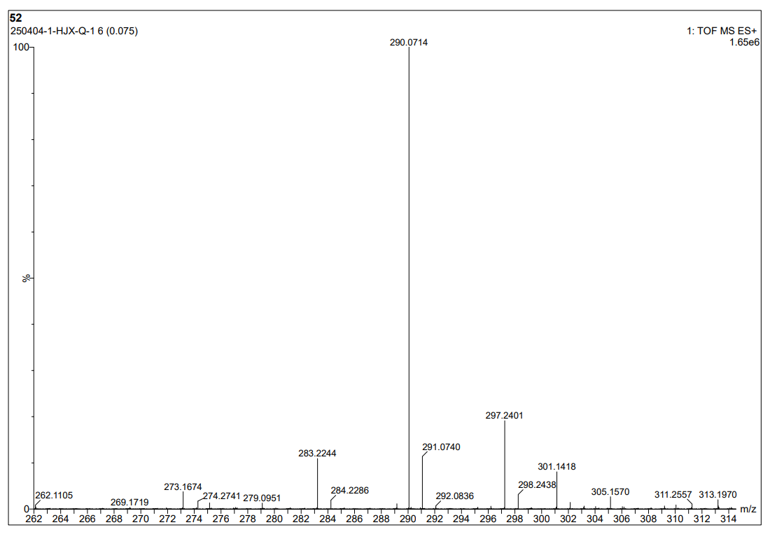
图S1 1-1 HR Mass spectrum (ESI) of compound 3a
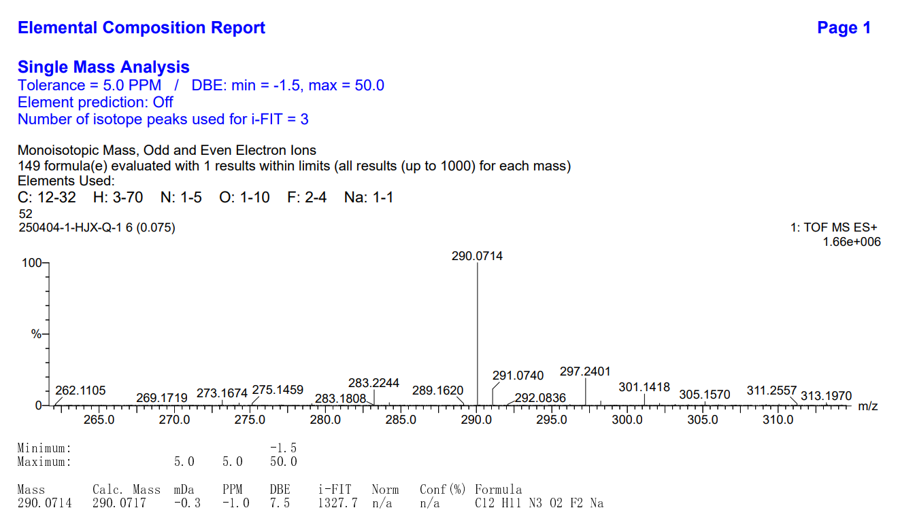
图S1 1-2 HR Mass spectrum (ESI) of compound 3a
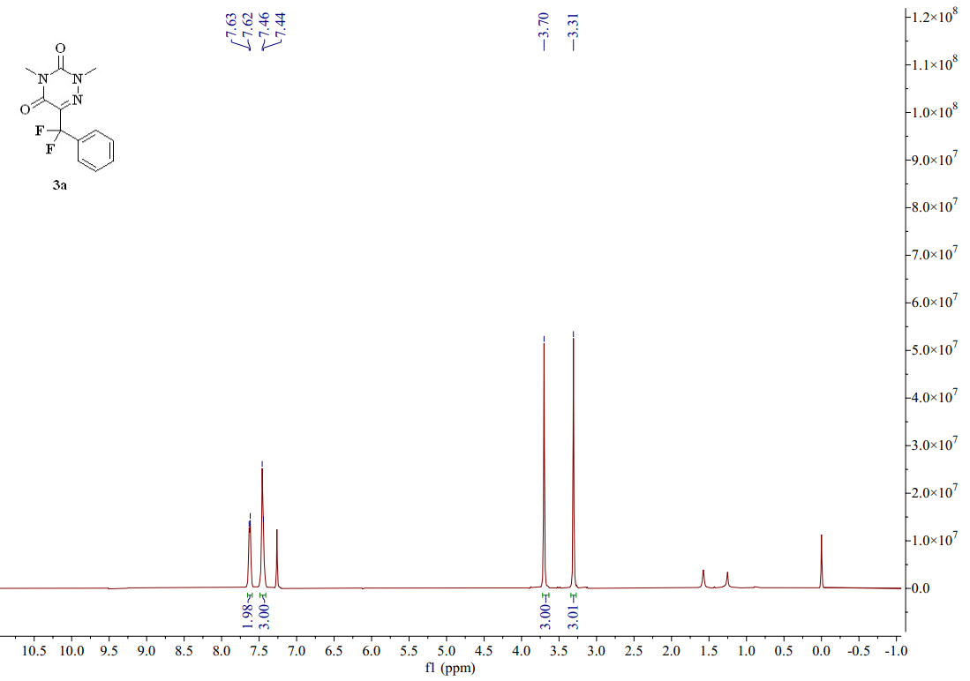
图S1 1-3 ¹H-NMR spectrum (CDCl₃, 400 MHZ) of compound 3a
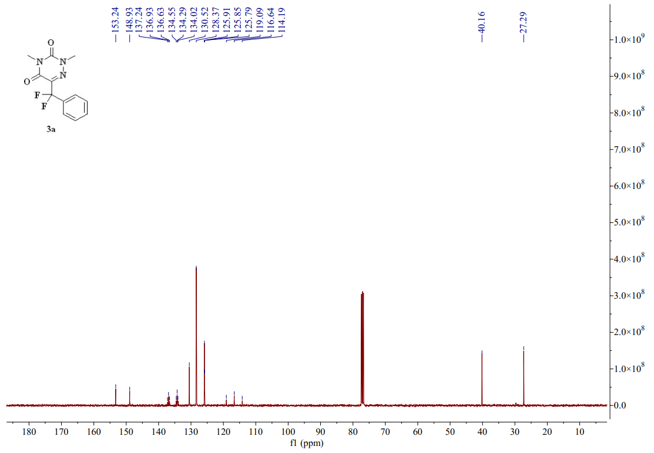
图 S1 1-4 ¹³C-NMR spectrum (CDCl₃, 101 MHZ) of compound 3a
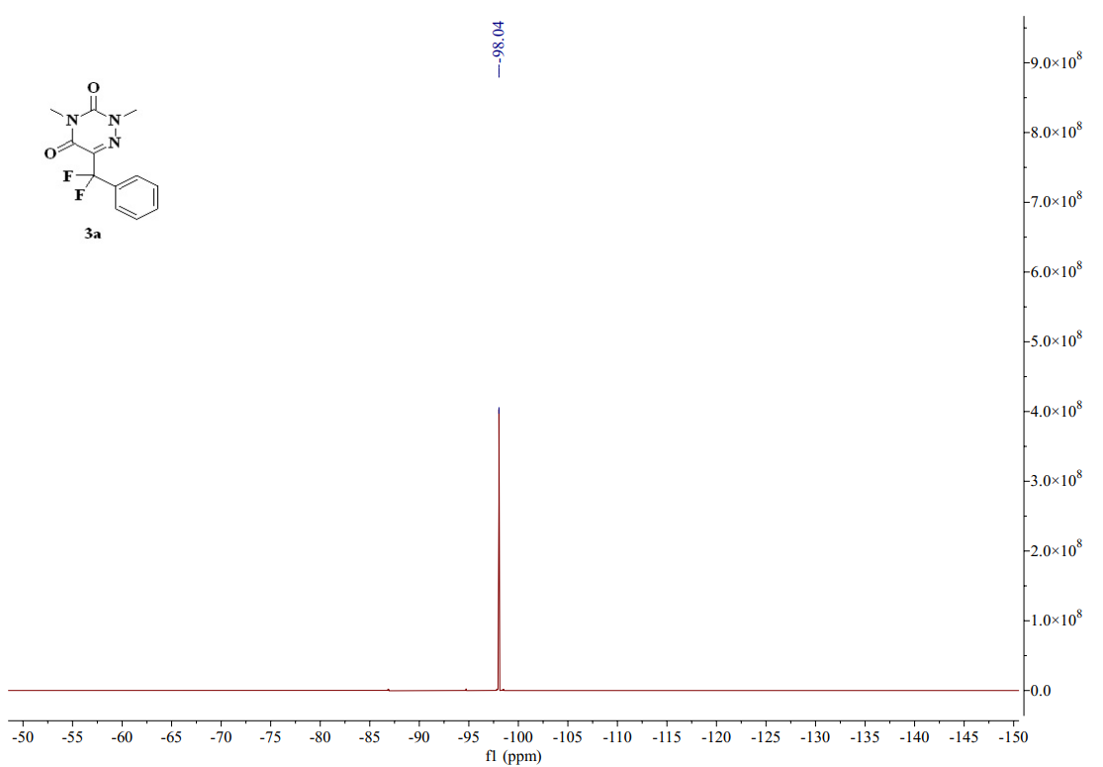
图S1 1-5 ¹⁹F-NMR spectrum (CDCl₃, 376 MHZ) of compound 3a
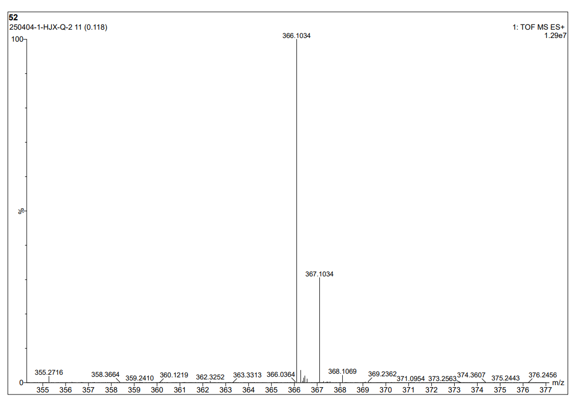
图S1 2-1 HR Mass spectrum (ESI) of compound 3b
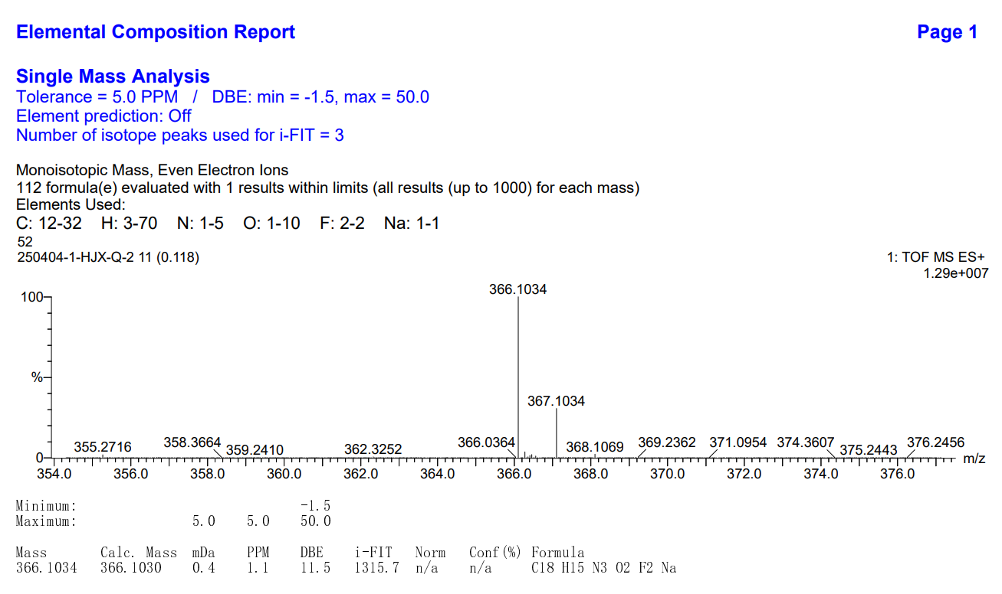
图S1 2-2 HR Mass spectrum (ESI) of compound 3b
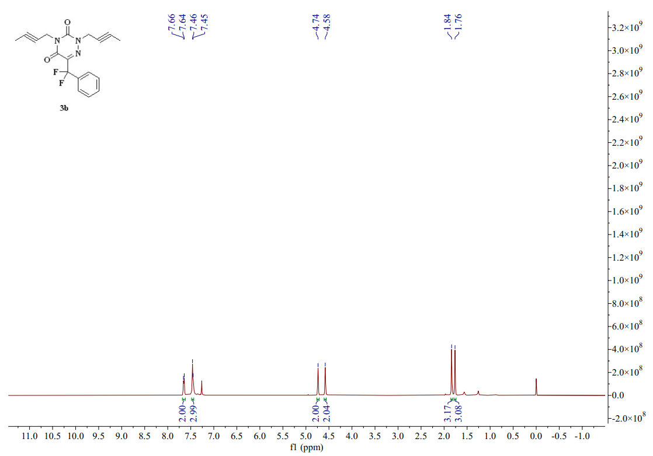
图S1 2-3 ¹H-NMR spectrum (CDCl₃, 400 MHZ) of compound 3b
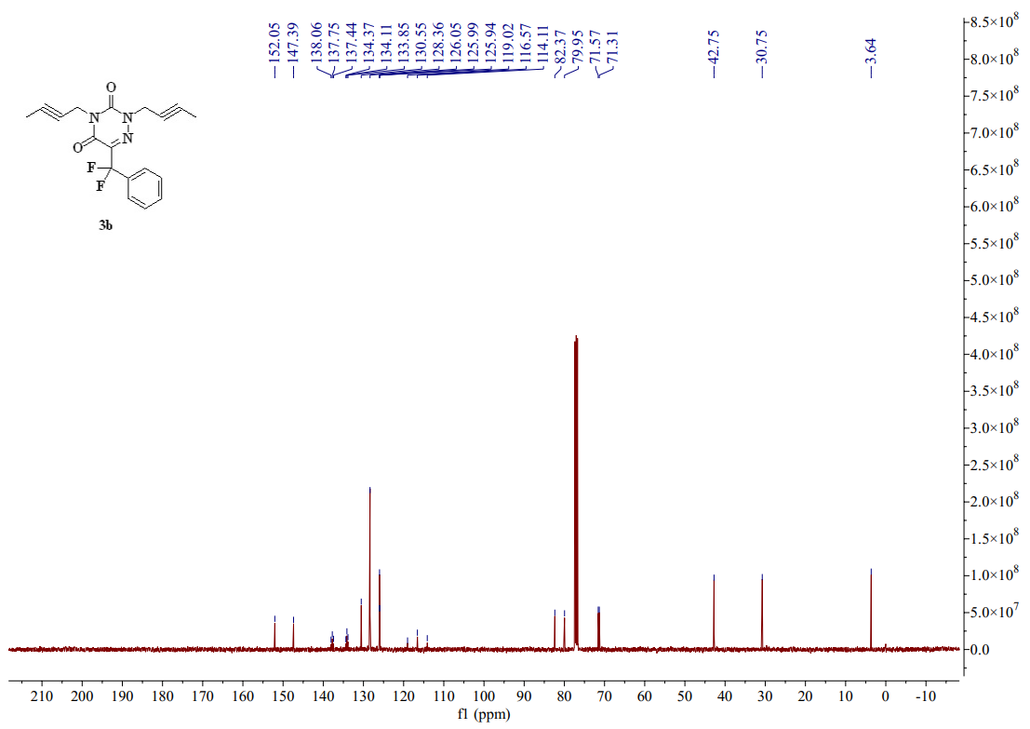
图S1 2-4 ¹³C-NMR spectrum (CDCl₃, 101 MHZ) of compound 3b
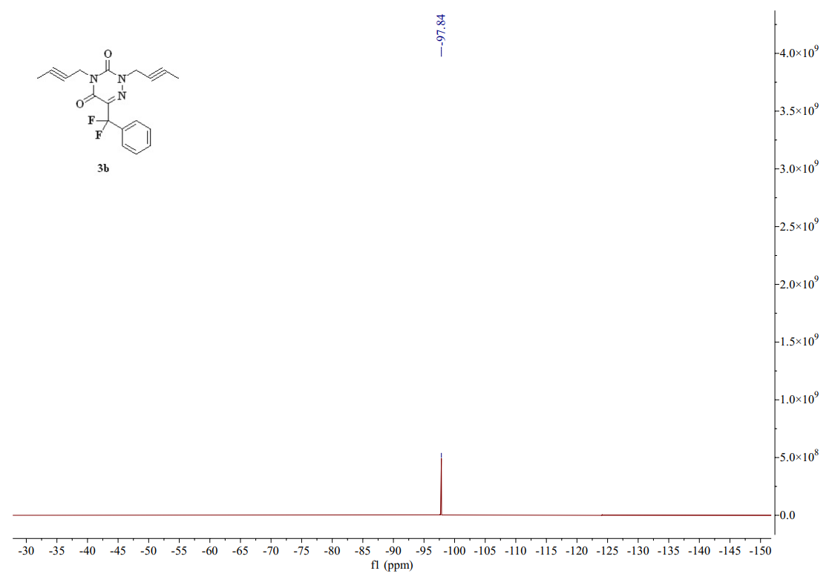
图S1 2-5 ¹⁹F-NMR spectrum (CDCl₃, 376 MHZ) of compound 3b
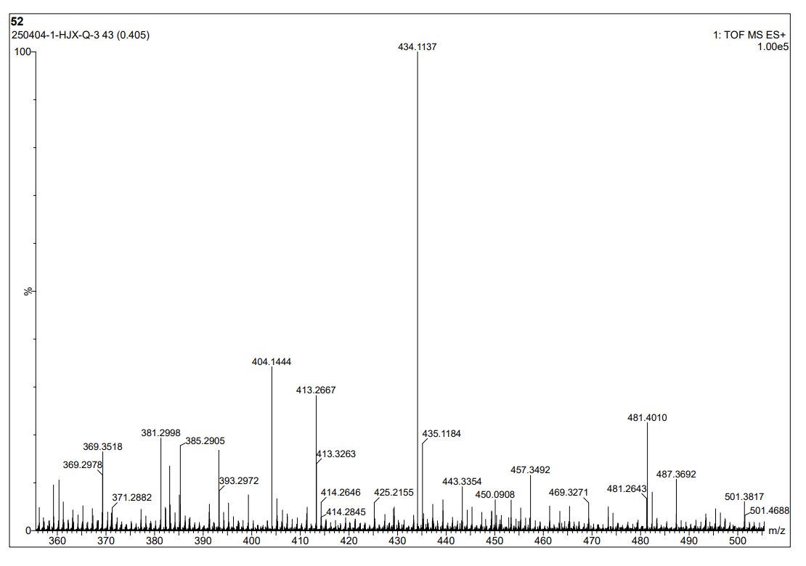
图S1 3-1 HR Mass spectrum (ESI) of compound 3c
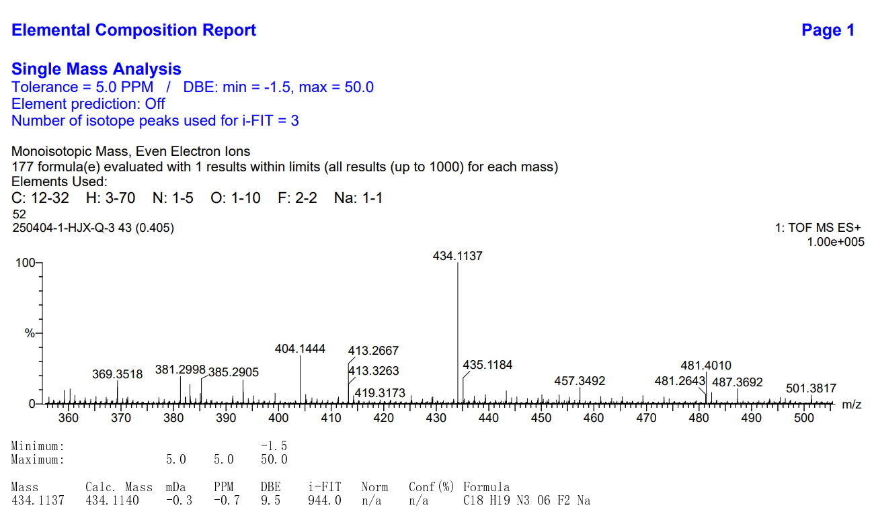
图S1 3-2 HR Mass spectrum (ESI) of compo und 3c
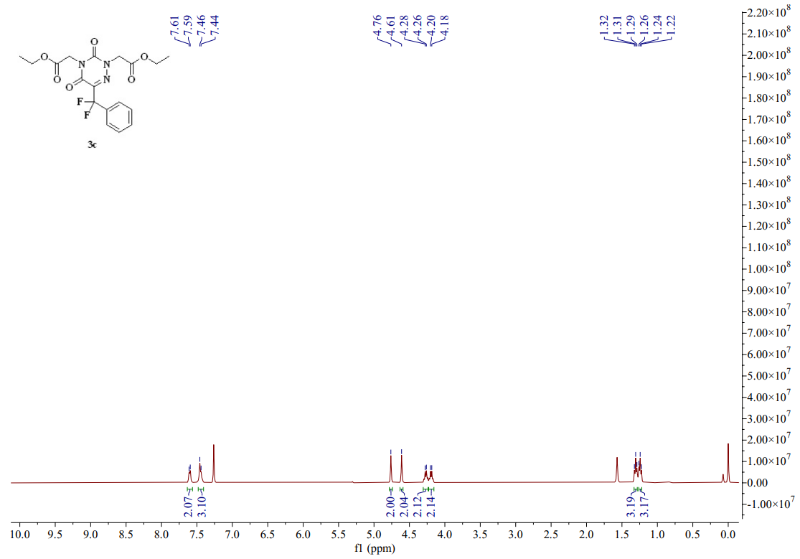
图S1 3-3 ¹H-NMR spectrum (CDCl₃, 400 MHZ) of compound 3c
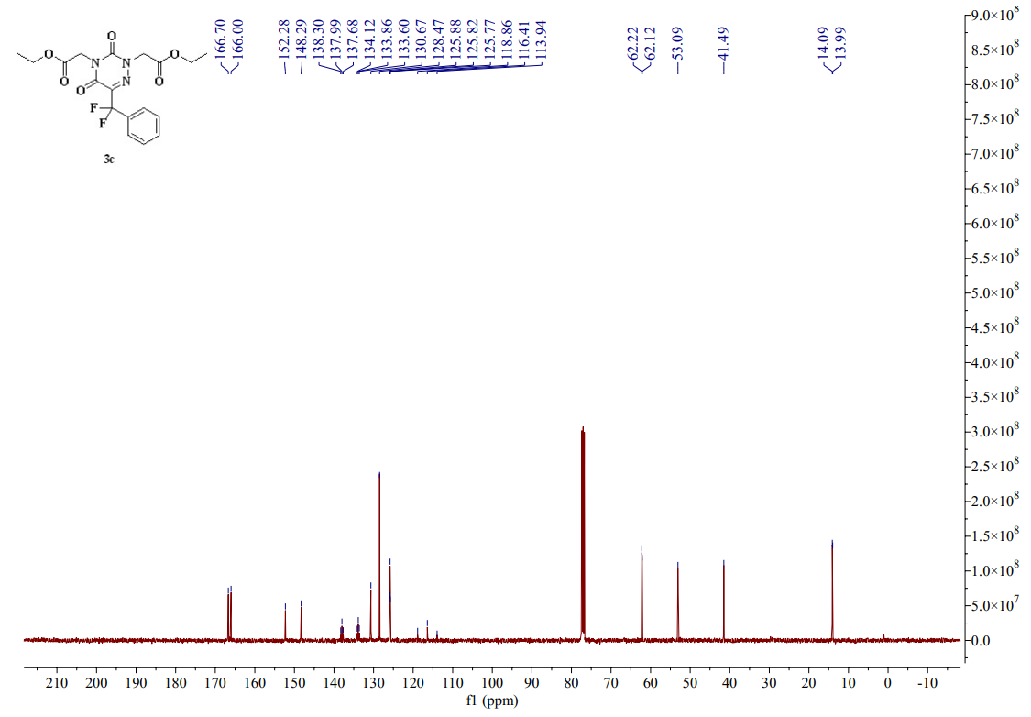
图S1 3-4 ¹³C-NMR spectrum (CDCl₃, 101 MHZ) of compound 3c
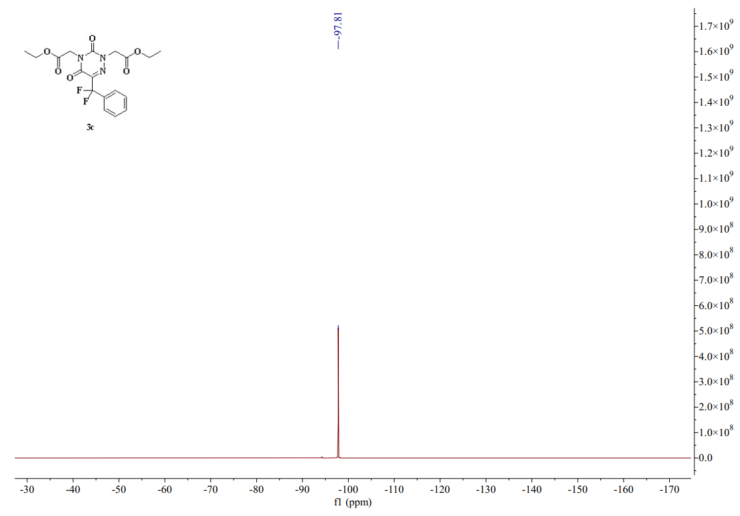
图S1 3-5 ¹⁹F-NMR spectrum (CDCl₃, 376 MHZ) of compound 3c
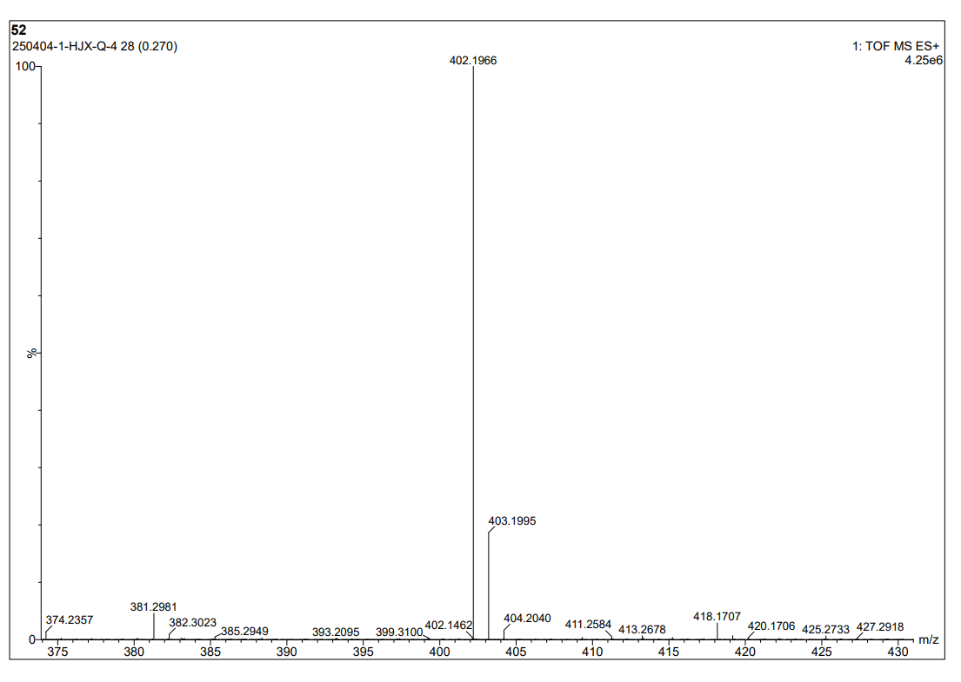
图S1 4-1 HR Mass spectrum (ESI) of compound 3d
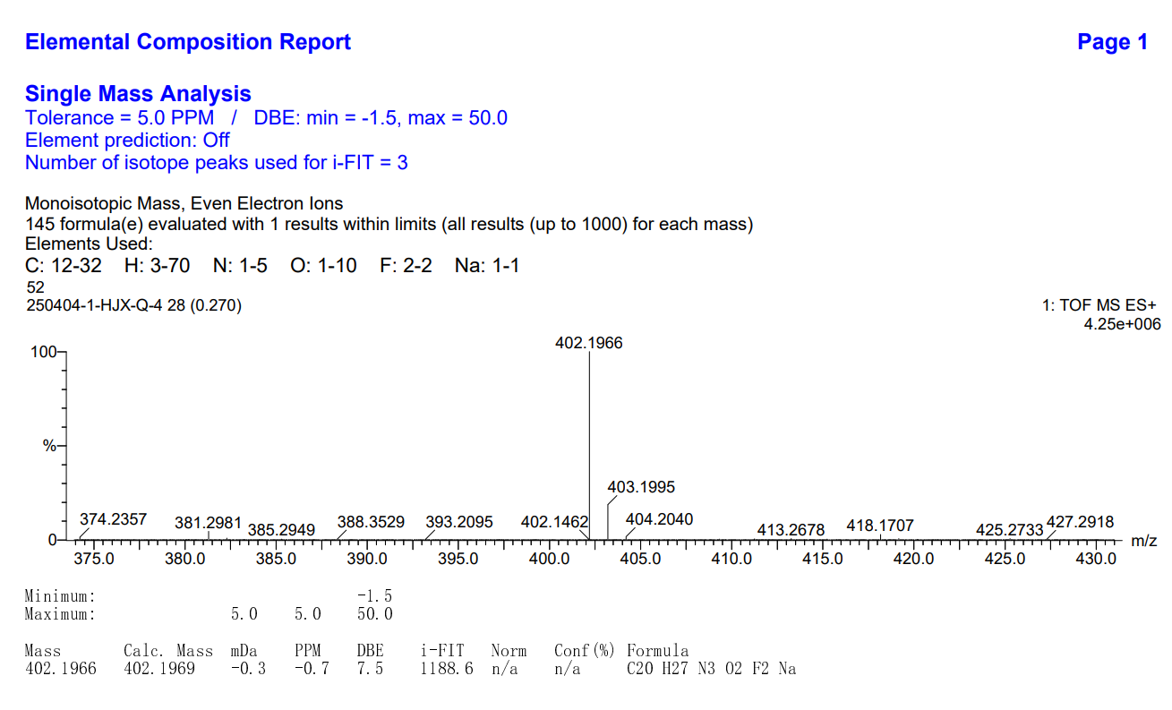
图S1 4-2 HR Mass spectrum (ESI) of compound 3d
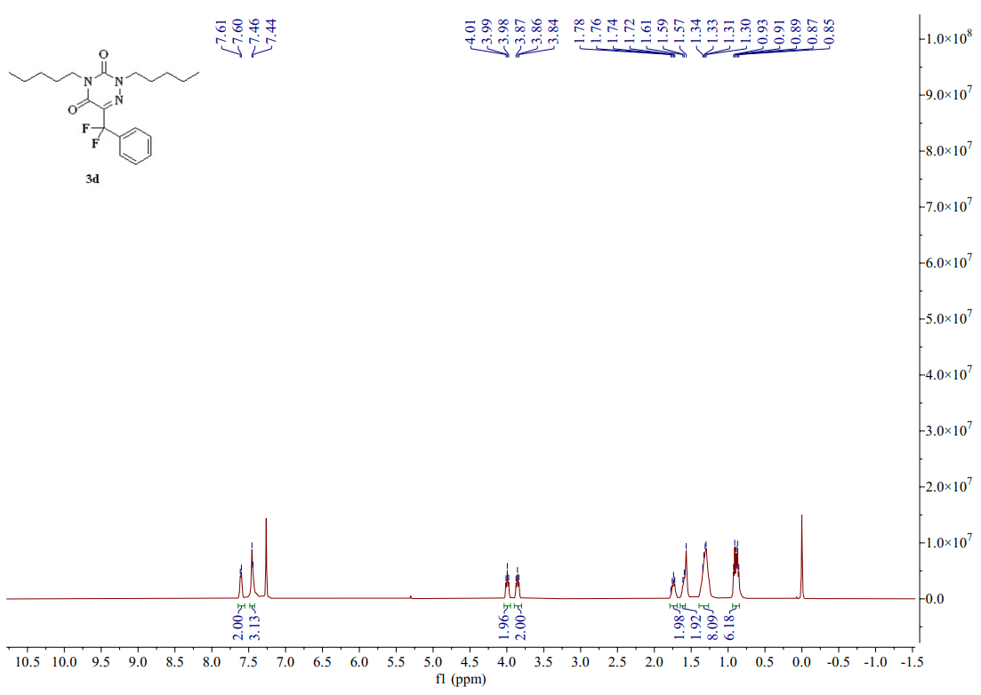
图S1 4-3 ¹H-NMR spectrum (CDCl₃, 400 MHZ) of compound 3d
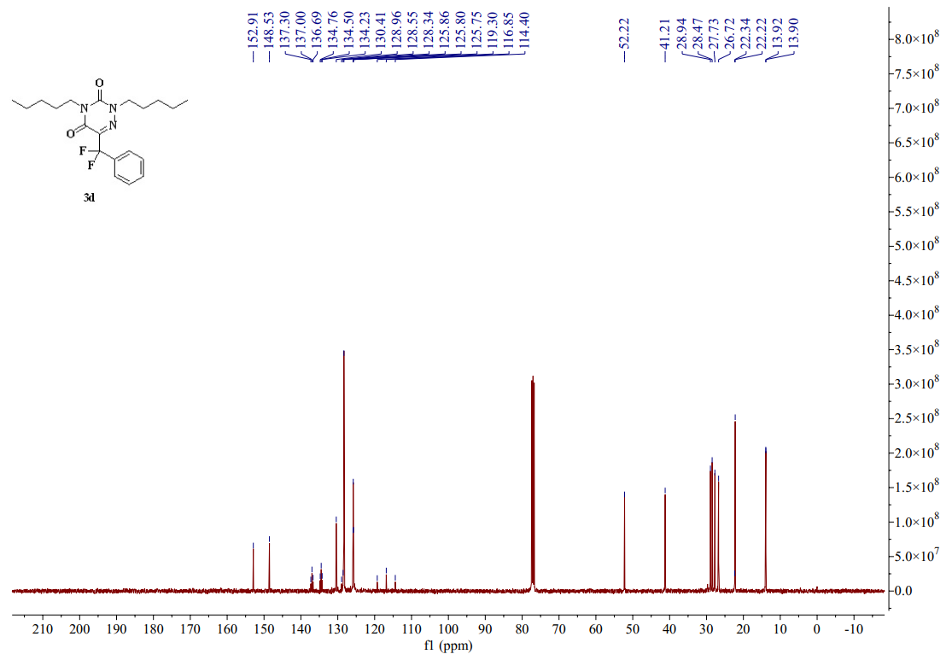
图S1 4-4 ¹³C-NMR spectrum (CDCl₃, 101 MHZ) of compound 3d
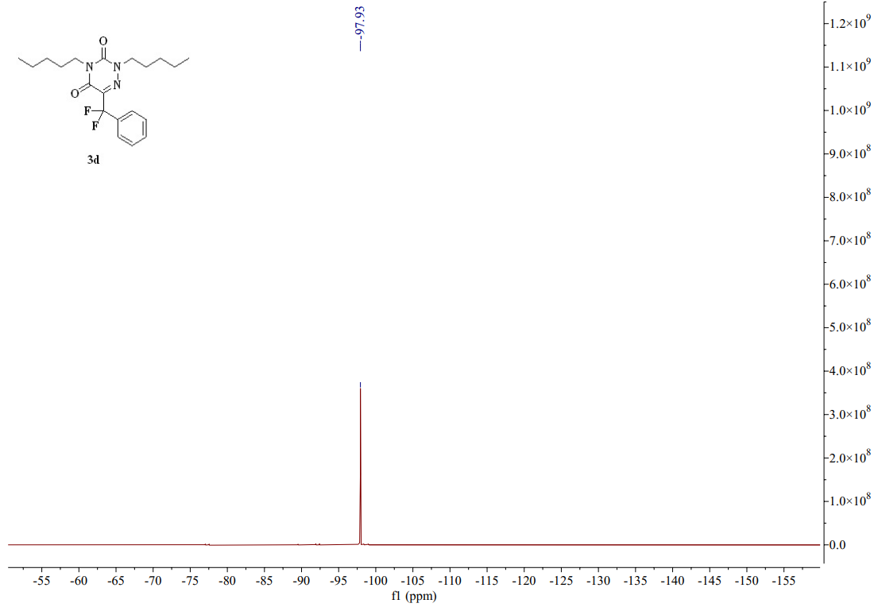
图S1 4-5 ¹⁹F-NMR spectrum (CDCl₃, 376 MHZ) of compound 3d
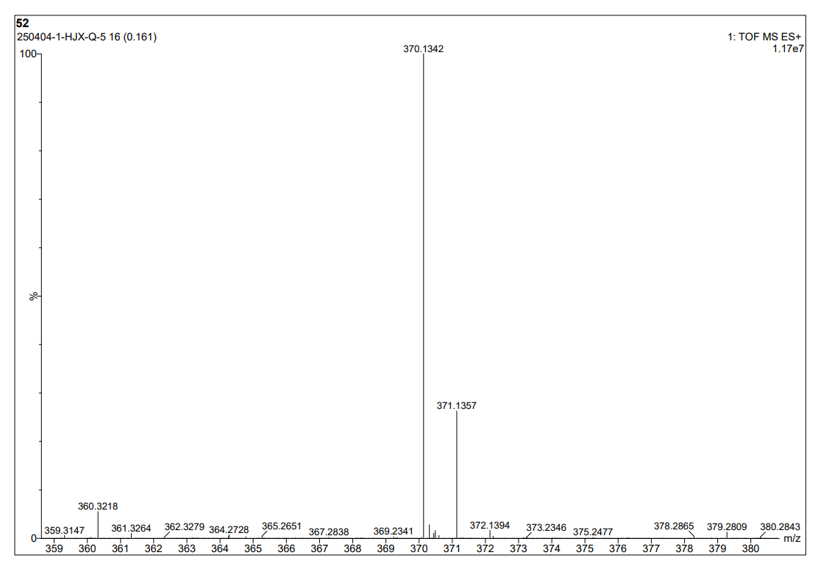
图S1 5-1 HR Mass spectrum (ESI) of compound 3e
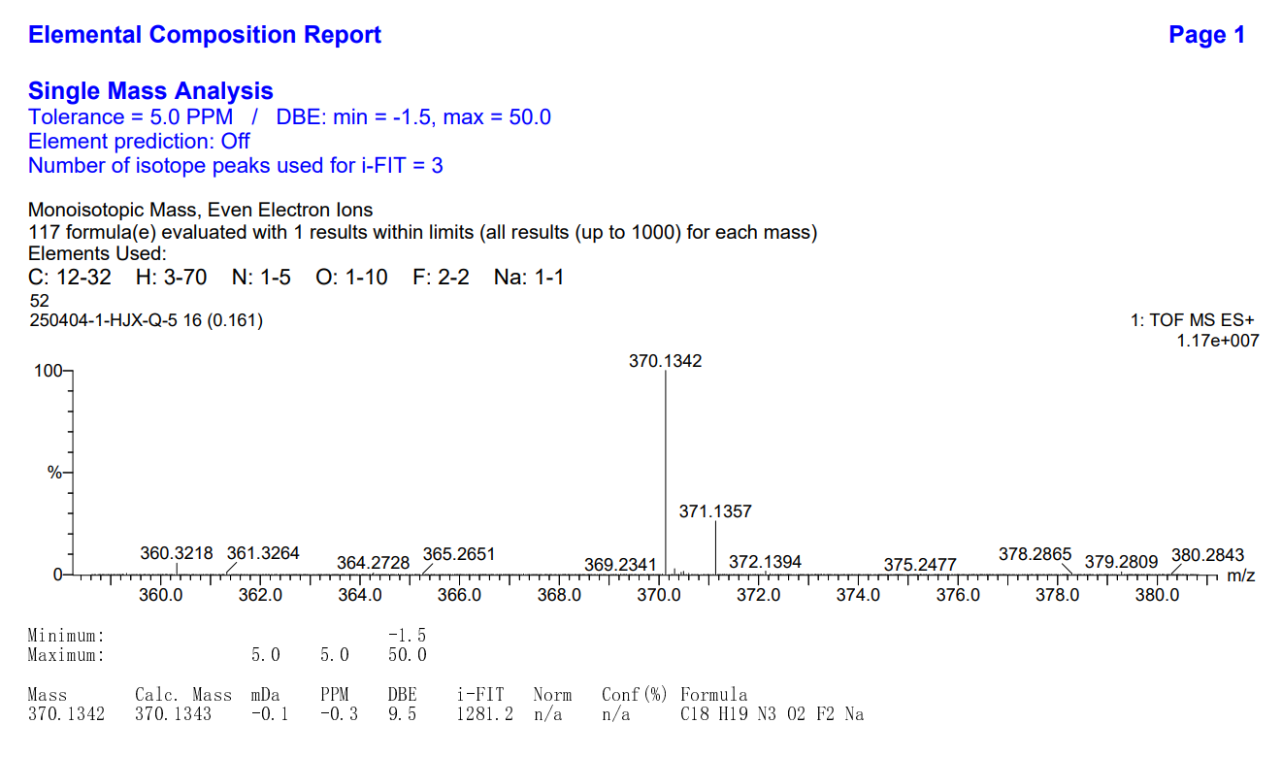
图S1 5-2 HR Mass spectrum (ESI) of compound 3e
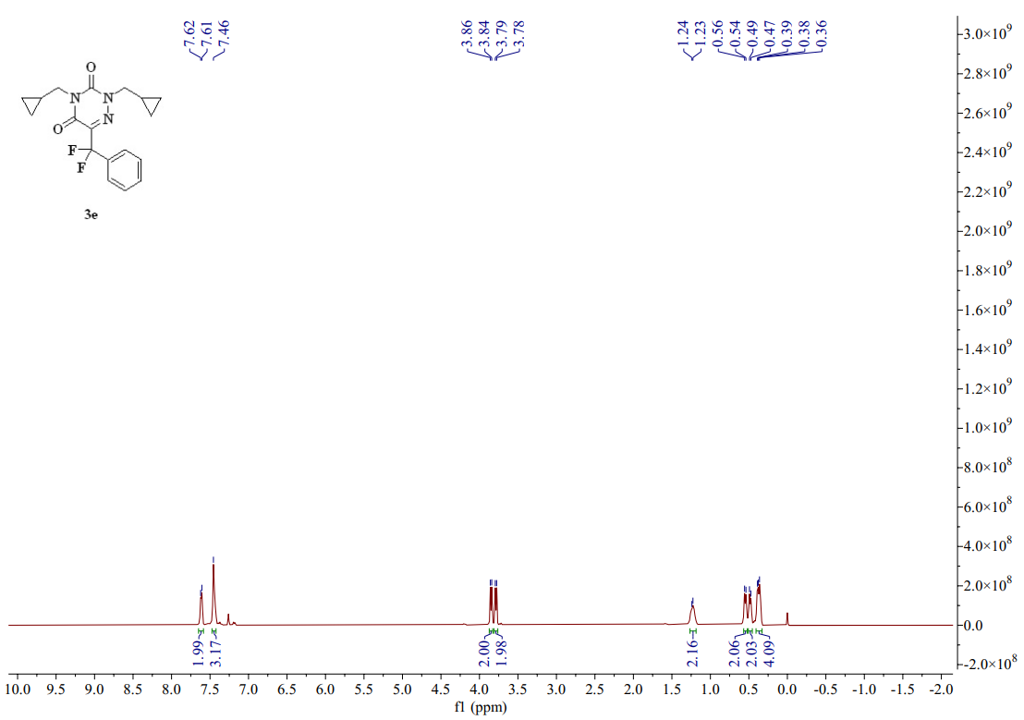
图S1 5-3 ¹H-NMR spectrum (CDCl₃, 400 MHZ) of compound 3e
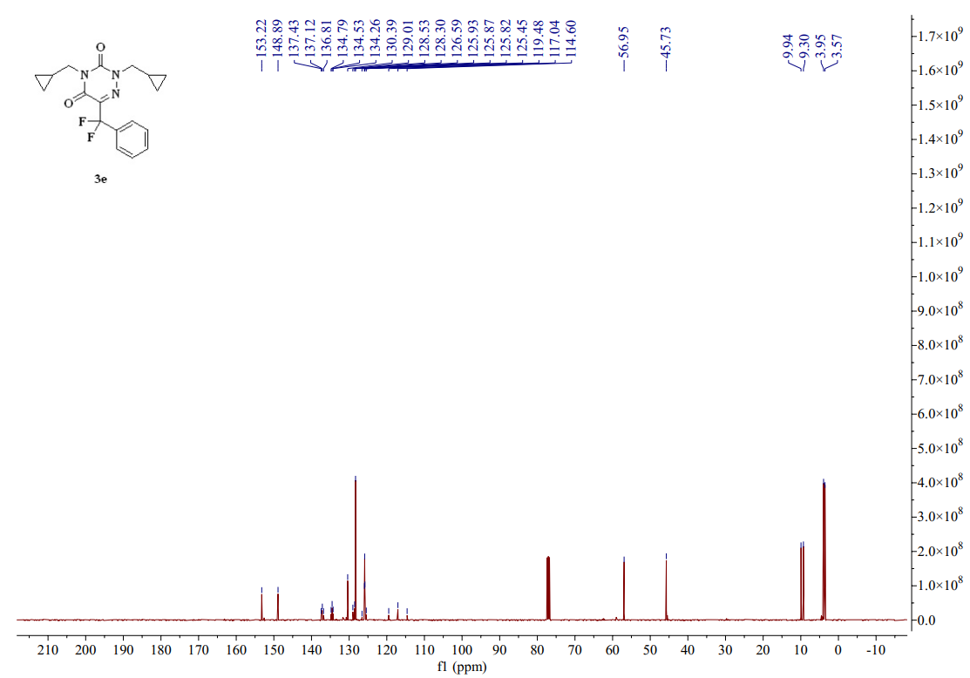
图S1 5-4 ¹³C-NMR spectrum (CDCl₃, 101 MHZ) of compound 3e
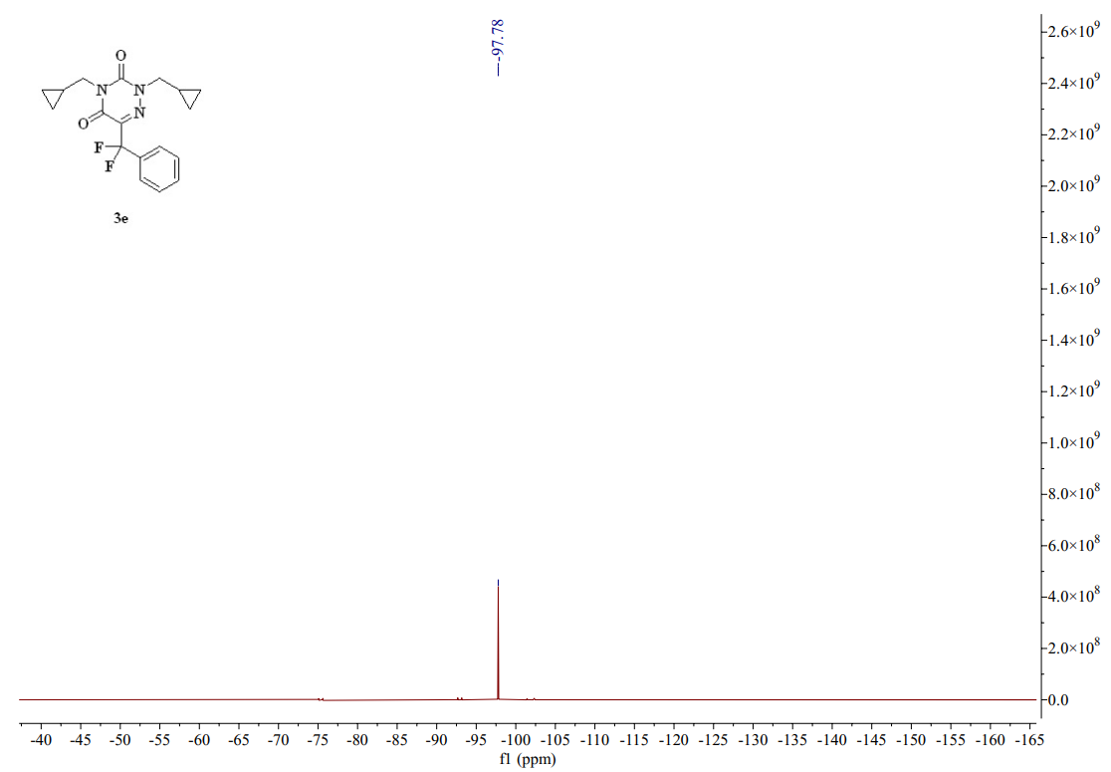
图S1 5-5 ¹⁹F-NMR spectrum (CDCl₃, 376 MHZ) of compound 3e
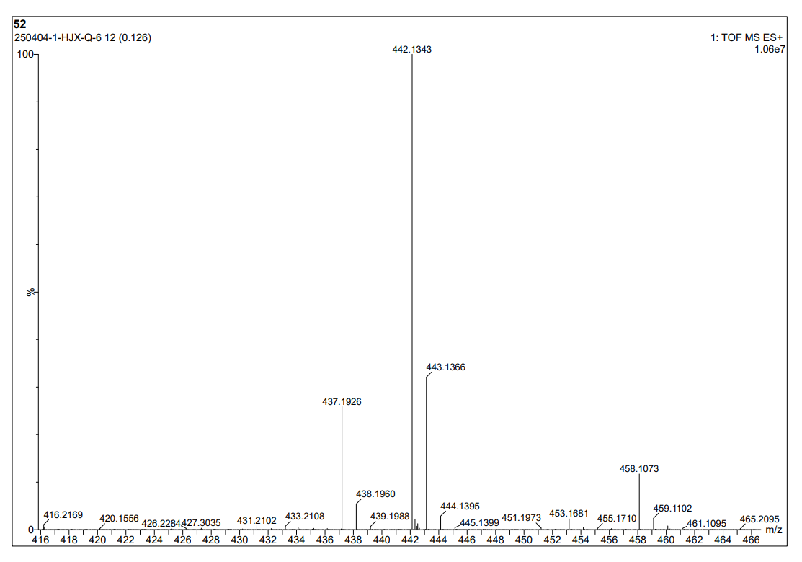
图S1 6-1 HR Mass spectrum (ESI) of compound 3f
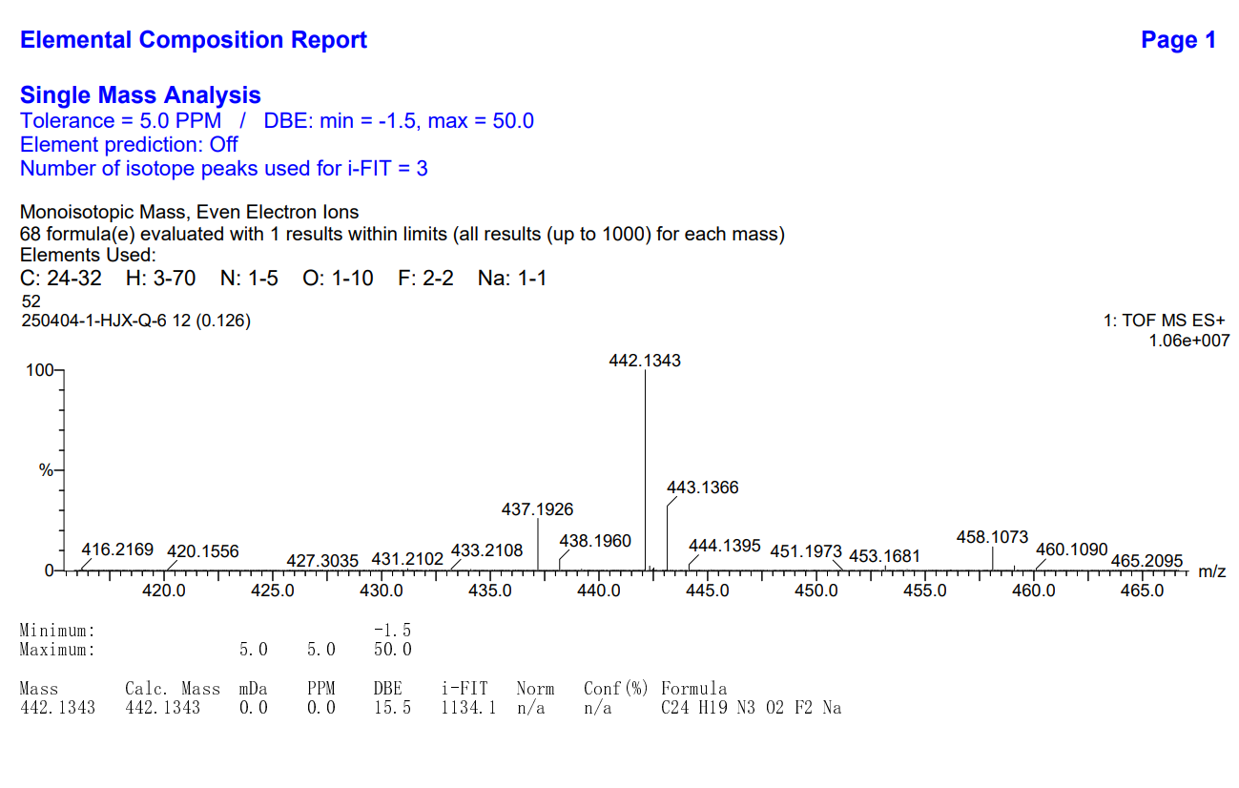
图S1 6-2 HR Mass spectrum (ESI) of compound 3f
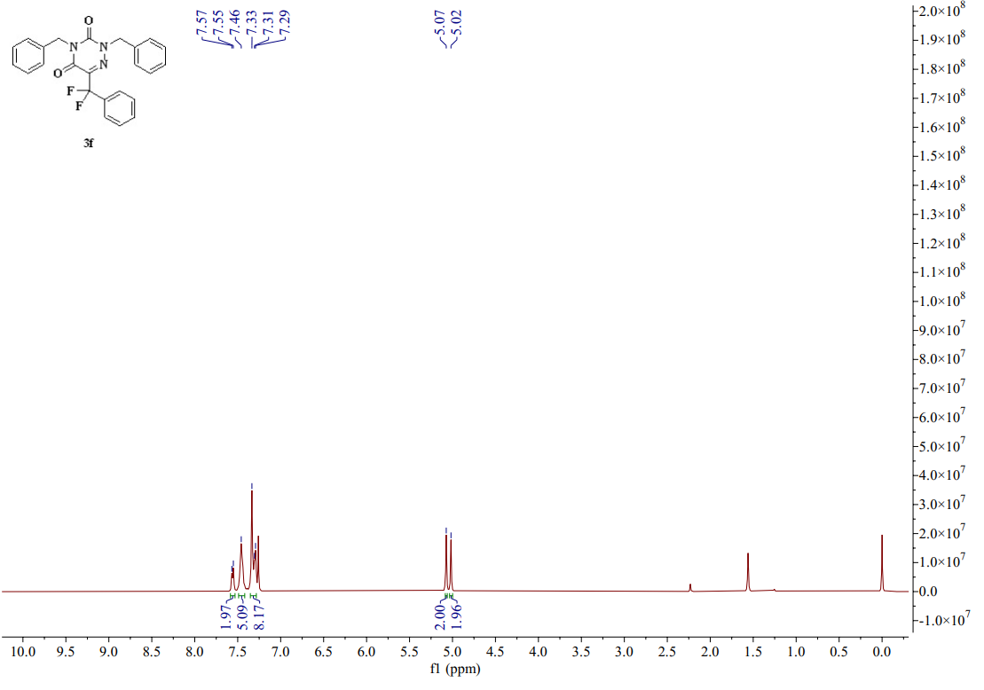
图S1 6-3 ¹H-NMR spectrum (CDCl₃, 400 MHZ) of compound 3f
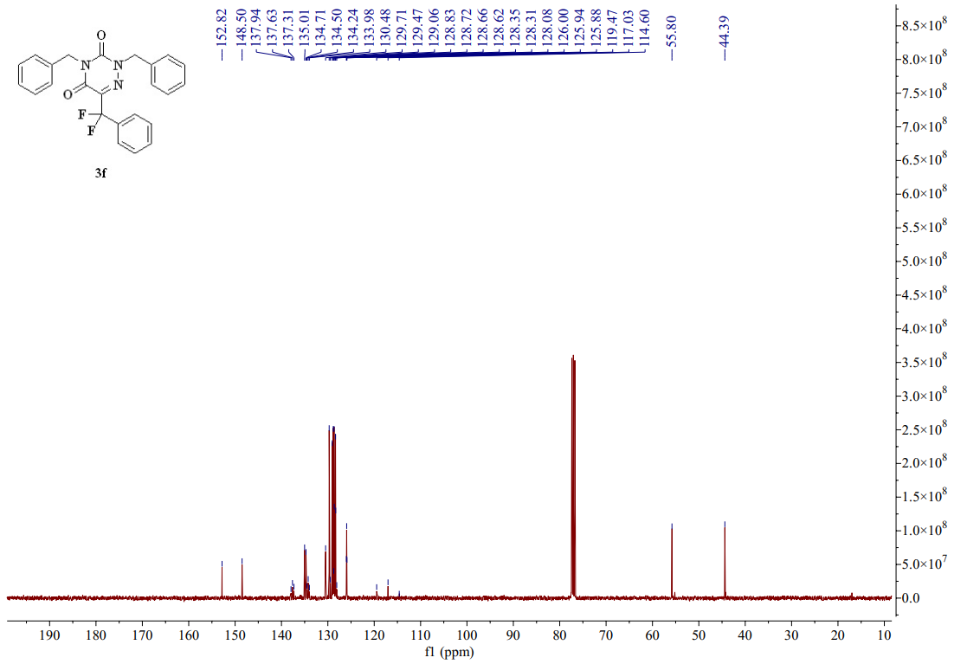
图S1 6-4 ¹³C-NMR spectrum (CDCl₃, 101 MHZ) of compound 3f
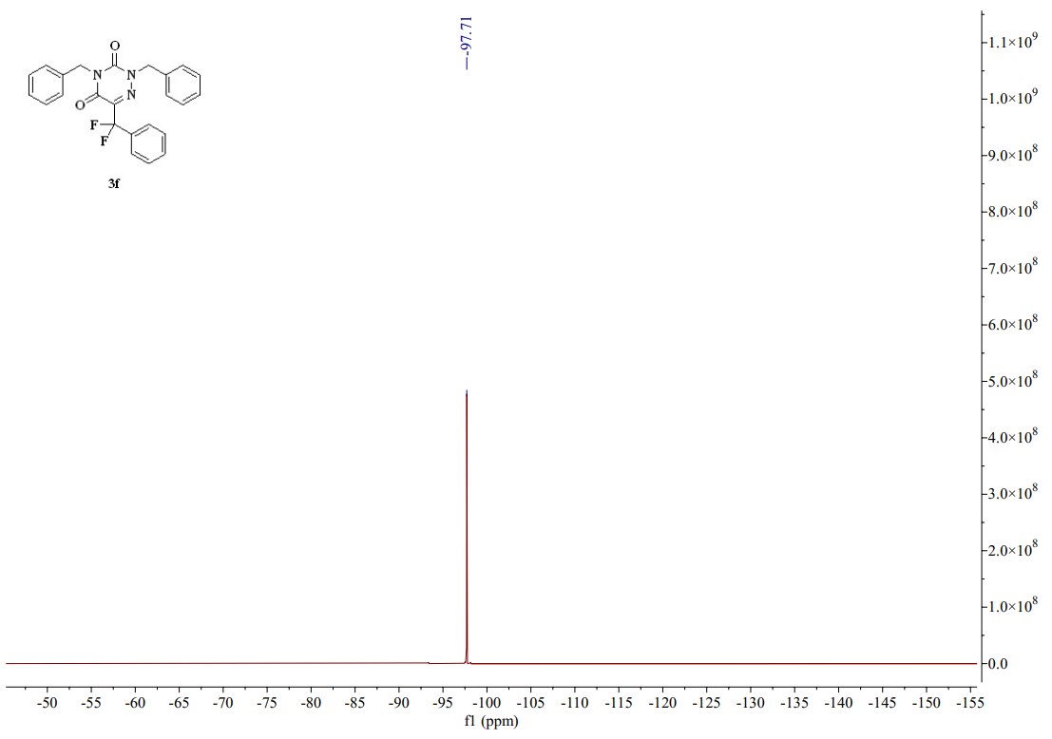
图S1 6-5 ¹⁹F-NMR spectrum (CDCl₃, 376 MHZ) of compound 3f
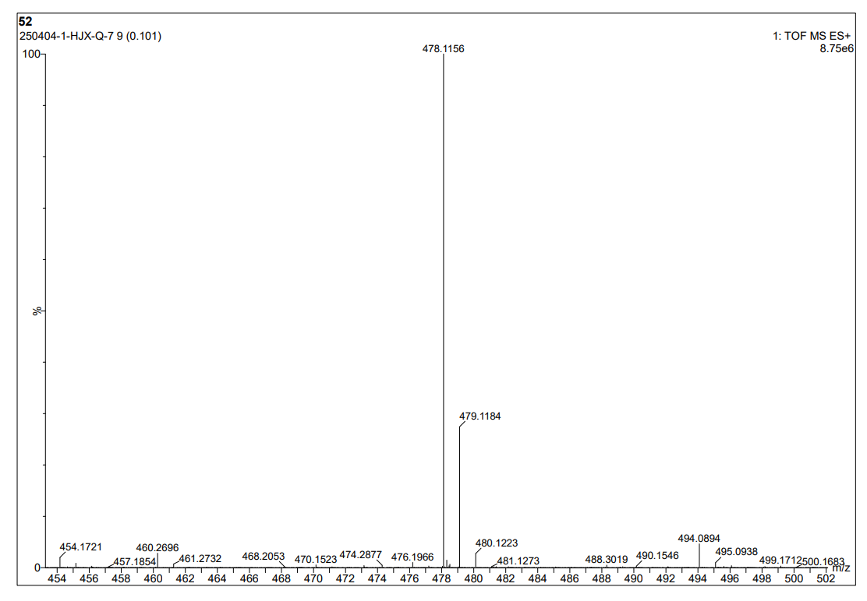
图S1 7-1 HR Mass spectrum (ESI) of compound 3g
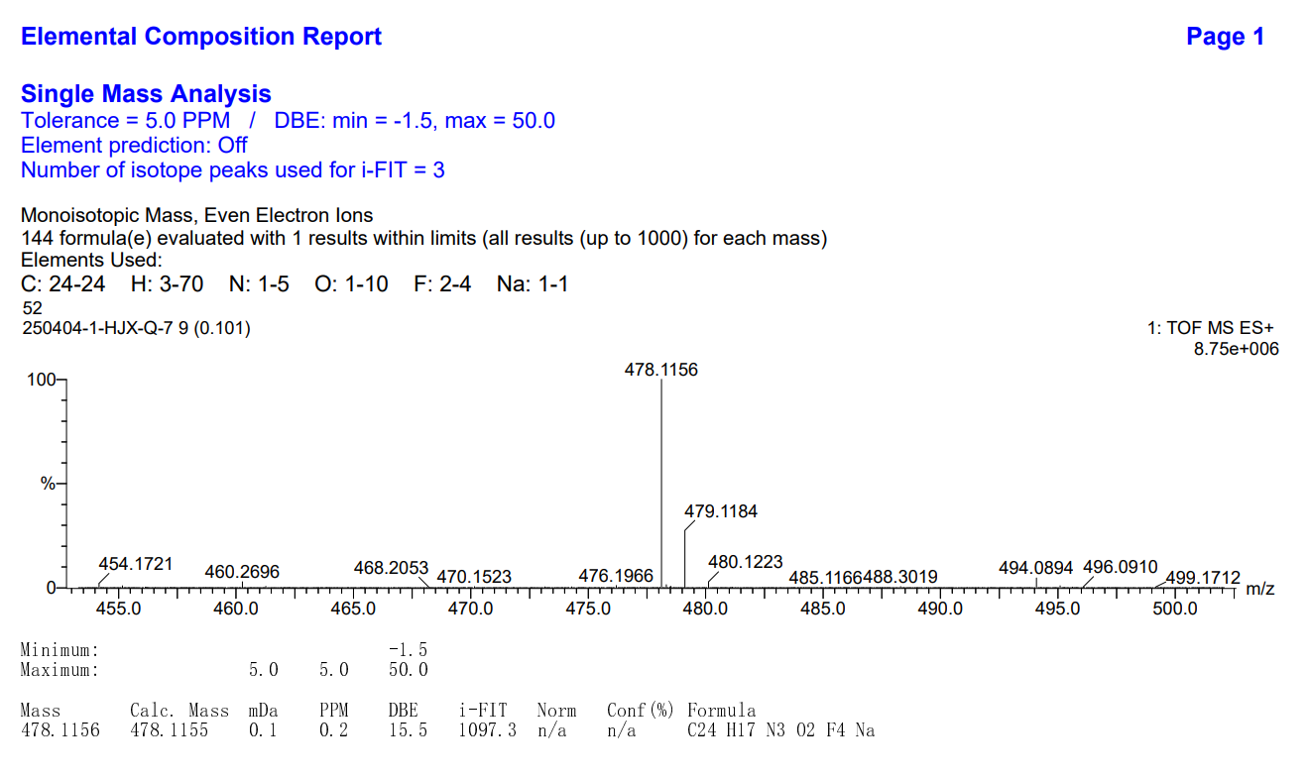
图S1 7-2 HR Mass spectrum (ESI) of compound 3g
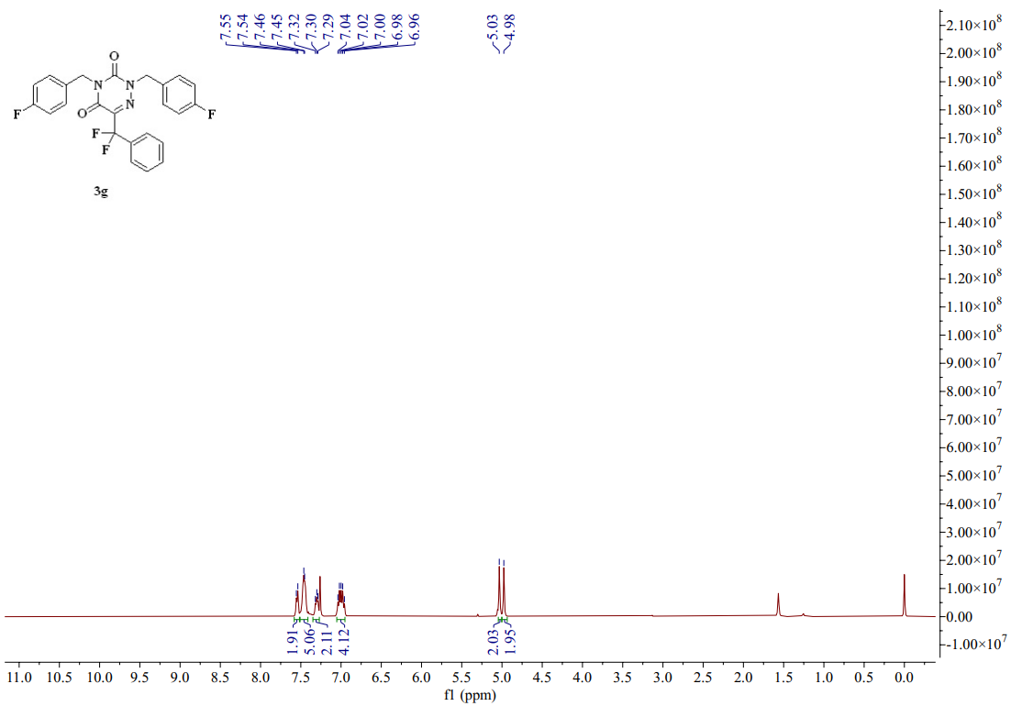
图S1 7-3 ¹H-NMR spectrum (CDCl₃, 400 MHZ) of compound 3g
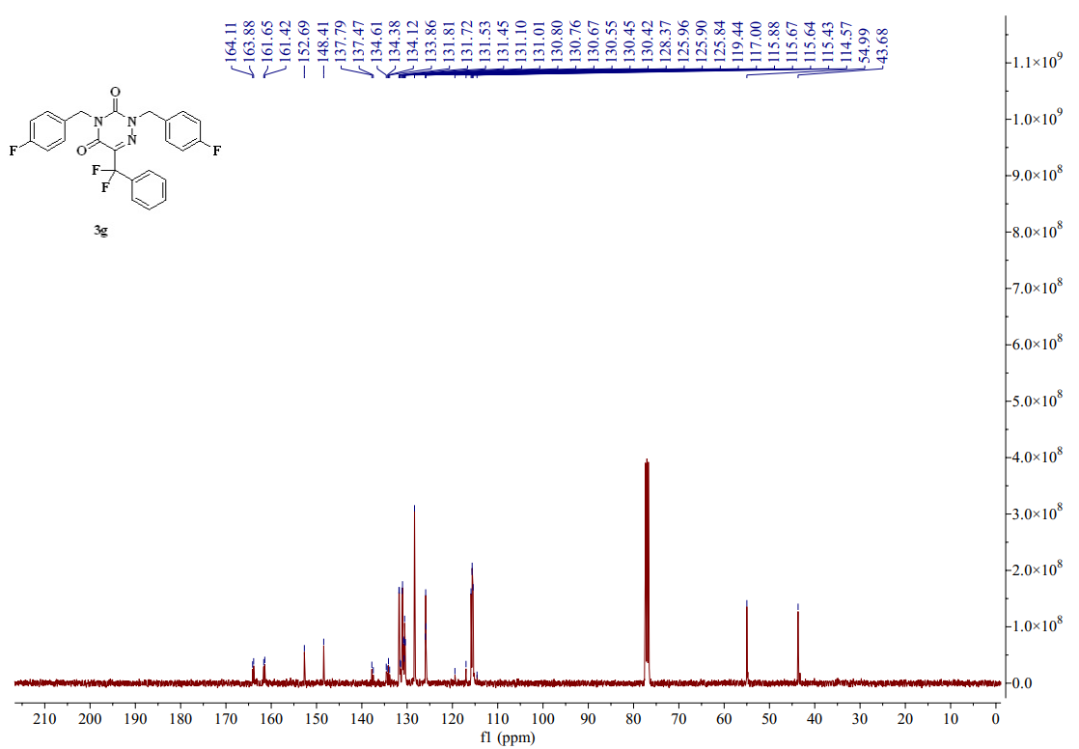
图S1 7-4 ¹³C-NMR spectrum (CDCl₃, 101 MHZ) of compound 3g
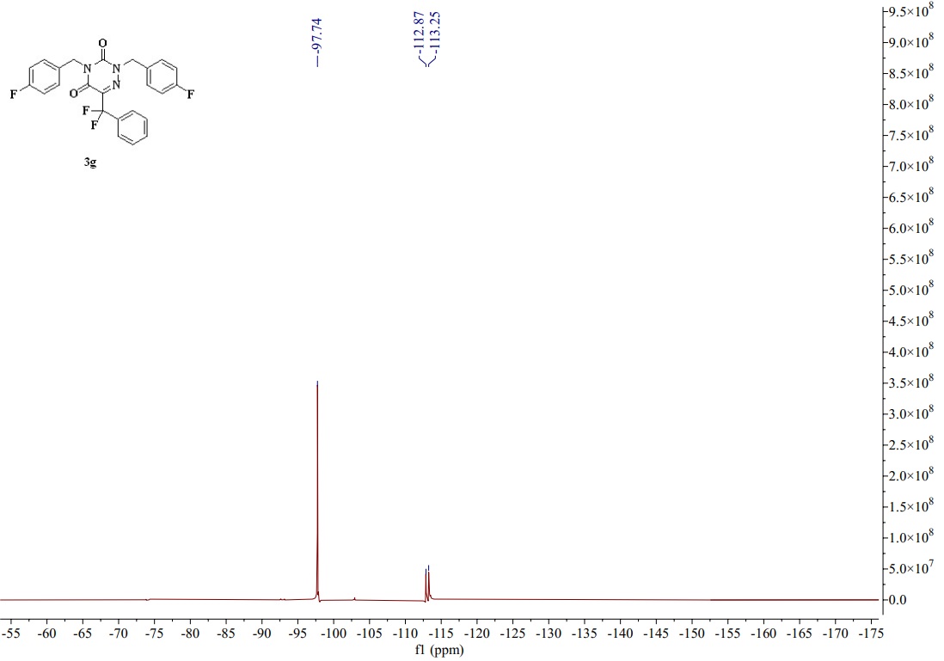
图S1 7-5 ¹⁹F-NMR spectrum (CDCl₃, 376 MHZ) of compound 3g
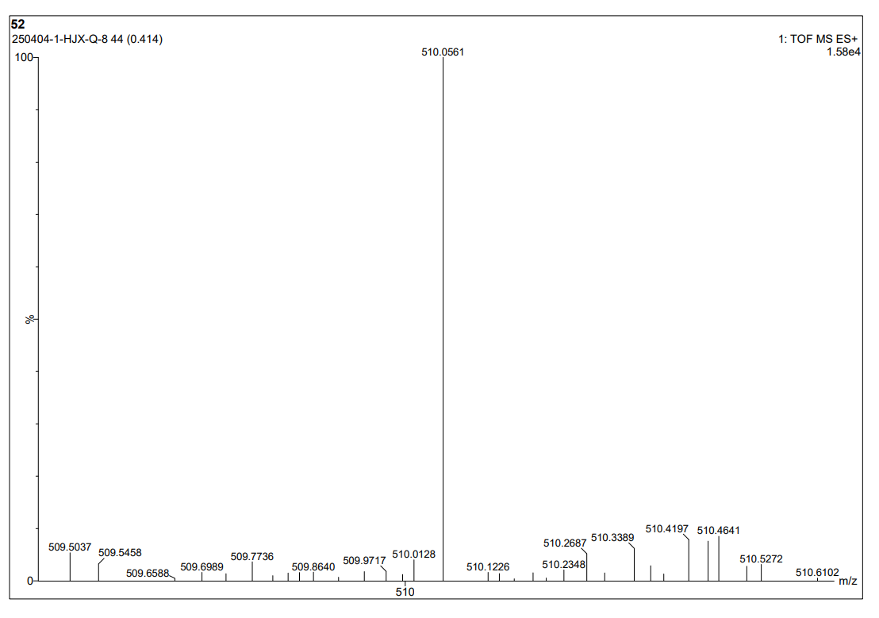
图S1 8-1 HR Mass spectrum (ESI) of compound 3h
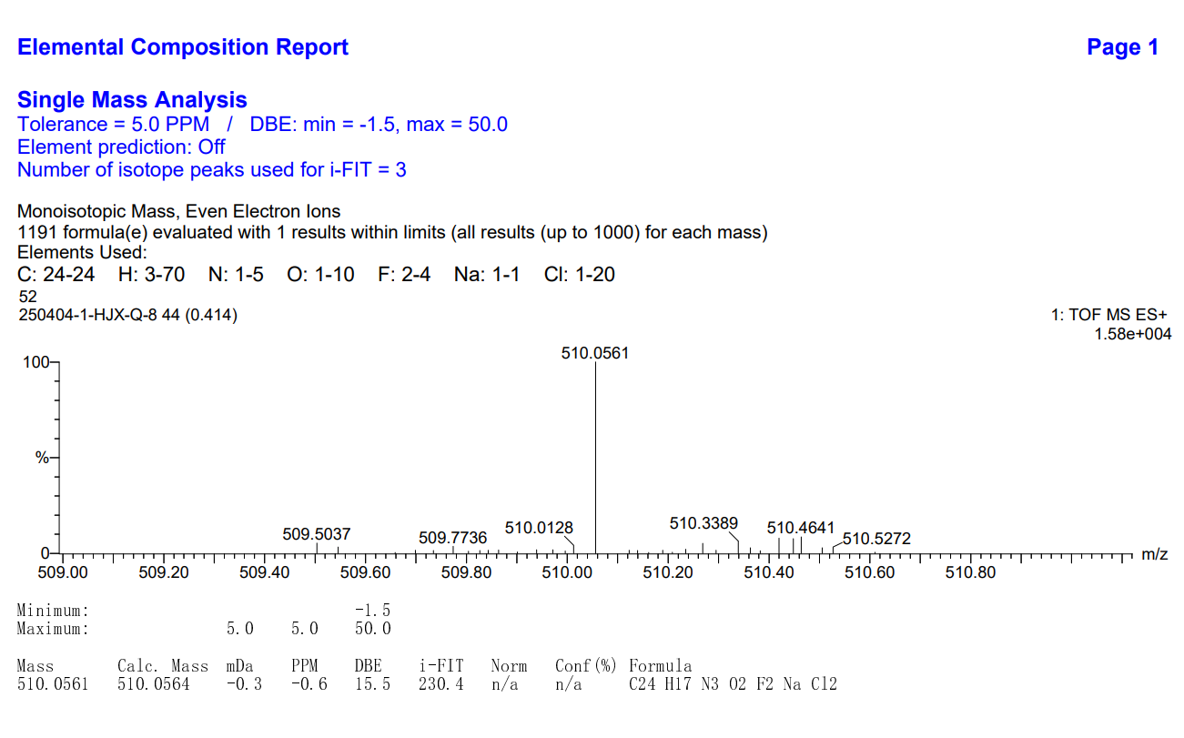
图S1 8-2 HR Mass spectrum (ESI) of compound 3h
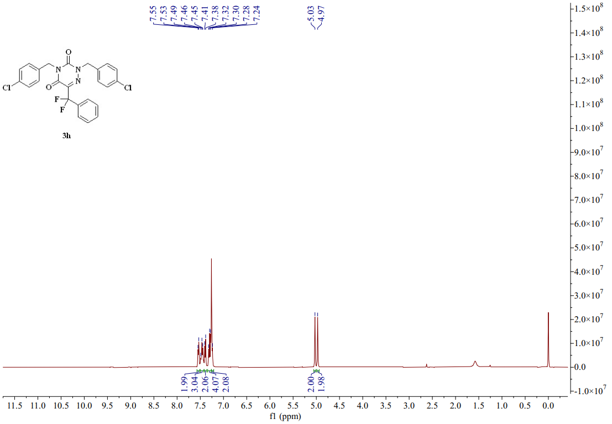
图S1 8-3 ¹H-NMR spectrum (CDCl₃, 400 MHZ) of compound 3h
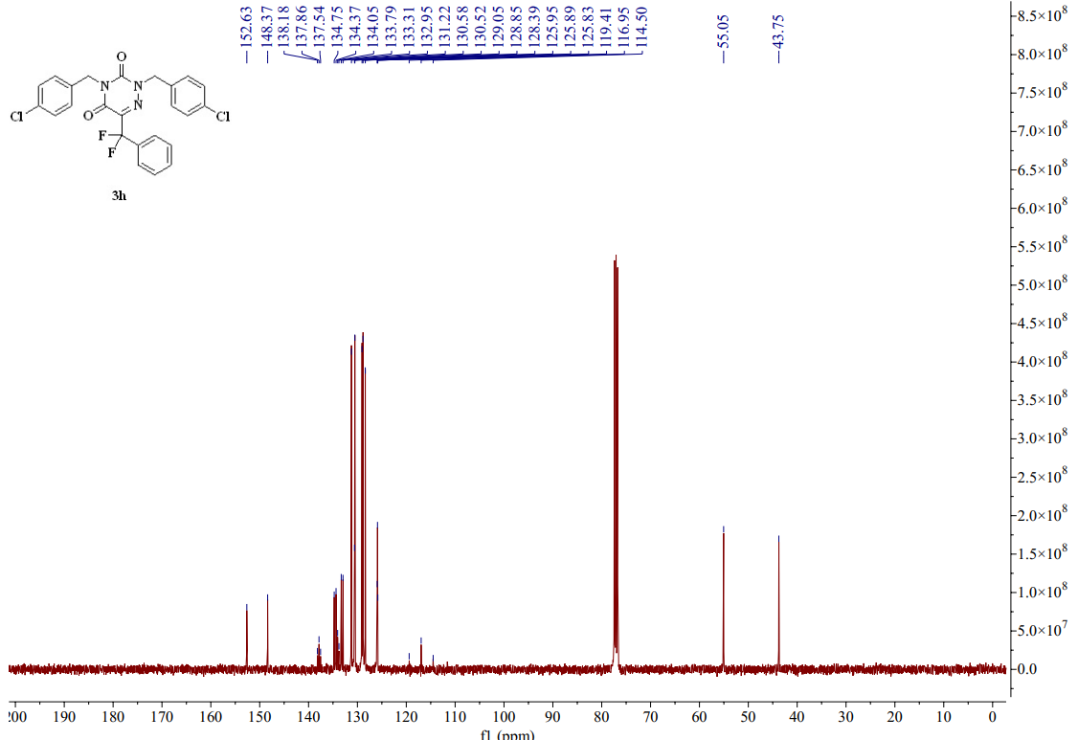
图S1 8-4 ¹³C-NMR spectrum (CDCl₃, 101MHZ) of compound 3h
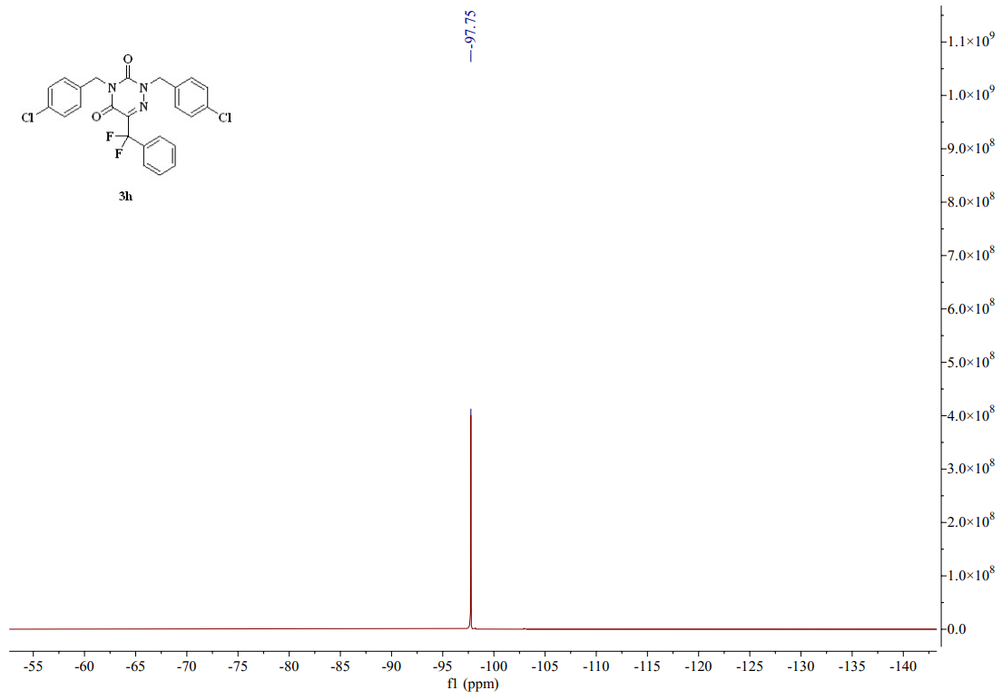
图S1 8-5 ¹⁹F-NMR spectrum (CDCl₃, 376 MHZ) of compound 3h
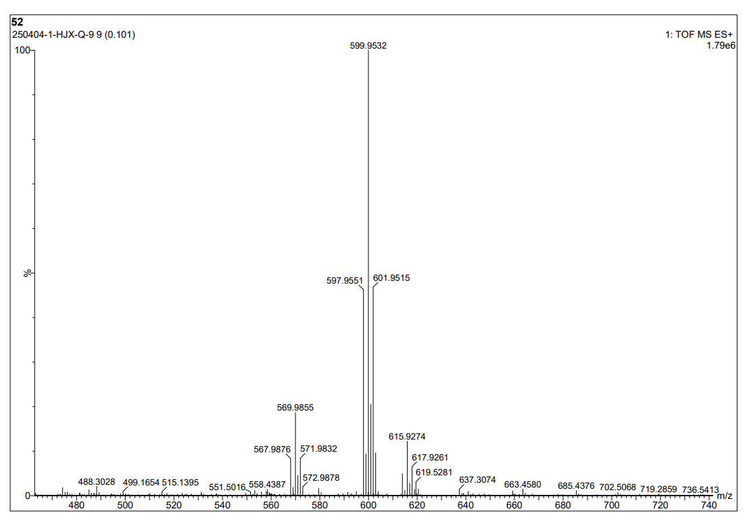
图S1 9-1 HR Mass spectrum (ESI) of compound 3i
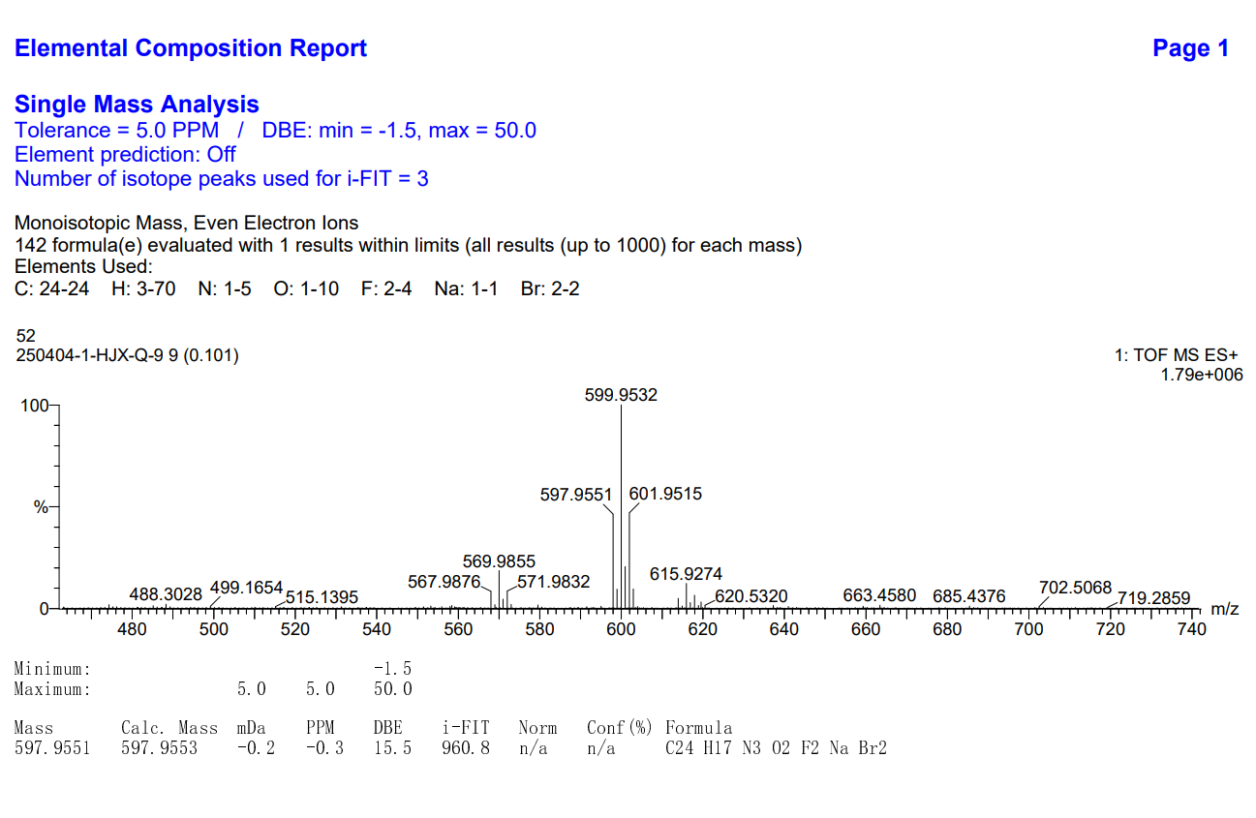
图S1 9-2 HR Mass spectrum (ESI) of compound 3i
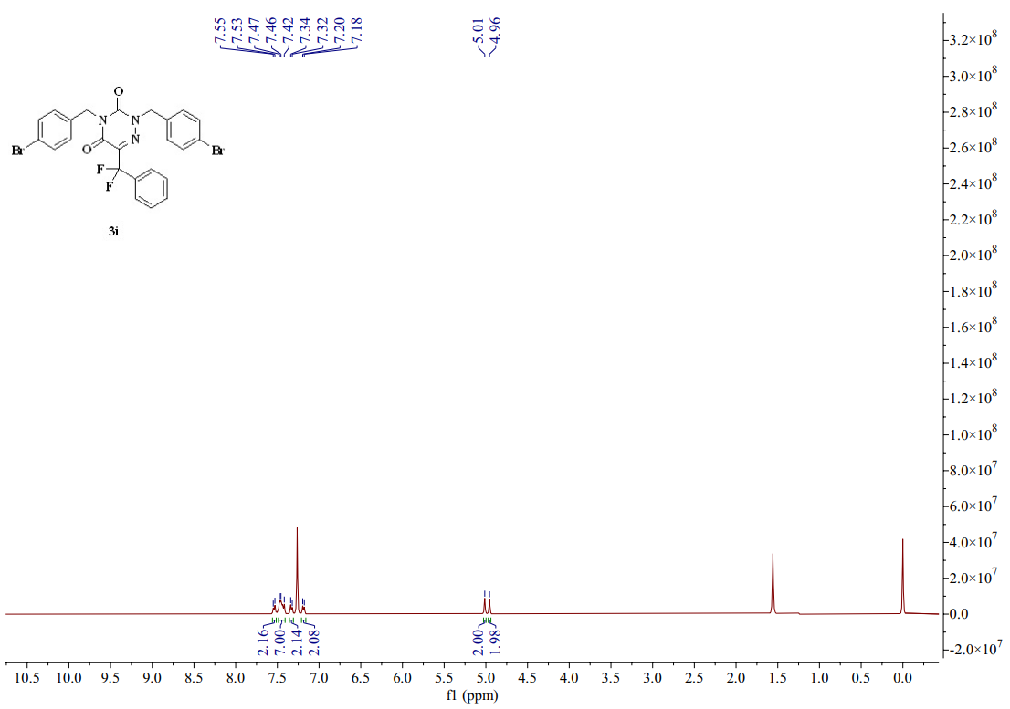
图S1 9-3 ¹H-NMR spectrum (CDCl₃, 400 MHZ) of compound 3i
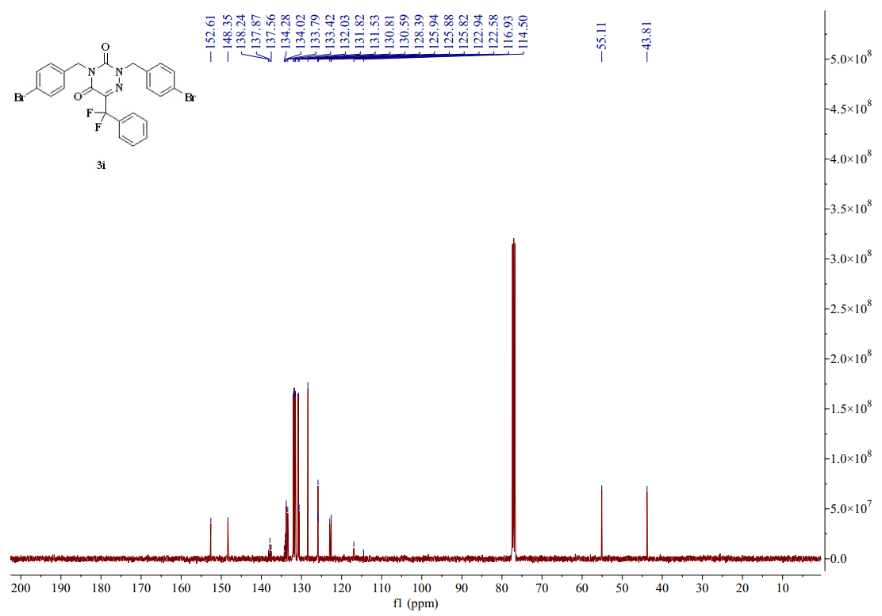
图S1 9-4 ¹³C-NMR spectrum (CDCl₃, 101 MHZ) of compound 3i
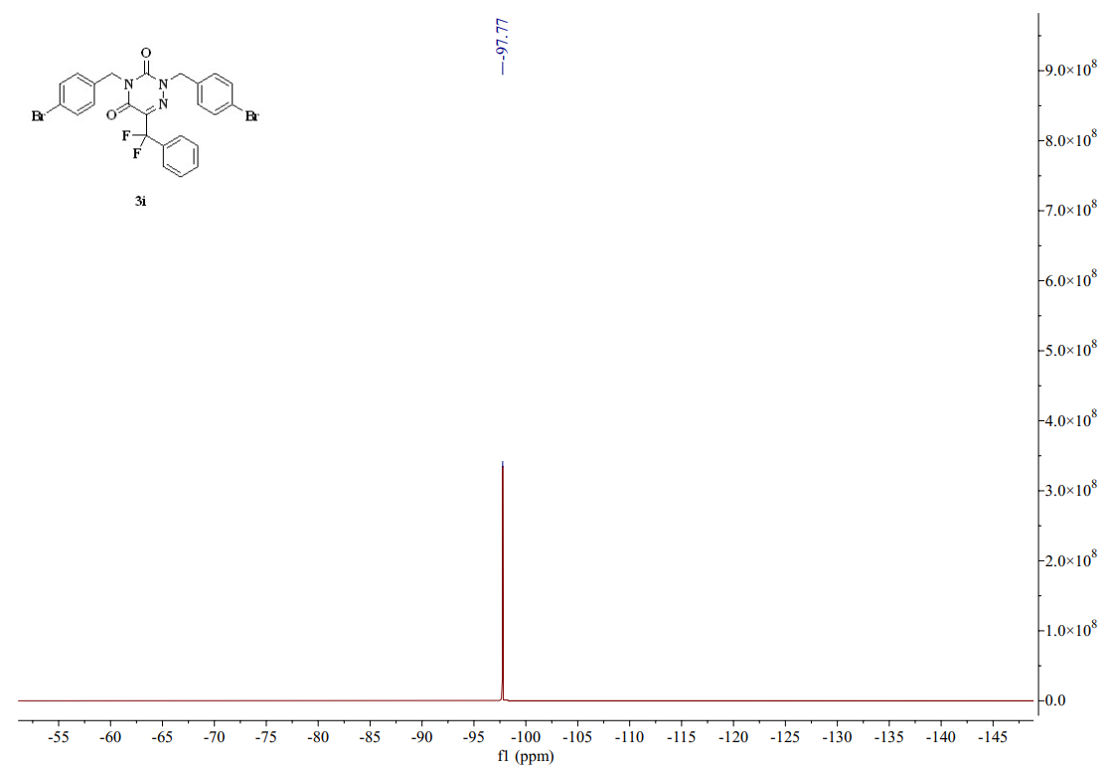
图S1 9-5 ¹⁹F-NMR spectrum (CDCl₃, 376 MHZ) of compound 3i
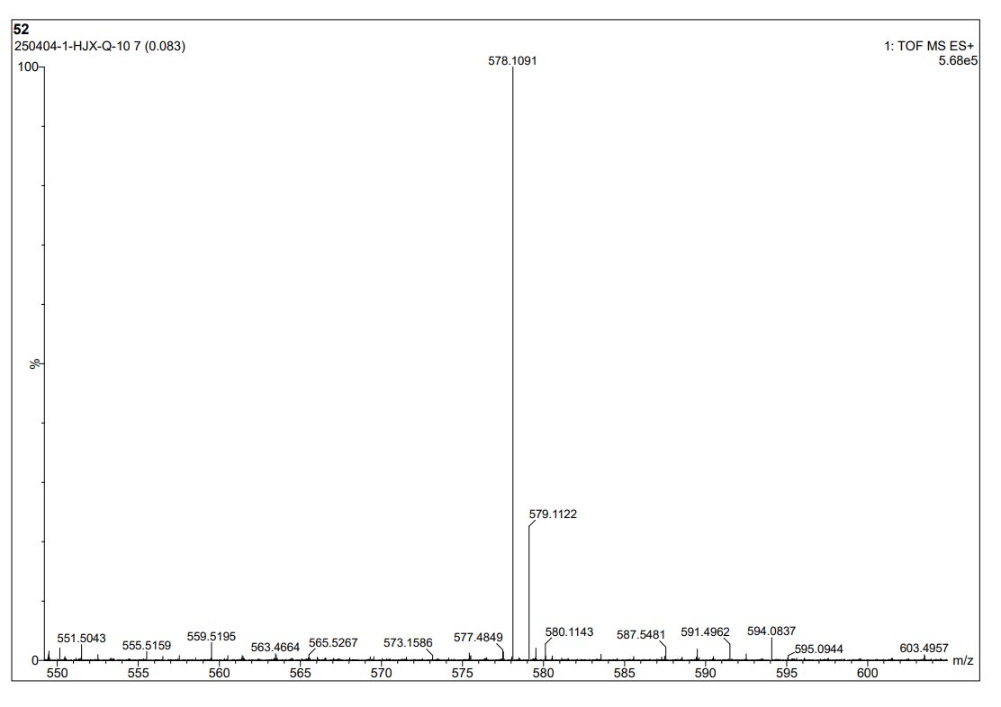
图S1 10-1 HR Mass spectrum (ESI) of compound 3j
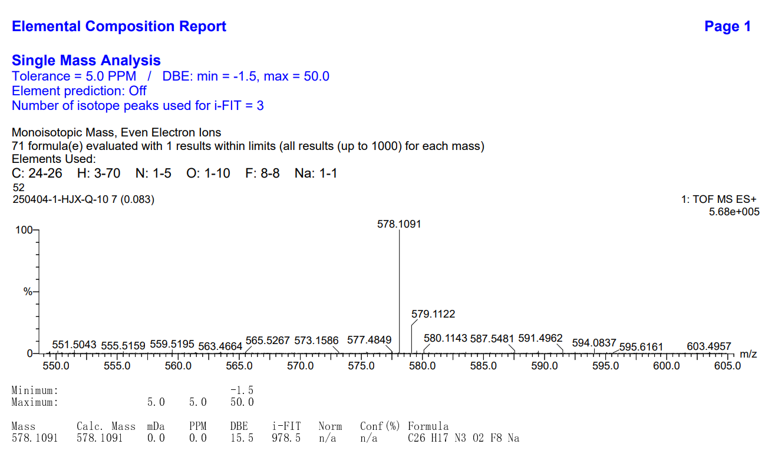
图S1 10-2 HR Mass spectrum (ESI) of compound 3j
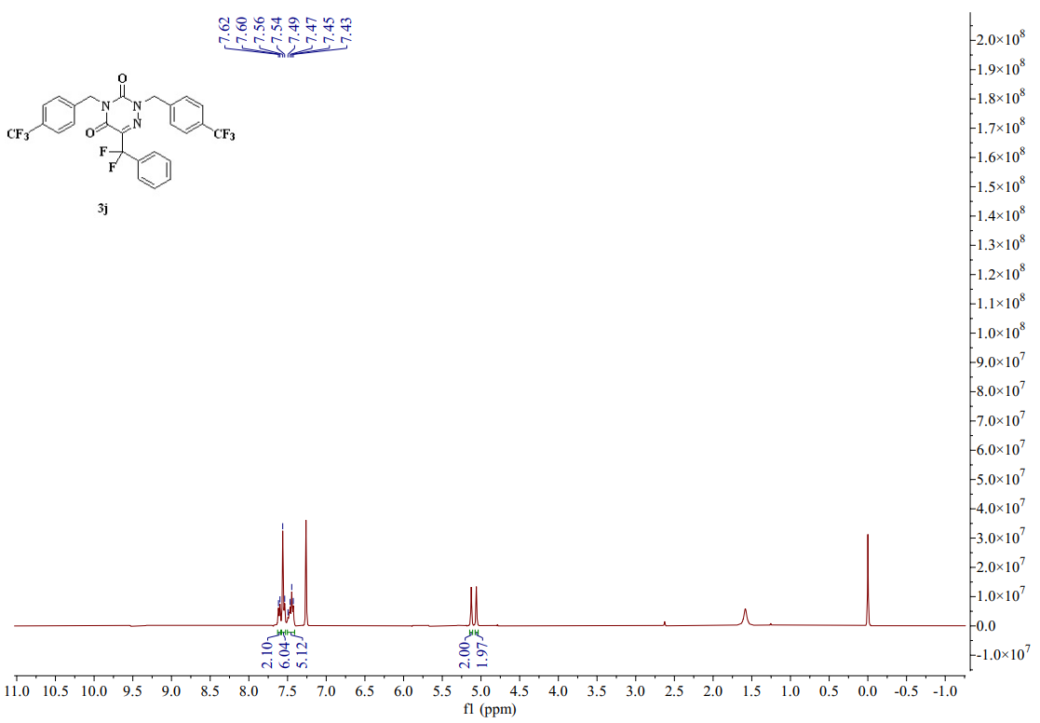
图S1 10-3 ¹H-NMR spectrum (CDCl₃, 400 MHZ) of compound 3j
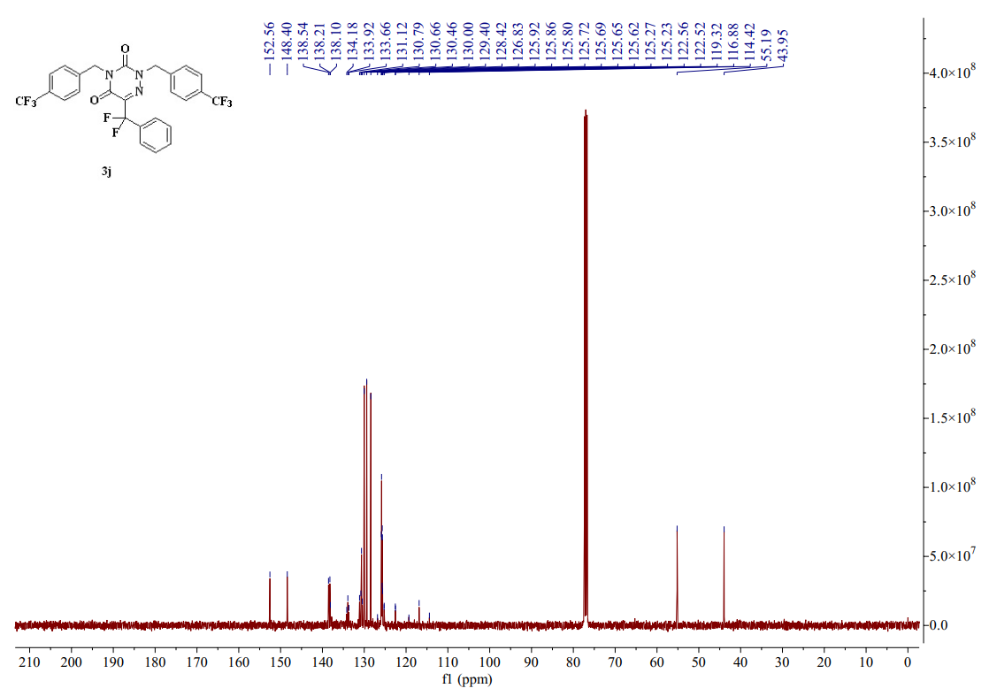
图S1 10-4 ¹³C-NMR spectrum (CDCl₃, 101 MHZ) of compound 3j
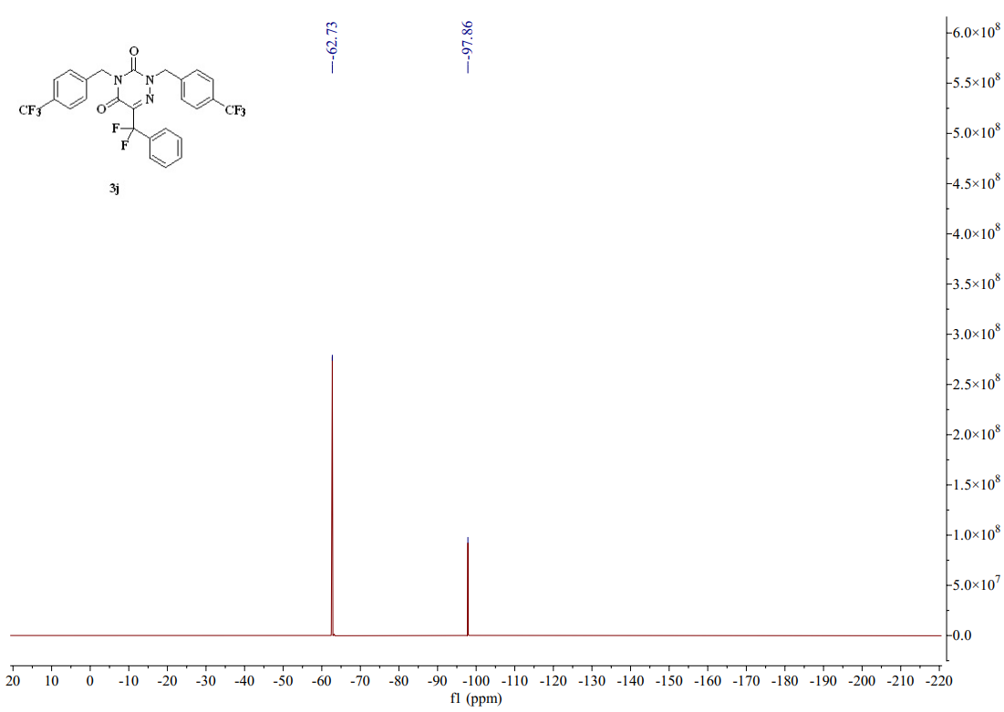
图S1 10-5 ¹⁹F-NMR spectrum (CDCl₃, 376 MHZ) of compound 3j
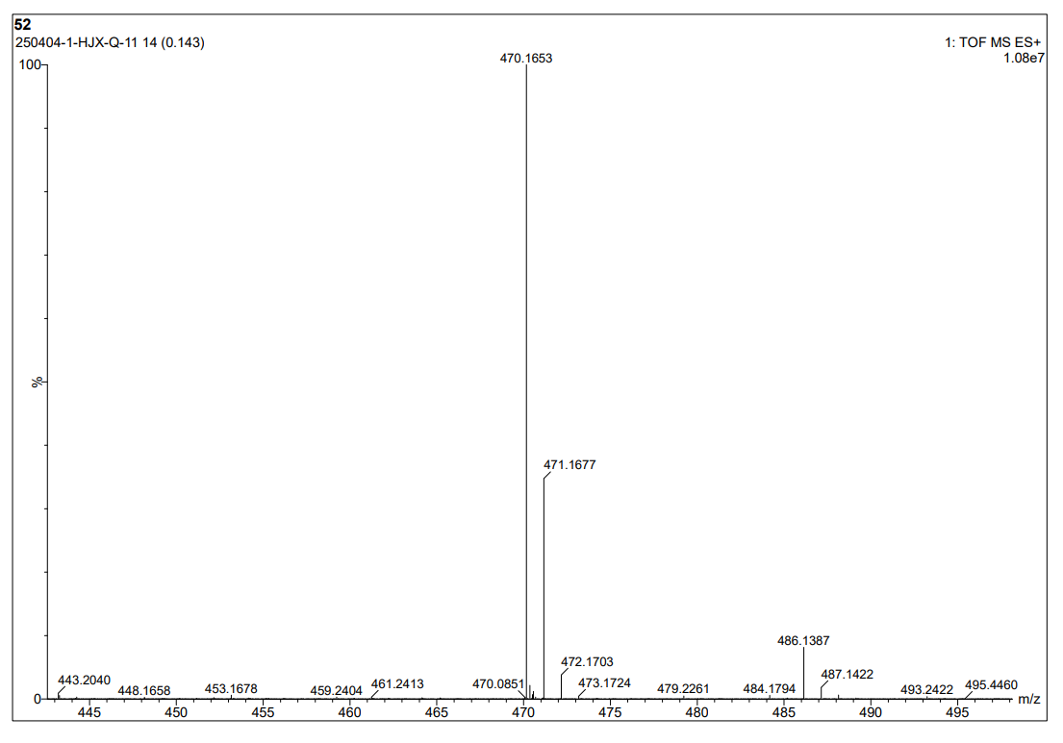
图S1 11-1 HR Mass spectrum (ESI) of compound 3k
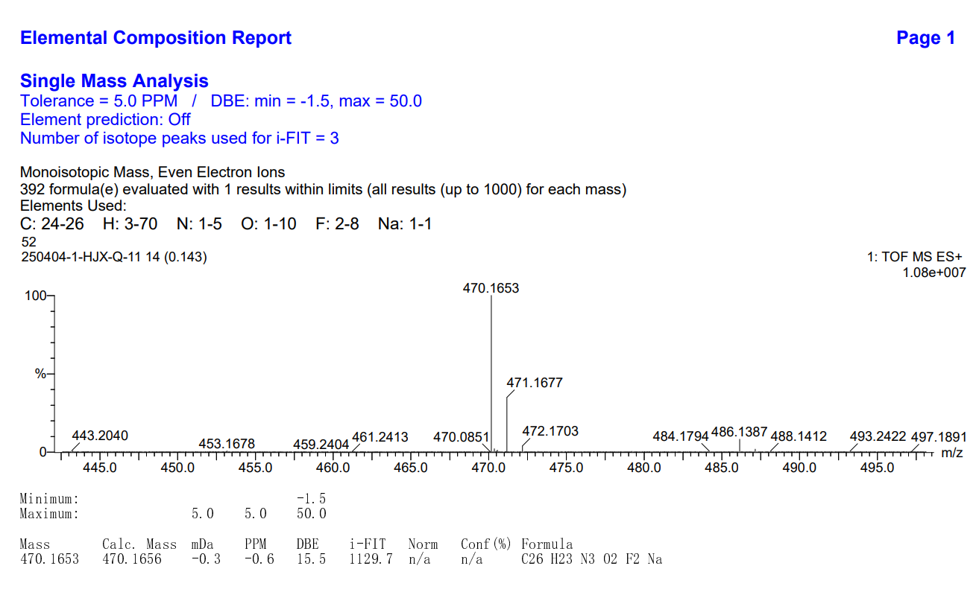
图S1 11-2 HR Mass spectrum (ESI) of compound 3k
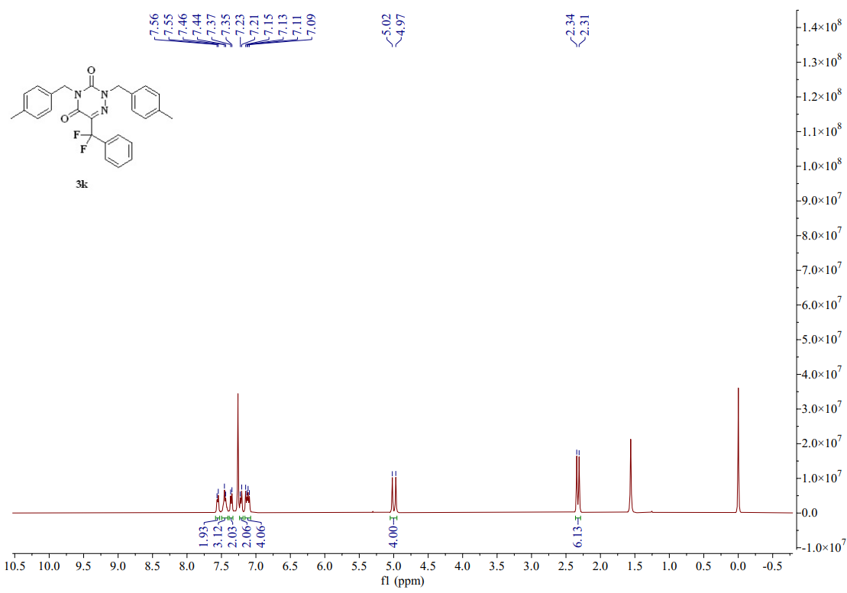
图S1 11-3 ¹H-NMR spectrum (CDCl₃, 400 MHZ) of compound 3k
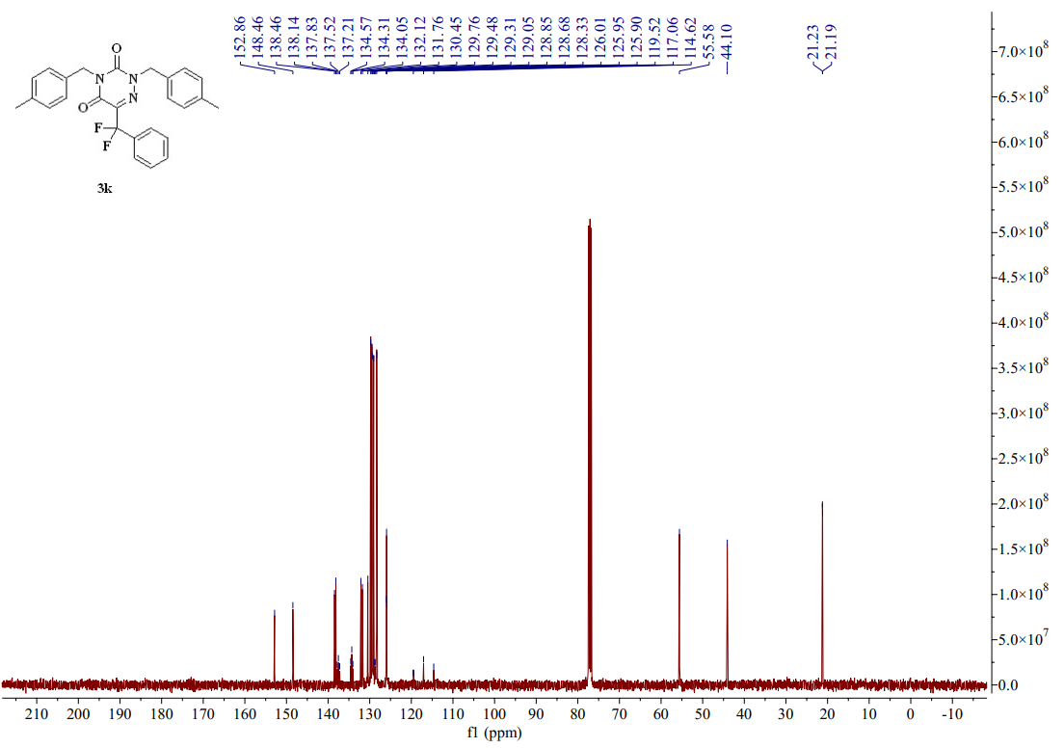
图S1 11-4 ¹³C-NMR spectrum (CDCl₃, 101 MHZ) of compound 3k
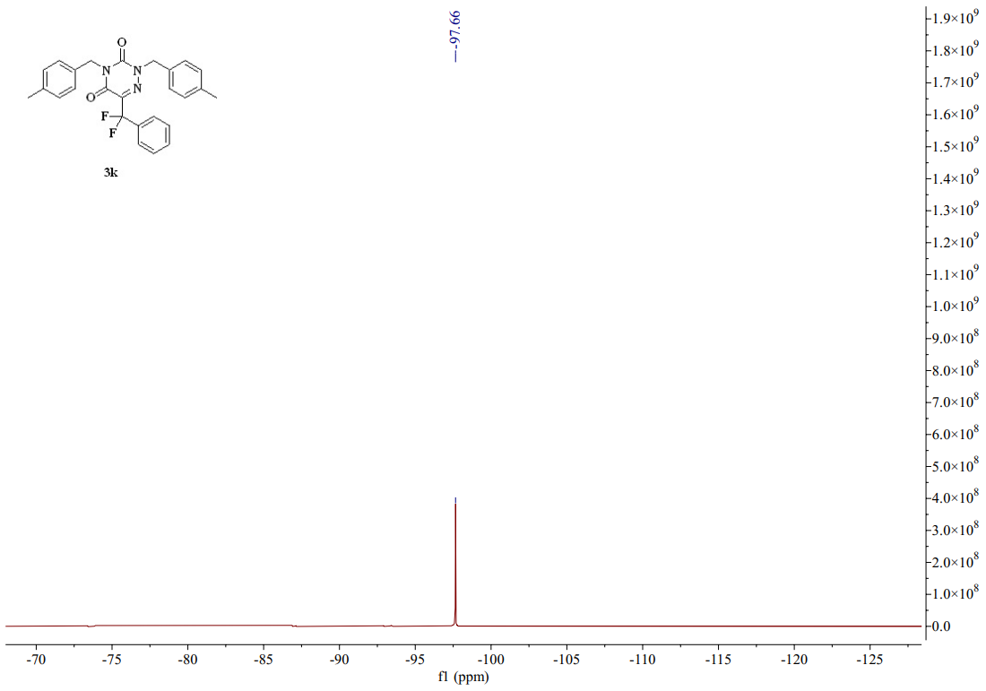
图S1 11-5 ¹⁹F-NMR spectrum (CDCl₃, 376 MHZ) of compound 3k
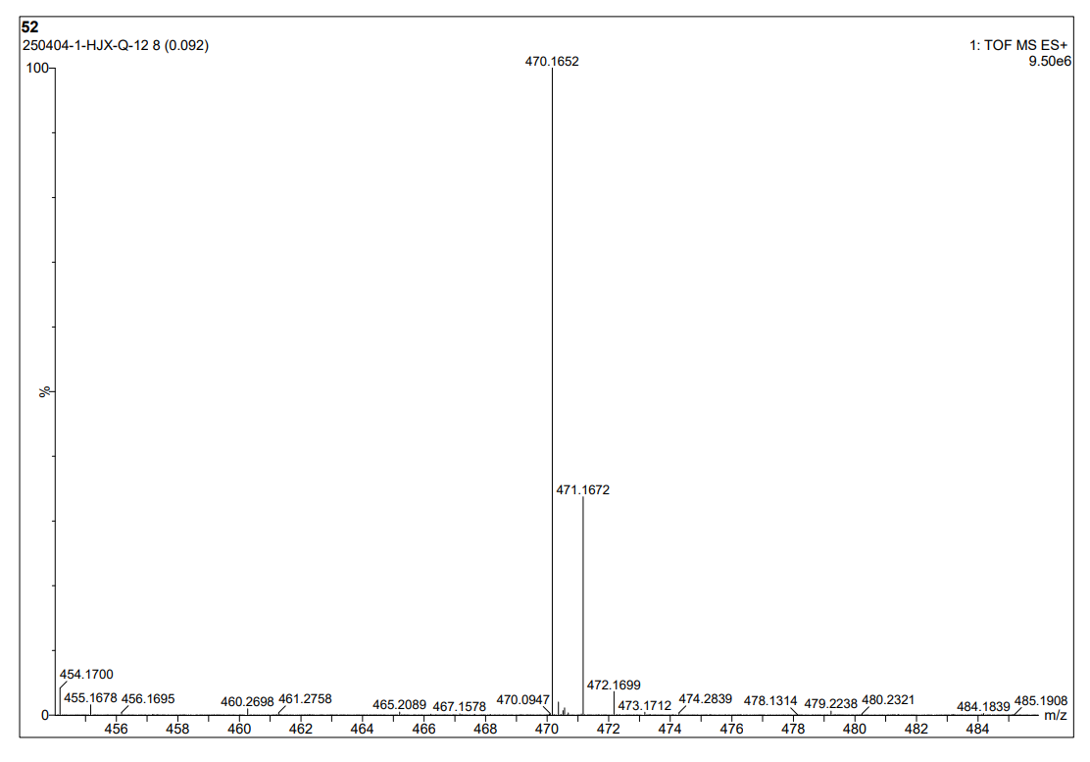
图S1 12-1 HR Mass spectrum (ESI) of compound 3l
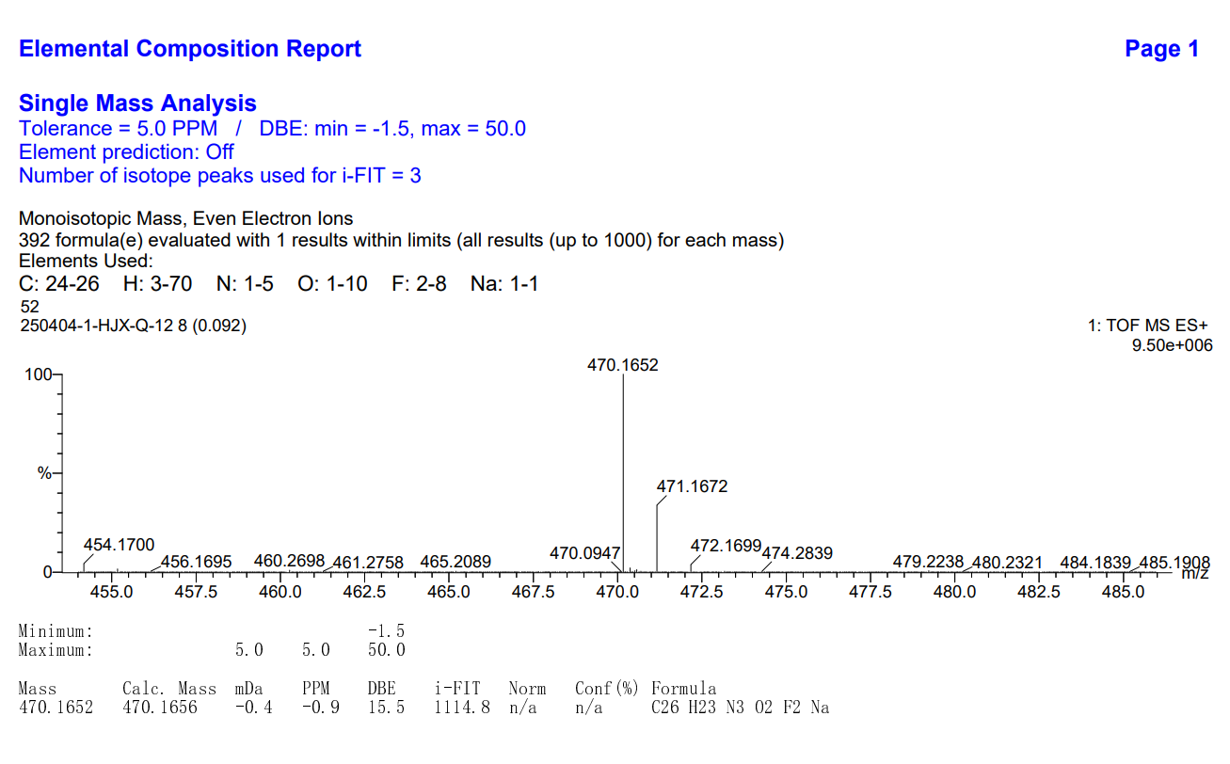
图S1 12-2 HR Mass spectrum (ESI) of compound 3l
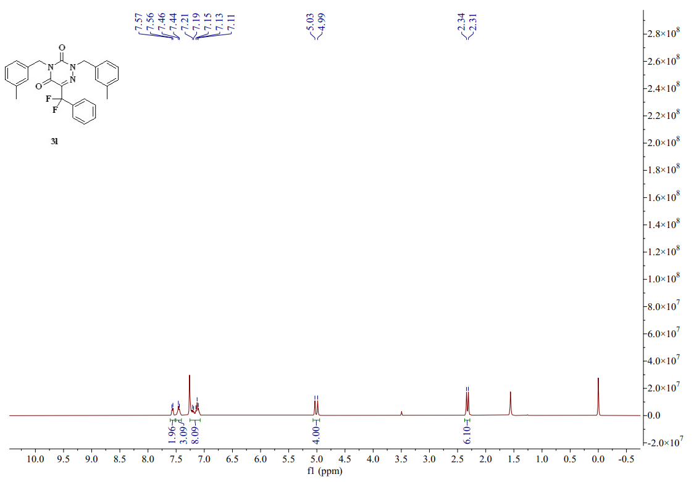
图S1 12-3 ¹H-NMR spectrum (CDCl₃, 400 MHZ) of compound 3l
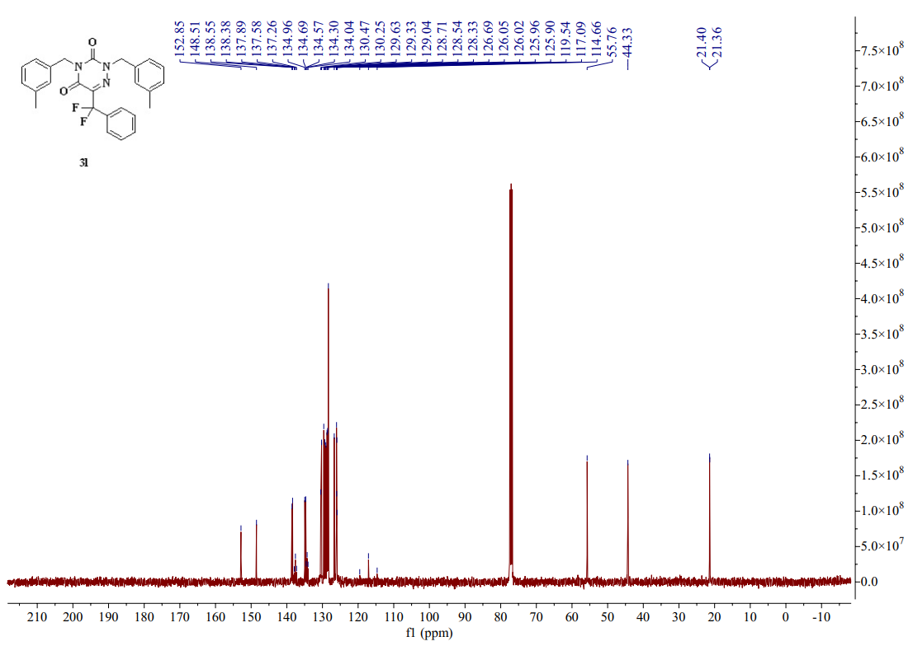
图S1 12-4 ¹³C-NMR spectrum (CDCl₃, 101 MHZ) of compound 3l
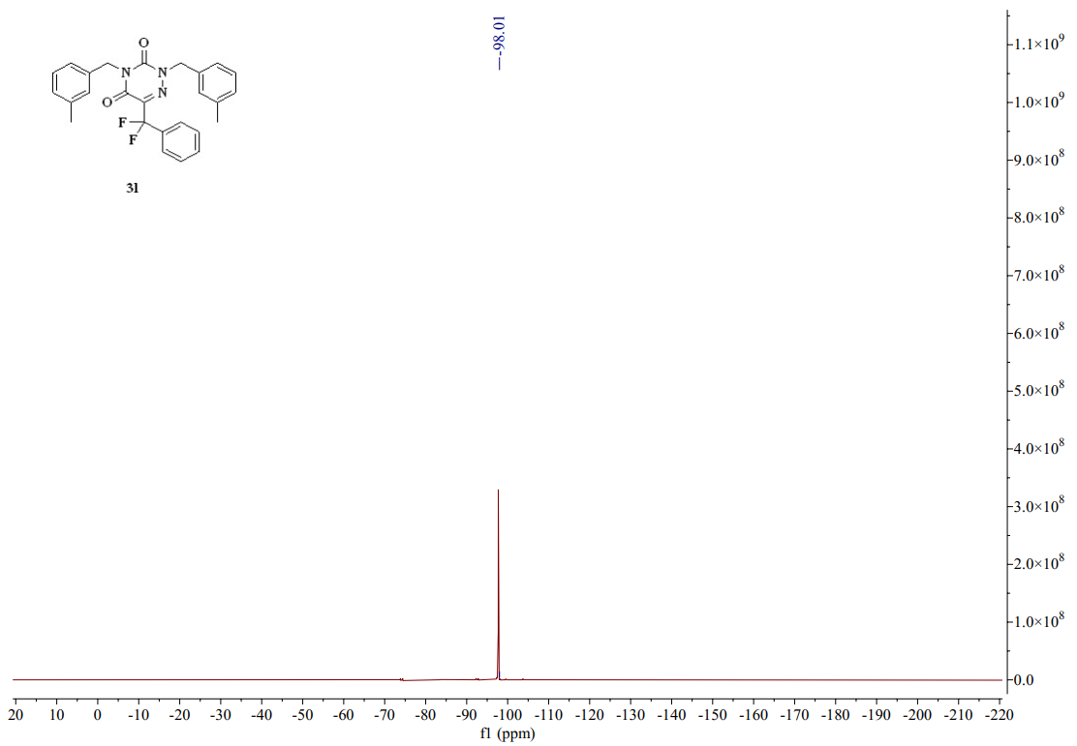
图S1 12-5 ¹⁹F-NMR spectrum (CDCl₃, 376MHZ) of compound 3l
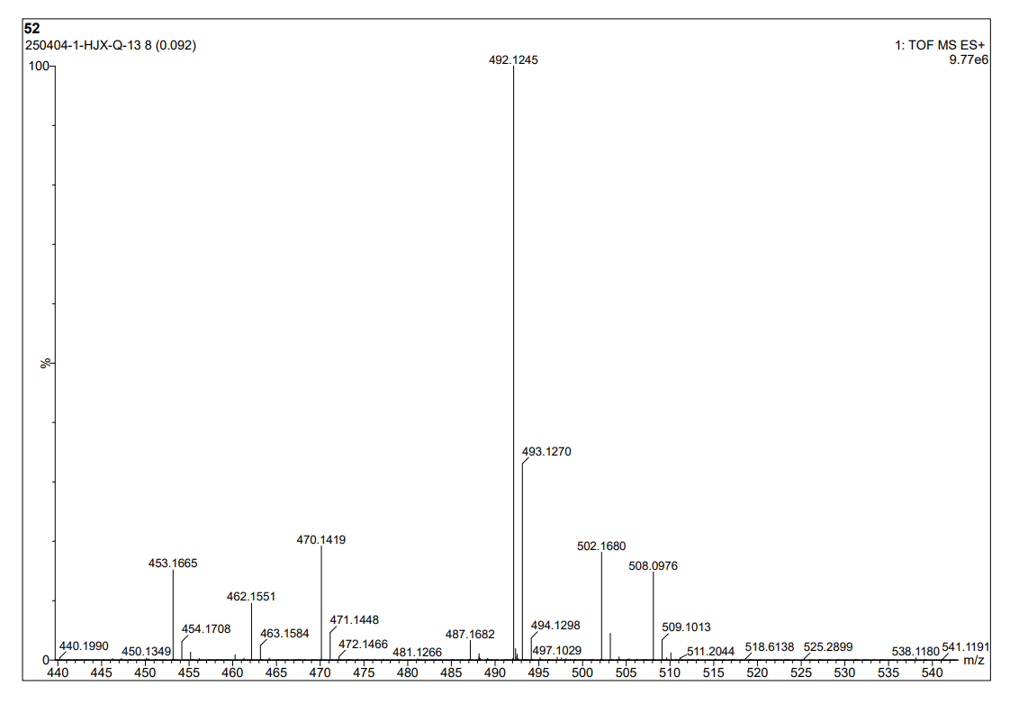
图S1 13-1 HR Mass spectrum (ESI) of compound 3m
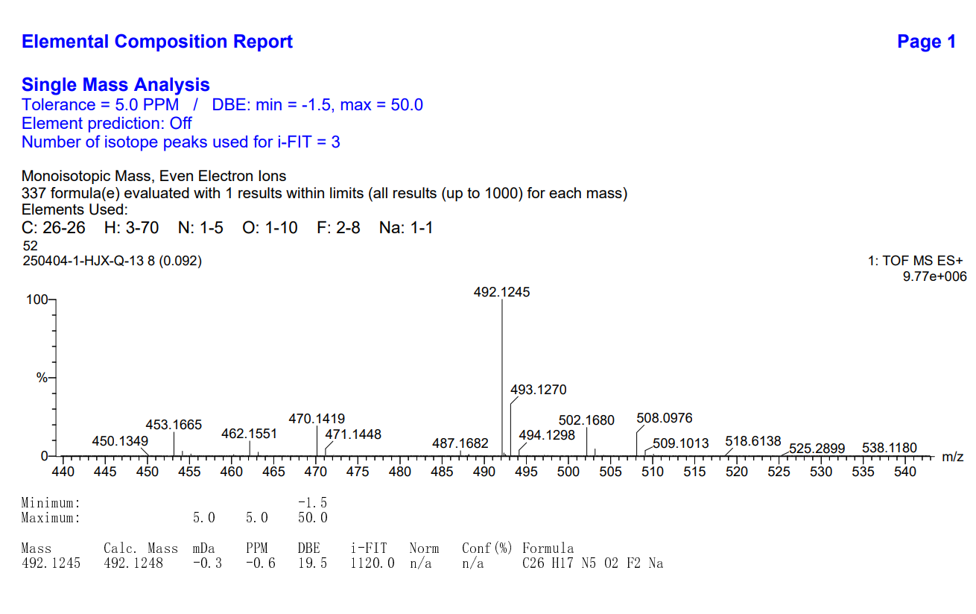
图S1 13-2 HR Mass spectrum (ESI) of compound 3m
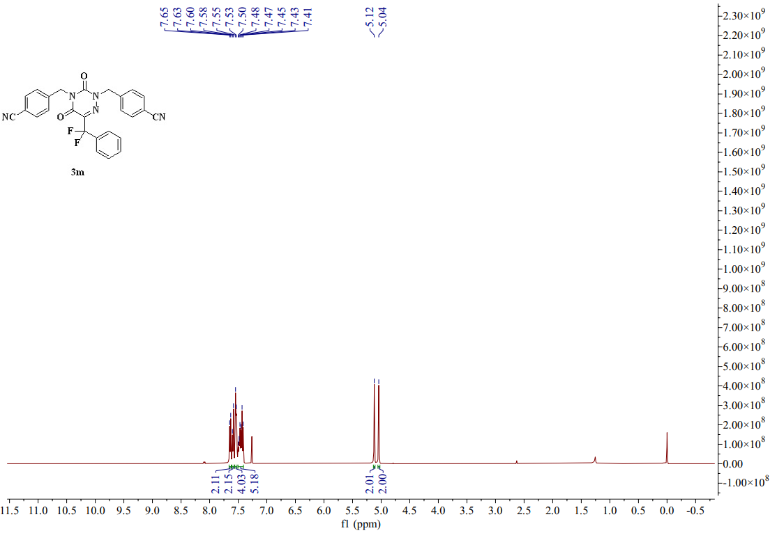
图S1 13-3 ¹H-NMR spectrum (CDCl₃, 400 MHZ) of compound 3m
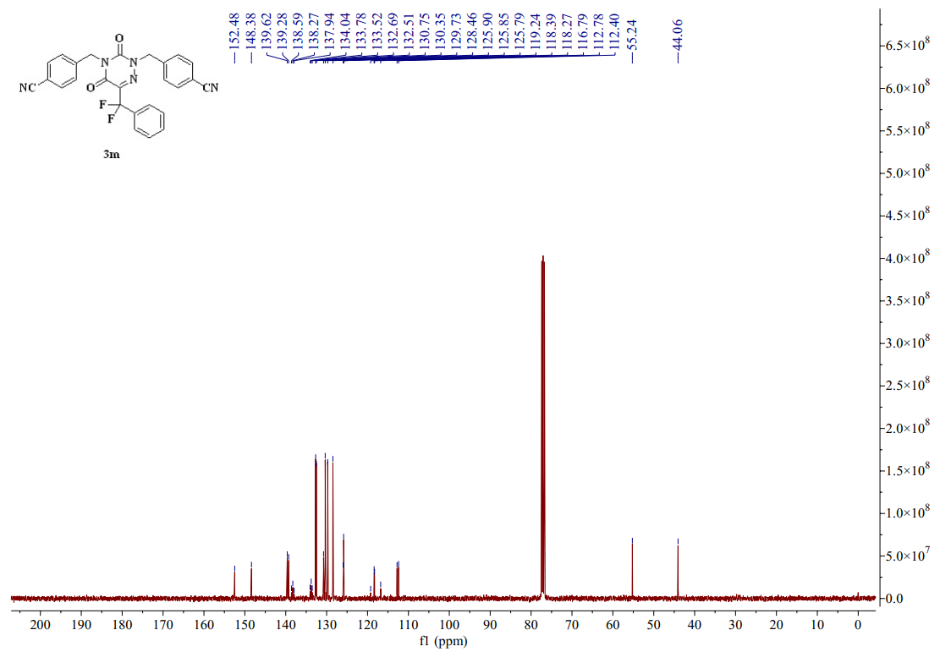
图S1 13-4 ¹³C-NMR spectrum (CDCl₃, 101 MHZ) of compound 3m
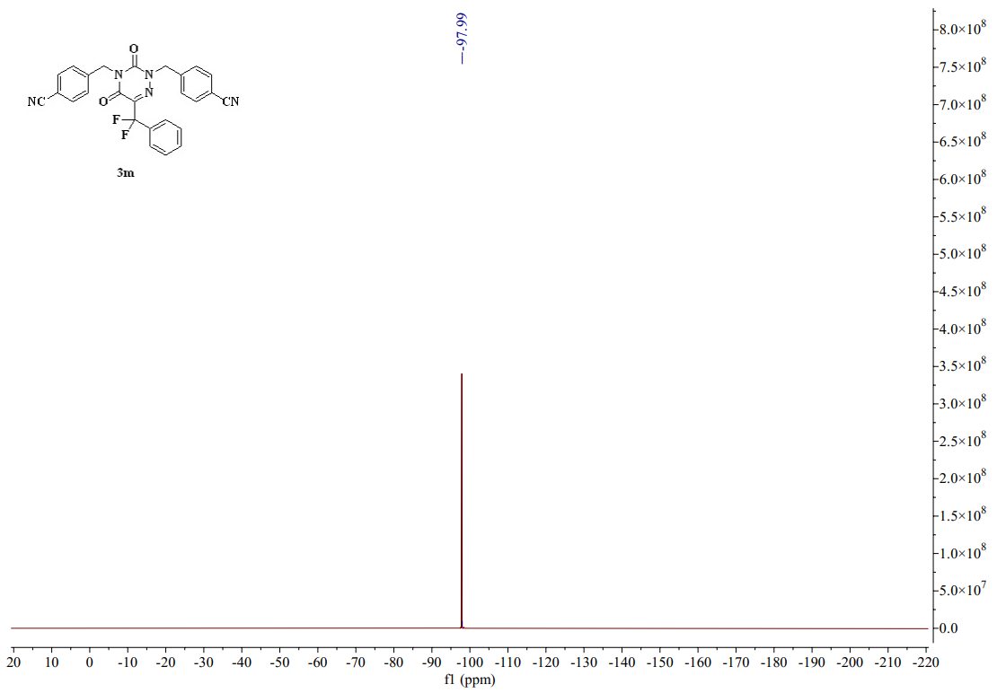
图S1 13-5 ¹⁹F-NMR spectrum (CDCl₃, 376 MHZ) of compound 3m
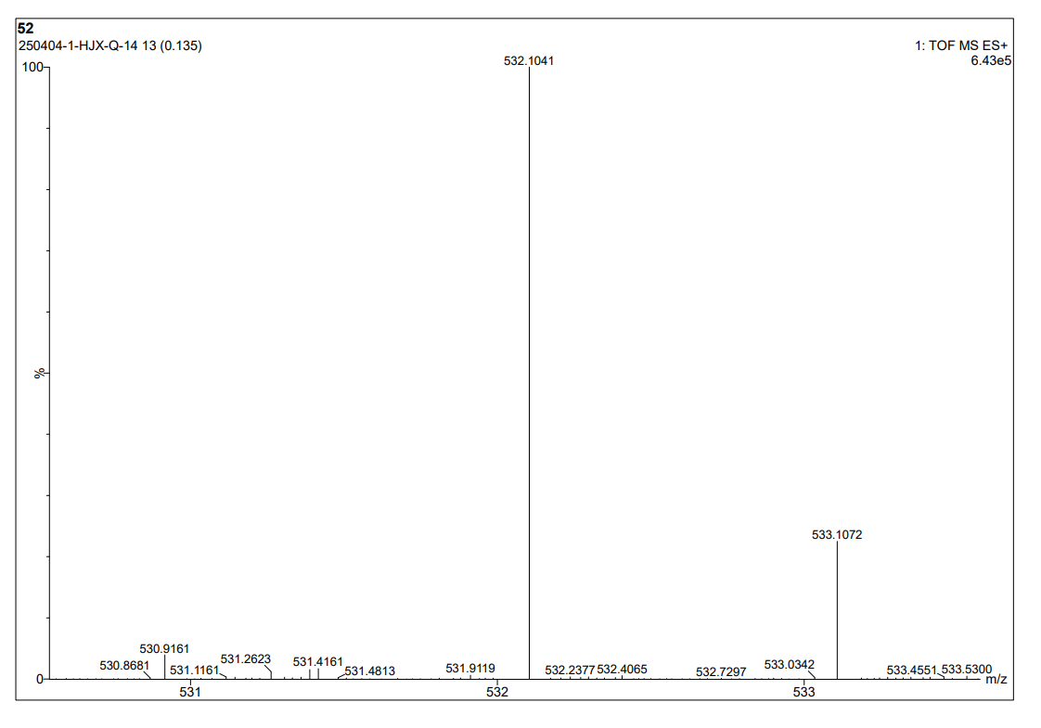
图S1 14-1 HR Mass spectrum (ESI) of compound 3n
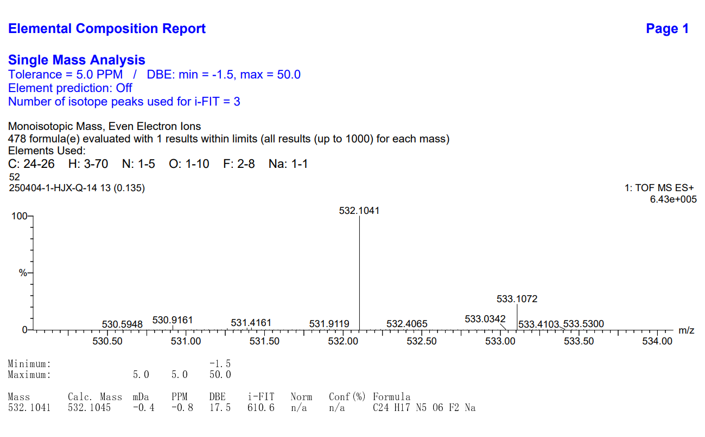
图S1 14-2 HR Mass spectrum (ESI) of compound 3n
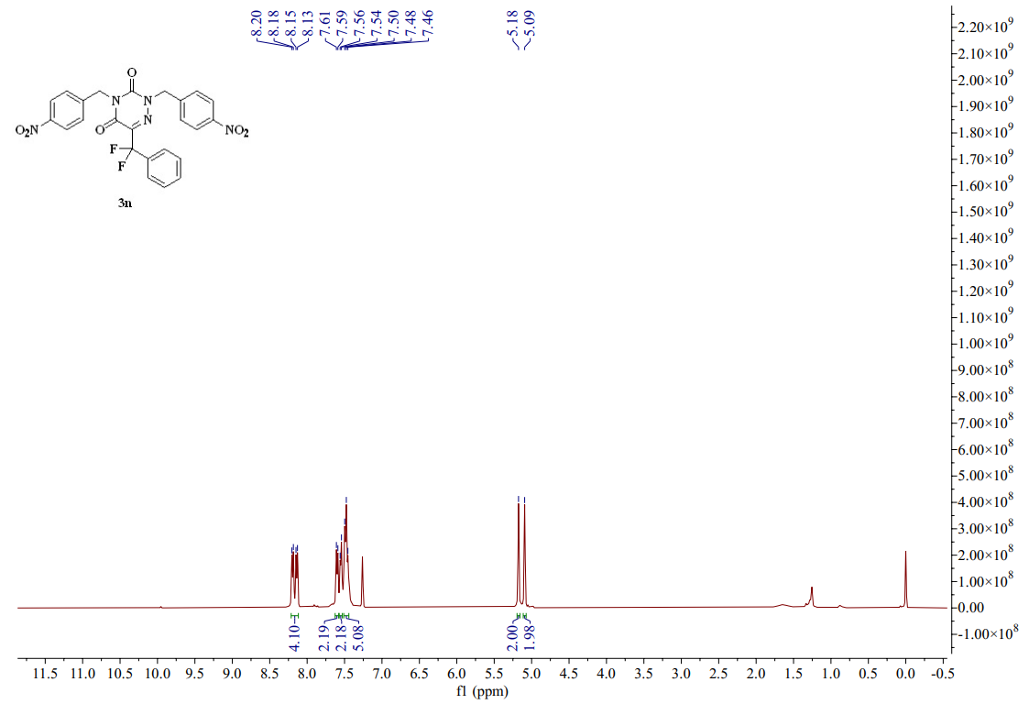
图S1 14-3 ¹H-NMR spectrum (CDCl₃, 400 MHZ) of compound 3n
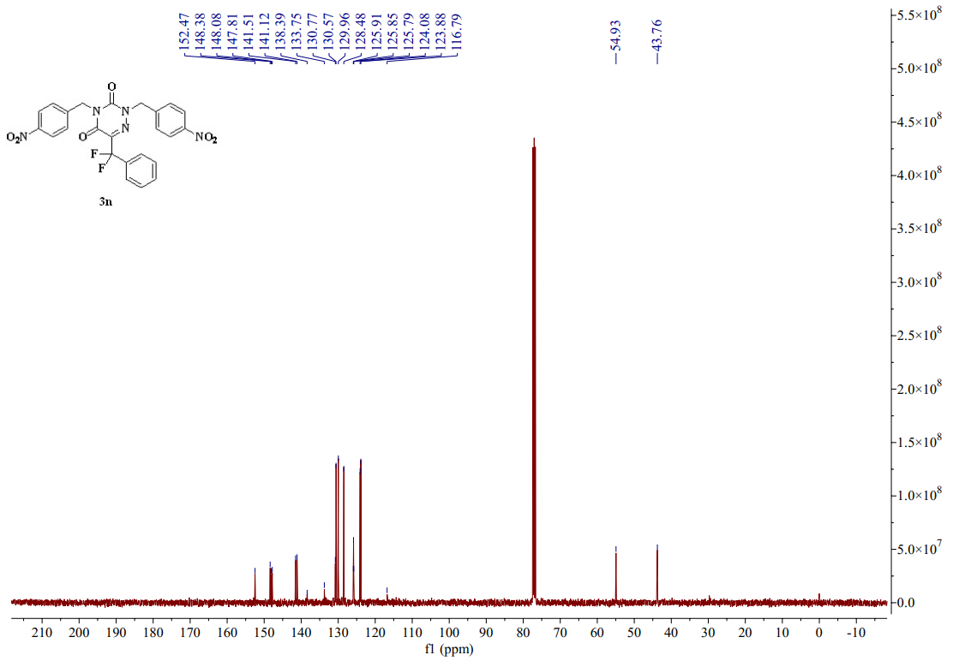
图S1 14-4 ¹³C-NMR spectrum (CDCl₃, 101 MHZ) of compound 3n
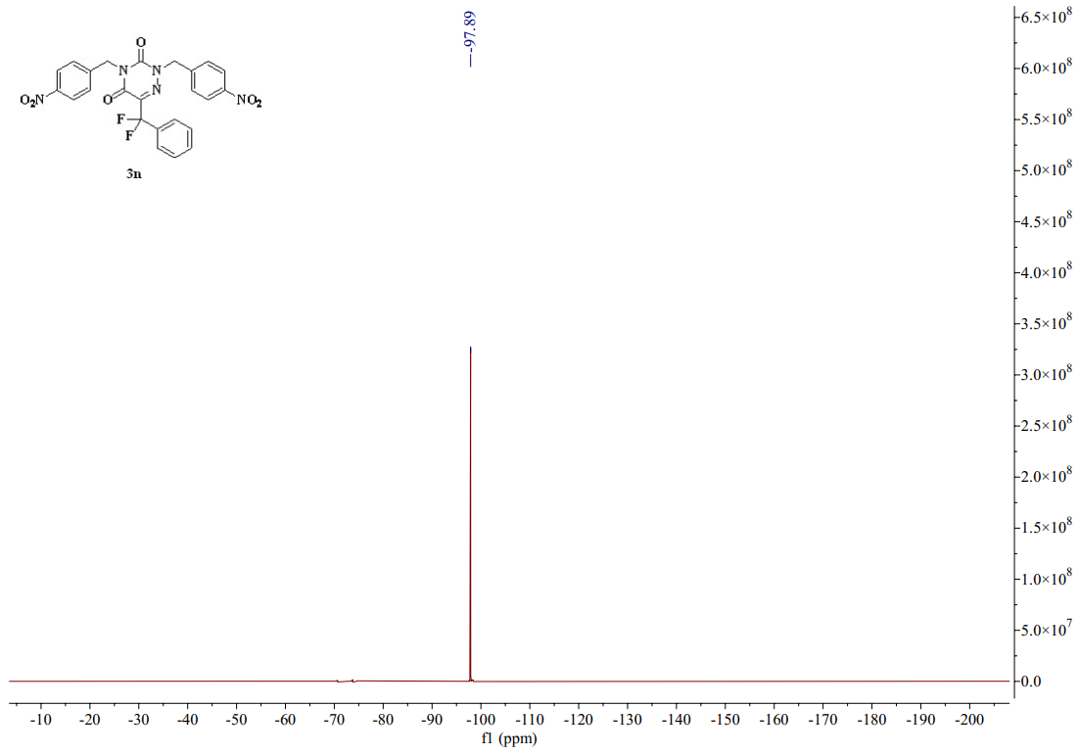
图S1 14-5 ¹⁹F-NMR spectrum (CDCl₃, 376 MHZ) of compound 3n
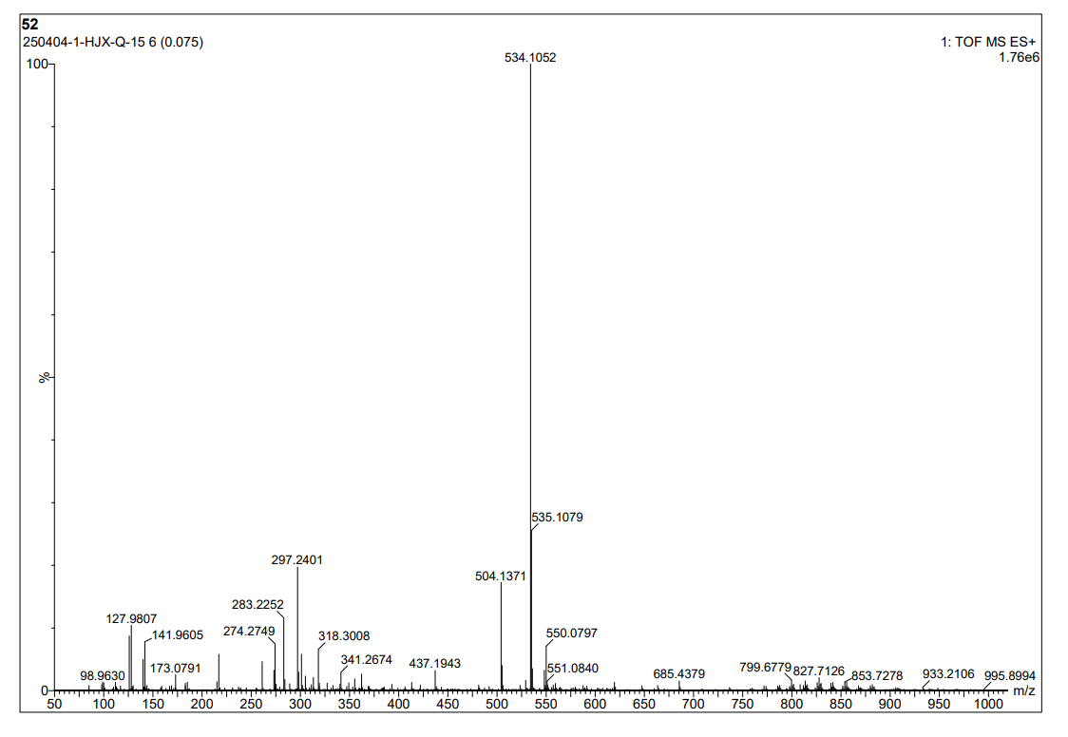
图S1 15-1 HR Mass spectrum (ESI) of compound 3o
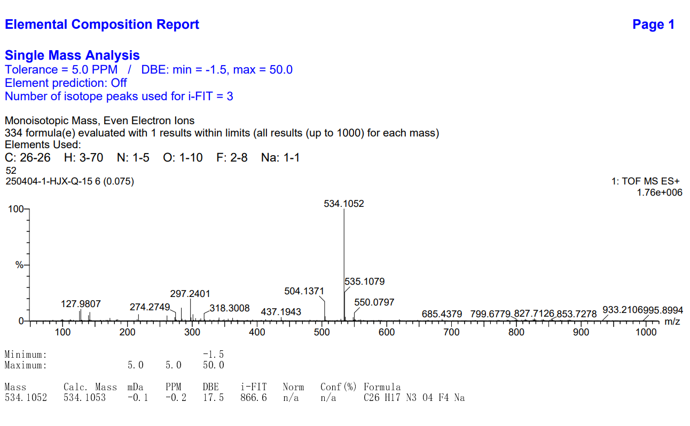
图S1 15-2 HR Mass spectrum (ESI) of compound 3o
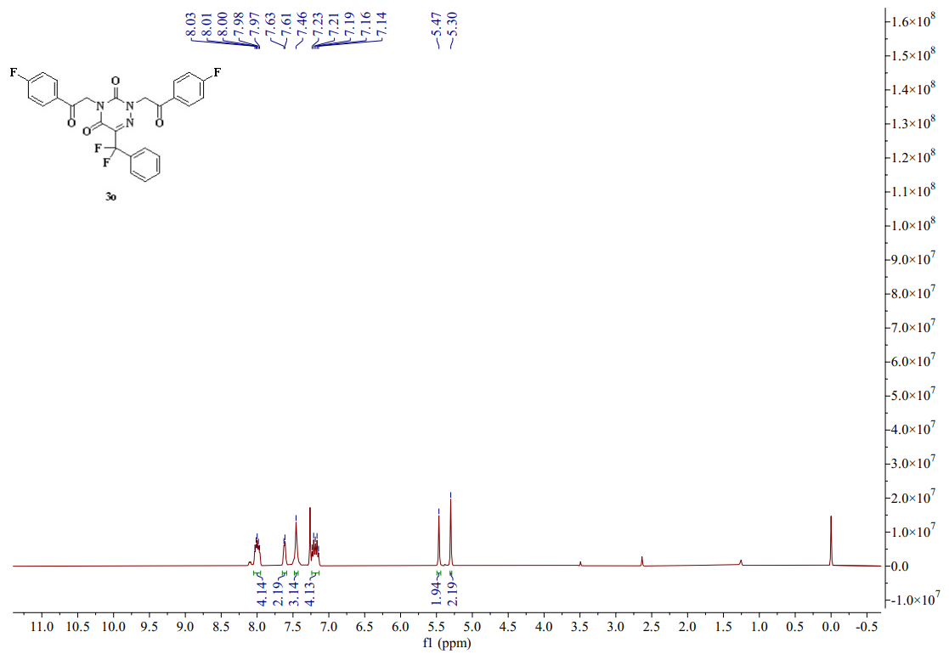
图S1 15-3 ¹H-NMR spectrum (CDCl₃, 400 MHZ) of compound 3o
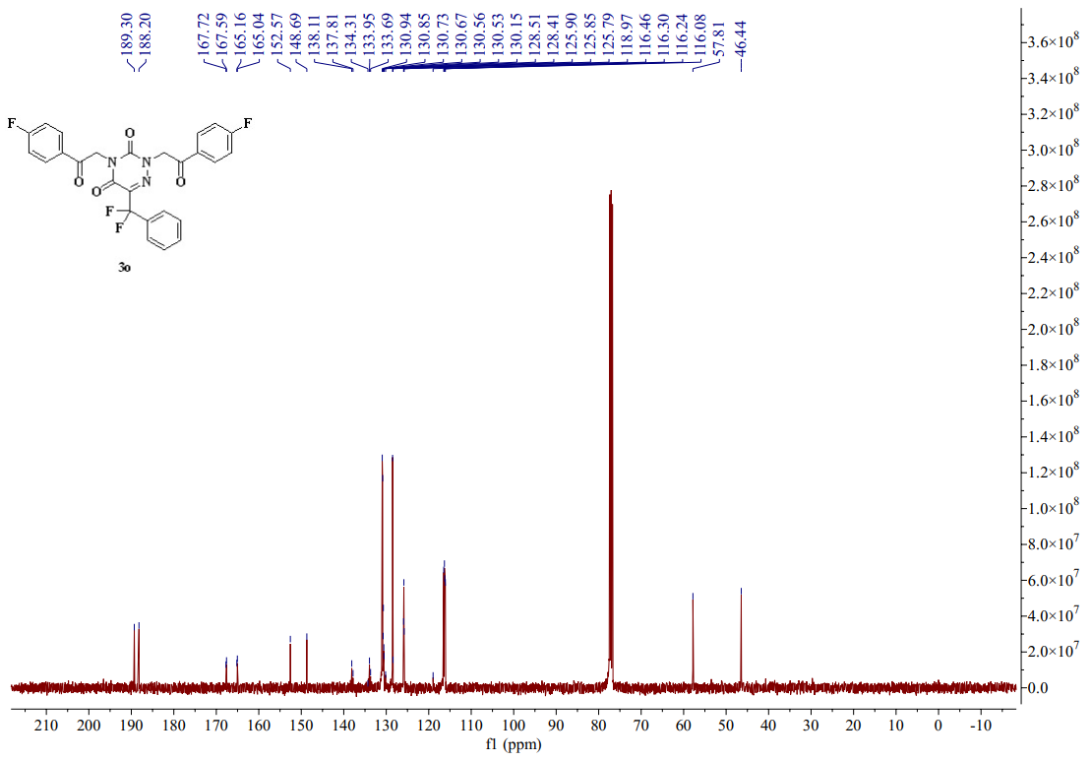
图S1 15-4 ¹³C-NMR spectrum (CDCl₃, 101 MHZ) of compound 3o
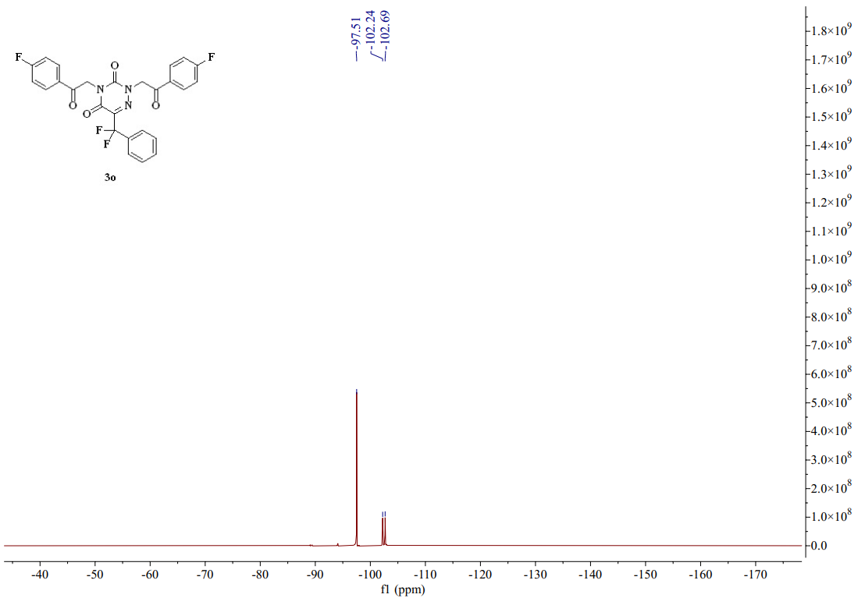
图S1 15-5 ¹⁹F-NMR spectrum (CDCl₃, 376 MHZ) of compound 3o
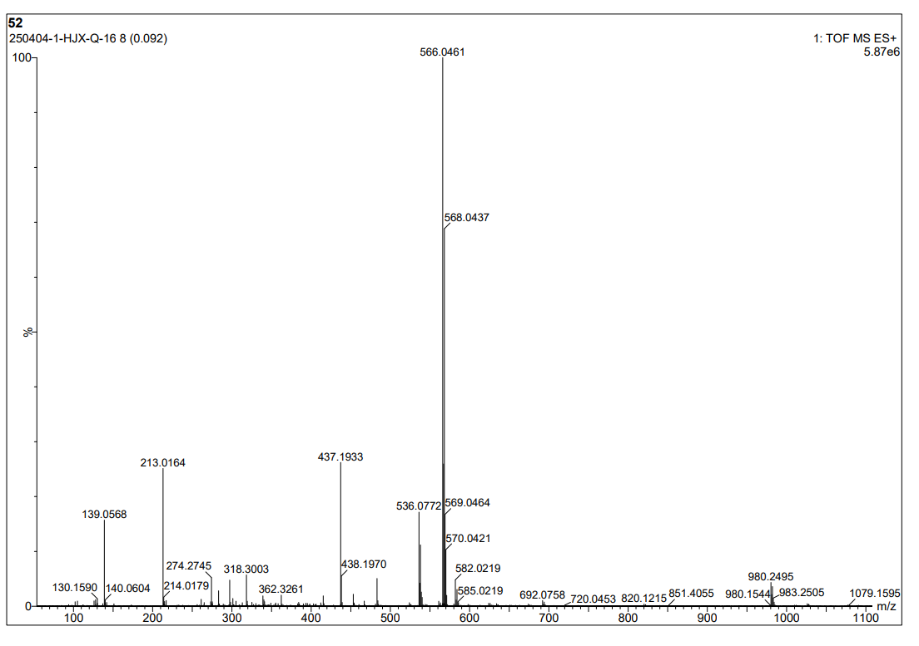
图S1 16-1 HR Mass spectrum (ESI) of compound 3p
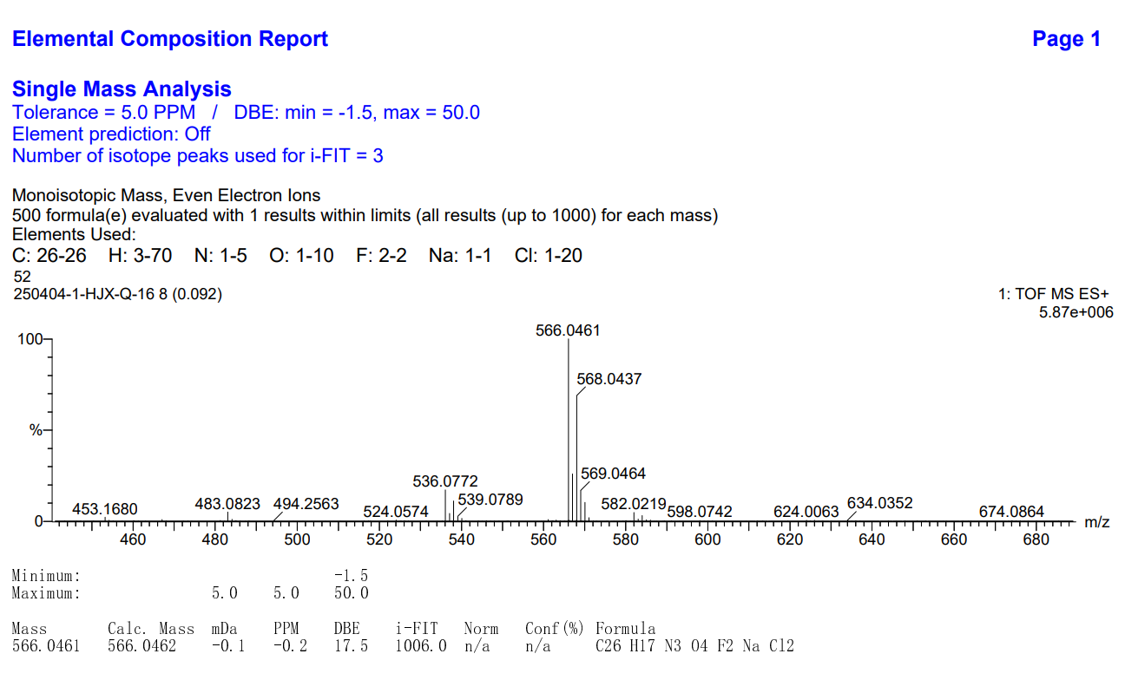
图S1 16-2 HR Mass spectrum (ESI) of compound 3p
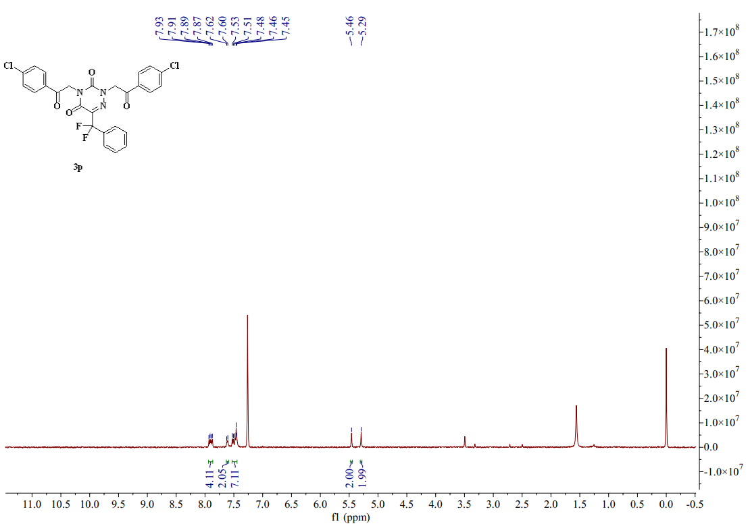
图S1 16-3 ¹H-NMR spectrum (CDCl₃, 400 MHZ) of compound 3p
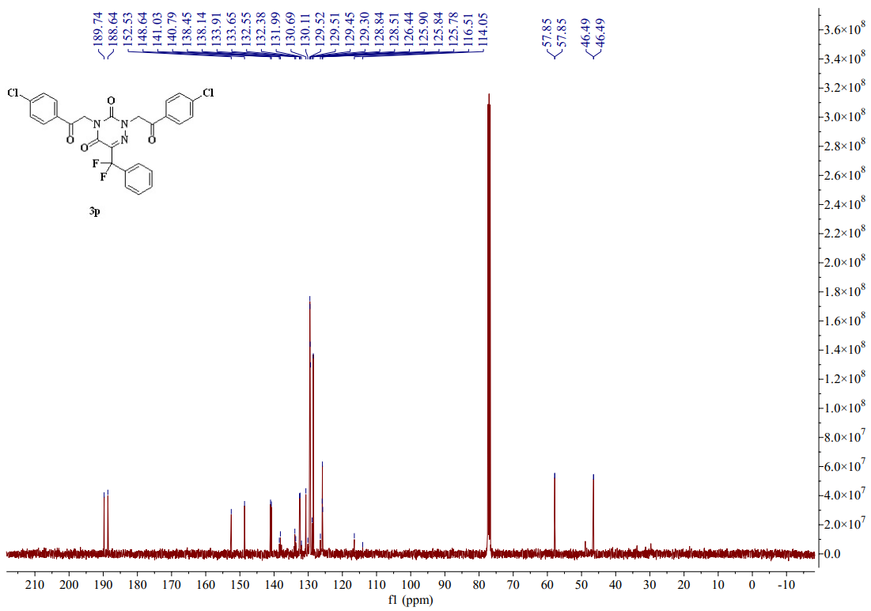
图S1 16-4 ¹³C-NMR spectrum (CDCl₃, 101 MHZ) of compound 3p
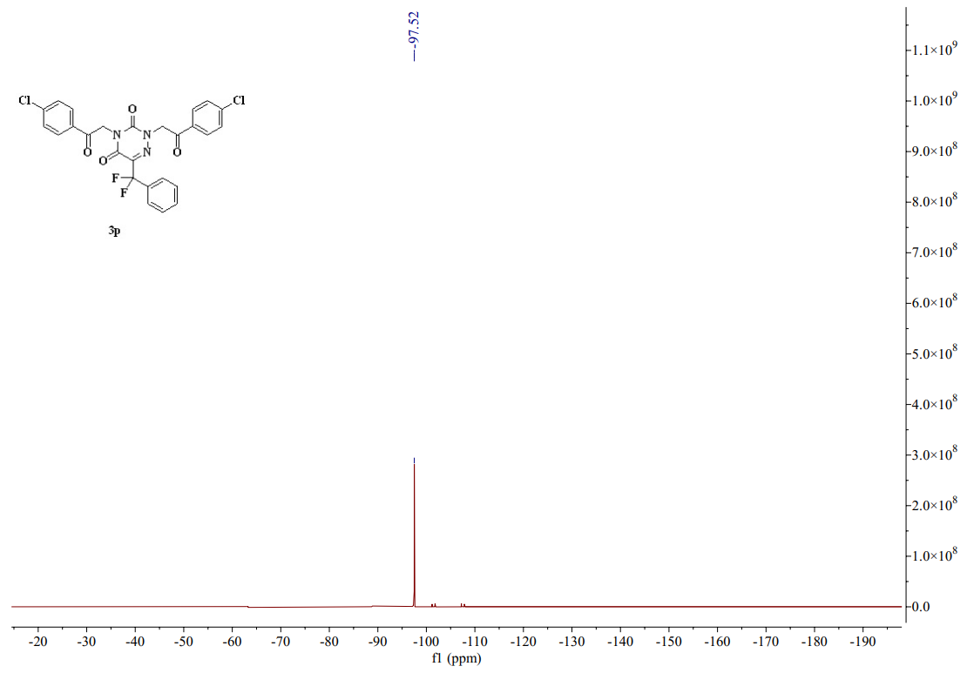
图S1 16-5 ¹⁹F-NMR spectrum (CDCl₃, 376 MHZ) of compound 3p
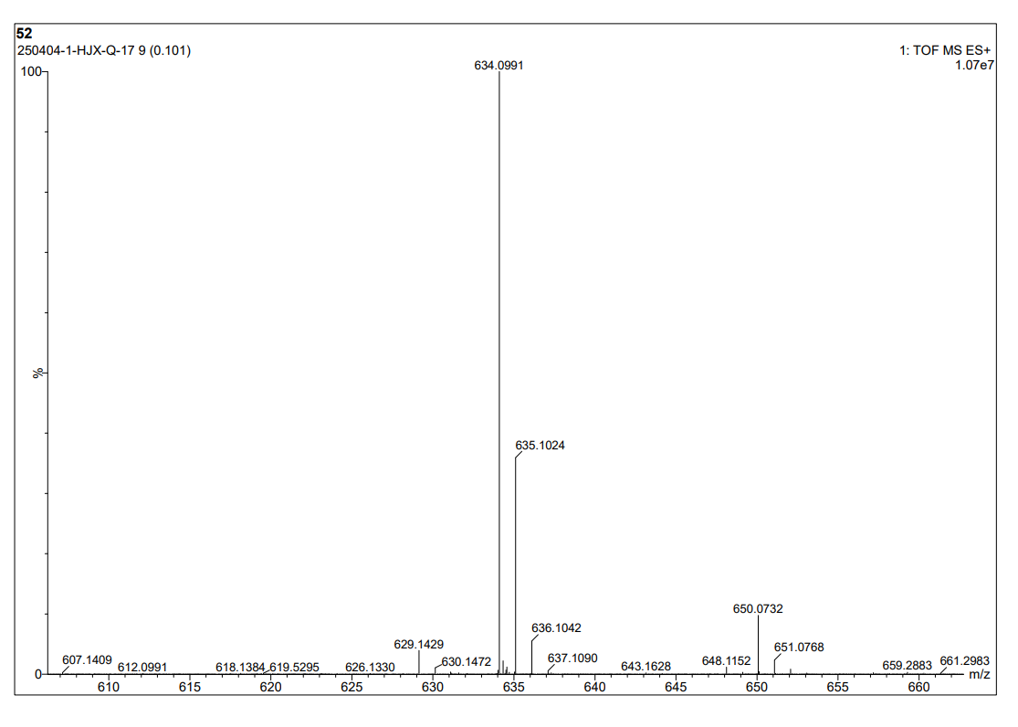
图S1 17-1 HR Mass spectrum (ESI) of compound 3q
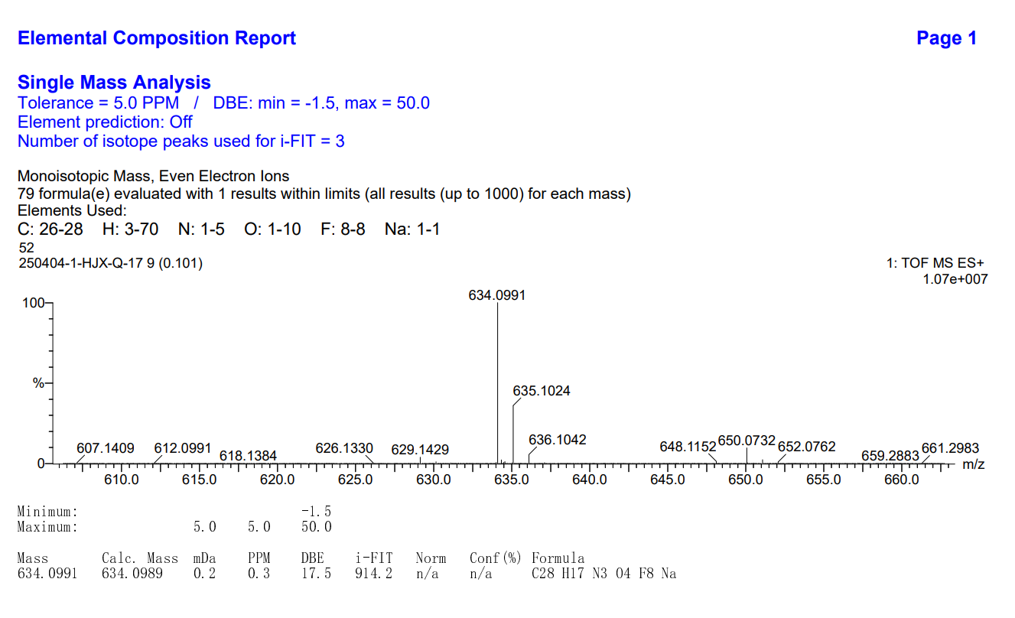
图S1 17-2 HR Mass spectrum (ESI) of compound 3q
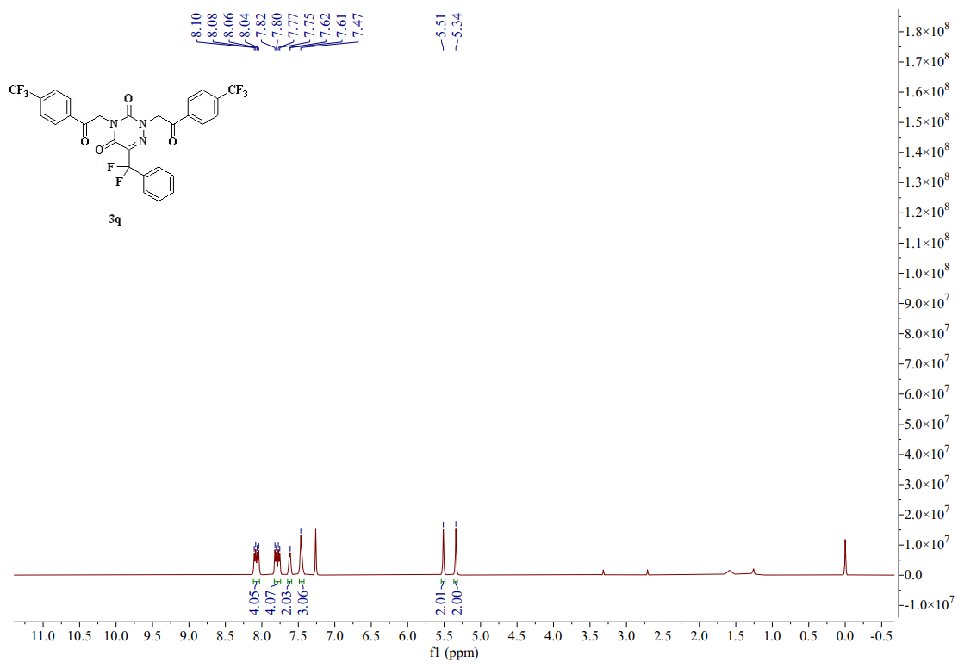
图S1 17-3 ¹H-NMR spectrum (CDCl₃, 400 MHZ) of compound 3q
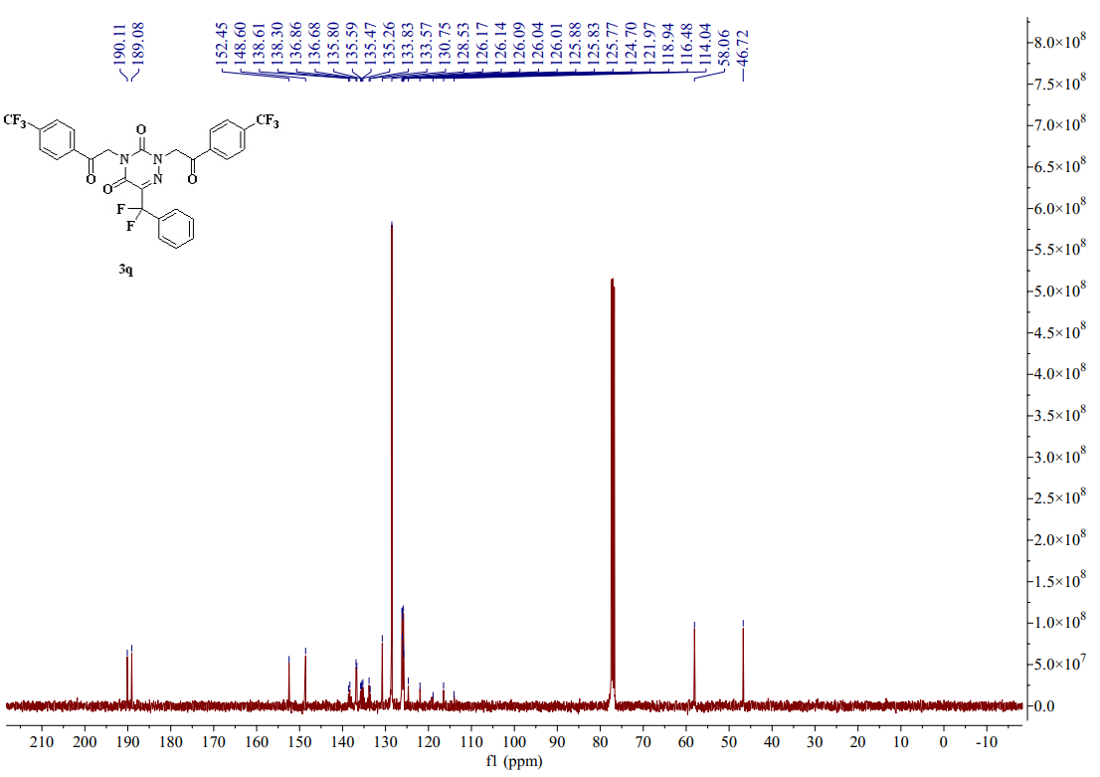
图S1 17-4 ¹³C-NMR spectrum (CDCl₃, 101 MHZ) of compound 3q
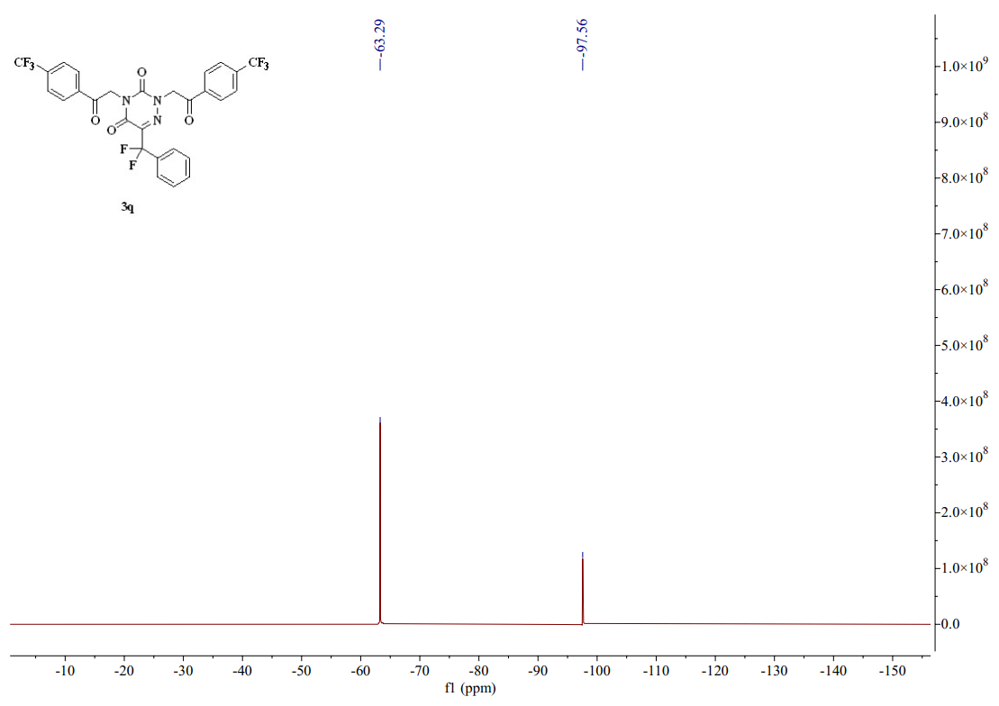
图S1 17-5 ¹⁹F-NMR spectrum (CDCl₃, 376 MHZ) of compound 3q
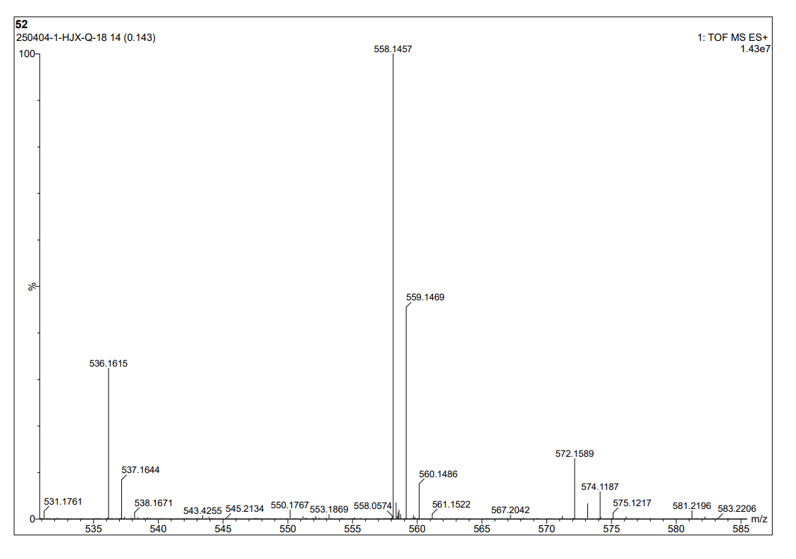
图S1 18-1 HR Mass spectrum (ESI) of compound 3r
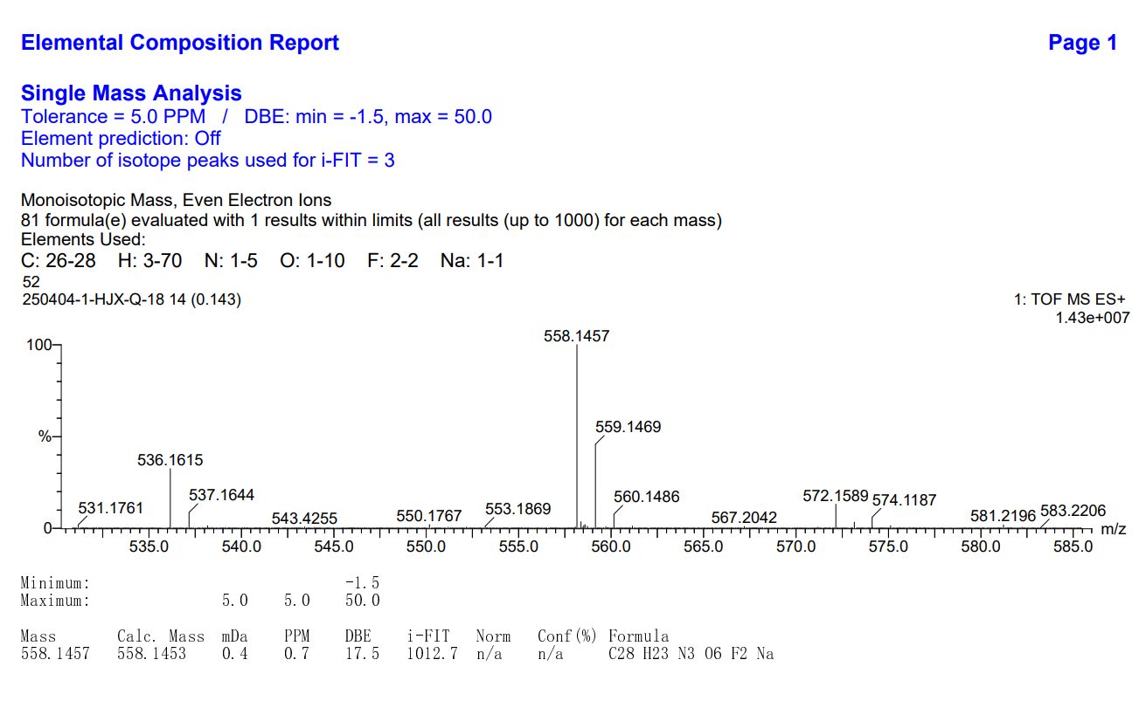
图S1 18-2 HR Mass spectrum (ESI) of compound 3r
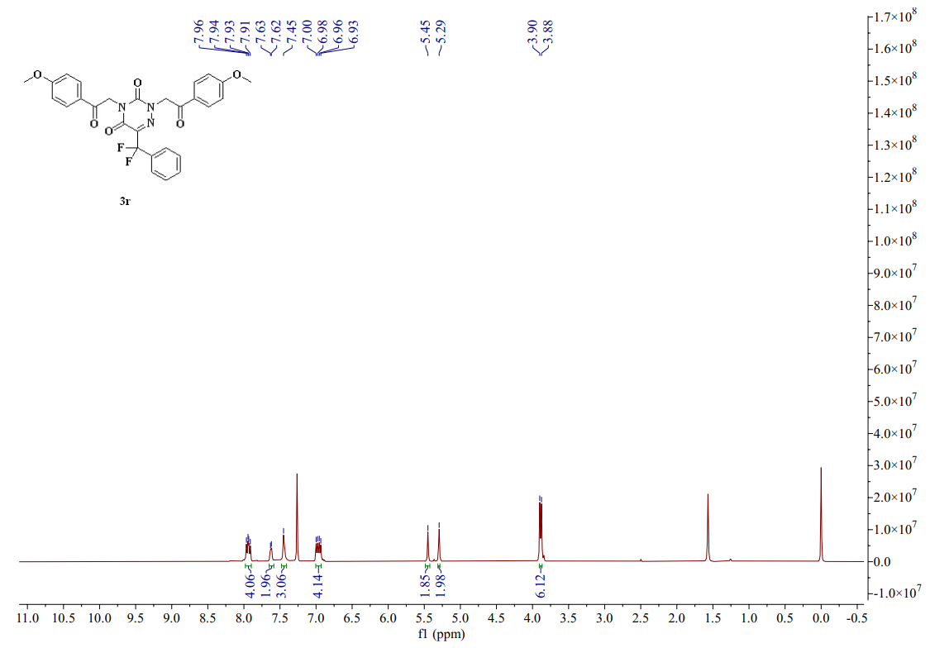
图S1 18-3 ¹H-NMR spectrum (CDCl₃, 400 MHZ) of compound 3r
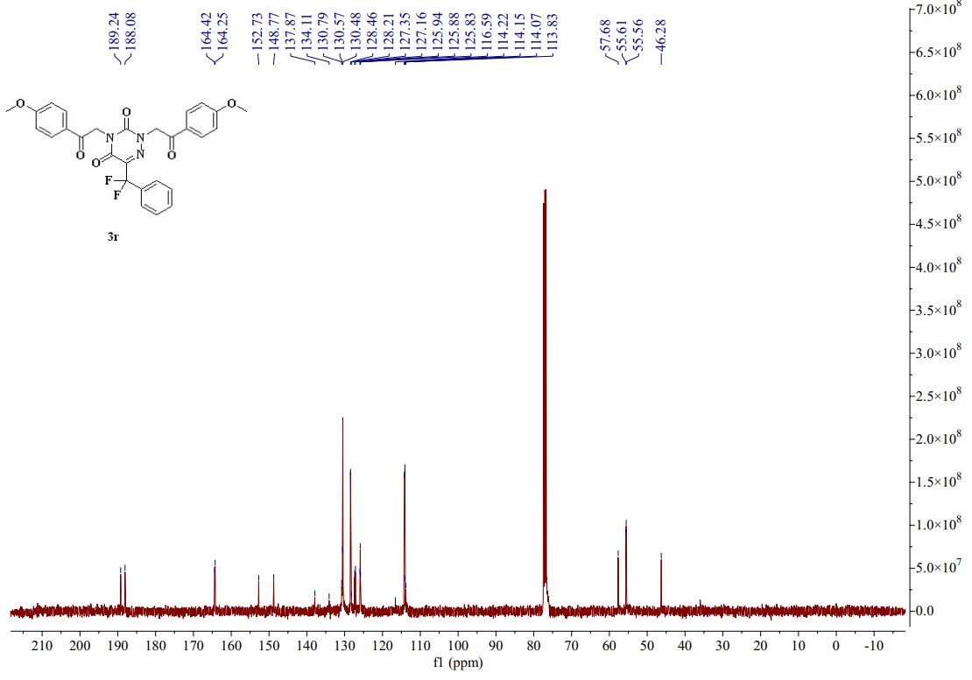
图S1 18-4 ¹³C-NMR spectrum (CDCl₃, 101 MHZ) of compound 3r
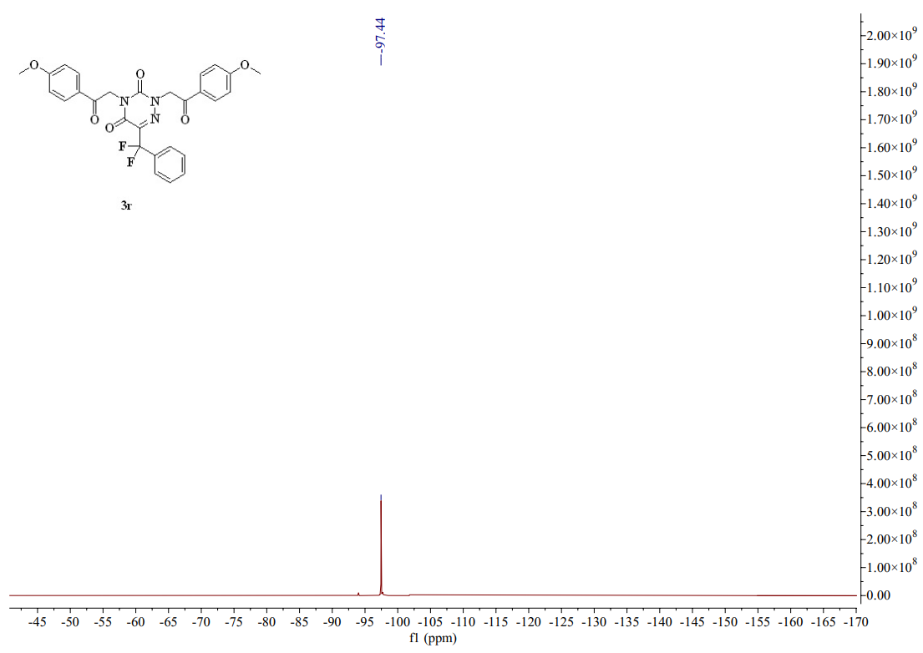
图S1 18-5 ¹⁹F-NMR spectrum (CDCl₃, 376 MHZ) of compound 3r
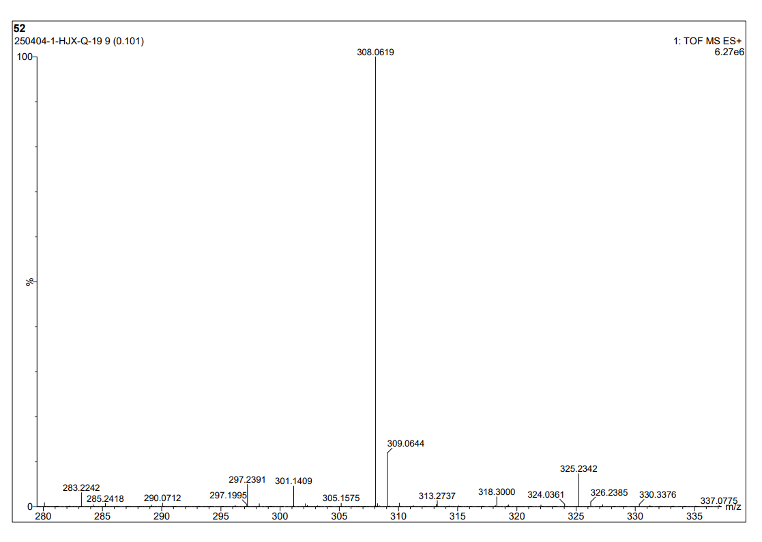
图S1 19-1 HR Mass spectrum (ESI) of compound 3s
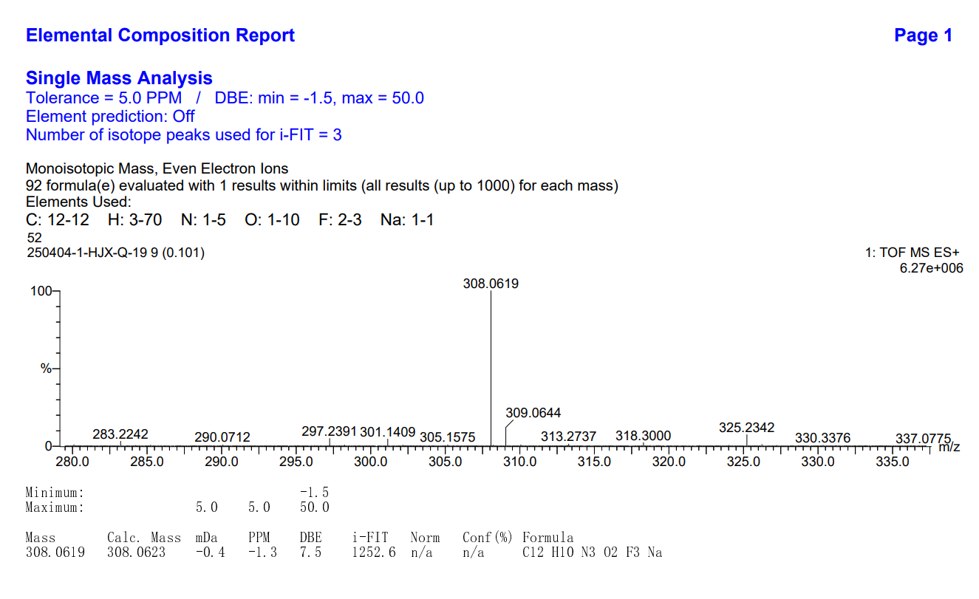
图S1 19-2 HR Mass spectrum (ESI) of compound 3s
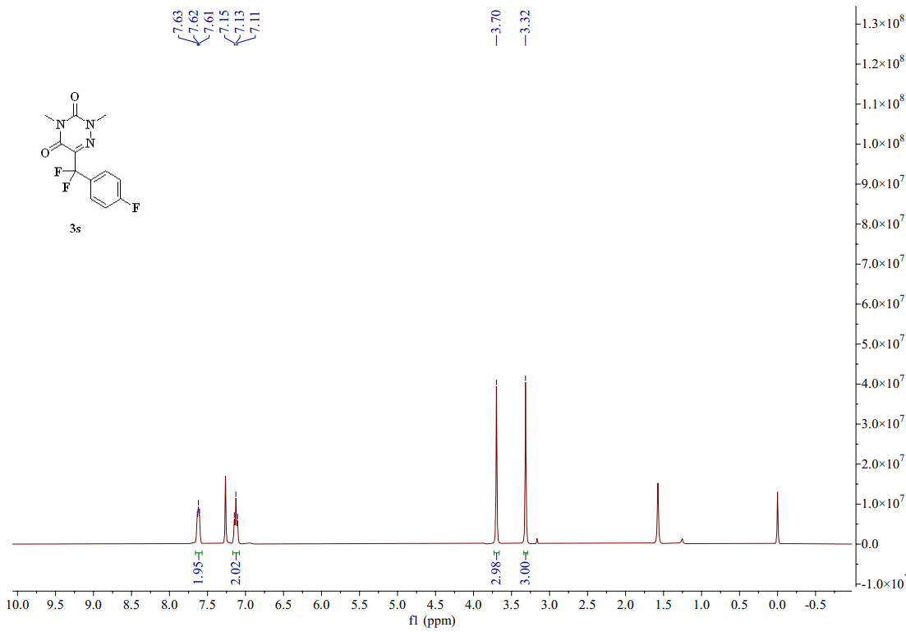
图S1 19-3 ¹H-NMR spectrum (CDCl₃, 400 MHZ) of compound 3s
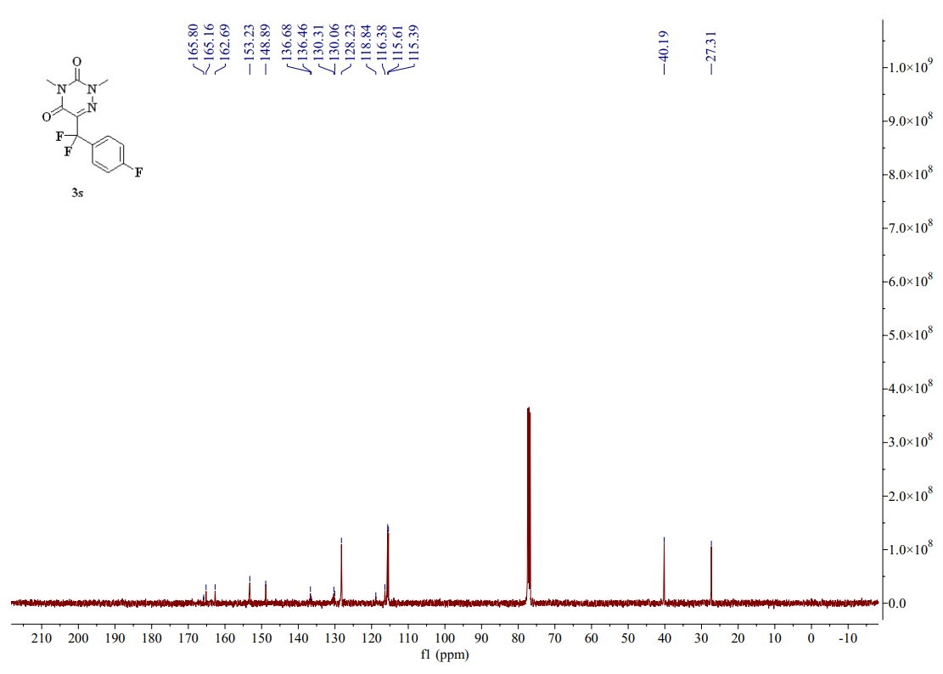
图S1 19-4 ¹³C-NMR spectrum (CDCl₃, 101 MHZ) of compound 3s
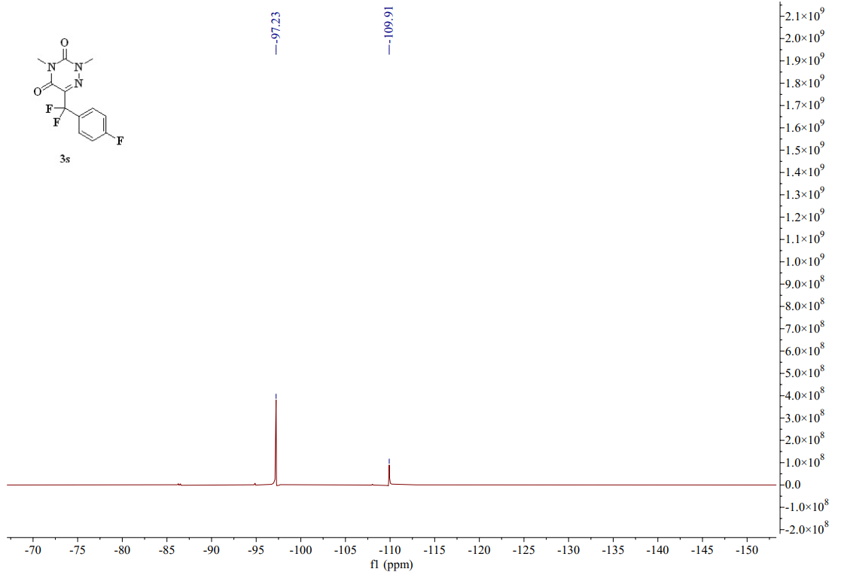
图S1 19-5 ¹⁹F-NMR spectrum (CDCl₃, 376 MHZ) of compound 3s
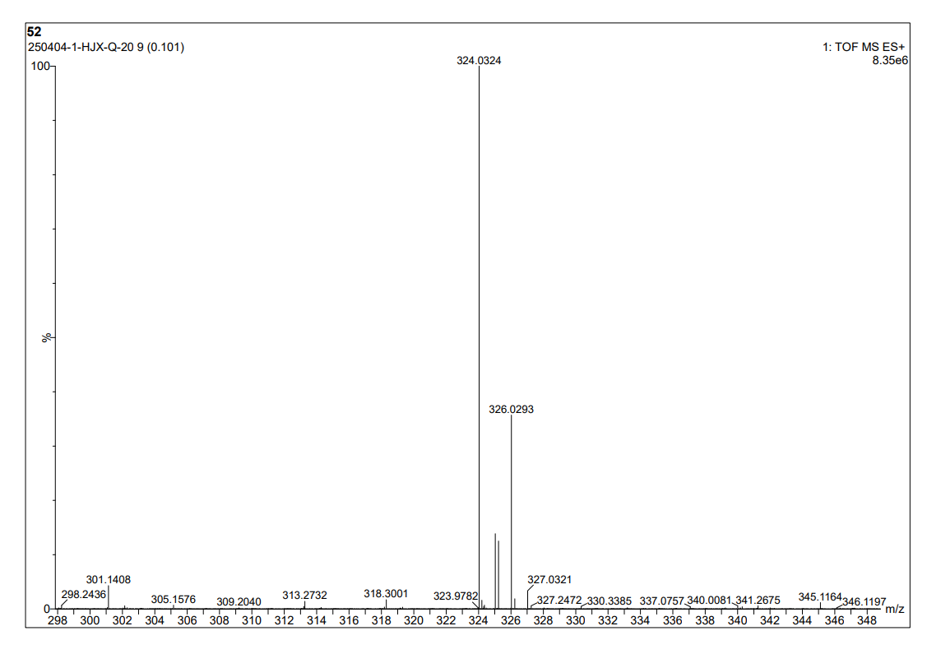
图S1 20-1 HR Mass spectrum (ESI) of compound 3t
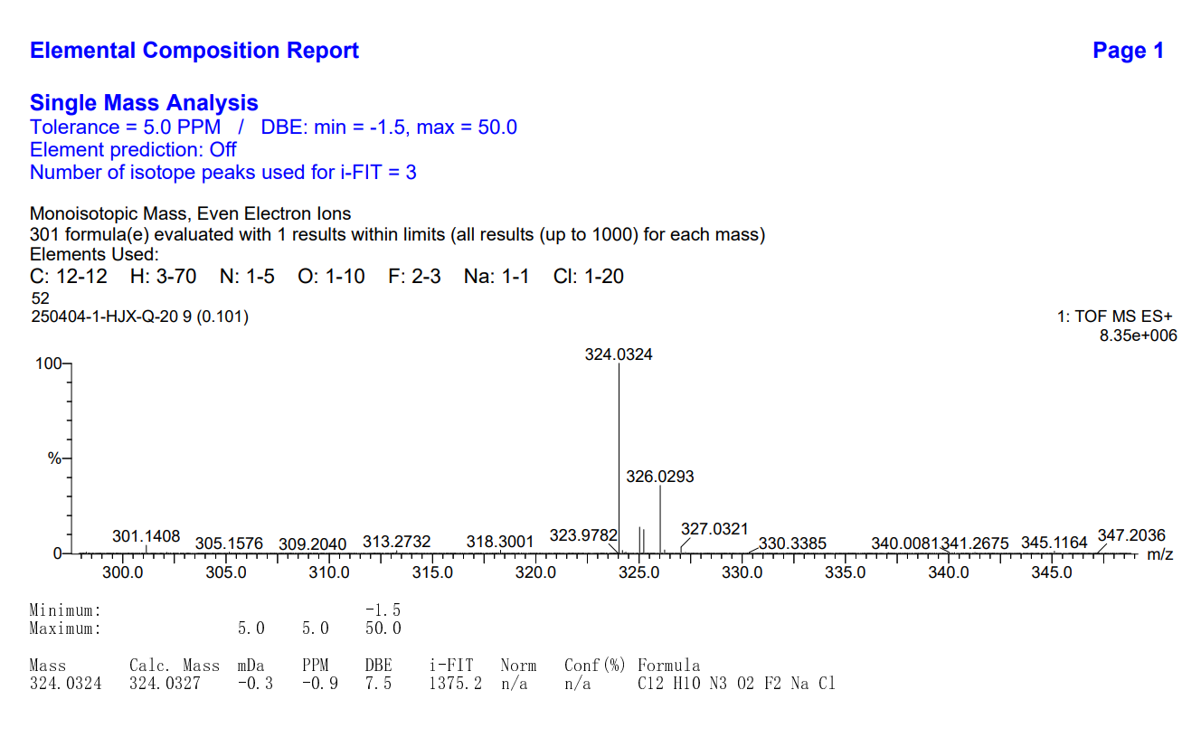
图S1 20-2 HR Mass spectrum (ESI) of compound 3t
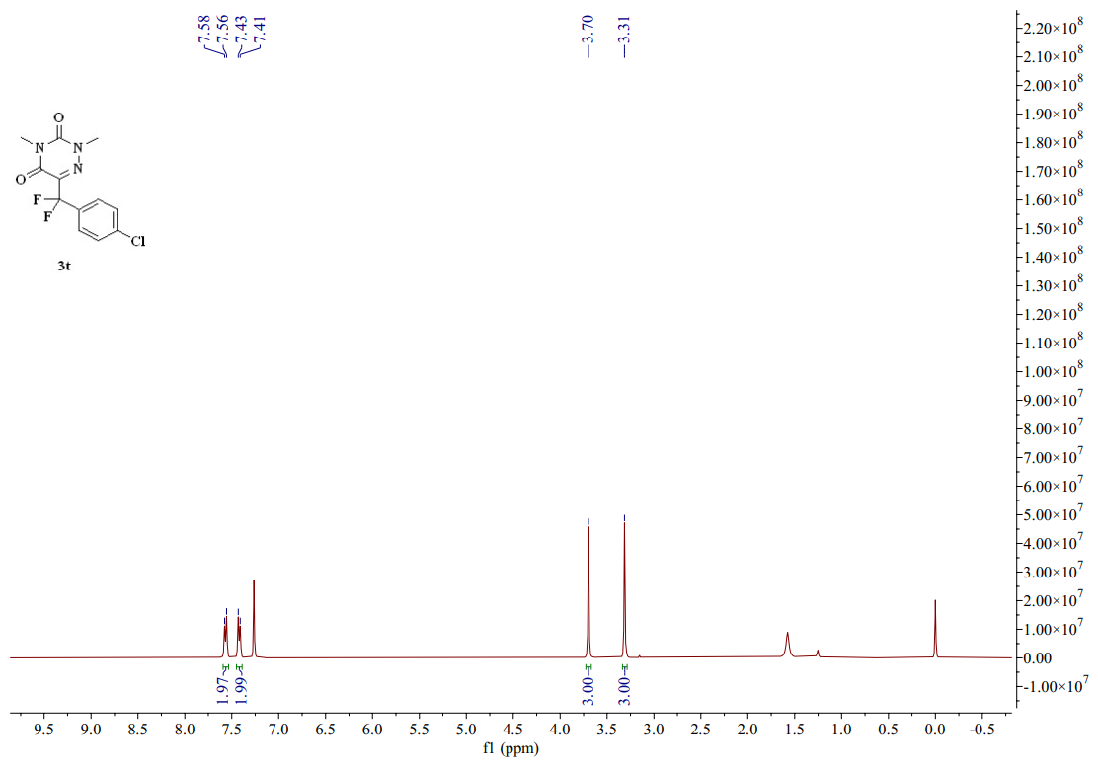
图S1 20-3 ¹H-NMR spectrum (CDCl₃, 400 MHZ) of compound 3t
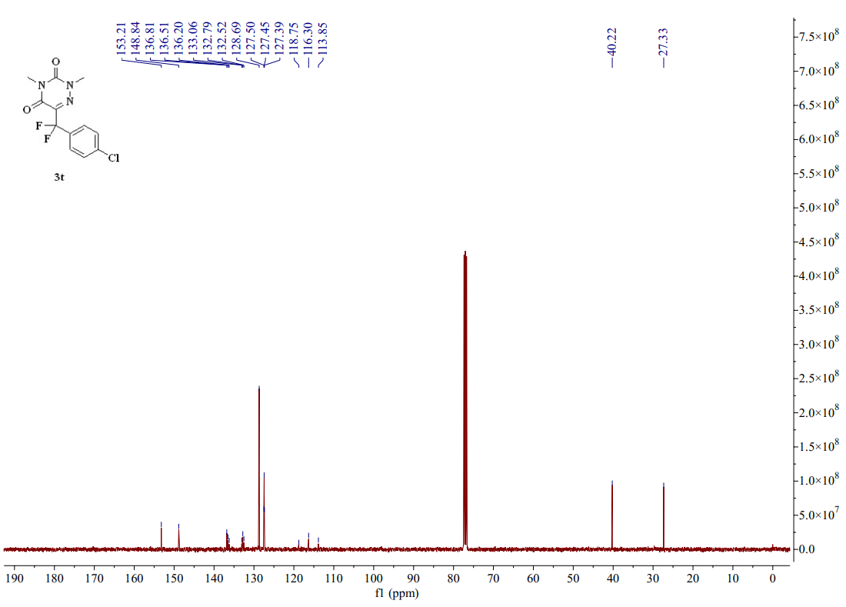
图S1 20-4 ¹³C-NMR spectrum (CDCl₃, 101 MHZ) of compound 3t
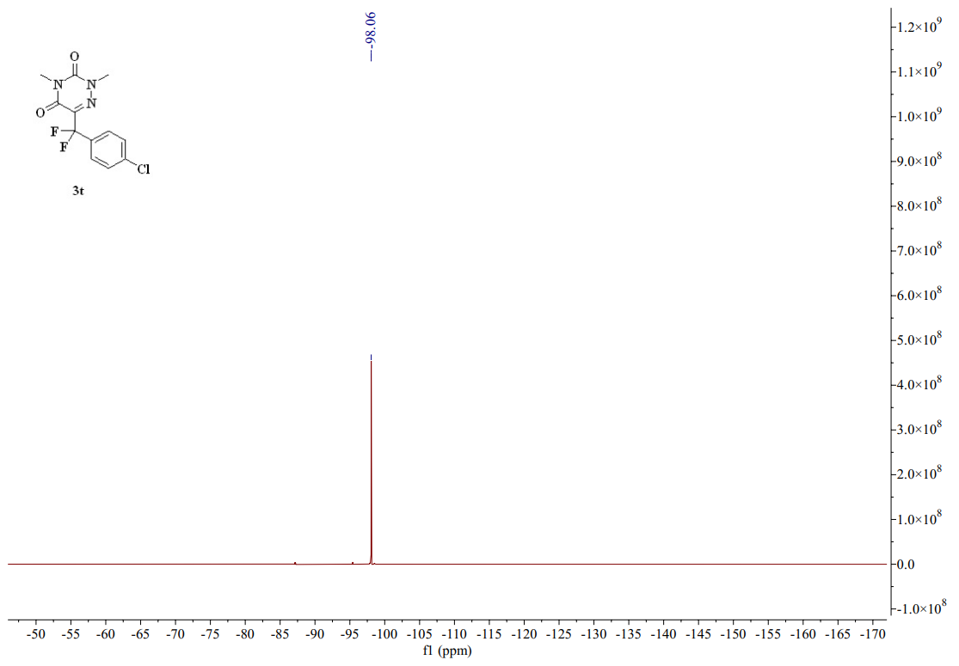
图S1 20-5 ¹⁹F-NMR spectrum (CDCl₃, 376 MHZ) of compound 3t
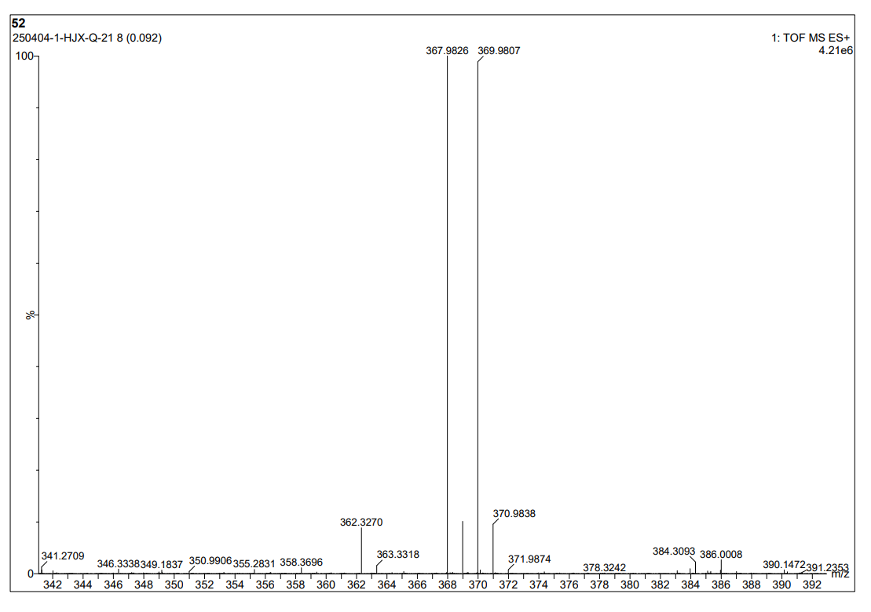
图S1 21-1 HR Mass spectrum (ESI) of compound 3u
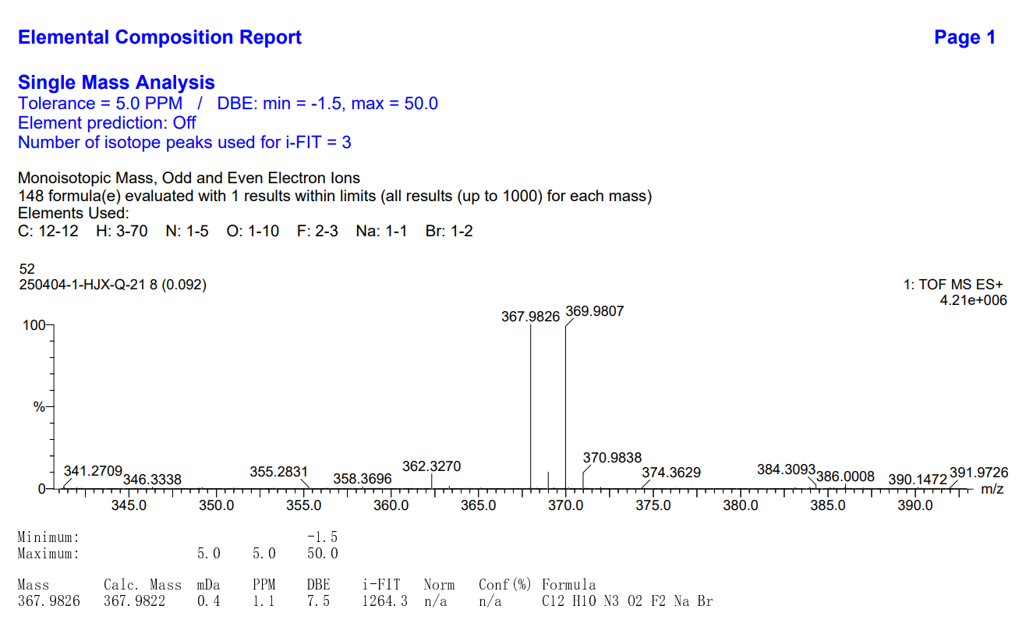
图S1 21-2 HR Mass spectrum (ESI) of compound 3u
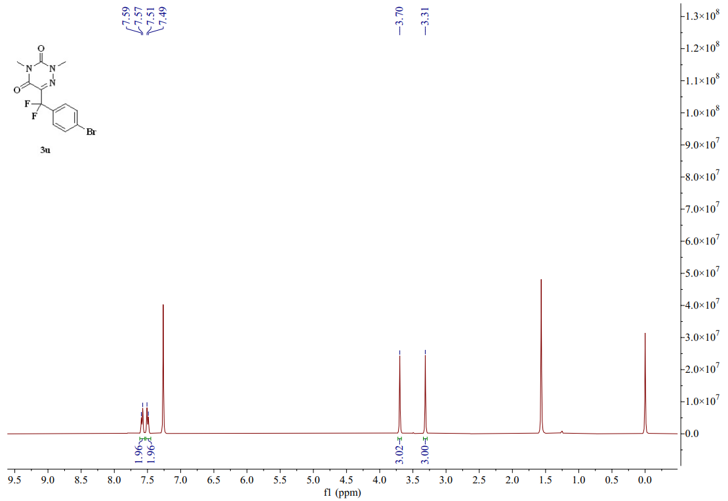
图S1 21-3 ¹H-NMR spectrum (CDCl₃, 400 MHZ) of compound 3u
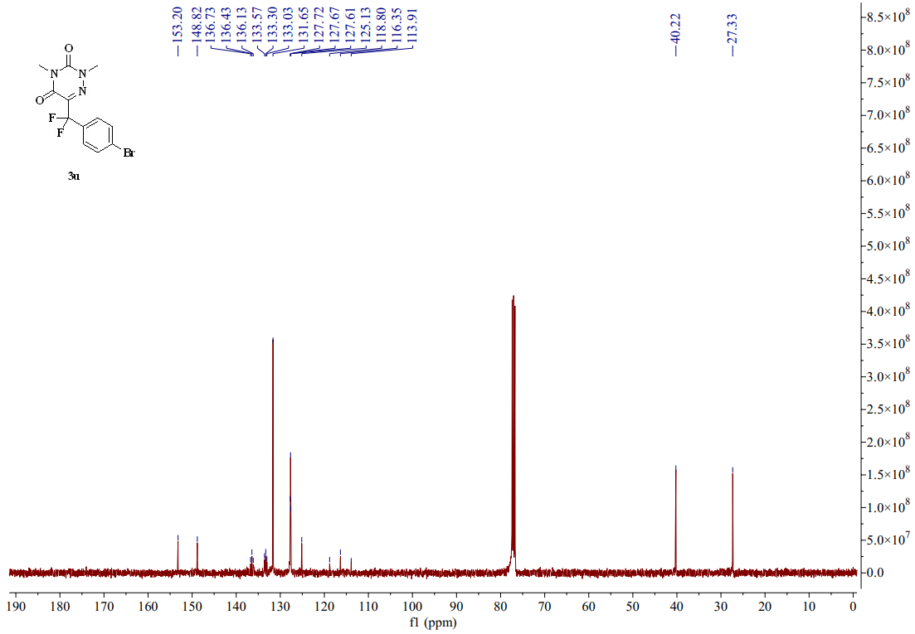
图S1 21-4 ¹³C-NMR spectrum (CDCl₃, 101 MHZ) of compound 3u
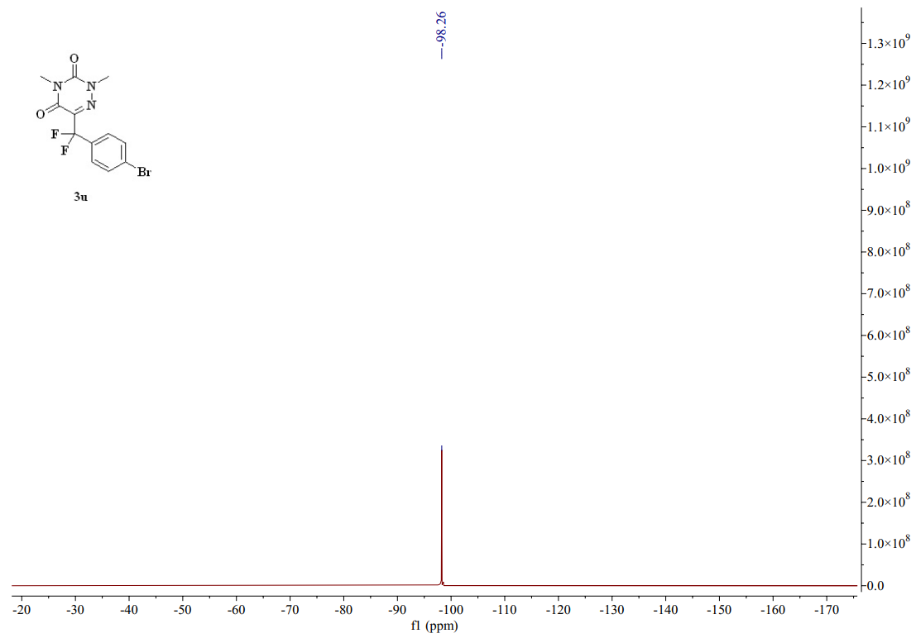
图S1 21-5 ¹⁹F-NMR spectrum (CDCl₃, 376 MHZ) of compound 3u
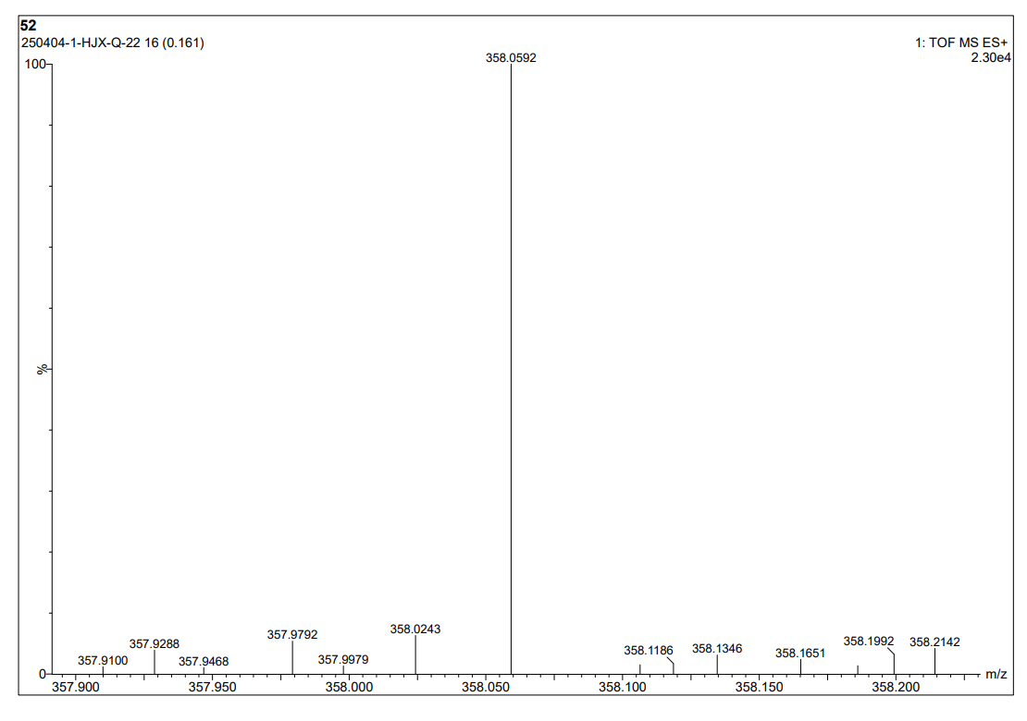
图S1 22-1 HR Mass spectrum (ESI) of compound 3v
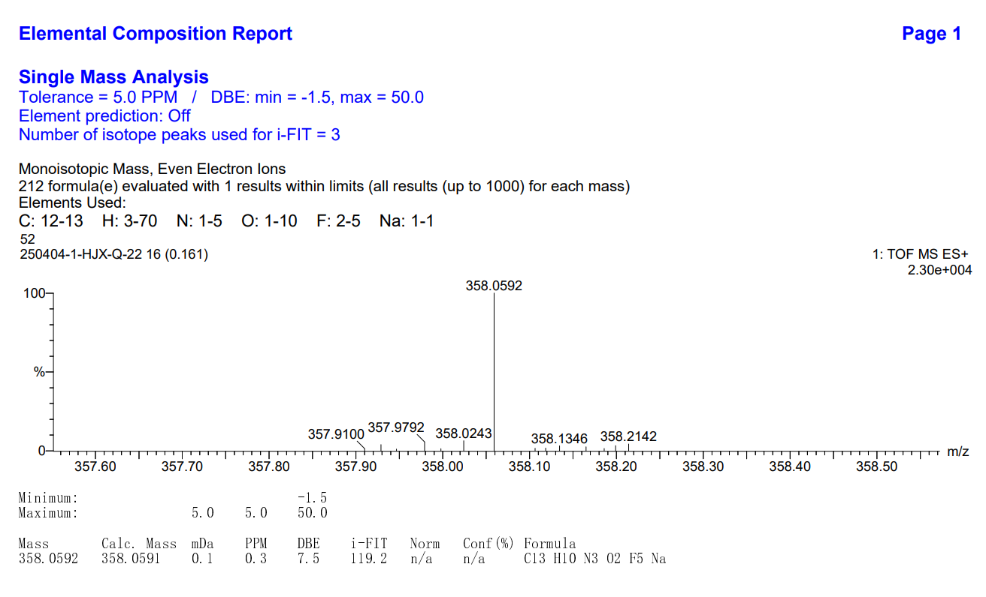
图S1 22-2 HR Mass spectrum (ESI) of compound 3v
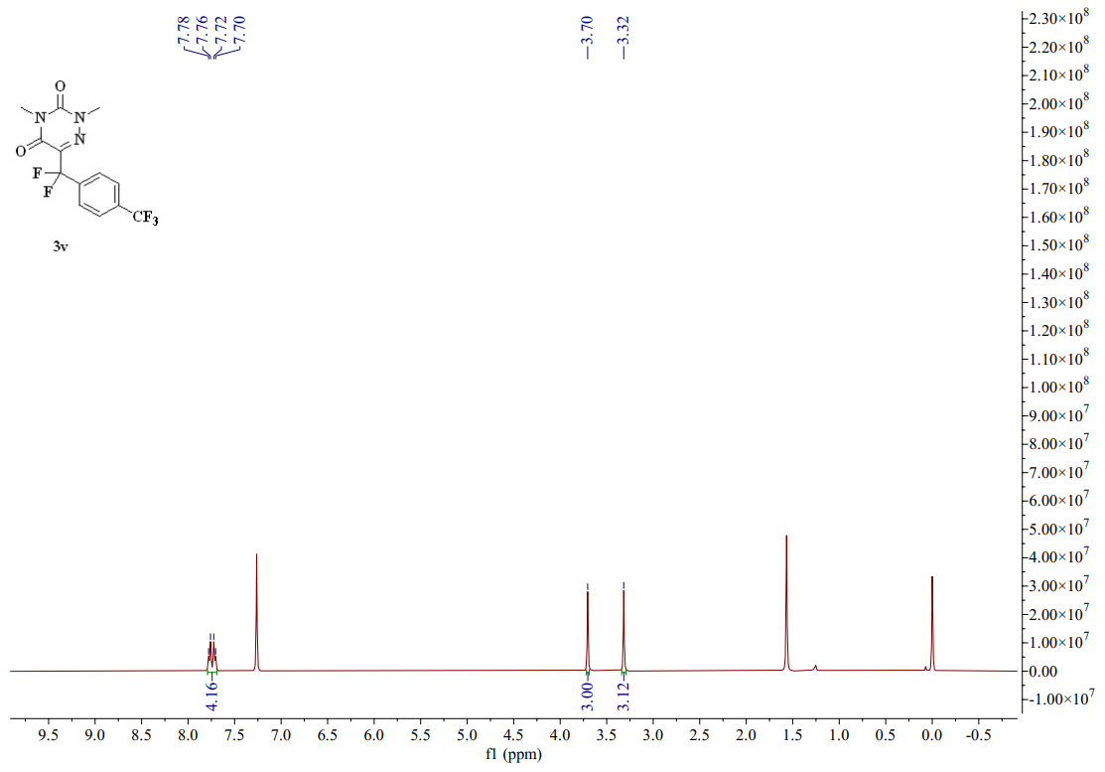
图S1 22-3 ¹H-NMR spectrum (CDCl₃, 400 MHZ) of compound 3v
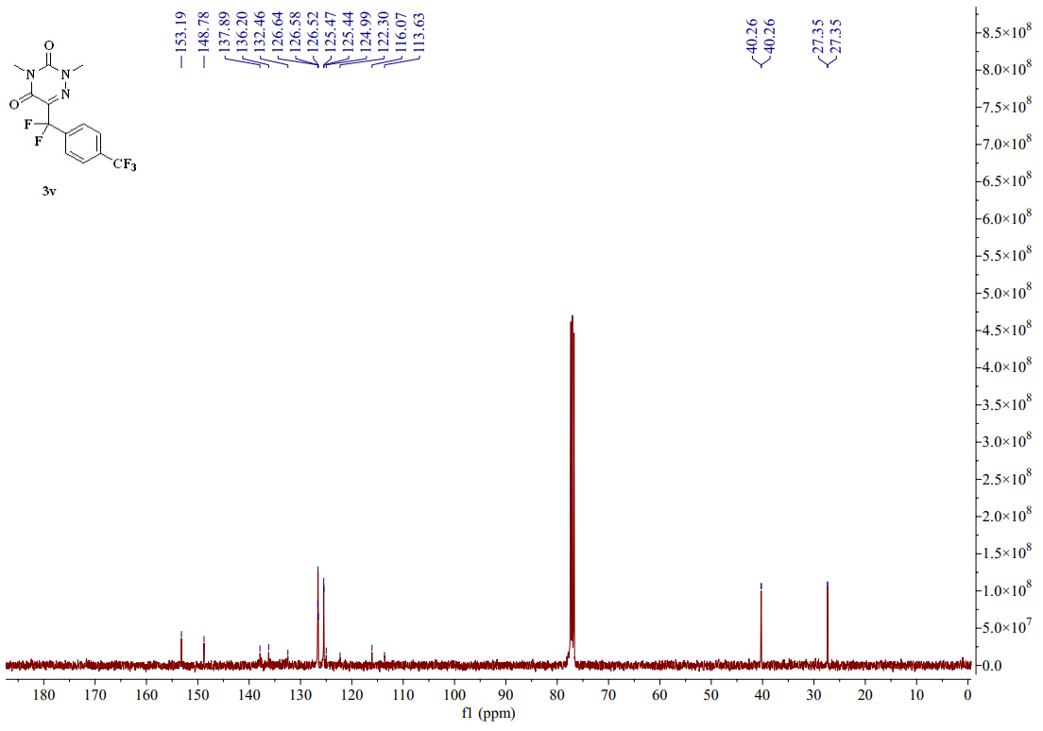
图S1 22-4 ¹³C-NMR spectrum (CDCl₃, 101 MHZ) of compound 3v
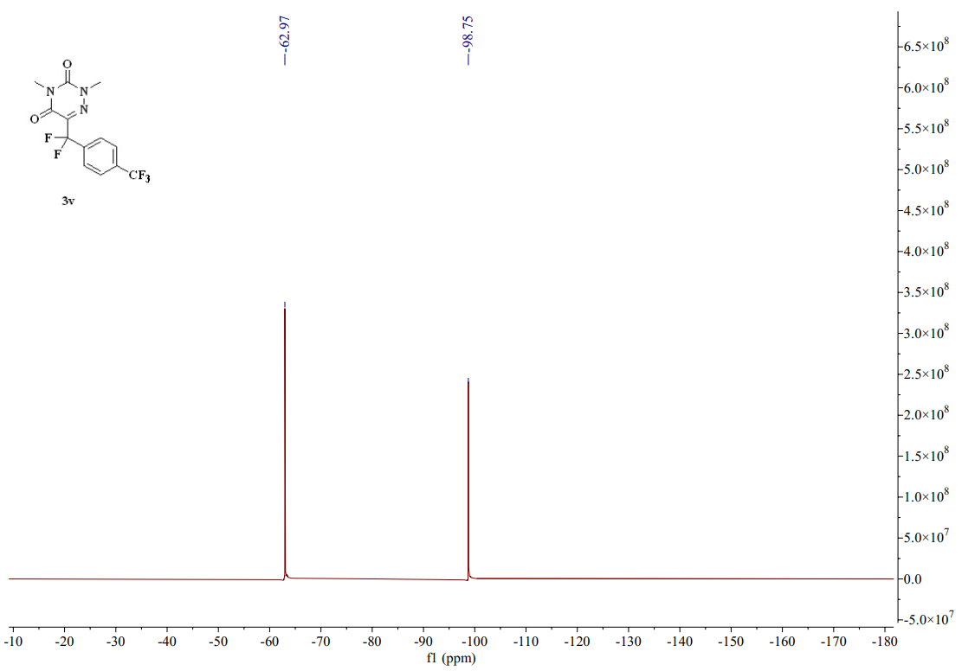
图S1 22-5 ¹⁹F-NMR spectrum (CDCl₃, 376 MHZ) of compound 3v
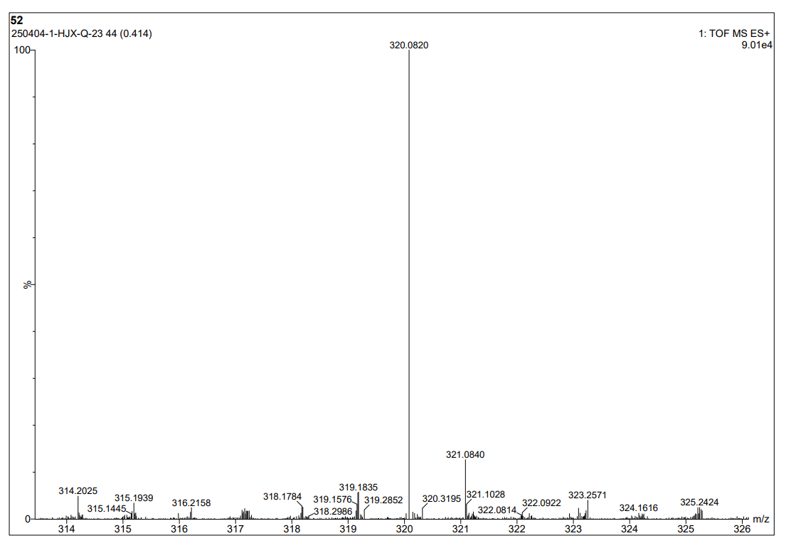
图S1 23-1 HR Mass spectrum (ESI) of compound 3w
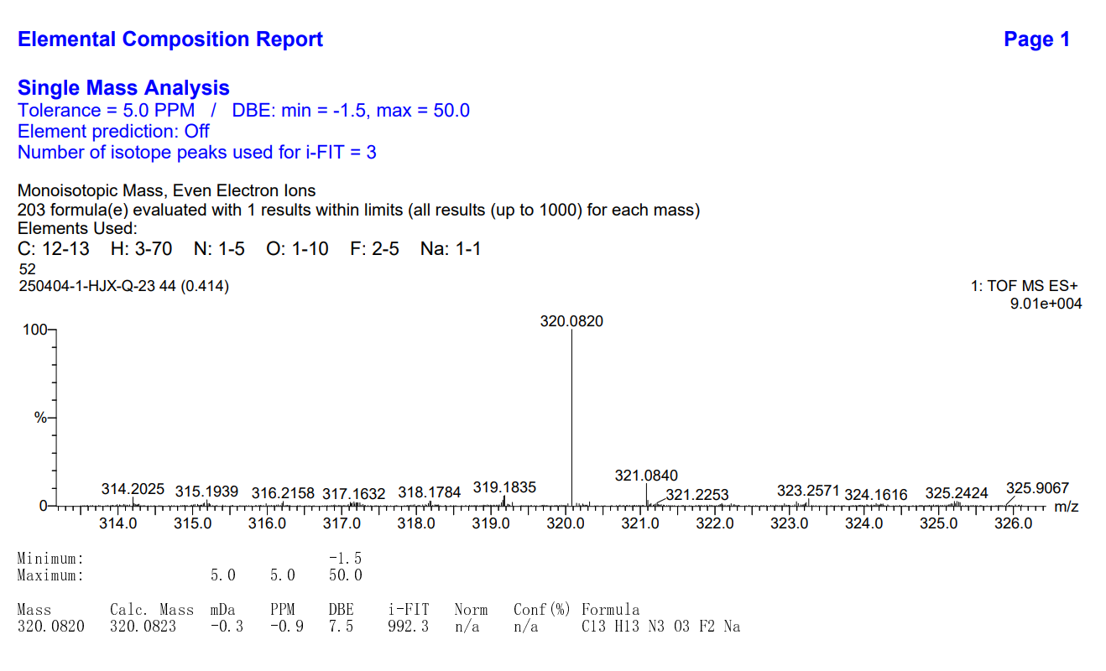
图S1 23-2 HR Mass spectrum (ESI) of compound 3w
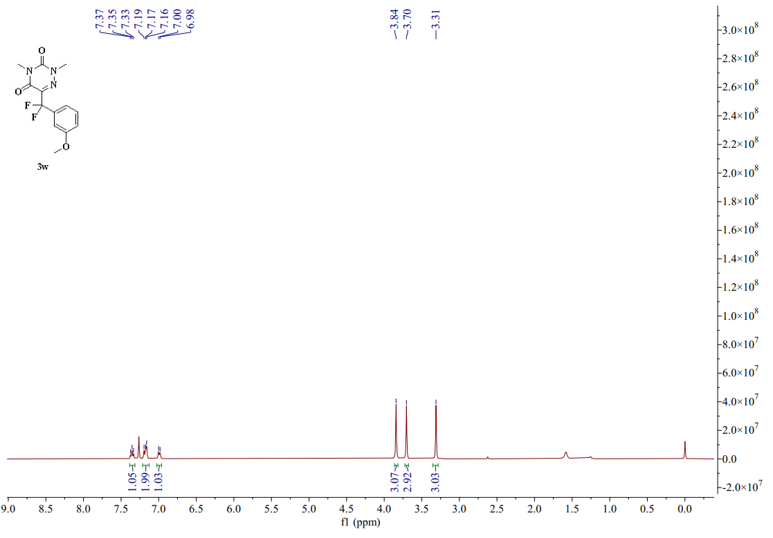
图S1 23-3 ¹H-NMR spectrum (CDCl₃, 400 MHZ) of compound 3w
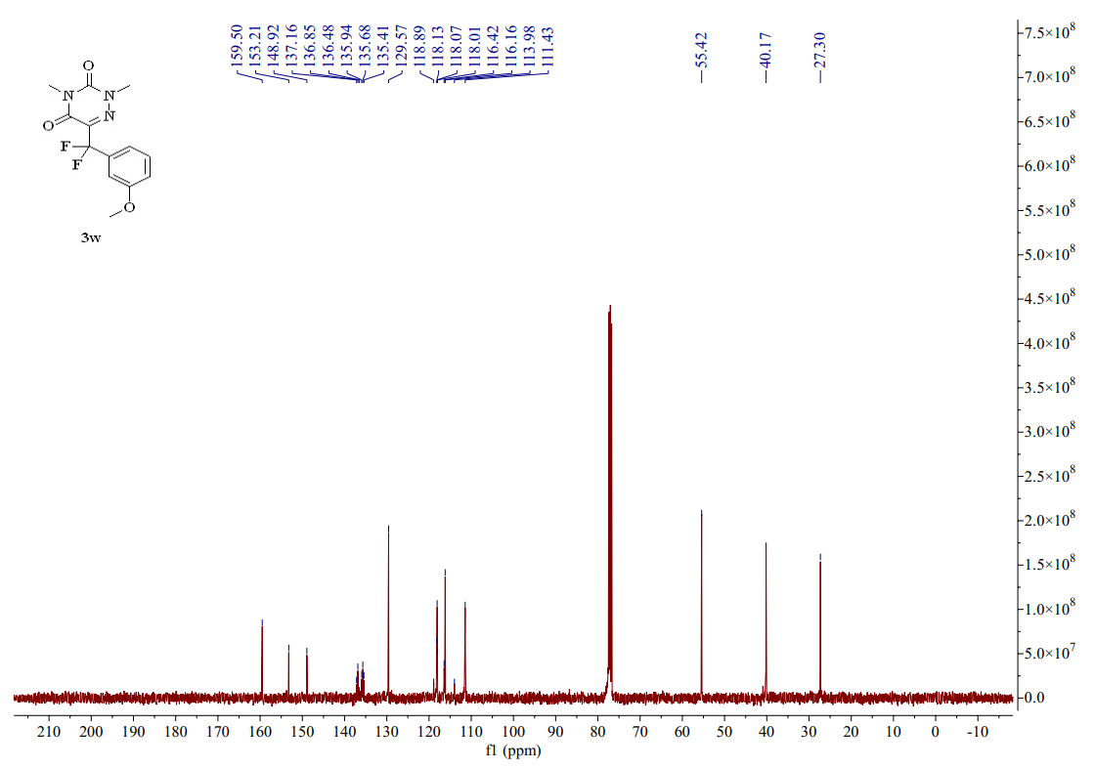
图S1 23-4 ¹³C-NMR spectrum (CDCl₃, 101 MHZ) of compound 3w
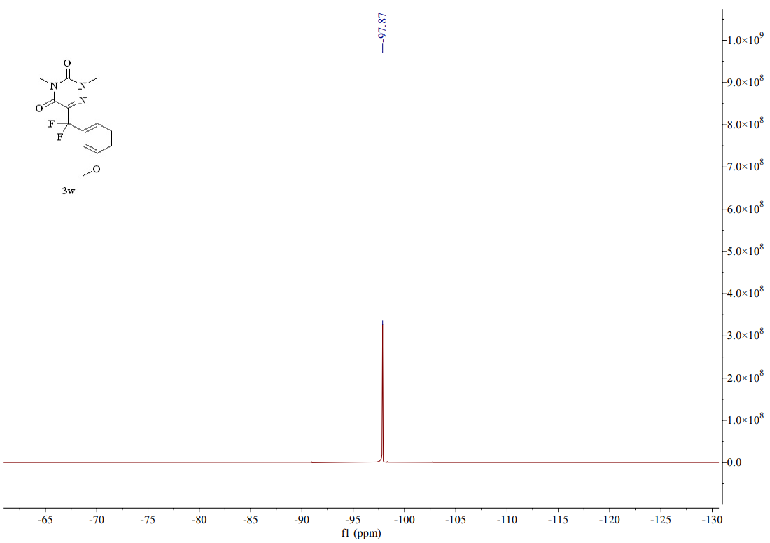
图S1 23-5 ¹⁹F-NMR spectrum (CDCl₃, 376 MHZ) of compound 3w
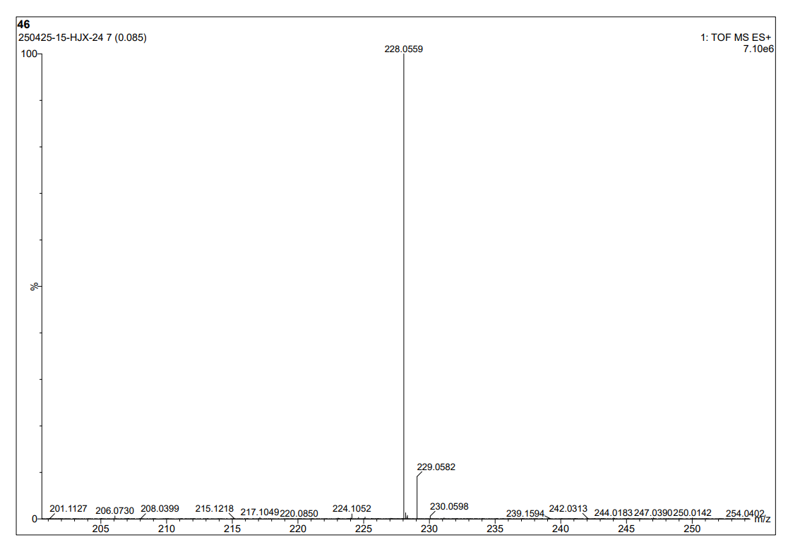
图S1 24-1 HR Mass spectrum (ESI) of compound 3x
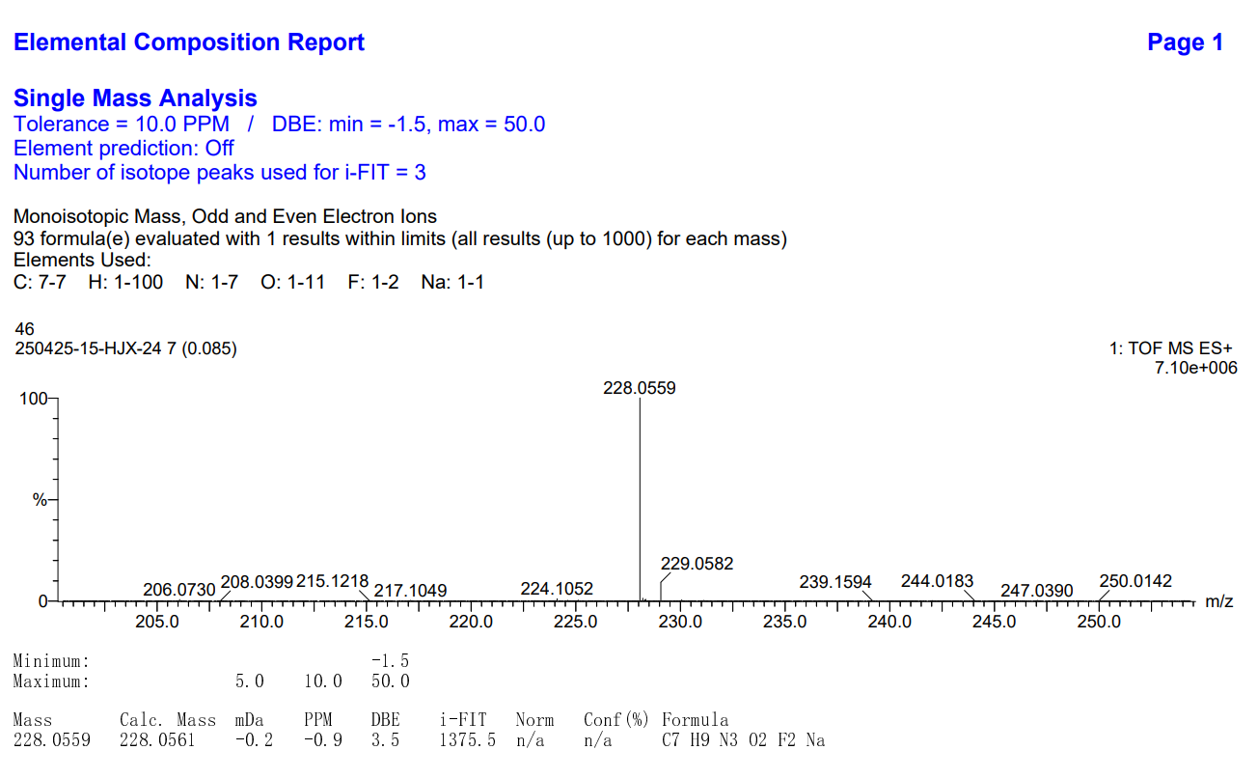
图S1 24-2 HR Mass spectrum (ESI) of compound 3x
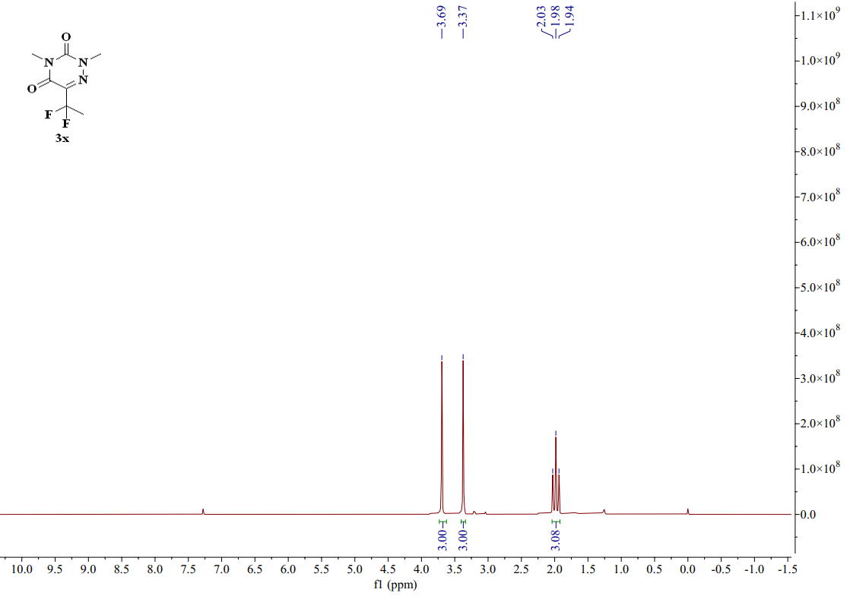
图S1 24-3 ¹H-NMR spectrum (CDCl₃, 400 MHZ) of compound 3x
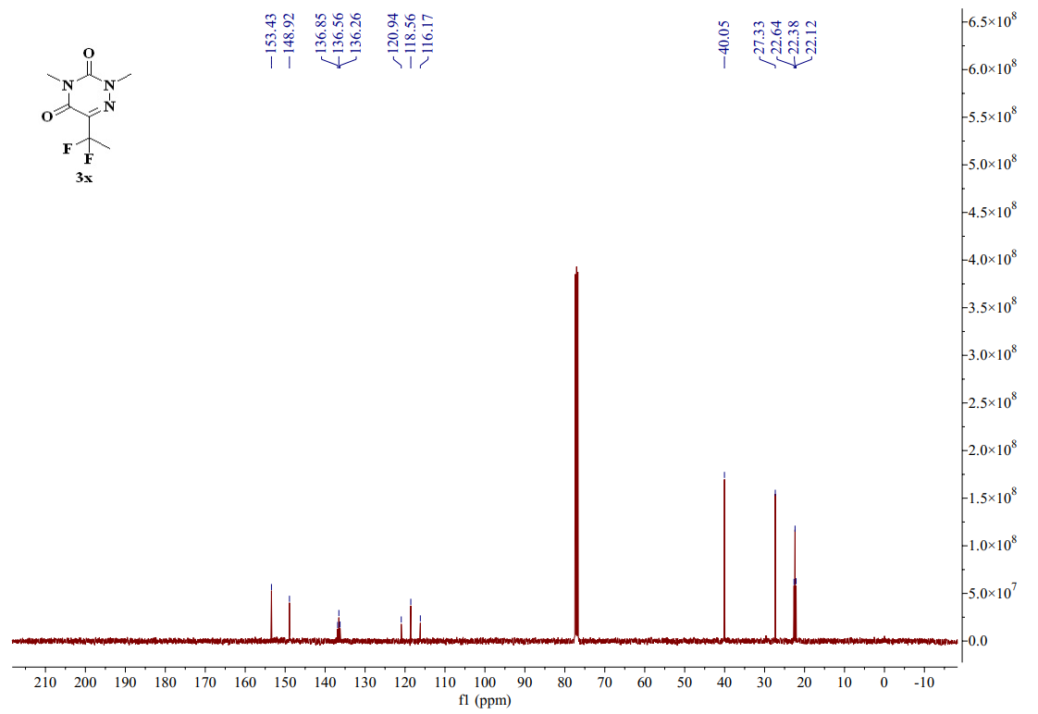
图S1 24-4 ¹³C-NMR spectrum (CDCl₃, 101 MHZ) of compound 3x
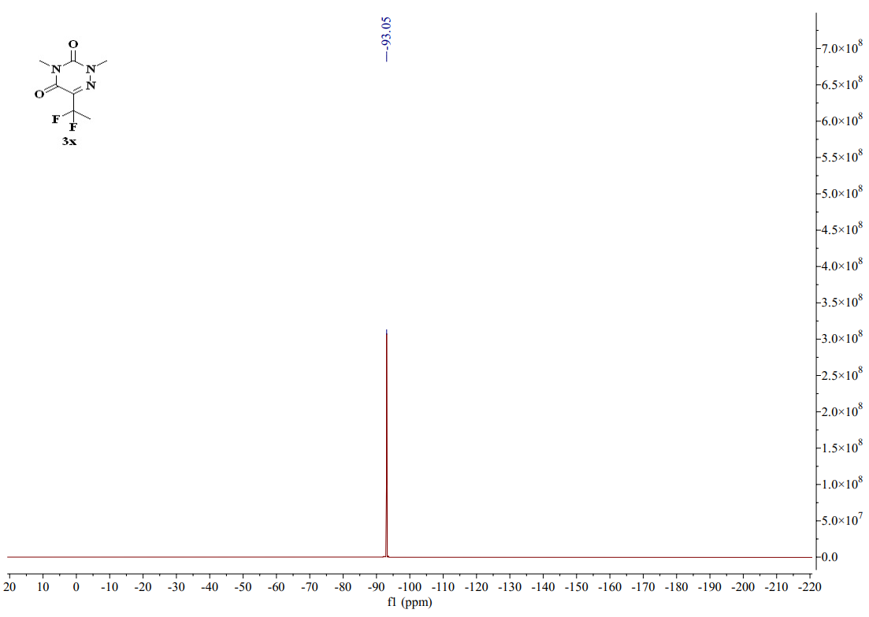
图S1 24-5 ¹⁹F-NMR spectrum (CDCl₃, 376 MHZ) of compound 3x
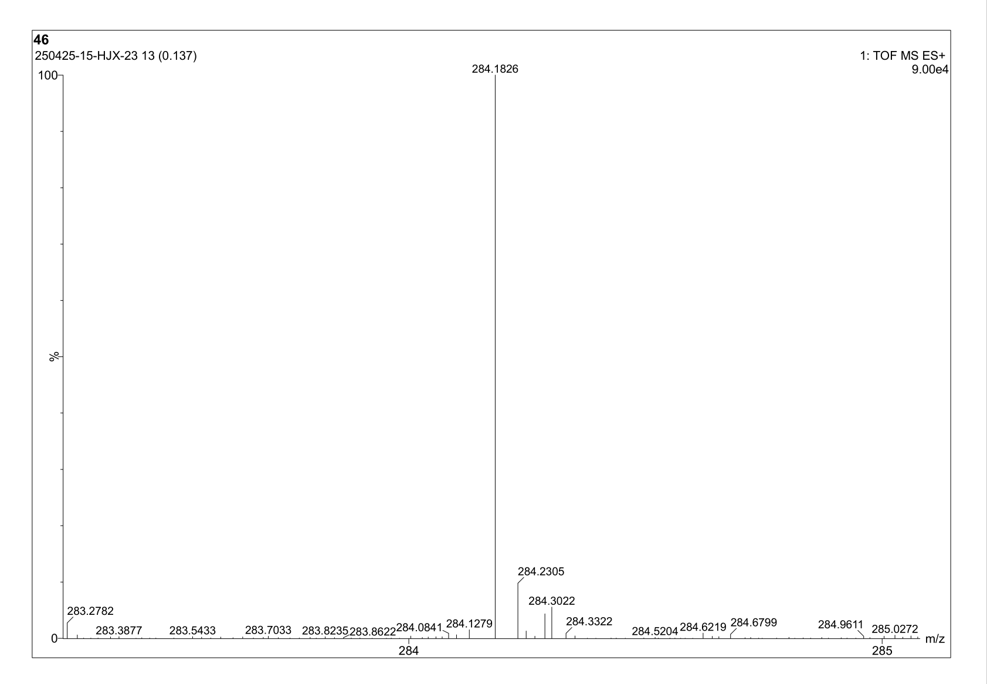
图S1 25-1 HR Mass spectrum (ESI) of compound 3ad

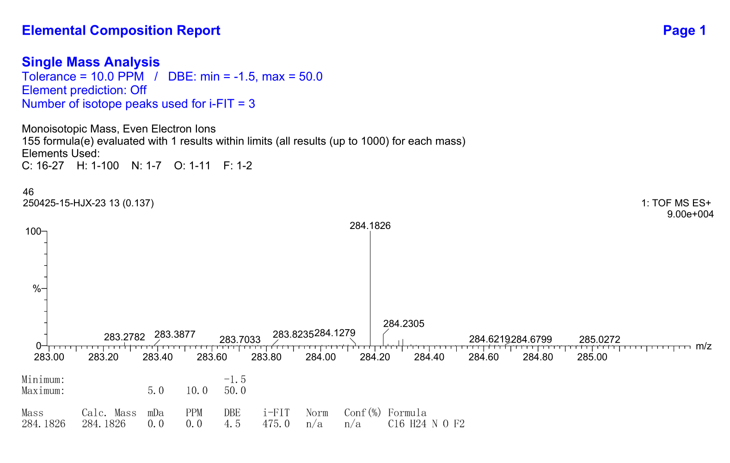
图S1 25-2 HR Mass spectrum (ESI) of compound 3ad

