Neuroinflammatory cytokine response, neuronal death and microglial proliferation in the hippocampus of rats during the early period after lateral fluid-percussion-induced traumatic injury of the neocortex
Ilia G. Komoltsev^{1,2}, Liya V. Tret’yakova¹, Stepan O. Frankevich¹, Natalia I. Shirobokova¹, Aleksandra A. Volkova¹, Alexey V. Butuzov¹, Margarita R. Novikova¹, Alexey A. Kvichansky¹, Yulia V. Moiseeva¹, Mikhail V. Onufriev^{1,2}, Alexey P. Bolshakov¹, Natalia V. Gulyaeva^{1,2}.
1 - Institute of Higher Nervous Activity and Neurophysiology, Russian Academy of Sciences, 117485 Moscow, Russia
2- Research and Clinical Center for Neuropsychiatry of Moscow Healthcare Department, 43 Donskaya Str., 115419 Moscow, Russia.
e-mail: nata_gul@ihna.ru

Table S1. Nucleotide sequences of using primers.
Gene | Forward | Reverse
Hprt2 | CGT CGT GAT TAG TGA TGATGA AC | CAA GTC TTT CAG TCC TGT CCA TA
Ywhaz | TTG AGC AGA AGA CGG AAG GT | GAA GCA TTG GGG ATC AAG AA
Il1b | TCT GTG ACT CGT GGG ATG AT | CAC TTG TTG GCT TAT GTT CTG TC
Il6 | GCC ACT GCC TTC CCT ACT TCA C | GAC AGT GCA TCA TCG CTG TTC ATA C
Tnf | GTCCAACTCCGGGCTCAGAAT | ACT CCC CCG ATC CAC TCA G
Cx3cl | ATC ACC ACC ATC ACC ACC AAC | GAG GAA CAC TTT AAA CCC TCA CAG A
Cx3cr1 | GGA CCT CAC CAT GCC TAC CT | CAC CAA CAG ATT CCC CAC CAG
Ncf1 | CTG CAG CAA AGG ACA GGA CTG | GGG TCA TGG CCA ACA GGT T
Nr3c1 | TCC CCC TGG TAG AGA CGA AGT | CTC CCC TGG CCA AGC AAA CTG
Nr3c2 | GAC CTT GGA GCG TTC TTC AC | AAT CTC CAT GTA GTT GTT CTC AGT G
Crh | TCT GAT CCG CAT GGG TGA AGA ATA C | CCA TGC CCA TTT CAA CTT TCC A
Crhr1 | CTG CAG ACC TGA GAG CCT AC | CCA TGC CCA TTT CAA CTT TCC A
Crhr2 | CGA CCC GGA ATG CCT ACA GAG | CAG GGC CAC CAC GGA AAC A

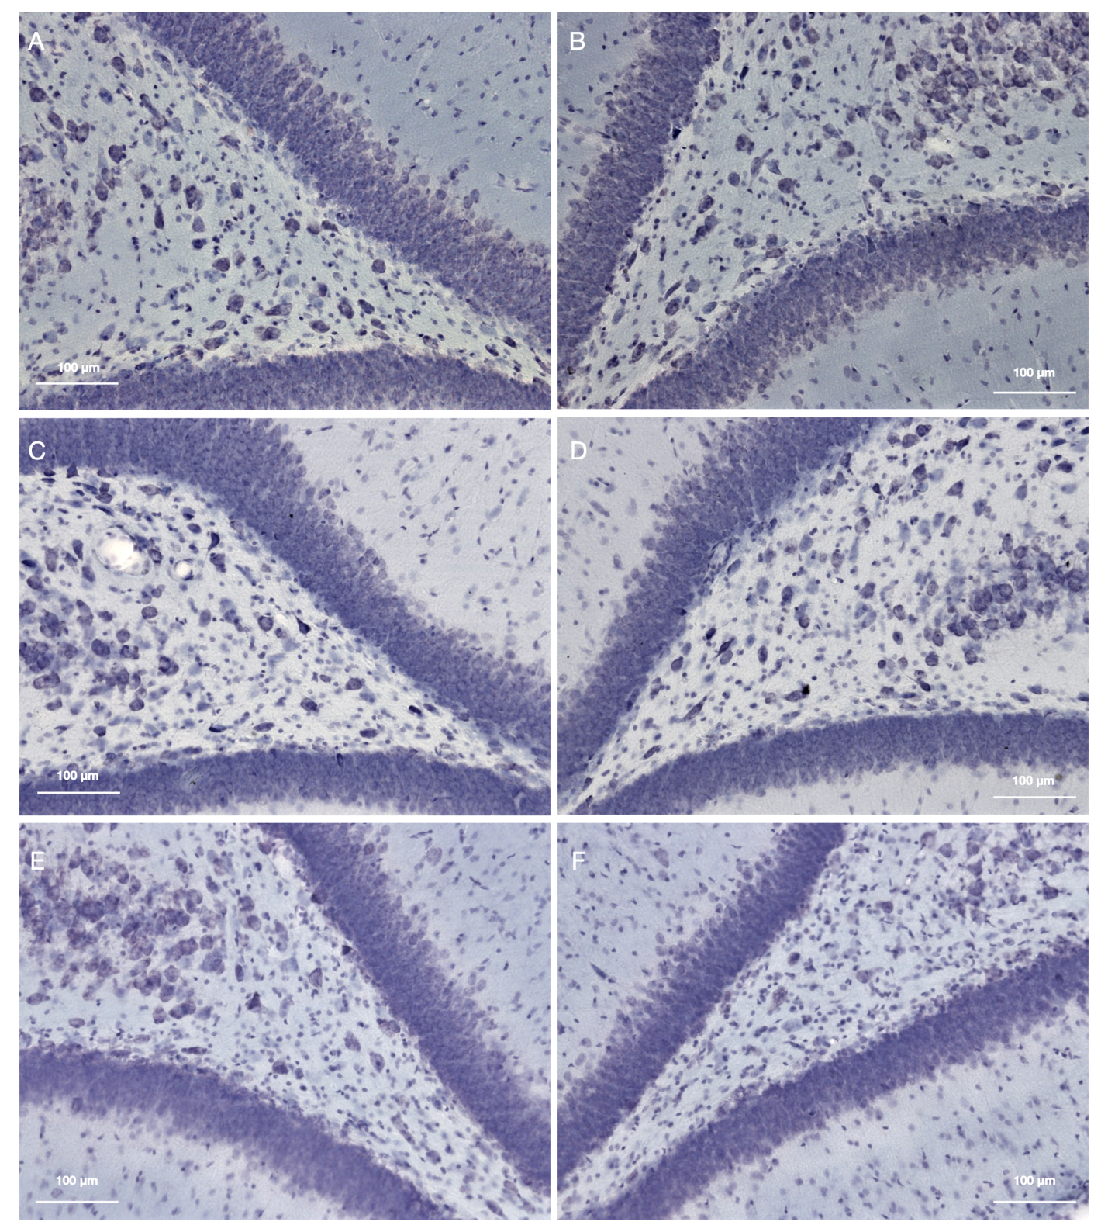
Fig. S1 Neuronal cell loss in the hippocampal dentate gyrus , representative microphotographas. A, B - control animal. C, D - Sham-operated rat on day 7 after craniotomy. E, F - Microglial activation on day 7 after TBI. The ipsilateral hippocampus is left (A, C, E). Nissl staining

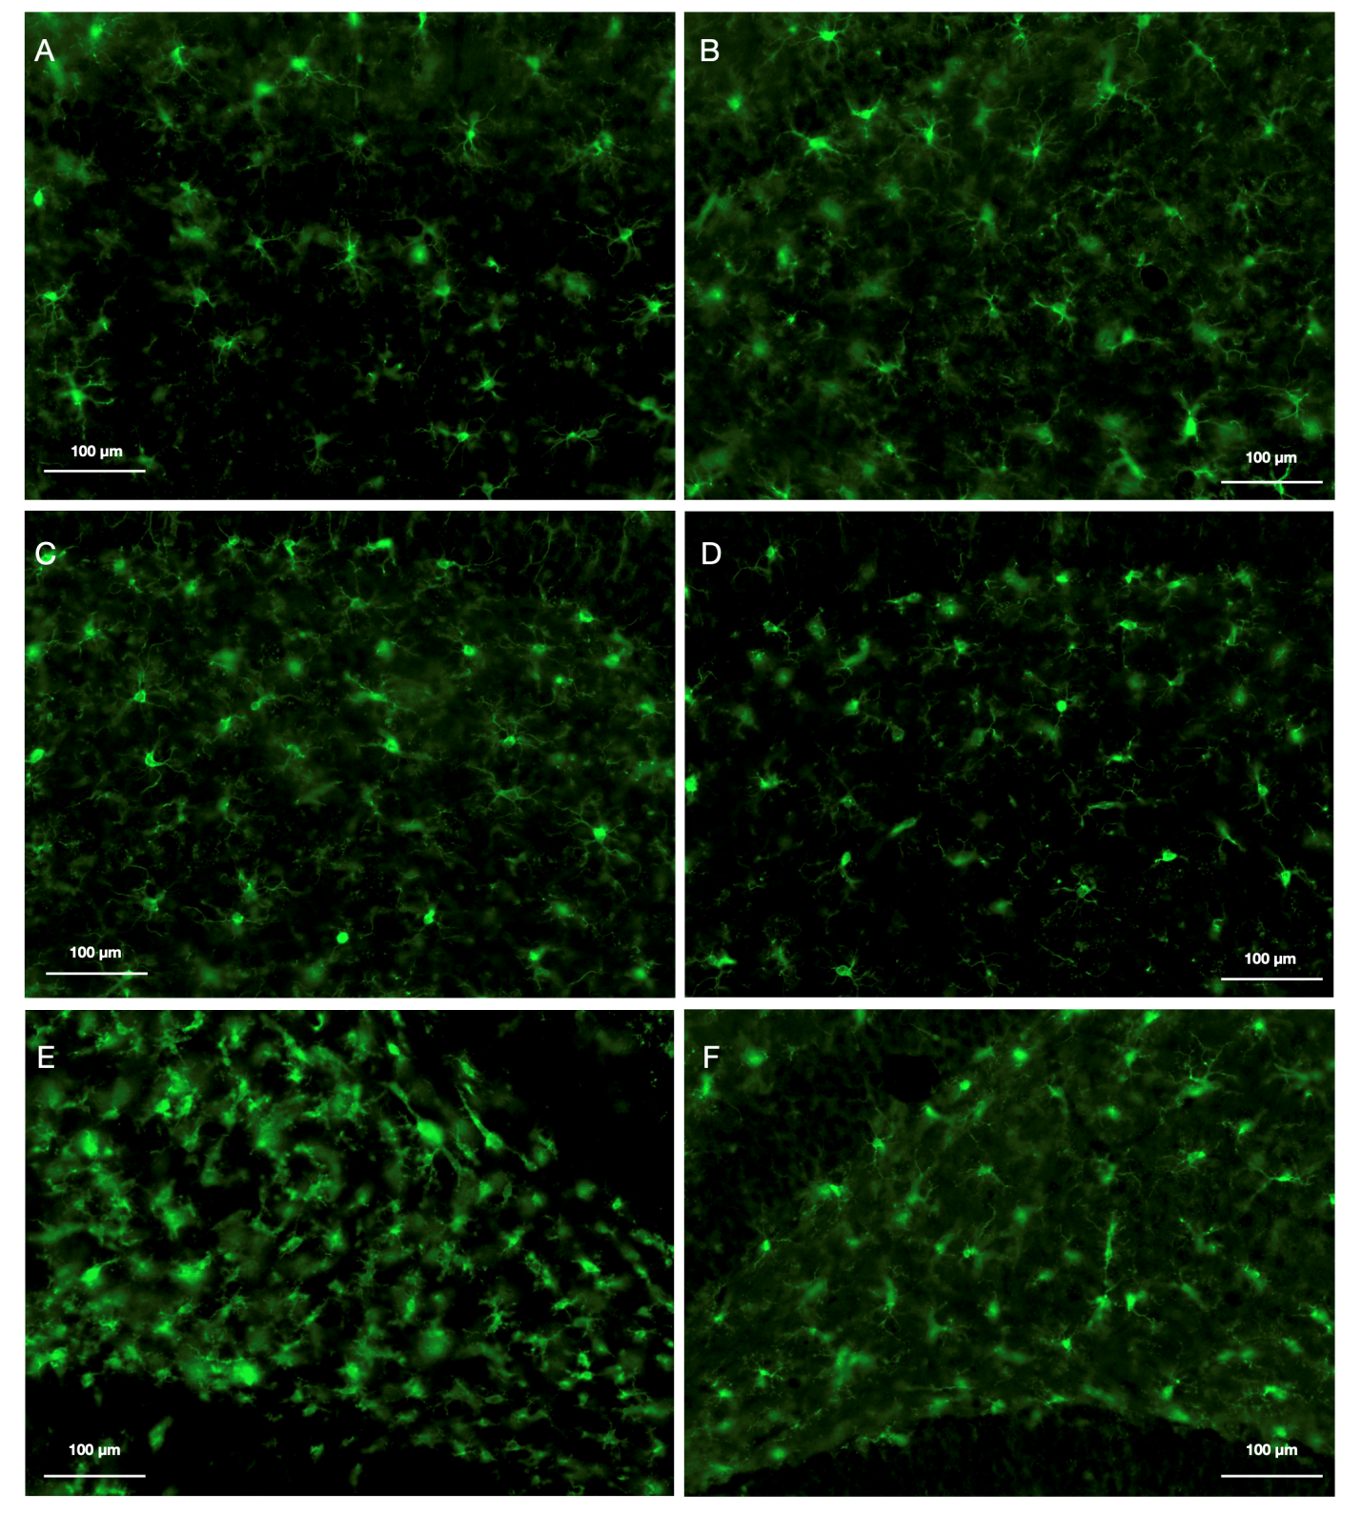
Fig. S2 Microglial activation in the hippocampal dentate gyrus, representative microphotographas. A, B - control animal. C, D - Sham-operated rat on day 7 after craniotomy. E, F - Microglial activation on day 7 after TBI. The ipsilateral hippocampus is left (A, C, E). Anti-Iba-1 staining.
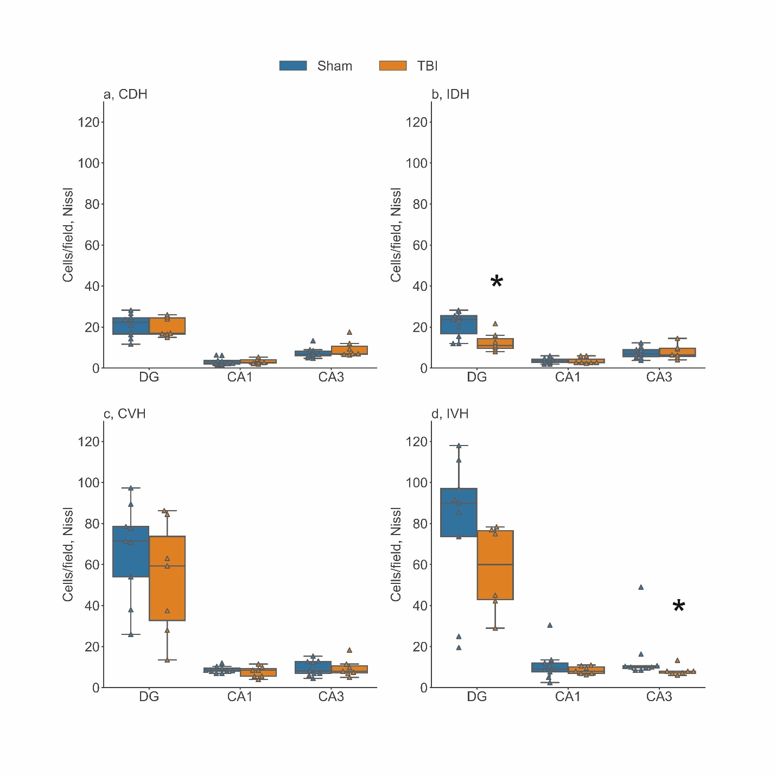
Fig. S3 Nissl staining of neurons in the hippocampus on day 3 after TBI. The number of neurons in the CA3 subfield of the ipsilateral dorsal and ventral hippocampus (b and d, respectively) decreased in rats after TBI as compared to sham-operated group. a, Contralateral Dorsal Hippocampus (CDH); b, Ipsilateral Dorsal Hippocampus (IDH); c, Contralateral Ventral Hippocampus (CVH); d, Ipsilateral Ventral Hippocampus (IVH). DG (dentate gyrus), CA1, CA3 – hippocampal regions. *, significant differences between TBI and sham-operated rats, p<0.05, Mann-Whitney U-test

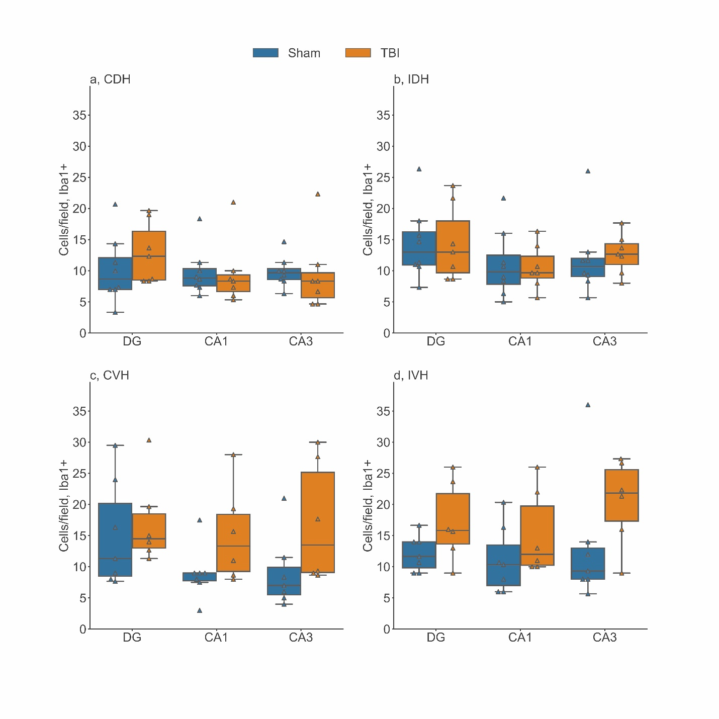
Fig. S4 Iba1 immunostaining of microglial cells in regions of the hippocampus on day 3 after TBI. No changes in the number of microglial cells in the hippocampal regions were revealed in after TBI as compared to shams. . a, Contralateral Dorsal Hippocampus (CDH); b, Ipsilateral Dorsal Hippocampus (IDH); c, Contralateral Ventral Hippocampus (CVH); d, Ipsilateral Ventral Hippocampus (IVH). DG (dentate gyrus), CA1, CA3 – hippocampal regions

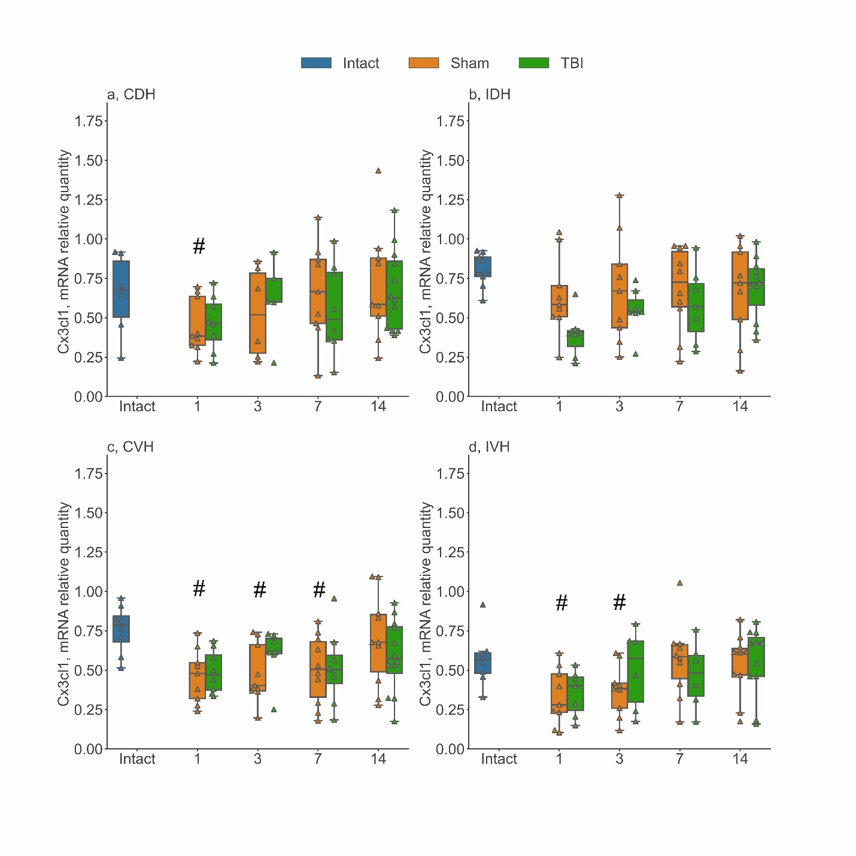
Fig. S5 The time course of Cx3cl1 mRNA expression in different regions of the hippocampus in early period after lateral fluid percussion TBI (1-14 days). TBI did not induce changes in Cx3cl1 expression in the hippocampus. In sham-operated animals, Cx3cl1 expression decreased on day 1 in the contralateral dorsal hippocampus (a), on days 1, 3 and 7 in the contralateral ventral hippocampus (c), and on days 1 and 3 in the ipsilateral ventral hippocampus (d). a, Contralateral Dorsal Hippocampus (CDH); b, Ipsilateral Dorsal Hippocampus (IDH); c, Contralateral Ventral Hippocampus (CVH); d, Ipsilateral Ventral Hippocampus (IVH). * - p<0.05, Mann-Whitney U-test, TBI rats as compared to sham-operated rats. # - p<0.05, Mann-Whitney U-test, sham-operated rats as compared to intact rats
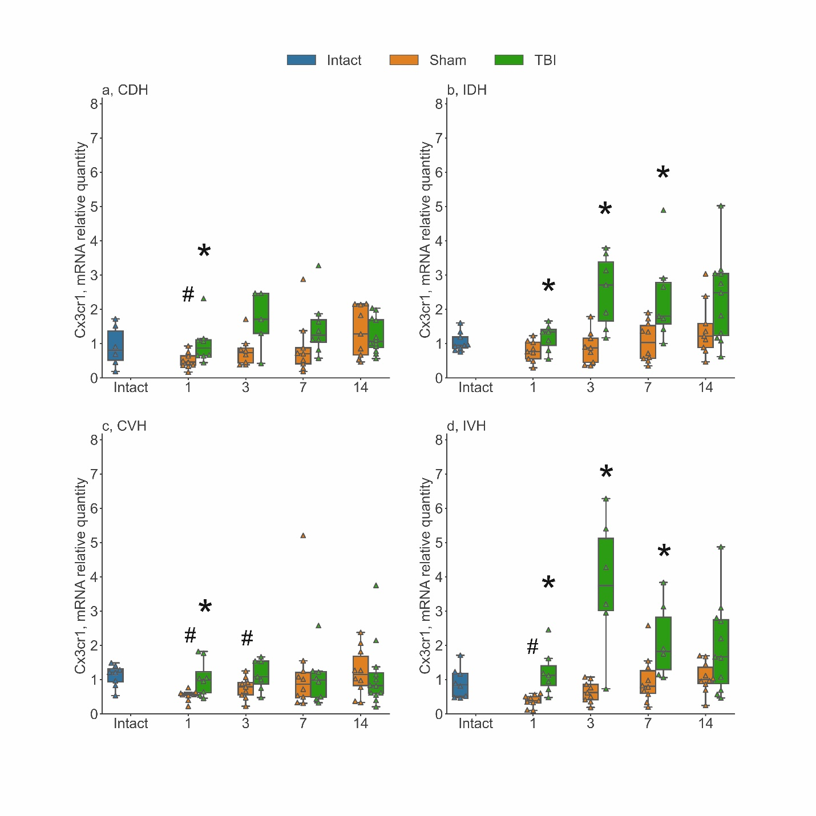
Fig. S6 The time course of Cx3cr1 mRNA expression in different regions of the hippocampus in early period after lateral fluid percussion TBI (1-14 days). TBI induced an increase in Cx3cr1 expression in the ipsilateral dorsal and ventral hippocampus up to day 7 with a peak of expression on day 3 and further decline to the level of sham-operated animals on day 14 (b and d). In the contralateral hemisphere, both the dorsal and ventral hippocampus responded by a small increase in Cx3cr1 on day 1 (a, c). Note that in sham-operated animals, a decrease in the expression of Cx3cr1 in the ipsilateral ventral hippocampus (d), contralateral dorsal hippocampus (a) at day 1, and in the contralateral ventral hippocampus (c) on days 1 and 3 was observed as compared to intact animals. a, Contralateral Dorsal Hippocampus (CDH); b, Ipsilateral Dorsal Hippocampus (IDH); c, Contralateral Ventral Hippocampus (CVH); d, Ipsilateral Ventral Hippocampus (IVH). * - p<0.05, Mann-Whitney U-test, TBI rats compared to Sham-operated rats. # - p<0.05, Mann-Whitney U-test, Sham-operated rats compared to Intact rats

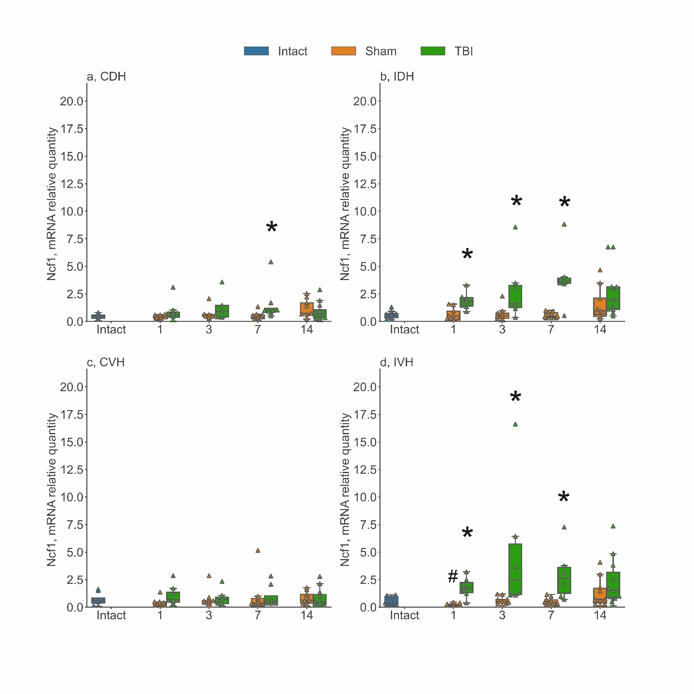
Fig. S7 The time course of Ncf1 mRNA expression in different regions of the hippocampus in early period after lateral fluid percussion TBI (1-14 days). TBI induced an increase in Ncf1 expression in the ipsilateral hemisphere (b, d) followed by a decline to the level of sham-operated animals on day 14. In the contralateral hemisphere, only the dorsal hippocampus responded by a small increase in Ncf1 on day 7 (a) whereas, in the ventral hippocampus no changes were observed (c). Note that in sham-operated animals, we also observed a decrease in the expression of Ncf1 in the ipsilateral ventral hippocampus (d) on day 1 as compared to intact animals. a, Contralateral Dorsal Hippocampus (CDH); b, Ipsilateral Dorsal Hippocampus (IDH); c, Contralateral Ventral Hippocampus (CVH); d, Ipsilateral Ventral Hippocampus (IVH). * - p<0.05, Mann-Whitney U-test, TBI rats compared to Sham-operated rats. # - p<0.05, Mann-Whitney U-test, Sham-operated rats compared to Intact rats

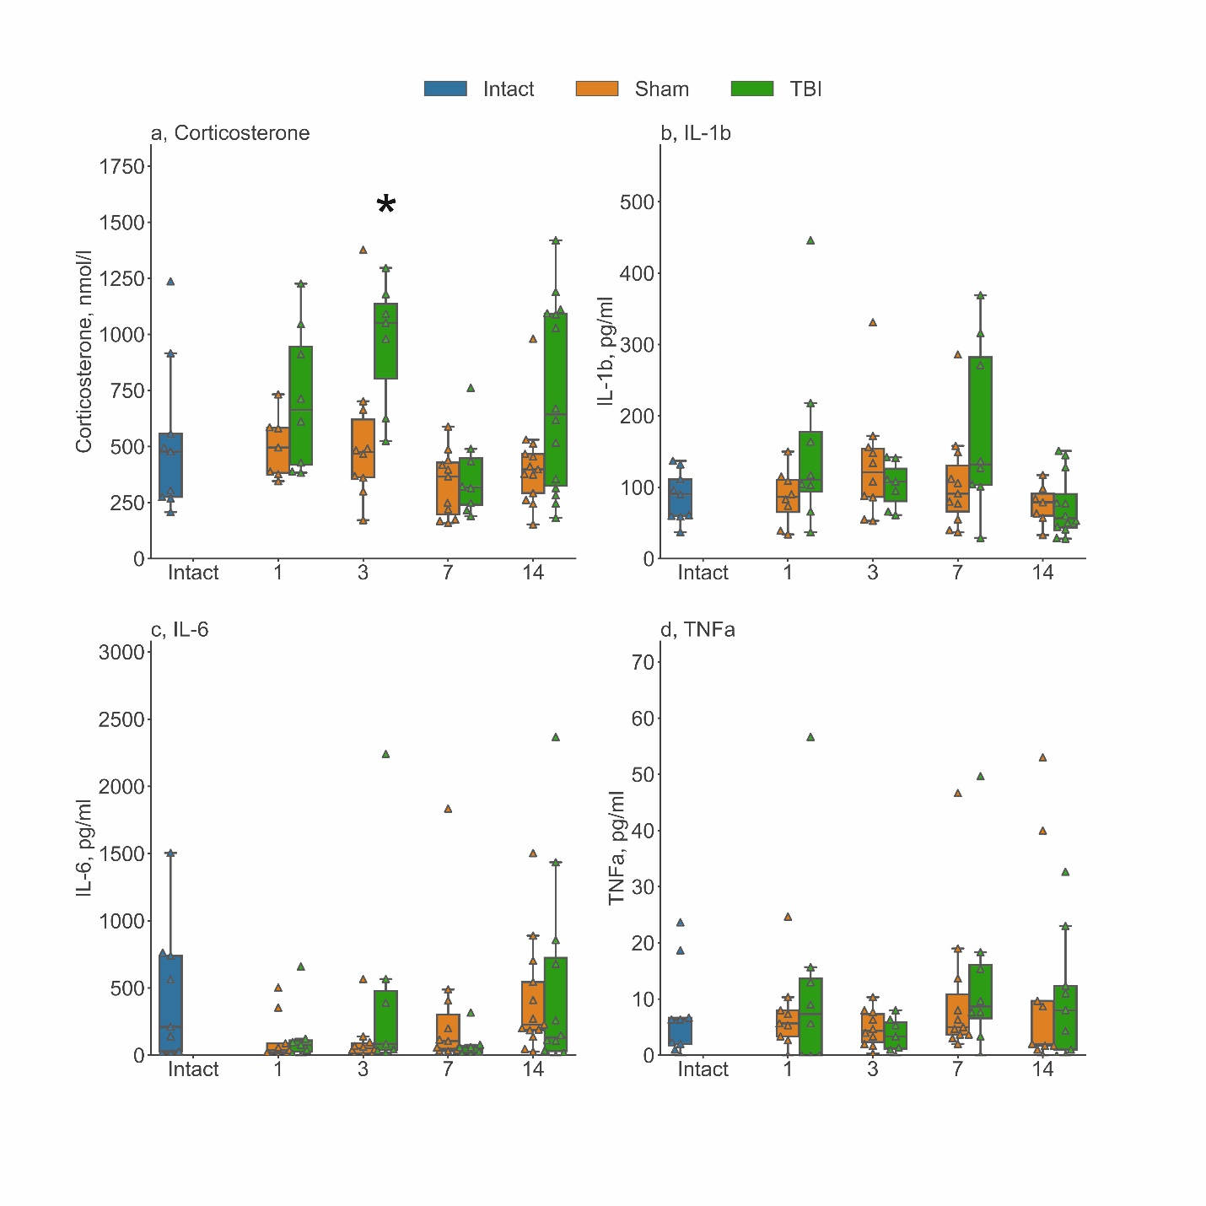
Fig. S8 Changes in blood concentrations of corticosterone, IL-1b, IL-6 and TNFa in early period after lateral fluid percussion TBI (1-14 days). TBI induced an increase of corticosterone concentration in blood serum at day 3. No changes were observed in blood concentrations of IL-1b (b), IL-6 (c) or TNFa (d). a, concentration of corticosterone; b, concentration of corticosterone IL-1b; c, concentration of corticosterone IL-6; d, concentration of corticosterone TNFa. * - p<0.05, Mann-Whitney U-test, TBI rats compared to Sham-operated rats

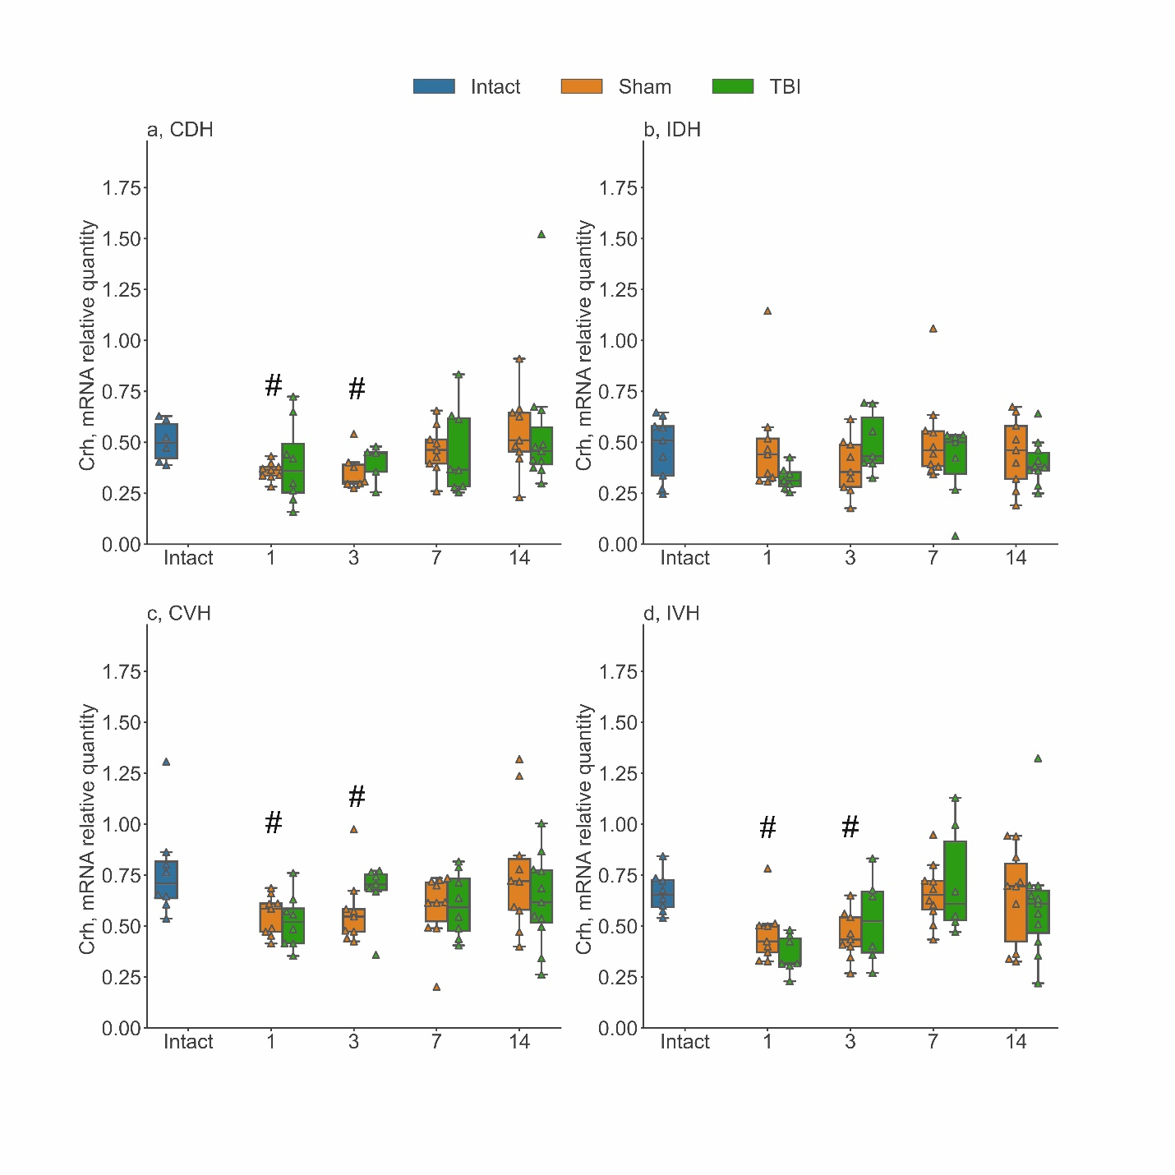
Fig. S9 The time course of Crh mRNA expression in different regions of the hippocampus in early period after lateral fluid percussion TBI (1-14 days). The decrease in Crh expression was observed in the contralateral dorsal hippocampus (a), the contralateral ventral hippocampus (c), and the ipsilateral ventral hippocampus (d) on days 1 and 3 after craniotomy in sham-operated animals. a, Contralateral Dorsal Hippocampus (CDH); b, Ipsilateral Dorsal Hippocampus (IDH); c, Contralateral Ventral Hippocampus (CVH); d, Ipsilateral Ventral Hippocampus (IVH). * - p<0.05, Mann-Whitney U-test, TBI rats compared to Sham-operated rats. # - p<0.05, Mann-Whitney U-test, Sham-operated rats compared to Intact rats

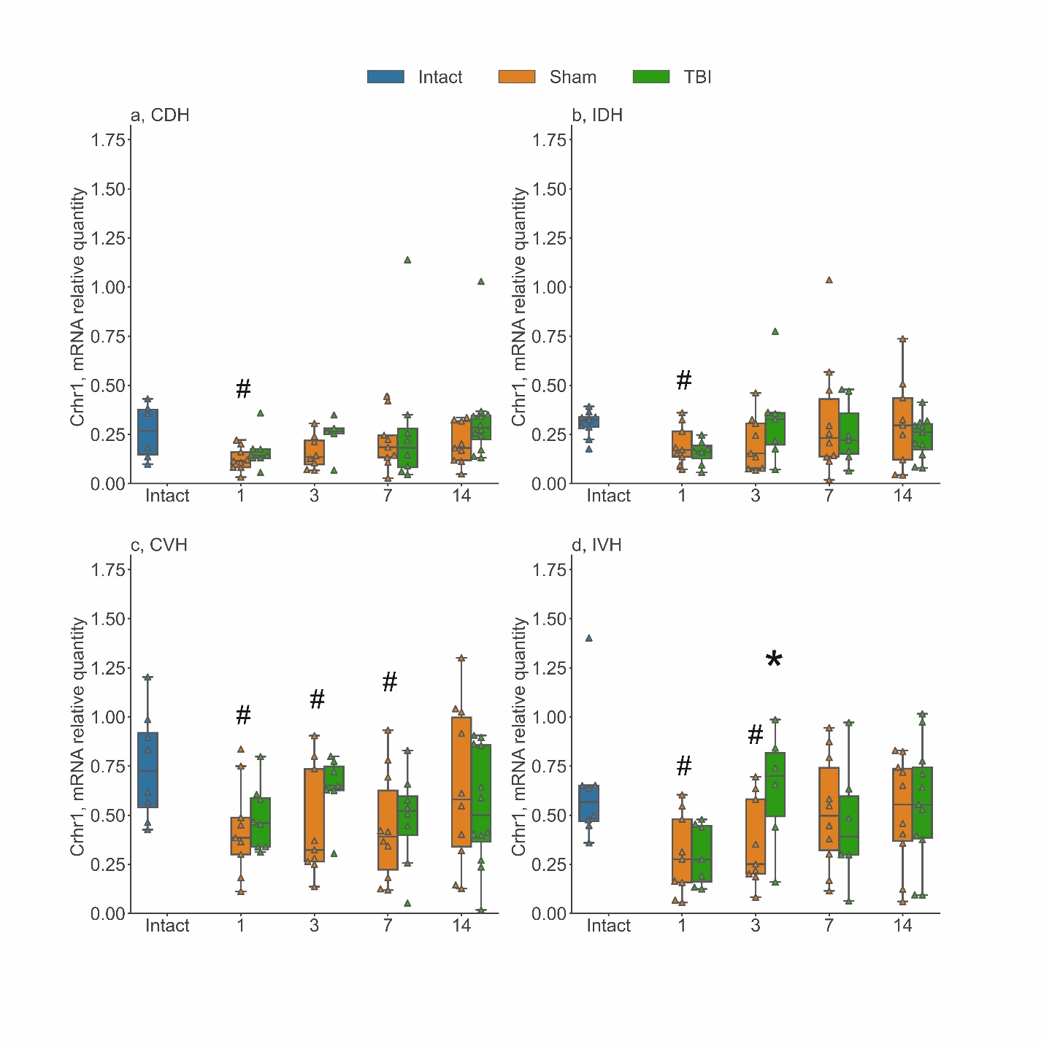
Fig. S10 The time course of Crhr1mRNA expression in different regions of the hippocampus in early period after lateral fluid percussion TBI (1-14 days). TBI induced an increase in Crhr1 expression in the ipsilateral ventral hippocampus (d) on day 3 after injury. In sham-operated animals, the decrease in Crhr1 expression was found on day 1 in the contralateral hippocampus (a) and the ipsilateral dorsal hippocampus (b), on days 1 and 3 in the ipsilateral ventral hippocampus (d), and on days 1, 3 and 7 in the contralateral ventral hippocampus (c). a, Contralateral Dorsal Hippocampus (CDH); b, Ipsilateral Dorsal Hippocampus (IDH); c, Contralateral Ventral Hippocampus (CVH); d, Ipsilateral Ventral Hippocampus (IVH). * - p<0.05, Mann-Whitney U-test, TBI rats compared to Sham-operated rats. # - p<0.05, Mann-Whitney U-test, Sham-operated rats compared to Intact rats

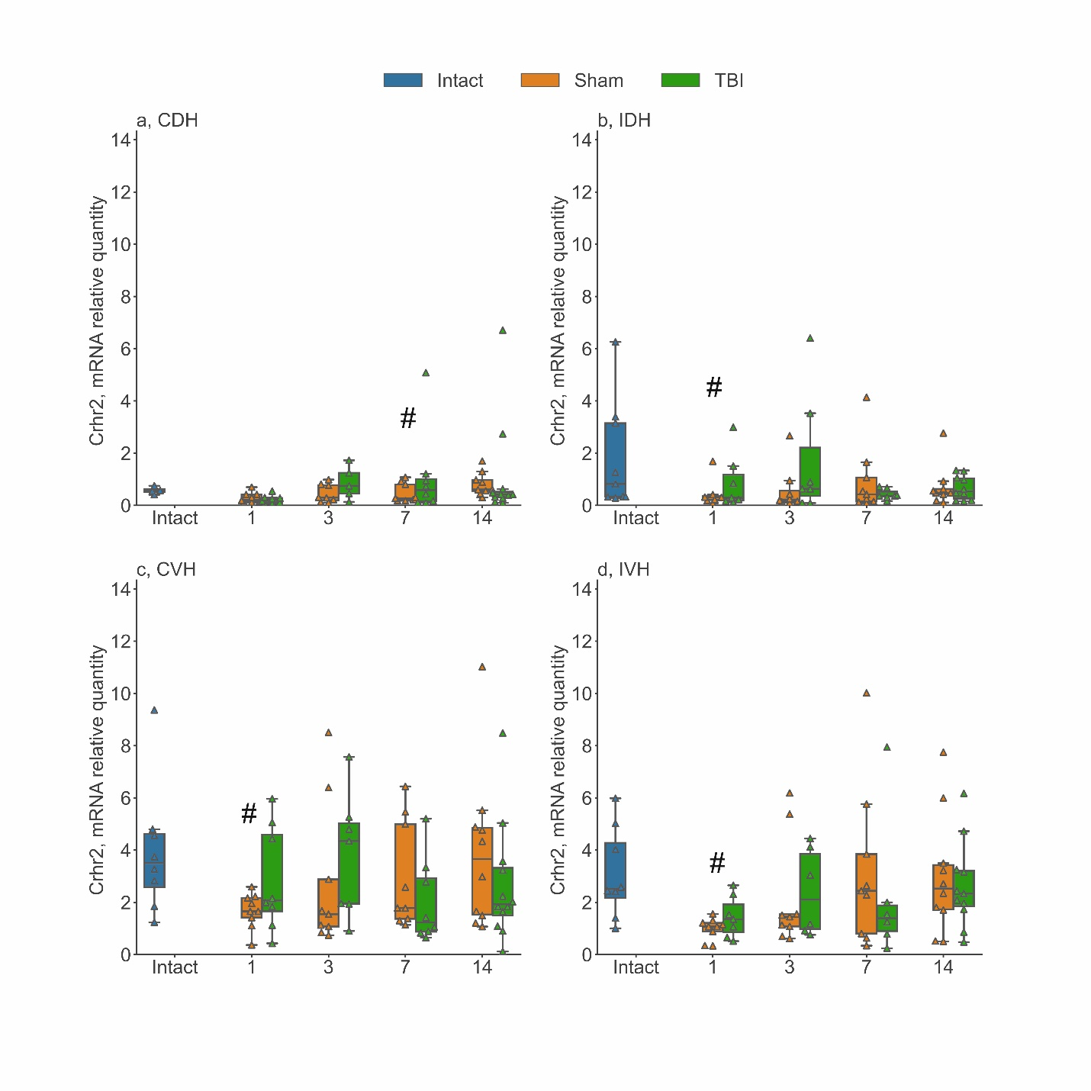
Fig. S11 The time course of Crhr2 mRNA expression in different regions of the hippocampus in early period after lateral fluid percussion TBI (1-14 days). In sham-operated animals the decrease of Crhr2 expression was shown on day 1 in the ipsilateral dorsal hippocampus (b), the contralateral ventral hippocampus (c), and the ipsilateral ventral hippocampus (d), and on day 7 in the contralateral dorsal hippocampus (a) after craniotomy. a, Contralateral Dorsal Hippocampus (CDH); b, Ipsilateral Dorsal Hippocampus (IDH); c, Contralateral Ventral Hippocampus (CVH); d, Ipsilateral Ventral Hippocampus (IVH). * - p<0.05, Mann-Whitney U-test, TBI rats compared to Sham-operated rats. # - p<0.05, Mann-Whitney U-test, Sham-operated rats compared to Intact rats

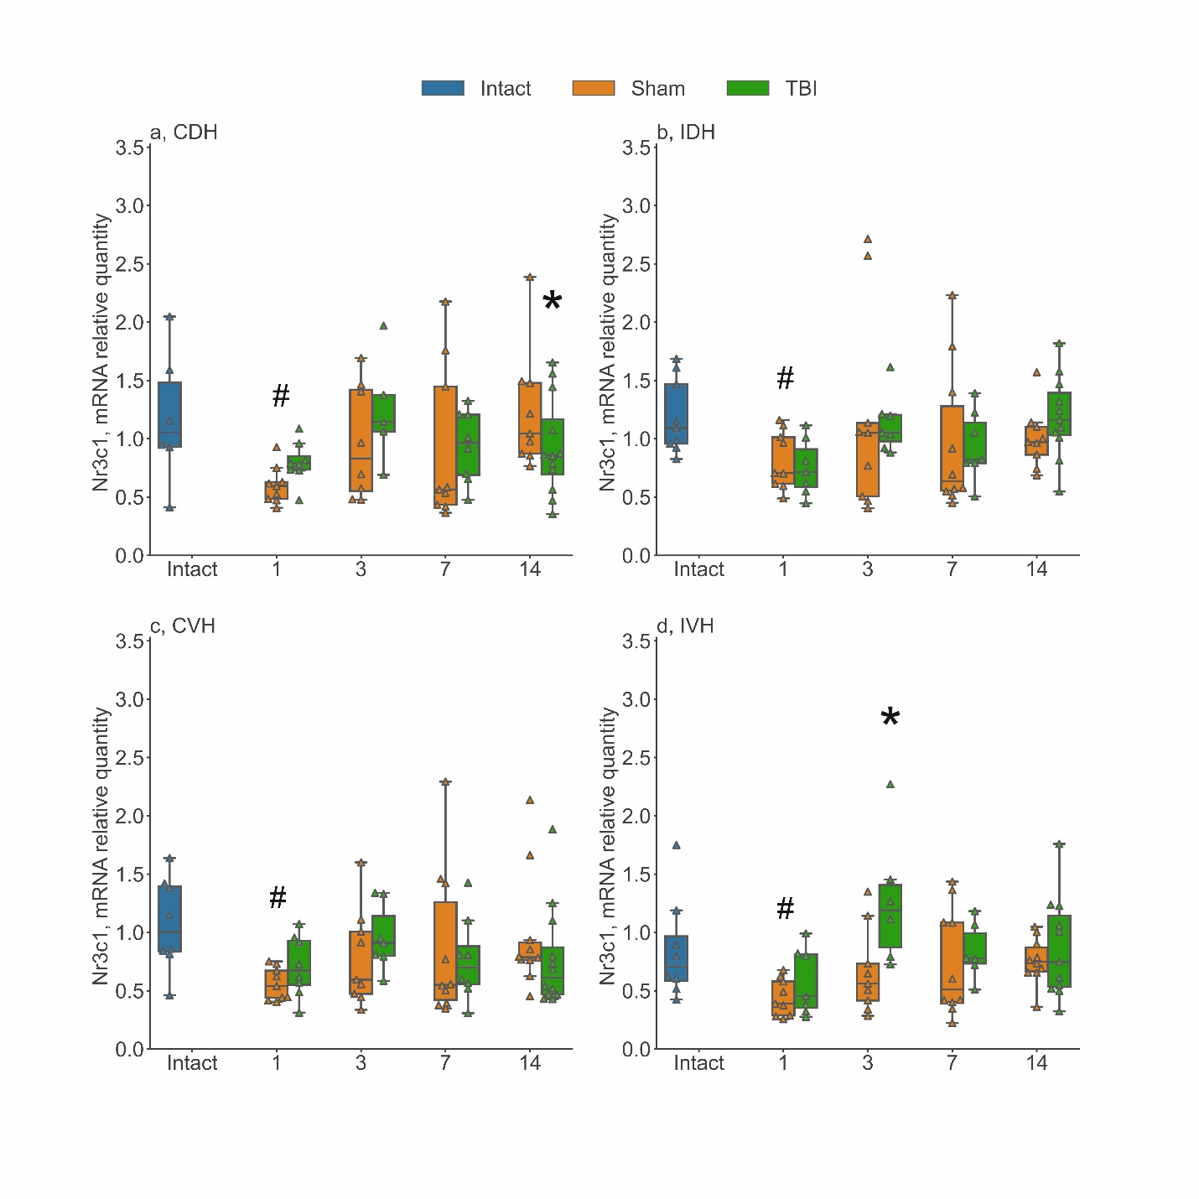
Fig. S12 The time course of Nr3c1 mRNA expression in different regions of the hippocampus in early period after lateral fluid percussion TBI (1-14 days). The increase in Nr3c1 expression was observed in the ipsilateral ventral hippocampus (d) on day 3 after TBI. In sham-operated animals the decrease in Nr3c1 expression was found in all hippocampal regions studied ont day 1 after craniotomy. a, Contralateral Dorsal Hippocampus (CDH); b, Ipsilateral Dorsal Hippocampus (IDH); c, Contralateral Ventral Hippocampus (CVH); d, Ipsilateral Ventral Hippocampus (IVH). * - p<0.05, Mann-Whitney U-test, TBI rats compared to Sham-operated rats. # - p<0.05, Mann-Whitney U-test, Sham-operated rats compared to Intact rats

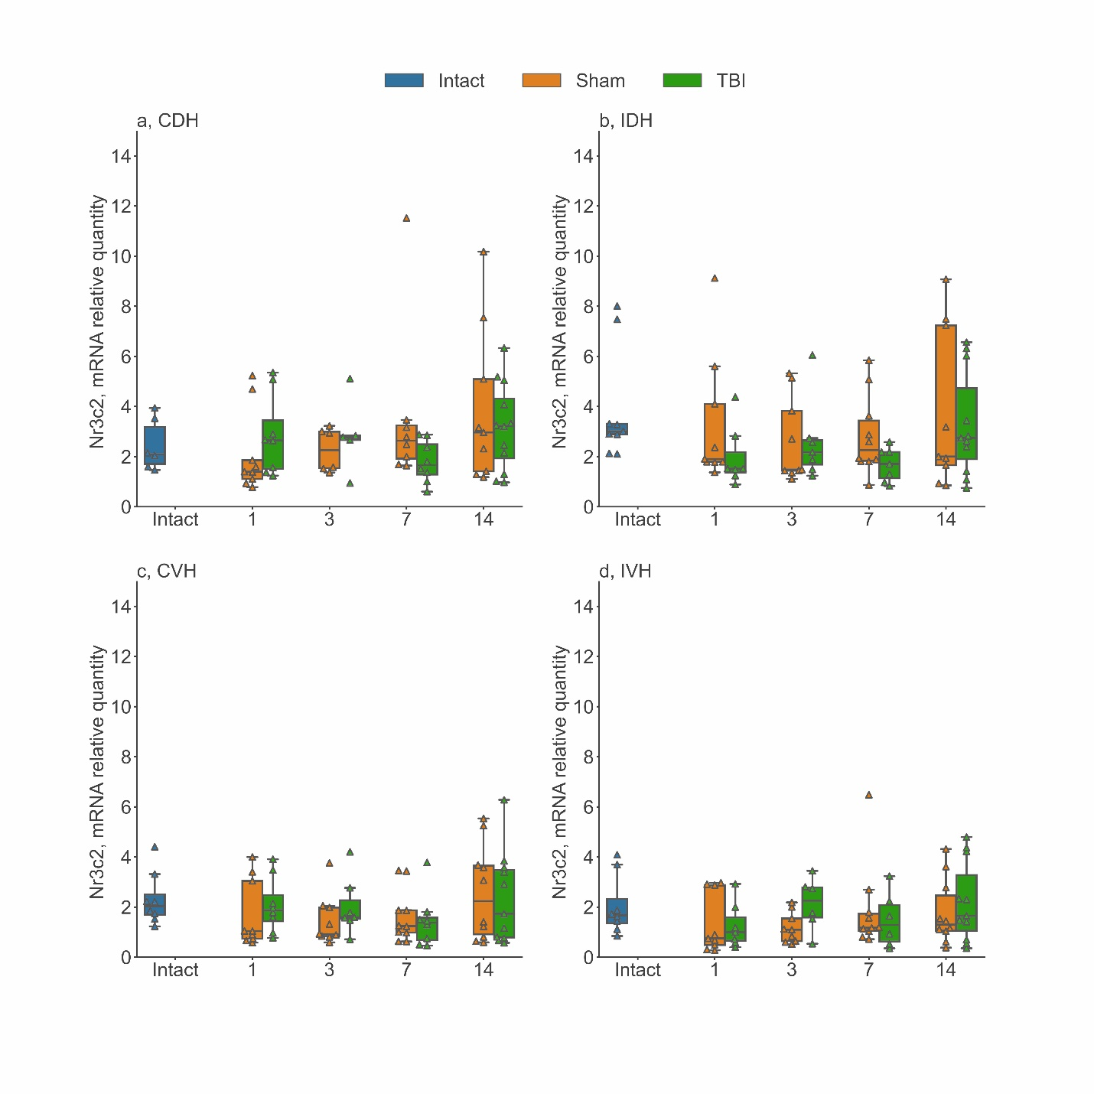
Fig. S13 The time course of Nr3c2 mRNA expression in different regions of the hippocampus in early period after lateral fluid percussion TBI (1-14 days). No changes were found in Nr3c2 gene expression. a, Contralateral Dorsal Hippocampus (CDH); b, Ipsilateral Dorsal Hippocampus (IDH); c, Contralateral Ventral Hippocampus (CVH); d, Ipsilateral Ventral Hippocampus (IVH). * - p<0.05, Mann-Whitney U-test, TBI rats compared to Sham-operated rats. # - p<0.05, Mann-Whitney U-test, Sham-operated rats compared to Intact rats

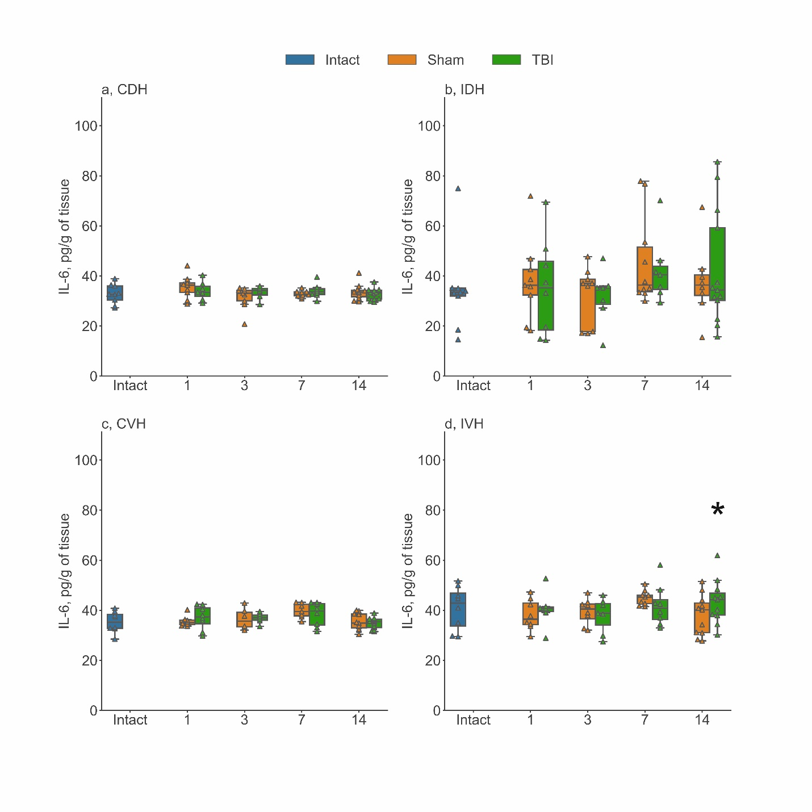
Fig. S14 The time course of IL-6 concentration in different regions of the hippocampus in early period after lateral fluid percussion TBI (1-14 days). The increase of IL-6 concentration was shown only in the ipsilateral ventral hippocampus (d) on day 14 after TBI. a, Contralateral Dorsal Hippocampus (CDH); b, Ipsilateral Dorsal Hippocampus (IDH); c, Contralateral Ventral Hippocampus (CVH); d, Ipsilateral Ventral Hippocampus (IVH). * - p<0.05, Mann-Whitney U-test, TBI rats compared to Sham-operated rats

