Supplementary Data

Mapping Fusion-Driven Cell Reprogramming Through Integrative Single-Cell Computational Frameworks

Fateme Nazaryabrbekoh^{1,#}, JoAnne Huang^{1,#}, Syeda S. Shoaib², Xun Tang², Somayeh Ebrahimi-Barough³, Joohyun Kim⁴, Brenda M. Ogle^{3,5,6,7} and Jangwook P. Jung^{1,}*

1. Department of Biological Engineering, Louisiana State University, Baton Rouge, LA
2. Cain Department of Chemical Engineering, Louisiana State University, Baton Rouge, LA
3. Department of Biomedical Engineering, University of Minnesota – Twin Cities, Minneapolis, MN
4. Vanderbilt Genetics Institute and Division of Genetic Medicine, Vanderbilt University Medical Center, Nashville, TN
5. Stem Cell Institute, University of Minnesota – Twin Cities, Minneapolis, MN
6. Department of Pediatrics, University of Minnesota – Twin Cities, Minneapolis, MN
7. Institute of Engineering in Medicine, University of Minnesota – Twin Cities, MN

#Equal contribution

*Corresponding author:
Jangwook P. Jung, Ph.D.
Department of Biological Engineering
Louisiana State University
167 E.B. Doran Hall
Baton Rouge, LA 70803
Phone: (225) 578-2919
Fax: (225) 578-3492

E-mail: jjung1@lsu.edu
Supplementary Figures
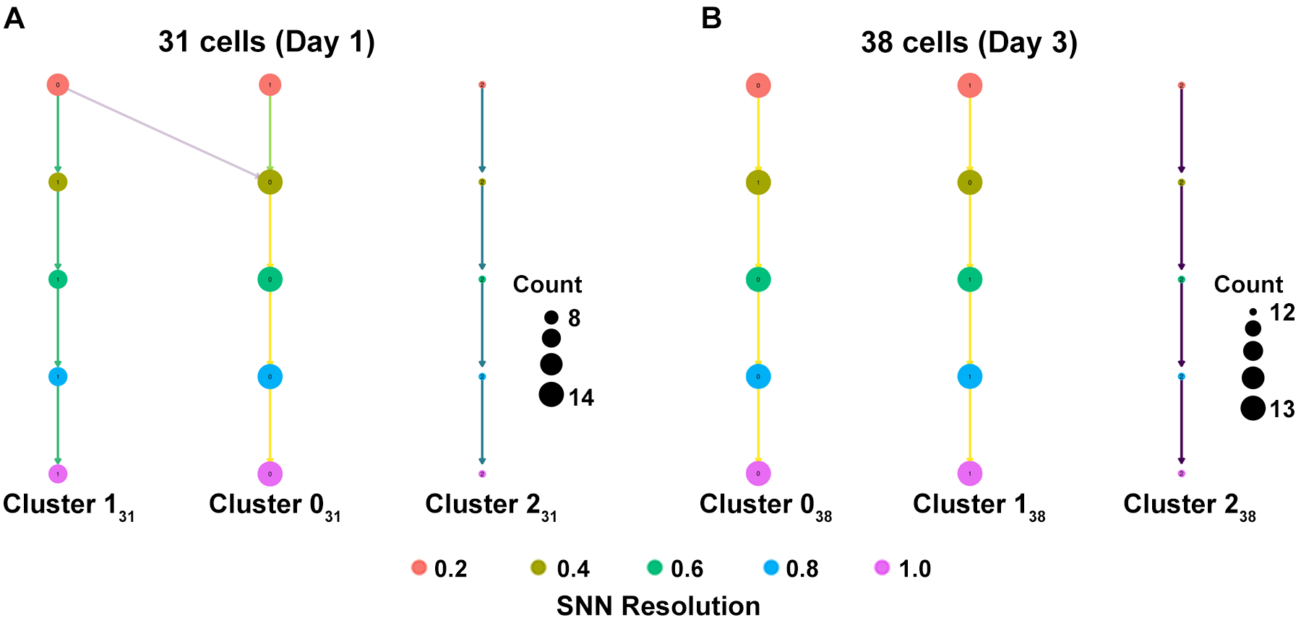
Figure S1. Unsupervised clustering of (A) 31 and (B) 38 co-cultured cells is visualized using Clustree. The resulting dendrogram-like structure illustrates the relationships between clusters detected at different SNN resolutions. For each resolution, the size of the points in the rightmost column reflects the number of cells within that designated cluster. Vertically, the figure shows how coarser clusters identified at lower SNN resolutions are progressively refined into more distinct clusters at higher resolutions. Cluster names from the two datasets differ, as indicated by their subscripts (e.g., Cluster1₃₁ versus Cluster1₃₈).

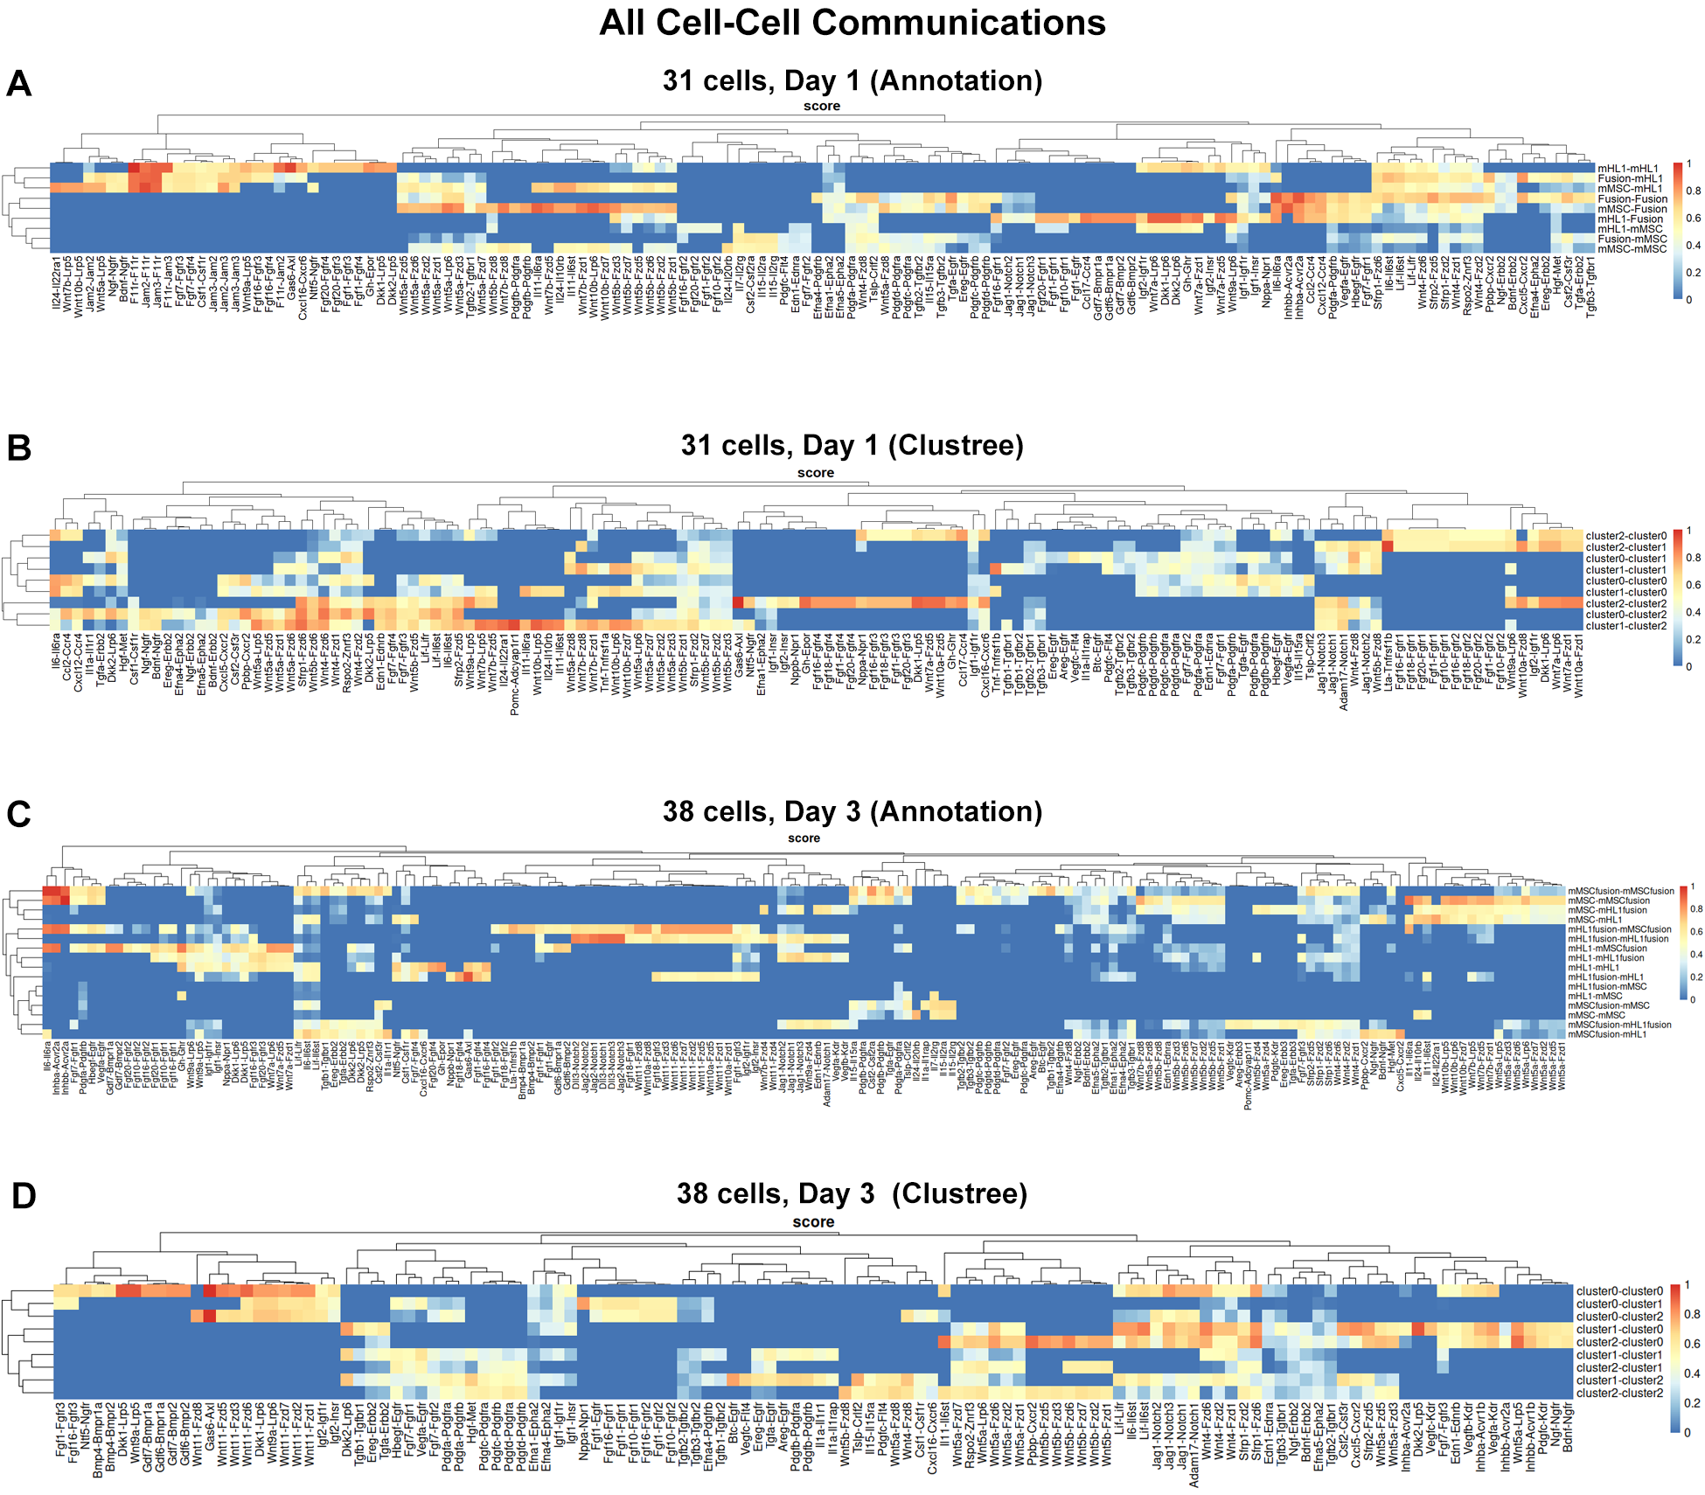
Figure S2. Inferred cell-cell communication networks in co-cultured cells at Day 1 (A and B) and Day 3 (C and D) are depicted as heatmaps. Communication scores between cell populations defined by prior annotation are illustrated in (A) and (C), while (B) and (D) present the same data with cell populations organized by unsupervised clustering using Clustree. The color intensity in each heatmap indicates the predicted strength of communication between specific LR pairs or signaling pathways. HC of sending and receiving cell populations is visualized by dendrograms along the top and left of each heatmap. The number of cells analyzed at each time point is specified in the panel titles.

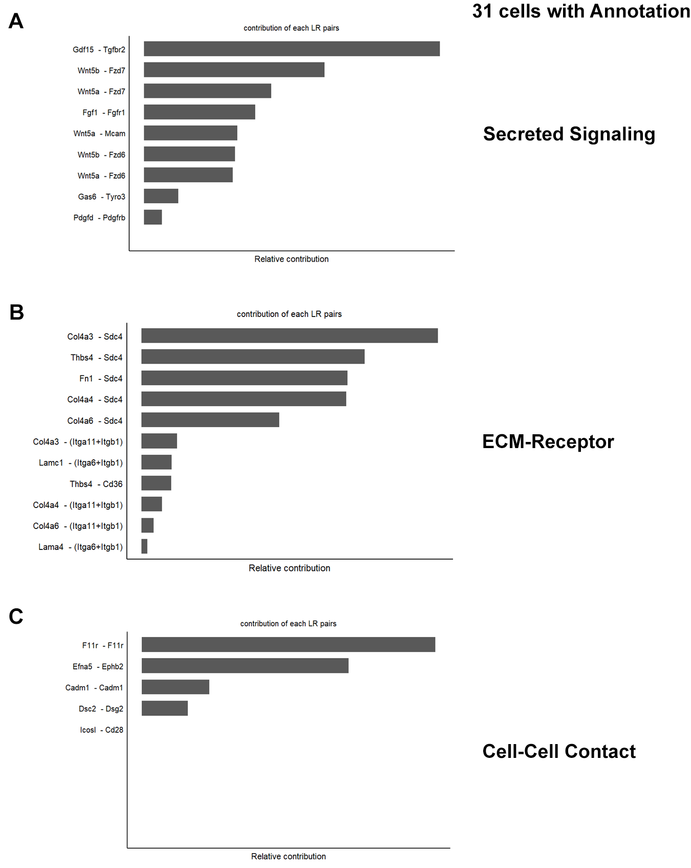
Figure S3. Bar plots depict the relative contributions of specific LR pairs to cell-cell communication in 31 annotated co-cultured cells, categorized by communication mechanism. The top contributing LR pairs within Secreted Signaling, ECM-Receptor interactions, and Cell-Cell Contact are detailed in (A), (B) and (C), respectively, with bar length indicating the relative contribution score of each LR pair.

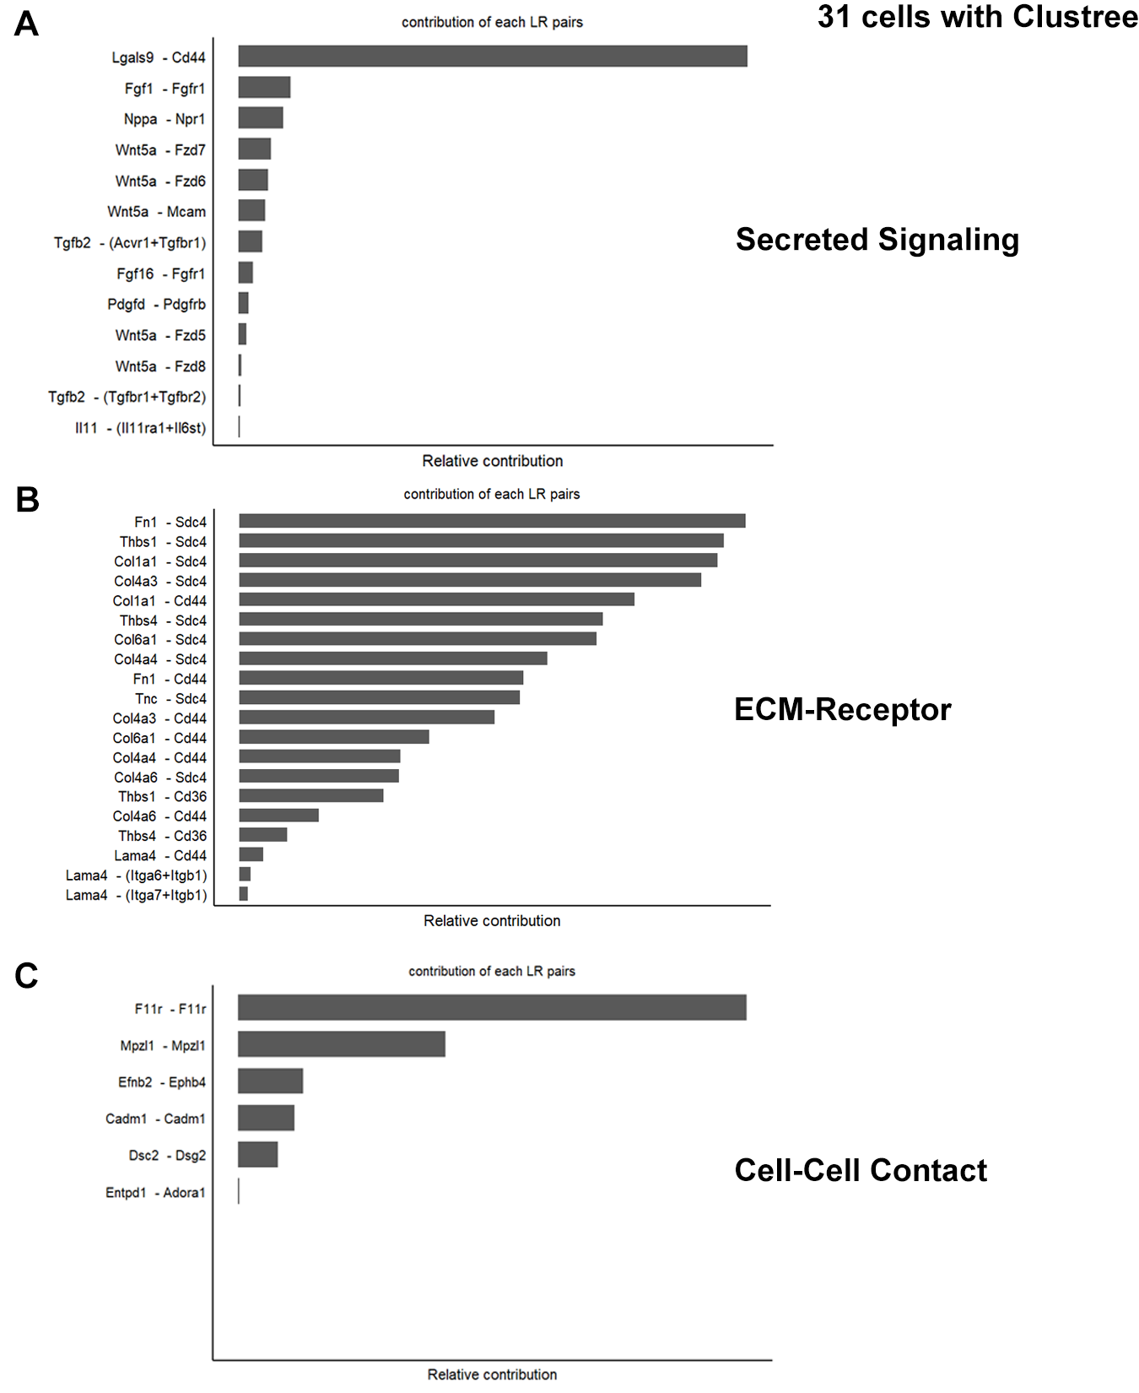
Figure S4. Bar plots illustrate the relative contribution of individual LR pairs to cell-cell communication in 31 co-cultured cells, with cell populations defined by unsupervised clustering using Clustree. The top contributing LR pairs within Secreted Signaling, ECM-Receptor interactions, and Cell-Cell Contact are detailed in (A), (B) and (C), respectively.
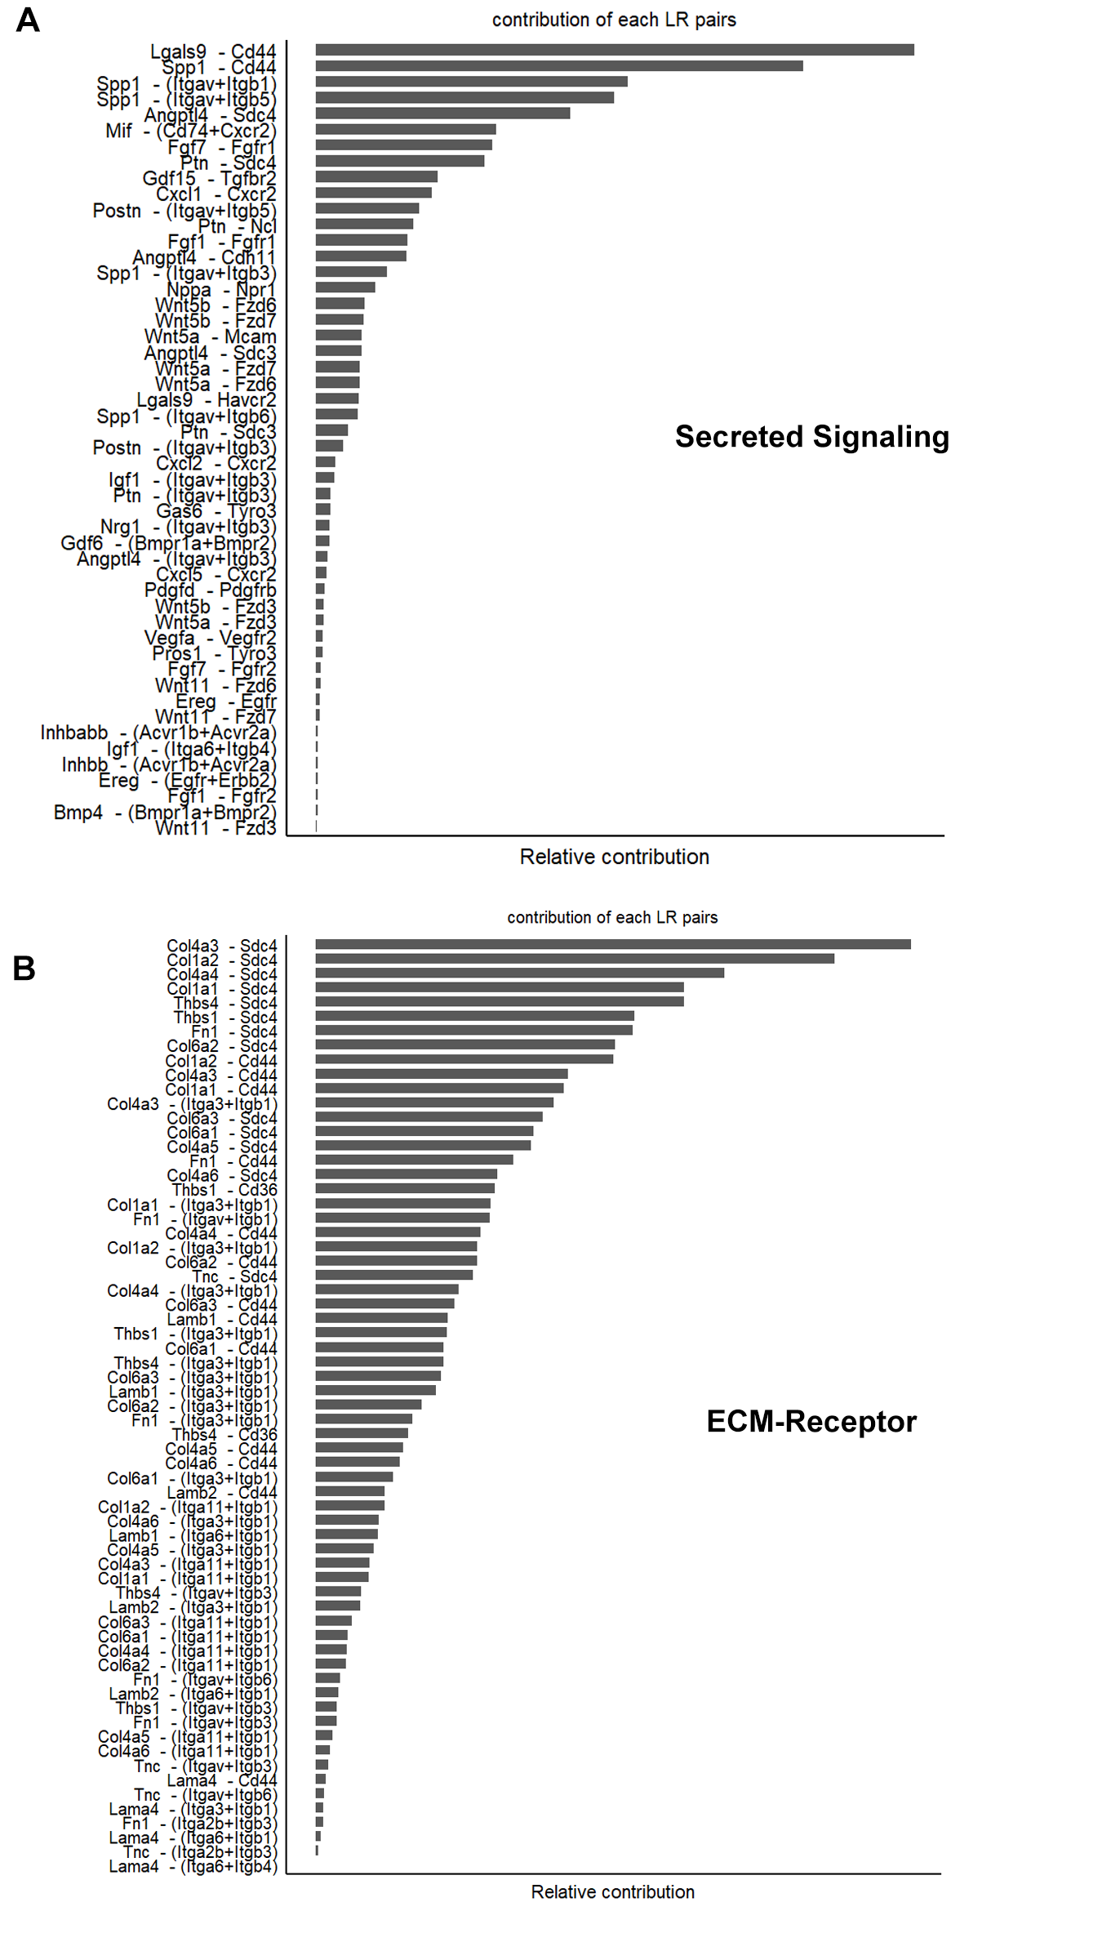

Figure S5. Bar plots illustrate the relative contributions of specific LR pairs to cell-cell communication among 38 annotated co-cultured cells, categorized by signaling mechanism. The top contributing LR pairs in Secreted Signaling are shown in (A), and those in ECM-Receptor interactions are highlighted in (B), with bar length representing the relative contribution score within each category. The relative contributions of LR pairs involved in Cell-Cell Contact are specifically detailed in (C).

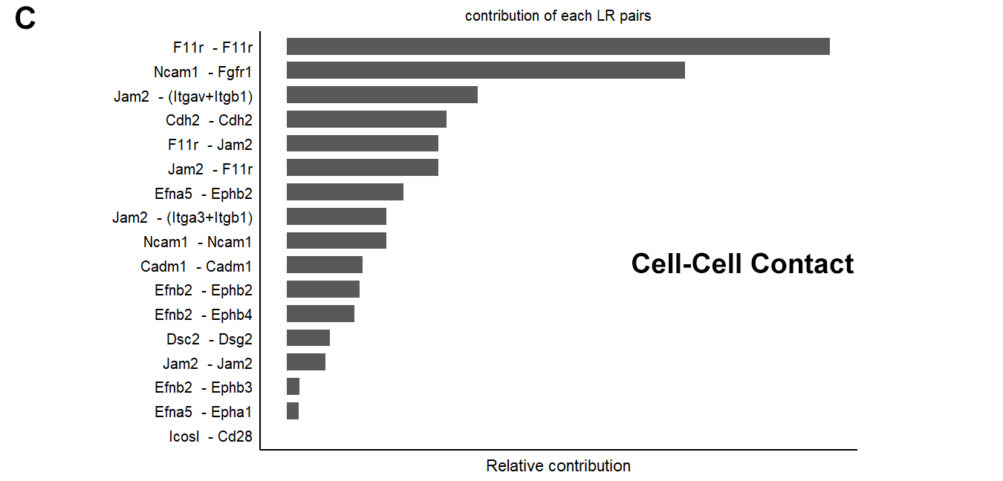

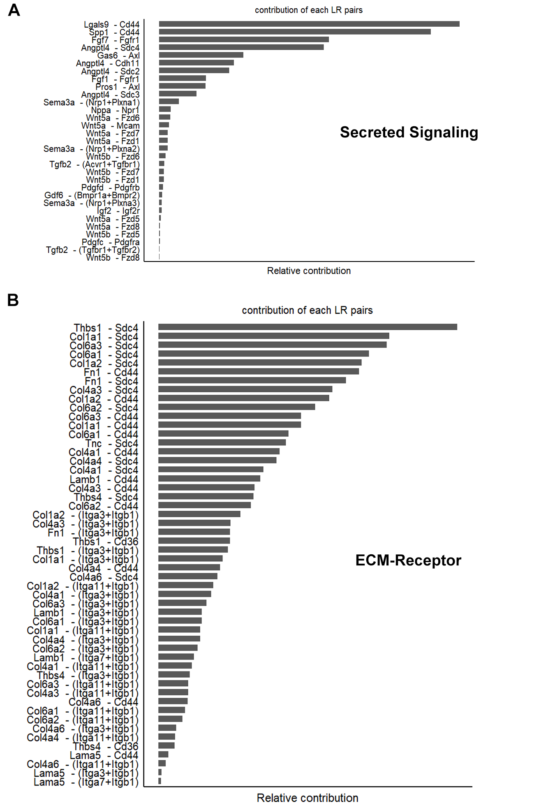
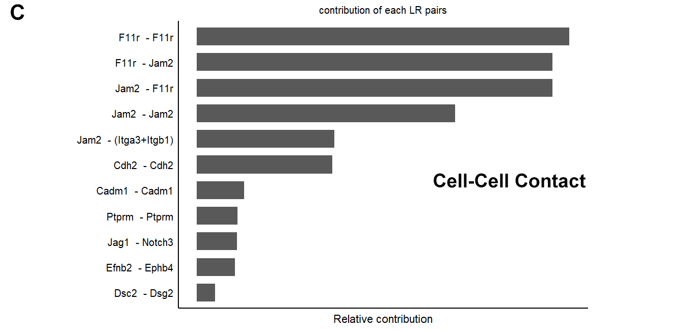
Figure S6. Bar plots illustrate the relative contributions of specific LR pairs to cell-cell communication among 38 cells, with cell populations defined by Clustree. Secreted Signaling is depicted in (A), and ECM-Receptor interactions are shown in (B); in both, bar length corresponds to the relative contribution score of each LR pair to the overall communication within that category. The relative contributions of LR pairs involved in Cell-Cell Contact are specifically illustrated in (C).

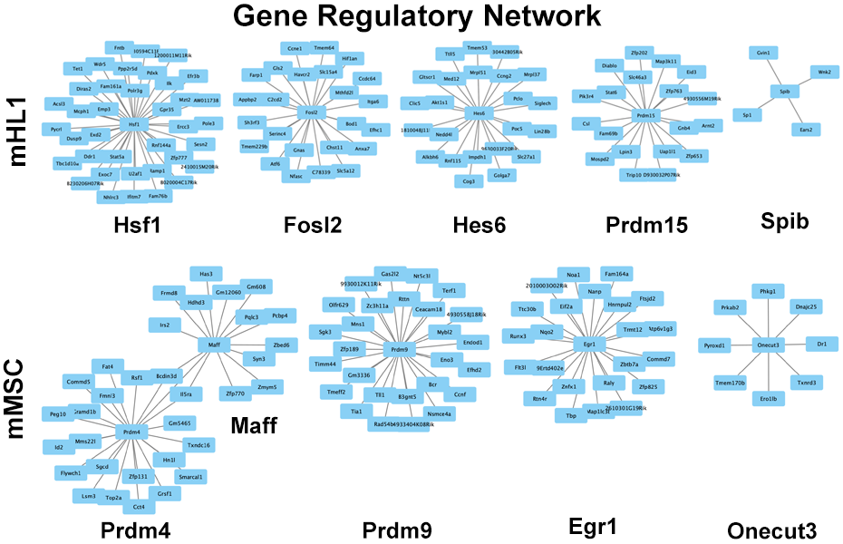
Figure S7. GRNs for selected TFs in mHL1 and mMSC. Each sub-network depicts the regulatory relationships between a central TF (labeled below each network) and its predicted target genes (connected nodes), with arrows indicating the direction of regulation (TF regulating target gene).

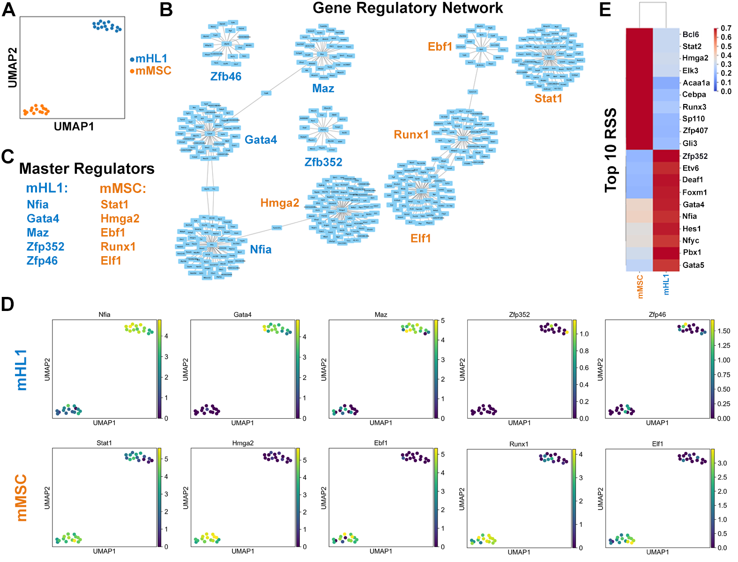
Figure S8. GRN analysis of mHL1 and mMSC. (A) UMAP visualization showing the distribution of mHL1 (blue) and mMSC (orange). (B) Network of master regulator TFs identified in mHL1 and mMSC, with edges representing potential regulatory relationships. (C) List of the top master regulator TFs identified for each cell type. (D) Feature plots on the UMAP embedding showing the expression levels of selected master regulator TFs in mHL1 and mMSC cells, with color intensity indicating expression level. (E) Heatmap displaying the RSS of the top 10 master regulator TFs for each cell type, indicating the degree to which their regulon activity is specific to either mHL1 or mMSC.

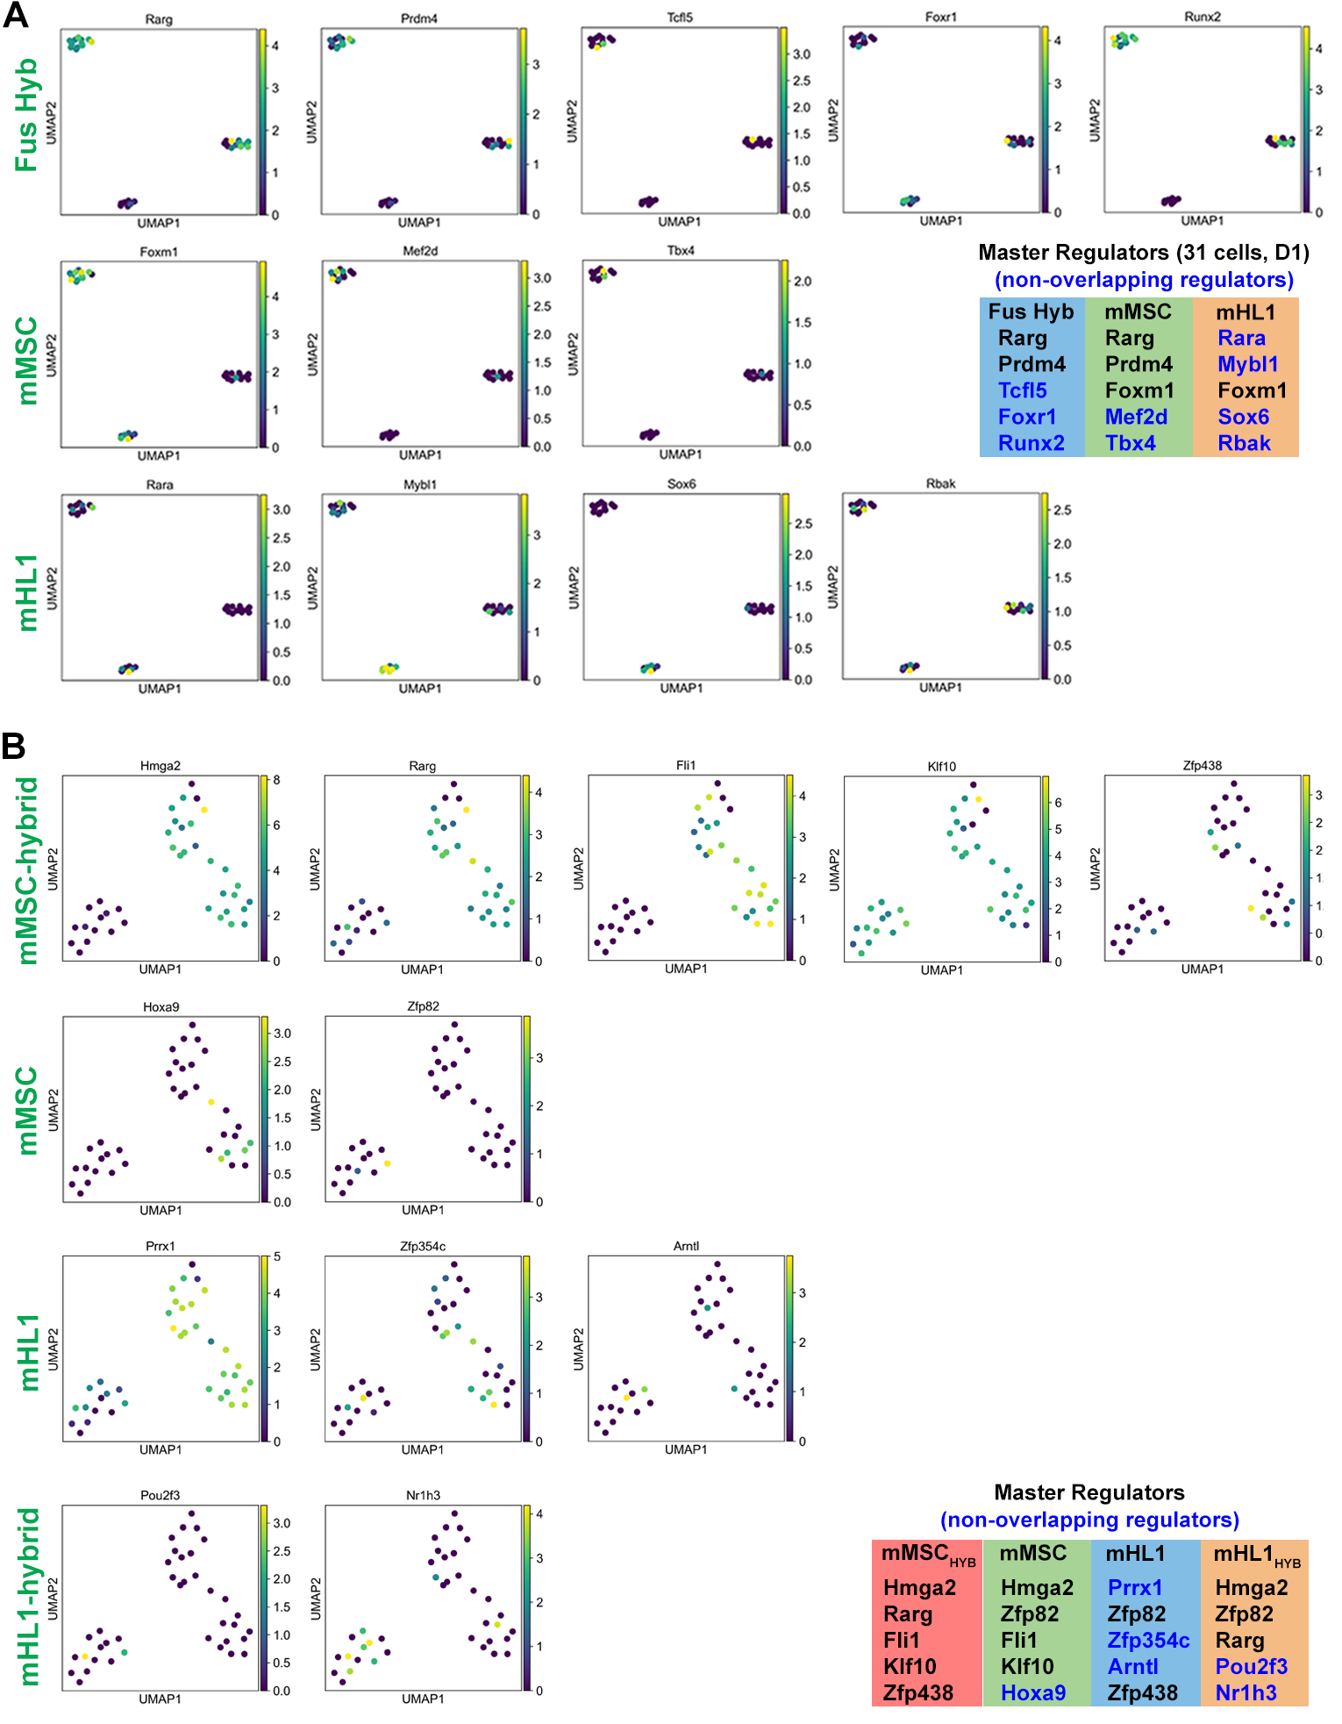
Figure S9. UMAP visualizations displaying the expression patterns of selected master regulator TFs in Fusion hybrid (Fus Hyb), mMSC and mHL1 cell populations (31 cells, Day 1). (A) Feature plots showing the expression levels of TFs identified as master regulators in Fusion hybrid, mMSC and mHL1. Color intensity indicates the expression level of each TF within the UMAP embedding. (B) Feature plots illustrating the expression levels of additional master regulator TFs identified in the respective cell populations (38 cells, Day 3). The legend provides a key to the TFs specific to each cell type.

Supplementary Tables

Table S1. Tabula Muris cell types per module.
Partition mMSC (D0)
Module 30 | Granulocyte, Fat CL:0000094
Module 27 | Natural Killer Cell, Marrow CL:0000623
Module 12 | Fibroblast, Heart CL:0000057
Module 13 | Mesenchymal cell, bladder CL:00008019
Module 11 | Mesenchymal cell, bladder CL:00008019
Partition Fusion Hybrid (D1)
Module 8 | Endothelial cell, kidney CL:0000115
Module 17 | Fraction A Pre Pro B Cell, Marrow CL:0002045
Module 26 | Mesenchymal cell, bladder CL:00008019
Module 1 | Mesenchymal stem cell, muscle CL:0000134
Module 19 | Epithelial cell, large intestine Colon CL:0002253
Partition mMSC (D1)
Module 15 | Stromal Cell, Trachea CL:0000499
Module 17 | Fraction A Pre Pro B Cell, Marrow CL:0002045
Module 10 | Basal Cell of Epidermis, Tongue CL:0002187
Module 19 | Epithelial cell, large intestine Colon CL:0002253
Module 6 | Skeletal Muscle Satellite Cell, Muscle CL:0000594
Partition mHL1 (D0)
Module 9 | Stem Cell of Epidermis, Skin CL:1000428
Module 24 | Cardiac Muscle Cell, Heart CL:0000746
Module 5 | Cardiac Muscle Cell, Heart CL:0000746
Module 7 | Stem Cell of Epidermis, Skin CL:1000428
Module 28 | Stem Cell of Epidermis, Skin CL:1000428
Partition mHL1 (D1)
Module 29 | Keratinocyte, Tongue CL:0000312
Module 18 | Stromal Cell, Trachea CL:0000499
Module 2 | Stem Cell of Epidermis, Skin CL:1000428
Module 4 | Stem Cell of Epidermis, Skin CL:1000428
Module 3 | Cardiac Muscle Cell, Heart CL:0000746
Partition Fusion Hybrid (D3)
Module 29 | Keratinocyte, Tongue CL:0000312
Module 21 | Smooth muscle cell, fat CL:0000192
Module 23 | Skeletal Muscle Satellite Cell, Muscle CL:0000594
Module 22 | Cardiac Muscle Cell, Heart CL:0000746
Module 3 | Cardiac Muscle Cell, Heart CL:0000746

