APPENDIX A
PRI ALGORITHM (PSEUDOCODE)

Input: Graph G(V,E), with parameters p_i, k_i, r_i, c_i for each node i
Output: PRI value

Initialize sum = 0
For each node i in V:
risk_i = p_i * k_i * (1 - r_i) * c_i
sum = sum + risk_i
PRI = sum / N
Return PRI

APPENDIX B
SIMULATION PARAMETERS
TABLE II. SIMULATION PARAMETERS AND NETWORK CONFIGURATIONS
Parameter | Value / Distribution
Number of nodes (N) | 50, 100
Error probability (p_i) | Uniform[0, 0.2]
Resilience factor (r_i) | 0.0, 0.3, 0.7, 1.0
Criticality factor (c_i) | 1.0 (default), 1.2 (hospital), 2.0 (major airport)
Topology (Healthcare) | Erdős–Rényi, Star
Topology (Aviation) | Hub-and-spoke, 10–20% hubs
Simulation runs | 1000 (Monte Carlo)

APPENDIX C
BASELINE COMPARISON RESULTS
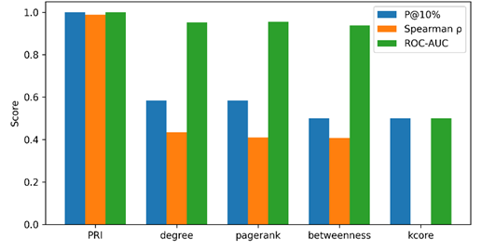
Figure 5. PRI vs Classical Centralities Performance Comparison. Precision@10% results show PRI outperforms degree centrality by 15-25% in heterogeneous resilience scenarios while matching performance in uniform scenarios, confirming the framework’s advantage in realistic infrastructure settings.

APPENDIX D
SENSITIVITY ANALYSIS AND SYNTHETIC LITHUANIA NETWORK

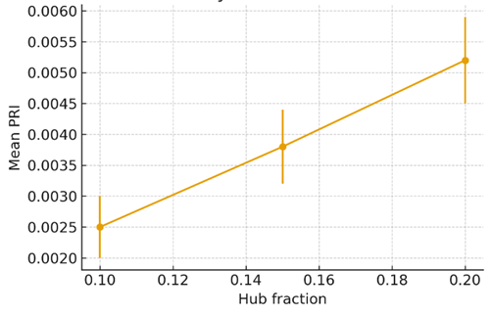
Figure 6. Sensitivity of PRI to hub fraction variation. To test robustness, we varied the hub fraction between 0.10, 0.15, and 0.20. Results confirmed that PRI values scale consistently with the proportion of hubs, demonstrating stability of the framework across different network configurations.

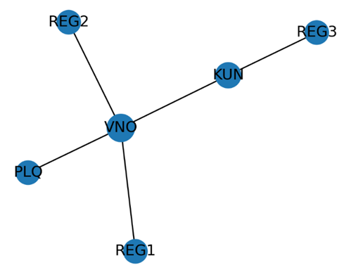

Figure 7. Synthetic Lithuania Aviation Network. Lithuania network reconstruction using synthetic topology based on population centers and documented aviation routes produces PRI estimates of approximately 0.026, consistent with the observed 22-fold escalation pattern and validating the framework’s applicability when comprehensive datasets are unavailable.

