Characteristics and possible function of wingbeat acoustic emissions of tortricid moths
Supplementary Material

Alejandro Martin-Gabarrella, Luis Elvira-Segura, Joaquin Baixeras, César Gemeno
Index
Figure S1 2
Figure S2 3
Figure S3 4
Figure S4 5
Figure S5 6
Figure S6 7
Table S1 8
Table S2 9
Table S3 10
Table S4 11
Table S5 12
Sound intensity calculation of the signal recorded with the Brüel & Kjaer microphone. 13
Distance attenuation calculation 13
Data 13
R code 15

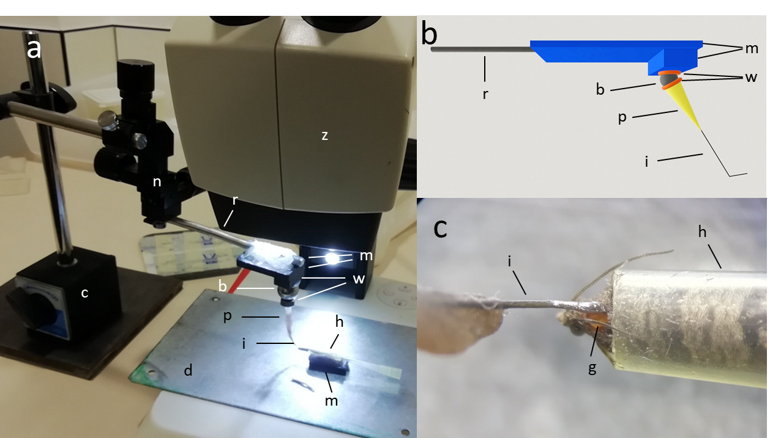

Figure S1. Insect tethering. The moth was introduced head-first inside a 20-µl pipette tip which small opening was cut so as to let pass the head, intact antennae, and thorax (c). Scales were removed by hand from the thorax with paper tissue. A drop of cyanoacrylate gel glue was placed on the tip of the insect pin which was attached to the insect holder (a picture, b diagram) and, with the help of a coarse micromanipulator, the glue drop was gently pressed over the scale-free torathic area, all the while watching the operation through the stereo microscope. A barrier placed in front of the head prevented the insect from leaving the pipette during the operation (not shown in the image). Once the glue dried, the barrier in front of the insect was removed and the insect holder was gently pulled back so that the moth exited the pipette tip. b: 1-cm-diameter steel ball bearing; c: magnetic base attached to a thick iron metal plate; d: galvanized steel plate; g: drop of cyanoacrylate gel (Ceys Superunick® Gel; the gel formulation stays in place, the liquid formulation spreads over to the wings); h: 20 µl pipette tip to hold the insect; i: 0.71-mm diameter tungsten insect pin (c shows a silver wire because this is what we were using at the initial stages when this picture was taken); m: magnets; n: coarse micromanipulator (Narishige UN-3C, Japan); p: pipette tip to hold the insect pin; r: metal rod; w: washers (a nut served as the bottom washer in a); z: stereo microscope.

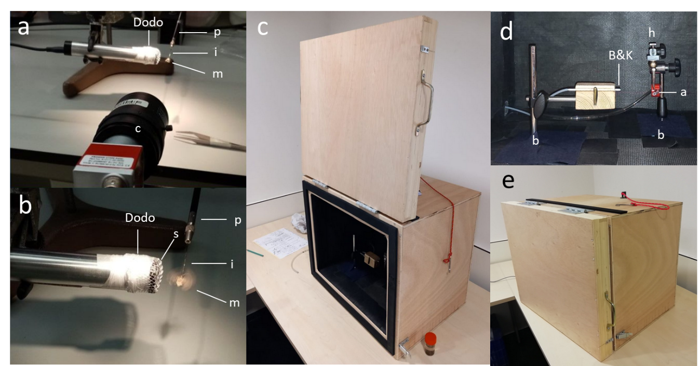

Figure S2. Recording setups. Synchronization of wing position and ultrasound emission (a, b is close-up of a with the moth wingfanning). Characterization of ultrasound and acoustic wingbeat emissions in anechoic chamber (c-e). The anechoic chamber was a 40 x 50 x 60 cm wooden box lined internally, door included, with 5-cm-thick rockwool.
a: air input; b: magnetic stand; B&K: Brüel & Kjaer 4391 microphone; c: high-speed video camera (PROMON U1000 and Imaging Studio v4 software, AOS Technologies, Switzerland, 320 x 240 pixels resolution at 980 fps); Dodo: Dodotronics 250K microphone; h: holder, as shown in Figure S1 (no insect attached here); i: 0.75-mm diam. insect pin; m: moth; p: pin holder; s: galvanized mosquito screen.

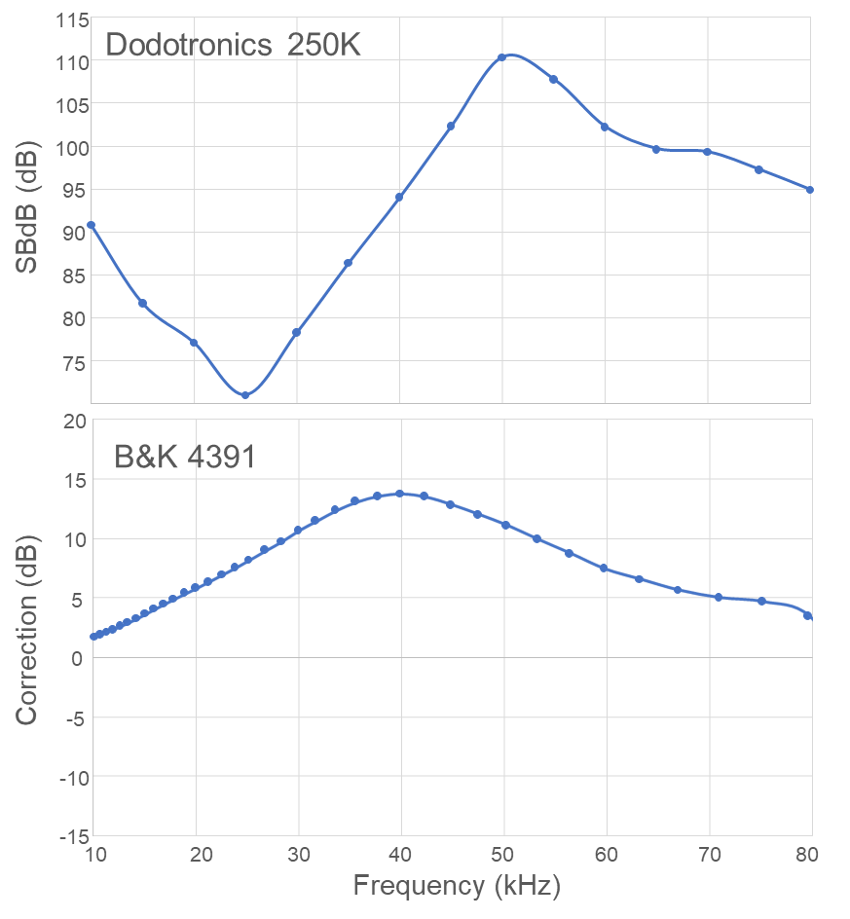

Figure S3. Calibration curves of Dodotronic and B&K microphones. To calibrate the Dodotronic 250K microphone, we use a calibrated ultrasound measurement microphone (model 4939, Brüel & Kjær -B&K-, Denmark), with the help of a tweeter speaker (Peerless XT25TG30-04, Tymphany, China) which emitted sine waveforms excited by a signal generator (DG1022Z, Rigol, China). The two microphones were placed simultaneously at 45° from the speaker midline at a distance of around 30 cm, and the emitted sound (with different intensities depending on the frequency to achieve well-shaped sine waveforms) allowed us to obtain a calibration curve in dB (Figure S2) with the following equation (Equation 1):
$SPL={SDB}_{d}(f)+20log\frac{{ V}_{A}}{E_{m}}$(1)
where $SPL$ is the sound pressure level (SPL) in dB (re. 20µPa), ${SDB}_{d}(f)$ is the calibrated sensitivity of the microphone in dB SPL as a function of frequency, ${ V}_{A}$ is wave amplitude in Audacity 3.1.1 software (Audacity Team, 2021) units and $E_{m}$ is the Audacity digital gain, which ranges from 0 to 1.

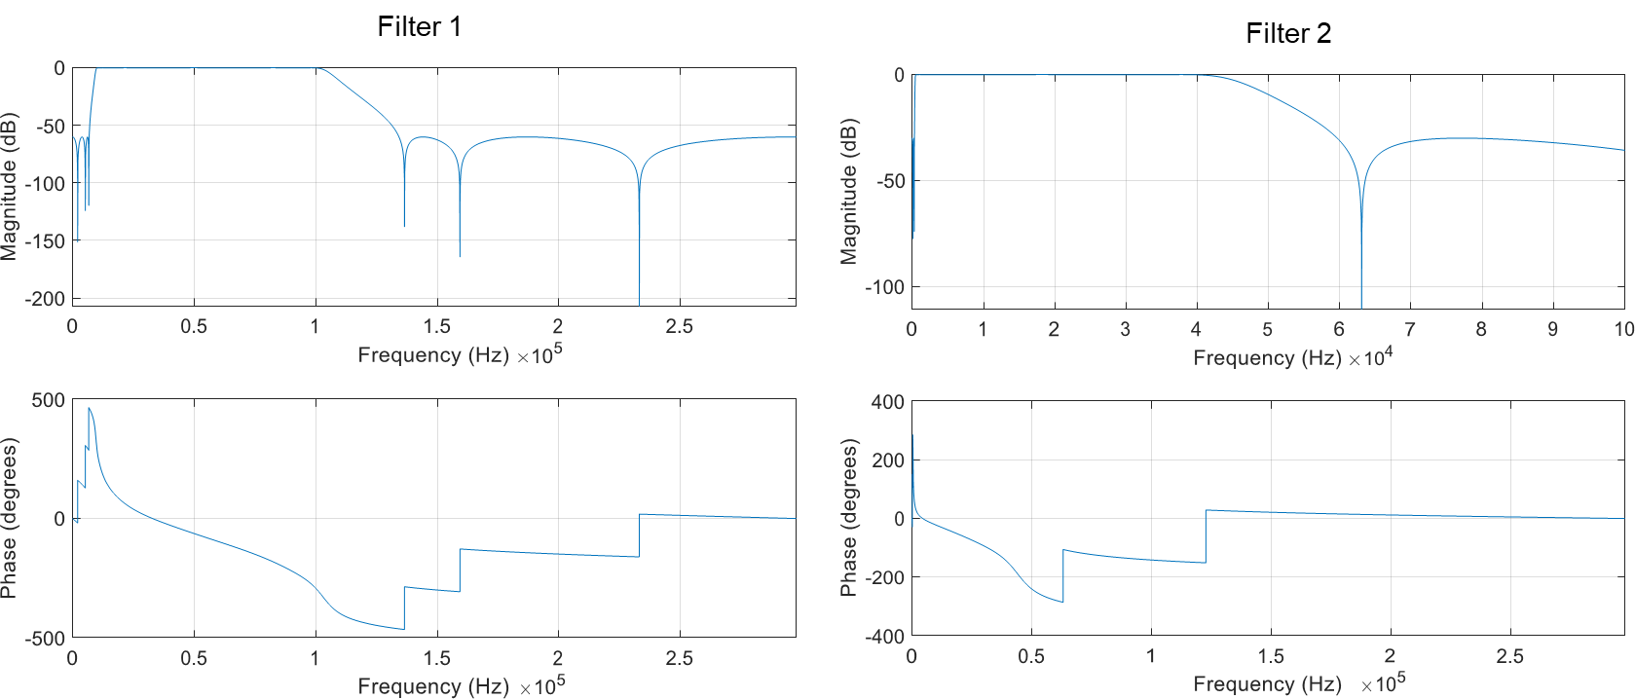

Figure S4. Magnitude and phase curves of the elliptic filters used on the Brüel & Kjaer (B&K 4391) microphone recordings. Filter 1 was used in the main experiment. Filter 2 was used to ensure that there were no frequencies below the ultrasonic range.

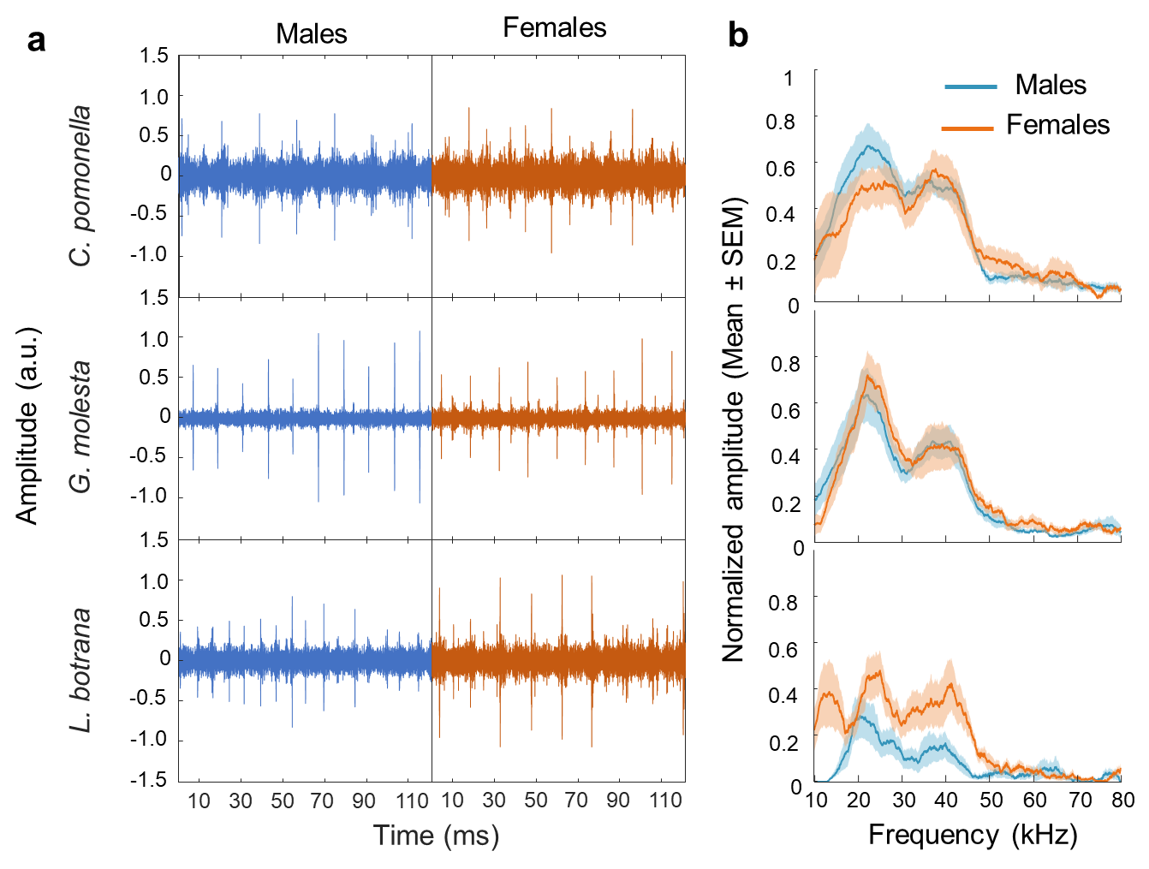

Figure S5. Recording of wingbeat acoustic emissions of male and female tortricid moths with a Dodotronic 250K microphone. a. Representative traces of high-pass filtered signals showing the ultrasound pulses. b. Averaged and normalized spectra of the ultrasound pulses. Solid lines represent means and shaded area represents ± SEM. N≥10

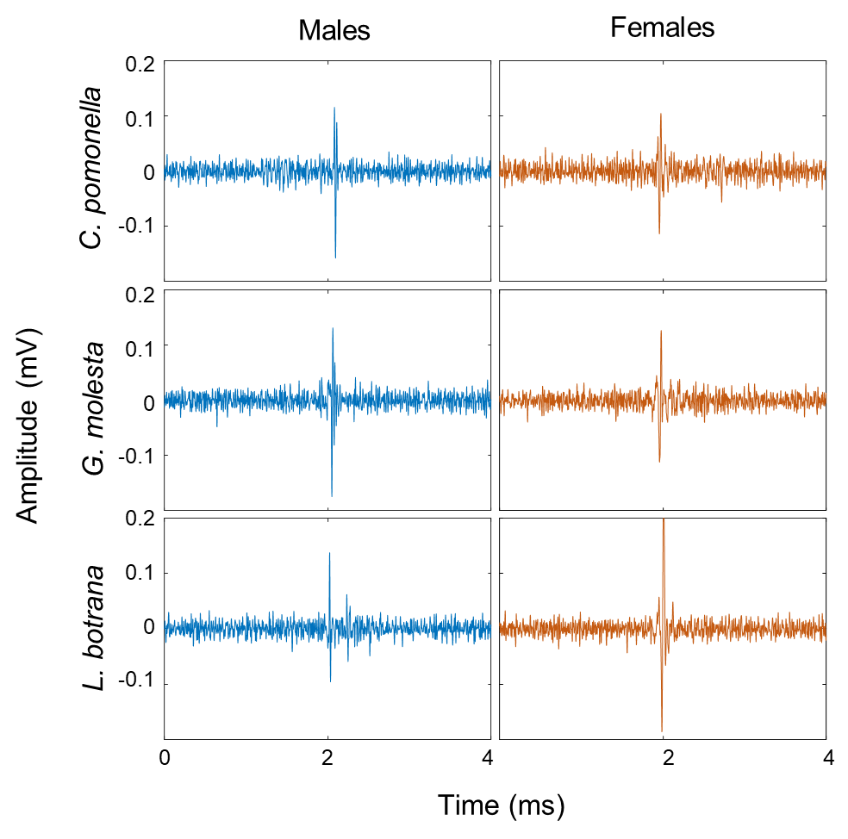

Figure S6. Representative traces of isolated ultrasound pulses from high-pass filtered acoustic emissions recorded with the Brüel & Kjaer microphone.

Table S1. Number of individuals that produced 1 ultrasound pulse, 2 ultrasound pulses or no ultrasound pulses during wingbeat. In the case of the recording with the Dodotronic microphone to synchronize wing position and ultrasound pulse (a), we did not keep track of the individuals that did not produce ultrasound pulses. In the case of the recordings in the anechoic chamber with the Brüel & Kjaer microphone to characterize the acoustic emissions (b), we did record the number of individuals in which we could no record ultrasound pulses. Percentages in the same line are over the total of the data cells above them.

a Dodotronics
Species | Sex | No pulse | 1 pulse | 2 pulses
C. pomonella | Male | NA | 6 | 4
C. pomonella | Female | NA | 5 | 5
G. molesta | Male | NA | 5 | 5
G. molesta | Female | NA | 3 | 7
L. botrana | Male | NA | 5 | 5
L. botrana | Female | NA | 5 | 5
 |  |  | 48% | 52%
b Brüel & Kjaer
Species | Sex | No pulse | 1 pulse | 2 pulses
C. pomonella | Male | 4 | 6 | 3
C. pomonella | Female | 4 | 5 | 3
G. molesta | Male | 4 | 7 | 3
G. molesta | Female | 2 | 7 | 3
L. botrana | Male | 4 | 6 | 2
L. botrana | Female | 4 | 5 | 2
 |  | 28% | 50% | 22%
 |  |  | 69% | 31%

Table S2. Statistical model comparison table for the analysis of ultrasound pulses emitted during wingbeat by three tortricid species (C. pomonella, G. molesta and L. botrana). Order model: 0 = no terms, 1 = species + sex, 2 = species + sex + species*sex.

Intensity (dB SPL at 10 cm)
Model order | Resid. Df | Resid. Dev | Df | Deviance | F | Pr(>F) | AIC
0 | 51 | 800.71 |  |  |  |  | 293.75
1 | 48 | 710.76 | 3 | 89.947 | 1.9895 | 0.1287 | 293.55
2 | 46 | 693.23 | 2 | 17.539 | 0.5819 | 0.5629 | 296.26
Peak frequency (kHz)
Order Model | Resid. Df | Resid. Dev | Df | Deviance | F | Pr(>F) | AIC
0 | 51 | 1372.7 |  |  |  |  | 321.78
1 | 48 | 1086.9 | 3 | 285.795 | 4.0923 | 0.0117 | 315.64
2 | 46 | 1070.8 | 2 | 16.049 | 0.3447 | 0.7102 | 318.87
Pulse duration (ms)
Order Model | Resid. Df | Resid. Dev | Df | Deviance | F | Pr(>F) | AIC
0 | 51 | 6.7067 |  |  |  |  | 45.07
1 | 48 | 6.1591 | 3 | 0.54765 | 1.3754 | 0.2621 | 46.64
2 | 46 | 6.1053 | 2 | 0.05379 | 0.2027 | 0.8173 | 50.18
Interpulse frequency (Hz)
Order Model | Resid. Df | Resid. Dev | Df | Deviance | F | Pr(>F) | AIC
0 | 51 | 4884.5 |  |  |  |  | 387.78
1 | 48 | 1102.6 | 3 | 3781.9 | 52.9408 | <0.001 | 316.39
2 | 46 | 1095.4 | 2 | 7.2 | 0.1516 | 0.8597 | 320.04

Table S3. ANOVA tables of the selected models and pairwise comparison tests of the significant model terms for the analysis of the ultrasound pulses emitted by the wingbeat of three tortricid species.
Intensity (dB at 10 cm). ANOVA table
Variables | Df | Deviance | Resid. Df | Resid. Dev | F | Pr(>F)
NULL |  |  | 51 | 800.71
Species | 2 | 6.628 | 49 | 794.08 | 0.22 | 0.8083
Sex | 1 | 83.319 | 48 | 710.76 | 5.63 | 0.02174
Pairwise: Sex
Sex | emmean | SE | df | Lower CL | Upper CL | Group
Female | 17.3 | 0.742 | 48 | 15.6 | 19 | a
Male | 19.9 | 0.774 | 48 | 18.1 | 21.6 | b
Peak frequency (kHz). ANOVA table
Variables | Df | Deviance | Resid. Df | Resid. Dev | F | Pr(>F)
NULL |  |  | 51 | 1372.7
Species | 2 | 156.42 | 49 | 1216.2 | 3.45 | 0.03967
Sex | 1 | 129.37 | 48 | 1086.9 | 5.71 | 0.02081
Pairwise: Species
Species | emmean | SE | df | Lower CL | Upper CL | Group
G. molesta | 33.4 | 1.06 | 48 | 30.8 | 36 | a
C. pomonella | 35.3 | 1.15 | 48 | 32.5 | 38.2 | ab
L. botrana | 37.6 | 1.23 | 48 | 34.5 | 40.6 | b
Pairwise: Sex
Sex | emmean | SE | df | Lower CL | Upper CL | Group
Female | 33.8 | 0.957 | 48 | 31.6 | 36.1 | a
Male | 37 | 0.918 | 48 | 34.9 | 39.1 | b
Interpulse frequency (Hz) ANOVA table
Variables | Df | Deviance | Resid. Df | Resid. Dev | F | Pr(>F)
NULL |  |  | 51 | 4884.5
Species | 2 | 3659.8 | 49 | 1224.7 | 79.66 | <0.001
Sex | 1 | 122.1 | 48 | 1102.6 | 5.32 | 0.02549
Pairwise: Species
Species | emmean | SE | df | Lower CL | Upper CL | Group
C. pomonella | 53.4 | 1.16 | 48 | 50.6 | 56.3 | a
L. botrana | 63 | 1.24 | 48 | 60 | 66.1 | b
G. molesta | 73.5 | 1.07 | 48 | 70.8 | 76.1 | c
Pairwise: Sex
Sex | emmean | SE | df | Lower CL | Upper CL | Group
Female | 61.8 | 0.964 | 48 | 59.6 | 64 | a
Male | 64.8 | 0.924 | 48 | 62.7 | 67 | b

Table S4. Statistical model comparison table for the analysis of low frequency components of the acoustic signal emitted during wingbeat by three tortricid species (C. pomonella, G. molesta and L. botrana). Order model: 0 = no terms, 1 = species + sex, 2 = species + sex + species*sex.
Intensity (dB SPL at 10 cm)
Model order | Resid. Df | Resid. Dev | Df | Deviance | F | Pr(>F) | AIC
0 | 59 | 783.44 |  |  |  |  | 328.43
1 | 56 | 432.01 | 3 | 351.43 | 14.7211 | <0.001 | 298.72
2 | 54 | 429.71 | 2 | 2.3 | 0.1445 | 0.8658 | 302.4
Peak frequency (Hz)
Model order | Resid. Df | Resid. Dev | Df | Deviance | F | Pr(>F) | AIC
0 | 59 | 5599.7 |  |  |  |  | 446.44
1 | 56 | 1022.9 | 3 | 4576.8 | 85.3881 | <0.001 | 350.44
2 | 54 | 964.8 | 2 | 58.1 | 1.6269 | 0.206 | 350.93

Table S5. ANOVA tables of the selected models and pairwise comparison tests of the significant model terms for the analyses of the low frequency acoustic components of the wingbeat of three tortricid species.
Intensity (dB at 10 cm). ANOVA table
Variables | Df | Deviance | Resid. Df | Resid. Dev | F | Pr(>F)
NULL |  |  | 59 | 783.44
Species | 2 | 301.171 | 57 | 482.27 | 19.52 | <0.001
Sex | 1 | 50.262 | 56 | 432.01 | 6.52 | 0.01345
Pairwise: Species
Species | emmean | SE | df | Lower CL | Upper CL | Group
L. botrana | 52.1 | 0.621 | 56 | 50.6 | 53.6 | a
G. molesta | 52.1 | 0.621 | 56 | 50.6 | 53.7 | a
C. pomonella | 56.9 | 0.621 | 56 | 51.3 | 58.4 | b
Pairwise: Sex
Sex | emmean | SE | df | Lower CL | Upper CL | Group
Female | 54.6 | 0.507 | 56 | 53.4 | 55.8 | b
Male | 52.8 | 0.507 | 56 | 51.6 | 53.9 | a
Peak frequency (Hz). ANOVA table
Variables | Df | Deviance | Resid. Df | Resid. Dev | F | Pr(>F)
NULL |  |  | 59 | 5599.7
Species | 2 | 4352.5 | 57 | 1247.2 | 119.00 | <0.001
Sex | 1 | 224.3 | 56 | 1022.9 | 12.28 | <0.001
Pairwise: Species
Species | emmean | SE | df | Lower CL | Upper CL | Group
C. pomonella | 53 | 0.956 | 56 | 50.8 | 55.6 | a
L. botrana | 65 | 9.56E-01 | 56 | 62.6 | 67.4 | b
G, molesta | 74 | 0.956 | 56 | 71.6 | 76.4 | c
Pairwise: Sex
Sex | emmean | SE | df | Lower CL | Upper CL | Group
Female | 62 | 0.78 | 56 | 60.3 | 63.9 | a
Male | 66 | 7.80E-01 | 56 | 64.2 | 67.8 | b

Sound intensity calculation of signals captured with the Brüel & Kjaer microphone.
To calculate the pulse amplitude in pressure units using the B&K microphone, the peak amplitude of the pulse (Aₚ) in volts was first extracted from the waveform. Assuming a sinusoidal shape, this value was converted to its root mean square (RMS) equivalent by multiplying by √2/2, enabling its transformation into sound pressure level (SPL) units. For simplicity, it was assumed that all ultrasonic frequency components contributing to the signal share the same voltage-to-pressure conversion factor as the peak frequency. This factor was obtained from the microphone's calibration chart. The amplitude in pascals was then referenced to a standard pressure of 20 µPa and expressed in decibels using base-10 logarithms. The pulse amplitude in dB SPL can therefore be calculated using Equation 2:
$I \left(dB SPL\right)=20\log{\frac{\sqrt{2}A_{p}}{2s_{d}(f)P_{0}}} (2)$
where Aₚ is the peak pulse amplitude (in volts), $s_{d}(f)$ is the microphone sensitivity at a given frequency (in V/Pa), and P₀ is the reference pressure of 20 µPa. The value of $s_{d}(f)$ is provided by the manufacturer and shown in Figure S2.

Distance attenuation calculation
To calculate distance-related attenuation, we used Equation 3, which accounts for amplitude loss due to both geometric spreading (spherical divergence) and medium absorption. The equation is based on a point-source approximation for spherical waves and includes an absorption term characterized by the frequency-dependent absorption coefficient:
$$P_{dB}\left(d_{2}\right)=P_{dB}\left(d_{1}\right)-20\log\left(\frac{d_{2}}{d_{1}}\right)-8.68·α\left(f\right)\left(d_{2}-d_{1}\right) (3)$$
Where $P_{dB}\left(d_{i}\right)$ is the sound pressure level at a distance $d_{i}$, and $α\left(f\right)$ is the absorption coefficient, which depends on the frequency $f$ of the sound wave. In air, this coefficient is given by $α\left(f\right)=1.37·{10}^{(-11)}f^{2}$ with $f$ in hertz. For simplification, we assumed that the absorption coefficient depends only on the peak frequency component of the signal. This equation is valid under the condition $d_{2}>d_{1}.$

Data
Acoustic recordings of tethered individuals using a Brüel & Kjaer microphone inside an anechoic chamber. sp: species; sex: male or female; ind: individual; low.db: dB of the low frequency signal at 0.5-cm distance; low.freq: dominant frequency of the low frequency signal (Hz); high.db: dB of the ultrasound pulse at 0.5-cm distance; high.freq: dominant frequency of the ultrasound pulses (kHz); high.dur: duration of the high frequency pulses (ms); high.ip: interpulse frequency or number of pulses/second (Hz), considering only one pulse per wingbeat
sp | sex | ind | low.db | low.freq | high.db | high.freq | high.dur | high.ip
lob | female | 1 | 85.22 | 68 | NA | NA | NA | NA
lob | female | 2 | 75.49 | 62 | NA | NA | NA | NA
lob | female | 3 | 77.29 | 60 | 53.55 | 29 | 1 | 62.50
lob | female | 4 | 77.91 | 62 | 42.60 | 40 | 0.7 | 62.50
lob | female | 5 | 74.11 | 56 | NA | NA | NA | NA
lob | female | 6 | 79.82 | 64 | 50.56 | 40 | 0.8 | 47.62
lob | female | 7 | 81.25 | 62 | 40.11 | 40 | 0.6 | 71.43
lob | female | 8 | 82.18 | 56 | 48.88 | 33 | 1.5 | 55.56
lob | female | 9 | 76.61 | 64 | 42.60 | 41 | 0.9 | 62.50
lob | female | 10 | 80.87 | 64 | 51.38 | 35 | 1 | 66.67
lob | male | 1 | 76.36 | 72 | 43.42 | 35 | 0.6 | 58.82
lob | male | 2 | 79.91 | 70 | 44.54 | 38 | 0.8 | 70.92
lob | male | 3 | 73.94 | 70 | NA | NA | NA | NA
lob | male | 4 | 77.97 | 64 | NA | NA | NA | NA
lob | male | 5 | 74.45 | 64 | 51.38 | 36 | 1 | 58.82
lob | male | 6 | 78.19 | 70 | 40.11 | 40 | 0.9 | 66.67
lob | male | 9 | 77.17 | 66 | 40.11 | 40 | 1.1 | 62.50
lob | male | 10 | 79.46 | 76 | 41.12 | 44 | 0.8 | 71.43
lob | male | 11 | 79.73 | 64 | 41.51 | 32 | 1.1 | 62.50
lob | male | 13 | 75.13 | 66 | 40.11 | 42 | 0.9 | 66.67
ofm | female | 1 | 74.41 | 64 | 45.60 | 30 | 0.8 | 66.67
ofm | female | 2 | 77.30 | 66 | 42.26 | 35 | 1.2 | 66.67
ofm | female | 3 | 80.80 | 72 | 38.52 | 38 | 1.1 | 71.43
ofm | female | 4 | 78.39 | 78 | 45.60 | 30 | 1.7 | 76.92
ofm | female | 5 | 84.35 | 74 | 42.26 | 36 | 0.9 | 71.43
ofm | female | 6 | 82.44 | 76 | 48.88 | 35 | 0.9 | 76.92
ofm | female | 7 | 80.82 | 74 | 53.25 | 22 | 0.7 | 74.07
ofm | female | 9 | 80.90 | 76 | 48.36 | 28 | 0.7 | 76.92
ofm | female | 10 | 76.58 | 70 | 40.92 | 35 | 1 | 71.43
ofm | female | 12 | 77.63 | 72 | 45.60 | 28 | 1.8 | 71.43
ofm | male | 1 | 77.58 | 76 | 40.32 | 35 | 2 | 77.42
ofm | male | 3 | 74.33 | 70 | 45.36 | 36 | 1.5 | 71.43
ofm | male | 4 | 76.43 | 74 | 40.11 | 40 | 1.8 | 76.92
ofm | male | 5 | 75.55 | 78 | 45.60 | 32 | 1 | 71.43
ofm | male | 7 | 75.53 | 72 | 49.12 | 28 | 1 | 76.92
ofm | male | 8 | 76.92 | 68 | 45.36 | 35 | 0.8 | 71.43
ofm | male | 9 | 78.60 | 80 | 42.26 | 35 | 1.1 | 76.92
ofm | male | 10 | 76.15 | 74 | 40.92 | 33 | 1.2 | 83.33
ofm | male | 12 | 79.51 | 78 | 40.11 | 40 | 0.7 | 62.50
ofm | male | 13 | 80.10 | 88 | 40.92 | 37 | 0.9 | 76.92
pomo | female | 1 | 85.95 | 52 | 50.48 | 20 | 1.4 | 50.00
pomo | female | 2 | 86.86 | 54 | 42.26 | 35 | 1.2 | 45.45
pomo | female | 3 | 77.69 | 50 | 43.42 | 36 | 1 | 50.00
pomo | female | 4 | 84.04 | 52 | 48.88 | 37 | 0.8 | 52.63
pomo | female | 5 | 86.68 | 56 | 42.60 | 38 | 0.8 | 55.56
pomo | female | 6 | 82.95 | 56 | 45.36 | 36 | 0.7 | 55.56
pomo | female | 7 | 82.24 | 46 | 40.11 | 42 | 2 | 47.62
pomo | female | 8 | 83.98 | 56 | 51.51 | 21 | 1.1 | 55.56
pomo | female | 9 | 85.57 | 52 | NA | NA | NA | NA
pomo | female | 10 | 79.87 | 50 | NA | NA | NA | NA
pomo | male | 1 | 82.21 | 58 | 45.37 | 40 | 1.2 | 58.82
pomo | male | 2 | 83.22 | 50 | 45.37 | 38 | 0.7 | 52.63
pomo | male | 3 | 78.50 | 54 | NA | NA | NA | NA
pomo | male | 4 | 83.84 | 50 | 42.26 | 35 | 2 | 52.63
pomo | male | 7 | 84.25 | 58 | 48.06 | 38 | 1 | 55.56
pomo | male | 9 | 80.67 | 58 | 42.60 | 41 | 0.8 | 55.56
pomo | male | 10 | 87.79 | 56 | 40.11 | 38 | 1.1 | 52.63
pomo | male | 11 | 80.71 | 48 | 43.42 | 34 | 1.2 | 55.56
pomo | male | 13 | 84.31 | 56 | 45.36 | 35 | 1.2 | 58.82
pomo | male | 14 | 76.95 | 52 | 44.54 | 38 | 1 | 55.56

R code
#libraries
library(emmeans) #mean separation tests
library(multcomp) #significance letters
library(plyr) #ddply()
library(dplyr) # mutate

#load data
#1) type text below, 2) copy data to clipboard, 3) hit enter
tort.db = read.table(file = "clipboard", sep = "\t",na.strings="NA", header=TRUE)

#dB at 10 cm distance
#dB are at 0.5 cm distance from the insect. Create columns for dB at 10 cm from insect
tort.db$high.db.10cm=tort.db$high.db-(20*log10(0.1/0.005))-(8.68*1.37*10^(-11)*(tort.db$high.freq*1000)^2*(0.1-0.005))
tort.db$low.db.10cm=tort.db$low.db-(20*log10(0.1/0.005))-(8.68*1.37*10^(-11)*(tort.db$low.freq*1000)^2*(0.1-0.005))

#Summary: sample size, means and SEM
#High frequency summary
summary.hf=ddply(tort.db, c("sp", "sex"), summarise,
n.hi=sum(!is.na(high.db)),
mean.freq = sum(high.freq, na.rm=T)/n.hi,
SEM.freq =sd(high.freq, na.rm=T)/sqrt(n.hi-1),
mean.db.10cm = sum(high.db.10cm, na.rm=T)/n.hi,
SEM.db.10cm =sd(high.db.10cm, na.rm=T)/sqrt(n.hi-1),
mean.dur = sum(high.dur, na.rm=T)/n.hi,
SEM.dur =sd(high.dur, na.rm=T)/sqrt(n.hi-1),
mean.ip = sum(high.ip, na.rm=T)/n.hi,
SEM.ip =sd(high.ip, na.rm=T)/sqrt(n.hi-1)
)
#reduce the number of digits
summary.hf=
summary.hf %>%
mutate(across(where(is.numeric),~round(.,digits=3)))
summary.hf

 | sp | sex | n.hi | mean.freq | SEM.freq | mean.db.10cm | SEM.db.10cm | mean.dur | SEM.dur | mean.ip | SEM.ip
1 | lob | female | 7 | 36.857 | 1.877 | 21.061 | 2.138 | 0.929 | 0.12 | 61.254 | 3.144
2 | lob | male | 8 | 38.375 | 1.484 | 16.75 | 1.452 | 0.9 | 0.064 | 64.791 | 1.865
3 | ofm | female | 10 | 31.7 | 1.641 | 19.093 | 1.445 | 1.08 | 0.129 | 72.389 | 1.284
4 | ofm | male | 10 | 35.1 | 1.201 | 16.973 | 1.046 | 1.2 | 0.144 | 74.522 | 1.867
5 | pomo | female | 8 | 33.125 | 3.054 | 19.544 | 1.596 | 1.125 | 0.16 | 51.548 | 1.477
6 | pomo | male | 9 | 37.444 | 0.831 | 18.085 | 0.817 | 1.133 | 0.131 | 55.308 | 0.852

#low frequency summary
summary.low=ddply(tort.db, c("sp", "sex"), summarise,
n.low=sum(!is.na(low.db)),
mean.freq = sum(low.freq, na.rm=T)/n.low,
SEM.freq =sd(low.freq, na.rm=T)/sqrt(n.low-1),
mean.db.10cm = sum(low.db.10cm, na.rm=T)/n.low,
SEM.db.10cm =sd(low.db.10cm, na.rm=T)/sqrt(n.low-1),
)
#reduce the number of digits
summary.low=
summary.low %>%
mutate(across(where(is.numeric),~round(.,digits=3)))
summary.low

 | sp | sex | n.low | mean.freq | SEM.freq | mean.db.10cm | SEM.db.10cm
1 | lob | female | 10 | 61.8 | 1.235 | 53.011 | 1.132
2 | lob | male | 10 | 68.2 | 1.35 | 51.158 | 0.733
3 | ofm | female | 10 | 72.2 | 1.489 | 53.282 | 1.001
4 | ofm | male | 10 | 75.8 | 1.897 | 50.984 | 0.618
5 | pomo | female | 10 | 52.4 | 1.08 | 57.531 | 0.999
6 | pomo | male | 10 | 54 | 1.257 | 56.191 | 1.05

#GML Modeling
#ULTRASOUND PULSES (HIGH FREQUENCY)
#Intensity
db0 =glm(high.db.10cm~1, data=tort.db)
db1 =glm(high.db.10cm~sp+sex, data=tort.db)
db2 =glm(high.db.10cm~(sp+sex)^2, data=tort.db)
anova(db0, db1, db2, test='F')

 | Resid. Df | Resid. Dev | Df | Deviance | F | Pr(>F)
1 | 51 | 800.71
2 | 48 | 710.76 | 3 | 89.947 | 1.9895 | 0.1287
3 | 46 | 693.23 | 2 | 17.539 | 0.5819 | 0.5629

AIC(db0,db1,db2)
 | df | AIC
db0 | 2 | 293.7510
db1 | 5 | 293.5547
db2 | 7 | 296.2554

#db1 is not different from db0, and db2 is not different from db1. db1 has slightly smaller AIC than db0: choose db1

#Selected model
anova(db1, test='F')

 | Df | Deviance | Resid. Df | Resid. Dev | F | Pr(>F)
NULL |  |  | 51 | 800.71
sp | 2 | 6.628 | 49 | 794.08 | 0.2238 | 0.80830
sex | 1 | 83.319 | 48 | 710.76 | 5.6268 | 0.02174 | *

#Effect of sex
emdb1=emmeans(db1, ~sex) #means and errors
emdb2=emmip(db1, ~sex, CIs=TRUE) #means and errors, plot
cld(object=emdb1,adjust="Tukey",Letters=letters, alpha=0.05)

sex | emmean | SE | df | lower.CL | upper.CL | .group
male | 17.3 | 0.742 | 48 | 15.6 | 19.0 | a
female | 19.9 | 0.774 | 48 | 18.1 | 21.6 | b

#Peak frequency
ff0 =glm(high.freq~1, data= tort.db)
ff1 =glm(high.freq~sp+sex, data= tort.db)
ff2 =glm(high.freq~(sp+sex)^2, data= tort.db)

anova(ff0,ff1, ff2, test='F')
 | Resid. Df | Resid. Dev | Df | Deviance | F | Pr(>F)
1 | 51 | 1372.7
2 | 48 | 1086.9 | 3 | 285.795 | 4.0923 | 0.0117 | *
3 | 46 | 1070.8 | 2 | 16.049 | 0.3447 | 0.7102

AIC(ff0,ff1,ff2)
 | df | AIC
ff0 | 2 | 321.7797
ff1 | 5 | 315.6403
ff2 | 7 | 318.8667

#ff1 is different from ff0 and ff2 is not different from ff1. ff1 has smaller AIC than ff0. We choose ff1

#Selected model
anova(ff1, test='F')

 | Df | Deviance | Resid. Df | Resid. Dev | F | Pr(>F)
NULL |  |  | 51 | 1372.7
sp | 2 | 156.42 | 49 | 1216.2 | 3.454 | 0.03967 | *
sex | 1 | 129.37 | 48 | 1086.9 | 5.7135 | 0.02081 | *

#Effect of sex
emff1=emmeans(ff1, ~sex)
emff2=emmip(ff1, ~sex, CIs=TRUE)
cld(object=emff1,adjust="Tukey",Letters=letters, alpha=0.05)
sex | emmean | SE | df | lower.CL | upper.CL | .group
female | 33.8 | 0.957 | 48 | 31.6 | 36.1 | a
male | 37 | 0.918 | 48 | 34.9 | 39.1 | b

#Effect of species
emff3=emmeans(ff1, ~sp)
emff4=emmip(ff1,~sp, CIs=TRUE)
cld(object = emff3,adjust= "Tukey",Letters = letters,alpha = 0.05)
sp | emmean | SE | df | lower.CL | upper.CL | .group
ofm | 33.4 | 1.06 | 48 | 30.8 | 36 | a
pomo | 35.3 | 1.15 | 48 | 32.5 | 38.2 | ab
lob | 37.6 | 1.23 | 48 | 34.5 | 40.6 | b

#Pulse duration
pd0 =glm(high.dur~1, data=tort.db)
pd1 =glm(high.dur~sp+sex, data= tort.db)
pd2 =glm(high.dur~(sp+sex)^2, data= tort.db)

anova(pd0,pd1, pd2, test='F')
 | Resid. Df | Resid. Dev | Df | Deviance | F | Pr(>F)
1 | 51 | 6.7067
2 | 48 | 6.1591 | 3 | 0.54765 | 1.3754 | 0.2621
3 | 46 | 6.1053 | 2 | 0.05379 | 0.2027 | 0.8173

AIC(pd0,pd1, pd2)
 | df | AIC
pd0 | 2 | 45.06674
pd1 | 5 | 46.63716
pd2 | 7 | 50.18099

#No model is significant, there is no effect of sex or species

#Interpulse frequency (Hz)
ip0 =glm(high.ip~1, data= tort.db)
ip1 =glm(high.ip~sp+sex, data= tort.db)
ip2 =glm(high.ip~(sp+sex)^2, data= tort.db)
anova(ip0,ip1, ip2, test='F')

 | Resid. Df | Resid. Dev | Df | Deviance | F | Pr(>F)
1 | 51 | 4884.5
2 | 48 | 1102.6 | 3 | 3781.9 | 52.9408 | 5.88E-15 | ***
3 | 46 | 1095.4 | 2 | 7.2 | 0.1516 | 0.8597
AIC(ip0,ip1, ip2)
 | df | AIC
ip0 | 2 | 387.7834
ip1 | 5 | 316.3861
ip2 | 7 | 320.0444

#ip1 is significantly different than ip0, ip2 is not significantly different than ip1, and the AIC of ip1 es lower than the AIC of ip0, so we choose ip1

#Selected model
anova(ip1, test='F')
 | Resid. Df | Resid. Dev | Df | Deviance | F | Pr(>F)
NULL |  |  | 51 | 4884.5
sp | 2 | 3659.8 | 49 | 1224.7 | 79.6629 | 5.63E-16 | ***
sex | 1 | 122.1 | 48 | 1102.6 | 5.3163 | 0.02549 | *
#Species and sex are significant
emip1=emmeans(ip1, ~sex)
emip2=emmip(ip1, ~sex, CIs=TRUE)
cld(object=emip1,adjust="Tukey",Letters=letters,alpha=0.05)
sex | emmean | SE | df | lower.CL | upper.CL | group
female | 61.8 | 0.964 | 48 | 59.6 | 64 | a
male | 64.8 | 0.924 | 48 | 62.7 | 67 | b | ***
emip3=emmeans(ip1, ~sp)
emip4=emmip(ip1,~sp, CIs=TRUE)
cld(object = emip3,adjust= "Tukey",Letters = letters,alpha = 0.05)
sp | emmean | SE | df | lower.CL | upper.CL | group
pomo | 53.4 | 1.16 | 48 | 50.6 | 56.3 | a
ofm | 63 | 1.24 | 48 | 60 | 6.61E+01 | b
lob | 73.5 | 1.07 | 48 | 70.8 | 76.1 | c

#LOW FREQUENCY
#Intensity
dbl0 =glm(low.db.10cm~1, data=tort.db)
dbl1 =glm(low.db.10cm~sp+sex, data=tort.db)
dbl2 =glm(low.db.10cm~(sp+sex)^2, data=tort.db)
anova(dbl0, dbl1, dbl2, test='F')
 | Resid. Df | Resid. Dev | Df | Deviance | F | Pr(>F)
1 | 59 | 783.44
2 | 56 | 432.01 | 3 | 351.43 | 14.7211 | 3.998E-07 | ***
3 | 54 | 429.71 | 2 | 2.30 | 0.1445 | 0.8658
AIC(dbl0, dbl1, dbl2)
 | df | AIC
dbl0 | 2 | 328.434
dbl1 | 5 | 298.719
dbl2 | 7 | 302.398

#Model dbl0 is different from model dbl1, but model dbl1 is not different from model dbl2, and model dbl1 has lower AIC than model dbl0, so we choose model dbl1

#Selected model
anova(dbl1, test='F')
 | Resid. Df | Resid. Dev | Df | Deviance | F | Pr(>F)
NULL |  |  | 59 | 783.44
sp | 2 | 301.171 | 57 | 482.27 | 19.520 | 3.697E-07 | ***
sex | 1 | 50.262 | 56 | 432.01 | 6.515 | 0.01345 | *

#Effect of sex
emdbl1=emmeans(dbl1, ~sex)
emdbl2=emmip(dbl1, ~sex, CIs=TRUE)
cld(object=emdbl1,adjust="Tukey",Letters=letters,alpha=0.05)
sex | emmean | SE | df | lower.CL | upper.CL | .group
male | 52.8 | 0.507 | 56 | 51.6 | 53.9 | a
female | 54.6 | 0.507 | 56 | 53.4 | 55.8 | b

#Effect of species
emdbl3=emmeans(dbl1, ~sp)
emdbl4=emmip(dbl1,~sp, CIs=TRUE)
cld(object = emdbl3,adjust= "Tukey",Letters = letters,alpha = 0.05)
sp | emmean | SE | df | lower.CL | upper.CL | .group
lob | 52.1 | 0.621 | 56 | 50.6 | 53.6 | a
ofm | 52.1 | 0.621 | 56 | 50.6 | 53.7 | a
pomo | 56.9 | 0.621 | 56 | 51.3 | 58.4 | b

#Frequency
ffl0 =glm(low.freq~1, data=tort.db)
ffl1 =glm(low.freq~sp+sex, data=tort.db)
ffl2 =glm(low.freq~(sp+sex)^2, data=tort.db)
anova(ffl0,ffl1,ffl2, test='F')
 | Resid. Df | Res. Dev | Df | Deviance | F | Pr(>F)
1 | 59 | 5599.7
2 | 56 | 1022.9 | 3 | 4576.8 | 85.3881 | <2e-16 | ***
3 | 54 | 964.8 | 2 | 58.1 | 1.6269 | 0.206

AIC(ffl0,ffl1, ffl2)
 | df | AIC
ffl0 | 2 | 446.4404
ffl1 | 5 | 350.4377
ffl2 | 7 | 350.9272

#Model ffl0 is different from model ffl1, but model ffl1 is not different from model ffl2, and model ffl1 has lower AIC than model ffl0, so we choose model fl1

#Selected model
anova(ffl1, test='F')
 | Df | Deviance | Resid. Df | Resid. Dev | F | Pr(>F)
NULL |  |  | 59 | 5599.7
sp | 2 | 4352.5 | 57 | 1247.2 | 1.19E+02 | < 2.2e-16 | ***
sex | 1 | 224.3 | 56 | 1022.9 | 12.277 | 0.0009093 | ***
#Effect of sex
emffl1=emmeans(ffl1, ~sex)
emffl2=emmip(ffl1, ~sex, CIs=TRUE)
cld(object=emffl1,adjust="Tukey",Letters=letters,alpha=0.05)
sex | emmean | SE | df | lower.CL | upper.CL | .group
female | 62 | 0.78 | 56 | 60.3 | 63.9 | a
male | 66 | 7.80E-01 | 56 | 64.2 | 67.8 | b
#Effect of species
emffl3=emmeans(ffl1, ~sp)
emffl4=emmip(ffl1,~sp, CIs=TRUE)
cld(object = emffl3,adjust= "Tukey",Letters = letters,alpha = 0.05)
sp | emmean | SE | df | lower.CL | upper.CL | .group
pomo | 53 | 0.956 | 56 | 50.8 | 55.6 | a
lob | 65 | 9.56E-01 | 56 | 62.6 | 67.4 | b
ofm | 74 | 0.956 | 56 | 71.6 | 76.4 | c

