Drug | Chemical  Estructure |  | PubChem CID | Mechanism of Action | Ref.
Antimalarial:
Artemisinin (AM) | 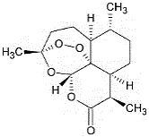 |  | 68827 | Cell cycle arrest  Apoptosis through ROS-dependent and independent mechanisms  Lysosomal disruption | [33]
Chloroquine (CQ) | 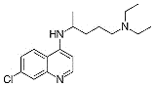 |  | 2719 | Lysosomal disruption | [22,34]
Primaquine (PQ) | 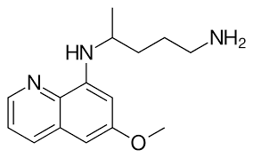 |  | 4908 | ROS-dependent mechanism  NF-kB inhibition | [23]
Mefloquine (MQ) | 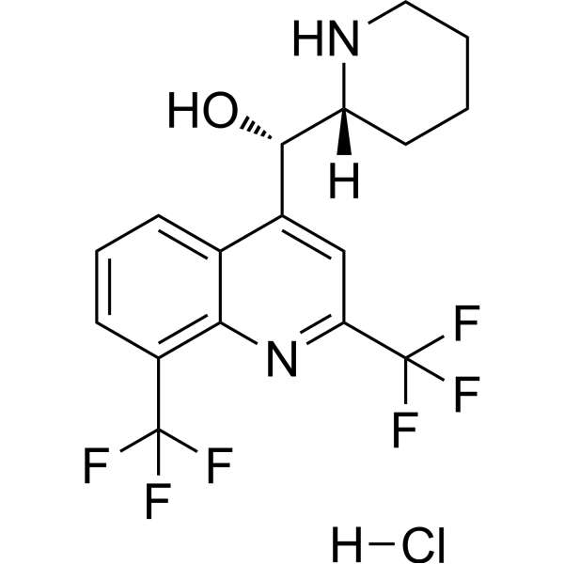 |  | 4046 | Lysosomal disruption | [24]
Anthelmintic:
Ivermectin (IM) | 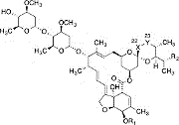 |  | 6321424 | Disruption of the mitochondrial functions  Oxidative stress  Chloride-dependent membrane hyperpolarization  Cell death | [25,26]
Moxidectin (MD) | 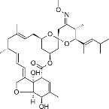 |  | 9832912 | Increase intracellular chloride Mitochondrial outer membrane permeabilization (MOMP)  Autophagy arrest | [19,35]
Antibiotics:
Doxorubicin (DR) | 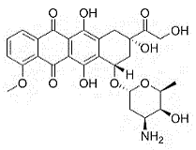 |  | 31703 | Apoptosis through ROS-dependent mechanism  DNA Alkylating agent | [31]
Minocycline (MC) | 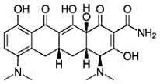 |  | 68858974 | Apoptosis through ROS-dependent mechanism | [32]
Chelator & Prooxidant
TPEN | 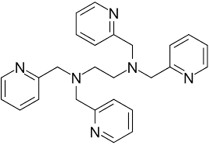 |  | 5519 | Apoptosis through ROS-dependent mechanism | [36]
Metalloid
As₂O₃ | 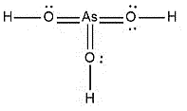 |  | 14888 | Apoptosis through ROS-dependent mechanism

Table 1. Drug name, Chemical structure, PubChem compound identification number, and mechanism of action of selected antimalarial, anthelmintic, and antibiotic drugs effective against leukemia cells.

