Table S1: Toxic and mutagenic equivalency for different PAH congeners
S/N | PAHs | Code | RfD^{k} | TEF^{n} | MEF^{r}
1 | *Acenaphthene | AceN | 0.06 | 0.001 | -
2 | *Acenapthylene | AcY | 0.06 | 0.001 | -
3 | *Anthracene | AntE | 0.30 | 0.010 | -
4 | ^{nc}Fluoranthene | FluT | 0.04 | 0.001 | -
5 | *Fluorene | FluE | 0.04 | 0.001 | -
6 | *Naphthalene | NaP | 0.02 | 0.001 | -
7 | *Phenanthrene | PheN | 0.30 | 0.001 | -
8 | *Pyrene | PyR | 0.03 | 0.001 | -
9 | **Benzo[a]pyrene | BaP | - | 1.000 | 1.000
10 | **Benzo[g,h,i]perylene | BpY | - | 0.010 | 0.190
11 | **Chrysene | ChrY | - | 0.010 | 0.017
12 | **Dibenz[a,h]anthracene | DbA | - | 5.000 | 0.290
13 | **Indeno[1,2,3-cd]pyrene | IcdP | - | 0.100 | 0.310
14 | **Benzo[b]fluoranthene | BfL | - | 0.100 | 0.250
15 | **Benzo[K]fluoranthene | BkL | - | 0.100 | 0.110
16 | **Benzo[a]anthracene | BaA | - | 0.100 | 0.082
17 | **Cyclopenta[c,d]pyrene | CdP | - | 1.000# | 1.000#
18 | **Dibenzo[a,i]pyrene | DbP | - | 1.000# | 1.000#
19 | 1-methylpyrene | MyP | - | 0.001
20 | *Biphenyl | BiP | 0.05 | 0.001
21 | Benzo[e]pyrene | BeP | 9E-05 | 0.01
22 | Naphthalene-d8 | NaP8 | - | 0.001
23 | Benzo(a,h)pyrene | BahP | 0.03 | 0.1
24 | *Biphenylene |  | - | - | -
*Listed non-carcinogenic PAHs; **carcinogenic PAHs; ^{nc}not classifiable; #≥ BaP; RfD: reference oral dose; ^{k}USEPA (2012), ^{n}Nisbet & LaGoy (1992), ^{r}Durant et al. (1996; 1999); TEF: toxic equivalent factor; MEF: mutagenic equivalent factor.
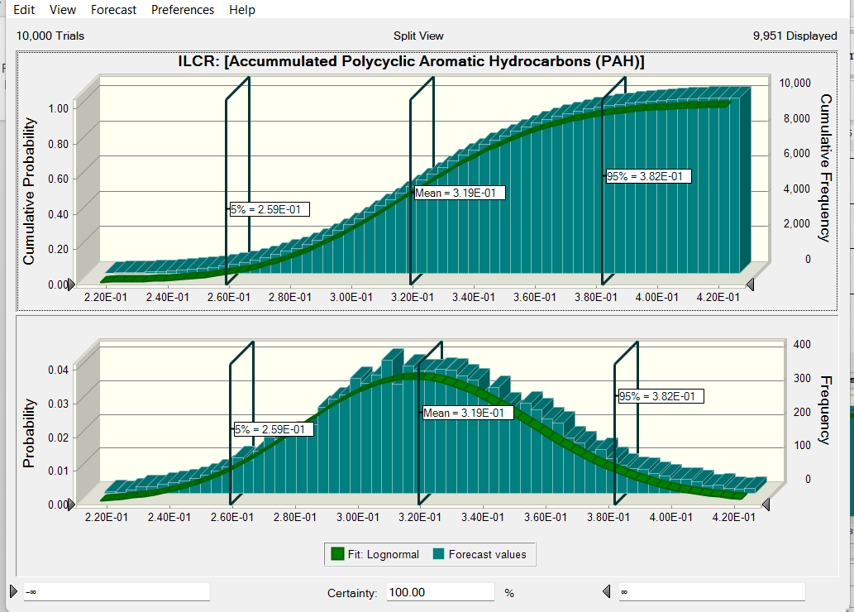
Fig. S1a: Simulated incremental lifetime cancer risk for cumulative PAHs

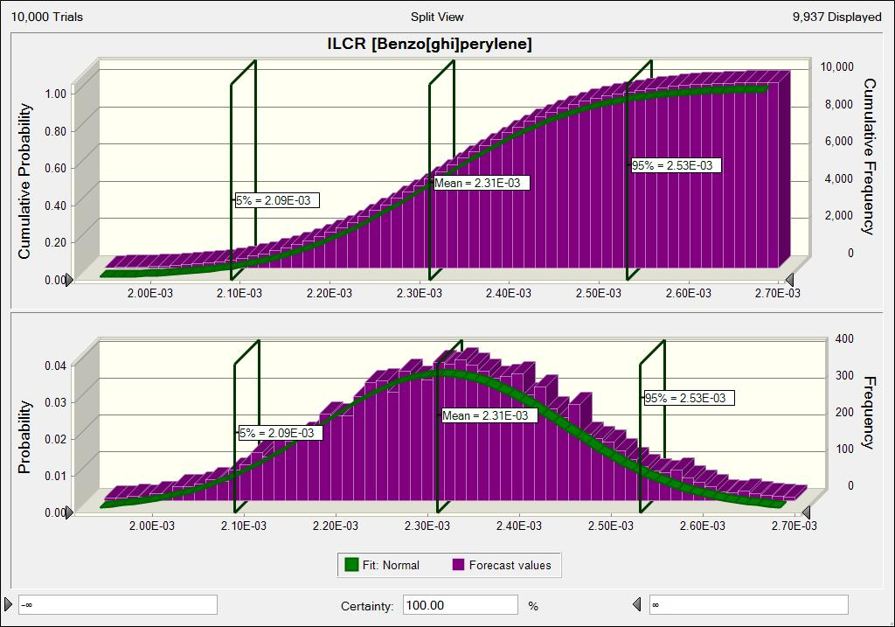
Fig. S1b. Simulated incremental lifetime cancer risk for Benzo[ghi]perylene
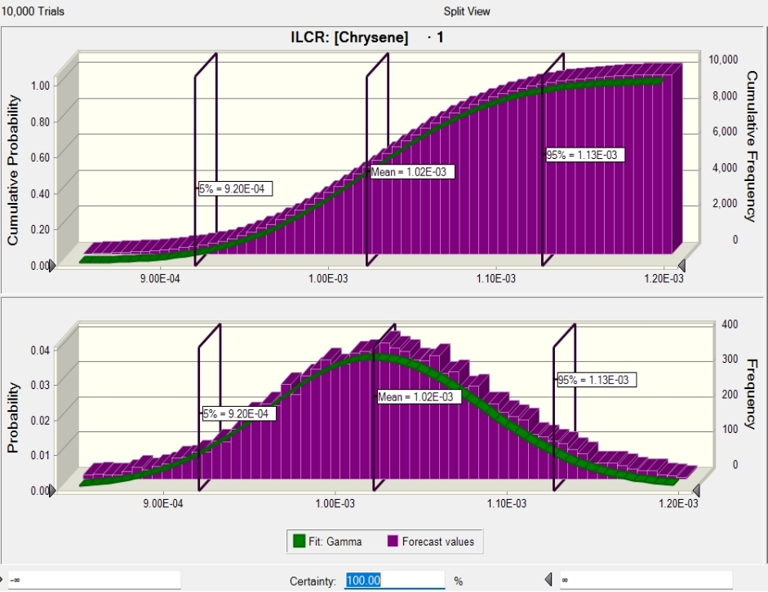
Fig. S1c. Simulated incremental lifetime cancer risk for Chrysene
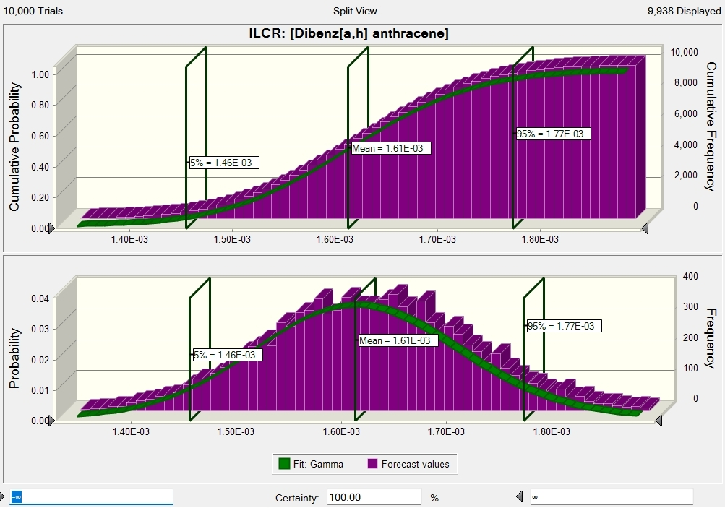
Fig. S1d. Simulated incremental lifetime cancer risk for Dibenz[a,h] anthracene
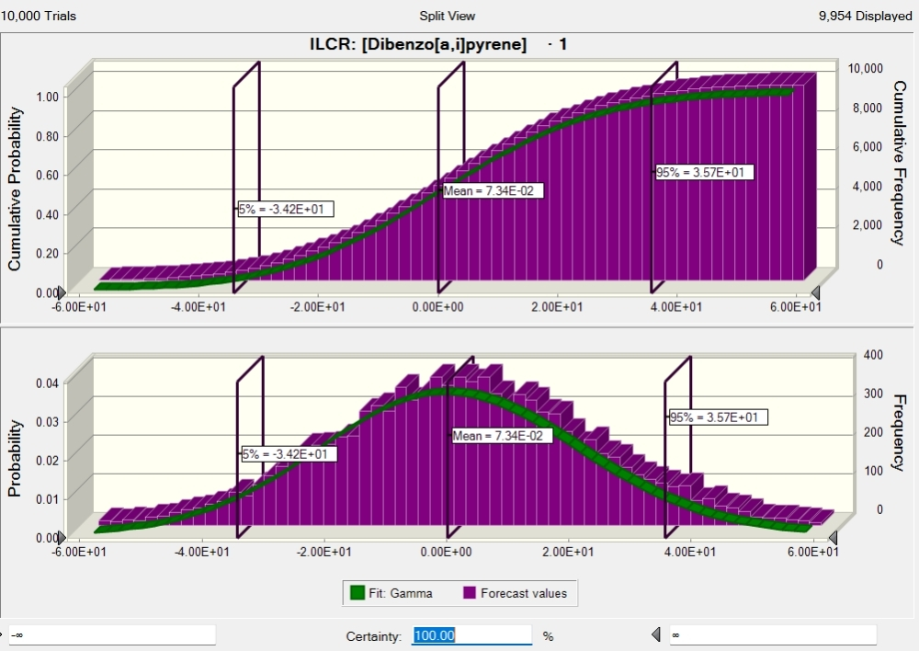
Fig. S1d. Simulated incremental lifetime cancer risk for Dibenzo[a,i]pyrene

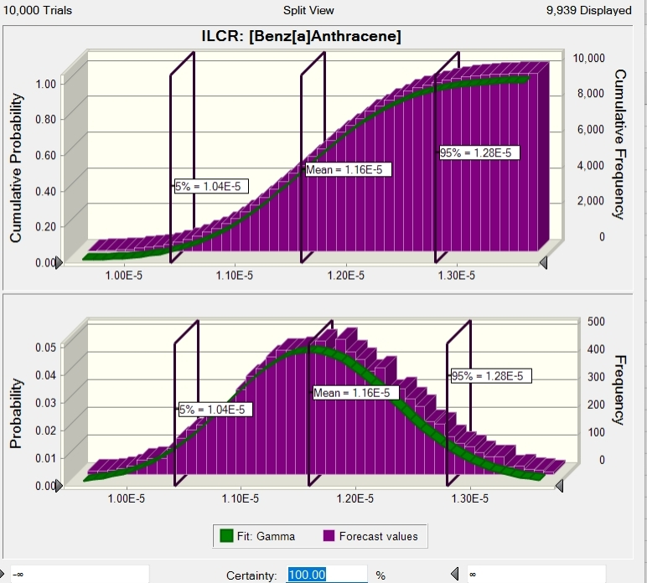
Fig. S1e. Simulated incremental lifetime cancer risk for Benz[a]Anthracene
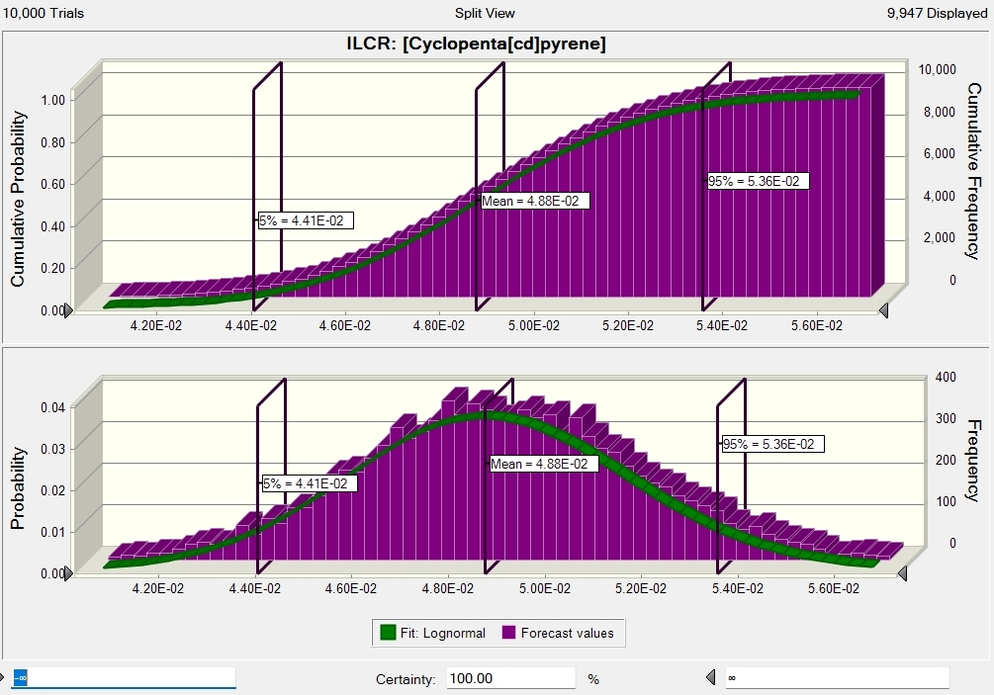Fig. S1f. Simulated incremental lifetime cancer risk for Cyclopenta[cd]pyrene

