SUPPLEMENTARY MATERIALS

S1. Distribution plots for the cases and controls in cognitively normal (CN), mild cognitive impairment (MCI) and total subjects in the Rotterdam Study

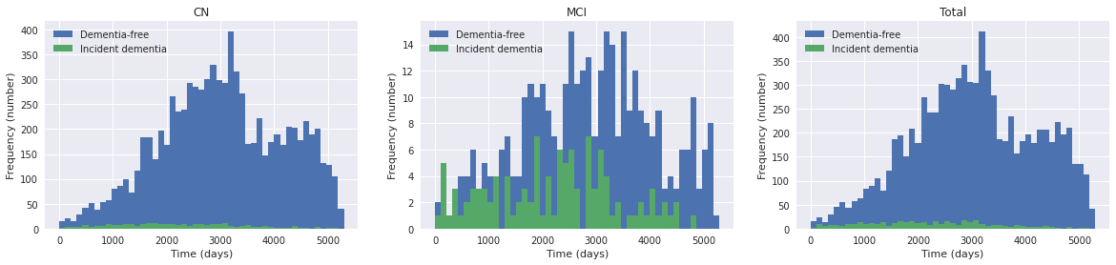
Figure S1.1 Time-to-event of dementia distribution

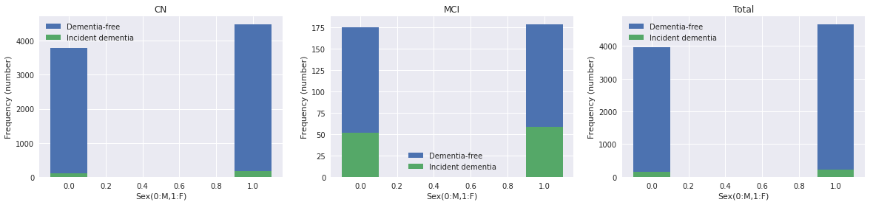
Figure S1.2 Sex distribution

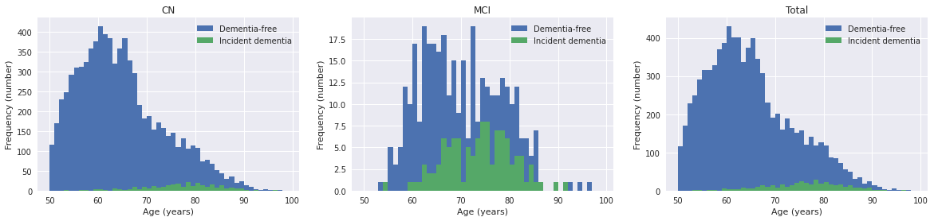
Figure S1.3 Age distribution

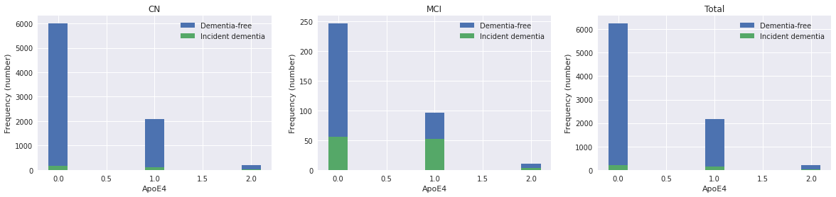
Figure S1.4 APOE-ε4 distribution

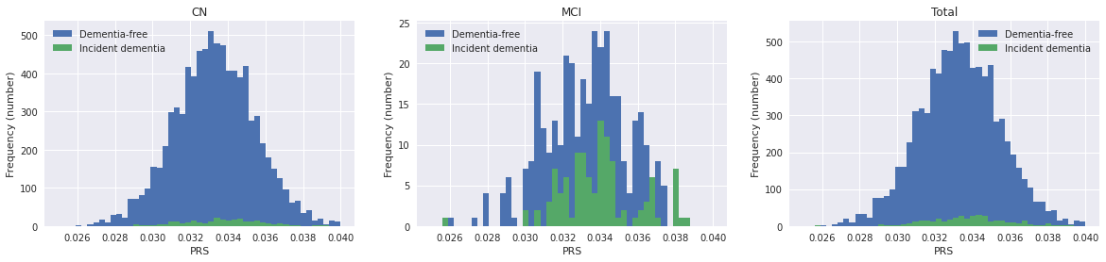
Figure S1.5 Polygenic risk score (PRS) distribution

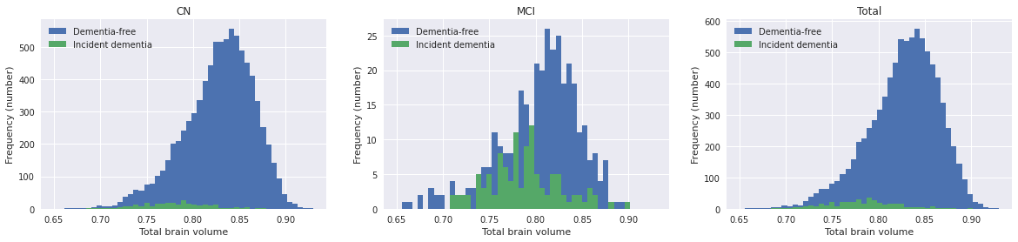
Figure S1.6 Intracranial-volume-adjusted total brain volume distribution

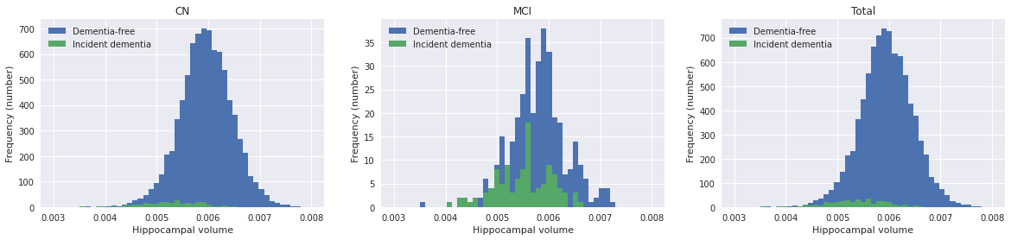
Figure S1.7 Intracranial-volume-adjusted hippocampal volume distribution

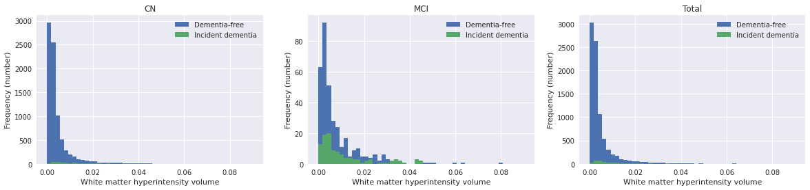
Figure S1.8 Intracranial-volume-adjusted white matter hyperintensity volume distribution

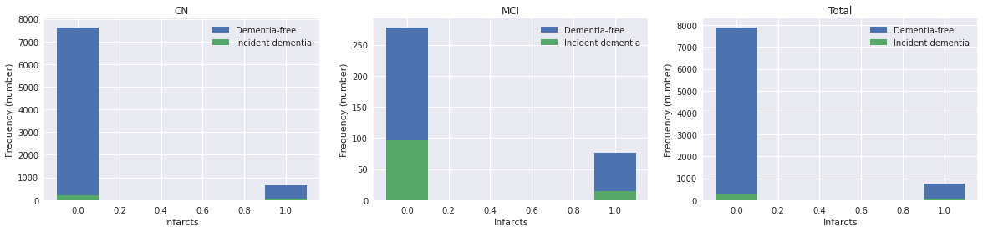
Figure S1.9 Lacunes/cortical infarcts distribution

S2. Dementia conversion curves for stratified subjects on APOE-ε4 carriership, Polygenic risk score (PRS), Sex and Age in the Rotterdam Study

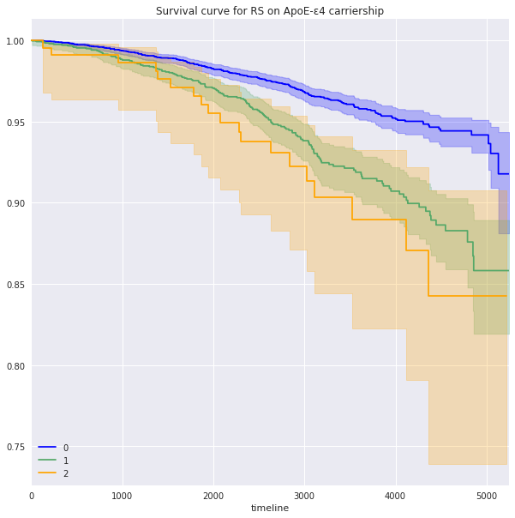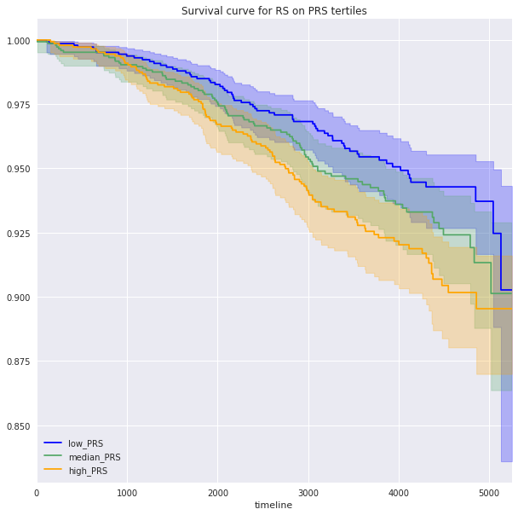
Figure S2.1 Dementia conversion curves on ApoE-ε4 carriership Figure S2.2 Dementia conversion curves on PRS tertiles

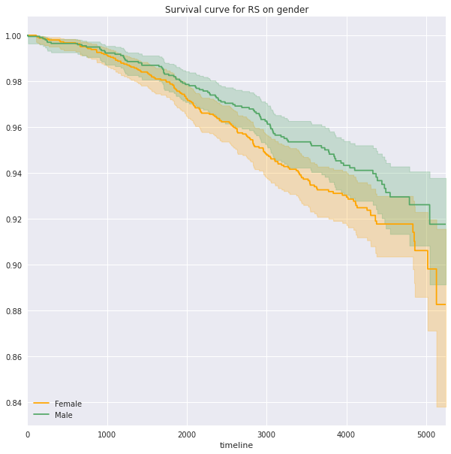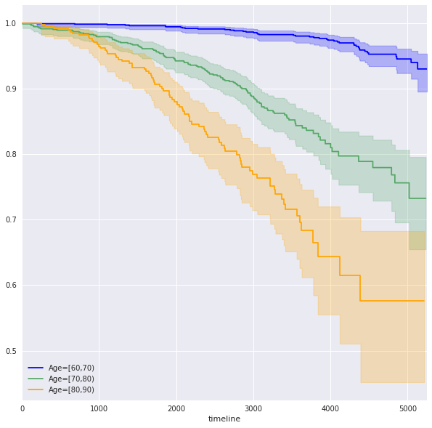
Figure S2.3 Dementia conversion curves on Sex Figure S2.4 Dementia conversion curves on Age groups

S3. Single nucleotide polymorphisms (SNPs) used in this study

Table S3 Single nucleotide polymorphisms (SNPs) used in this study, ranked by chromosome and position
 | SNP | Chromosome | Position |  |  | SNP | Chromosome | Position
1 | rs679515 | 1 | 207577223 |  | 39 | rs10437655 | 11 | 47370397
2 | rs72777026 | 2 | 9558882 |  | 40 | rs1582763 | 11 | 60254475
3 | rs17020490 | 2 | 37304796 |  | 41 | rs3851179 | 11 | 86157598
4 | rs143080277 | 2 | 105749599 |  | 42 | rs74685827 | 11 | 121482368
5 | rs6733839 | 2 | 127135234 |  | 43 | rs11218343 | 11 | 121564878
6 | rs10933431 | 2 | 233117202 |  | 44 | rs6489896 | 12 | 113281983
7 | rs16824536 | 3 | 155069722 |  | 45 | rs17125924 | 14 | 52924962
8 | rs61762319 | 3 | 155084189 |  | 46 | rs7401792 | 14 | 92464917
9 | rs3822030 | 4 | 993555 |  | 47 | rs12590654 | 14 | 92472511
10 | rs6846529 | 4 | 11023507 |  | 48 | rs7157106 | 14 | 105761758
11 | rs2245466 | 4 | 40197226 |  | 49 | rs10131280 | 14 | 106665591
12 | rs112403360 | 5 | 14724304 |  | 50 | rs8025980 | 15 | 50701814
13 | rs62374257 | 5 | 86927378 |  | 51 | rs602602 | 15 | 58764824
14 | rs871269 | 5 | 151052827 |  | 52 | rs117618017 | 15 | 63277703
15 | rs113706587 | 5 | 180201150 |  | 53 | rs3848143 | 15 | 64131307
16 | rs10947943 | 6 | 41036354 |  | 54 | rs12592898 | 15 | 78936857
17 | rs143332484 | 6 | 41161469 |  | 55 | rs1140239 | 16 | 30010081
18 | rs75932628 | 6 | 41161514 |  | 56 | rs889555 | 16 | 31111250
19 | rs60755019 | 6 | 41181270 |  | 57 | rs4985556 | 16 | 70660097
20 | rs7767350 | 6 | 47517390 |  | 58 | rs450674 | 16 | 79574511
21 | rs785129 | 6 | 114291731 |  | 59 | rs12446759 | 16 | 81739398
22 | rs6943429 | 7 | 7817263 |  | 60 | rs72824905 | 16 | 81908423
23 | rs10952097 | 7 | 8204382 |  | 61 | rs16941239 | 16 | 86420604
24 | rs13237518 | 7 | 12229967 |  | 62 | rs7225151 | 17 | 5233752
25 | rs6966331 | 7 | 37844191 |  | 63 | rs2242595 | 17 | 18156140
26 | rs76928645 | 7 | 54873635 |  | 64 | rs5848 | 17 | 44352876
27 | rs7384878 | 7 | 100334426 |  | 65 | rs199515 | 17 | 46779275
28 | rs11771145 | 7 | 143413669 |  | 66 | rs616338 | 17 | 49219935
29 | rs1065712 | 8 | 11844613 |  | 67 | rs2526377 | 17 | 58332680
30 | rs73223431 | 8 | 27362470 |  | 68 | rs4277405 | 17 | 63471557
31 | rs11787077 | 8 | 27607795 |  | 69 | rs12151021 | 19 | 1050875
32 | rs34173062 | 8 | 144103704 |  | 70 | rs9304690 | 19 | 49950060
33 | rs1800978 | 9 | 104903697 |  | 71 | rs587709 | 19 | 54267597
34 | rs7912495 | 10 | 11676714 |  | 72 | rs1358782 | 20 | 413334
35 | rs7068231 | 10 | 60025170 |  | 73 | rs6014724 | 20 | 56423488
36 | rs6586028 | 10 | 80494228 |  | 74 | rs6742 | 20 | 63743088
37 | rs6584063 | 10 | 96266650 |  | 75 | rs2154481 | 21 | 26101558
38 | rs7908662 | 10 | 122413396 |  | 76 | rs2830489 | 21 | 26775872

S4. Paired plot
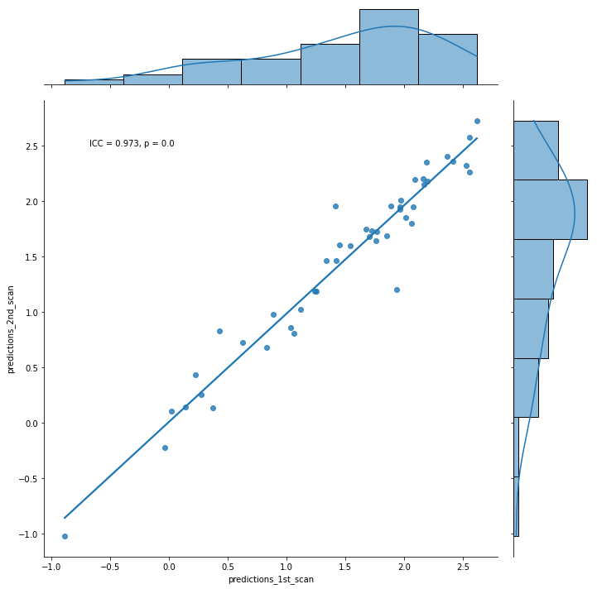
Figure S4. The prediction outcome scatter plot of paired scan-rescan measures. Model: Deep survival (fine-tuned) Model 3 (MRI images + Age + Sex + ApoE-ε4)

S5. Evaluation of different inclusion strategies for samples under age of 60
We optimized our method on study samples for the range of age. According to the age distribution plot in S1, very few dementia cases are present with scans taken under 60-years-old (‘risk-free’ age). These samples will make models more dependent on age, but their brain imaging data may still be useful for providing information to distinguish from dementia. Therefore, we experimented excluding or including samples at ‘risk-free’ age, and tested on different age groups to see the performance difference.

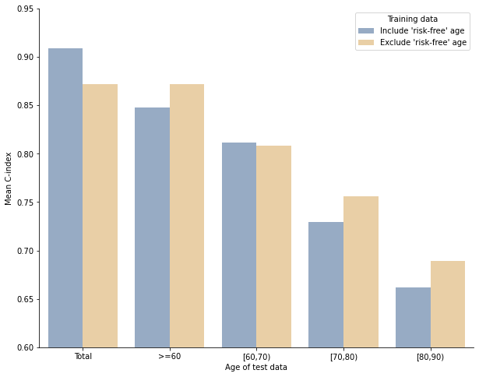
Figure S5. The model prediction C-index of including or excluding samples at ‘risk-free’ age on different age groups. Model: Deep survival (fine-tuned) Model 3 (MRI images + Age + Sex + APOE-ε4)

Figure S5 compares the deep survival model performances with and without samples at ‘risk-free’ age included in the study. While including these samples led to higher C-index values across all test samples, restricting the test samples to age >= 60 and to different age groups revealed lower test C-index values in most cases. It appears that the inclusion primarily boosted the prediction performance among the 60-69 age group, but decreased in older age groups. Therefore, the inclusion of samples at ‘risk-free’ age artificially inflated the model performance due to the abundance of younger control samples, but did not actually help with model discrimination. We then excluded all the samples under age of 60 in this study.

S6. Evaluation of different case-control proportions
Imbalanced data was a problem mentioned when case proportion is low, which may result in inaccurate risk predictions for individuals who are more likely to develop an event. Therefore, we did simulations with 10 different control sampling ratios from 0.1 to 1 for 100 runs on the Cox proportional hazards models to check the influence of case-control proportions on the model discriminability. We tested model performance only on cases.
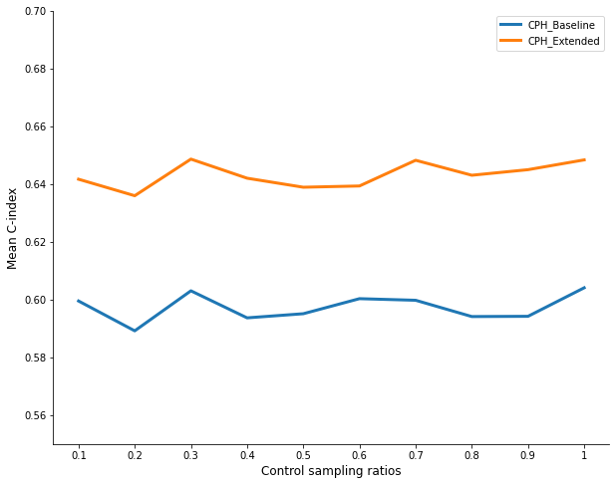
*For control sampling ratio = 1, the case-control proportion = 1:15.
Figure S6. The model prediction C-index across different case-control proportions. Model: Cox proportional hazards Model 3 (MRI images + Age + Sex+ APOE-ε4)

Figure S6 shows the model prediction C-index remained stable across different case-control proportions used in the model training, suggesting that the imbalanced data did not degrade prediction accuracy among individuals with higher risk in our task. Therefore, we maintained the real case-control distribution in the model training.

S7. Evaluation of different inclusion strategies for MCI samples
Mild cognitive impairment (MCI) is an intermediate state between normal and dementia, their scans may appear closer to the dementia class, making binary dementia labels (0/1) inaccurate for reflecting their conditions and potentially affecting model training. However, their image data can still provide useful information on progression clues. Therefore, we compared three different inclusion strategies for MCI samples in the model training: excluding all samples that have ever converted to MCI during study (MCI samples), only excluding control samples with MCI but including MCI samples progressed to dementia, and including all MCI samples. We did simulations on the three strategies and five different model inputs for 100 runs.
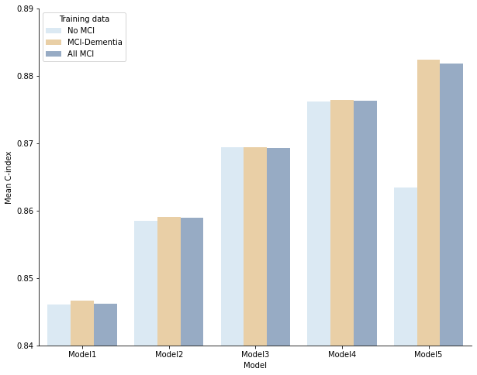
Figure S7. The model prediction C-index of different inclusion strategies for MCI samples. Model: Extended Cox proportional hazards models

Figure S7 compares three different inclusion strategies for MCI samples in the model training. Although very little difference was observed, models only including MCI patients progressed to dementia performed the best among three strategies. We reasoned that even though people with MCI do not yet have dementia, their scans may appear closer to those converted to dementia learned by the deep learning model, which may confuse the model during training.

S8. Attention maps on 2D slices and brain region importance

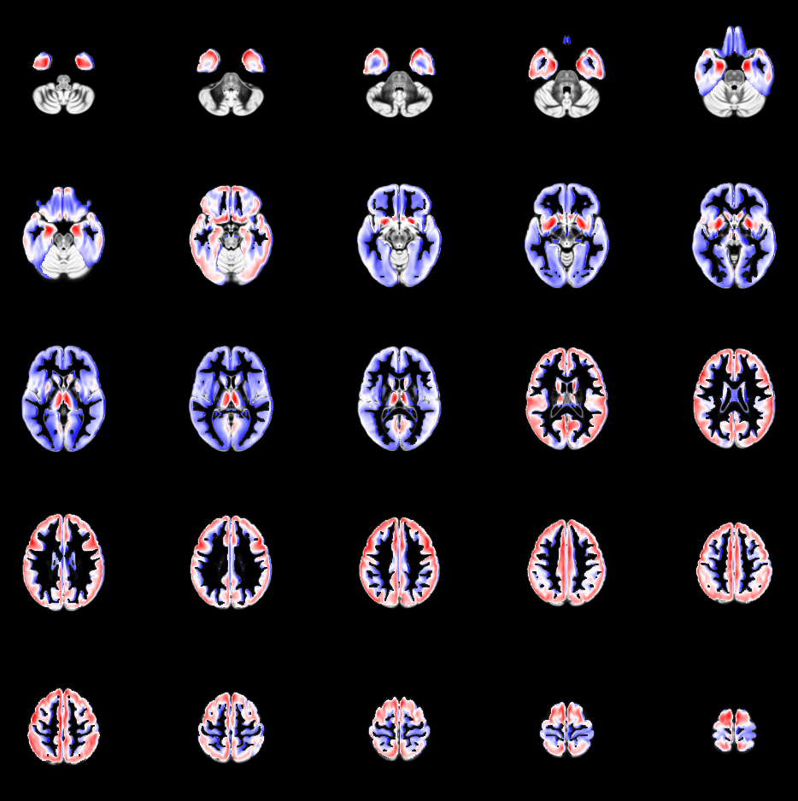

Figure S8.1 Attention heatmaps on 2D image slices. Model: Deep survival (trained from scratch) Model 5 (MRI images + Age + Sex + APOE-ε4 + SNPs)

Table S8.1 Top 10 of attention maps intensity per region. Model: Deep survival (trained from scratch) Model 5 (MRI images + Age + Sex + APOE-ε4 + SNPs)

Rank | Region name | Region size | Mean
1 | Amygdala | 4398 | 0.651253
2 | Nucleus accumbens | 888 | 0.639326
3 | Putamen | 14502 | 0.617297
4 | Hippocampus | 6687 | 0.611876
5 | Subcallosal area | 788 | 0.60923
6 | Thalamus | 20953 | 0.597907
7 | Superior temporal gyrus, anterior part | 14369 | 0.56993
8 | Caudate nucleus | 12229 | 0.563696
9 | Pallidum (globus pallidus) | 3835 | 0.561598
10 | Gyri parahippocampalis et ambiens | 13767 | 0.560158

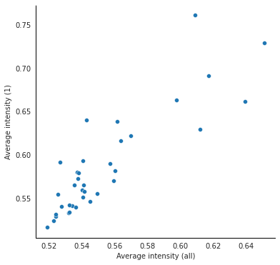
Figure S8.2 The scatter plot of average intensity in brain regions. X: average intensity calculated from all iterations of the 5-fold cross-validation. Y: average intensity calculated from one iteration. Model: Deep survival (trained from scratch) Model 5 (MRI images + Age + Sex + APOE-ε4 + SNPs)

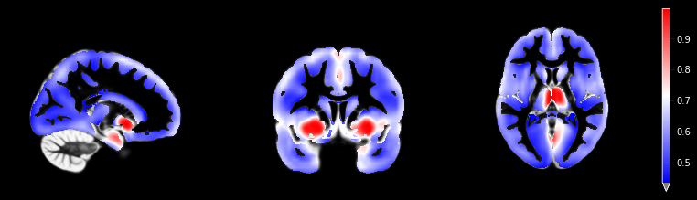
Figure S8.3 Attention heatmaps of Image feature 2 on 2D image slices on 3 different axes. Model: Deep survival (trained from scratch) Model 5 (MRI images + Age + Sex + APOE-ε4 + SNPs)

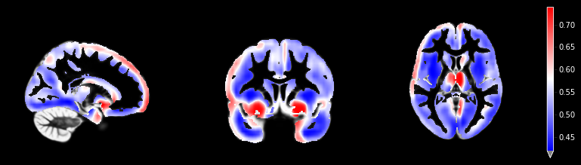
Figure S8.4 Attention heatmaps of Image feature 4 on 2D image slices on 3 different axes. Model: Deep survival (trained from scratch) Model 5 (MRI images + Age + Sex + APOE-ε4 + SNPs)

S9. Feature importance and interaction based on SHAP value

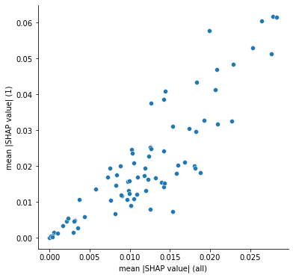

Figure S9.1 The scatter plot of mean absolute SHAP value of SNPs. X: mean absolute SHAP value calculated from all iterations of the 5-fold cross-validation. Y: mean absolute SHAP value calculated from one iteration. Model: Deep survival (trained from scratch) Model 5 (MRI images + Age + Sex + APOE-ε4 + SNPs)

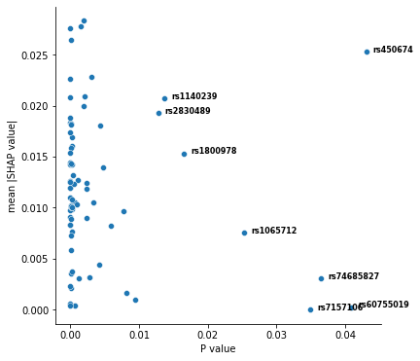

Figure S9.2 The scatter plot of mean absolute SHAP value of SNPs and p-value (the stage II replication meta-analysis p-value below 0.05) reported from the GWAS results of Alzheimer’s disease. Model: Deep survival (trained from scratch) Model 5 (MRI images + Age + Sex + APOE-ε4 + SNPs)

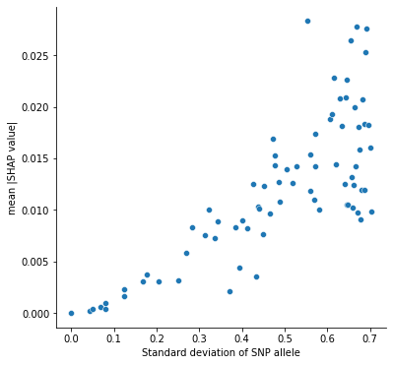
Figure S9.3 The scatter plot of mean absolute SHAP value of SNPs and the standard deviation of SNPs carried among the Rotterdam Study population. Model: Deep survival (trained from scratch) Model 5 (MRI images + Age + Sex + APOE-ε4 + SNPs)

Image credit: Allen Institute for Brain Science . https://human.brain-map.org/. Red: high; Blue: low.
Figure S9.4 The gene expression pattern in brain structures according to the Allen human brain atlas

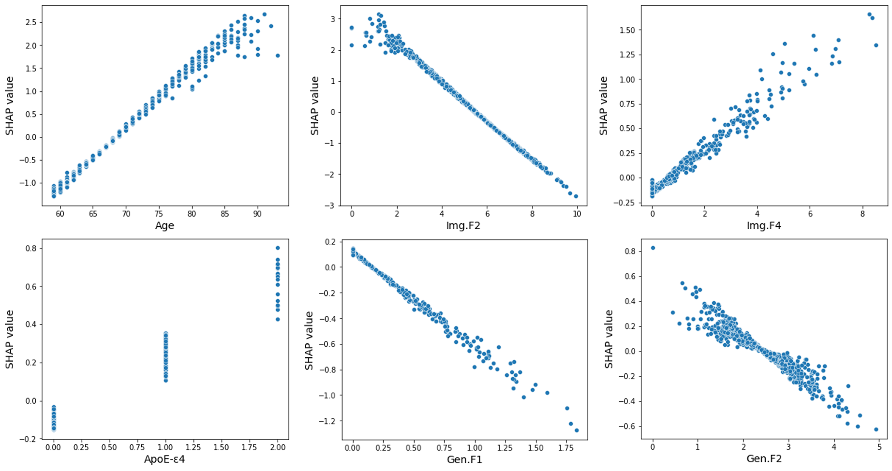
Figure S9.5 SHAP value for Age, Image Feature 2 (Img.F2), Image Feature 4 (Img.F4), APOE-ε4 carriership, Genetic Feature 1 (Gen.F1) and Genetic Feature 2 (Gen.F2) in the deep survival (trained from scratch) Model 5 (MRI images + Age + Sex + APOE-ε4 + SNPs)

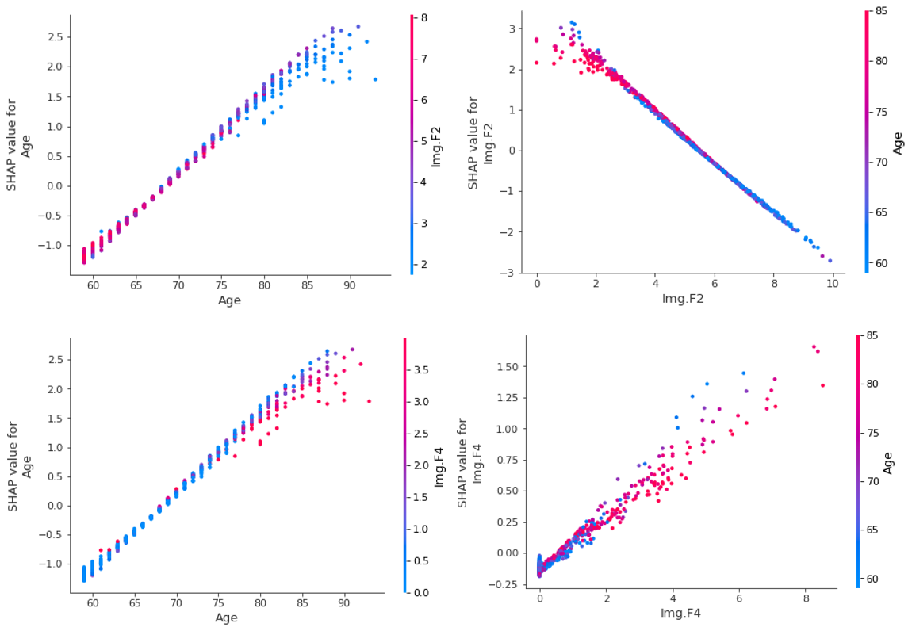
Figure S9.6 SHAP Interaction plots between Image features (Img.F2, Img.F4) and Age in the deep survival (trained from scratch) Model 5 (MRI images + Age + Sex + APOE-ε4 + SNPs)

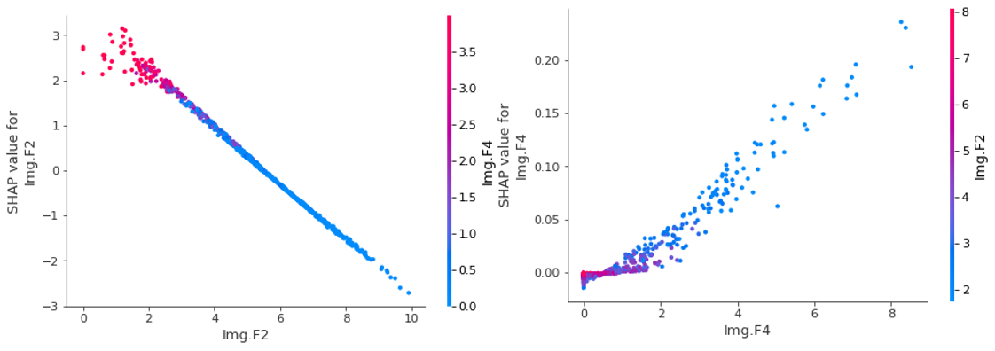

Figure S9.7 SHAP Interaction plots between Image Feature 2 (Img.F2) and Image Feature 4 (Img.F4) in the deep survival (trained from scratch) Model 5 (MRI images + Age + Sex + APOE-ε4 + SNPs)

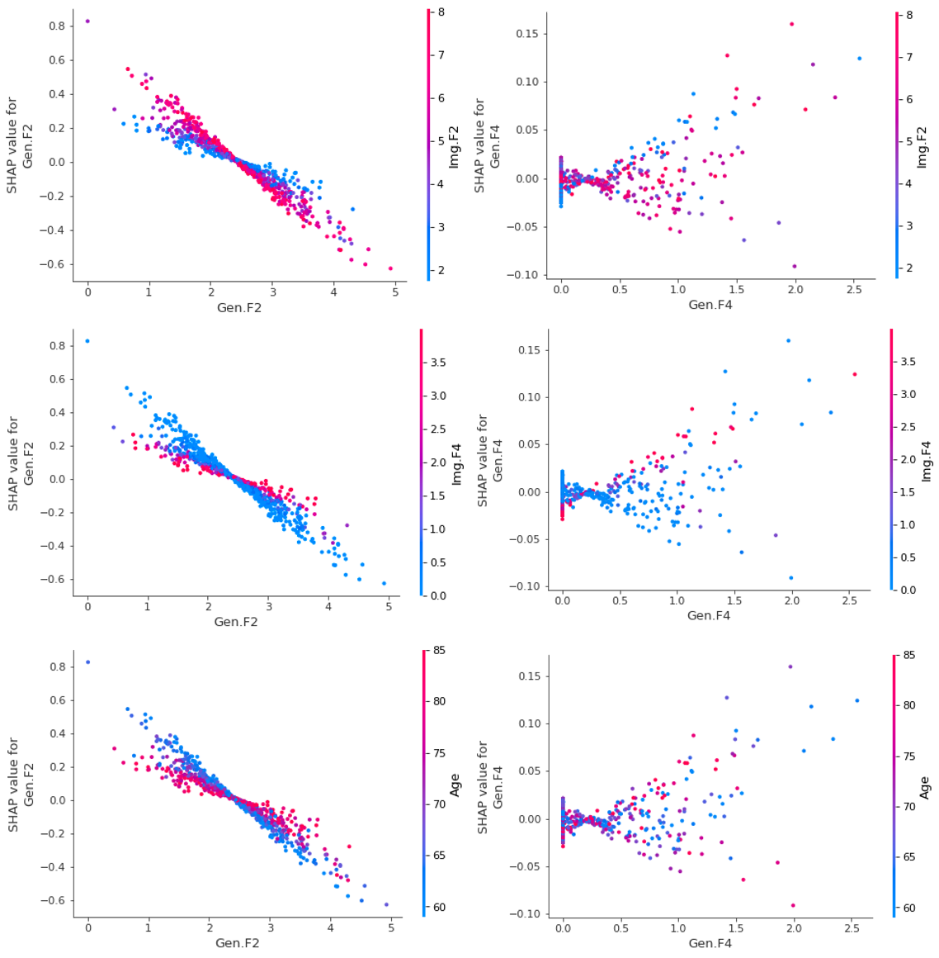
Figure S9.8 SHAP Interaction plots between Genetic features (Gen.F1, Gen.F2) and other features (Image features, Age) in the deep survival (trained from scratch) Model 5 (MRI images + Age + Sex + APOE-ε4 + SNPs)

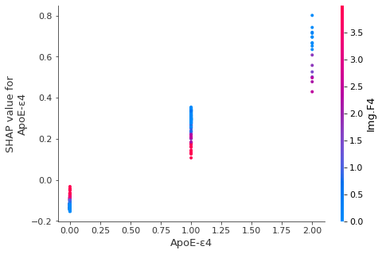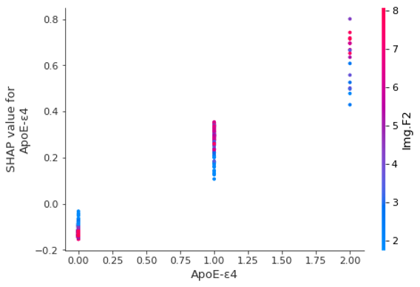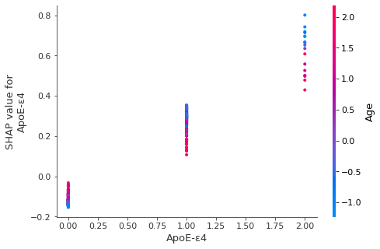
Figure S9.9 SHAP Interaction plots between APOE-ε4 and other features (Image features, Age) in the deep survival (trained from scratch) Model 5 (MRI images + Age + Sex + APOE-ε4 + SNPs)

