SUPPLEMENTARY MATERIAL
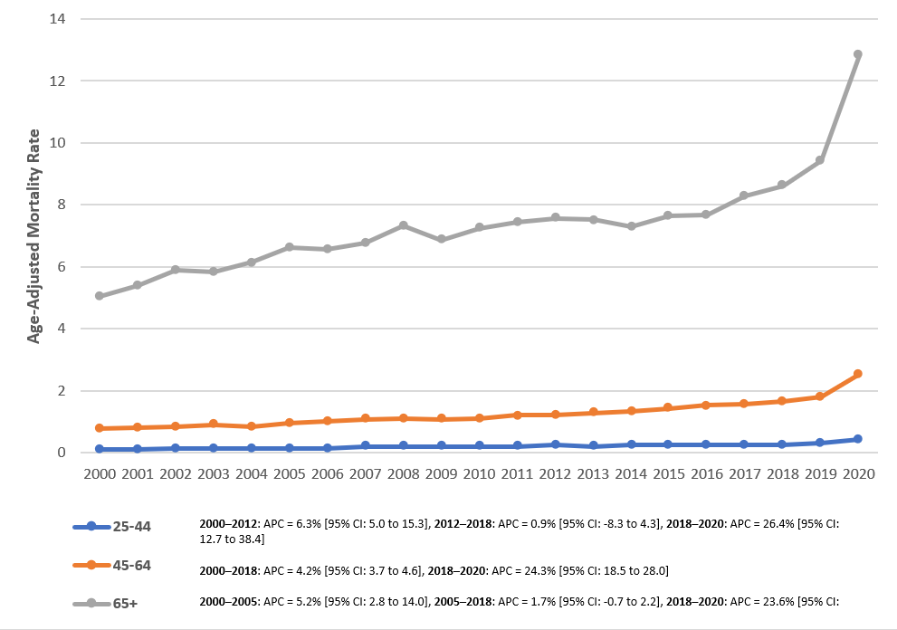

Supplementary Figure 1: Trends in HTN and PE-related AAMR per 100,000, stratified by age groups, in the United States from 2000-2020.

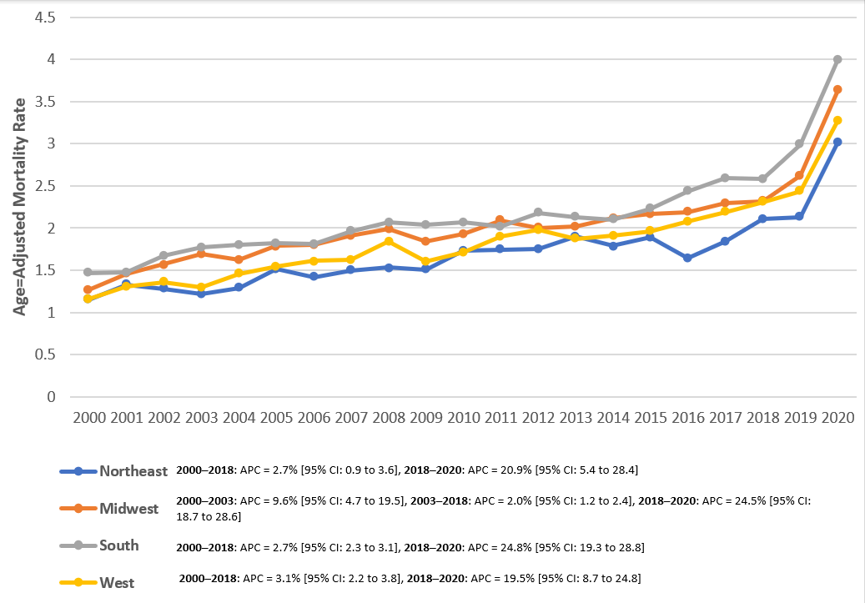

Supplementary Figure 2: Trends in HTN and PE-related AAMR per 100,000, stratified by census region, in the United States from 2000-2020.

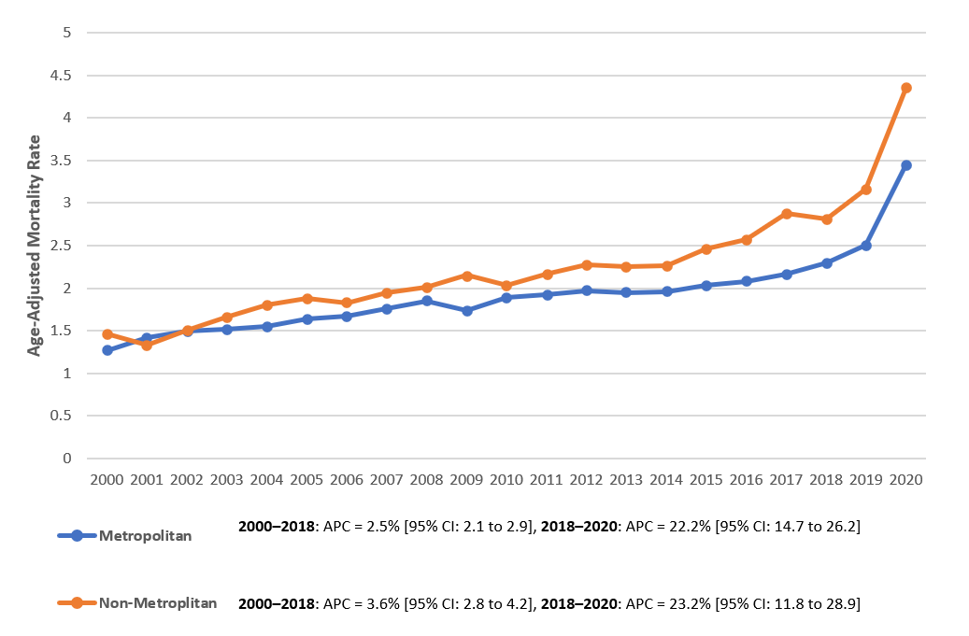

Supplementary Figure 3: Trends in HTN and PE-related AAMR per 100,000, stratified by urbanization, in the United States from 2000-2020.

Year | Overall | Female | Male | Hispanic or Latino | NH Asian | NH Black | NH white | Population
2000 | 2330 | 1457 | 873 | 78 | 23 | 542 | 1674 | 181984640
2001 | 2562 | 1544 | 1018 | 113 | 26 | 586 | 1814 | 184305128
2002 | 2790 | 1759 | 1031 | 122 | 27 | 663 | 1963 | 186208028
2003 | 2898 | 1785 | 1113 | 95 | 23 | 661 | 2111 | 188090429
2004 | 3001 | 1791 | 1210 | 108 | 37 | 680 | 2165 | 190205384
2005 | 3295 | 1989 | 1306 | 145 | 31 | 767 | 2334 | 192551384
2006 | 3345 | 1991 | 1354 | 135 | 33 | 742 | 2421 | 195019359
2007 | 3611 | 2068 | 1543 | 143 | 43 | 812 | 2596 | 197403777
2008 | 3898 | 2264 | 1634 | 179 | 50 | 861 | 2787 | 199795090
2009 | 3799 | 2184 | 1615 | 189 | 43 | 871 | 2673 | 202107016
2010 | 4069 | 2298 | 1771 | 203 | 48 | 886 | 2907 | 203891983
2011 | 4298 | 2392 | 1906 | 214 | 63 | 856 | 3138 | 206592936
2012 | 4534 | 2562 | 1972 | 229 | 62 | 962 | 3238 | 208826037
2013 | 4621 | 2547 | 2074 | 230 | 50 | 978 | 3333 | 211085314
2014 | 4702 | 2518 | 2184 | 292 | 52 | 972 | 3354 | 213809280
2015 | 5037 | 2652 | 2385 | 303 | 68 | 1008 | 3614 | 216553817
2016 | 5260 | 2777 | 2483 | 333 | 69 | 1048 | 3772 | 218641417
2017 | 5730 | 2995 | 2735 | 321 | 84 | 1152 | 4113 | 221447331
2018 | 6093 | 3121 | 2972 | 341 | 88 | 1221 | 4380 | 223311190
2019 | 6818 | 3559 | 3259 | 424 | 123 | 1418 | 4797 | 224981167
2020 | 9490 | 4871 | 4619 | 663 | 164 | 2015 | 6560 | 226635013
Tota | 92181 | 51124 | 41057 | 4860 | 1207 | 19701 | 65744 | 4293445720
Supplementary Table 1. Overall and sex stratified HTN and PE-related mortality among United States adults from 2000 to 2020.

Year | Overall | Female | Male
2000 | 1.30 (1.25–1.36) | 1.37 (1.30–1.44) | 1.17 (1.09–1.25)
2001 | 1.39 (1.33–1.44) | 1.41 (1.34–1.48) | 1.36 (1.27–1.44)
2002 | 1.52 (1.46–1.57) | 1.61 (1.54–1.69) | 1.36 (1.27–1.44)
2003 | 1.53 (1.47–1.58) | 1.61 (1.53–1.68) | 1.41 (1.33–1.50)
2004 | 1.57 (1.51–1.63) | 1.59 (1.52–1.67) | 1.52 (1.43–1.61)
2005 | 1.70 (1.64–1.75) | 1.74 (1.66–1.81) | 1.59 (1.51–1.68)
2006 | 1.71 (1.65–1.76) | 1.70 (1.62–1.78) | 1.61 (1.52–1.70)
2007 | 1.79 (1.73–1.85) | 1.75 (1.68–1.83) | 1.79 (1.70–1.88)
2008 | 1.91 (1.85–1.97) | 1.88 (1.80–1.96) | 1.86 (1.77–1.96)
2009 | 1.81 (1.76–1.87) | 1.82 (1.74–1.90) | 1.79 (1.70–1.88)
2010 | 1.90 (1.84–1.95) | 1.87 (1.79–1.95) | 1.91 (1.82–2.00)
2011 | 1.97 (1.91–2.03) | 1.89 (1.81–1.96) | 2.00 (1.91–2.09)
2012 | 2.02 (1.96–2.08) | 2.01 (1.93–2.09) | 2.00 (1.91–2.09)
2013 | 2.01 (1.95–2.07) | 1.96 (1.88–2.03) | 2.04 (1.95–2.13)
2014 | 2.01 (1.96–2.07) | 1.88 (1.81–1.96) | 2.13 (2.04–2.22)
2015 | 2.11 (2.05–2.17) | 1.97 (1.89–2.04) | 2.24 (2.15–2.33)
2016 | 2.15 (2.09–2.21) | 2.01 (1.93–2.09) | 2.29 (2.20–2.38)
2017 | 2.28 (2.22–2.34) | 2.11 (2.03–2.19) | 2.45 (2.36–2.54)
2018 | 2.37 (2.31–2.43) | 2.16 (2.08–2.24) | 2.60 (2.51–2.70)
2019 | 2.61 (2.55–2.68) | 2.42 (2.34–2.50) | 2.79 (2.70–2.89)
2020 | 3.58 (3.50–3.65) | 3.24 (3.15–3.33) | 3.92 (3.80–4.03)
Supplementary Table 2. Overall and sex stratified HTN and PE-related AAMR per 100,000 in the United States from 2000-2020

Year | Hispanic or Latino | NH Asian | NH Black or African American | NH White
2000 | 0.86 (0.67–1.08) | 0.51 (0.32–0.78) | 3.49 (3.19–3.79) | 1.11 (1.06–1.16)
2001 | 1.20 (0.97–1.43) | 0.54 (0.34–0.81) | 3.69 (3.39–3.99) | 1.21 (1.15–1.27)
2002 | 1.19 (0.97–1.42) | 0.56 (0.36–0.83) | 4.10 (3.78–4.42) | 1.27 (1.21–1.33)
2003 | 0.87 (0.69–1.07) | 0.46 (0.29–0.71) | 3.96 (3.65–4.27) | 1.38 (1.32–1.44)
2004 | 0.91 (0.73–1.09) | 0.69 (0.48–0.96) | 4.11 (3.79–4.42) | 1.40 (1.34–1.46)
2005 | 1.16 (0.96–1.36) | 0.54 (0.36–0.77) | 4.48 (4.16–4.80) | 1.47 (1.41–1.53)
2006 | 1.06 (0.87–1.24) | 0.55 (0.37–0.78) | 4.19 (3.88–4.50) | 1.48 (1.42–1.54)
2007 | 1.05 (0.86–1.23) | 0.66 (0.47–0.90) | 4.44 (4.13–4.76) | 1.58 (1.52–1.64)
2008 | 1.28 (1.09–1.48) | 0.72 (0.52–0.96) | 4.63 (4.31–4.94) | 1.68 (1.62–1.75)
2009 | 1.26 (1.07–1.45) | 0.59 (0.42–0.80) | 4.50 (4.19–4.80) | 1.61 (1.54–1.67)
2010 | 1.30 (1.11–1.49) | 0.59 (0.43–0.80) | 4.52 (4.21–4.83) | 1.74 (1.67–1.80)
2011 | 1.30 (1.12–1.49) | 0.78 (0.59–1.00) | 4.20 (3.91–4.49) | 1.81 (1.75–1.88)
2012 | 1.26 (1.08–1.43) | 0.72 (0.55–0.93) | 4.58 (4.28–4.88) | 1.85 (1.78–1.92)
2013 | 1.22 (1.05–1.38) | 0.53 (0.39–0.71) | 4.49 (4.20–4.78) | 1.88 (1.81–1.94)
2014 | 1.43 (1.26–1.60) | 0.50 (0.37–0.66) | 4.32 (4.04–4.60) | 1.85 (1.79–1.91)
2015 | 1.47 (1.30–1.65) | 0.64 (0.50–0.82) | 4.28 (4.01–4.55) | 1.96 (1.90–2.03)
2016 | 1.52 (1.35–1.69) | 0.64 (0.49–0.81) | 4.33 (4.06–4.60) | 2.02 (1.95–2.08)
2017 | 1.34 (1.19–1.49) | 0.67 (0.53–0.84) | 4.68 (4.40–4.96) | 2.17 (2.11–2.24)
2018 | 1.40 (1.25–1.56) | 0.71 (0.56–0.87) | 4.86 (4.58–5.14) | 2.27 (2.20–2.34)
2019 | 1.69 (1.53–1.86) | 0.93 (0.76–1.10) | 5.39 (5.11–5.68) | 2.44 (2.37–2.52)
2020 | 2.47 (2.28–2.67) | 1.20 (1.01–1.38) | 7.52 (7.18–7.86) | 3.31 (3.23–3.39)
Supplementary Table 3. HTN and PE-related AAMR per 100,000 stratified by race in the United States from 2000-2020.

Year | Young Adults (25-44) | Middle-Aged Adults (45-64) | Old Adults (65-85+)
2000 | 0.11 (0.09–0.13) | 0.78 (0.71–0.84) | 5.04 (4.81–5.28)
2001 | 0.11 (0.09–0.13) | 0.81 (0.75–0.88) | 5.41 (5.17–5.65)
2002 | 0.15 (0.13–0.18) | 0.85 (0.78–0.92) | 5.90 (5.65–6.16)
2003 | 0.15 (0.13–0.18) | 0.91 (0.84–0.99) | 5.83 (5.59–6.08)
2004 | 0.15 (0.13–0.18) | 0.85 (0.79–0.92) | 6.16 (5.91–6.42)
2005 | 0.15 (0.13–0.18) | 0.95 (0.88–1.02) | 6.64 (6.38–6.90)
2006 | 0.15 (0.12–0.18) | 1.01 (0.94–1.09) | 6.58 (6.33–6.84)
2007 | 0.21 (0.18–0.24) | 1.08 (1.00–1.15) | 6.76 (6.50–7.02)
2008 | 0.21 (0.17–0.24) | 1.11 (1.04–1.19) | 7.34 (7.07–7.61)
2009 | 0.21 (0.18–0.24) | 1.09 (1.02–1.16) | 6.87 (6.61–7.13)
2010 | 0.21 (0.18–0.24) | 1.11 (1.04–1.19) | 7.25 (6.98–7.51)
2011 | 0.21 (0.18–0.24) | 1.21 (1.14–1.29) | 7.43 (7.17–7.69)
2012 | 0.26 (0.23–0.30) | 1.23 (1.16–1.31) | 7.57 (7.31–7.83)
2013 | 0.21 (0.18–0.24) | 1.29 (1.22–1.37) | 7.52 (7.26–7.78)
2014 | 0.26 (0.23–0.30) | 1.35 (1.28–1.43) | 7.31 (7.06–7.56)
2015 | 0.26 (0.23–0.30) | 1.43 (1.35–1.51) | 7.66 (7.41–7.91)
2016 | 0.26 (0.23–0.30) | 1.53 (1.45–1.62) | 7.69 (7.44–7.94)
2017 | 0.26 (0.23–0.30) | 1.57 (1.49–1.65) | 8.29 (8.04–8.55)
2018 | 0.26 (0.23–0.30) | 1.65 (1.56–1.74) | 8.62 (8.36–8.87)
2019 | 0.32 (0.28–0.36) | 1.81 (1.72–1.90) | 9.44 (9.17–9.70)
2020 | 0.42 (0.37–0.46) | 2.55 (2.44–2.65) | 12.83 (12.53–13.14)
Supplementary Table 4. HTN and PE-related AAMR per 100,000 stratified by Age Grp in the United States from 2000-2020.

Year | Northeast | Midwest | South | West
2000 | 1.15 (1.04–1.25) | 1.27 (1.17–1.38) | 1.47 (1.37–1.56) | 1.16 (1.05–1.27)
2001 | 1.33 (1.21–1.44) | 1.46 (1.35–1.58) | 1.48 (1.39–1.57) | 1.31 (1.19–1.43)
2002 | 1.28 (1.17–1.39) | 1.57 (1.45–1.69) | 1.67 (1.57–1.77) | 1.36 (1.24–1.48)
2003 | 1.22 (1.11–1.33) | 1.69 (1.57–1.81) | 1.77 (1.67–1.87) | 1.30 (1.19–1.41)
2004 | 1.29 (1.18–1.41) | 1.62 (1.50–1.73) | 1.80 (1.70–1.90) | 1.46 (1.34–1.58)
2005 | 1.52 (1.40–1.64) | 1.79 (1.66–1.91) | 1.82 (1.72–1.92) | 1.54 (1.42–1.66)
2006 | 1.42 (1.30–1.54) | 1.80 (1.68–1.92) | 1.81 (1.71–1.91) | 1.61 (1.49–1.74)
2007 | 1.50 (1.38–1.62) | 1.91 (1.78–2.04) | 1.96 (1.86–2.06) | 1.62 (1.49–1.74)
2008 | 1.53 (1.41–1.65) | 1.99 (1.86–2.11) | 2.07 (1.96–2.17) | 1.84 (1.71–1.97)
2009 | 1.51 (1.39–1.64) | 1.84 (1.71–1.96) | 2.04 (1.93–2.14) | 1.60 (1.48–1.72)
2010 | 1.73 (1.60–1.86) | 1.93 (1.80–2.05) | 2.07 (1.97–2.18) | 1.71 (1.59–1.83)
2011 | 1.74 (1.61–1.86) | 2.09 (1.96–2.22) | 2.02 (1.92–2.12) | 1.90 (1.78–2.03)
2012 | 1.75 (1.63–1.88) | 2.00 (1.88–2.13) | 2.18 (2.08–2.28) | 1.98 (1.85–2.10)
2013 | 1.90 (1.77–2.03) | 2.02 (1.89–2.14) | 2.13 (2.03–2.23) | 1.87 (1.75–1.99)
2014 | 1.79 (1.66–1.92) | 2.12 (1.99–2.24) | 2.10 (2.00–2.19) | 1.91 (1.79–2.03)
2015 | 1.89 (1.76–2.01) | 2.17 (2.04–2.30) | 2.23 (2.13–2.33) | 1.96 (1.84–2.08)
2016 | 1.64 (1.52–1.76) | 2.19 (2.07–2.32) | 2.44 (2.34–2.55) | 2.08 (1.96–2.20)
2017 | 1.84 (1.71–1.97) | 2.30 (2.17–2.43) | 2.59 (2.49–2.70) | 2.19 (2.06–2.31)
2018 | 2.11 (1.98–2.25) | 2.32 (2.19–2.45) | 2.58 (2.47–2.68) | 2.31 (2.18–2.43)
2019 | 2.13 (2.00–2.26) | 2.62 (2.48–2.75) | 2.99 (2.87–3.10) | 2.44 (2.31–2.57)
2020 | 3.02 (2.86–3.18) | 3.63 (3.47–3.79) | 4.00 (3.87–4.12) | 3.28 (3.14–3.43)
Supplementary Table 5 HTN and PE-related AAMR per 100,000 stratified by census region in the United States from 2000-2020.

Year | Metropolitan | Non-Metropolitan
2000 | 1.27 (1.22–1.33) | 1.46 (1.33–1.59)
2001 | 1.42 (1.36–1.49) | 1.33 (1.21–1.45)
2002 | 1.50 (1.44–1.56) | 1.51 (1.38–1.64)
2003 | 1.52 (1.45–1.58) | 1.66 (1.52–1.80)
2004 | 1.55 (1.48–1.61) | 1.80 (1.65–1.94)
2005 | 1.64 (1.58–1.70) | 1.88 (1.74–2.02)
2006 | 1.67 (1.61–1.74) | 1.83 (1.69–1.97)
2007 | 1.76 (1.70–1.82) | 1.94 (1.79–2.08)
2008 | 1.85 (1.79–1.92) | 2.01 (1.87–2.16)
2009 | 1.74 (1.68–1.80) | 2.15 (2.00–2.30)
2010 | 1.89 (1.82–1.95) | 2.03 (1.88–2.18)
2011 | 1.92 (1.85–1.98) | 2.17 (2.02–2.32)
2012 | 1.97 (1.91–2.04) | 2.28 (2.13–2.44)
2013 | 1.95 (1.89–2.02) | 2.25 (2.10–2.40)
2014 | 1.96 (1.90–2.02) | 2.26 (2.11–2.41)
2015 | 2.03 (1.97–2.10) | 2.46 (2.30–2.62)
2016 | 2.08 (2.01–2.14) | 2.57 (2.41–2.73)
2017 | 2.17 (2.11–2.24) | 2.88 (2.71–3.05)
2018 | 2.30 (2.24–2.37) | 2.81 (2.64–2.98)
2019 | 2.50 (2.44–2.57) | 3.16 (2.99–3.34)
2020 | 3.45 (3.37–3.53) | 4.35 (4.15–4.56)
Supplementary Table 6. HTN and PE-related AAMR per 100,000 stratified by urbanization in the United States from 2000-2020
State | Age Adjusted Rate  (95% CI)
Alabama | 1.88 (1.78–1.98)
Alaska | 1.35 (1.07–1.69)
Arizona | 1.44 (1.36–1.51)
Arkansas | 2.68 (2.53–2.84)
California | 2.07 (2.03–2.11)
Colorado | 2.69 (2.57–2.82)
Connecticut | 1.38 (1.29–1.48)
Delaware | 1.93 (1.69–2.16)
District of Columbia | 5.54 (5.02–6.05)
Florida | 1.30 (1.26–1.34)
Georgia | 1.85 (1.78–1.93)
Hawaii | 0.93 (0.80–1.05)
Idaho | 1.70 (1.52–1.87)
Illinois | 1.71 (1.65–1.77)
Indiana | 2.19 (2.09–2.28)
Iowa | 1.90 (1.78–2.02)
Kansas | 1.50 (1.38–1.62)
Kentucky | 2.26 (2.14–2.38)
Louisiana | 2.21 (2.09–2.32)
Maine | 0.91 (0.79–1.04)
Maryland | 3.11 (2.99–3.23)
Massachusetts | 1.12 (1.06–1.19)
Michigan | 1.85 (1.78–1.91)
Minnesota | 2.45 (2.34–2.56)
Mississippi | 3.96 (3.77–4.15)
Missouri | 1.71 (1.62–1.79)
Montana | 1.74 (1.54–1.94)
Nebraska | 2.54 (2.35–2.72)
Nevada | 1.30 (1.18–1.42)
New Hampshire | 1.38 (1.22–1.54)
New Jersey | 1.84 (1.77–1.91)
New Mexico | 1.52 (1.37–1.66)
New York | 1.83 (1.78–1.87)
North Carolina | 2.37 (2.28–2.45)
North Dakota | 2.09 (1.82–2.37)
Ohio | 2.58 (2.51–2.65)
Oklahoma | 2.92 (2.78–3.06)
Oregon | 1.65 (1.55–1.76)
Pennsylvania | 1.79 (1.74–1.85)
Rhode Island | 2.17 (1.96–2.39)
South Carolina | 2.74 (2.61–2.86)
South Dakota | 2.26 (2.01–2.52)
Tennessee | 2.65 (2.55–2.76)
Texas | 2.58 (2.52–2.64)
Utah | 1.43 (1.29–1.57)
Vermont | 2.65 (2.33–2.96)
Virginia | 1.68 (1.61–1.76)
Washington | 1.90 (1.81–1.99)
West Virginia | 2.50 (2.33–2.68)
Wisconsin | 2.00 (1.91–2.10)
Wyoming | 2.90 (2.53–3.28)

Supplementary Table 7. HTN and PE-related AAMR per 100,000 stratified by states in the United States from 2000-2020.

Year | Medical Facility | Nursing Home/Long Term Care | Hospices | Home | Other
2000 | 1718 | 304 | - | 256 | 52
2001 | 1863 | 343 | - | 313 | 43
2002 | 2029 | 354 | - | 351 | 55
2003 | 1999 | 411 | - | 396 | 79
2004 | 2036 | 453 | - | 425 | 67
2005 | 2167 | 505 | 16 | 501 | 92
2006 | 2110 | 532 | 30 | 568 | 97
2007 | 2245 | 563 | 53 | 646 | 99
2008 | 2385 | 591 | 72 | 685 | 110
2009 | 2227 | 557 | 81 | 736 | 96
2010 | 2402 | 575 | 90 | 863 | 137
2011 | 2485 | 637 | 123 | 905 | 147
2012 | 2499 | 686 | 172 | 1011 | 166
2013 | 2537 | 657 | 160 | 1109 | 152
2014 | 2474 | 722 | 174 | 1190 | 138
2015 | 2659 | 717 | 220 | 1294 | 147
2016 | 2666 | 739 | 239 | 1426 | 189
2017 | 2830 | 817 | 254 | 1599 | 227
2018 | 2991 | 894 | 312 | 1637 | 258
2019 | 3236 | 935 | 429 | 1952 | 265
2020 | 4481 | 1164 | 458 | 2980 | 406
Total | 52,039 | 13,156 | 2,883 | 20,843 | 3042

Supplementary Table 8. HTN and PE-related mortality among United States adults stratified by place of death from 2000-2020.

UCD - 15 Leading Causes of Death | Total Deaths 2000-2020
Diseases of heart (I00-I09,I11,I13,I20-I51) | 29473
Malignant neoplasms (C00-C97) | 16357
Essential hypertension and hypertensive renal disease (I10,I12,I15) | 5799
Cerebrovascular diseases (I60-I69) | 5688
Accidents (unintentional injuries) (V01-X59,Y85-Y86) | 3919
Diabetes mellitus (E10-E14) | 3715
Chronic lower respiratory diseases (J40-J47) | 3483
Alzheimer disease (G30) | 1292
COVID-19 (U07.1) | 959
Influenza and pneumonia (J09-J18) | 612
Septicemia (A40-A41) | 536
In situ neoplasms, benign neoplasms and neoplasms of uncertain or unknown behavior (D00-D48) | 525
Complications of medical and surgical care (Y40-Y84,Y88) | 364
Parkinson disease (G20-G21) | 310
Aortic aneurysm and dissection (I71) | 259

Supplementary Table 9. HTN and PE-related mortality among United States adults stratified by top 15 leading causes of death from 2000-2020.

Year Interval | APC (95% CI) | P-value
Overall
2000-2018 | 2.67 (2.21, 3.12) | < 0.000001
2018-2020 | 22.16 (14.99, 26.19) | < 0.000001
Men
2000-2018 | 3.72 (3.16, 4.21) | < 0.000001
2018-2020 | 22.85 (14.47, 27.20) | < 0.000001
Women
2000-2005 | 4.42 (2.26, 14.05) | 0.0004
2005-2018 | 1.47 (-2.12, 1.98) | 0.123575
2018-2020 | 22.83 (15.78, 27.97) | < 0.000001
2021–2024 |  | 0.000001
25-44 years
2000-2012 | 6.27 (5.02, 15.29) | 0.002799
2012-2018 | 0.95 (-8.33, 4.26) | 0.932214
2018-2020 | 26.43 (12.71, 38.44) | < 0.000001
45-64 years
2000-2018 | 4.15 (3.71, 4.65) | < 0.000001
2018-2020 | 24.31 (18.46, 27.99) | < 0.000001
65-85+ years
2000-2005 | 5.20 (2.83, 14.00) | < 0.000001
2005-2018 | 1.68 (-0.69, 2.19) | 0.065587
2018-2020 | 23.56 (17.46, 28.19) | < 0.000001
NH White
2000-2018 | 3.32 (2.88, 3.77) | < 0.000001
2018-2020 | 21.07 (13.36, 24.73) | < 0.000001
NH Black
2000-2005 | 4.21 (1.47, 14.27) | 0.0004
2005-2018 | 0.25 (-3.76, 0.87) | 0.629474
2018-2020 | 27.45 (19.65, 33.50) | < 0.000001
NH Asian
2000-2018 | 1.08 (-0.24, 2.31) | 0.102779
2018-2020 | 33.60 (16.06, 45.77) | < 0.000001
Hispanic
2000-2018 | 2.07 (0.52, 3.29) | 0.022795
2018-2020 | 28.27 (10.56, 37.95) | < 0.000001
Non-Metropolitan
2000-2018 | 3.57 (2.80, 4.19) | 0.0008
2018-2020 | 23.22 (11.76, 28.88) | < 0.000001
Metropolitan
2000-2018 | 2.50 (2.05, 2.95) | < 0.000001
2018-2020 | 22.16 (14.74, 26.20) | < 0.000001
Northeast region
2000-2018 | 2.65 (0.88, 3.58) | 0.023995
2018-2020 | 20.95 (5.39, 28.42) | < 0.000001
South region
2000-2018 | 2.68 (2.27, 3.11) | < 0.000001
2018-2020 | 24.84 (19.35, 28.78) | < 0.000001
Midwest region
2000-2003 | 9.56 (4.70, 19.53) | < 0.000001
2003-2018 | 1.96 (1.22, 2.39) | 0.010798
2018-2020 | 24.49 (18.71, 28.61) | < 0.000001
West region
2000-2018 | 3.14 (2.23, 3.84) | 0.003599
2018-2020 | 19.49 (8.65, 24.85) | < 0.000001
Supplementary Table 10. Summary APCs of HTN and PE-related AAMR per 100,000 in the United States from 2000 to 2020.

APC = annual percent change; NH = non-Hispanic; * Indicates that the annual percentage change (APC) is significantly different from zero at α = 0.05. AAMR = age-adjusted mortality rate. The data for urbanization was only available till 2020 in the CDC Wonder Database.

