Tables
Table 1. Clinical characteristics of the enrolled very preterm infants.
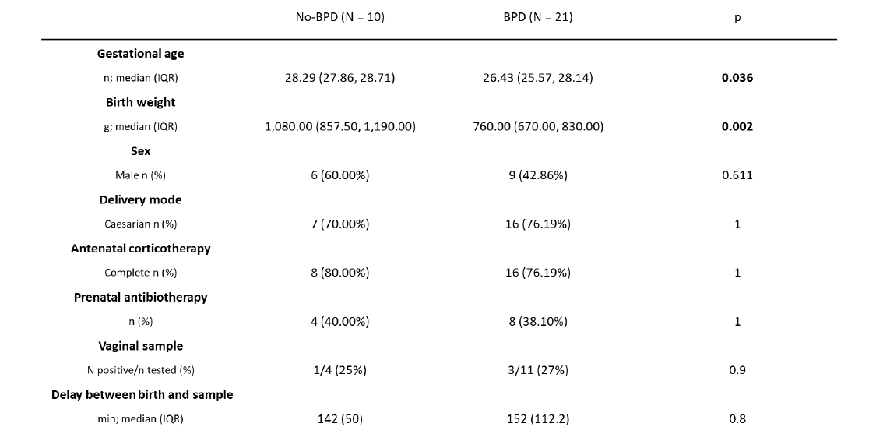
Table 2. Microbiological and clinical features of the identified microbial endotypes.
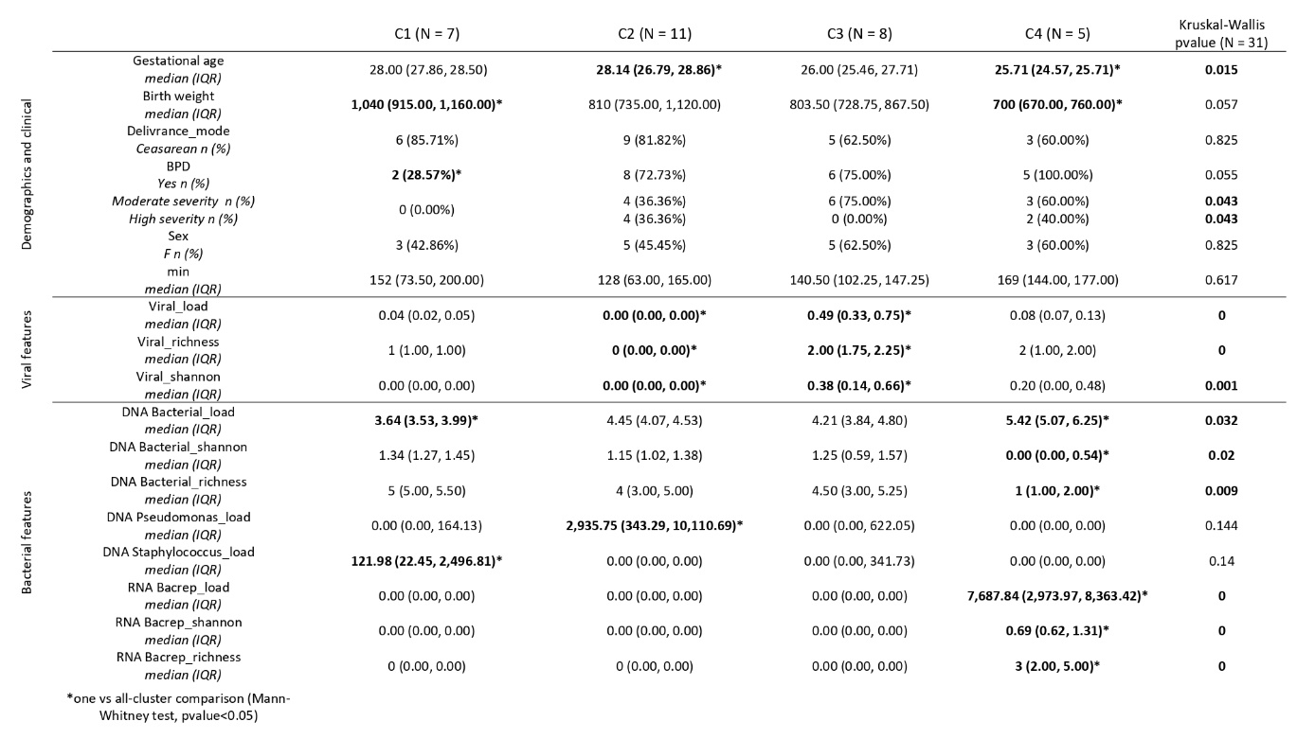

SUPPLEMENTARY
Supplementary Figures
Figure S1. Boxplots representing relative abundances of bacteriophages and eukaryotic viruses stratified by gestational age (left), delivery mode (middle) and BPD status (right). (Mann-Whitney U test: *p < 0.05, **p < 0.01, ***p < 0.001)
Figure S2. Boxplots of virulent, temperate, and undetermined lifecycle phage abundances (VDR), stratified by delivery mode (left) and BPD status (right). (Mann-Whitney U test: *p < 0.05, **p < 0.01, ***p < 0.001)
Figure S3. Relative abundances (top) and occurrences (bottom) of endotracheal bacterial genera identified via 16S rRNA-seq.
Figure S4. Abundance of transcriptionally active bacterial species (log₁₀ bacterial decontaminated ratio) in endotracheal samples.
Figure S5. Boxplots of Shannon index and richness according to bacterial genera identified by 16S rRNA-seq (A-B) and RNA bacterial species identified by metaRNA-seq (C-D), and stratified by gestational age (left), delivery mode (midlle) and BPD status (right). (Mann-Whitney U test: *p < 0.05, **p < 0.01, ***p < 0.001)
Figure S6. Optimal number of clusters as suggested by the gap statistic method.
Figure S7. Expression levels of transcripts involved in antiviral responses across microbial endotypes. (Mann-Whitney U test: *p < 0.05, **p < 0.01, ***p < 0.001)

Supplementary Tables
Table S1. Summary of sequencing data characteristics.

