Supplementary information
Alien mammal introductions can reshape global viral sharing networks
Andrea Tonelli^{1*} <andrea.tonelli@uniroma1.it>, Gregory F. Albery², Moreno Di Marco¹

Affiliations:
¹Department of Biology and Biotechnologies “Charles Darwin”, Sapienza University of Rome, Rome, Italy.
²School of Natural Sciences, Trinity College Dublin, Dublin, Ireland.

Corresponding author: *Andrea Tonelli <andrea.tonelli@uniroma1.it>; Phone: +39 06 4991 4956; Department of Biology and Biotechnologies “Charles Darwin”, Sapienza University of Rome, 00185 Rome, Italy.

Supplementary Table 1. Performance metrics used to assess the models. (TN = True negatives, TP = True positives, FN = False negatives, FP = False positives).
Metric | Mean | s.d. | Formula | Description
Precision | 0.51 | 0.02 | $\frac{TP}{TP+FP}$ | Proportion of true positives among predicted positives. Ranges from 0 to 1. The performance of a random classifier is equal to the proportion of positives in the data.
Specificity | 0.79 | 0.02 | $\frac{TN}{TN+FP}$ | Proportion of correctly classified negatives. Ranges from 0 to 1, where 0.5 is the performance of a random classifier.
Recall | 0.71 | 0.01 | $\frac{TP}{TP+FN}$ | Proportion of correctly classified positives. Ranges from 0 to 1, where 0.5 is the performance of a random classifier.
AUC | 0.83 | 0.01 | Area under the ROC curve | Indicates the model's ability to classify positive and negative instances and is calculated based on the True Positive rate and False Positive rate.

Supplementary Table 2. Ranges and descriptions of hyperparameters tuned in our extreme gradient boosting models (xgboost¹ R package).
Hyperparameter | Range of selected values | Description
mtry | 1–4 | Number of randomly sampled predictors at each tree node
trees | 118–1,767 | Number of trees
tree_depth | 1–15 | Maximum depth of a tree
learn_rate | 0.0013–0.073 | Penalization applied to the new trees that are added to the model
loss_reduction | 0.00047–23.54 | Minimum loss reduction required to split a node further
sample_size | 0.83–0.99 | The proportion of training data that is used for model fitting
scale_positive_weight | 2.75–3.00 | Instance weight associated to the positive class

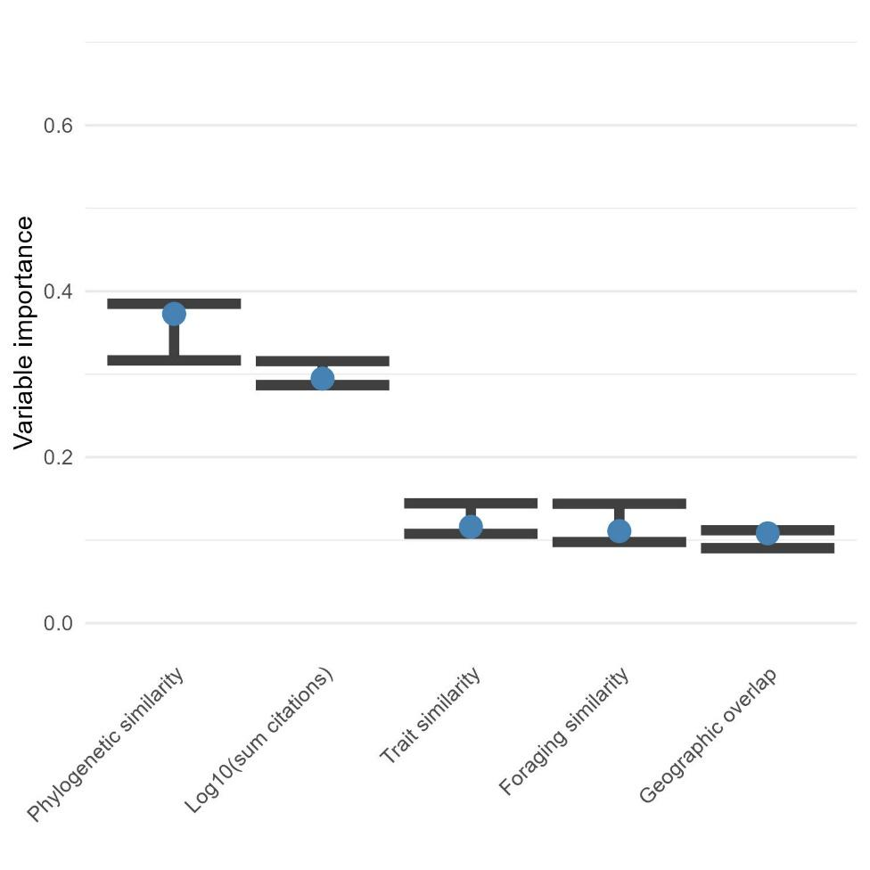
Supplementary Figure 1. Variable importance scores for the predictors used to model viral sharing among mammals. The points indicate the median improvement in accuracy contributed by each predictor variable, while error bars indicate the first and third quartile across 10 model iterations.

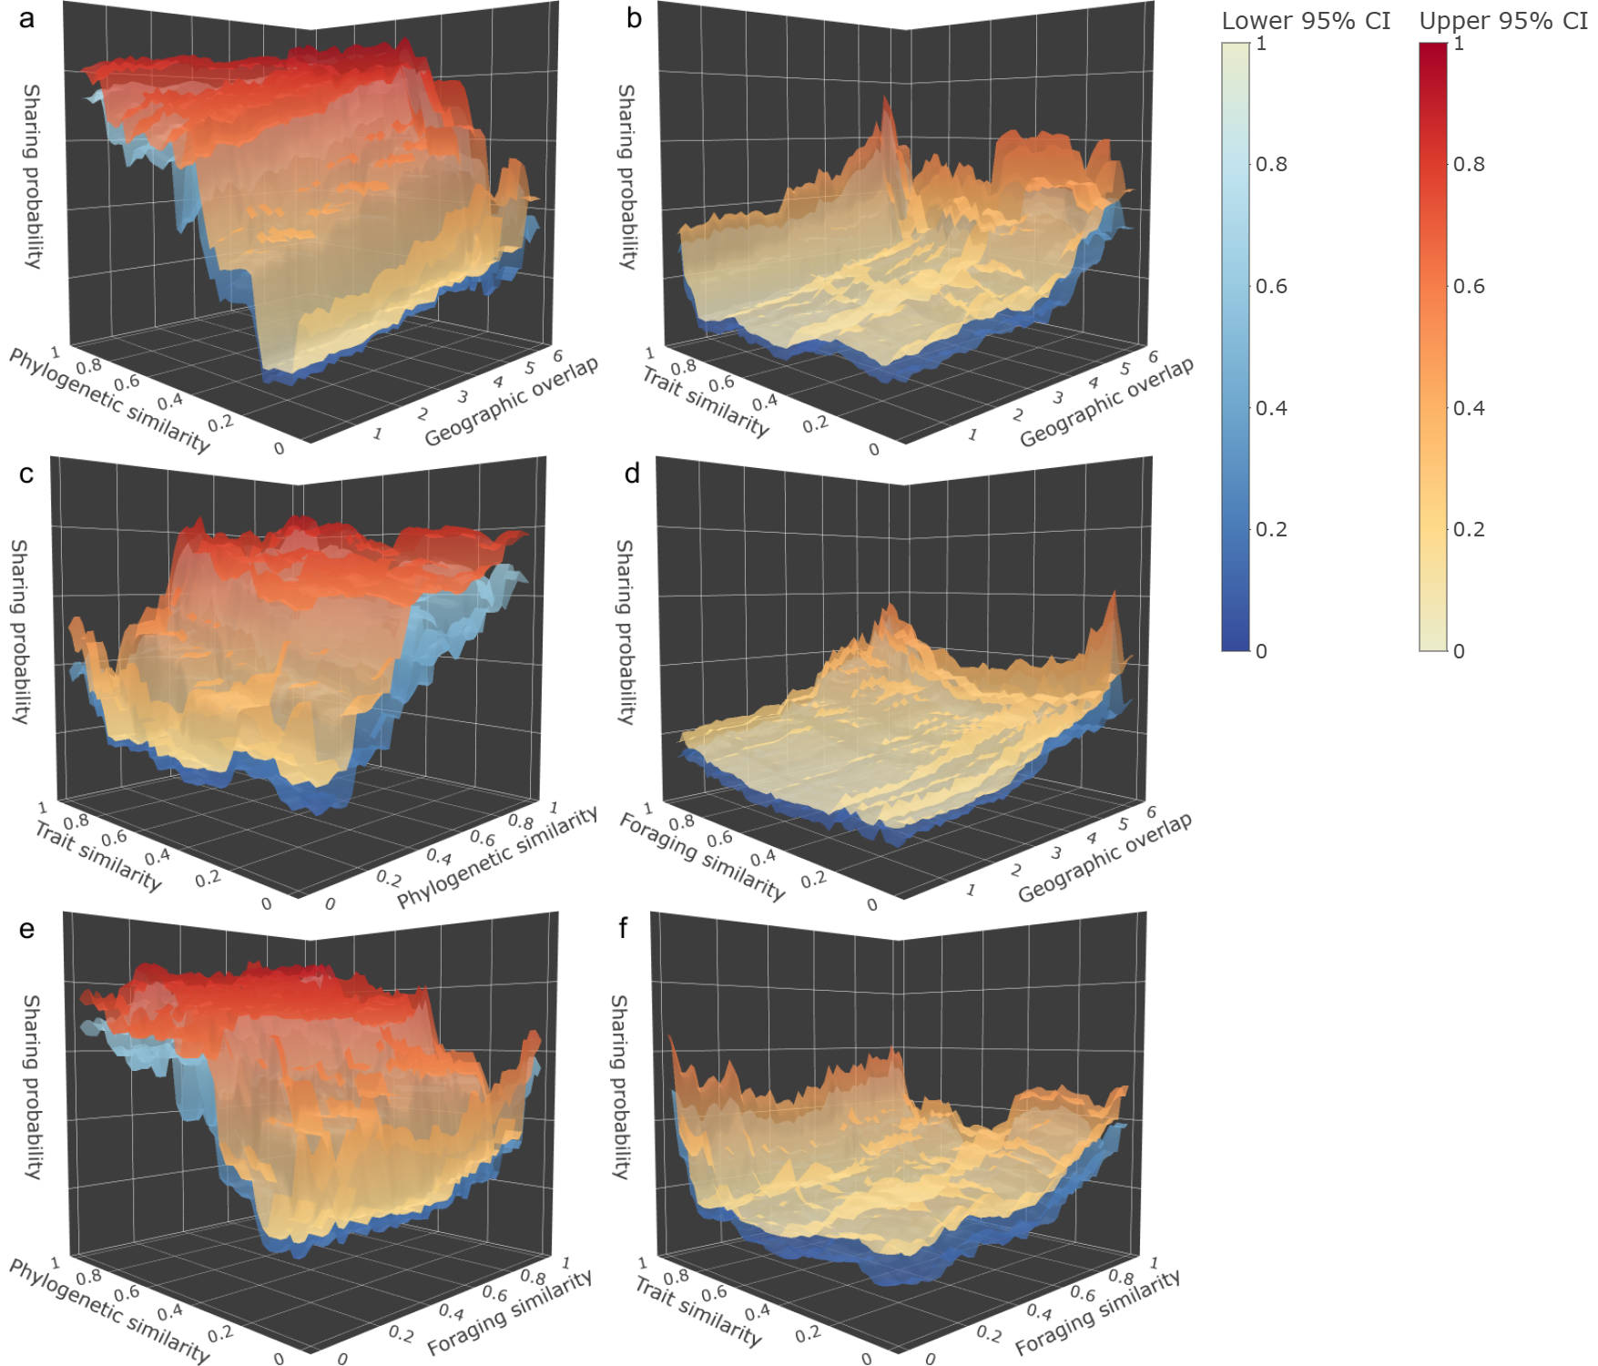

Supplementary Figure 2. Upper and lower bounds of the 95% CI around the average estimates of viral sharing probability for different combinations of predictor variables. The surfaces show the effect on viral sharing of the interaction between phylogenetic similarity (a, c, e), geographic overlap (a, b, d), foraging similarity (d, e, f), trait similarity (b, c, f), net of the interaction with other predictors.

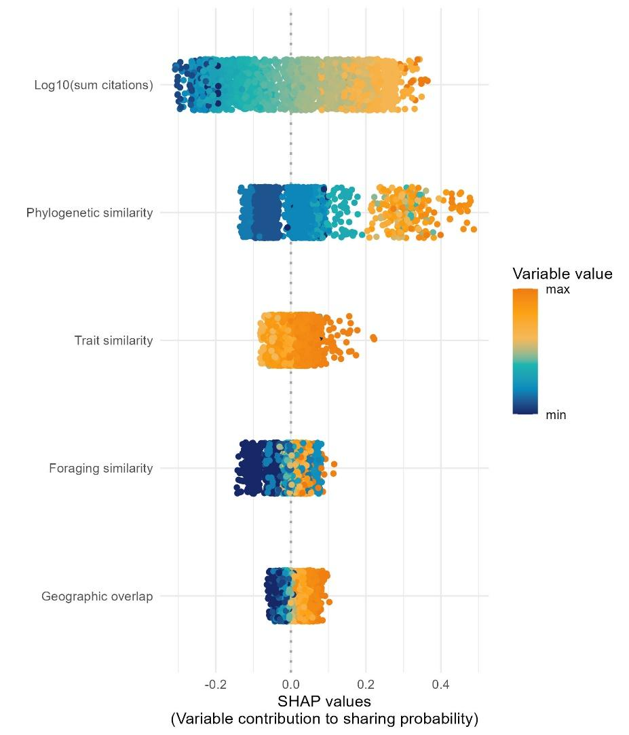
Supplementary Figure 3. Distribution of the marginal contribution of each feature to the predicted viral sharing probability (SHAP values) across 3,153 alien-native pairs. Positive SHAP values indicate a positive contribution to the predicted sharing probability, while negative values indicate a negative contribution. Each point corresponds to an alien-native pair, colored by the value of the predictor variable. Overall, increasing values of research effort, phylogenetic, trait and foraging similarities and geographic overlap gave a positive contribution to viral sharing probability. Variables are arranged by overall contribution, quantified as the absolute sum of SHAP values across all species pairs.

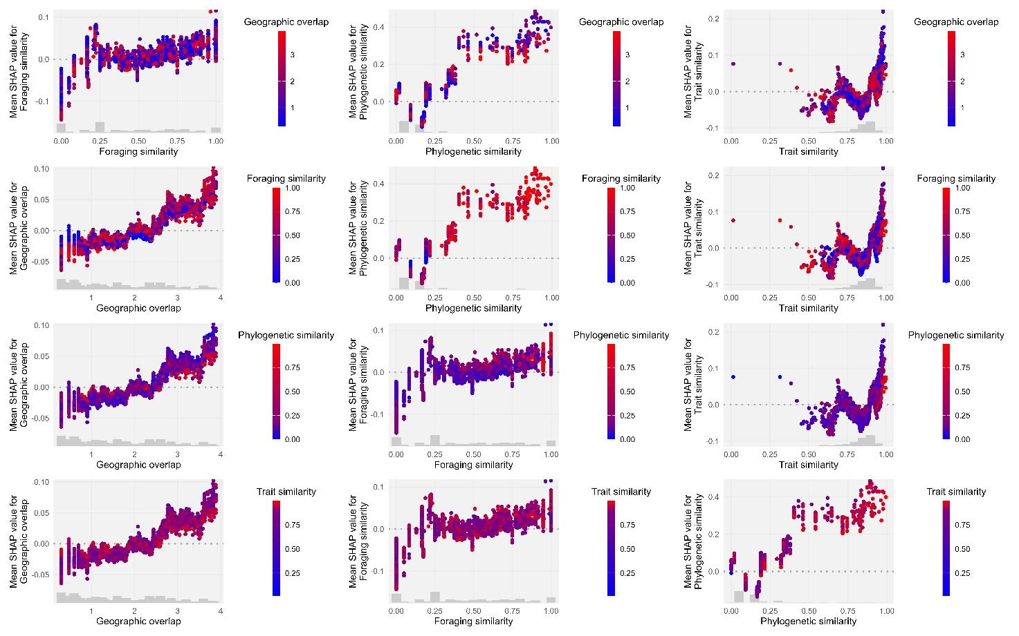
Supplementary Figure 4. Trends of the marginal contribution of each feature to the predicted viral sharing probability (SHAP values) in interaction with other features. Each plot shows the trend of SHAP values for a given feature (y axis) for different values of that feature (x axis) and a third feature (color). These plots highlight complex interactions between predictors, in which the marginal contribution of a feature may be modulated by other features.

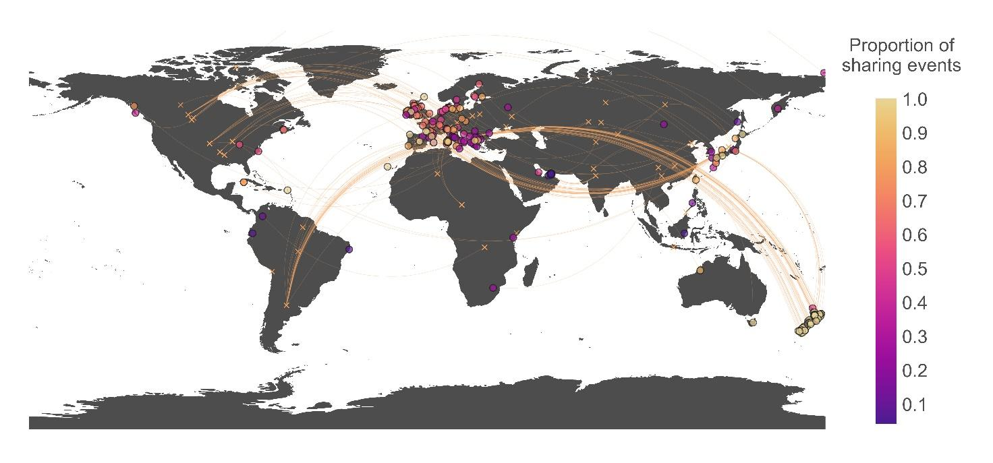
Supplementary Figure 5. The map shows the proportion of viral sharing events on the number of novel alien-native encounters. Lines connect the centroids of native (crosses) and alien (circles) ranges of 67 species that established alien populations outside of their native range in the past 50 years. Circle color indicates the proportion of realized sharing events associated with each introduction event, with brighter colors denoting higher counts.

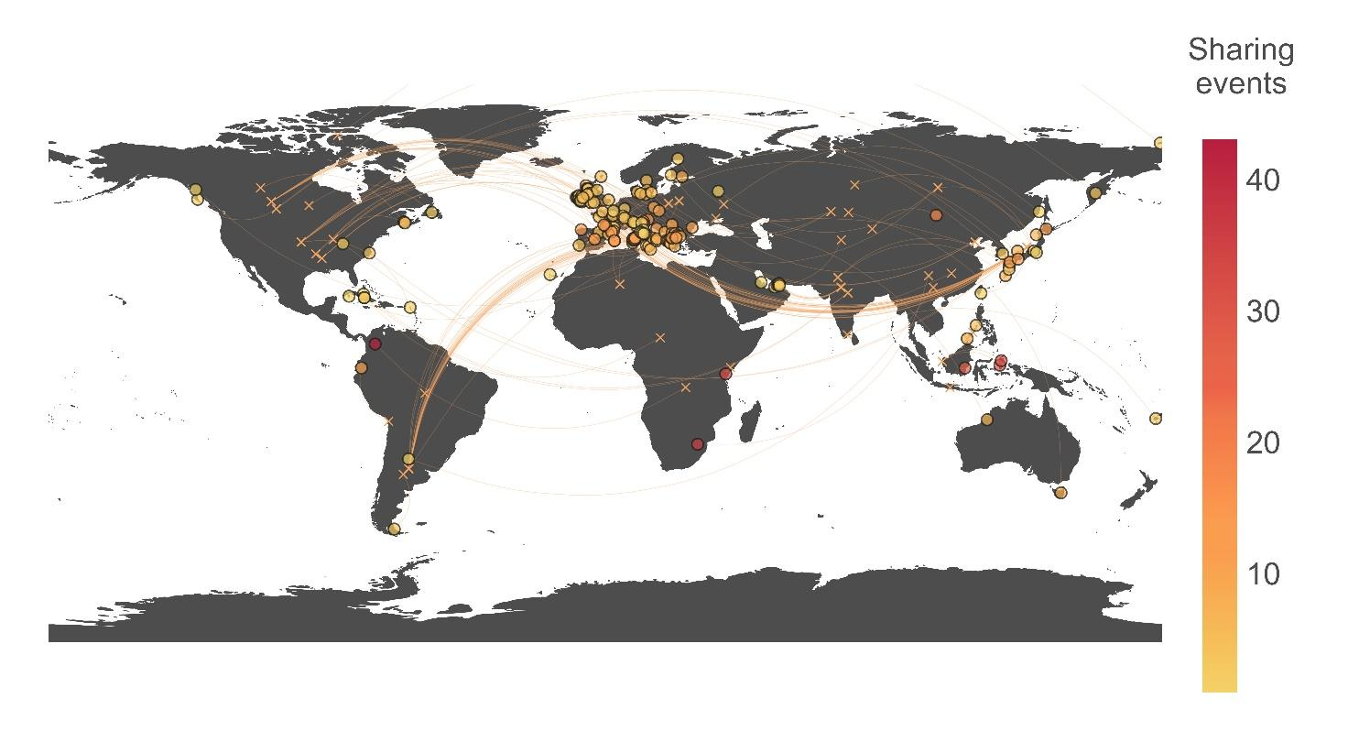
Supplementary Figure 6. The map shows predicted viral sharing events between alien and native mammal species, assuming equal research effort across all species pairs (see Methods). Lines connect the centroids of native (crosses) and alien (circles) ranges of 67 species that established alien populations outside of their native range in the past 50 years. Circle colour indicates the number of predicted sharing events associated with each introduction event, with darker red denoting higher counts.

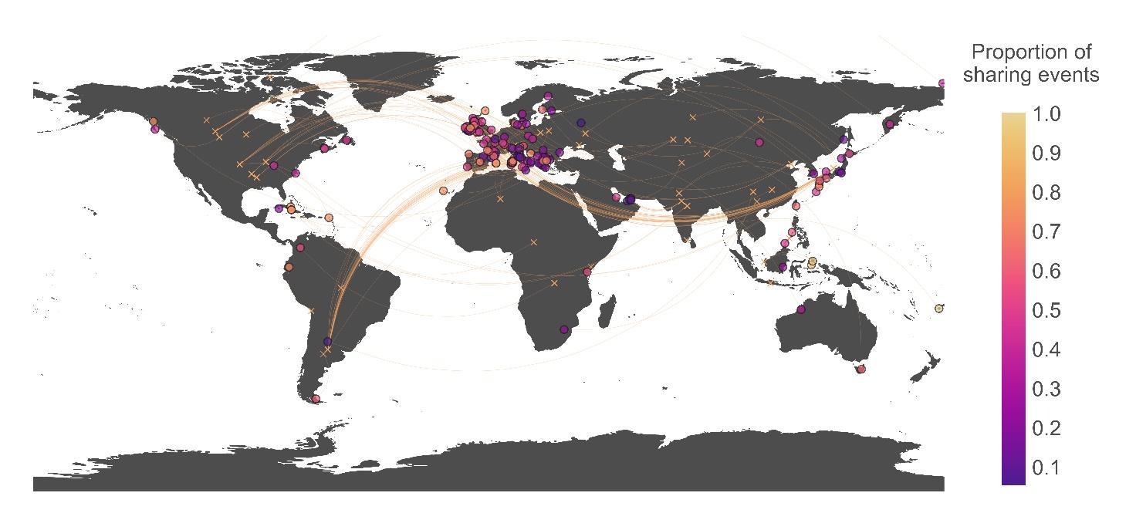
Supplementary Figure 7. The map shows the proportion of viral sharing events on the number of novel alien-native encounters, assuming equal research effort across all species pairs (see Methods). Lines connect the centroids of native (crosses) and alien (circles) ranges of 67 species that established alien populations outside of their native range in the past 50 years. Circle color indicates the proportion of realized sharing events associated with each introduction event, with brighter colors denoting higher counts.

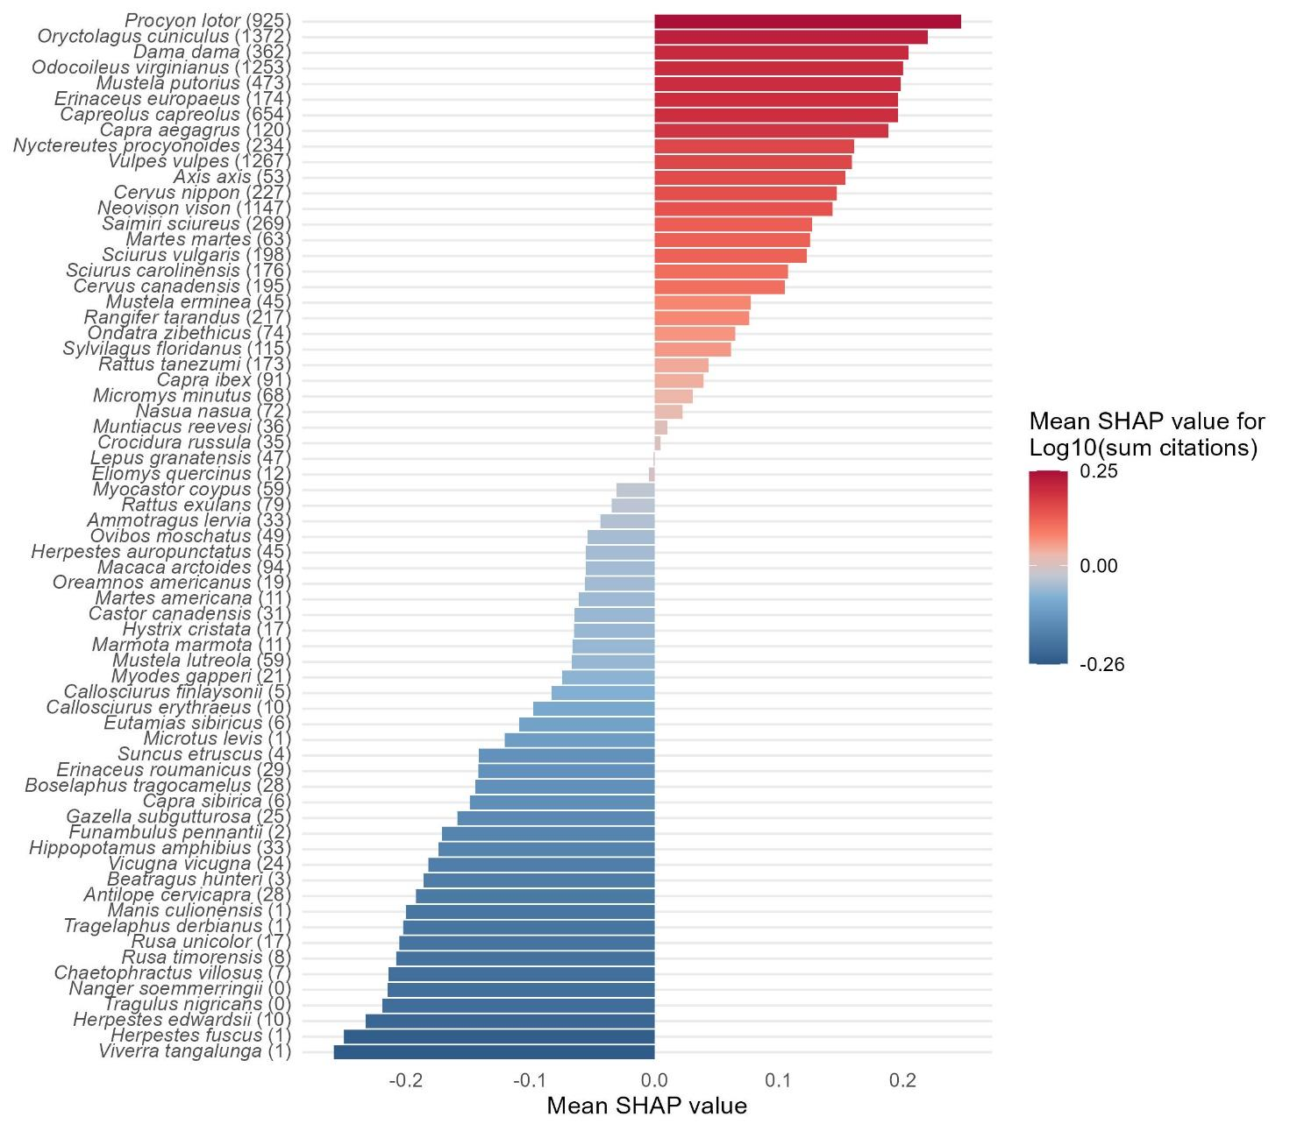
Supplementary Figure 8. Averages of the marginal contribution of research effort (sum of the number of citations for alien-native pairs) to the predicted viral sharing probability (SHAP values) for each of the 60 alien species. Brighter colors indicate a stronger contribution (red positive, blue negative) of research effort to the probabilities of viral sharing for a given alien species, averaged across all its potential sharing events. The species-level number of citations is reported in brackets for each alien species.

Supplementary References
1. Chen, T. & Guestrin, C. XGBoost: A Scalable Tree Boosting System. in Proceedings of the 22nd ACM SIGKDD International Conference on Knowledge Discovery and Data Mining 785–794 (Association for Computing Machinery, New York, NY, USA, 2016). doi:10.1145/2939672.2939785.

