Supplemental files
Contents
Supplement 1: Search strategy 2
Supplement 2: Study characteristics 3
Supplement 3: Risk of bias assessments 11
Supplement 4: Pairwise meta-analyse 13
Supplement 5: Heterogeneity assessments 14
Supplement 6: Intransitivity assessments 16
Supplement 7: Inconsistency (incoherence) assessments 17
Supplement 8: Forest plot of all studies 20
Supplement 9: Comparison-adjusted funnel plots 21
Supplement 10: Network meta-regression 22

Supplement 1: Search strategy
Search level | Search terms with Boolean operators
Search#1 | “caffeine*” OR “coffein*” OR “coffee” OR “chewing  gum” OR “gum chewing” OR “caffeine capsule” OR “caffeine mouth rinse”
Search#2 | #1 AND (“Endurance” OR “exercise” OR “running” OR “Performance” OR “Athletic performance” OR “aerobic capacity” OR “Time trial” OR “time to exhaustion”)
Search#3 | #2 NOT (“patient” OR “patients”)

Supplement 2: Study characteristics
Study | Sample | Age  (years) | $\dot{V}$O_{2max} (ml/min/kg) | Caffeine does  (mg/kg) | Timing (min) | Habitual caffeine intake (mg/day) | Caffeine withdrawal (h) | Caffeine form | Mode of exercise | Performance levels | Exercise protocol | Total exercise duration (min) | performance % change  (Time) | performance % change  (MPO)
Ghaderi et al. a 2013 | 15 M | 21 ± 4 | n/a | 5 | 5 | n/a | 24 | Gum | Running | Recreational | 1.5 Km TT | 5.7 | -2.8% | n/a
Ghaderi et al. b 2013 | 15 M | 21 ± 4 | n/a | 5 | 35 | n/a | 24 | Capsules | Running | Recreational | 1.5 Km TT | 5.7 | -2.3% | n/a
Skinner et al. a 2010 | 10 M | 20 ± 1 | 58.1 ± 6.8 | 2 | 60 | n/a | 24 | Capsules | Rowing | Competitive | 2 Km TT | 6.7 | -0.3% | 1.1%
Skinner et al. b 2010 | 10 M | 20 ± 1 | 58.1 ± 6.8 | 4 | 60 | n/a | 24 | Capsules | Rowing | Competitive | 2 Km TT | 6.7 | -0.7% | 1.7%
Skinner et al. c 2010 | 10 M | 20 ± 1 | 58.1 ± 6.8 | 6 | 60 | n/a | 24 | Capsules | Rowing | Competitive | 2 Km TT | 6.7 | -0.3% | 0.9%
Carr et al. 2011 | 6 M / 2 F | n/a | n/a | 6 | 30 | n/a | 48 | Capsules | Rowing | Recreational | 2 Km TT | 6.7 | -0.7% | 2.3%
Gharaat et al. a 2020 | 9 M | 18 ± 1 | 51.4 ± 3.9 | 3 | 30 | < 50 | n/a | Capsules | Rowing | Recreational | 2 Km TT | 6.9 | -1.0% | 3.4%
Gharaat et al. b 2020 | 9 M | 18 ± 1 | 51.4 ± 3.9 | 6 | 30 | < 50 | n/a | Capsules | Rowing | Recreational | 2 Km TT | 6.8 | -2.7% | 7.6%
Khcharem et al. 2021 | 13 M | 21 ± 1 | 51.3 ± 6.1 | 3 | 60 | 28.2 ± 11.6 | 48 | Capsules | Running | Recreational | 3 Km TT | 10.1 | -1.1% | n/a
Santos et al. 2013 | 8 M | 32 ± 5 | 57.5 ± 5.8 | 5 | 60 | n/a | 24 | Capsules | Cycling | Recreational | 4 Km TT | 6.8 | -2.3% | 5.9%
Felippe et al. 2018 | 11 M | 34 ± 4 | 55 ± 4 | 5 | 60 | n/a | 24 | Capsules | Cycling | Recreational | 4 Km TT | 6.6 | -1.6% | 12.0%
Tomazini et al. 2022 | 11 M | 33 ± 7 | 56.1 ± 13.2 | 5 | 60 | 171 ± 143 | 24 | Capsules | Cycling | Recreational | 4 Km TT | 6.1 | -0.9% | 2.1%
Viana et al. 2020 | 9 M | 32 ± 8 | 55 ± 6.1 | 6 | 60 | 50 - 200 | 24 | Capsules | Cycling | Recreational | 4 Km TT | 5.8 | -2.0% | 7.6%
Couto et al. 2022 | 9 M | 32 ± 6 | 55.2 ± 5.7 | 5 | 60 | 86 ± 71 | 24 | Capsules | Cycling | Recreational | 4 Km TT | 6.1 | -1.8% | n/a
Khcharem et al. 2020 | 10 M | 21 ± 1 | 51.3 ± 6.4 | 5 | 60 | 28.2 ± 11.6 | n/a | Capsules | Running | Recreational | 8 Km TT | 33.2 | -2.4% | n/a
Griest et al. a 2023 | 11 M / 4 F | 39 ± 15 | 54.2 ± 6.2 | 6 | 60 | < 500 | 0 | Capsules | Cycling | Recreational | 10 Km TT | 18.2 | -0.4% | 1.9%
Griest et al. b 2023 | 11 M / 4 F | 39 ± 15 | 54.2 ± 6.2 | 6 | 60 | < 500 | 24 | Capsules | Cycling | Recreational | 10 Km TT | 18.1 | -4.3% | 8.5%
Graham-Paulson et al. 2016 | 11 M | 24 ± 4 | 42.9 ± 7.3 | 4 | 45 | 160 ± 160 | 24 | Capsules | Cycling | Recreational | 30 min 65% $\dot{V}$O_{2max}; 10 Km TT | 46.6 | -2.1% | n/a
Saunders et al. 2016 | 42 M | 37 ± 8 | 50 ± 6.8 | 6 | 60 | n/a | n/a | Capsules | Cycling | Recreational | 16 Km TT | n/a | n/a | 2.6%
Bortolotti et al. 2014 | 13 M | 26 ± 10 | n/a | 6 | 60 | n/a | 48 | Capsules | Cycling | Recreational | 20 Km TT | 36.4 | -0.5% | -1.1%
Glaister et al. 2015 | 14 F | 31 ± 7 | 52.3 ± 4.9 | 5 | 60 | 249 ± 131 | 24 | Capsules | Cycling | Recreational | 20 Km TT | 34.6 | -2.1% | 5.4%
Skinner et al. 2013 | 14 M | 31 ± 5.2 | 69.5 ± 6.1 | 6 | 60 | n/a | 48 | Capsules | Cycling | Competitive | 40 Km TT | 58.5 | -1.1% | n/a
Potgieter et al. a 2018 | 14 M | 37 ± 10 | n/a | 6 | 60 | 413 ± 5.5 | 48 | Capsules | Triathlon | Recreational | 1.5 Km swim; 40 Km cycle; 10 Km run | 144.5 | -1.8% | n/a
Potgieter et al. b 2018 | 12 F | 37 ± 10 | n/a | 6 | 60 | 413 ± 5.5 | 48 | Capsules | Triathlon | Recreational | 1.5 Km swim; 40 Km cycle; 10 Km run | 157.8 | -0.9% | n/a
Desbrow et al. a 2012 | 16 M | 32 ± 8 | 60.4 ± 4.1 | 3 | 90 | 210 ± 115 | 24 | Capsules | Cycling | Competitive | 0.75 × W_{max} × 3600 KJ TT | 62.3 | -4.2% | n/a
Desbrow et al. b 2012 | 16 M | 32 ± 8 | 60.4 ± 4.1 | 6 | 90 | 210 ± 115 | 24 | Capsules | Cycling | Competitive | 0.75 × W_{max} × 3600 KJ TT | 63.2 | -2.8% | n/a
Irwin et al. a 2011 | 12 M | 28 ± 5 | 63.7 ± 7.4 | 3 | 90 | 240 ± 162 | 96 | Capsules | Cycling | Recreational | 0.75 ×$\dot{V}$O_{2max} × 1100 KJ TT | 58.1 | -3.0% | 3.3%
Irwin et al. b 2011 | 12 M | 28 ± 5 | 63.7 ± 7.4 | 3 | 90 | 240 ± 162 | n/a | Capsules | Cycling | Recreational | 0.75 ×$\dot{V}$O_{2max} × 1100 KJ TT | 57.7 | -3.5% | 3.9%
Wallman et al. 2010 | 10 F | 22 ± 2 | n/a | 6 | 60 | < 100 | 48 | Capsules | Cycling | Recreational | 15 min 65% HR_{max}; 10 min TT | 25.0 | n/a | 5.6%
Barreto et al. 2020 | 15 M | 38 ± 8 | 51.1 ± 7.1 | 6 | 60 | < 200 | 24 | Capsules | Cycling | Recreational | 25 min TT | 25.0 | n/a | 2.4%
Conway et al. 2002 | 8 M | 25 ± 5 | 72 ± 3.9 | 6 | 60 | < 250 | 48 | Capsules | Cycling | Competitive | 90 min 70% $\dot{V}$O_{2max}; 30 min TT | 113.8 | -15.9% | n/a
Laurence et al. 2012 | 12 M | 25 ± 2 | n/a | 6 | 60 | n/a | 48 | Capsules | Cycling | Recreational | 30 min TT | 30.0 | n/a | 0.3%
Ruiz-Moreno et al. 2022 | 11 M / 4 F | 29 ± 6 | 49.3 ± 10.4 | 3 | 60 | n/a | n/a | Capsules | Cycling | Recreational | 60 min TT | 60.0 | n/a | 10.3%
Vinícius et al. 2025 a | 13 M | 36.2 ± 3.3 | n/a | 5 | 50 | 458.6 ± 375.5 | n/a | Capsules | Cycling | Competitive | 4 Km TT |  | -1.9% | n/a
Vinícius et al. 2025 b | 13 M | 36.2 ± 3.3 | n/a | 5 | 50 | 458.6 ± 375.5 | n/a | Capsules | Cycling | Competitive | 4 Km TT | 6.2 | -0.5% | n/a
Vinícius et al. 2025 c | 13 M | 36.2 ± 3.3 | n/a | 5 | 80 | 458.6 ± 375.5 | n/a | Capsules | Cycling | Competitive | 4 Km TT | 6.2 | -0.5% | n/a
Vinícius et al. 2025 d | 13 M | 36.2 ± 3.3 | n/a | 5 | 80 | 458.6 ± 375.5 | n/a | Capsules | Cycling | Competitive | 4 Km TT | 6.2 | -0.5% | n/a
Farhadi et al. a 2011 | 15 M | 21 ± 4 | n/a | 3 | 5 | n/a | 24 | Gum | Running | Recreational | 1.5 Km TT | 5.6 | -4.3% | n/a
Farhadi et al. b 2011 | 15 M | 21 ± 4 | n/a | 4 | 5 | n/a | 24 | Gum | Running | Recreational | 1.5 Km TT | 5.6 | -4.0% | n/a
Farhadi et al. c 2011 | 15 M | 21 ± 4 | n/a | 5 | 5 | n/a | 24 | Gum | Running | Recreational | 1.5 Km TT | 5.7 | -2.8% | n/a
Whalley. a 2020 | 10 M / 4 F | 40 ± 8 | n/a | 4 | 10 | < 400 | 24 | Gum | Running | Recreational | 5 Km TT | 20.5 | -1.1% | n/a
Whalley. b 2020 | 10 M / 4 F | 40 ± 8 | n/a | 4 | 60 | < 400 | 24 | Capsules | Running | Recreational | 5 Km TT | 20.3 | -2.1% | n/a
Lynn et al. 2024 | 36 M | 33.7 ± 10.7 | n/a | 4 | 30 | n/a | 24 | Gum | Running | Recreational | 5 Km TT | 22.0 | -3.6% | n/a
Oberlin-Brown et al. 2016 | 11 M | 32 ± 7 | 60.2 ± 4 | 3 | 5 | n/a | 24 | Gum | Cycling | Recreational | 20 Km TT | 32.3 | -0.4% | n/a
Lane et al. a 2014 | 12 M | 31 ± 7 | 71.6 ± 4.6 | 3 | 40 | n/a | 24 | Gum | Cycling | Competitive | 43.83 Km TT | 62.7 | -1.3% | 3.2%
Lane et al. b 2014 | 12 F | 28 ± 6 | 59.9 ± 5.1 | 3 | 40 | n/a | 24 | Gum | Cycling | Competitive | 29.53 KM TT | 50.8 | -1.6% | 4.2%
Ryan et al. a 2013 | 8 M | 25 ± 5 | 50 ± 5 | 4 | 5 | n/a | n/a | Gum | Cycling | Recreational | 15 min 75% $\dot{V}$O_{2max}; 700 KJ TT | 53.7 | -4.9% | n/a
Ryan et al. b 2013 | 8 M | 25 ± 5 | 50 ± 5 | 4 | 60 | n/a | n/a | Gum | Cycling | Recreational | 15 min 75% $\dot{V}$O_{2max}; 700 KJ TT | 56.8 | 2.7% | n/a
Ryan et al. c 2013 | 8 M | 25 ± 5 | 50 ± 5 | 4 | 120 | n/a | n/a | Gum | Cycling | Recreational | 15 min 75% $\dot{V}$O_{2max}; 700 KJ TT | 57.6 | 4.7% | n/a
Algrain et al. a 2016 | 11 | 23 ± 2 | 31.9 ± 1.8 | 4 | 5 | < 300 | 48 | Gum | Cycling | Recreational | 15 min 75% $\dot{V}$O_{2max}; 15 min TT | 30.0 | n/a | 2.3%
Algrain et al.b 2016 | 9 | 26 ± 1 | 31.7 ± 2.7 | 4 | 5 | < 300 | 48 | Gum | Cycling | Recreational | 15 min 75% $\dot{V}$O_{2max}; 15 min TT | 30.0 | n/a | 3.6%
O’Rourke et al. a 2008 | 15 M | 32 ± 8 | n/a | 5 | 60 | n/a | 48 | Capsules | Running | Recreational | 5 Km TT | 17.5 | -1.0% | n/a
O’Rourke et al. b 2008 | 15 M | 29 ± 5 | n/a | 5 | 60 | n/a | 48 | Capsules | Running | Recreational | 5 Km TT | 21.4 | -0.9% | n/a
Christensen et al. 2014 | 11 M / 1 F | 25 ± 3 | n/a | 3 | 45 | < 200 | 36 | Capsules | Rowing | Competitive | 6 min TT | 6.0 | n/a | 1.8%
Jenkins et al. a 2008 | 13 M | 26 ± 6 | 55.2 ± 7.2 | 2 | 60 | 132 ± 41 | 48 | Capsules | Cycling | Competitive | 15 min 80% $\dot{V}$O_{2max}; 15 min TT | 30.0 | n/a | 3.9%
Jenkins et al. b 2008 | 13 M | 26 ± 6 | 55.2 ± 7.2 | 3 | 60 | 132 ± 41 | 48 | Capsules | Cycling | Competitive | 15 min 80% $\dot{V}$O_{2max}; 15 min TT | 30.0 | n/a | 3.0%
Boat et al. 2021 | 15 M | 22 ± 2 | n/a | 3 | 10 s | n/a | 24 | Mouth- rinse | Cycling | Recreational | 10 Km TT | 16.5 | -0.6% | n/a
Figueiredo et al. 2021 | 8 M / 2 F | 30 ± 6 | n/a | 4 | 10 s | n/a | 48 | Mouth- rinse | Running | Recreational | 10 Km TT | 47.5 | 0.8% | n/a
Lesniak et al. 2016 | 7 F | 21 ± 1 | 37.99 ± 0.92 | 5 | 5 s | n/a | 24 | Mouth- rinse | Cycling | Recreational | 0.6 × W_{max} × 3600 KJ TT | 61.6 | 0.1% | -0.4%
Bottoms et al. 2014 | 12 M | 20 ± 1 | n/a | 2 | 5 s | n/a | 24 | Mouth- rinse | Cycling | Recreational | 30 min TT | 30.0 | n/a | 6.4%
Doering et al. 2014 | 10 M | 32 ± 7 | 59.8 ± 3.5 | 4 | 10 s | n/a | 24 | Mouth- rinse | Cycling | Recreational | 60 min TT | 65.3 | -0.6% | n/a
Acker-Hewitt et al. 2012 | 12 M | 28 ± 9 | 66 ± 9 | 6 | 60 | n/a | 24 | Capsules | Cycling | Competitive | 20 min 60% W_{max}; 20 Km TT | 63.6 | -1.4% | 3.80%
Spence et al. 2013 | 10 M | 30 ± 2 | 59 ± 2 | 2.5 | 60 | n/a | 48 | Capsules | Cycling | Competitive | 10 min 55% W_{max}; 10 Km TT | 28.0 | -4.5% | 9.30%
Goncalves et al. a 2017 | 14 M | 34 ± 9 | 50 ± 9 | 6 | 60 | 58 ± 29 | 24 | Capsules | Cycling | Competitive | 0.85 × W_{max} ×1500 KJ TT | 30.3 | −1.6% | n/a
Goncalves et al. b 2017 | 12 M | 37 ± 7 | 51 ± 6 | 6 | 60 | 143 ± 25 | 24 | Capsules | Cycling | Competitive | 0.85 × W_{max} ×1500 KJ TT | 29.7 | −3.7% | n/a
Goncalves et al. c 2017 | 14 M | 37 ± 8 | 51 ± 8 | 6 | 60 | 351 ± 139 | 24 | Capsules | Cycling | Competitive | 0.85 × W_{max} ×1500 KJ TT | 30.4 | −1.4% | n/a
Kilding et al. 2013 | 10 M | 24 ± 5 | n/a | 3 | 60 | n/a | 24 | Capsules | Cycling | Competitive | 20 min 60–65% MPO; 3 Km TT | 23.8 | -1.0% | 2.10%
Quinlivan et al. 2015 | 11 M | 32 ± 6 | 61 ± 8 | 3 | 90 | 271 ± 295 | 24 | Capsules | Cycling | Competitive | 0.75 × W_{max} ×3600 KJ TT | 62.6 | -3.1% | 2.80%
Larson et al. 2018 | 9 M | 34 ± 11 | 61 ± 6 | 5 | 60 | 100–400 | 12 | Capsules | Cycling | Competitive | 20 Km TT | 33.2 | -3.9% | 4.40%
Santos et al. a 2020 | 8 M | 35 ± 5 | 57 ± 8 | 5 | 60 | n/a | 24 | Capsules | Cycling | Competitive | 4 Km TT | 6.1 | -1.5% | 4.30%
Santos et al. b 2020 | 8 M | 35 ± 4 | 49 ± 10 | 5 | 60 | n/a | 24 | Capsules | Cycling | Competitive | 4 Km TT | 6.7 | -2.5% | 6.50%
“a”, “b”, “c”, “d” represents the number of trials of the same study. F: Females, M: Males, KJ: Kilojoules. MPO: mean power output, n/a: no available, Time: completion time, Timing: time of ingestion before the experimental session, TT: time trail, $\dot{V}$O_{2max}: maximal oxygen uptake, W_{max}: work rate max.

Supplement 3: Risk of bias assessments
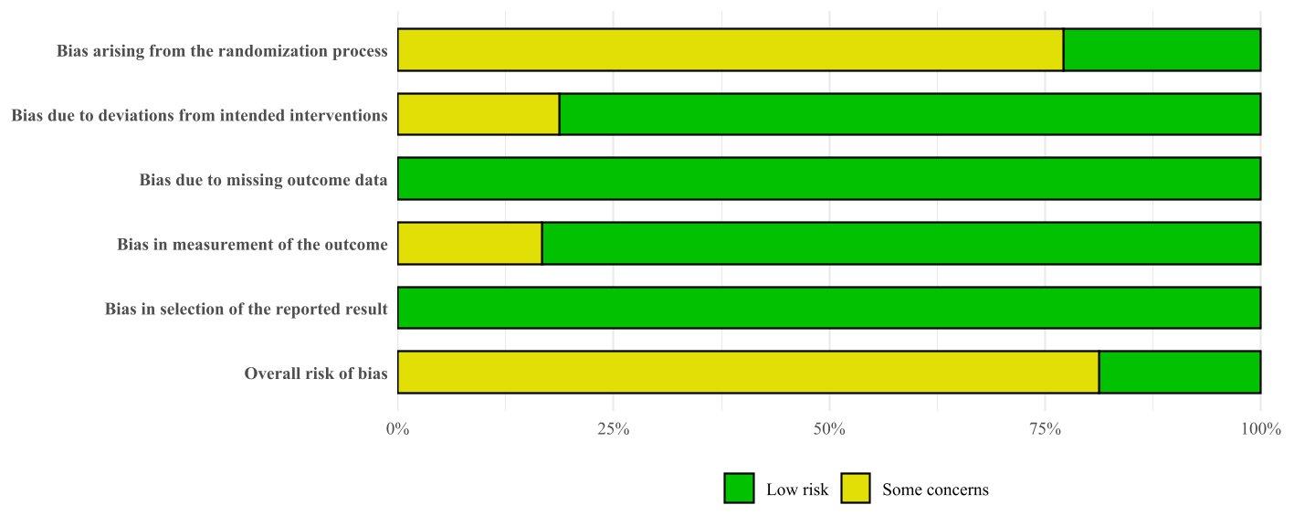
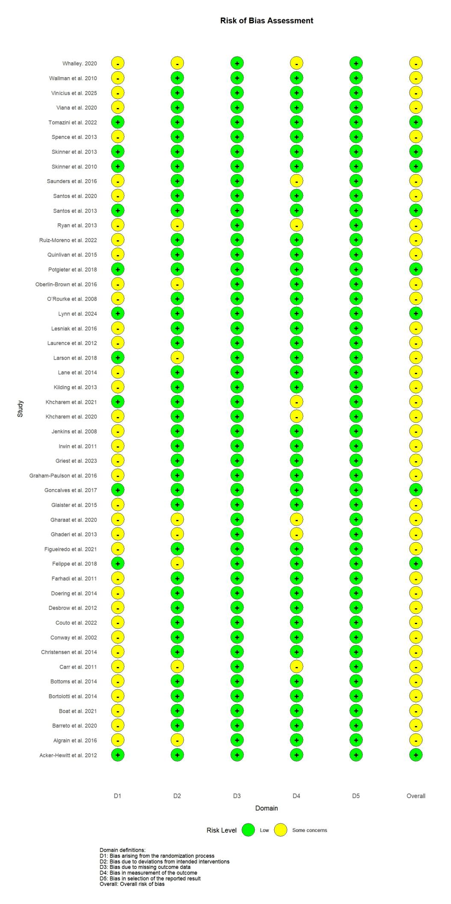

Supplement 4: Pairwise meta-analyse
Comparison | Number of studies | SMD (95% CrI) | I²
Completion time
Low-dose gum vs Placebo | 4 | -0.34 (-0.74, 0.05) | 0
Low-dose capsules vs Placebo | 9 | -0.34 (-0.62, -0.06) | 0
Moderate-dose capsules vs Placebo | 35 | -0.31 (-0.44, -0.17) | 0
Moderate-dose gum vs Placebo | 8 | -0.28 (-0.57, -0.01) | 0
Low-dose mouth rinse vs Placebo | 1 | -0.26 (-0.98, 0.46) | 0
Moderate-dose mouth rinse vs Placebo | 3 | -0.00 (-0.54, 0.53) | 0
Mean power output
Low-dose mouth rinse vs Placebo | 1 | 0.39 (-0.42, 1.19) | 0
Low-dose capsules vs Placebo | 8 | 0.38 (0.09, 0.67) | 0
Moderate-dose capsules vs Placebo | 20 | 0.29 (0.10, 0.49) | 0
Low-dose gum vs Placebo | 5 | 0.17 (-0.41, 0.75) | 0
Moderate-dose gum vs Placebo | 3 | 0.24 (-0.25, 0.73) | 0
Moderate-dose mouth rinse vs Placebo | 1 | -0.05 (-1.10, 1.00) | 0
Note: Bolded numbers indicate the presence of significance. SMD: standardized mean differences. CrI: credible interval.

Supplement 5: Heterogeneity assessments
Outcomes | Design-based Q statistic, comparisons, and overall statement | Q statistic | Degree of freedom | P -value
Completion time | Design-specific decomposition of within-designs Q statistic
Completion time | Placebo: Moderate-dose gum | 4.41 | 5 | 0.4921
Completion time | Placebo: Low-dose gum | 1.20 | 3 | 0.7526
Completion time | Placebo: Moderate-dose capsules | 0.17 | 2 | 0.9187
Completion time | Placebo: Moderate-dose mouth rinse | 0.07 | 2 | 0.9670
Completion time | Placebo: Low-dose capsules | 1.10 | 8 | 0.9976
Completion time | Placebo: Moderate-dose capsules | 11.53 | 32 | 0.9997
Completion time | Between-designs Q statistic after detaching of single designs
Completion time | Placebo: Moderate-dose capsules | 0.17 | 1 | 0.6759
Completion time | Placebo: Moderate-dose gum | 0.20 | 1 | 0.6536
Completion time | Placebo: Moderate-dose capsules: Moderate-dose gum | 0.00 | 0 | --
Completion time | Q statistic to assess consistency under the assumption of a full design-by-treatment interaction random effects model: between designs Q statistic, 0.27; degree of freedom, 2; p-value, 0.8744; tau. within, 0; tau2.within, 0.
Mean power output | Design-specific decomposition of within-designs Q statistic
Mean power output | Placebo: Moderate-dose capsules | 14.22 | 19 | 0.7710
Mean power output | Placebo: Low-dose capsules | 2.89 | 7 | 0.8947
Mean power output | Placebo: Moderate-dose gum | 0.05 | 2 | 0.9733
Mean power output | Placebo: Low-dose gum | 0.19 | 4 | 0.9957
Mean power output | Q statistic to assess consistency under the assumption of a full design-by-treatment interaction random effects model: between designs Q statistic, 0.00; degree of freedom, 0; p-value, 0.00; tau. within, 0; tau².within, 0.

Supplement 6: Intransitivity assessments
 | $\dot{V}$O_{2max} | Age | Caffeine withdrawal | Sample size
Low-dose capsules | 56.18 ± 4.84 | 25.36 ± 4.17 | 43.15 ± 19.77 | 12.54 ± 1.96
Moderate-dose capsules | 55.22 ± 5.01 | 30.63 ± 6.56 | 34.06 ± 10.41 | 13.03 ± 5.82
Low-dose gum | 62.10 ± 8.71 | 28.00 ± 6.08 | 24.00 ± 0.00 | 12.66 ± 2.08
Moderate-dose gum | 49.63 ± 9.27 | 26.25 ± 5.87 | 31.15 ± 9.50 | 13.81 ± 7.96
Low-dose mouth rinse | 54.49 ± 0.00 | 21.00 ± 1.41 | 24.00 ± 0.00 | 13.50 ± 2.12
Moderate-dose mouth rinse | 50.76 ± 11.37 | 27.67 ± 5.85 | 32.00 ± 13.85 | 8.33 ± 1.52
Placebo | 54.49 ± 6.78 | 28.34 ± 6.30 | 34.25 ± 12.85 | 12.85 ± 5.45
P-value | P = 0.078 | P = 0.093 | P = 0.156 | P = 0.872
Data is presented as mean ± standard deviation.

Supplement 7: Inconsistency (incoherence) assessments
Completion time
Comparison | No.Studies | NMA | Direct | Indirect | Difference | Diff 95CI lower | Diff 95CI upper | P-value
Low-dose capsules: Low-dose gum | 0 | 0 | NA | 0 | NA | NA | NA | NA
Low-dose capsules: Low-dose mouth rinse | 0 | -0.08 | NA | -0.08 | NA | NA | NA | NA
Low-dose capsules: Moderate-dose capsules | 0 | -0.03 | NA | -0.03 | NA | NA | NA | NA
Low-dose capsules: Moderate-dose gum | 0 | -0.05 | NA | -0.05 | NA | NA | NA | NA
Low-dose capsules: Moderate-dose mouth rinse | 0 | -0.34 | NA | -0.34 | NA | NA | NA | NA
Low-dose capsules: Placebo | 9 | -0.34 | -0.34 | NA | NA | NA | NA | NA
Low-dose gum: Low-dose mouth rinse | 0 | -0.08 | NA | -0.08 | NA | NA | NA | NA
Low-dose gum: Moderate-dose capsules | 0 | -0.03 | NA | -0.03 | NA | NA | NA | NA
Low-dose gum: Moderate-dose gum | 0 | -0.05 | NA | -0.05 | NA | NA | NA | NA
Low-dose gum: Moderate-dose mouth rinse | 0 | -0.34 | NA | -0.34 | NA | NA | NA | NA
Low-dose gum: Placebo | 4 | -0.34 | -0.34 | NA | NA | NA | NA | NA
Low-dose mouth rinse: Moderate-dose capsules | 0 | 0.05 | NA | 0.05 | NA | NA | NA | NA
Low-dose mouth rinse: Moderate-dose gum | 0 | 0.03 | NA | 0.03 | NA | NA | NA | NA
Low-dose mouth rinse: Moderate-dose mouth rinse | 0 | -0.26 | NA | -0.26 | NA | NA | NA | NA
Low-dose mouth rinse: Placebo | 1 | -0.26 | -0.26 | NA | NA | NA | NA | NA
Moderate-dose capsules: Moderate-dose gum | 2 | -0.01 | 0 | -0.02 | 0.02 | -0.61 | 0.64 | 0.96
Moderate-dose capsules: Moderate-dose mouth rinse | 0 | -0.31 | NA | -0.31 | NA | NA | NA | NA
Moderate-dose capsules: Placebo | 35 | -0.31 | -0.31 | -0.46 | 0.15 | -0.98 | 1.28 | 0.8
Moderate-dose gum: Moderate-dose mouth rinse | 0 | -0.29 | NA | -0.29 | NA | NA | NA | NA
Moderate-dose gum: Placebo | 8 | -0.3 | -0.28 | -0.44 | 0.15 | -0.82 | 1.13 | 0.76
Moderate-dose mouth rinse: Placebo | 3 | 0 | 0 | NA | NA | NA | NA | NA
Mean power output
Comparison | No.Studies | NMA | Direct | Indirect | Difference | Diff 95CI lower | Diff 95CI upper | P-value
Low-dose capsules: Low-dose gum | 0 | 0.16 | NA | 0.16 | NA | NA | NA | NA
Low-dose capsules: Low-dose mouth rinse | 0 | -0.01 | NA | -0.01 | NA | NA | NA | NA
Low-dose capsules: Moderate-dose capsules | 0 | 0.08 | NA | 0.08 | NA | NA | NA | NA
Low-dose capsules: Moderate-dose gum | 0 | 0.14 | NA | 0.14 | NA | NA | NA | NA
Low-dose capsules: Moderate-dose mouth rinse | 0 | 0.43 | NA | 0.43 | NA | NA | NA | NA
Low-dose capsules: Placebo | 8 | 0.38 | 0.38 | NA | NA | NA | NA | NA
Low-dose gum: Low-dose mouth rinse | 0 | -0.16 | NA | -0.16 | NA | NA | NA | NA
Low-dose gum: Moderate-dose capsules | 0 | -0.08 | NA | -0.08 | NA | NA | NA | NA
Low-dose gum: Moderate-dose gum | 0 | -0.02 | NA | -0.02 | NA | NA | NA | NA
Low-dose gum: Moderate-dose mouth rinse | 0 | 0.28 | NA | 0.28 | NA | NA | NA | NA
Low-dose gum: Placebo | 5 | 0.22 | 0.22 | NA | NA | NA | NA | NA
Low-dose mouth rinse: Moderate-dose capsules | 0 | 0.09 | NA | 0.09 | NA | NA | NA | NA
Low-dose mouth rinse: Moderate-dose gum | 0 | 0.15 | NA | 0.15 | NA | NA | NA | NA
Low-dose mouth rinse: Moderate-dose mouth rinse | 0 | 0.44 | NA | 0.44 | NA | NA | NA | NA
Low-dose mouth rinse: Placebo | 1 | 0.39 | 0.39 | NA | NA | NA | NA | NA
Moderate-dose capsules: Moderate-dose gum | 0 | 0.06 | NA | 0.06 | NA | NA | NA | NA
Moderate-dose capsules: Moderate-dose mouth rinse | 0 | 0.35 | NA | 0.35 | NA | NA | NA | NA
Moderate-dose capsules: Placebo | 20 | 0.3 | 0.3 | NA | NA | NA | NA | NA
Moderate-dose gum: Moderate-dose mouth rinse | 0 | 0.29 | NA | 0.29 | NA | NA | NA | NA
Moderate-dose gum: Placebo | 3 | 0.24 | 0.24 | NA | NA | NA | NA | NA
Moderate-dose mouth rinse: Placebo | 1 | -0.05 | -0.05 | NA | NA | NA | NA | NA

Supplement 8: Forest plot of all studies
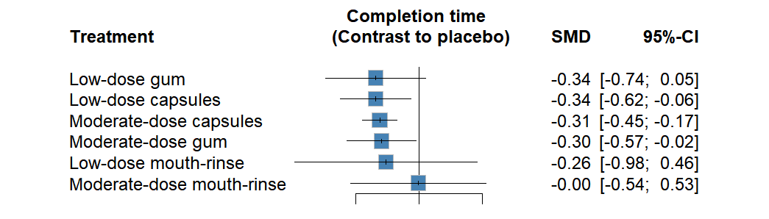

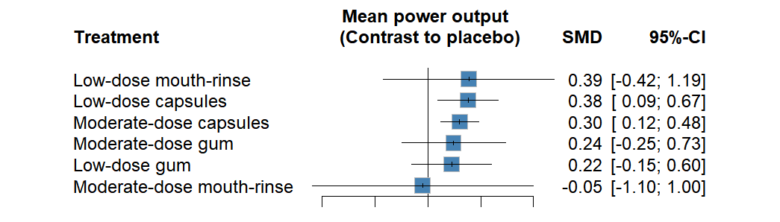

Supplement 9: Comparison-adjusted funnel plots
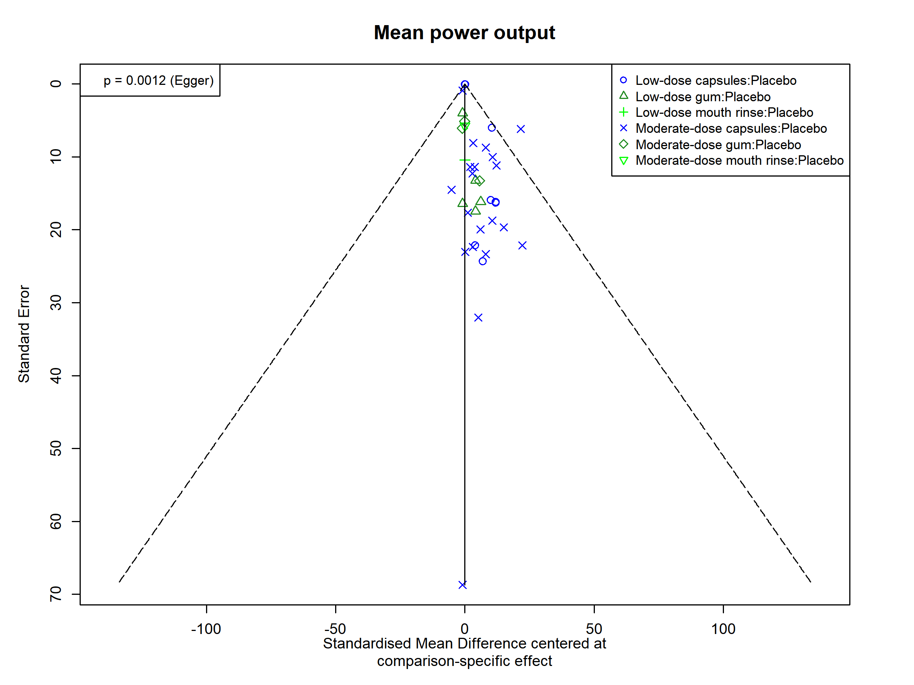
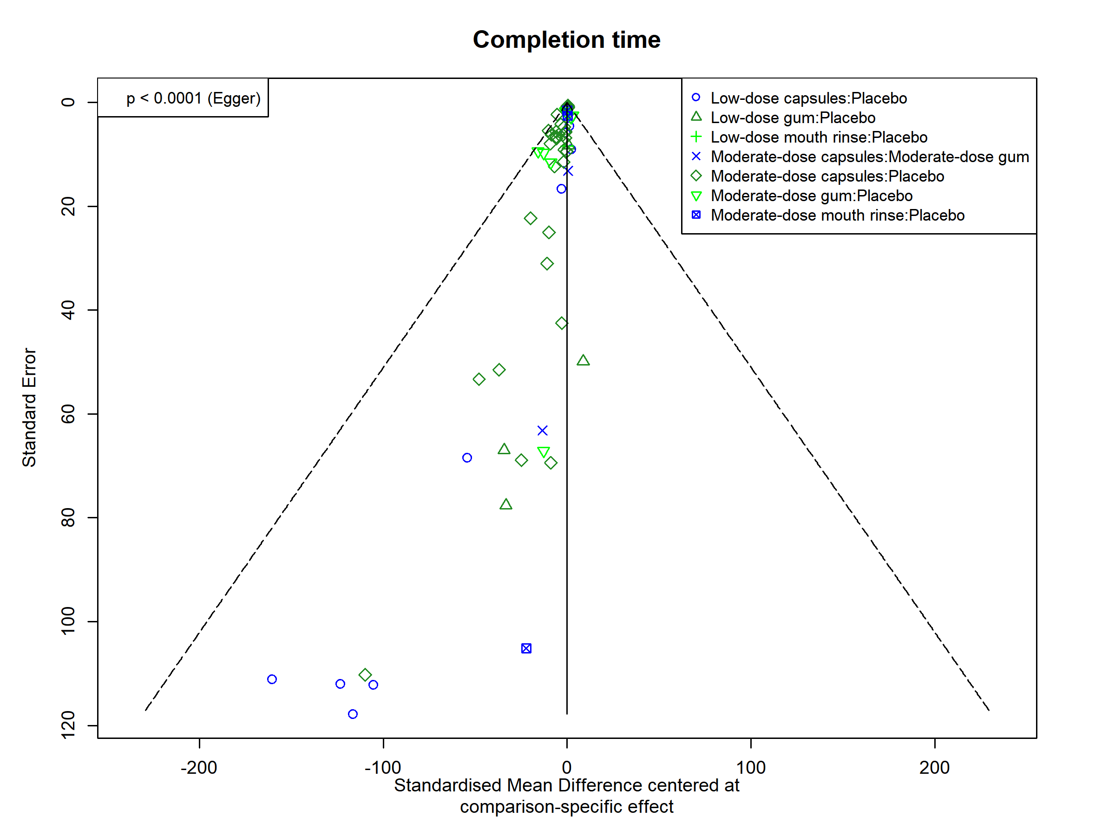

Supplement 10: Network meta-regression
Network meta-regression analyses of completion time and mean power output outcome were performed to investigate potential moderating variables. The network meta-regression model was fitted in a Bayesian framework using the Markov chain Monte Carlo (MCMC) method in the R statistical package “Gemtc”. Four chains were run using a non-informative prior. The number of iterations for each chain was 25,000, with the first 5,000 iterations discarded.
Covariate | Completion time
Covariate | DIC | pD | Residual  Deviance | Shared beta  (Median and 95% CrI) | SD
Age | 32.9 | 8.4 | 24.5 | 0.04 (-0.21, 0.29) | 0.12
$\dot{V}$O_{2max} | 32.7 | 8.3 | 24.4 | -0.02 (-0.29, 0.25) | 0.14
Exercise distance | 31.8 | 7.7 | 24.0 | 0.09 (-0.14, 0.34) | 0.12
Exercise duration | 32.1 | 7.9 | 24.2 | 0.06 (-0.18, 0.30) | 0.12
Ingestion timing | 28.7 | 5.6 | 23.1 | 0.19 (-0.13, 0.52) | 0.12
Exercise mode | 32.7 | 8.3 | 24.4 | 0.03 (-0.19, 0.27) | 0.12
Covariate | mean power output
Covariate | DIC | pD | Residual  Deviance | Shared beta  (Median and 95% CrI) | SD
Age | 32.0 | 8.6 | 23.4 | -0.09 (-0.44, 0.25) | 0.17
$\dot{V}$O_{2max} | 32.6 | 9.1 | 23.5 | -0.01 (-0.47, 0.44) | 0.23
Exercise distance | 30.8 | 7.8 | 23.0 | -0.15 (-0.57, 0.26) | 0.21
Exercise duration | 30.6 | 7.7 | 22.9 | -0.16 (-0.55, 0.22) | 0.19
Ingestion timing | 28.7 | 6.0 | 22.6 | -0.26 (-0.82, 0.29) | 0.28
Exercise mode | 32.5 | 8.9 | 23.6 | 0.03 (-0.31, 0.37) | 0.17
Note: CrI, credible interval. DIC, deviance information criterion. SD, standard deviation. $\dot{V}$O_{2max}: maximal oxygen uptake

