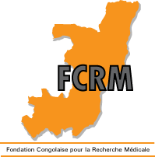
Fondation Congolaise pour la Recherche Médicale
Cité OMS/AFRO, Villa D6
Brazzaville, Congo

CONSENT FORM FOR ADULT TAKING PART IN THE STUDY
(Adults : 18 years or more)
Title of the protocol : Characterization of the resistance profile of HIV strains to antiretrovirals in infected Congolese children, adolescents and young adults on treatment.

Each participant must receive a copy of this information sheet.
Participant number: ………………………………………….……………………………
Initials of participant or legal guardian: ………………………………………………….
I, the undersigned (full name)……………………………………………………….living at

Street……………………………………Quarter…………………………..District…………….

To have been invited to collaborate with the team of FCRM (research institute conductin the study) to take part in the HIV resistance study.

I have been informed about the research study to be conducted. I had the opportunity to ask questions about the nature of the study, its objectives and methodology. All questions have been responded to my satisfaction.
Having taken information of all the above, I hereby agree to take part in the study.

I also agree that the results of this research may be published, insofar as my anonymity (or the anonymity of my child) and my rights relating to private property are respected.

Date,……………………………………….

Investigator Signature Participant or parent/legal guardian Signature

