SUPPLEMENTS

1 Univariable and multivariable analysis
For univariable and multivariable logistic regression modelling, the whole cohort was used as no microbiome data was included, excluding participants with no data on gestational week of birth, had induced PTB, or answered the first questionnaire before gestational week 4 or after gestational week 20. The logistic regression modelling was repeated on the case-control cohort for comparison of risk factors.
A stepwise approach was used to make a prediction model to assess the association between the different covariates on the risk of sPTB, using the term group (>38 weeks) as reference. First, we looked at the overall group of sPTB using a univariable logistic regression model. The univariable analysis included known risk factors for sPTB from literature [1-5]; age (as groups), BMI (as groups), parity (primiparous or multiparous), family status (single or in a relationship), depression (continuous as scored on EPDS scale [6]), stress (continuous as scored on perceived stress scale [7]), socioeconomic status (high socioeconomic status if any two of the following: university degree, in a relationship, working full time), current smoking (yes or no), previous PTB, previous recurrent pregnancy loss, previous intrauterine fetal demise (IUFD), subfertility (taking more than 12 months to conceive), use of assisted reproductive technologies, gynaecological infections in the last 3 months, non-gestational diabetes and hypertension. Furthermore, some prescribed and over-the-counter medications that are known to affect the microbiome negatively were included; antibiotics, gastrointestinal drugs (such as proton pump inhibitors and laxatives), neurological drugs (sedatives, sleep medication and antidepressants), antihistamines and allergy medication [8].
Those variables with a p-value <0.10 were selected for inclusion in the multivariable model. The model was additionally adjusted for preselected variables; maternal age, maternal BMI, family status (single or cohabiting), gestational week of answering the first questionnaire, and if it was before or after arrival of the COVID-19 pandemic to Sweden (defined as March 1^{st,} 2020). Descriptive statistical analyses were performed in R in Jupyter notebook v7.0.4.
Table S1. Univariable analysis for the entire cohort and for the case-control subset using variables from questionnaires answered prior to week 20 of gestation. Variables with a p-value <0.1 were kept in the multivariable analysis and are highlighted in bold.
 | Univariable (n=3483) |  | Univariable  Cases and matched controls (n=396)
 | OR (95%CI) | P-value | OR (95%CI) | P-value
Age in years
< 25 | 1.28 (0.57-2.49) | 0.50 | 1.20 (0.24-4.99) | 0.81
25 - 35 | REF | REF | REF | REF
> 35 | 1.32 (0.91-1.86) | 0.13 | 0.98 (0.60-1.60) | 0.95
BMI* prior to pregnancy
< 18.5 Underweight | 0.63 (0.15-1.70) | 0.44 | 0.84 (0.12-3.98) | 0.83
18.5 - 25 Normal weight | REF | REF | REF | REF
> 25 Overweight | 1.41 (1.03-1.94) | 0.03 | 1.06 (0.66-1.68) | 0.81
Swedish born | 1.24 (0.75-2.21) | 0.43 | 1.33 (0.64-2.98) | 0.46
University education | 1.29 (0.92-1.78) | 0.13 | 0.98 (0.57-1.64) | 0.93
Socioeconomic score | 0.87 (0.65-1.17) | 0.35 | 1.00 (0.60-1.42) | 0.71
Primiparous | 1.31 (0.98-1.76) | 0.06 | 0.97 (0.64-1.47) | 0.89
Family status (single/not) | 1.99 (0.83-4.05) | 0.08 | 2.47 (0.73-8.70) | 0.14
Natural conception | 0.76 (0.50-1.20) | 0.22 | 0.91 (0.50-1.69) | 0.76
Previous IUFD ** | 2.89 (1.10-6.27) | 0.01 | NA | NA
Previous preterm birth | 12.08 (4.24-30.48) | 4.50E-07 | 2.56 (0.67-10.49) | 0.17
Previous RPL *** | 1.31 (0.64-2.38) | 0.42 | 0.52 (0.15-1.46) | 0.25
Subfertility | 1.11 (0.74-1.63) | 0.59 | 0.77 (0.43-1.33) | 0.36
Regular menstruation | 1.11 (0.76-1.69) | 0.59 | 1.28 (0.73-2.29) | 0.40
Diagnosed PCOS **** | 0.84 (0.45-1.43) | 0.55 | 1.00 (0.42-2.24) | 1.00
Diagnosed endometriosis | 1.58 (0.80-2.81) | 0.15 | 1.25 (0.48-3.04) | 0.64
Regular contact with animals | 0.97 (0.73-1.30) | 0.85 | NA | NA
Daily fiber | 1.11 (0.75-1.70) | 0.62 | 1.39 (0.77-2.60) | 0.28
Healthy diet | 0.81 (0.60-1.12) | 0.19 | 1.06 (0.66-1.73) | 0.81
Recent intake of probiotics | 1.23 (0.85-1.77) | 0.25 | NA | NA
Intake of iron during pregnancy | 2.90 (0.46-10.08) | 0.15 | 2.01 (0.08-51.04) | 0.62
Snuff / smokeless tobacco use during pregnancy | 0.41 (0.02-1.87) | 0.38 | NA | NA
Smoking during pregnancy | 2.20 (0.76-5.03) | 0.09 | 4.05 (0.38-87.54) | 0.26
Any drugs used during pregnancy | 1.54 (1.15-2.06) | 0.004 | 0.98 (0.64-1.50) | 0.94
Multiple drugs used during pregnancy | 1.29 (0.96-1.74) | 0.09 | 0.97 (0.62-1.49) | 0.88
Thyroid medication | 0.88 (0.48-1.47) | 0.64 | 0.55 (0.24-1.15) | 0.13
Allergy and antihistamines | 1.21 (0.78-1.81) | 0.36 | 1.04 (0.52-1.99) | 0.91
Neurological medication | 1.81 (1.16-2.72) | 0.006 | 0.96 (0.46-1.89) | 0.91
Gastrointestinal medication | 6.02 (2.23-13.77) | 8.27E-05 | NA | NA
Diabetes medication | 4.58 (0.24-26.99) | 0.16 | 2.01 (0.08-51.04) | 0.62
Antibiotics | 1.45 (0.76-2.53) | 0.22 | NA | NA
Blood pressure medication | 1.50(0.80-2.58) | 0.17 | 0.92 (0.32-2.39) | 0.87
High blood pressure early pregnancy | 6.56 (1.87-17.92) | 0.0008 | NA | NA
EPDS ***** score | 1.00 (0.98-1.01) | 0.77 | 0.98 (0.94-1.01) | 0.20
PSS-4 ¤ score | 0.98 (0.95-1.02) | 0.24 | 0.96 (0.90-1.03) | 0.29
*Body mass index, **Intrauterine fetal demise, ***Recurrent pregnancy loss, ****Polycystic ovary syndrome, ***** Edinburgh Postnatal Depression Scale, ¤ perceived stress scale
REF refers to the Reference group; NA, not applicable

Table S2. Multivariable logistic regression for the entire SweMaMi cohort and the case-control subset; variables with a p-value <0.05 are highlighted in bold.
 | Entire cohort - spontaneous preterm birth vs full term |  | Cases (preterm birth) and matched controls
 | OR (95%CI) | P-value | OR (95%CI) | P-value
Age, in years
< 25 | 1.05 (0.45-2.15) | 0.91 | 1.34 (0.25-6.10) | 0.71
25 - 35 | REF | REF | REF | REF
> 35 | 1.28 (0.87-1.84) | 0.2 | 1.03 (0.61-1.72) | 0.92
BMI * prior to pregnancy
< 18.5 Underweight | 0.66 (0.16-1.80) | 0.49 | 1.27 (0.16-7.44) | 0.79
18.5 - 25 Normal weight | REF | REF | REF | REF
> 25 Overweight | 1.27 (0.91-1.76) | 0.16 | 1.20 (0.73-1.97) | 0.47
University education | 1.17 (0.81-1.66) | 0.38
Family status | 1.47 (0.60-3.10) | 0.35
Smoking | 1.85 (0.62-4.43) | 0.21
Previous IUFD ** | 2.53 (0.93-5.72) | 0.04
Previous preterm birth | 9.15 (2.98-24.92) | 3.00E-05
Any drugs used during pregnancy | 2.38 (1.00-5.93) | 0.05
Multiple drugs used during pregnancy | 0.52 (0.22-1.18) | 0.12
Neurological medication | 1.03 (0.49-1.98) | 0.92
Gastrointestinal medication | 3.40 (1.10-8.91) | 0.02
High blood pressure early pregnancy | 3.31 (0.84-10.44) | 0.06
Pregnancy week of sampling | 0.98 (0.94-1.03) | 0.53
Pre Covid-19 *** | 0.76 (0.55-1.06) | 0.09 | 0.61 (0.37-1.01) | 0.06
*Body mass index, **Intrauterine fetal demise, ***Defined as March 1st 2020; REF, Reference group

2 PERMANOVA variables tested
Table S3. Questionnaire variables included in PERMANOVA analysis for vaginal and fecal microbiome samples.
Timepoint | Variables
Timepoint one and two microbiome analysis | Background variables:  Age (groups; <25, 25-35, >35)  BMI before pregnancy (Groups; underweight, average weight, overweight, obese)  BMI early pregnancy (Groups; underweight, average weight, overweight, obese)  Parity (primiparous or not)  Time to pregnancy (Groups; < 6 months, 6-12 months, > 12 months)  Smoking (yes/no)  Snuff / smokeless tobacco (yes/no)  Number of cigarettes daily (continuous)  Alcohol 3 months before pregnancy (yes/no)  Socio-economic score (continuous, 0-3)  Low socio-economic score (cut-off; <3)  Pregnancy before start of Covid-19 (yes/no)  Diet (separate answers for timepoint one and two):  Vegetarian diet (yes/no)  Vegan diet (yes/no)  Intake of fish (yes/no)  Frequency of sugar drinks (Groups; Daily, Often/week, Once a week, More seldom)  Frequency of fruit consumption (Groups; Daily, Often/week, Once a week, More seldom)  Frequency of vegetable consumption (Groups; Daily, Often/week, Once a week, More seldom)  Frequency of fibre rich bread consumption (Groups; Daily, Often/week, Once a week, More seldom)  Use of vitamins or supplements (yes/no)  Iron supplements (yes/no)  Probiotics (yes/no)  Health:  Number of previous miscarriages (continuous)  Previous recurrent pregnancy loss (> 2, yes/no)  Previous PTB (yes/no)  Previous intrauterine fetal death (yes/no)  Non-hormonal contraceptives (yes/no)  Hormonal contraceptives (yes/no)  Regular menstruation (yes/no)  Menstrual pain (groups; none, low or high)  Polycystic ovary syndrome (PCOS) (yes/no)  Endometriosis (yes, no or maybe)  Bristol rating (Groups; normal, slow, fast, various)  Early pregnancy (separate answers for timepoint one and two):  EPDS score (continuous)  PSS-4 score (continuous)  High PSS-4 score (PSS-4 >6)  PUQE score (continuous)  PUQE score group (Groups; mild, moderate, severe)
Only timepoint one | Assisted conception (yes/no)  Natural conception (yes/no)
Only timepoint two | Diet score (continuous, based on frequency of fruit, vegetables, whole grain bread, sugar and sugar-free drinks)  Healthy diet (diet score <3)  Gastrointestinal medication (yes/no)  Neurological medication (yes/no)  Haematological medication (yes/no)  Blood pressure medication (yes/no)  Any issues during pregnancy (yes/no)
3 Longitudinal comparisons
Vaginal microbiome
In the taxonomic profile of both cases and controls, minimal changes in the dominant organisms (Lactobacilli and G. vaginalis) were observed (Figure S1A and B). However, an ANCOMBC-2 analysis indicated a significant (Benjamini-Hochberg-adjusted) log fold-change increase of greater than 0.5 in the relative abundance of minor bacteria at the second timepoint in both cases and controls (Figure S1C and D).
For both cases and controls, Corynebacterium sp. HMSC08D02, Corynebacterium aurimucosum, Coriobacteriales bacterium DNF00809, Streptococcus SGB3665 and Limosilactobacillus portuensis were decreased at timepoint two. Fannyhessea vaginae was found to be differentially abundant in the control group but not in the cases.
A significant change in alpha diversity (Shannon index) from early to late pregnancy was observed for cases (all preterm birth subgroups combined; p = 0.039), which wasn’t observed for the controls (Figure S1E and F).
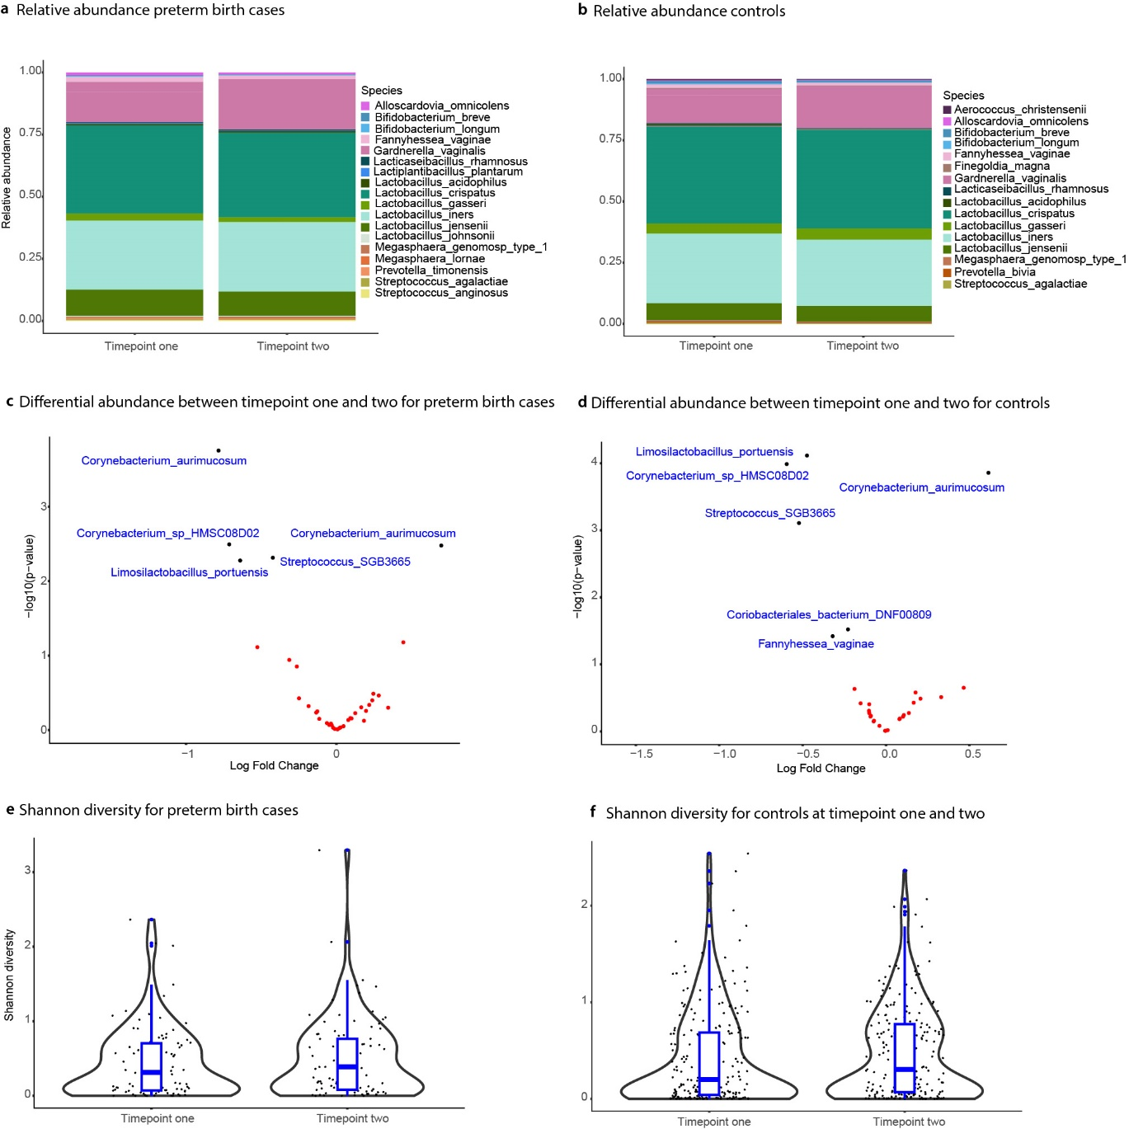Supplementary Figure S1. Comparison of vaginal microbiome between timepoint one and timepoint two. Relative abundance of species for (a) preterm birth cases and (b) controls. Comparison of species enriched in timepoint 1 (left) or timepoint 2 (right) for (c) cases and (d) controls. Organisms that are significantly different between timepoint one two (FDR-adjusted p < 0.05) are named and highlighted in blue. Differences in Shannon diversity between timepoint one and two for (e) preterm birth cases (p = 0.039) and (f) controls (n.s.).
Faecal microbiome
There were no notable changes in the major microbial organisms belonging to the Feacalibacterium and Bifidobacterium genera between the two timepoints in the faecal samples. The ANCOM-BC2 results between the two timepoints for cases and controls showed several organisms with significant log-fold changes.
For cases, Campylobacter hominis was more abundant at timepoint two, while Ruminoccus bromii, Escherichia coli and Enterocloster adelensis were more abundant at timepoint one (Figure S2A).
For controls, Lancefieldella_parvula, GGB3513 SGB4691 (phylum Firmicutes), GGB38744 SGB14842 (family Oscillospiraceae) were more present in the second timepoint, while Actinomyces SGB17168 and Agathobaculum butyriciproducens were more abundant in the first timepoint (Figure S2B).
The Shannon index was used to measure the alpha diversity between cases and controls. No significant difference between the two timepoints was observed, neither for cases nor controls (Figure S2C and D).
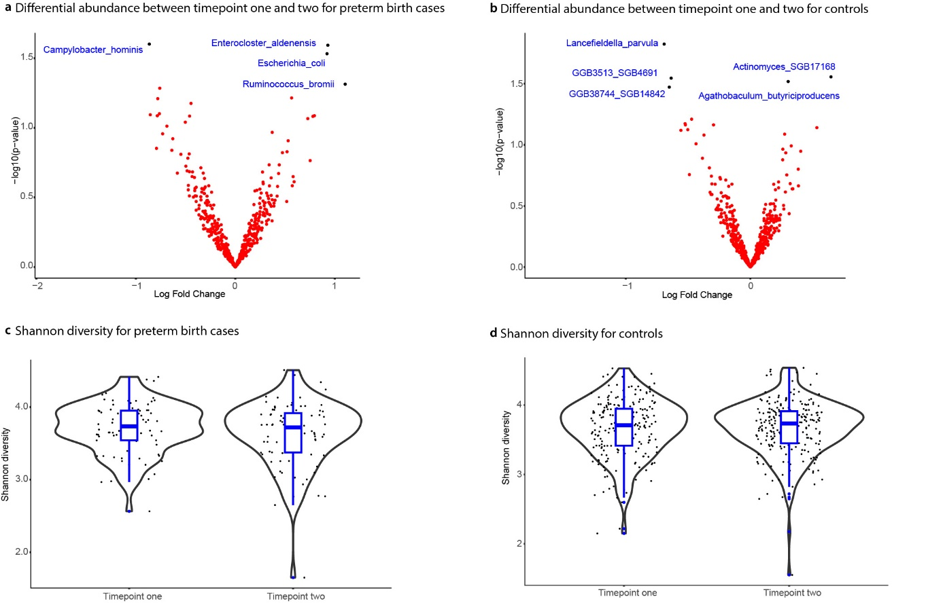Supplementary Figure S2. Comparison of species enriched in timepoint 1 (left) or timepoint 2 (right) for (c) cases and (d) controls. Organisms that are significantly different between timepoint one two (FDR-adjusted p < 0.05) are named and highlighted in blue.Fecal microbiome Shannon diversity at timepoint one and two for (c) preterm birth cases and (d) controls, none of which were significant.
Supplementary Figures

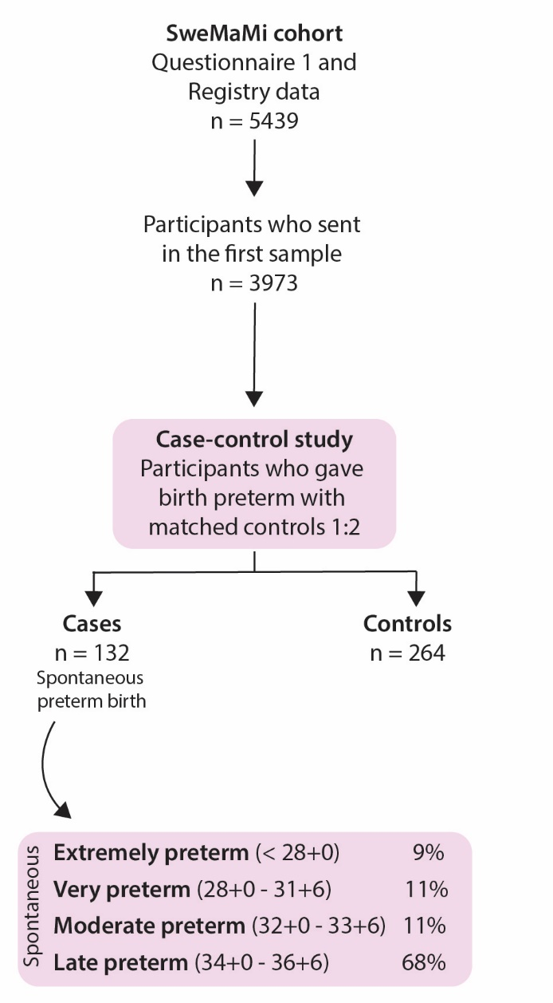
Supplementary Figure S3: Flowchart of the SweMaMi cohort, cases of preterm birth (and its subgroups) and controls.

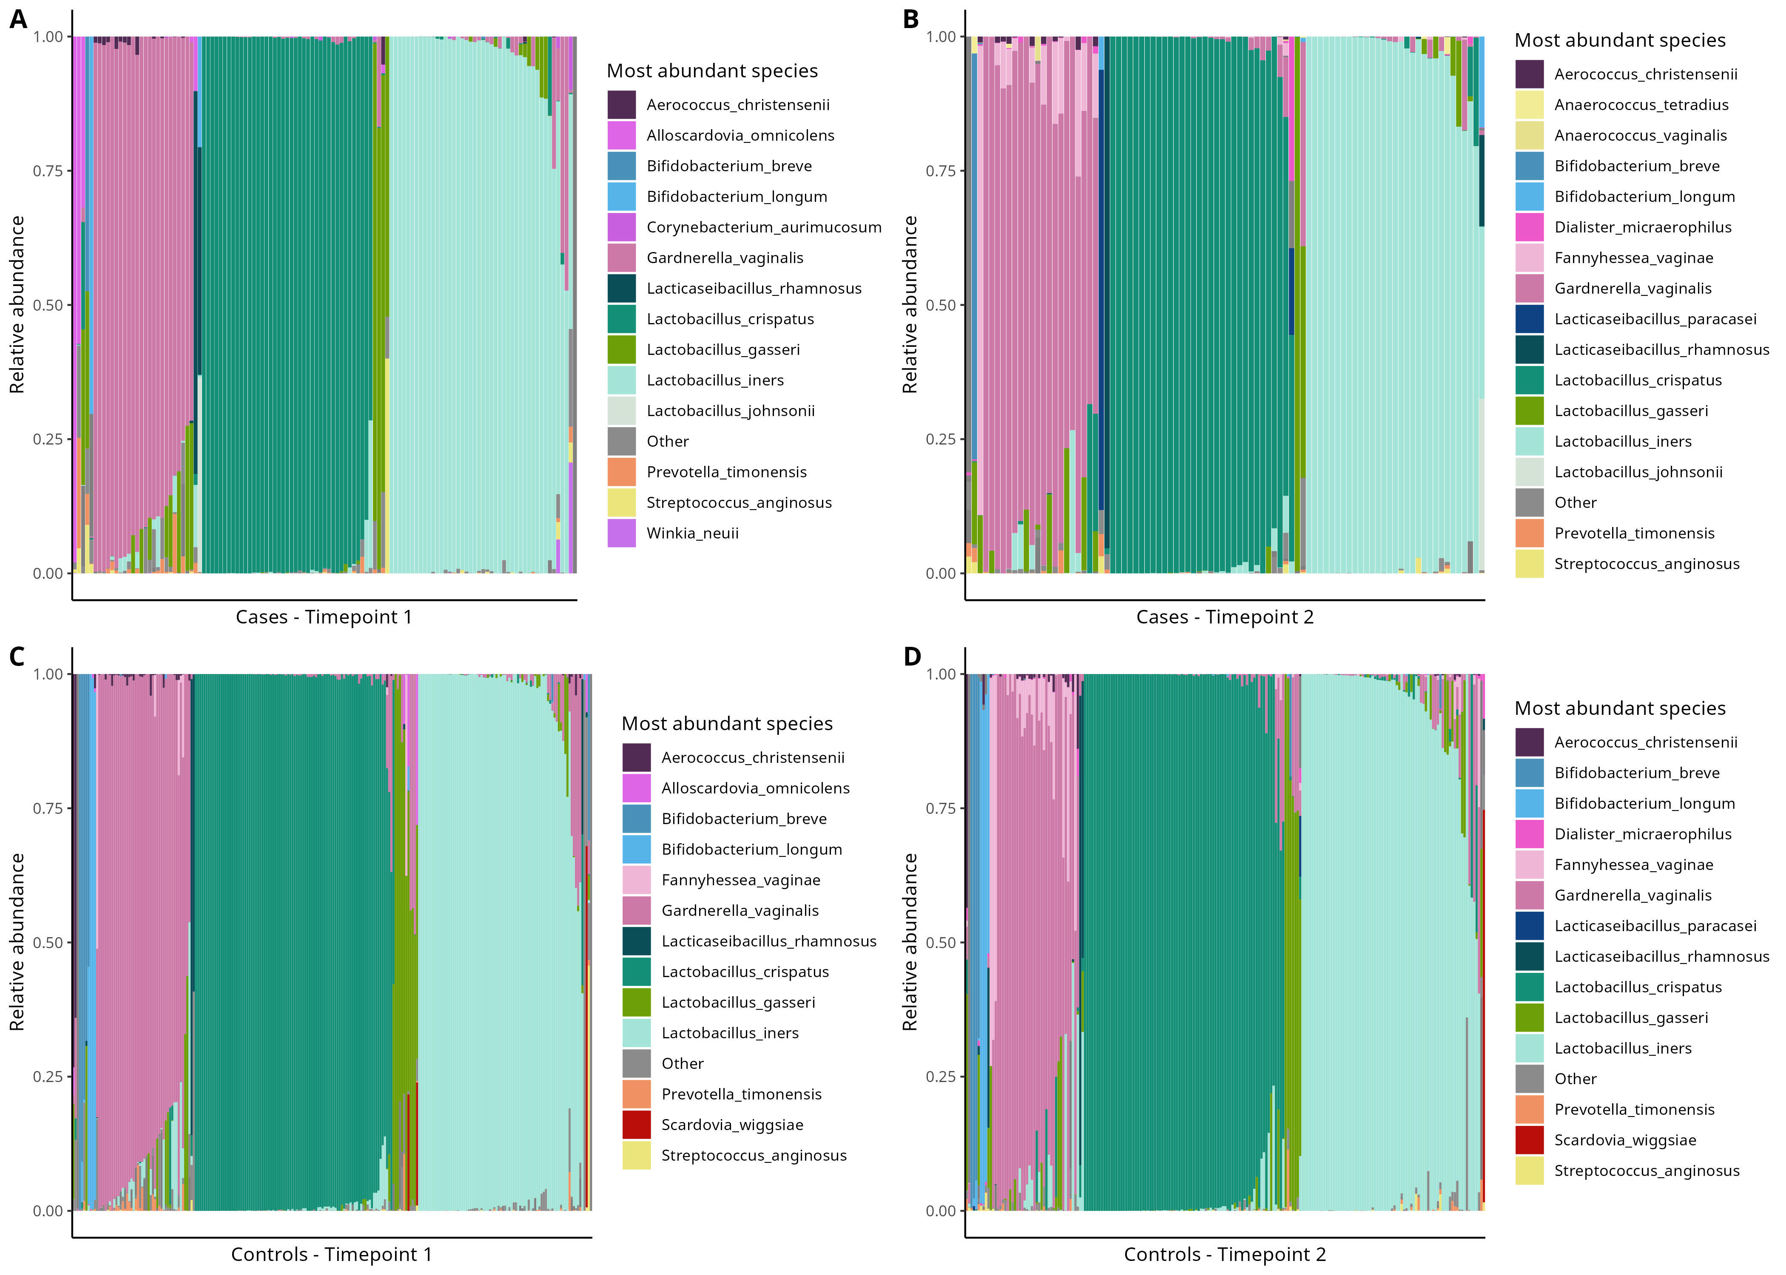
Supplementary Figure S4. Relative abundance of the most abundant vaginal microbiome species in preterm birth cases at (a) timepoint one and (b) two, and matched controls at (c) timepoint one and (d) two.
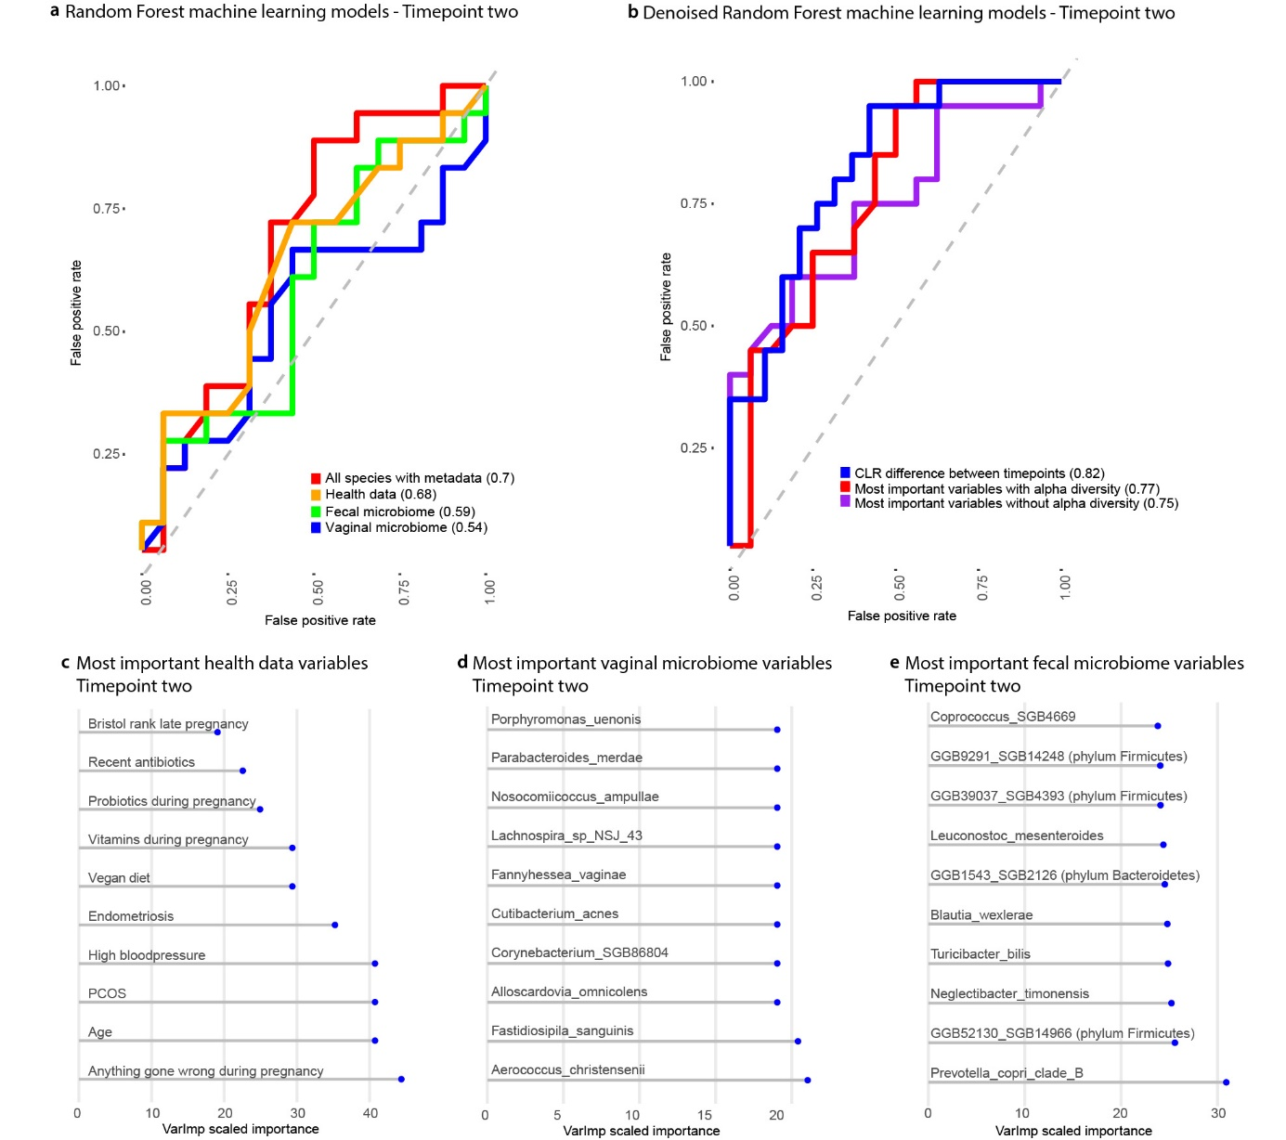Supplementary Figure S5. Random forest machine learning models at timepoint two using (a) all data and (b) denoised with AUROC values. The most important (c) health data, (d) vaginal and (e) faecal variables in the model are shown in relation to the Varlmp scaled importance.

References
1. Goldenberg, R.L., et al., Epidemiology and causes of preterm birth. Lancet, 2008. 371(9606): p. 75-84.
2. Koullali, B., et al., Risk assessment and management to prevent preterm birth. Semin Fetal Neonatal Med, 2016. 21(2): p. 80-8.
3. Frey, H.A. and M.A. Klebanoff, The epidemiology, etiology, and costs of preterm birth. Semin Fetal Neonatal Med, 2016. 21(2): p. 68-73.
4. Oskovi Kaplan, Z.A. and A.S. Ozgu-Erdinc, Prediction of Preterm Birth: Maternal Characteristics, Ultrasound Markers, and Biomarkers: An Updated Overview. J Pregnancy, 2018. 2018: p. 8367571.
5. Axmon, A. and L. Hagmar, Time to pregnancy and pregnancy outcome. Fertil Steril, 2005. 84(4): p. 966-74.
6. Cox, J.L., J.M. Holden, and R. Sagovsky, Detection of postnatal depression. Development of the 10-item Edinburgh Postnatal Depression Scale. Br J Psychiatry, 1987. 150: p. 782-6.
7. Cohen, S., T. Kamarck, and R. Mermelstein, A global measure of perceived stress. J Health Soc Behav, 1983. 24(4): p. 385-96.
8. Brusselaers, N., Prescribed Drugs and the Microbiome. Gastroenterol Clin North Am, 2019. 48(3): p. 331-342.

