Supporting Information
Real-Time Formation of Nitrate and Nitrite Species in Plasma-Activated Liquids: From Distilled Water to Cell Culture Solutions
Jin Hee Bae, Seong-Cheol Huh, Negar Rahdar and Sanghoo Park*

Department of Nuclear and Quantum Engineering, Korea Advanced Institute of Science and Technology, 291 Daehak-ro, Yuseong-gu, Daejeon 34141, Republic of Korea

* Corresponding author, E-mail address: sanghoopark@kaist.ac.kr (S. Park).
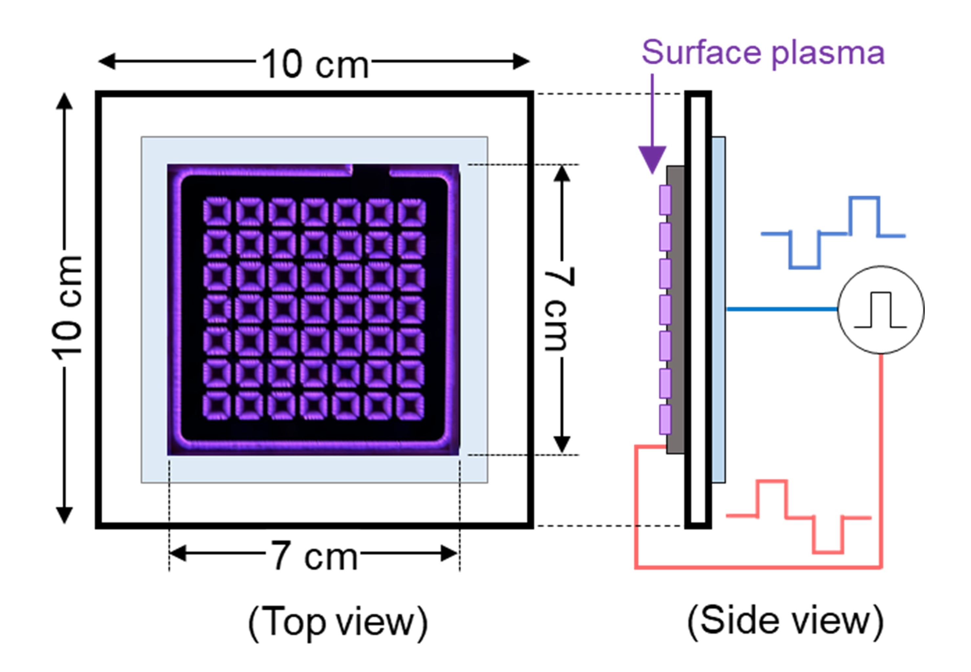
Fig S1. Configuration of the surface dielectric barrier discharge (sDBD) plasma source used in this study. The schematic shows both the top view (7 × 7 cm discharge area within a 10 × 10 cm frame) and the side view of the electrode assembly. Oppositely phased signals were applied to each electrode, as illustrated by the waveform diagram.
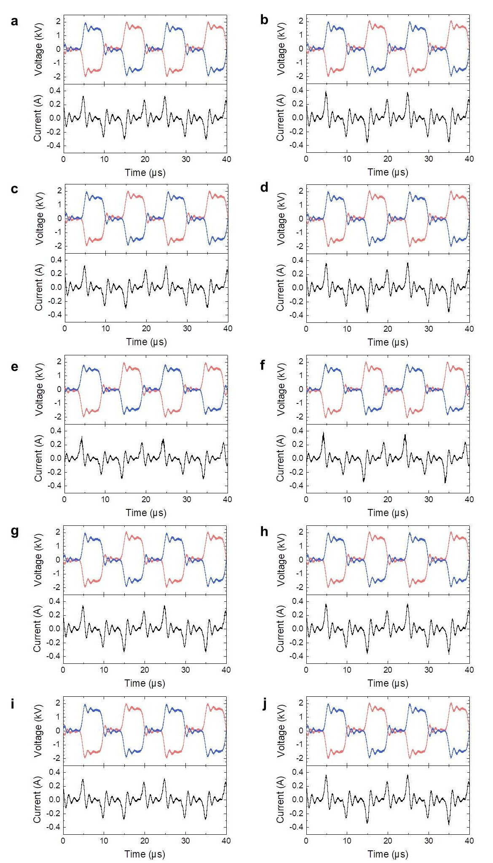
Fig S2. Voltage–current waveforms applied to the sDBD plasma source for each solution type. For each case, the left panel corresponds to the O₃-dominant mode observed at the beginning of the discharge, and the right panel corresponds to the NO_{x}-dominant mode observed at the end of treatment. (a, b) DW; (c, d) MW; (e, f) TW; (g, h) PBS; (i, j) DMEM.

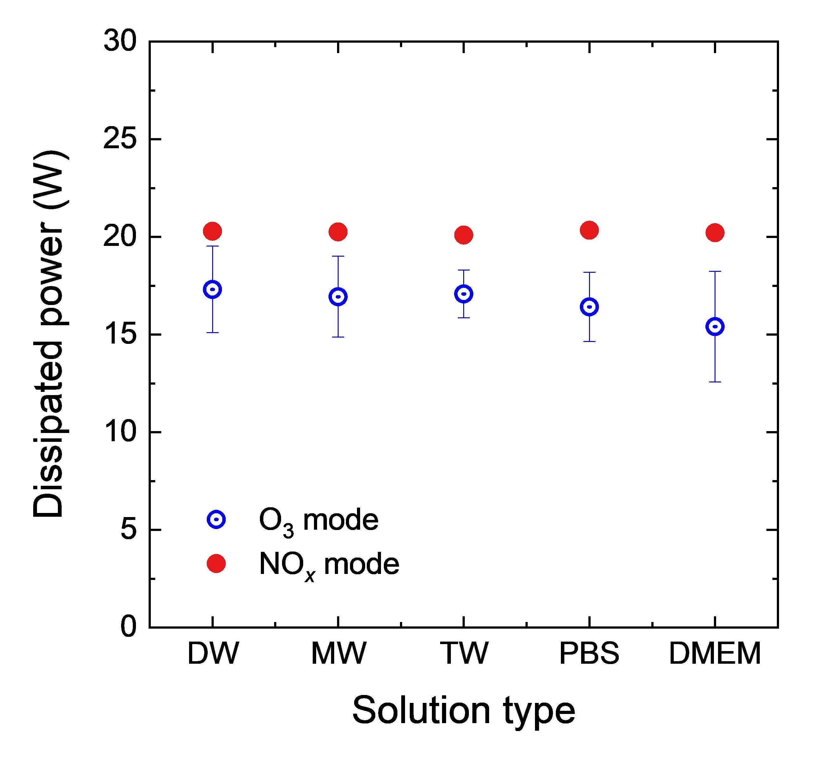
Fig S3. Cycle-averaged dissipated power in the O₃ and NO_{x} modes for different solution types (DW, MW, TW, PBS, and DMEM). Power values were calculated from the voltage–current waveforms shown in Figure S2, with blue open circles representing the O₃ mode and red filled circles representing the NO_{x} mode.
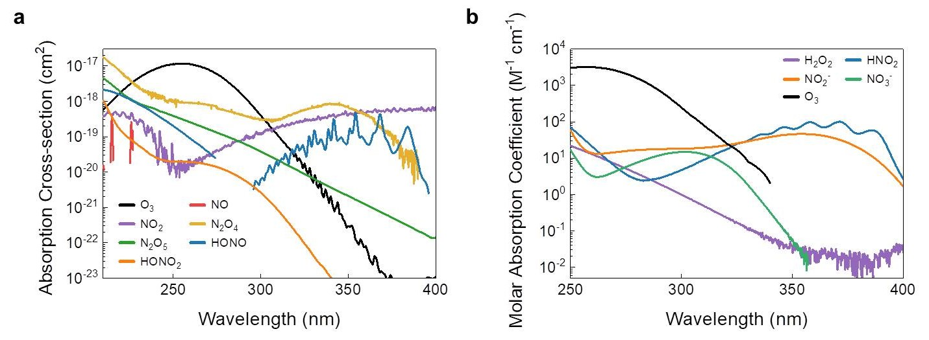
Fig S4. The absorption cross-sections and molar absorption coefficients used for analysis in this study. (a) Absorption cross-sections of O₃, NO, NO₂, N₂O₄, N₂O₅, HONO, and HONO₂ in 210–400 nm. (b) Molar absorption coefficients of O₃, NO₂⁻, NO₃⁻, HNO₂, and H₂O₂ in 250–410 nm.
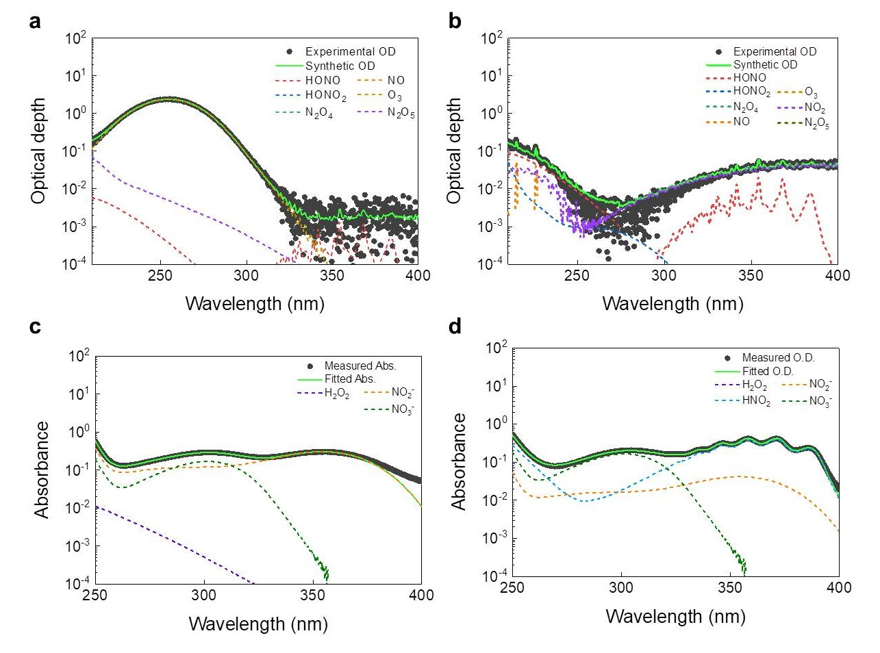
Fig S5. Deconvolution of the absorption spectra obtained (a, b) in the gas phase and (c, d) in the liquid phase. (a) DW at 20 s under the O₃-dominant mode, (b) DW at 900 s under the NO_{x}-dominant mode, (c) PBS at 900 s showing pronounced NO₂⁻ accumulation, and (d) DW at 900 s showing dominant HNO₂ formation. Measured spectra (black dots) are well matched with the fitted spectra (green solid lines), which represent the summation of individual spectra (dashed lines) of relevant species.
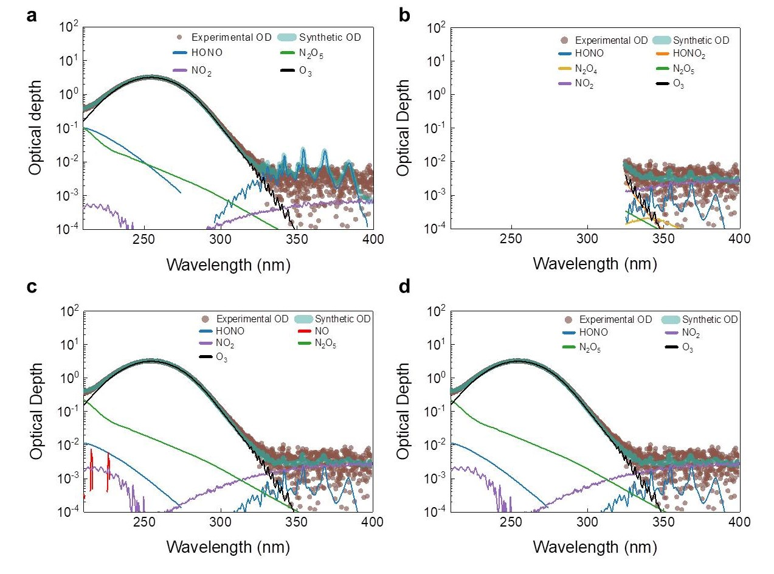
Fig S6. Example of spectral fitting procedure applied under O₃-mode conditions. (a) Initial NNLS fitting showing HONO overestimation and NO₂ underestimation. (b–c) Stepwise fitting with wavelength restriction and fixed HONO and NO₂ densities to improve accuracy. (d) Final result after iterative removal of false positives.

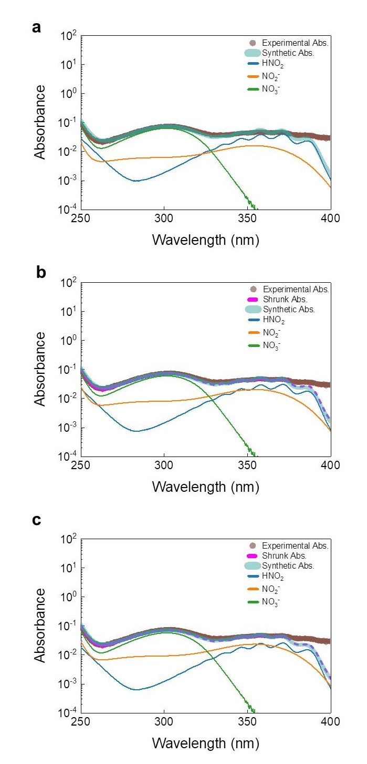
Fig S7. Spectral fitting of liquid-phase species using the absorbance shrinking technique. (a) Initial fitting based on experimental absorbance, (b) application of shrunk absorbance as the approximation target to guide the NNLS algorithm, and (c) final synthetic absorbance after iterative fitting. The method corrects overestimation or underestimation by inducing the synthetic absorbance to come below the experimental curve.

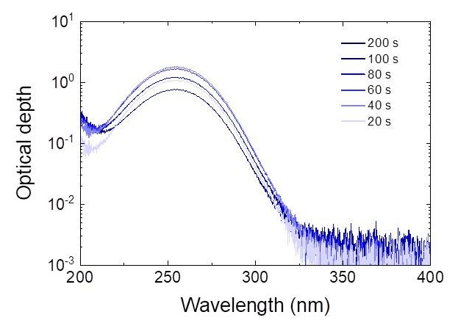
Fig S8. UV–visible absorption spectra measured in the gas phase of PBS during plasma operation. Spectral acquisition was performed continuously from t = 0 s to t = 900 s; however, only the spectra from t = 0–200 s are shown here to represent the initial O₃-dominant mode. The data shown here are sample spectra collected at each time point.
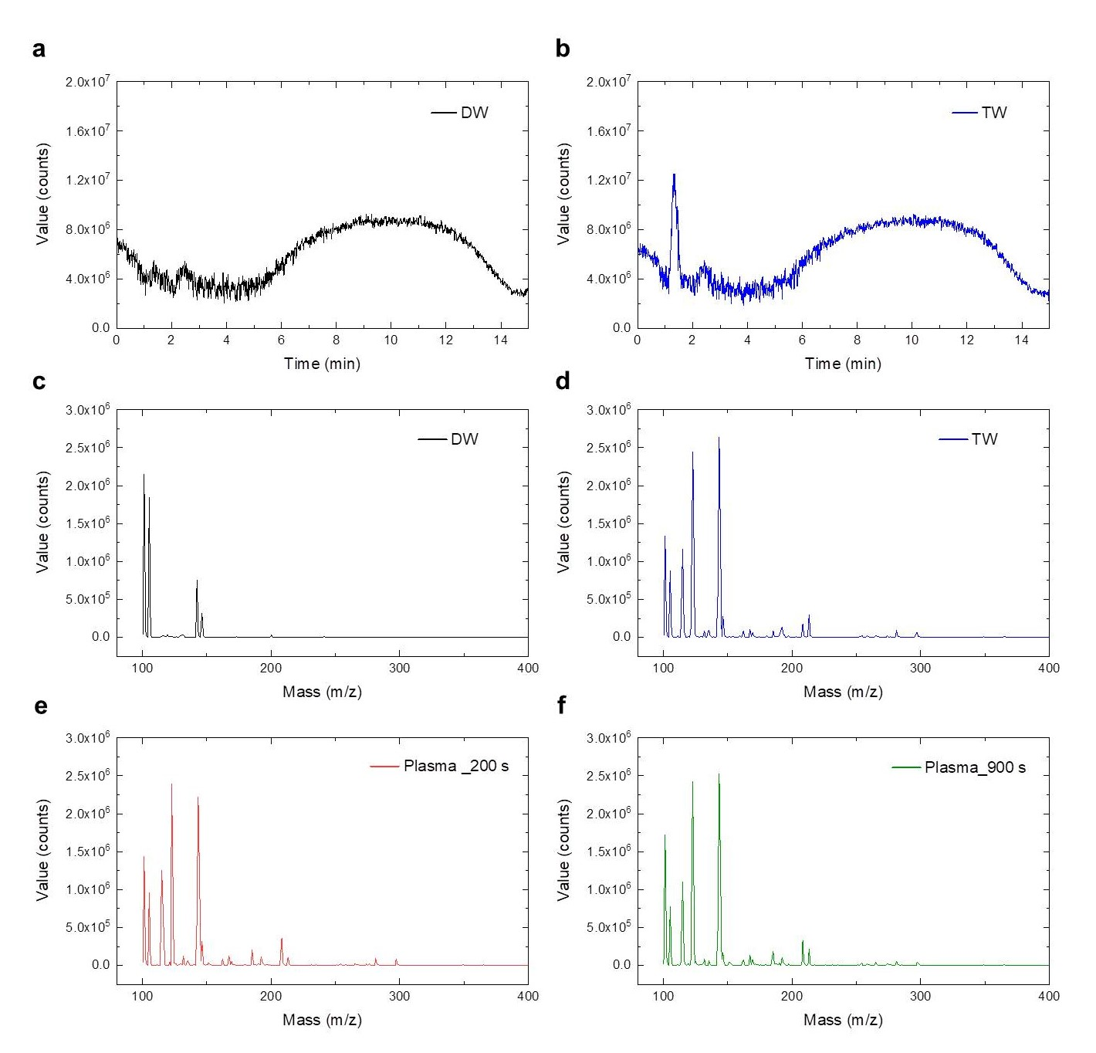
Fig S9. A total ion chromatogram (a, b) and mass spectra (c–f) of TW and DW obtained in positive-ion mode LC-MS. (a) DW shows no significant TIC peaks, whereas (b) TW exhibits distinct peaks absent in DW. (c, d) Mass spectra of DW and TW before treatment, and (e, f) TW after 200 s and 900 s plasma treatment, respectively. Plasma treatment did not noticeably change peak intensities compared to plasma-untreated TW, but additional organic components unique to TW may contribute to optical absorption interference observed in Figure 5.

Supplementary Methods
LC–MS Analysis
Liquid chromatograph mass spectrometer (Thermo Fisher Scientific, Ultimate-3000 ISQ EC) was coupled with a Waters ACQUITY HSS T3 column (2.1 × 100 mm, 1.8 µm particle size, Waters Corporation, Milford, MA, USA), operating at a flow rate of 0.2 mL min⁻¹ and at 40 °C. Chromatographic separation was performed in gradient mode using a mobile phase system consisting of two solvents, A and B. Solvent A was 0.1 % formic acid in Milli-Q water, and solvent B was 0.1 % formic acid in acetonitrile. The gradient started with 95 % A and 5 % B, changed linearly to 5 % A and 95 % B at 10 min, held for 1.25 min, returned to the initial composition at 11.5 min, and was re-equilibrated at 95 % A and 5 % B until 15 min. The injection volume was 20 µL.

