Fig. S1. Characterization of muscle EV-isomiR isoforms in muscle EVs.
(A-F) The boxplots show ntC (A), ntG (B), lv5pE (C), lv3pE (D), lv3pT (E) and lv5pT (F) nucleotidic modification of isomiRs in EVs from CTRL, NPGC, FSHD STIR- and FSHD STIR+ muscles. Groups are compared by one-way ANOVA followed by Tukey’s post hoc test or Wilcoxon signed-rank test, depending on the distribution assessed by Shapiro–Wilk test.

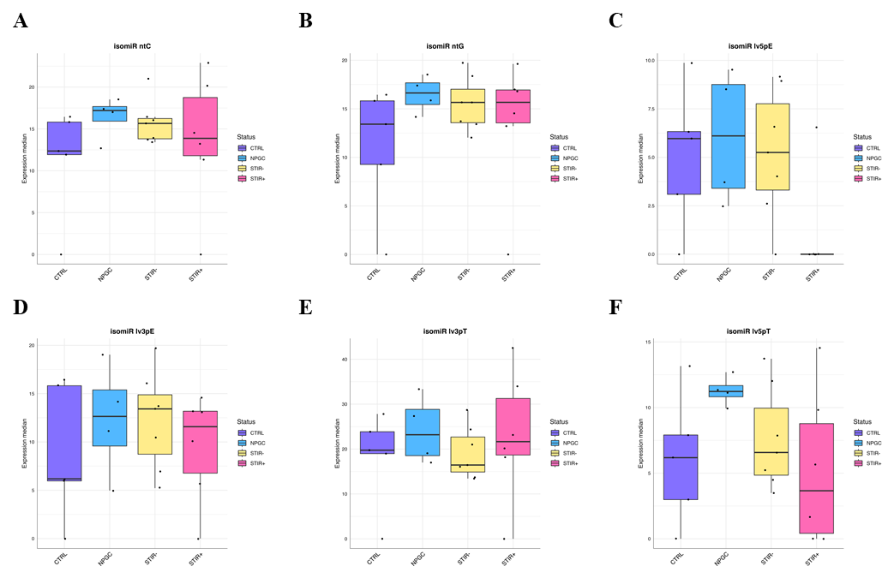

Fig. S2. Characterization of muscle EV-isomiR isoforms in FSHD T1+ and T1- muscle EVs.
(A-F) The boxplots show ntC (A), ntG (B), lv5pE (C), lv3pE (D), lv3pT (E), lv5pT (F), mv (G) and ntU (H) nucleotidic modification of isomiRs in EVs from CTRL, NPGC, FSHD STIR- and FSHD STIR+ muscles. Groups are compared by Unpaired two-tailed t test or Wilcoxon signed-rank test, depending on the distribution assessed by Shapiro–Wilk test.

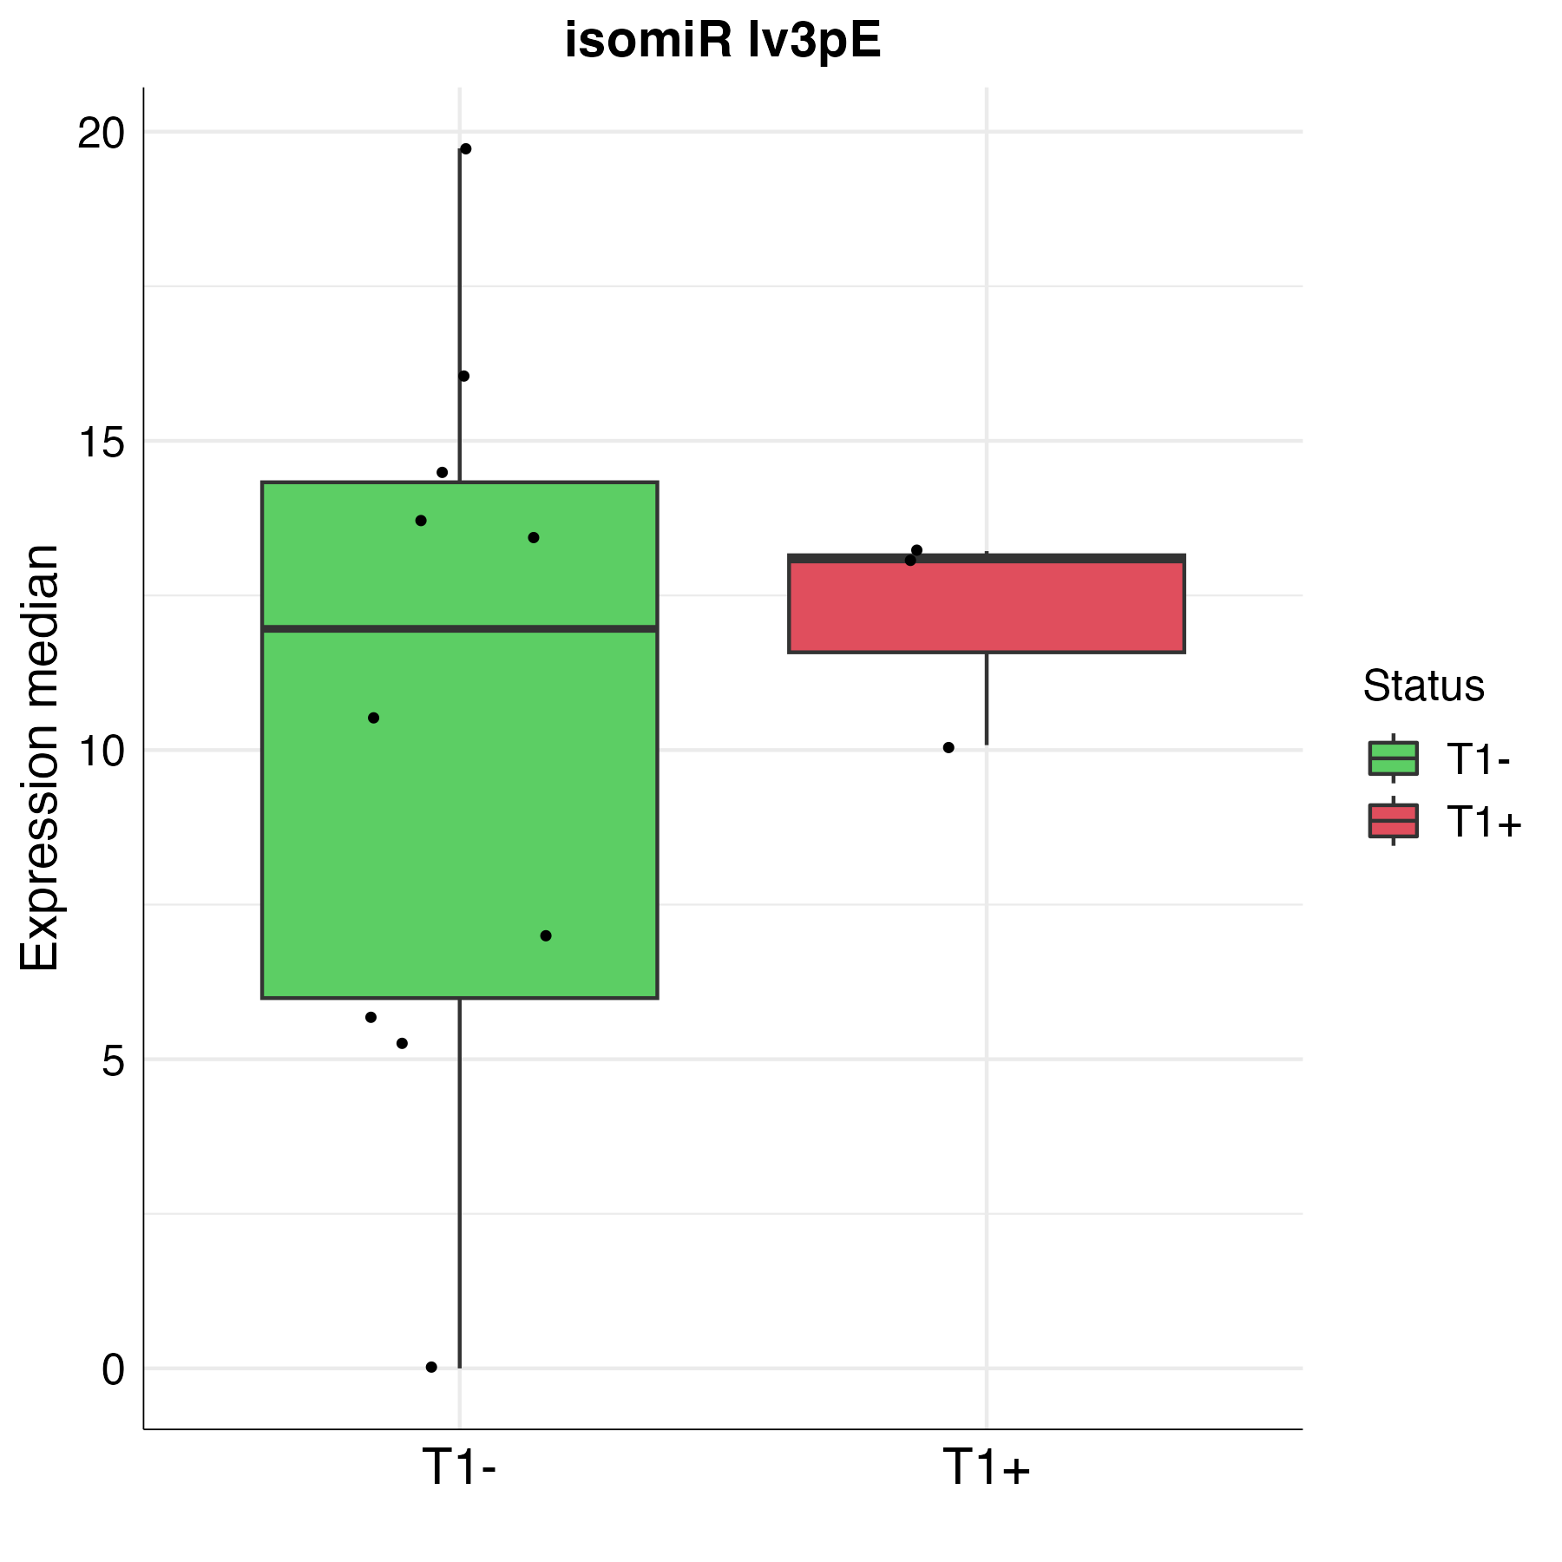
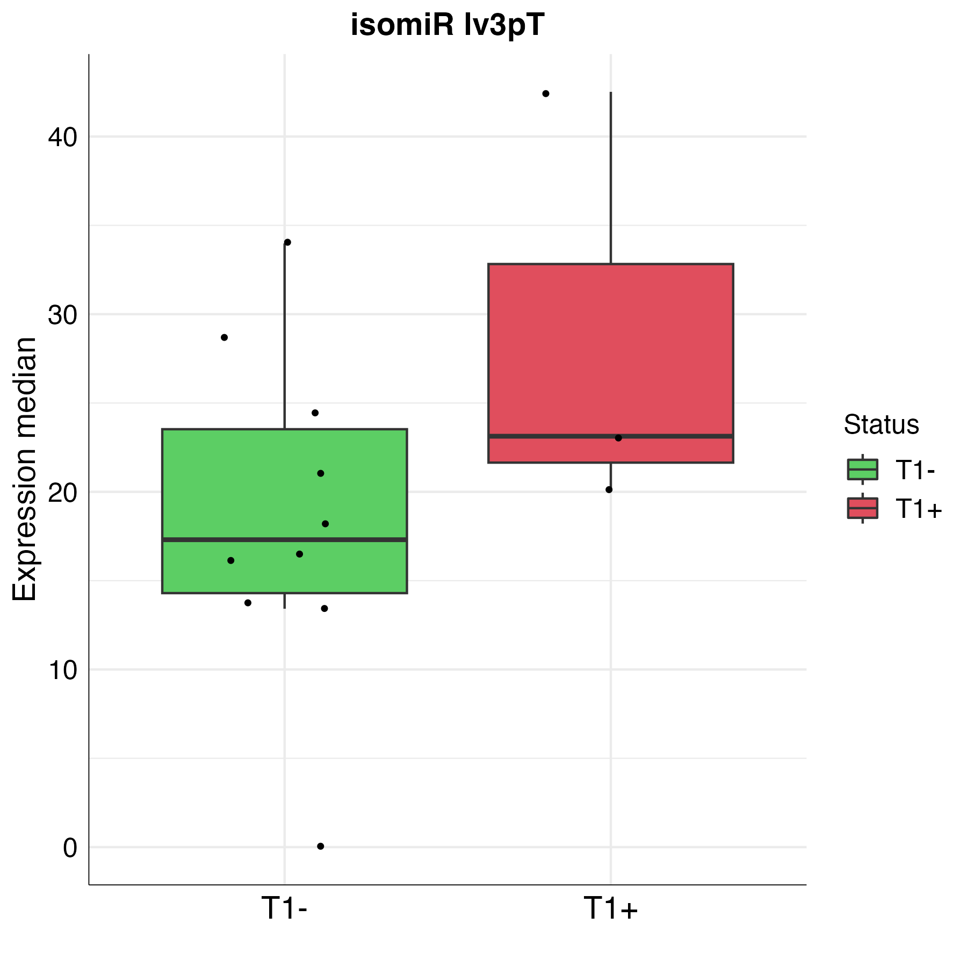
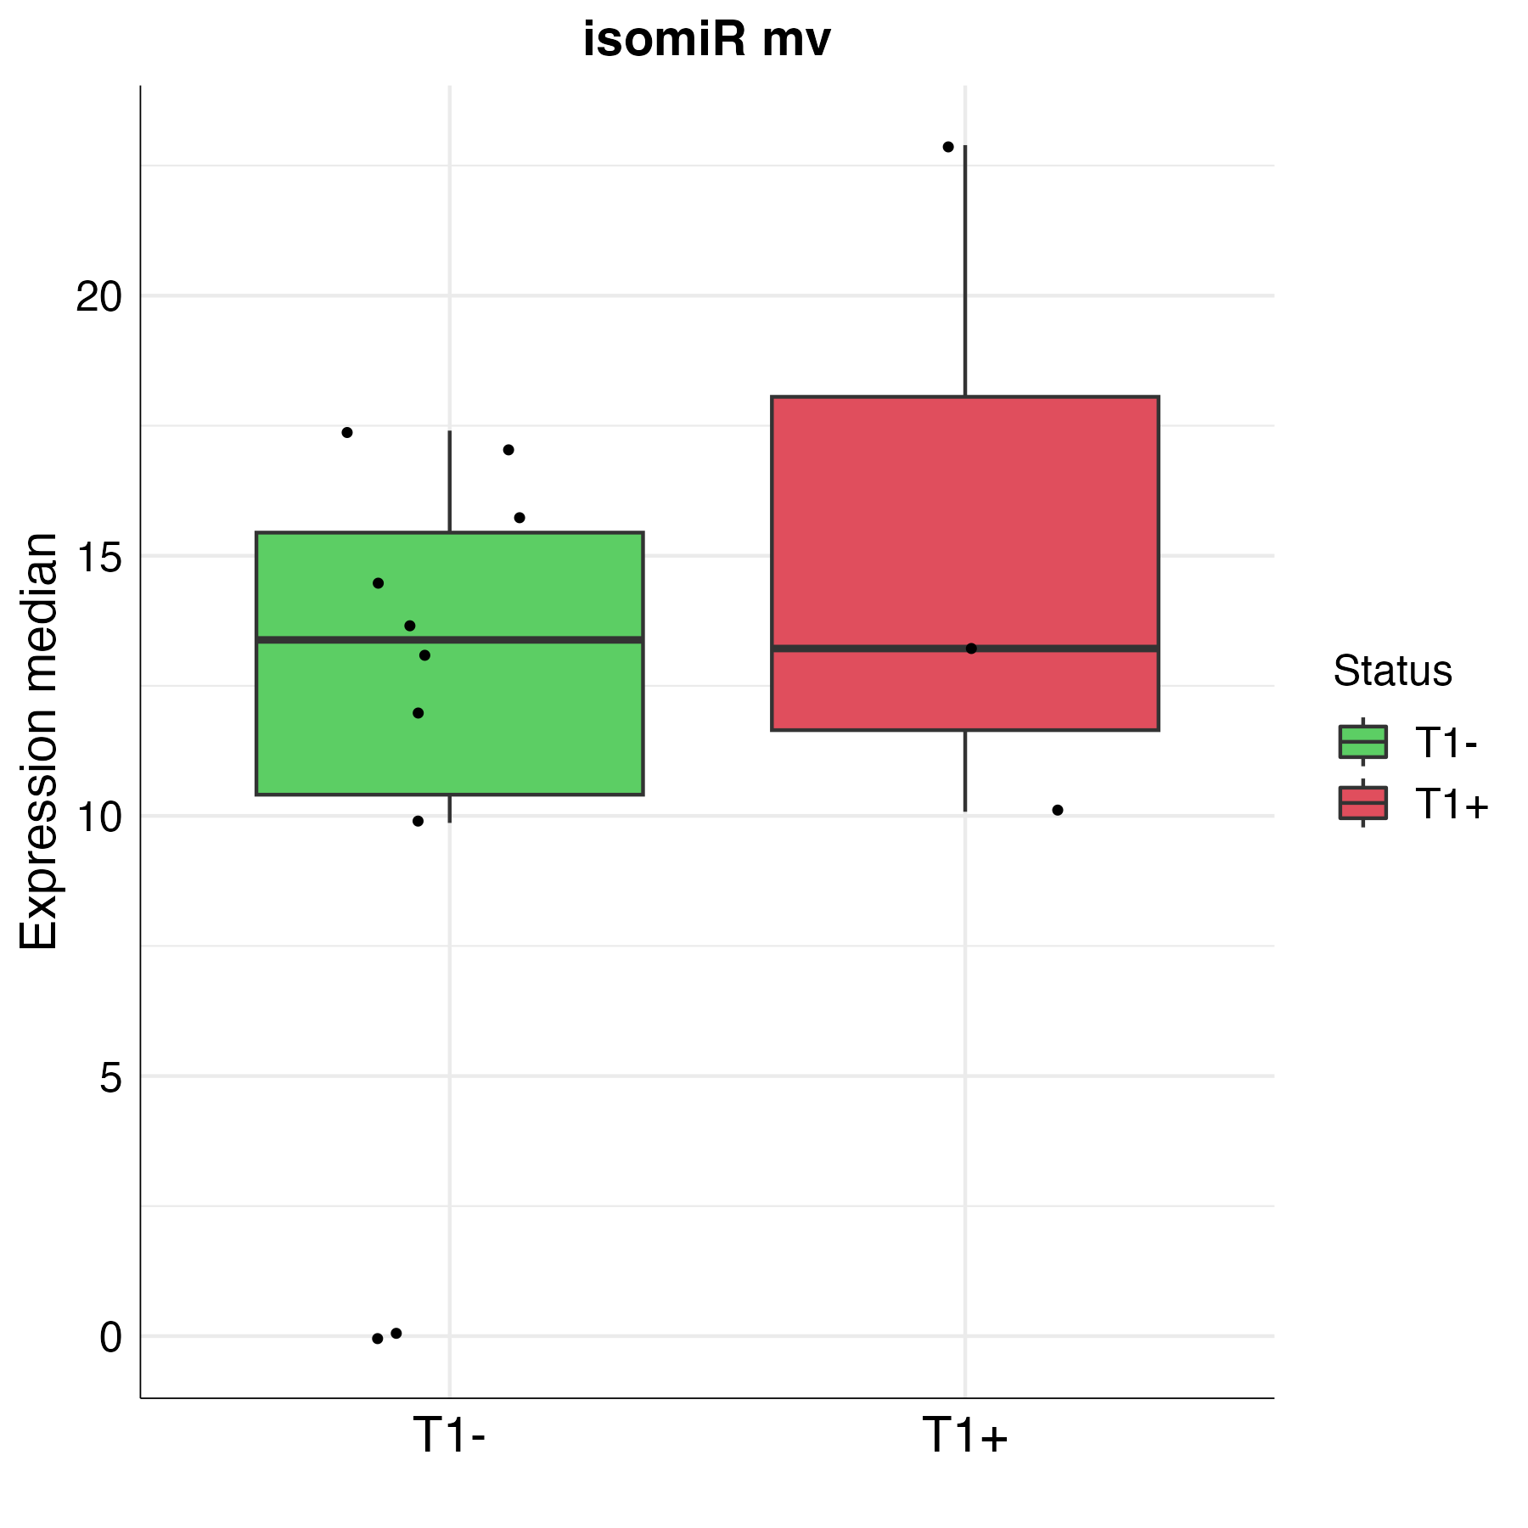
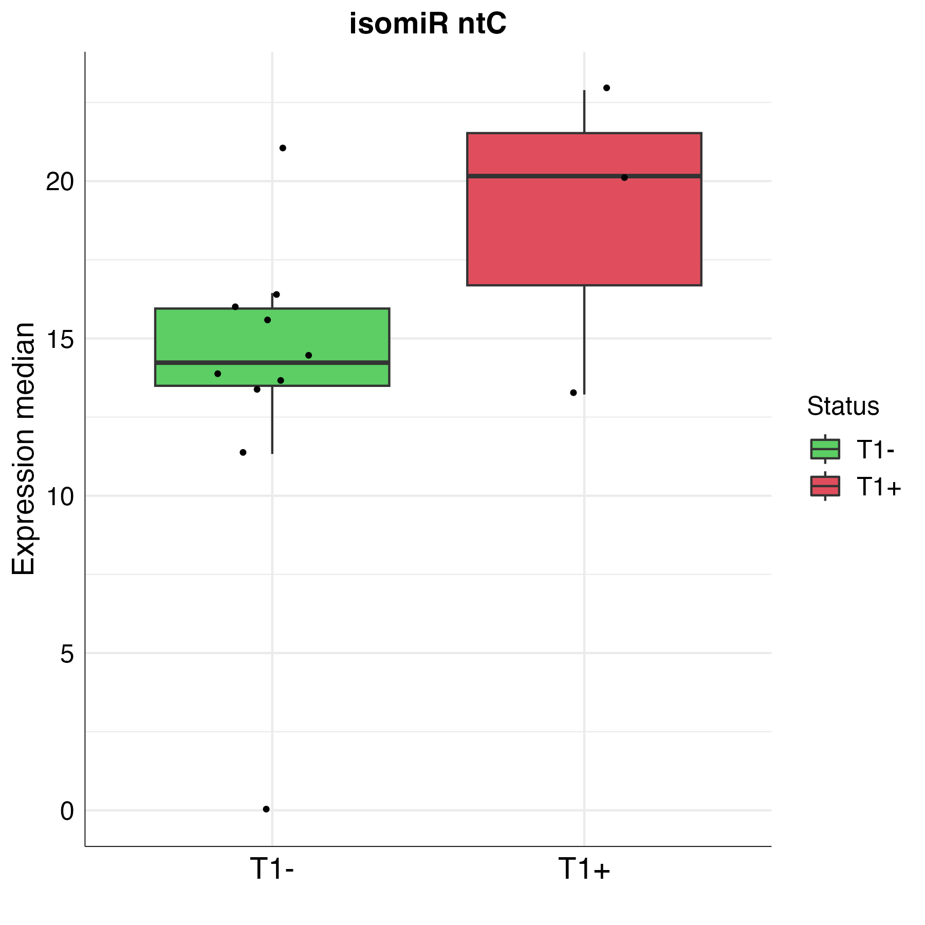
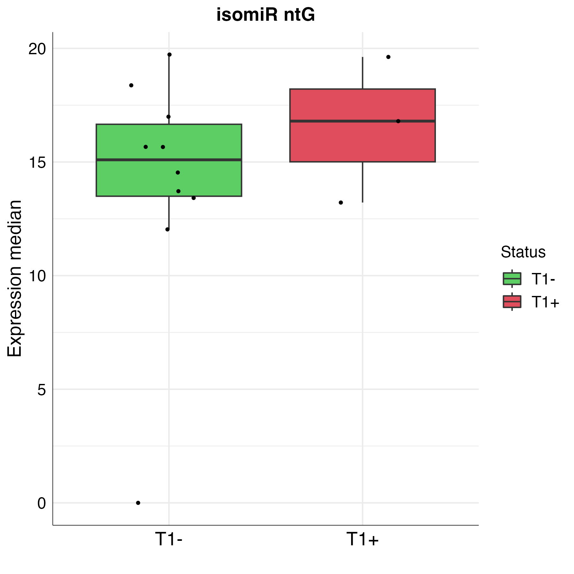
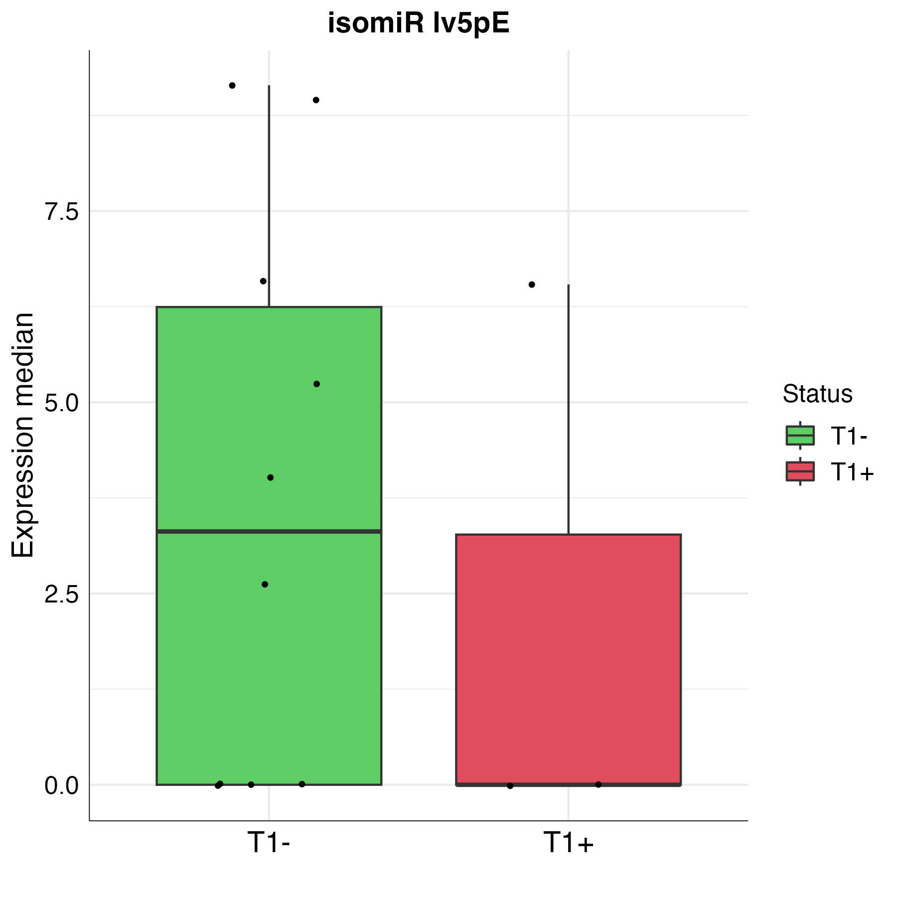
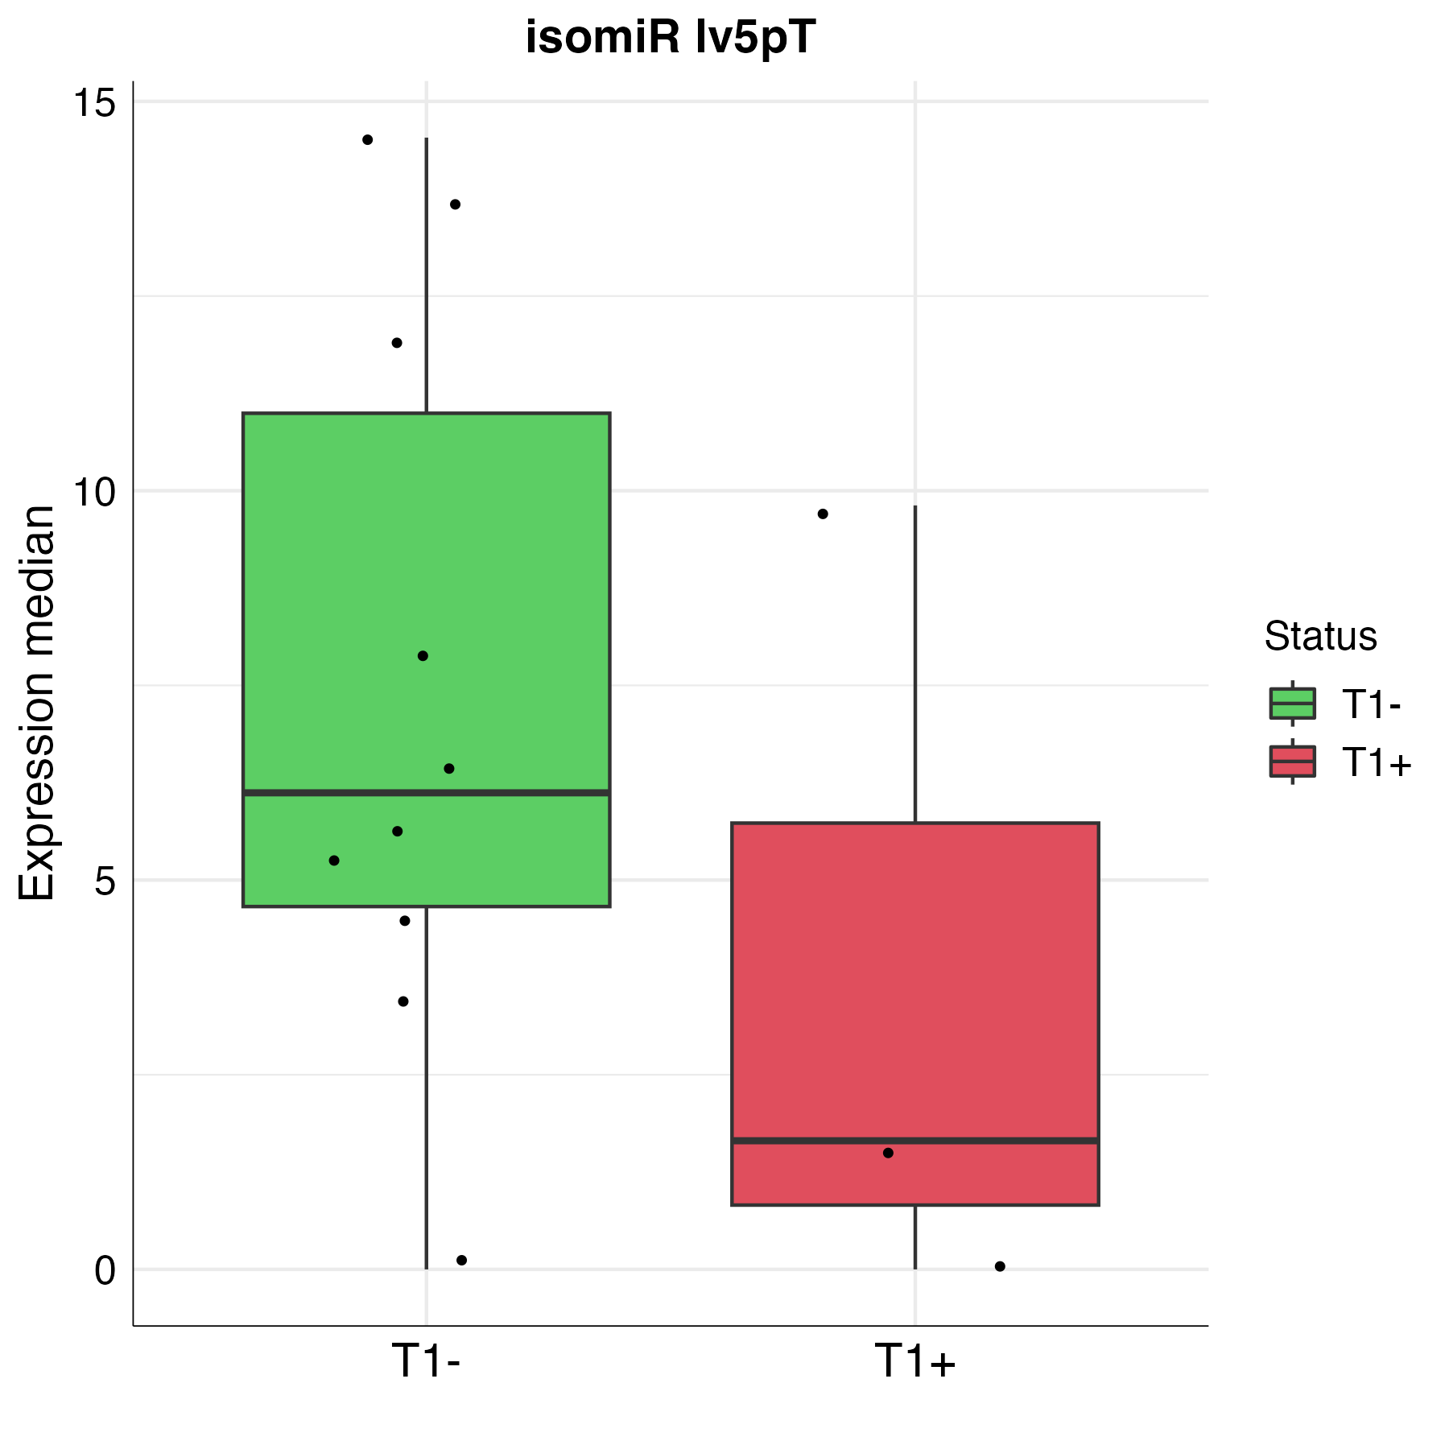
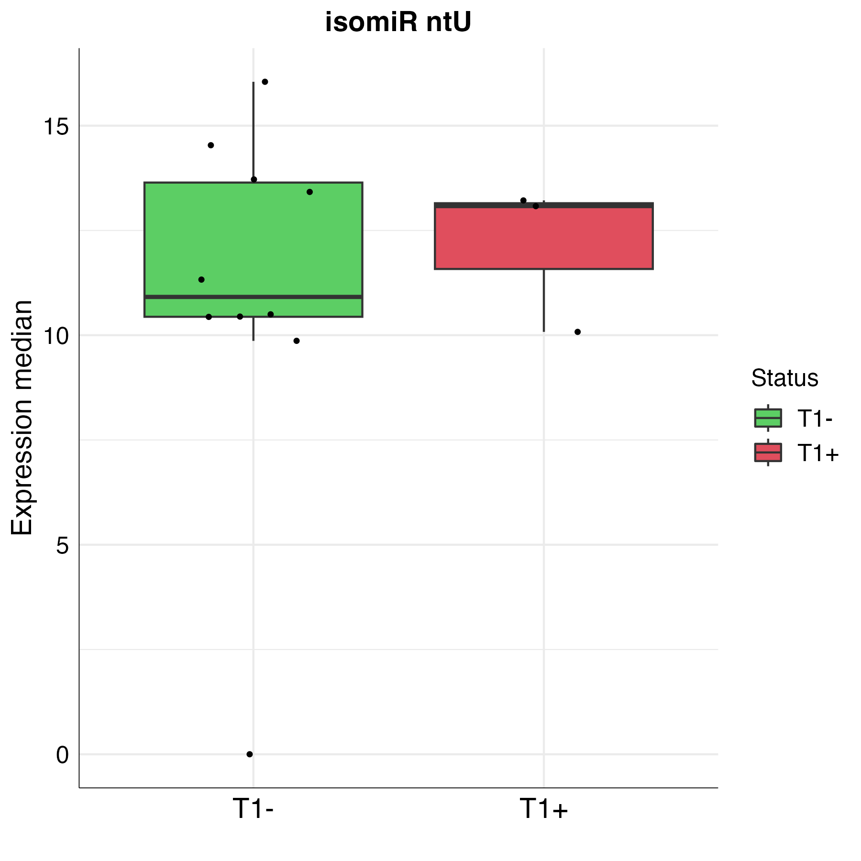
A
B
C
D
E
F
G
H

Fig. S3. Baseline expression of EV-RNA biomarkers and disease progression.
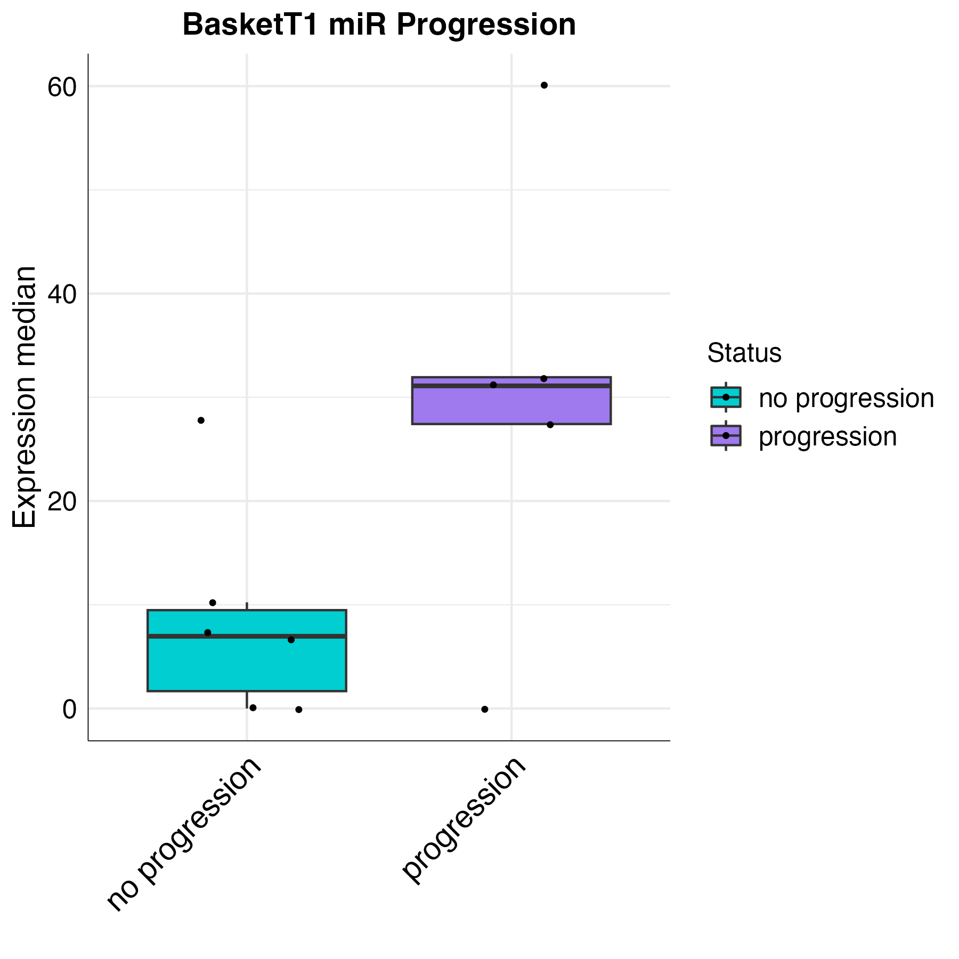
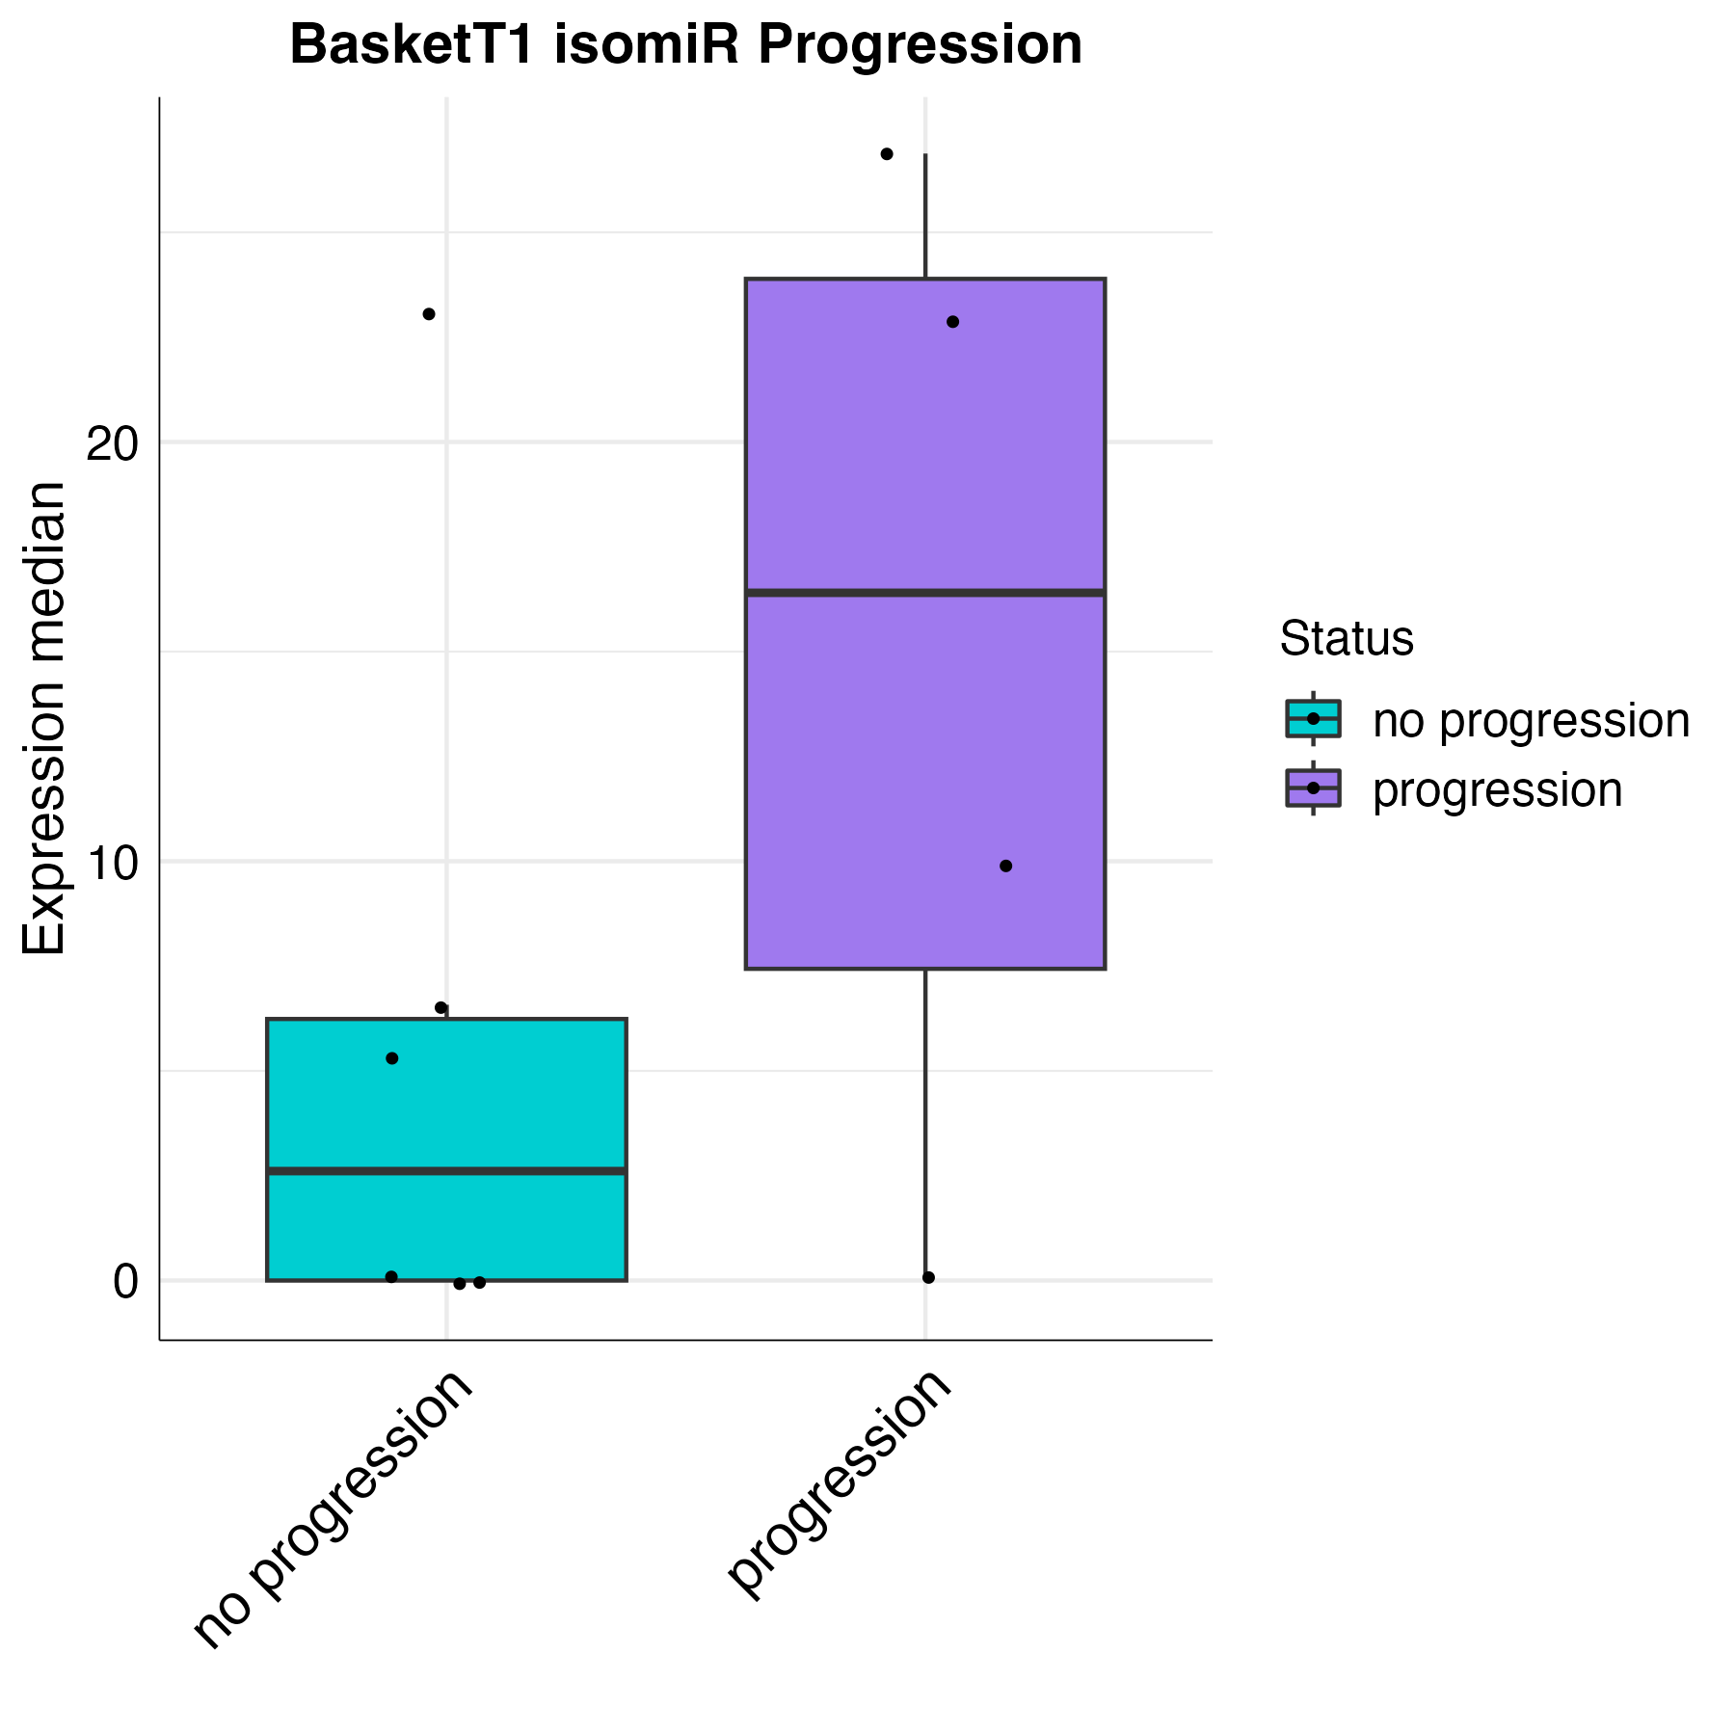
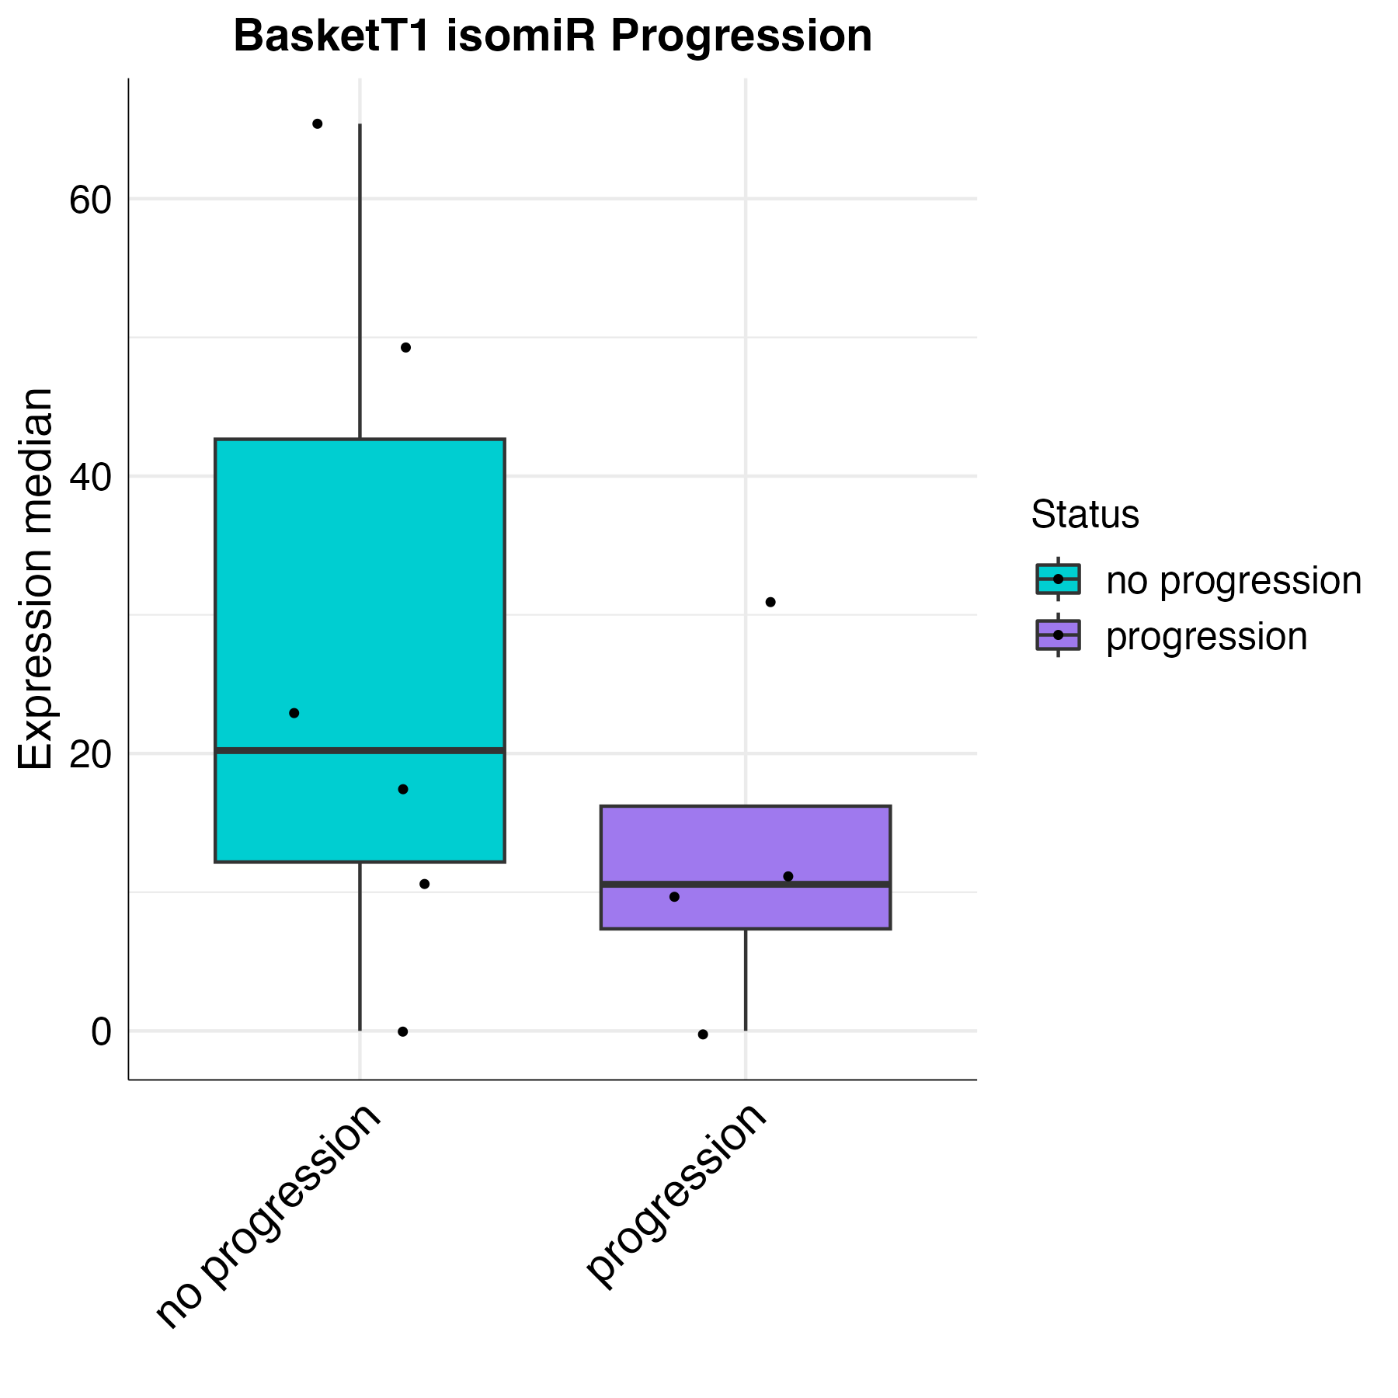
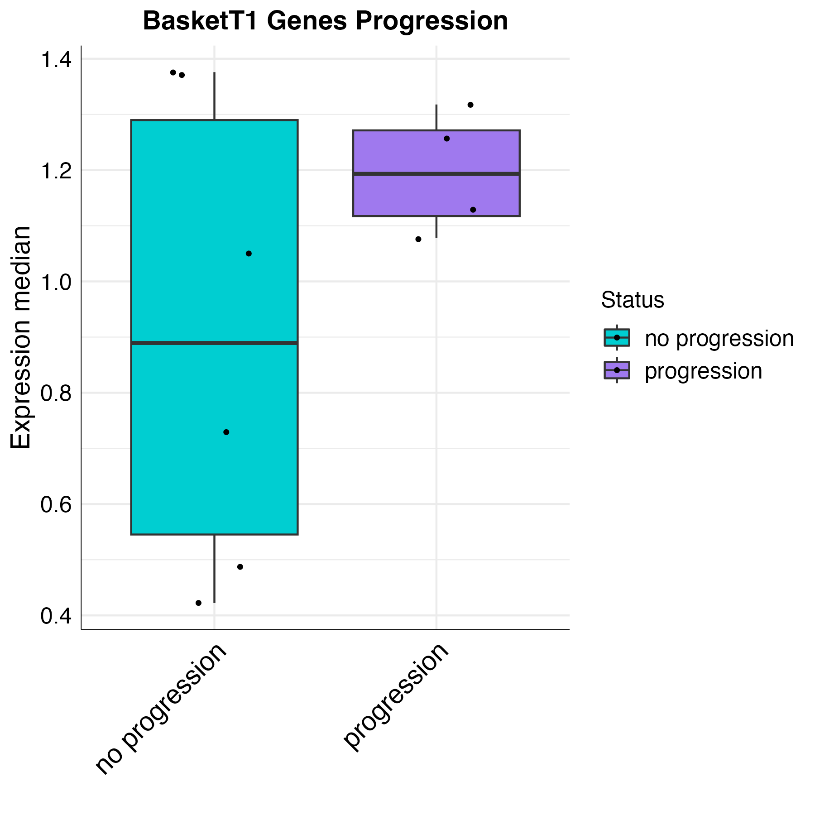
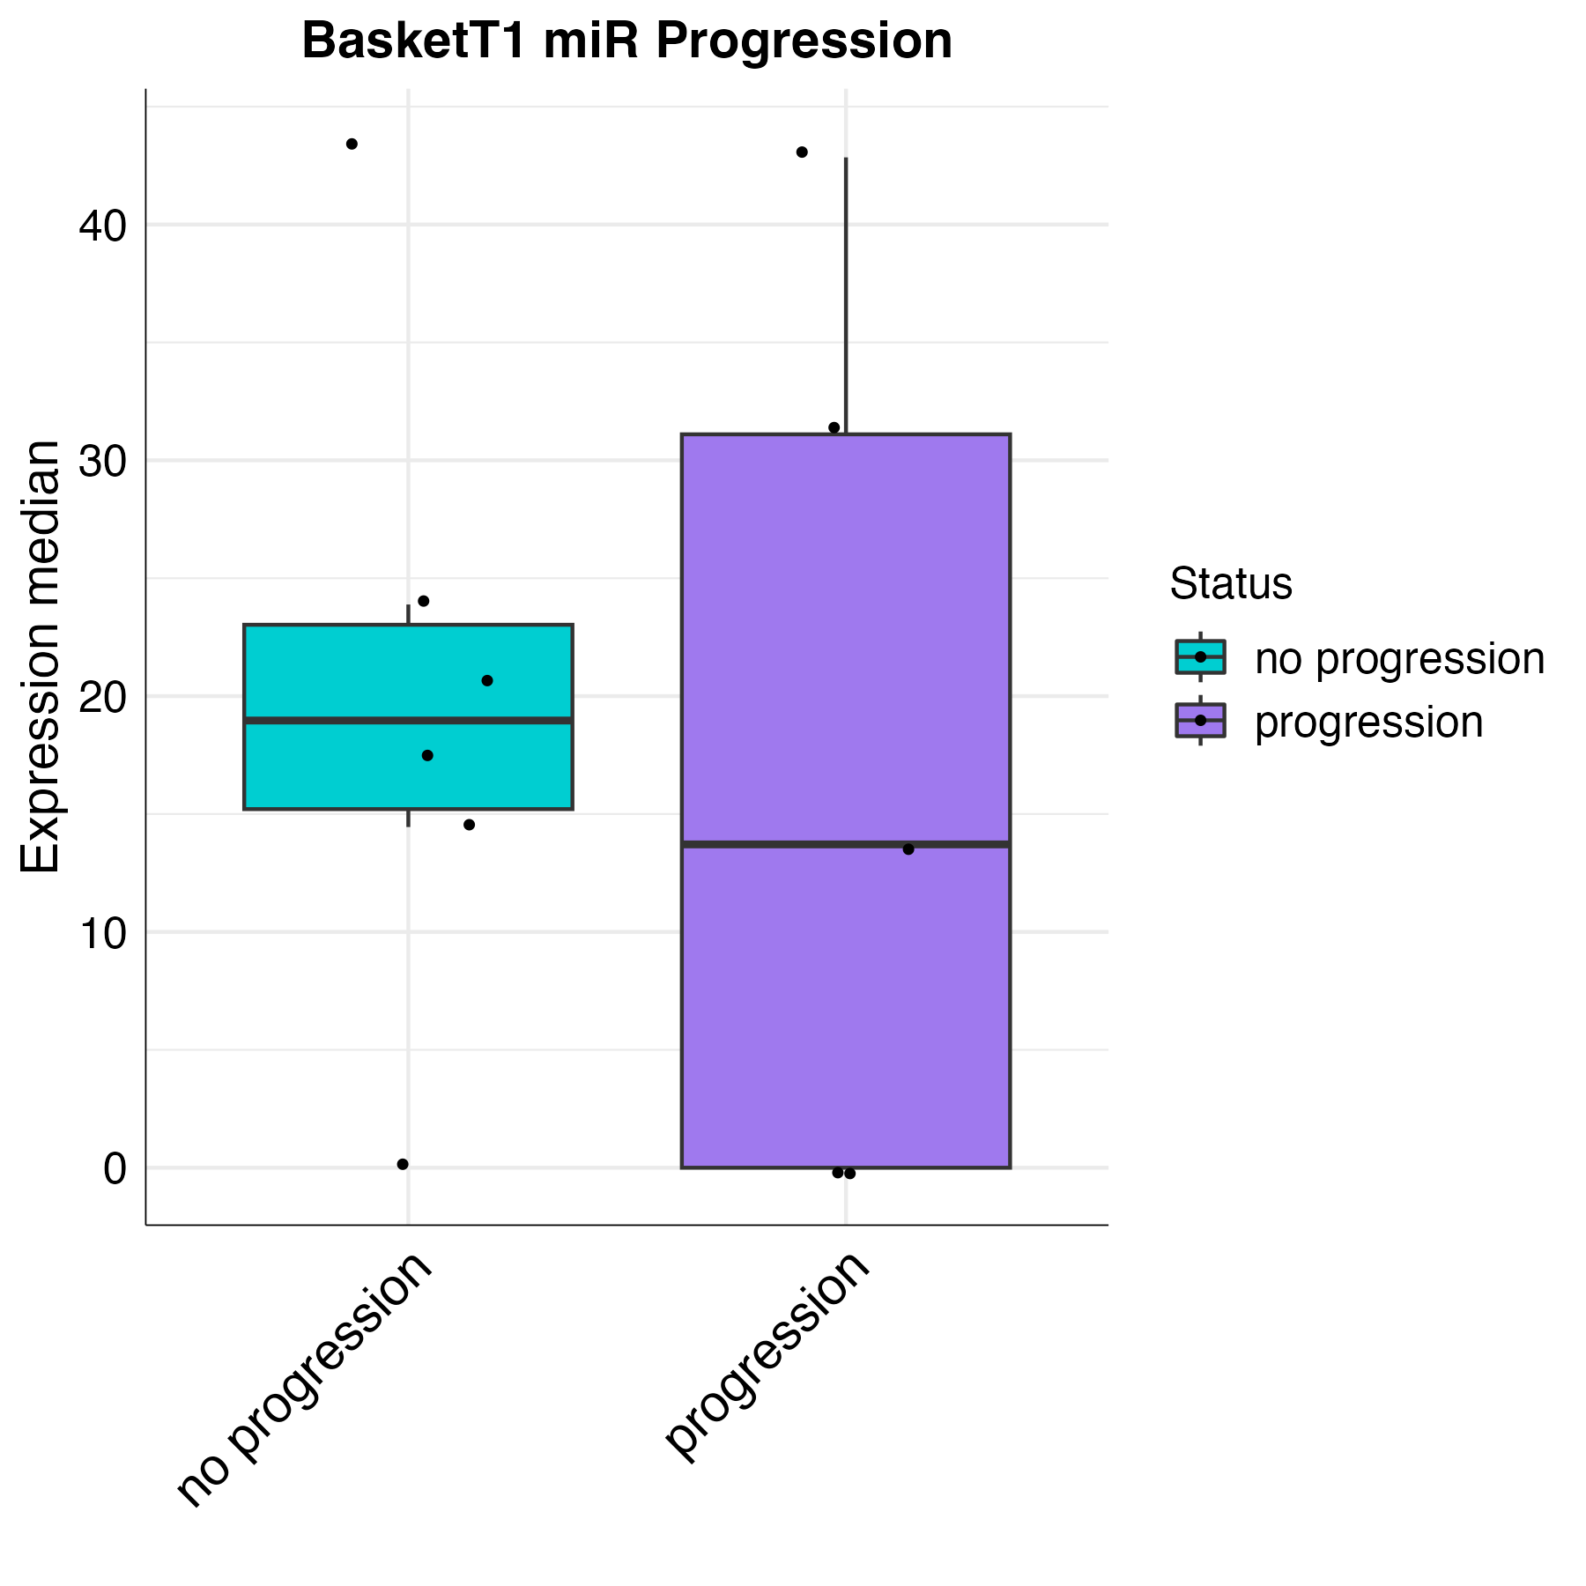
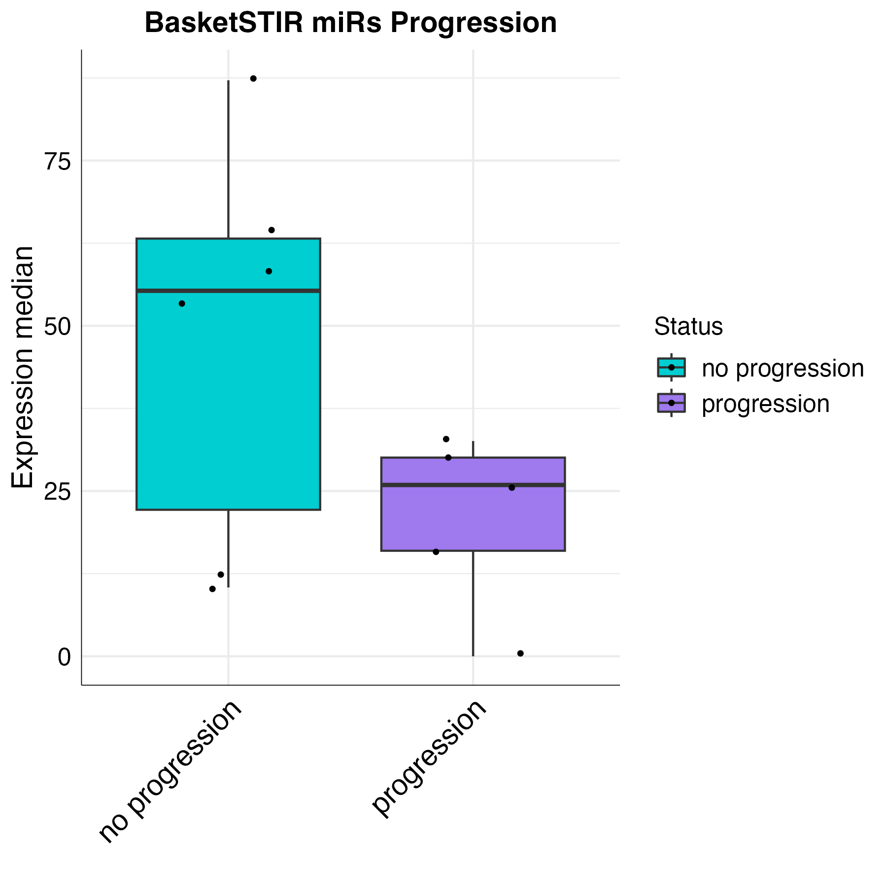
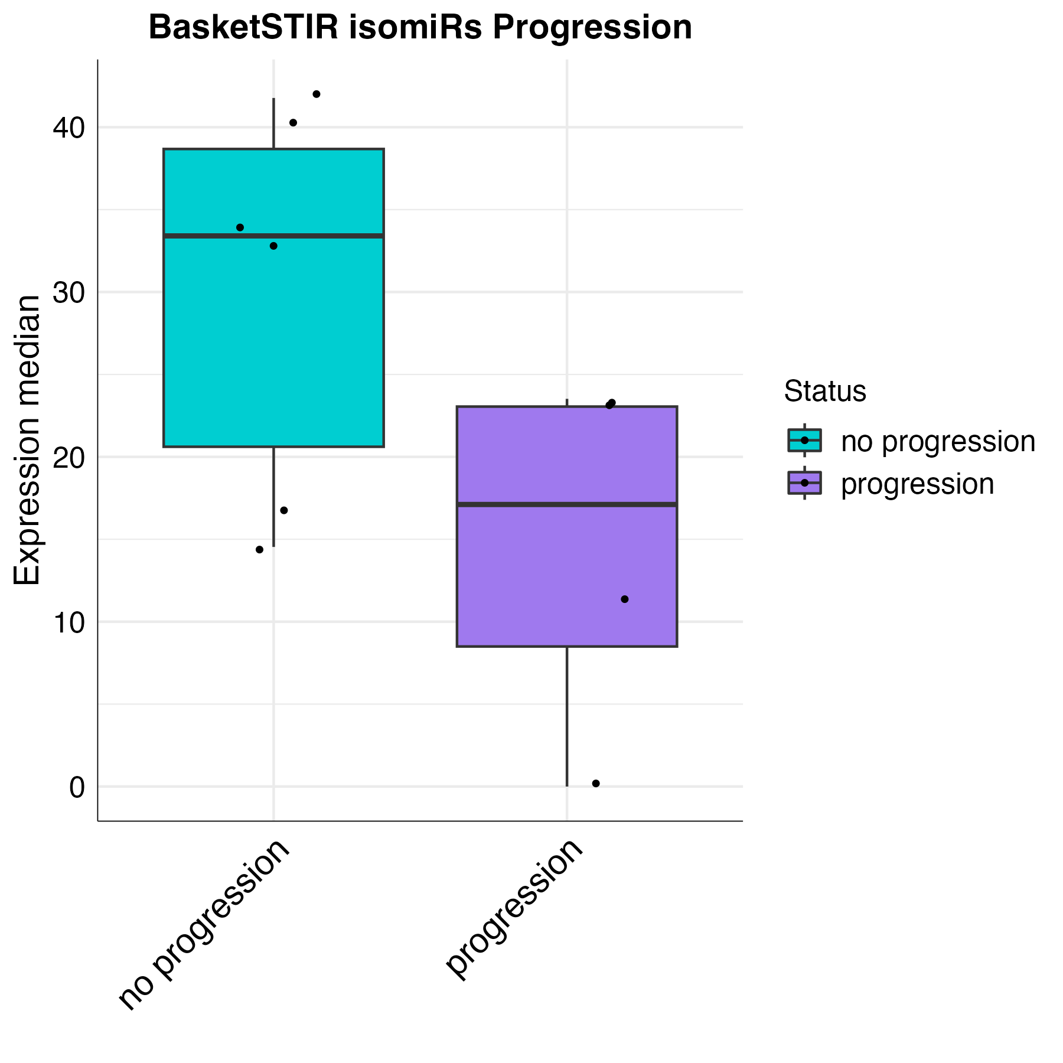
(A–G) Boxplots show the expression levels of candidate EV-miRNAs (A), EV-isomiRs (B) associated with STIR-positivity, as well as EV-miRNAs (C-D), EV-isomiRs (E-F) and EV-long RNAs (G) linked to T1-positivity. Data refer to baseline expression in FSHD muscle–derived EVs from samples that did or did not show T1-score changes at the 2-year MRI follow-up. Each dot represents the sum of the relative expression log₁₀ sum of the selected EV-RNA biomarkers in each sample. Groups were compared using unpaired two-tailed t tests (assuming equal or unequal variances) or Wilcoxon rank-sum test, based on data distribution and variance homogeneity assessed by Shapiro–Wilk and Levene’s tests.
A
B
C
D
E
F
EV-long RNAs associated
with disease severity
EV-miRNA associated
with disease severity
EV-isomiR associated
with disease severity
EV-isomiR associated
with disease severity
EV-miRNA associated
with disease severity
EV-miRNA associated
with disease activity
EV-isomiR associated
with disease activity
G

