Supplementary materials for “Global warming and the Pacific Decadal Oscillation drive seasonally varying increases in extreme fire weather over the southwestern US”

Jiale Lou ¹, Youngji Joh ², Darri A. Stuber ³, Thomas L. Delworth ², and Andrew T. Wittenberg ²
¹Atmospheric and Oceanic Sciences Program, Princeton University, Princeton, NJ, USA.
² Geophysical Fluid Dynamics Laboratory/NOAA, 201 Forrestal Road, Princeton, NJ, USA.
³ Department of Environmental Studies and Department of Mathematics, The University of Tampa, Tampa, FL, USA.

Corresponding author: Jiale Lou
Email address: jiale.lou@noaa.gov

Supplementary Table 1: Canadian forest service fire weather index (FWI) rating categories and associated fire behavior characteristics. The FWI values are grouped into five operational risk categories, each describing the expected fire intensity and suppression difficulty.
FWI rating | Category | Description
0-5 | Low | Fires likely to be self-extinguishing and new ignitions unlikely. Any existing fires limited to smoldering in deep, drier layers.
5-10 | Moderate | Creeping or gentle surface fires. Fires easily contained by ground crews with pumps and hand tools.
10-20 | High | Moderate to vigorous surface fire with intermittent crown involvement. Challenging for ground crews to handle; heavy equipment (bulldozers, tanker trucks, aircraft) often required to contain fire.
20-30 | Very high | High-intensity fire with partial to full crown involvement. Head fire conditions beyond the ability of ground crews; air attack with retardant required to effectively attack fire's head.
30+ | Extreme | Fast-spreading, high-intensity crown fire. Very difficult to control. Suppression actions limited to flanks, with only indirect actions possible against the fire's head.

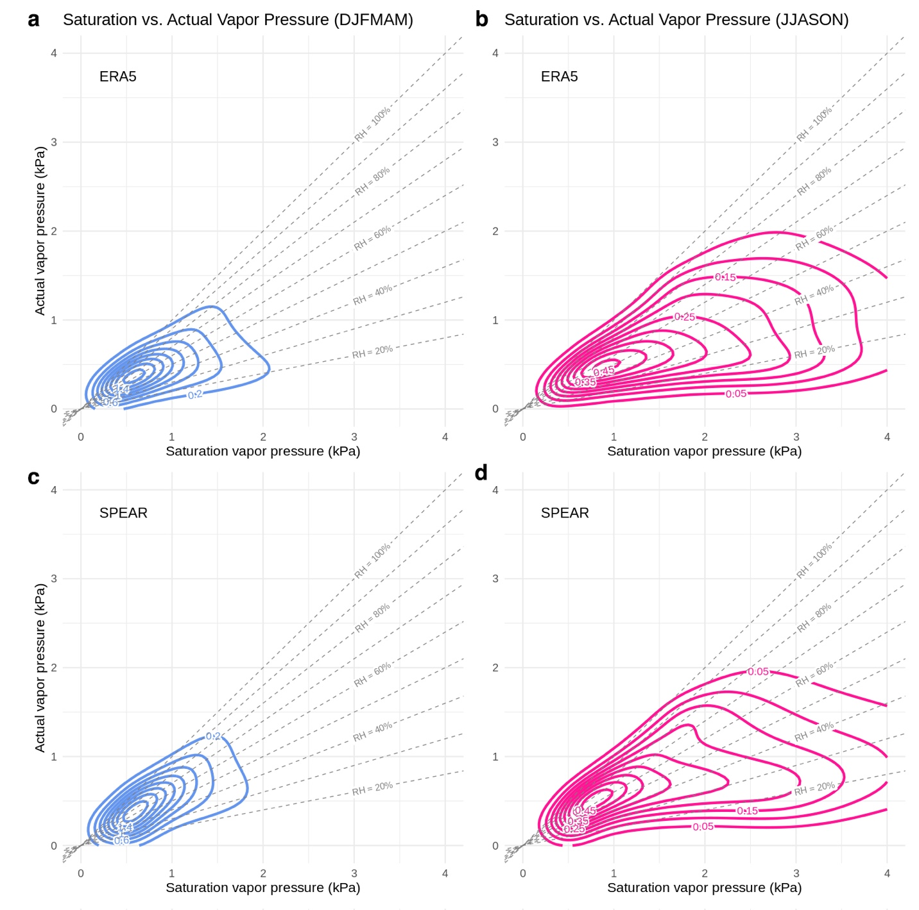
Supplementary Figure 1: Joint probability distributions between daily saturation vapor pressure and actual vapor pressure. Joint probability distributions of daily saturation vapor pressure and actual vapor pressure over the southwestern U.S., shown for the ERA5 dataset (top row) and SPEAR simulations (bottom row), during extended winter (left column) and extended summer (right column). Radial dashed lines originating from [0, 0] denote lines of constant relative humidity (RH), with RH values labeled along selected radial lines. Contour levels represent joint probability density values: 0.2–1.6 in steps of 0.2 for extended winter (panels a and c), and 0.05–0.45 in steps of 0.05 for extended summer (panels b and d). Density values are expressed in units of 1/kPa² and indicate the number of occurrences per unit area in the saturation vs. actual vapor pressure space. The distribution is not normalized, and values reflect the relative frequency of observed combinations across the dataset.

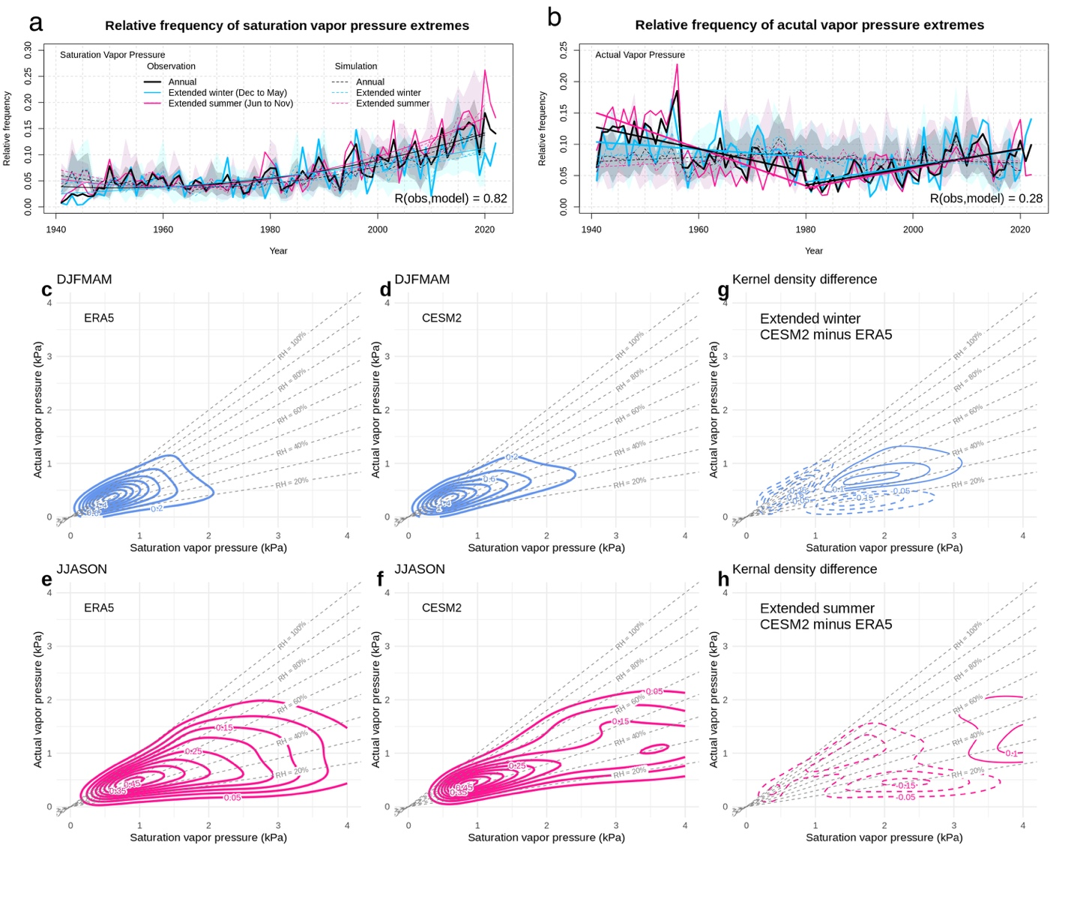Supplementary Figure 2: Temporal characteristics of daily saturation vapor pressure and actual vapor pressure from ERA5 and CESM2 AMIP-type simulations. (a–b) Same as Fig. 3c–d, but for CESM2 simulations, showing the relative frequency of saturation vapor pressure (a) and actual vapor pressure (b). Solid lines indicate ERA5 observations; dashed lines indicate CESM2 simulations. Annual, extended summer, and extended winter values are colored black, sky blue, and deep pink, respectively. Shaded areas represent ensemble spread. A quadratic polynomial trend is fitted to the full period in panel (a), while linear trends are applied to the pre-1980 and post-1980 subperiods in panel (b). (c–f) Same as Supplementary Fig. 1, but for CESM2 simulations. For comparison, the corresponding ERA5 distributions are shown in panels (c) and (e); these are identical to those in Supplementary Fig. 1. (g–h) Identical to Fig. 4c–d in the text, repeated here for ease of comparison.

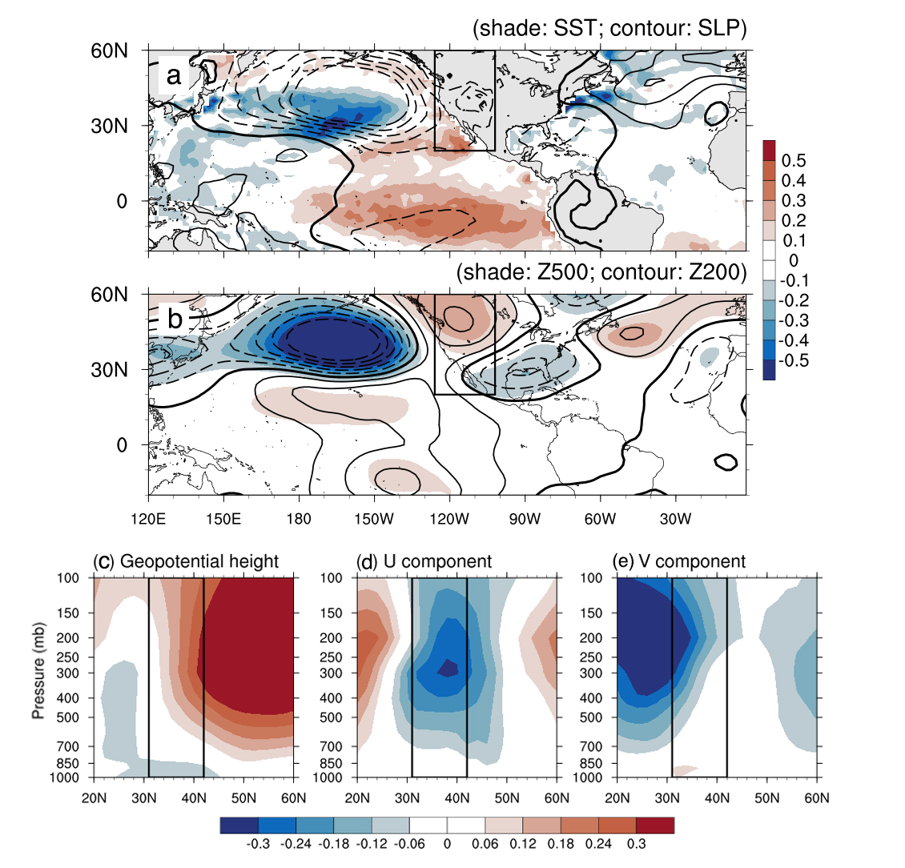
Supplementary Figure 3: Same as in Fig. 5 b-f, but for the seasonal mean RH anomalies over the western U.S. (a–e) Regression maps showing the relationship between summer mean RH anomalies over the southwestern U.S. and large-scale climatic conditions in preceding winter (December–February; DJF). (a) Winter sea surface temperature (SST; shading) and sea level pressure (SLP; contours); (b) Winter 500 hPa geopotential height (Z500; shading) and 200 hPa geopotential height (Z200; contours). (c–e) Longitudinal mean cross-sections showing regressions onto (c) geopotential heights, (d) zonal wind (U), and (e) meridional wind (V). Black boxes in (a) and (b) indicate the region used for cross-sections, while those in (c–e) show the latitudinal extent of the SWUS. Note that RH refers to the aggregated intensity of low-RH extremes (values below the 10th percentile) in Fig. 5. In contrast, RH in this figure refers to unfiltered summer mean RH anomalies, which include both extreme and non-extreme conditions.

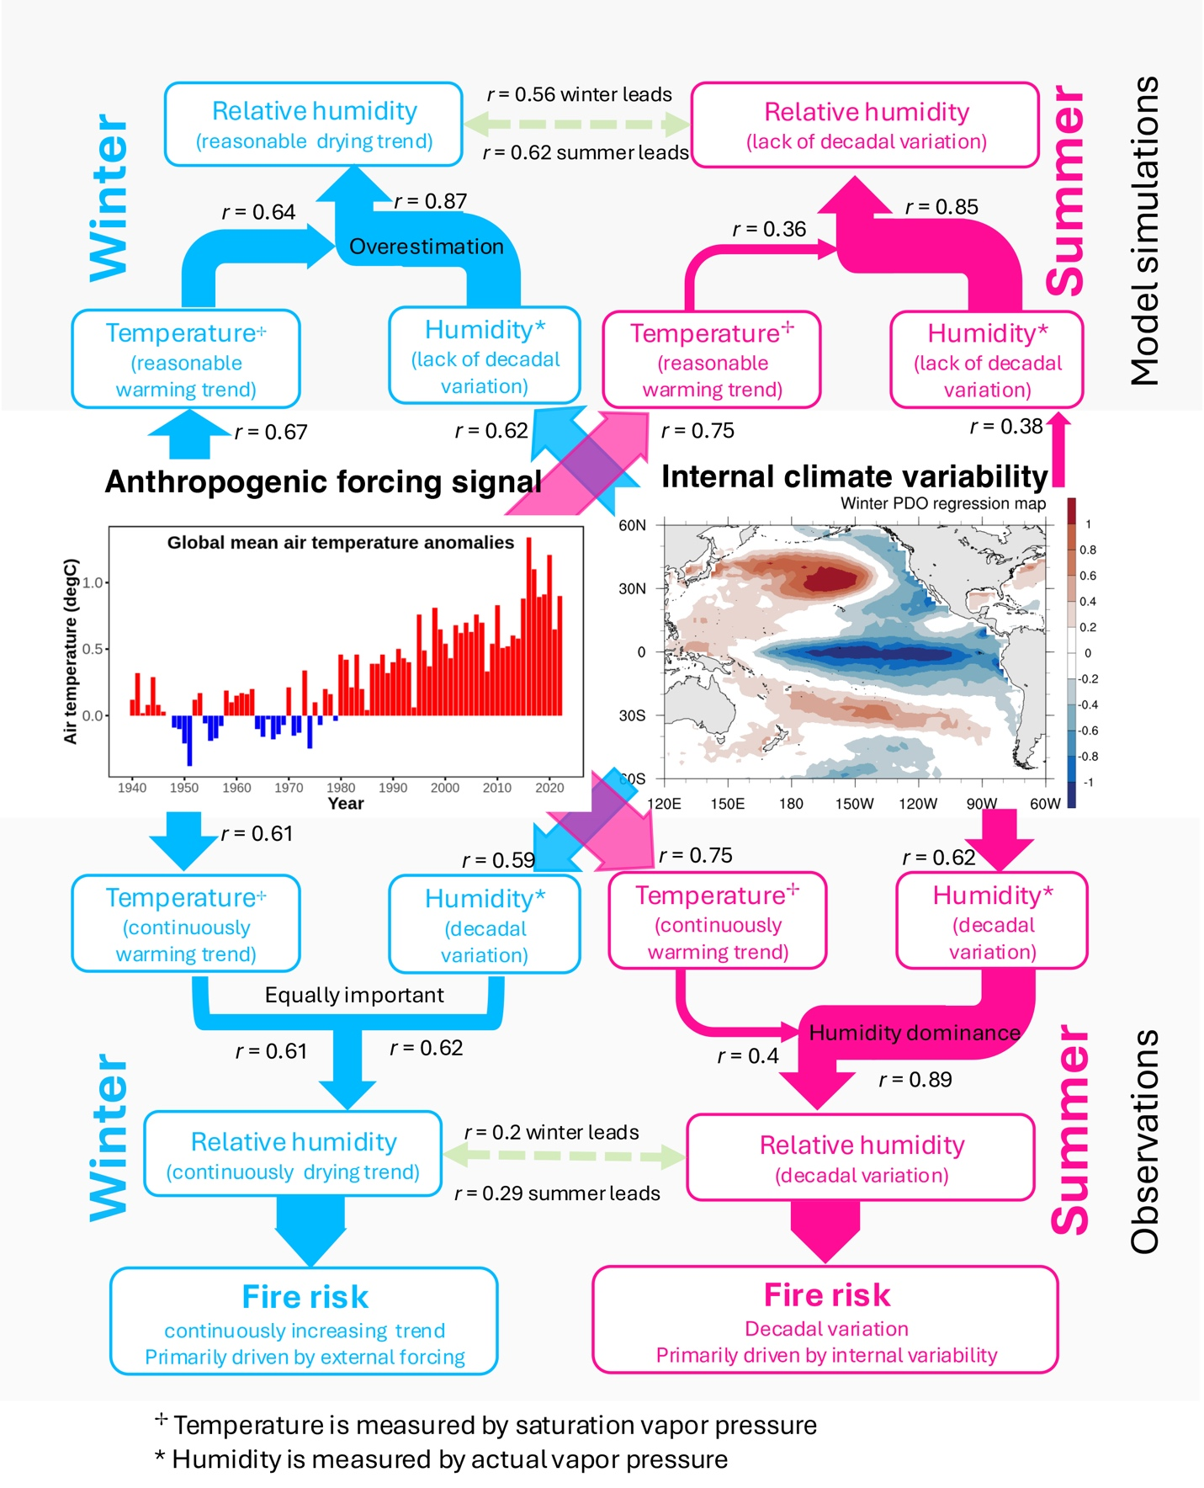
Supplementary Figure 4. Same as Fig. 6, but with the addition of model simulations incorporated into the top portion of the schematic for comparison.

Supplementary Figure 5: Comparison of baseline period definitions. Time series of near-global (60°S–60°N) mean sea surface temperature (SST) anomalies (top), the traditional Pacific Decadal Oscillation (PDO) index (middle), and the relative PDO index (bottom), calculated using different climatological baselines. Colored lines represent anomalies based on fixed climatologies over the full period (green), the first 30 years (pink), and the last 30 years (blue). The black line represents anomalies computed using a 30-year sliding climatology. The shaded area denotes the reference period used in this study (1940–2020). The comparison highlights how the choice of baseline period affects the magnitude and sign of SST and PDO anomalies, while the proposed relative PDO index minimizes sensitivity to baseline selection.

