SUPPLEMENTARY INFORMATION
Supplementary Figure 1
MIC Value distribution for each drug Sample size distribution across antibiotics in the CRyPTIC dataset, showing the number of MIC-labelled isolates per drug.
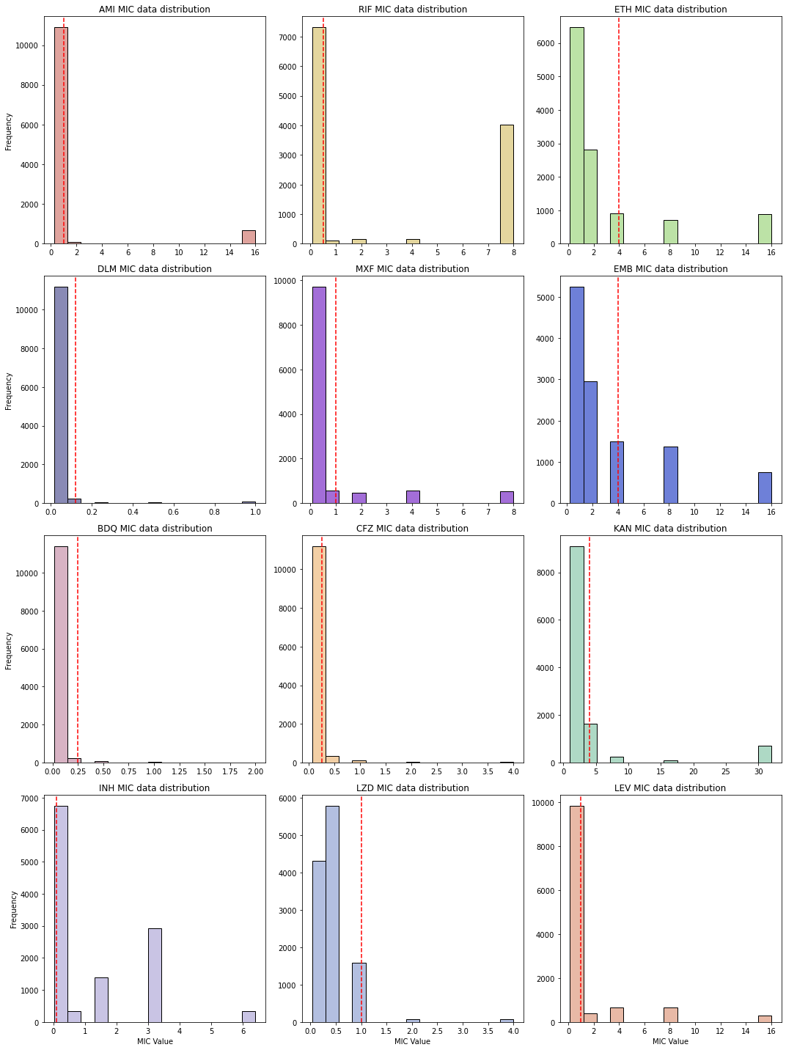

Supplementary Figure 2
Stack plot for MIC value prediction
This figure presents stacked bar charts of correct vs. incorrect predictions for binary-supported CNN (left column) and XGBoost (right column) across four drugs (top to bottom) (AMI, BDQ, RIF, EMB)
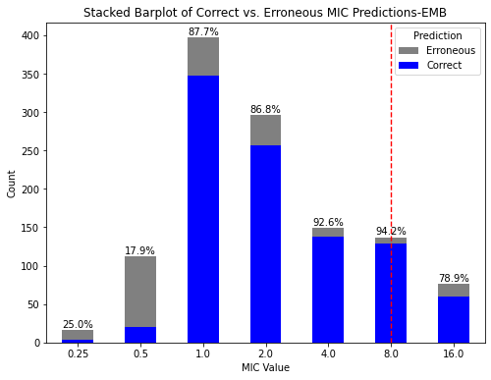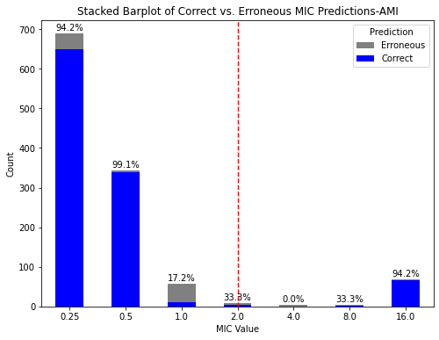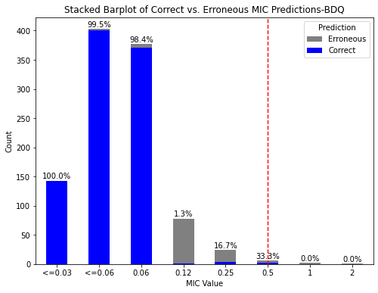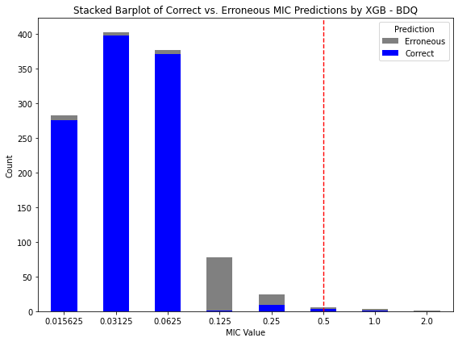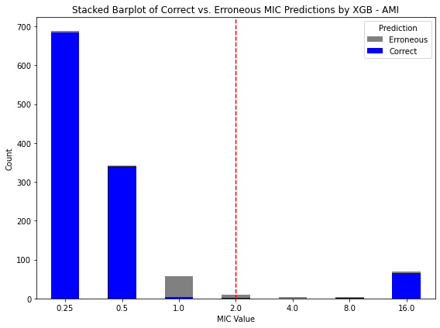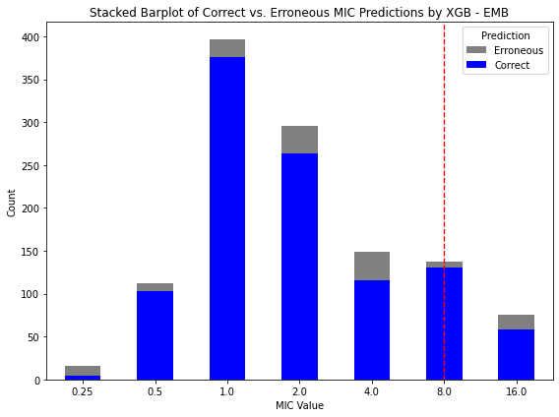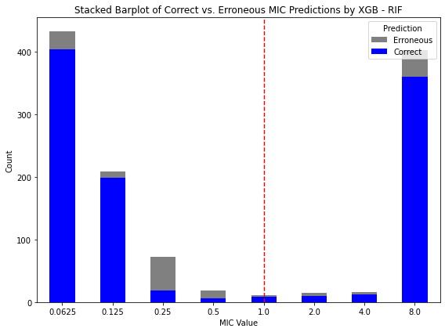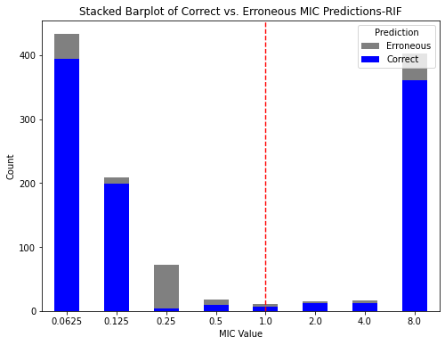
AMI
BDQ
RIF
EMB

Supplementary Figure 3
Sankey plot for MIC value prediction
A comparative visualisation of prediction distributions for binary-supported CNN (left column) and XGBoost (right column) across four drugs (top to bottom) - amikacin (AMI), bedaquiline (BDQ), rifampicin (RIF), and ethambutol (EMB) - with paired Sankey diagrams showing true MIC on the left the Sankey plot and predicted MIC on the right side of the Sankey plot.
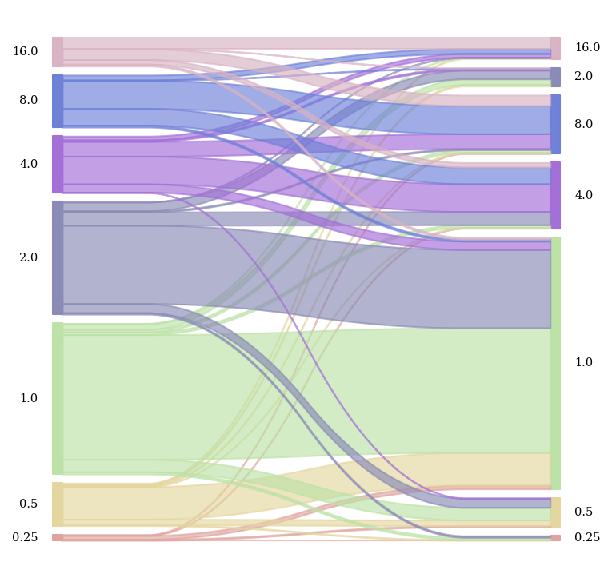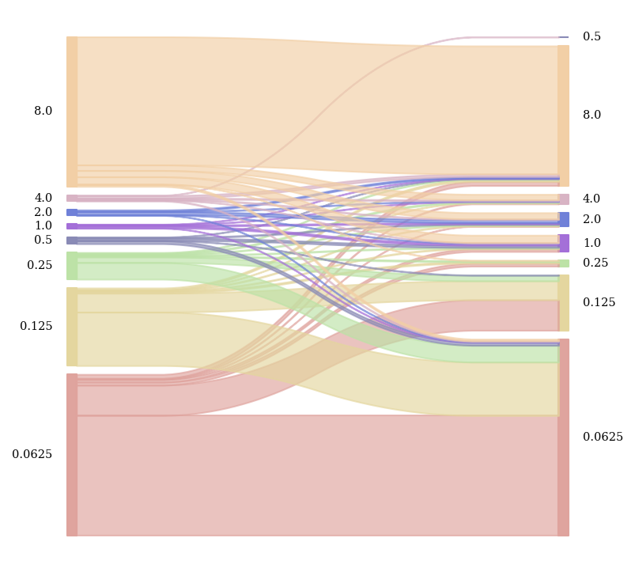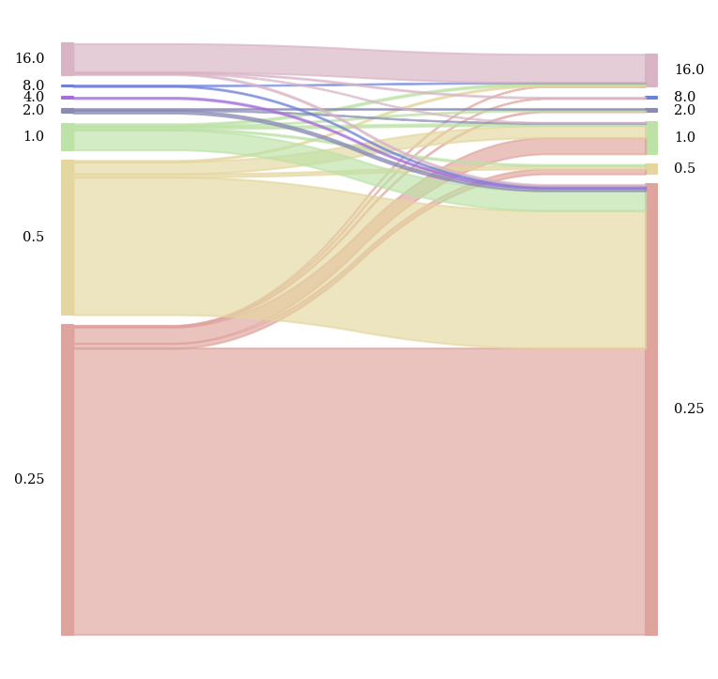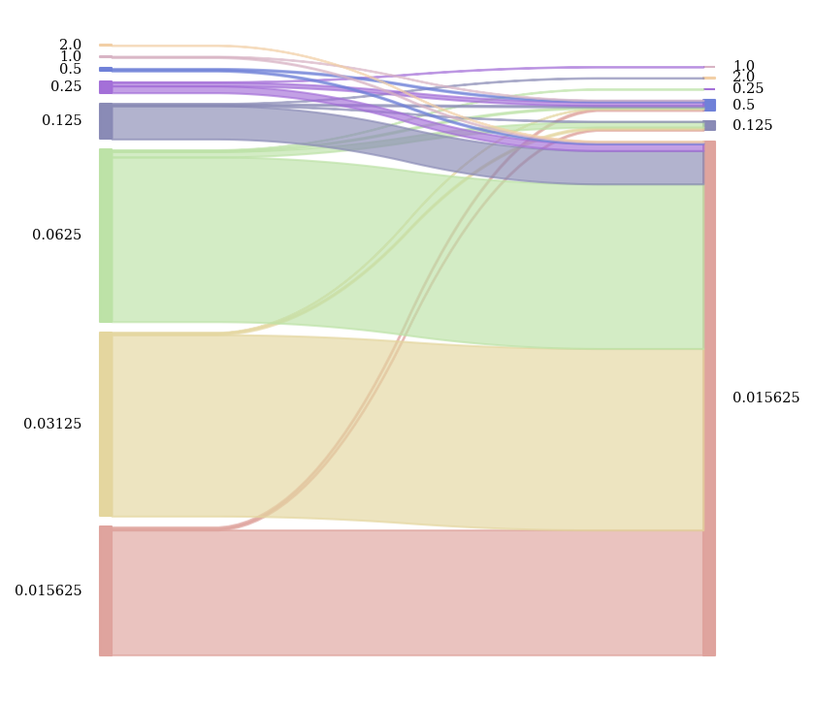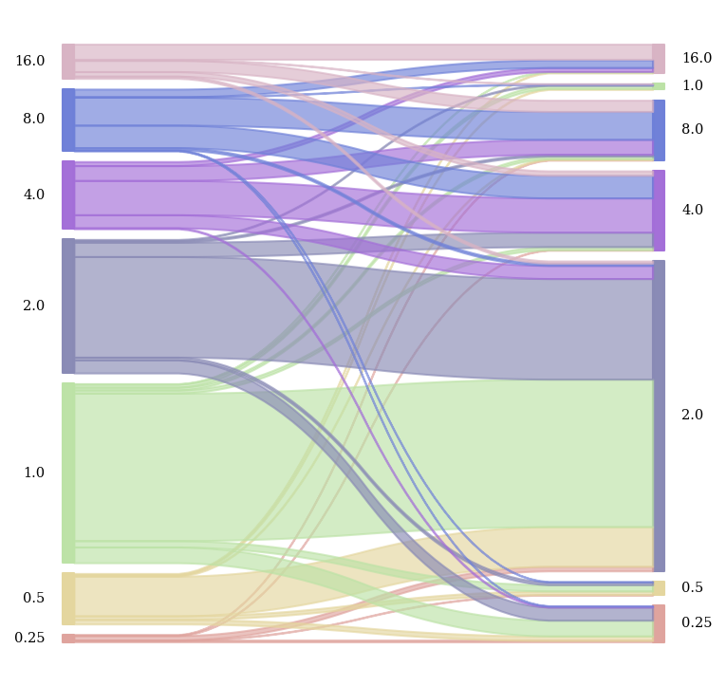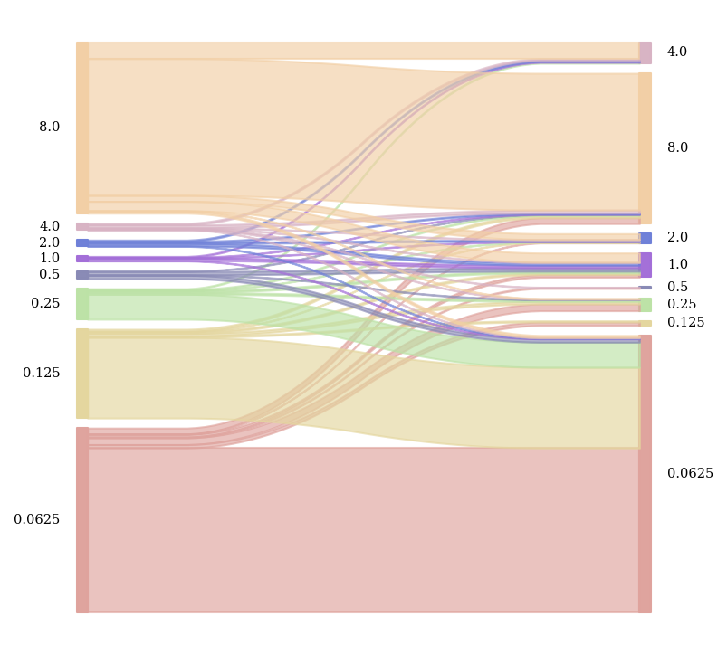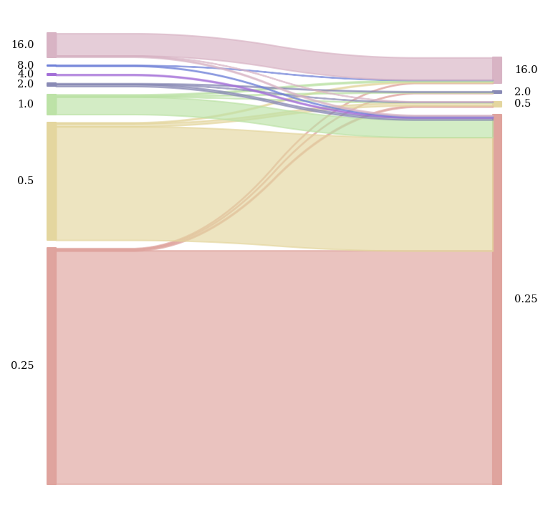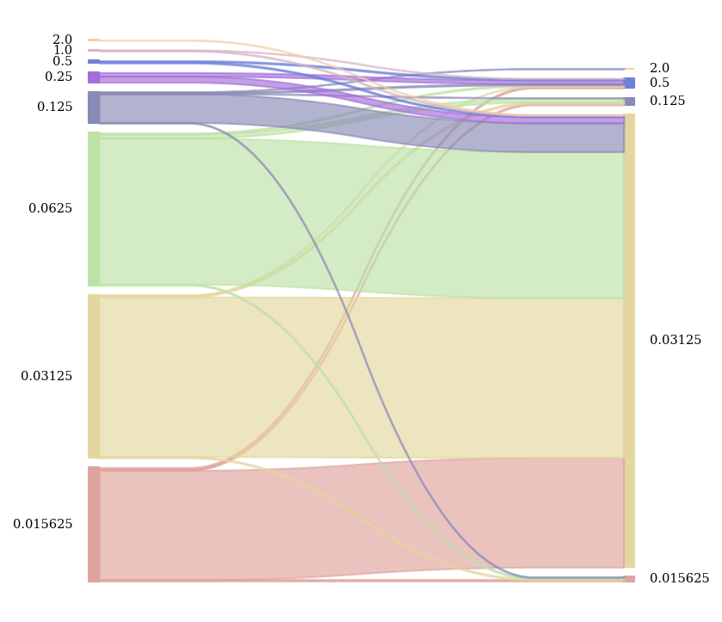
AMI
BDQ
RIF
EMB
Supplementary Table 1
Top 20 predictive genomic features ranked by their impact on model output (ranked by IG_{abs}) for rifampicin resistance.
Gene | Change | Delta AUC | IG direction | IG_{abs}
Binary Drug resistance input |  | 4.21e+00 | 4.21e+00 | 1.01e+01
rpoA | c.141C>G | 5.76e-02 | 5.76e-02 | 5.76e-02
rpoC | Val1039Gly | 5.26e-02 | 5.26e-02 | 5.26e-02
rpoA | Ile3Val | 5.25e-02 | 5.25e-02 | 5.25e-02
rpoC | Leu1245Arg | 3.19e-02 | 3.19e-02 | 3.19e-02
rpoC | c.339T>C | -1.81e-02 | -1.81e-02 | 2.41e-02
Rv2752c | Gly28Ser | -2.41e-02 | -2.41e-02 | 2.41e-02
rpoC | Val684Ile | 2.32e-02 | 2.32e-02 | 2.32e-02
rpoC | Leu516Pro | 1.82e-02 | 1.82e-02 | 2.01e-02
rpoC | Val431Met | 2.00e-02 | 2.00e-02 | 2.00e-02
rpoB | Val970Met | -1.97e-02 | -1.97e-02 | 1.97e-02
rpoC | Pro833Leu | 1.54e-02 | 1.54e-02 | 1.54e-02
rpoC | Glu266Gln | 1.41e-02 | 1.41e-02 | 1.41e-02
rpoA | c.74_73insCAACCCA | 1.39e-02 | 1.39e-02 | 1.39e-02
rpoC | Glu948Ala | 1.34e-02 | 1.34e-02 | 1.34e-02
rpoA | c.120T>A | 1.30e-02 | 1.30e-02 | 1.30e-02
rpoA | c.111A>C | -7.57e-03 | -7.57e-03 | 1.19e-02
rpoA | c.88C>T | 1.19e-02 | 1.19e-02 | 1.19e-02
rpoB | c.112G>A | 1.16e-02 | 1.16e-02 | 1.16e-02
rpoB | Asp435Tyr | 1.07e-02 | 1.07e-02 | 1.07e-02
rpoB | Gly463Trp | 9.80e-03 | 9.80e-03 | 9.80e-03
ΔAUC: Change in model AUC upon feature ablation, indicating its impact on predictive performance. IG direction: Signed integrated gradients attribution; positive values support resistance prediction, negative oppose. IG abs: Absolute integrated gradients magnitude, representing feature importance regardless of direction.

Supplementary Table 2. MIC value transformation
Amikacin |  | Bedaquiline |  | Clofazimine
Raw | Transformed | Raw | Transformed | Raw | Transformed
<=0.25 | 0.25 | <=0.015 | 0.015625 | <=0.015 | 0.015625
0.5 | 0.5 | 0.03 | 0.03125 | 0.03 | 0.03125
1 | 1 | 0.06 | 0.0625 | 0.06 | 0.0625
2 | 2 | 0.12 | 0.125 | 0.12 | 0.125
4 | 4 | 0.25 | 0.25 | 0.25 | 0.25
8 | 8 | 0.5 | 0.5 | 0.5 | 0.5
>8 | 16 | 1 | 1 | 1 | 1
 |  | >1 | 2 | >2 | 4
Delamanid |  | Ethambutol |  | Ethionamide
Raw | Transformed | Raw | Transformed | Raw | Transformed
<=0.015 | 0.0078125 | 0.5 | 0.5 | 0.5 | 0.5
0.015 | 0.015625 | 1 | 1 | 1 | 1
0.03 | 0.03125 | 2 | 2 | 2 | 2
0.06 | 0.0625 | 4 | 4 | 4 | 4
0.12 | 0.125 | 8 | 8 | 8 | 8
0.25 | 0.25 | >8 | 16 | >8 | 16
0.5 | 0.5
>0.5 | 1
Isoniazid |  | Kanamycin |  | Levofloxacin
Raw | Transformed | Raw | Transformed | Raw | Transformed
<=0.025 | 0.025 | <=1 | 1 | <=0.12 | 0.125
0.05 | 0.05 | 2 | 2 | 0.25 | 0.25
0.1 | 0.1 | 4 | 4 | 0.5 | 0.5
0.2 | 0.2 | 8 | 8 | 1 | 1
0.4 | 0.4 | 16 | 16 | 2 | 2
0.8 | 0.8 | >16 | 32 | 4 | 4
1.6 | 1.6 |  |  | 8 | 8
>1.6 | 3.2 |  |  | >8 | 16
Linezolid |  | Moxifloxacin |  | Rifampicin
Raw | Transformed | Raw | Transformed | Raw | Transformed
<=0.03 | 0.015625 | <=0.06 | 0.03 | <=0.06 | 0.03125
0.06 | 0.0625 | 0.12 | 0.125 | 0.06 | 0.0625
0.12 | 0.125 | 0.25 | 0.25 | 0.12 | 0.125
0.25 | 0.25 | 0.5 | 0.5 | 0.25 | 0.25
0.5 | 0.5 | 1 | 1 | 0.5 | 0.5
1 | 1 | 2 | 2 | 1 | 1
2 | 2 | 4 | 4 | 2 | 2
>2 | 4 | >4 | 8 | >4 | 8
 |  |  |  | >8 | 16

Supplementary Table 3. CNN architecture
Component | Layer Type | Details
Input | – | 1D sequence tensor (B, 1, L), plus scalar additional input
Feature Extraction | Conv1D + BatchNorm + ReLU | Filters: 64, Kernel: 25
Conv Block 1 × 2 | Dropout + Conv1D + BN + ReLU + MaxPool1D | Filter scaling applied, Kernel: 3, Pool: 3
Conv Block 2 × 2 | Dropout + Conv1D + BN + ReLU + MaxPool1D | Fixed filters: 32, Kernel: 3, Pool: 3
Flatten | – | Flatten before dense layers
Dense Block × 2 | Dropout + Linear + BN + ReLU | Hidden units: 128
Concatenation | – | Concatenate scalar additional input (reshaped to B×1)
Prediction Head | Linear → ReLU → Dropout → Linear → ReLU → Dropout → Linear | Output: 6 classes
Activation | – | Softmax applied externally during evaluation
Regularization | Dropout, L1 penalty | conv_dropout = 0.4, dense_dropout = 0.7, L1 = 0.1
Output | Linear (number of MIC classes,) | Logits for multi-class classification

