Additional Material to
Self-Stigma but not Mental Health Literacy Predicts Attitudes toward Professional Help-Seeking in an Indonesian Community Sample
by Nurul Hartini et al.

Additional file 1: Vignettes
Depression vignette
Indonesian version | English translation
“Dewi adalah remaja berusia 17 tahun. Dalam beberapa minggu belakangan, ia merasa begitu sedih dan tertekan, tidak seperti biasanya. Meskipun sepulang sekolah ia merasa sangat lelah, hampir setiap malam ia mengalami susah tidur. Dewi juga merasa kehilangan nafsu makannya, sehingga berat badannya turun drastis. Ketika mengerjakan tugasnya, ia merasa kesulitan untuk berkonsentrasi dan sulit mengambil keputusan. Kegiatan-kegiatan rutin yang biasa ia lakukan setiap hari sekarang terasa begitu berat untuk dilakukan. Hal ini juga menjadi perhatian guru, orang tua dan teman-temannya yang mulai mengkhawatirkan kondisi Dewi.” | “Dewi is a 17-year-old teenager. In the past few weeks, she has been feeling very sad and depressed, unlike usual. Although she feels exhausted after school, almost every night she has trouble falling asleep. Dewi has also lost her appetite, so her weight has been drastically decreasing. When she does her assignments, she has difficulty concentrating and making decisions. Her daily routines have become very difficult to follow. These changes have come to the attention of her teacher, parents, and friends, who have started to feel concerned with Dewi’s condition.”
Schizohrenia vignette
Indonesian version | English translation
“Joko adalah pemuda yang berusia 21 tahun dan tinggal di rumah orang tuanya. Sejak lulus SMA, ia bekerja serabutan, namun saat ini hari-harinya banyak dihabiskan dengan menganggur. Sejak 6 bulan terakhir, ia tidak lagi mau bertemu dengan teman-temannya dan mulai mengunci diri di dalam kamar. Ia juga menolak makan bersama orang tuanya dan menolak untuk mandi. Orang tuanya juga sering mendengar Joko mengetuk-ngetuk dinding dan berjalan mondar-mandir di dalam kamarnya ketika malam hari. Meskipun orang tuanya tidak melihat ada orang lain di kamar Joko, mereka sering mendengar Joko berbicara dan berteriak seolah-olah ada orang lain di kamarnya. Ketika orang tuanya menyuruh Joko untuk keluar rumah dan segera mencari pekerjaan, Joko menolak dengan alasan ia sedang di mata-matai oleh seseorang. Orang tuanya sangat yakin bahwa Joko tidak kecanduan obat-obatan terlarang, karena ia nyaris tidak pernah keluar rumah ataupun terlihat berinteraksi dengan orang lain.” | “Joko is a 21-year-old man living in his parents’ house. After graduating high school, he took a few odd jobs, but now his days are mostly spent without any work. For six months, he has refused to meet his friends and isolated himself in his room. He also refuses to eat with his parents or take a bath. His parents often hear him banging on the wall and walking back and forth in his room at night. Although his parents do not see anyone in his room, they often hear Joko talking and yelling as if someone is in his room. When his parents ask him to go out and find a job soon, Joko refuses and says someone is spying on him. His parents are convinced that Joko is addicted to drugs, because he almost never leaves the house or interacts with other people.”

Appendix 2: Measures

Appendix 2a. Indonesian version of SSOSH
- Saya merasa menjadi orang yang lemah jika pergi ke ahli terapi untuk mendapatkan bantuan psikologis.
(I would feel inadequate if I went to a therapist for psychological help.)
- Kepercayaan diri saya TIDAK akan menurun jika saya mencari bantuan profesional. *
(My self-confidence would NOT go down if I sought professional help.)
- Mencari bantuan psikologis akan membuat saya merasa kurang pintar.
(Seeking psychological help would make me feel less intelligent.)
- Harga diri saya akan meningkat jika saya berkonsultasi dengan seorang ahli terapi. *
(My self-esteem would increase if I talked to a therapist.)
- Pandangan saya terhadap diri sendiri tidak akan berubah hanya karena saya memutuskan untuk menemui seorang ahli terapi. *
(My view of myself would not change just because I made the choice to see a therapist.)
- Meminta bantuan dari seorang ahli terapi akan membuat saya merasa rendah diri.
(It would make me feel inferior to ask a therapist for help.)
- Saya akan merasa baik-baik saja tentang diri saya jika saya memutuskan untuk mencari bantuan profesional. *
(If I went to a therapist, I would feel okay about myself.)
- Jika saya pergi ke ahli terapi, saya akan merasa kurang puas dengan diri saya sendiri.
(If I went to a therapist, I would feel less satisfied with myself.)
- Kepercayaan diri saya akan tetap sama jika saya mencari bantuan untuk masalah yang tidak bisa saya selesaikan. *
(My self-confidence would remain the same if I sought help for a problem I could not solve.)
- Saya akan merasa lebih buruk tentang diri saya jika saya tidak bisa menyelesaikan masalah saya sendiri.
(I would feel worse about myself if I could not solve my own problems.)
Note: * Scores are reversed.

Appendix 2b. Indonesian version of ATSPPH-SF.
- Jika saya pikir saya punya permasalahan mental, pikiran pertama saya adalah mendapatkan perhatian profesional.
(If I believed I was having a mental breakdown, my first inclination would be to get professional attention.)
- Bagi saya, berkonsultasi dengan seorang psikolog tentang permasalahan saya sepertinya adalah cara yang buruk untuk menyelesaikan masalah emosional. *
(The idea of talking about problems with a psychologist strikes me as a poor way to get rid of emotional conflicts.)
- Jika saya mengalami permasalahan emosional yang serius, saya yakin terapi psikologis akan membantu.
(If I were experiencing a serious emotional crisis at this point in my life, I would be confident that I could find relief in psychotherapy.)
- Saya kagum dengan orang-orang yang mau menyelesaikan masalah dan ketakutan mereka tanpa mencari bantuan profesional. *
(There is something admirable in the attitude of a person who is willing to cope with his or her conflicts and fears without resorting to professional help.)
- Jika saya merasa cemas atau sedih dalam waktu yang lama, saya ingin mendapatkan bantuan psikologis.
(If I were troubled by severe emotional difficulties, I would be inclined to seek professional help.)
- Saya mungkin ingin menjalani konseling psikologis suatu hari nanti.
(I might want to have psychological counseling in the future.)
- Seseorang dengan masalah emosional tidak mungkin menyelesaikannya sendiri, dia lebih mungkin menyelesaikannya dengan bantuan profesional.
(A person with an emotional problem is not likely to solve it alone; he or she is more likely to solve it with professional help.)
- Mempertimbangkan waktu dan uang yang dibutuhkan, saya tidak yakin terapi psikologis akan bermanfaat bagi orang seperti saya. *
(Considering the time and expense involved in psychotherapy, it would have doubtful value for a person like me.)
- Orang-orang seharusnya menyelesaikan masalah mereka sendiri; sehingga menjalani konseling psikologis menjadi pilihan terakhir mereka. *
(A person should work out his or her own problems; getting psychological counseling would be a last resort.)
- Masalah pribadi dan emosional, seperti banyak hal dalam hidup, cenderung akan selesai dengan sendirinya. *
(Personal and emotional troubles, like many things, tend to work out by themselves.)
Note: * Scores are reversed.

Appendix 3: Descriptive Statistics after Outlier Exclusion

Table A3. Descriptive statistics after excluding outliers (N = 887)
Variables | n (%) | Range | $$\underline{x}$$ | SD | Group Difference ª
 |  |  |  |  | Statistics | Effect Size [95% Confidence Intevral]
1. Sex |  | - | - | - | X²(1, N_{total} = 912) = 5.40 × 10⁻³, p = .941 | Φ = 0.00 [0.00 – 0.06]
Male (0) | 344 (38.8%) |  |  |  | X²(1, N_{total} = 912) = 5.40 × 10⁻³, p = .941
Female (1) | 543 (61.2%) |  |  |  | X²(1, N_{total} = 912) = 5.40 × 10⁻³, p = .941
2. Education level |  | - | - | - | X²(NA, N_{total} = 912) = 153.82, p < .001 | V = .41 [.34 – .47]
9 years (0) | 0 (0%)
12 years (1) | 655 (73.8%)
Higher education (2) | 232 (26.2%)
3. Vignette |  | - | - | - | X²(1, N_{total} = 912) = 0.69, p = .405 | Φ = 8.93 ×10⁻³ [0.00 – 0.09]
Depression (0) | 448 (50.5%)
Schizophrenia (1) | 439 (49.5%)
4. Age |  | 18-40 | 21.51 | 2.79 | W = 1569.5, p < .001 | r = -.86 [-.91 – -.78]
5. Literacy index |  | - | - | - | X²(1, N_{total} = 912) = 1.11, p = .291 | Φ = 0.03 [0.00 – 0.10]
Incorrect (0) | 603 (68.0%)
Correct (1) | 284 (32.0%)
6. Self-stigma |  | 10-42 | 24.53 | 5.60 | W = 11486, p = .759 | r = -.04 [-.19 – .26]
7. Attitudes toward help-seeking |  | 13-40 | 28.43 | 4.51 | W = 12428, p = .301 | r = .12 [-.11 – .34]
Note. ª between the final sample and the outliers; n = count; x = mean; SD = standard deviation; Literacy index = dichotomized score of recognition of mental disorder; Self-stigma = sum of SSOHS scores; Attitudes toward help-seeking = sum of ATSPPH-SF scores.

Appendix 4: Assumption Checking

Figure A4a. Normality of residual distribution
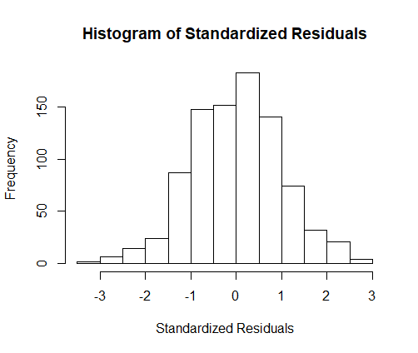

Figure A4b. Linearity of residuals
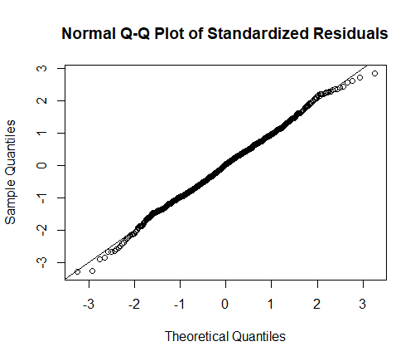

Figure A4c. Equality of variances
