Additional Material to
Self-Stigma but not Mental Health Literacy Predicts Attitudes toward Professional Help-Seeking in an Indonesian Community Sample
by Nurul Hartini et al.

Additional file 3: Tests of the model assumptions of hierarchical regression analysis
Multicollinearity (Spearman’s rho correlations among independent variables)
 | 1 | 2 | 3 | 4 | 5 | 6
1. Sex | 1.0 | .05 | -.06 | .11 | -.02 | .03
2. Education level |  | 1.0 | -.01 | -.40 | -.01 | -.01
3. Vignette |  |  | 1.0 | .01 | .08 | .03
4. Age |  |  |  | 1.0 | -.04 | .07
5. Mental health literacy |  |  |  |  | 1.0 | -.04
6. Self-stigma |  |  |  |  |  | 1.0

Normality of residuals Linearity of residuals
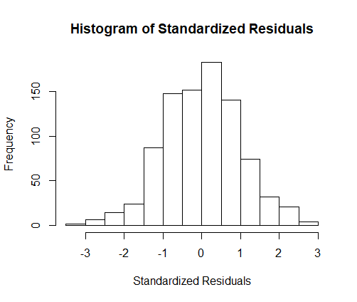
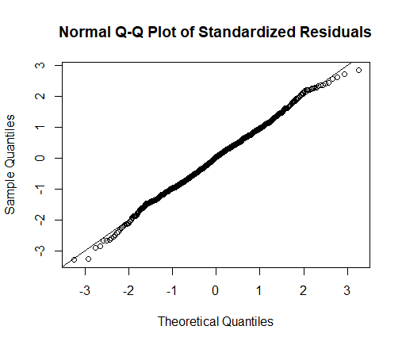

Homoscedasticity. Equality of variances
