Microbial community structure and niche differentiation in healthy and infected samples of Kappaphycus alvarezii in the commercial farming sites of Tamil Nadu coastal, India
Nagarajan Dhanya^{1,2}, Balakrishnan Prakriti^{1,2}, Arup Ghosh^{2,3}, Lakkakula Satish^{1,2}
¹Applied Phycology and Biotechnology Division, Marine Algal Research Station, Mandapam, CSIR - Central Salt and Marine Chemicals Research Institute, Tamil Nadu – 623519, India.
²Academy of Scientific and Innovative Research (AcSIR), Ghaziabad - 201002, India.
³Applied Phycology and Biotechnology Division, CSIR-Central Salt & Marine Chemicals Research Institute, Bhavnagar, 364002, Gujarat, India.
Correspondence: satishl.csmcri@csir.res.in

Supplementary figures
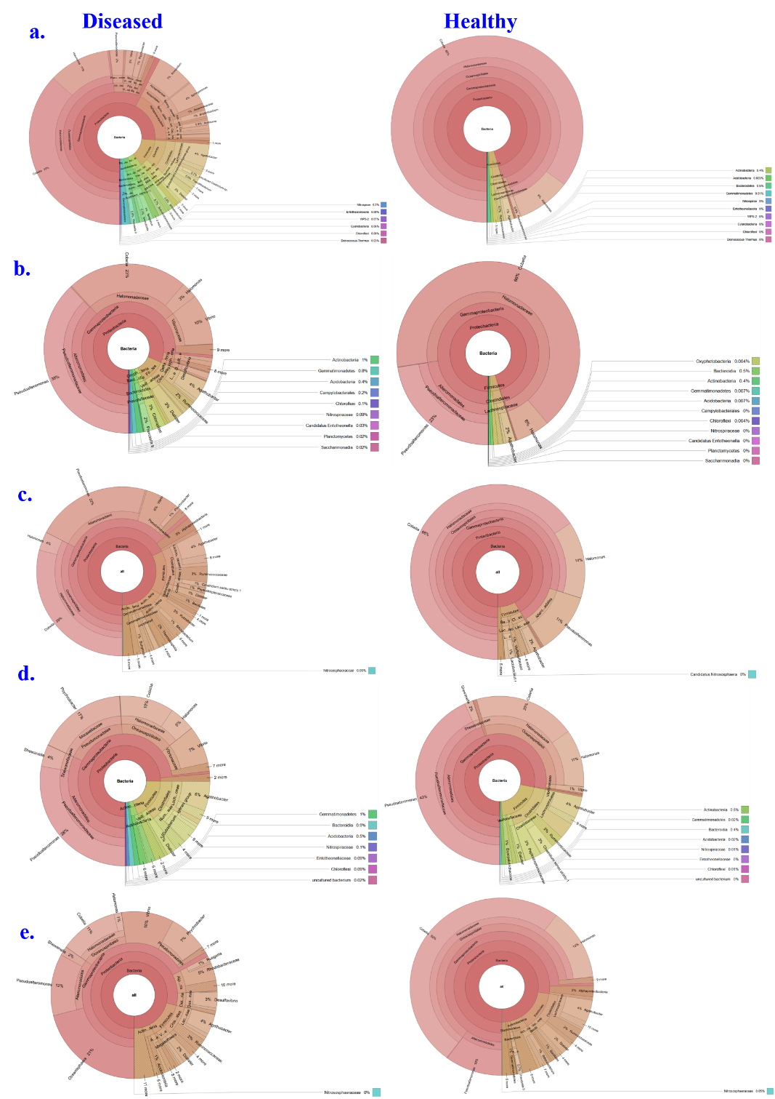
Supplementary Figure 1: Krona Chart. Shows the percentage of the domain, phylum, class, order and genus lever diversity in each of the diseased and healthy K. alvarezii samples from 5 different sites. a. Mangadu, b. soliyakudi, c. Nambuthalai, d. Jegathapattinam and e. Odavimadam. The phylum Proteobacteria has the highest abundance in healthy (70-95%) and diseased (<70%) samples, followed by Firmicutes and Actinobacteria, and the genus Cobetia followed by Pseudoalteriomonas shows the highest abundance.

