Supplementary Table 1 Main materials and reagents
Reagents | Source | Identifier
Sodium iodate | Sigma | S4007
Erastin | MCE | HY-15763
RSL3 | MCE | HY-100218A
Chloroquine | MCE | HY-17589A
CsA | MCE | HY-B0579
BAPTA-AM | MCE | HY-100545
Ferrostatin-1 | MCE | HY-100579
H-151 | MCE | HY-112693
XRK3F2 | MCE | HY-112904
BX795 | MCE | HY-10514
Protein A/G Magnetic Beads | MCE | HY-K0202
MG132 | Selleck | S2619
Cycloheximide | Selleck | S7418
Cell counting kit-8 | Beyotime | C0043
RIPA lysis buffer  BCA protein assay kit | Beyotime  Beyotime | P0013B  P0010
JC1 assay kit  MPTP assay kit | Beyotime  Beyotime | C2006  C2009S
Mito-Tracker Red  MitoSOX™ Red  ER-Tracker™ Green  Rhod-2-AM | Beyotime  Thermo Fisher  Thermo Fisher  Thermo Fisher | C1035  M36008  E34251  R1245MP
C11-BODIPY (581/591) | Thermo Fisher | D3861
Lipofectamine 3000  Pierce™ IP lysis buffer | Thermo Fisher  Thermo Fisher | L3000015  87787
DAPI | Thermo Fisher | R37606
ECL kit | Thermo Fisher | 34580
HE staining kit | BOSTER | AR1180
IHC staining kit | BOSTER | SV0004
DAB | BOSTER | AR1027
Fetal Bovine Serum | Gibco | 10099-141
Trypsin-EDTA (0.25%) | Gibco | 25200072
DMEM/F-12 | Gibco | 11330057
riboFECT CP Transfection Kit  DNA Extraction Kit | Ribo  Qiagen | C10511-1  69504
HiScript III RT SuperMix kit | Vazyme | R323-01
Fast SYBR Green Master Mix | Roche | 04913914001

Supplementary Table 2 Primary antibodies
Reagents | Source | Identifier
Rabbit monoclonal anti-Ubiquitin | CST | 43124
Rabbit monoclonal anti-cGAS | CST | 15102
Rabbit monoclonal anti-STING | CST | 13647
Rabbit monoclonal anti-p-STING | CST | 50907
Rabbit monoclonal anti-P62 | CST | 39749
Rabbit monoclonal anti-p-P62 | CST | 39786
Rabbit monoclonal anti-TBK1 | CST | 3504
Rabbit monoclonal anti-p-TBK1 | CST | 5483
Rabbit monoclonal anti-GPX4 | Abcam | ab125066
Rabbit polyclonal anti-4-HNE  Rabbit monoclonal anti-LC3B  Rabbit monoclonal anti-TOM20  Mouse monoclonal anti-GPX4  Mouse monoclonal anti-dsDNA | Abcam  Abcam  Abcam  Santa  Santa | ab46545  ab192890  ab186735  sc-166570  sc-58749
Mouse monoclonal anti-RPE65 | Santa | sc-390787
Mouse monoclonal anti-PTGS2 | Santa | sc-19999
Mouse monoclonal anti-Rhodopsin | Santa | sc-57432
Mouse monoclonal anti-Arrestin | Santa | sc-166383
Normal mouse IgG | Santa | sc-2025
Mouse monoclonal anti-GRP75 | Santa | sc-133137
Mouse monoclonal anti-VDAC1 | Santa | sc-390996
Mouse monoclonal anti-IP3R1 | Santa | sc-271197
Rabbit polyclonal anti-ZO-1 | Proteintech | 21773-1-AP
Mouse monoclonal anti-β-actin | Proteintech | 66009-1-Ig
DYKDDDDK tag Polyclonal antibody | Proteintech | 20543-1-AP
Goat anti-Mouse IgG (H+L), Alexa Fluor 594 | Thermo Fisher | A11005
Goat anti-Rabbit IgG (H+L), Alexa Fluor 594 | Thermo Fisher | A11012
Goat anti-Mouse IgG (H+L), Alexa Fluor 488 | Thermo Fisher | A11001
Goat anti-Rabbit IgG (H+L), Alexa Fluor 488 | Thermo Fisher | A11008
Goat Anti-Mouse IgG(H+L) | Jackson | 115-035-003
Goat Anti-Rabbit IgG (H+L) | Jackson | 111-035-003

Supplementary Table 3 The sequences of the siRNA and shRNA
Product name | Serial number
si-GRP75-001 (Human) | GCGATATGATGATCCTGAA
si-GRP75-002 (Human) | GAGTCAGATTGGAGCATTT
si-GRP75-003 (Human) | GCTGGAATGGCCTTAGTCA
si-STING-001(Human) | CUGGCAUGGUCAUAUUACATT
si-STING-002 (Human) | GCAUCAAGGAUCGGGUUUATT
si-STING-003 (Human) | GGCAUCAAGGAUCGGGUUUTT
NC-siRNA (Human) | UUCUCCGAACGUGUCACGUTT
GRP75-shRNA (Mouse)  NC-shRNA (Mouse) | GAGGCGTCTTTACCAAACTTA  TTCTCCGAACGTGTCACGT

Supplementary Table 4 Primers for Quantitative Real-Time PCR
Primer | Sequence
Human ND1 Forward | CTCTTCGTCTGATCCGTCCT
Human ND1 Reverse | TGAGGTTGCGGTCTGTTAGT
Human ND2 Forward | GTAGACAGTCCCACCCTCAC
Human ND2 Reverse | TTGATCCCGTTTCGTGCAAG
Human ATP6 Forward | AATCCAAGCCTACGTTTTCACA
Human ATP6 Reverse | AGTATGAGGAGCGTTATGGAGT
Human CO2 Forward | AATCGAGTAGTACTCCCGATTG
Human CO2 Reverse | TTCTAGGACGATGGGCATGAAA
Human DLOOP Forward | CTATCACCCTATTAACCACTCA
Human DLOOP Reverse | TTCGCCTGTAATATTGAACGTA
Human 18S Forward | TAGAGGGACAAGTGGCGTTC
Human 18S Reverse | CGCTGAGCCAGTCAGTGT

Supplementary Fig. S1 Validation of GRP75 modulation efficiency. A Screening of siRNA sequences for effective GRP75 silencing in ARPE-19 cells, assessed by Western blot analysis (n = 3). B Confirmation of GRP75 overexpression following plasmid transfection (n = 3). C Verification of GRP75 knockdown in vivo via AAV8-shGRP75 injection (n = 3). D Representative immunofluorescence images of PTGS2 and GPX4 in the retinas of mice (n = 3). Scale bars, 50 μm. Data are presented as the mean ± SD. One-way ANOVA was used for statistical analysis. *p < 0.05 versus control group. #p < 0.05 versus NaIO₃+NC group.

Supplementary Fig. S2 GRP75 knockdown attenuates ferroptosis and ER-mitochondria coupling. A ARPE-19 cells were stimulated with NaIO₃ and transfected with GRP75 siRNA. Quantification of intracellular Fe²⁺ using FerroOrange (1 μM, 30 min) (n = 3). B-E ARPE-19 cells were exposed to RSL3 or Erastin, with or without GRP75 siRNA (n = 3). B, C Co-immunoprecipitation analysis of GRP75 interactions with IP3R1 or VDAC1 (n = 3). D, E Quantification of intracellular Fe²⁺ using FerroOrange (1 μM, 30 min) (n = 3).

Supplementary Fig. S3 Validation of STING siRNA sequences. Screening of siRNA sequences for specific knockdown of STING in ARPE-19 cells, confirmed by Western blot (n = 3).

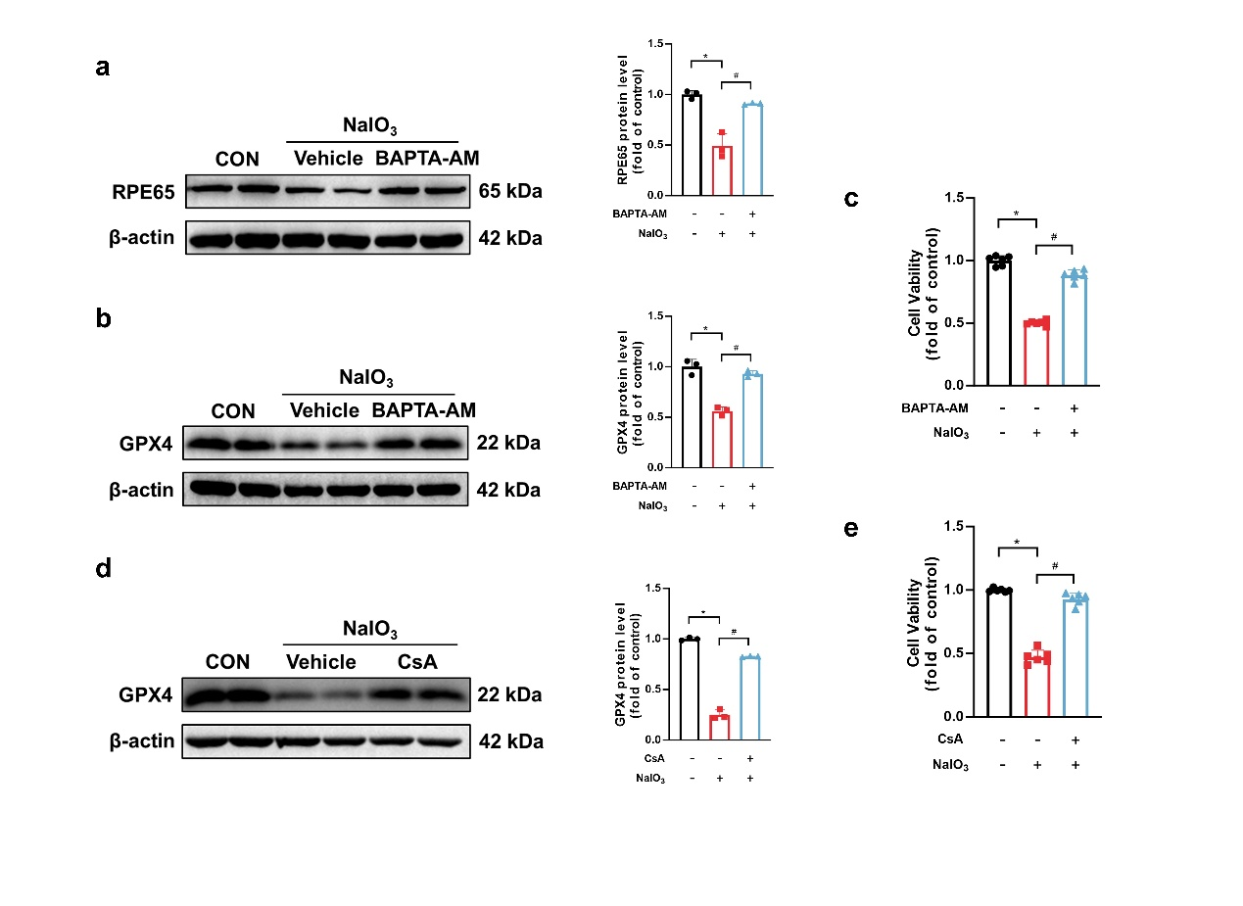Supplementary Fig. S4 Protective effects of BAPTA-AM and CsA against ferroptosis. A-C ARPE-19 cells were treated with BAPTA-AM (5 μM) under NaIO₃ exposure. A, B Representative immunoblots of RPE65 and GPX4 proteins in the indicated groups (n = 3). C Cell viability assessed by CCK-8 assay in the indicated groups (n = 6). D, E ARPE-19 cells were treated with CsA (5 μM) under NaIO₃ exposure. D Representative immunoblots of GPX4 proteins in the indicated groups (n = 3). E Cell viability assessed by CCK-8 assay in the indicated groups (n = 6). Data are presented as the mean ± SD. One-way ANOVA was used for statistical analysis. *p < 0.05 versus control group. #p < 0.05 versus NaIO₃+BAPTA-AM or NaIO₃+CsA group.

