A.
The expression of GAPDH in pDC lysates of control and critical HFMD patients were detected by western blotting.
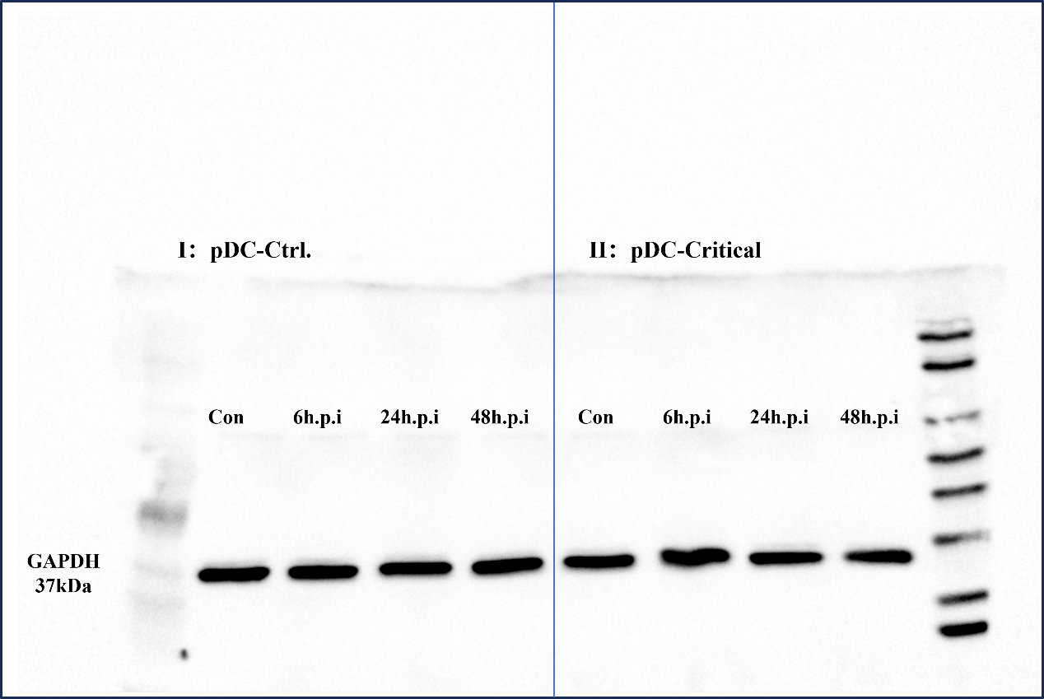

B.
EV71-VP1 expression in pDC lysates of healthy donors were detected by western blotting.
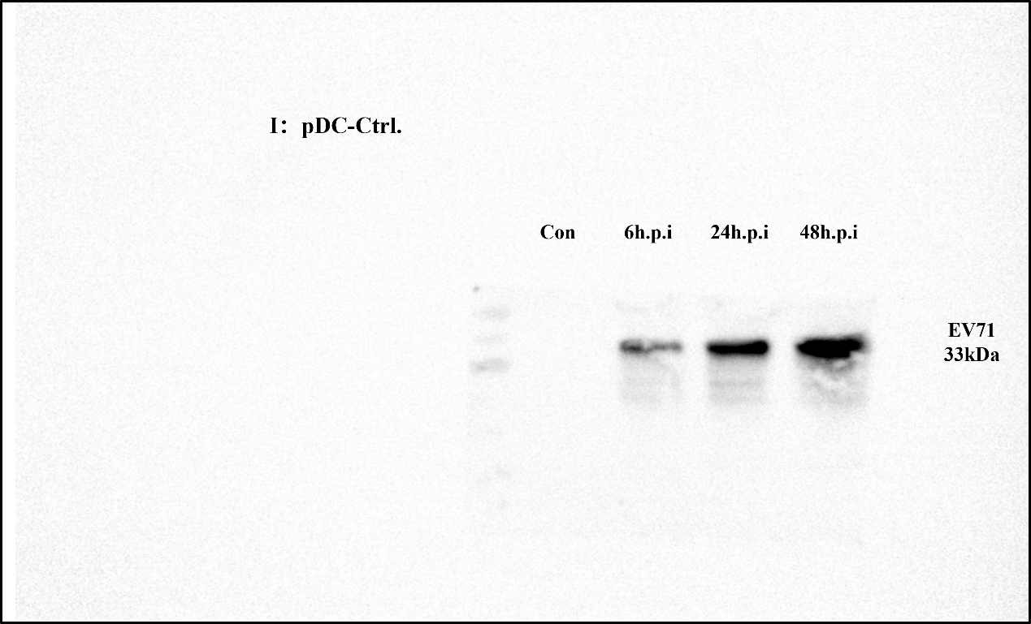

C.
EV71-VP1 expression in pDC lysates of critical HFMD patients were detected by western blotting.
