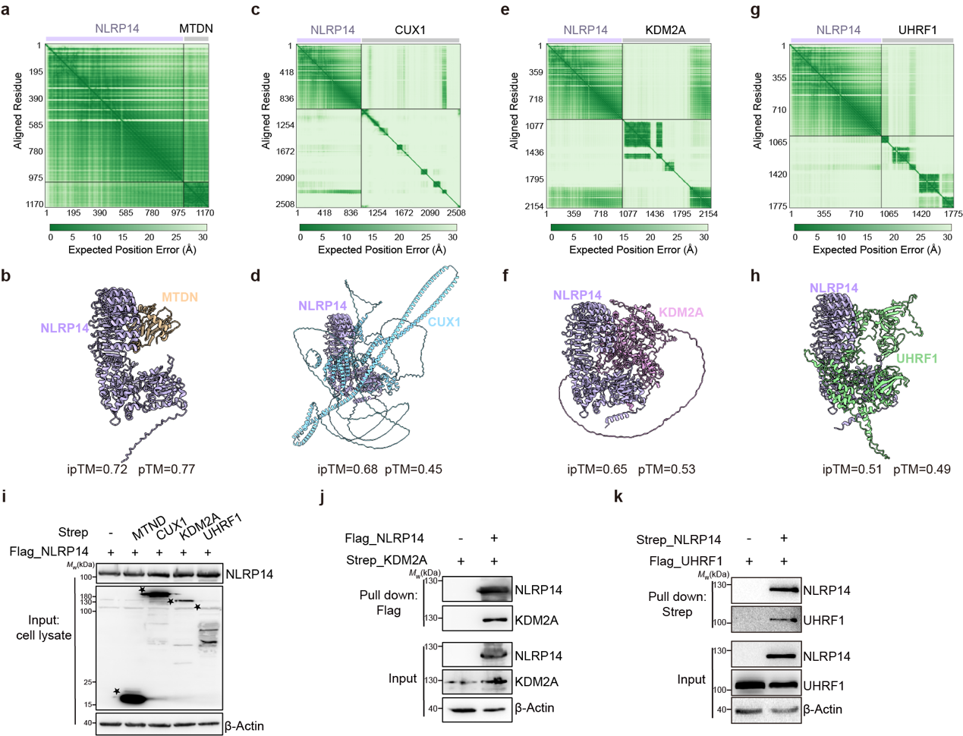
Extended data Figure 1. Predict and validate the NLRP14 binding partners. a-h, AlphaFold3 predicted structural models, PAE (predicted aligned error) and pTM/ipTM scores of NLRP14 and MTDN (a-b)/CUX1 (c-d)/KDM2A (e-f)/UHRF1 (g-h). PAE estimates of the error in the relative position and orientation between two tokens in the predicted structure, and higher values indicate higher predicted error and therefore lower confidence. In the structral models, NLRP14 is shown in purple, and MTDN /CUX1/KDM2A/UHRF1 are shown in yellow/blue/pink/green. i, The input of the pull-down assay between mouse NLRP14 and MTDN/CUX1/KDM2A/UHRF1. Mouse NLRP14 was cotransfected with mouse MTDN/CUX1/KDM2A/UHRF1 into HEK293F cells, and the input (cell lysate) was immunoblotted with antibodies against the Flag tag and the Strep tag. The stars (★) indicate the position of the target protein. j. Interaction between NLRP14 and KDM2A was confirmed by Flag-tag pull-down assay. Flag-tagged NLRP14 was cotransfected with Strep-tagged KDM2A into HEK293F cells. The samples in cell lysates (input) or after pull-down were subjected to immunoblotting with the antibodies to the indicated protein tags. k, Interaction between NLRP14 and UHRF1 was confirmed by Strep-tag pull-down assay. Strep-tagged NLRP14 was cotransfected with Flag-tagged KDM2A into HEK293F cells. The samples in cell lysates (input) or after pull-down were subjected to immunoblotting with the antibodies to the indicated protein tags. (i-k) Three biological replicates.

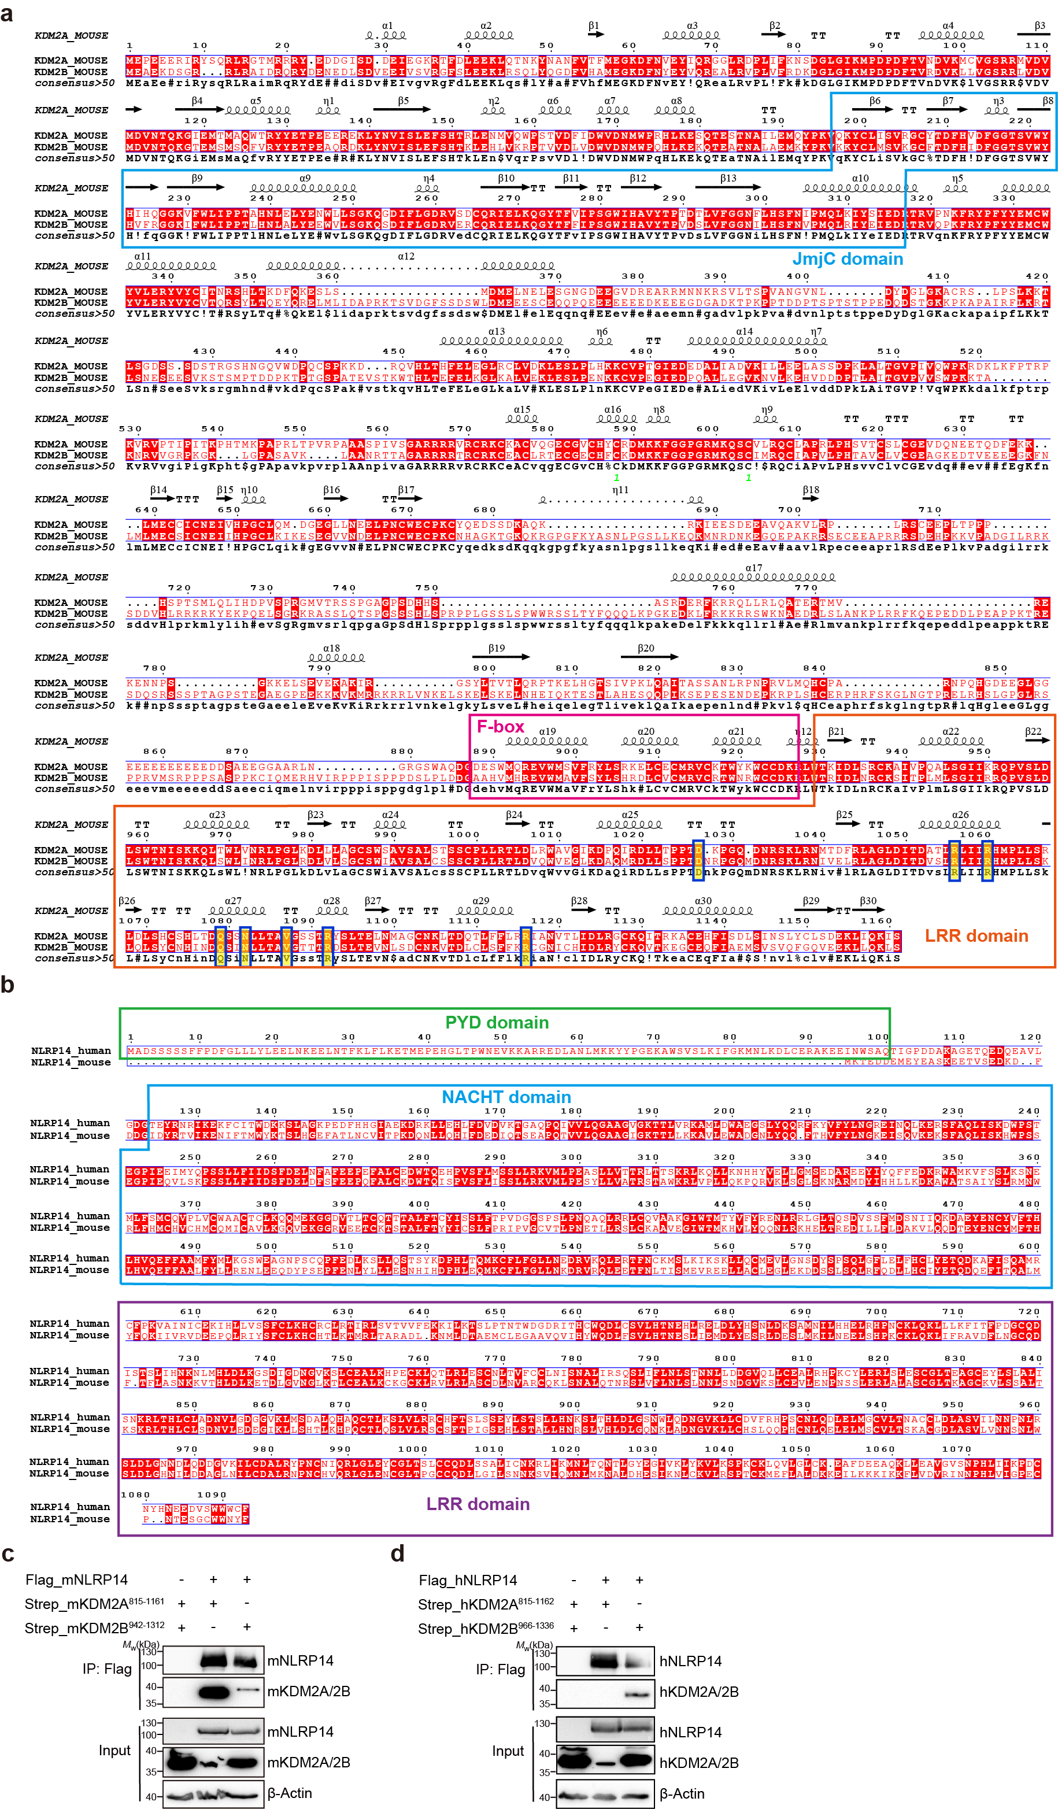
Extended data Figure 2. The conversed interaction between KDM2A/2B and NLRP14 in mouse and human.
a, Sequence alignment of mouse KDM2A and mouse KDM2B. The domains were denoted with boxes, and amino acids mediating the interaction between NLRP14 and KDM2A were highlighted in yellow. b, Sequence alignment of human NLRP14 and mouse NLRP14. The domains were denoted with boxes. (a-b) Sequence alignment was performed using MultAlign and visualized by ESPript. c, Interaction between mouse NLRP14 and mouse N-terminal KDM2A (815-1,161 aa)/KDM2B (942-1,312 aa) was confirmed by immunoprecipitation. Mouse KDM2A or KDM2B was cotransfected with mouse NLRP14 into HEK293F cells. The proteins in cell lysates (input) or after IP with anti-Flag affinity gel were subjected to immunoblotting. d, Interaction between human NLRP14 and human N-terminal KDM2A (815-1,162 aa)/KDM2B (966-1,336 aa) was confirmed by immunoprecipitation. human KDM2A or KDM2B was cotransfected with human NLRP14 into HEK293F cells. The proteins in cell lysates (input) or after IP with anti-Flag affinity gel were subjected to immunoblotting. (c-d) Three biological replicates.

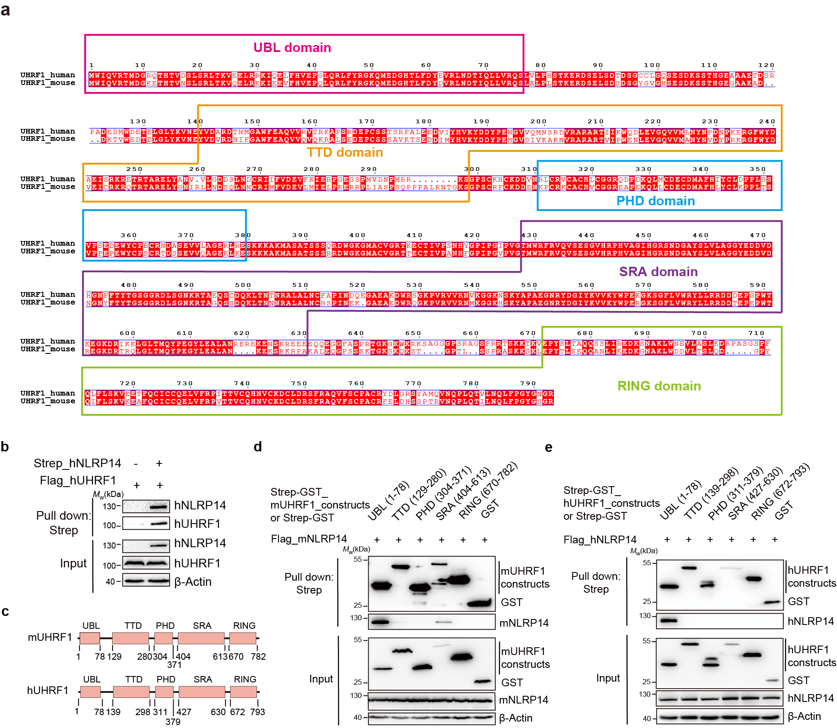
Extended data Figure 3. The Conservative interaction between UHRF1 and NLRP14 in mouse and human.
a, Sequence alignment of human UHRF1 and mouse UHRF1. The domains were denoted with boxes. b, Pull-down assay to determine the interaction between human NLRP14 and human UHRF1 in HEK293F cells. Human Strep-tagged NLRP14 was cotransfected with human Flag-tagged UHRF1 into HEK293F cells. The proteins in cell lysates (input) or after pull-down with Strep beads were subjected to immunoblotting with antibodies against target tags. c, Mouse and human UHRF1 domain schematic illustration. d, Domain mapping of the interaction of mouse UHRF1 with mouse NLRP14. The GST-tagged truncated versions of mouse UHRF1 and Flag-tagged NLRP14 were coexpressed in HEK293F cells, and the cell lysates (input) were pulled down with Strep-Tactin resin. The input and pull-down samples were subjected to immunoblotting. e, Domain mapping of the interaction of human UHRF1 with human NLRP14. The pull-down samples and inputs were analyzed by immunoblotting. (b, d-e) Three biologically independent experiments.

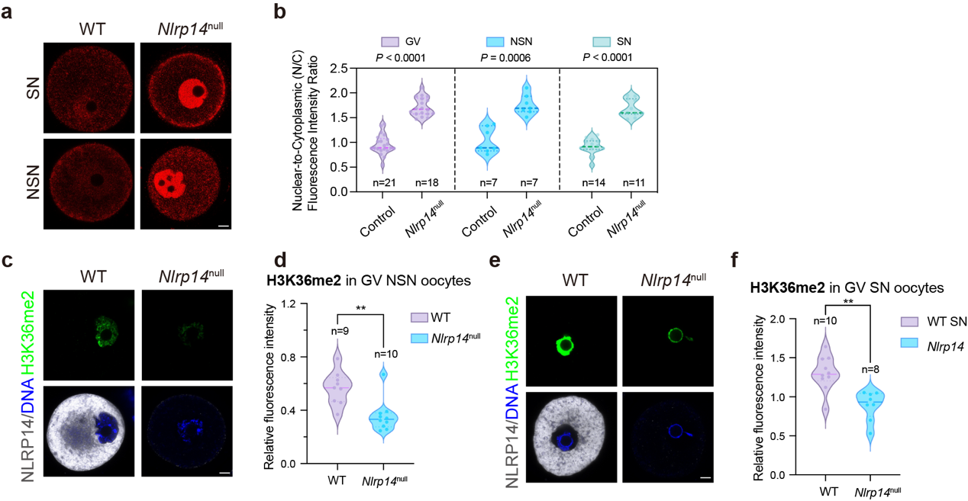
Extended data Figure 4. NLRP14 deficiency results in reduced levels of H3K36me2 in GV oocytes.
a, IF staining of KDM2A in the normal control and Nlrp14^{null} GV oocytes, depicting the SN and NSN configurations. Scale bar, 10 μm. b, Quantification of the Nuclear-to-Cytoplasmic (N/C) relative fluorescence intensity ratio of KDM2A in the control and Nlrp14^{null} GV oocytes, depicting the SN and NSN configurations. The data were normalized to the mean value of the control group. c, IF staining of H3K36me2 in the normal control and Nlrp14^{null} mouse GV oocytes of the NSN type. DNA was stained with DAPI. Scale bar, 10 μm. d, Quantification of the relative fluorescence intensity of H3K36me2 in the normal control and Nlrp14^{null} mouse GV oocytes of the NSN type. The data were normalized to the mean value of the control group. e, IF staining of H3K36me2 in the normal control and Nlrp14^{null} mouse GV oocytes of the SN type. DNA was stained with DAPI. Scale bar, 10 μm. f, Quantification of the relative fluorescence intensity of H3K36me2 in the normal control and Nlrp14^{null} mouse GV oocytes of the SN type. The data were normalized to the mean value of the control group.

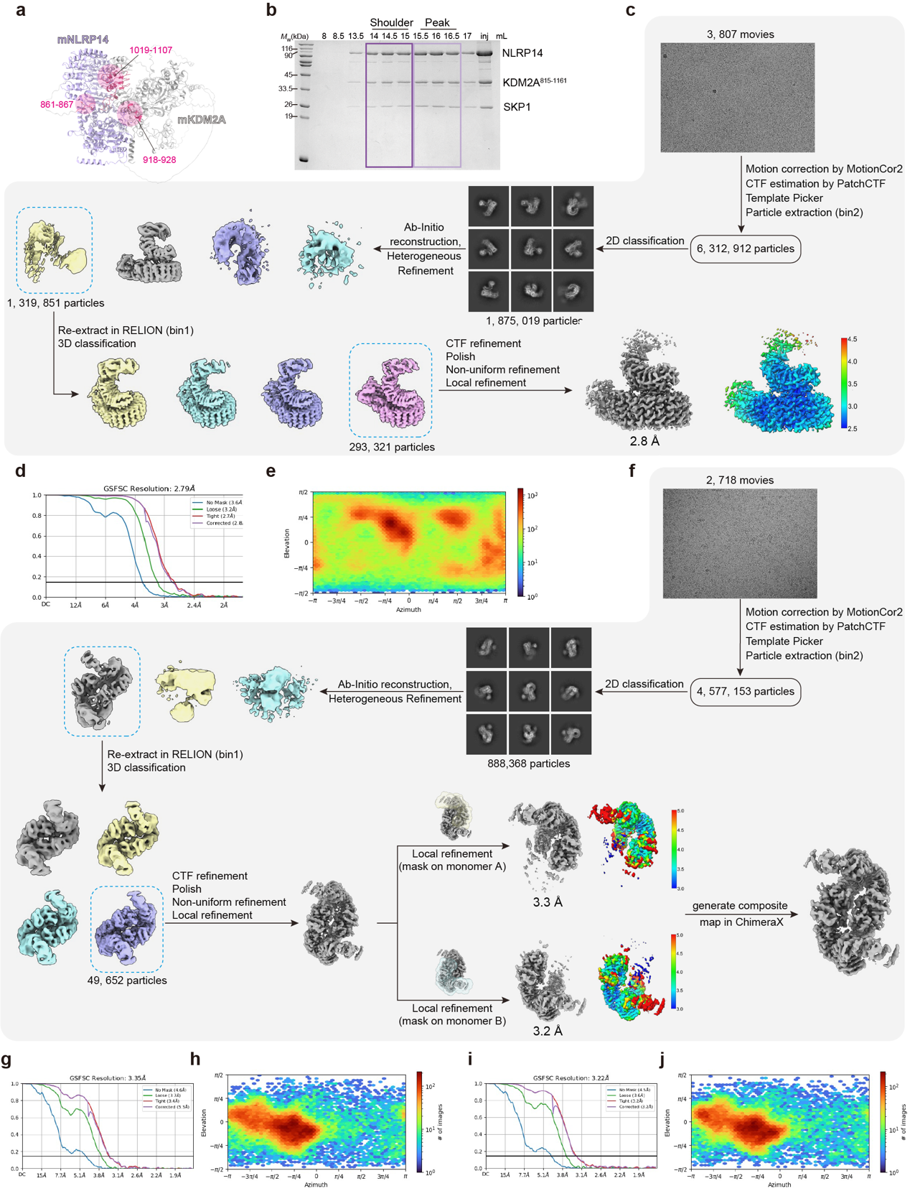
Extended data Figure 5. Flowchart of cryo-EM data processing for the mouse NLRP14-KDM2A-SKP1 complex.
a, AlphaFold3 predicted structural models of mouse NLRP14-KDM2A complex. The interface and region involved in interactions of NLRP14 and KDM2A are shown in pink and highlighted. b, Reconstitution of the mouse NLRP14-KDM2A-SKP1 complex. NLRP14, KDM2A and SKP1 were coexpressed in HEK293F cells and purified with anti-Flag affinity gel. Purified proteins were subjected to SEC (Superose 6 increase 10/300 GL) and analyzed by SDS-PAGE. n > 3 biologically independent experiments were performed. c, Workflow of the cryo-EM data processing of the monomer of mouse NLRP14-KDM2A complex. Details are described in the Methods section. d, Gold-standard Fourier shell correlation (FSC) curve for the refined map of the monomer of mouse NLRP14-KDM2A. e, Particle angular distribution for the map of the monomer of mouse NLRP14-KDM2A. f, Workflow of the cryo-EM data processing of the dimer of mouse NLRP14-KDM2A complex. Details are described in the Methods section. g, Gold-standard Fourier shell correlation (FSC) curve for the refined map of the monomer A of mouse NLRP14-KDM2A. h, Particle angular distribution for the map of the monomer A of mouse NLRP14-KDM2A. i, Gold-standard Fourier shell correlation (FSC) curve for the refined map of the monomer B of mouse NLRP14-KDM2A. j, Particle angular distribution for the map of the monomer B of mouse NLRP14-KDM2A.

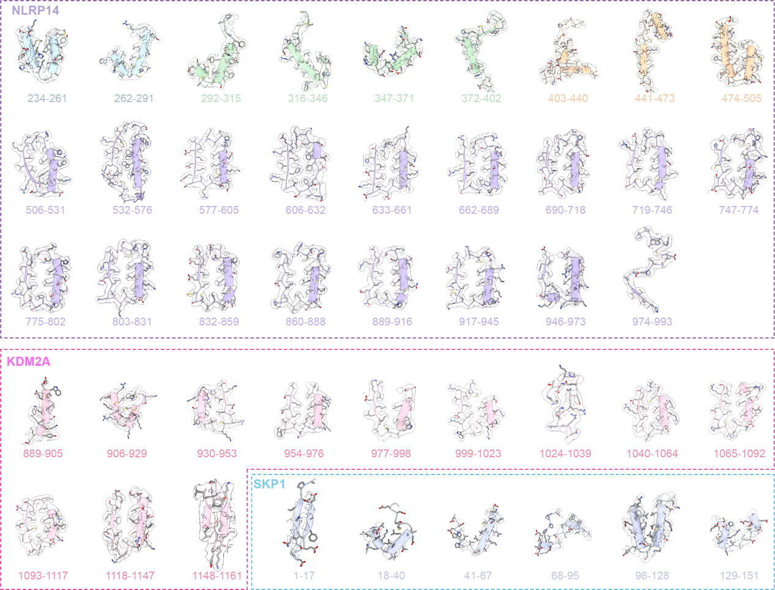
Extended data Figure 6. Segmented map density of the mouse NLRP14-KDM2A-SKP1 complex.
The atomic structures of the mouse NLRP14-KDM2A-SKP1 complex were fitted into the cryo-EM map.

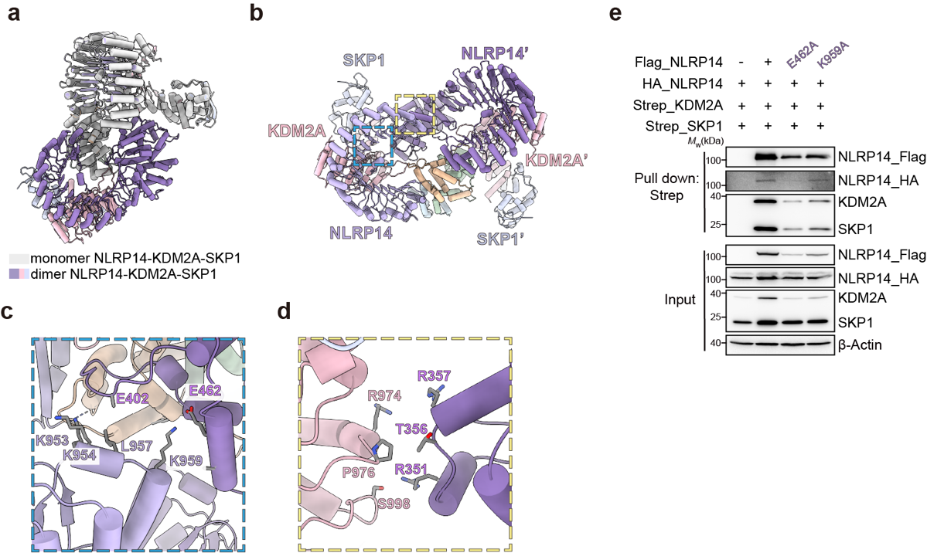
Extended data Figure 7. The dimerization of mouse NLRP14-KDM2A-SKP1 complex.
a, Superposition of monomer and dimer NLRP14-KDM2A-SKP1 through NLRP14. Monomer complex is shown in light grey, and dimer NLRP14-KDM2A-SKP1 is colored as in Fig. 2h. b, Another view of dimeric mouse NLRP14-KDM2A-SKP1 complex model. c-d, Magnified view of the interface between two NLRP14-KDM2A-SKP1 ternaries in the model. The residues involved in interactions are shown. e, Immunoblotting analysis of the pull-down assay for the mutations of the interface in dimeric NLRP14-KDM2A-SKP1. The denoted constructs were cotransfected into HEK293F cells, and the expressed proteins were purified by Flag gel and analyzed by immunoblotting. Three biological replicates.

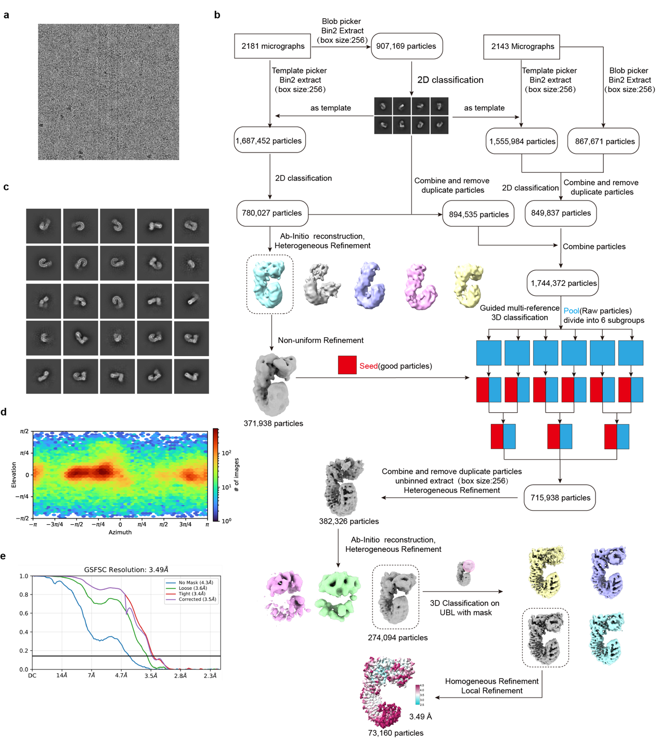
Extended data Figure 8. Flowchart of cryo-EM data processing for the hNLRP14-UBL_{hUHRF1} complex.
a, Representative micrograph of the cryo-EM data collection. b, Workflow of the cryo-EM data processing. Details are described in the Methods section. c, Representative micrograph of the 2D classification. d, Particle angular distribution for the map of the hNLRP14-UBL_{hUHRF1} complex. e, FSC curve for the refined map of the hNLRP14-UBL_{hUHRF1} complex.

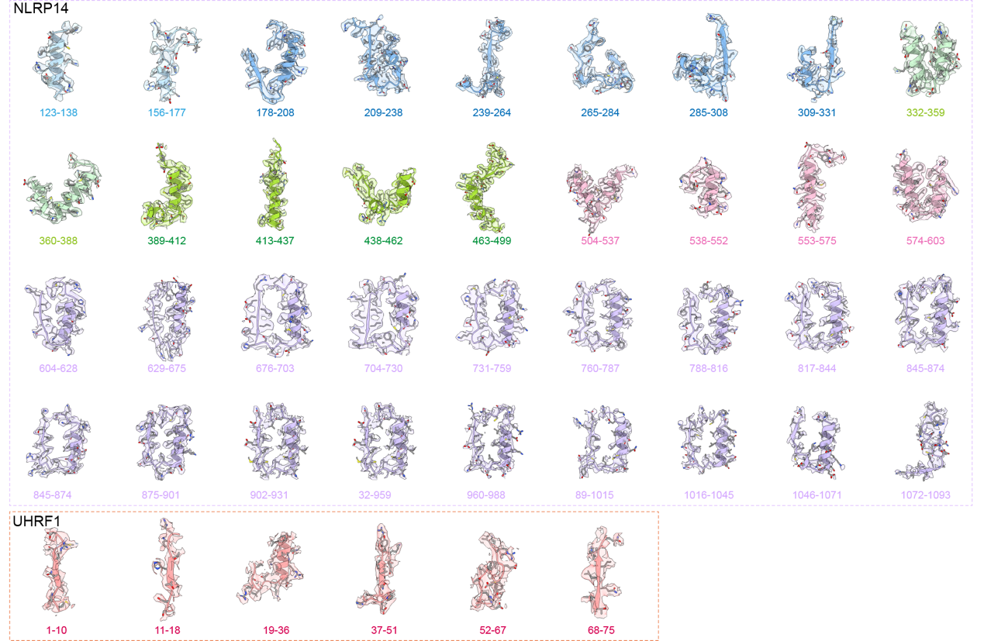
Extended data Figure 9. Segmented map density of the hNLRP14-UBL_{hUHRF1} complex.
The atomic structures of the hNLRP14-UBL_{hUHRF1} complex were fitted into the cryo-EM map.

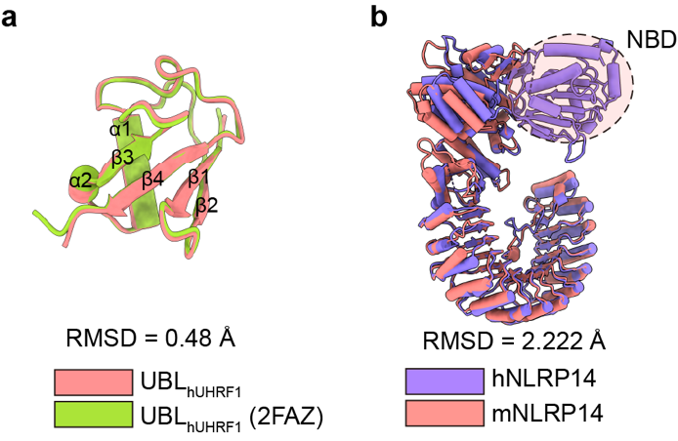
Extended data Figure 10. Structure comparisons of UBL_{hUHRF1} and hNLRP14.
a, Superposition of UBL_{hUHRF1} apo (green, PDB:2FAZ) and UBL_{hUHRF1} in the NLRP14-UHRF1 complex (salmon, this study), RMSD = 0.484 Å. b, Superposition of hNLRP14 in the NLRP14-UHRF1 complex (purple, this study) and mNLRP14 in the NLRP14-KDM2A-SKP1 complex (salmon, this study).

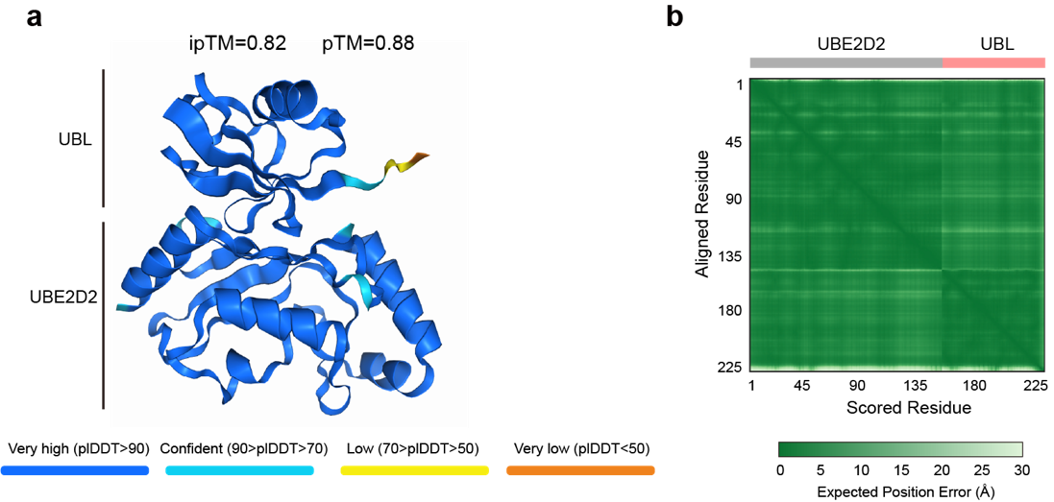
Extended data Figure 11. Structure prediction of the human UBE2D2-UBL_{hUHRF1} complex using AlphaFold 3.
a, Prediction model of the UBL_{hUHRF1}- UBE2D2 complex. b, Predicted aligned error (PAE) matrix of the UBL_{hUHRF1}-UBE2D2 complex prediction.

Extended Data Table 1. Cryo-EM data collection, refinement, and validation statistics
 | NLRP14-KDM2A-SKP1  (EMD-66204)  (PDB: 9WSR) | Dimer of NLRP14-KDM2A-SKP1  (EMD-66203)  (PDB: 9WSQ) |  | NLRP14-UHRF1  (EMD-63227)  (PDB: 9LN6)
Data collection and processing
Magnification | 105,000× | 105,000× | 130,000×
Voltage (kV) | 300 | 300 | 300
Electron exposure (e–/Å2) | 55.225 | 53.633 | 51.336
Defocus range (μm) | -1.2~-1.8 | -1.2~-1.8 | -1.1~-1.8
Pixel size (Å) | 0.85 | 0.85 | 1.1
Symmetry imposed | C1 | C1 | C1
Initial particle images (no.) | 6,312,912 | 4,577,153 | 4, 111, 107
Final particle images (no.) | 293,321 | 49,652 | 73,160
Map resolution (Å) | 2.79 | 3.35/3.22 | 3.49
FSC threshold | 0.143 | 0.143 | 0.143
Refinement
Initial model used (PDB code) | AlphaFoldDB: Q6B966, P59997, and Q9WTX5 | AlphaFoldDB: Q6B966, P59997, and Q9WTX5 | AlphaFoldDB: Q86W24 and Q96T88
Model resolution (Å) | 2.8/3.1 | 3.1/3.6 | 3.2
FSC threshold | 0.143/0.5 | 0.143/0.5 | 0.143
Map sharpening B factor (Å2) | 116.1 | 81.24 | 79.9
Model composition  Non-hydrogen atoms  Protein residues  Ligands | 9, 419  1, 194  - | 18, 827  2. 388  - | 8, 134  1, 012  -
B factors (Å2)  Protein  Ligand | 94.92  - | 52.39  - | 84.42  -
R.m.s. deviations  Bond lengths (Å)  Bond angles (°) | 0.003  0.523 | 0.002  0.414 | 0.006  0.647
Validation  MolProbity score  Clashscore  Poor rotamers (%) | 0.87  0.85  0.09 | 1.03  2.44  0.38 | 1.42  3.93  0.54
Ramachandran plot  Favored (%)  Allowed (%)  Disallowed (%) | 97.47  2.53  0.00 | 98.57  1.43  0.00 | 96.41  3.59  0.00

