Supplementary Materials
Figure S1. Subgroup analysis of the association between RCII and risk of MAFLD.
Figure S2. Subgroup analysis of the association between RCII and all-cause mortality risk in patients with MAFLD.
Figure S3. Subgroup analysis of the association between RCII and cardiovascular mortality risk in patients with MAFLD.
Figure S4. Subgroup analysis of the association between RCII and premature mortality risk in patients with MAFLD.
Figure S5. Mendelian randomization analysis of the causal association between total cholesterol and MAFLD.
Figure S6. Mendelian randomization analysis of the causal association between LDL-C and MAFLD
Figure S7. Mendelian randomization analysis of the causal association between HDL-C and MAFLD
Figure S8. Mendelian randomization analysis of the causal association between CRP and MAFLD.
Figure S9. Key variables associated with MAFLD identified by the Boruta algorithm
Table S1. Estimated mediation effects of FPG on the associations between RCII and MAFLD or related mortality outcomes

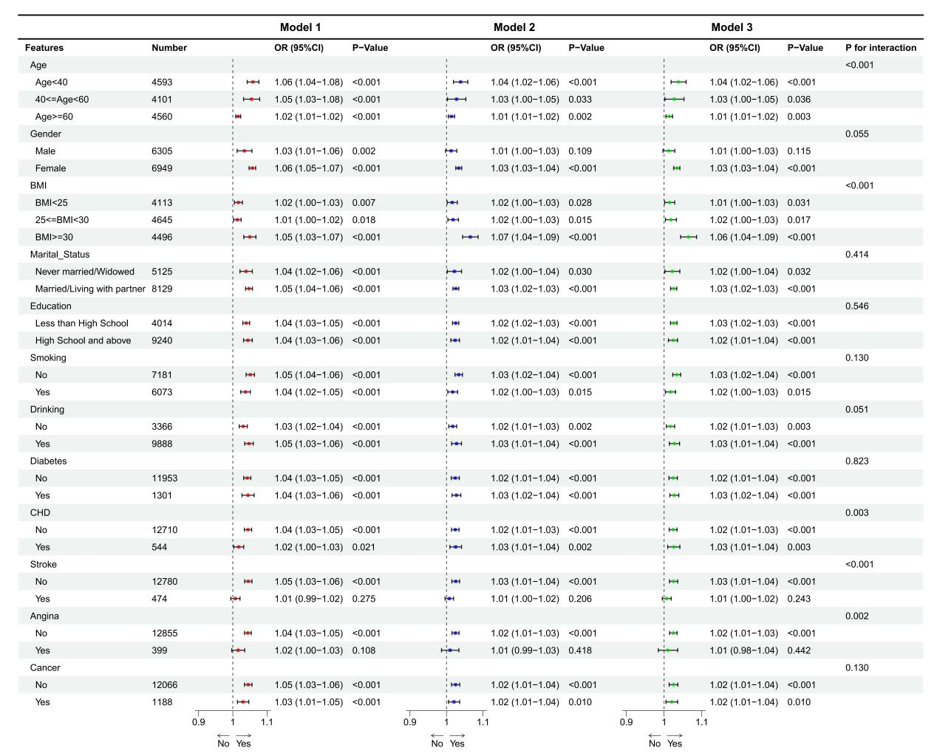
Figure S1. Subgroup analysis of the association between RCII and risk of MAFLD. RCII, Residual cholesterol-inflammation index; MAFLD, Metabolic dysfunction-associated fatty liver disease
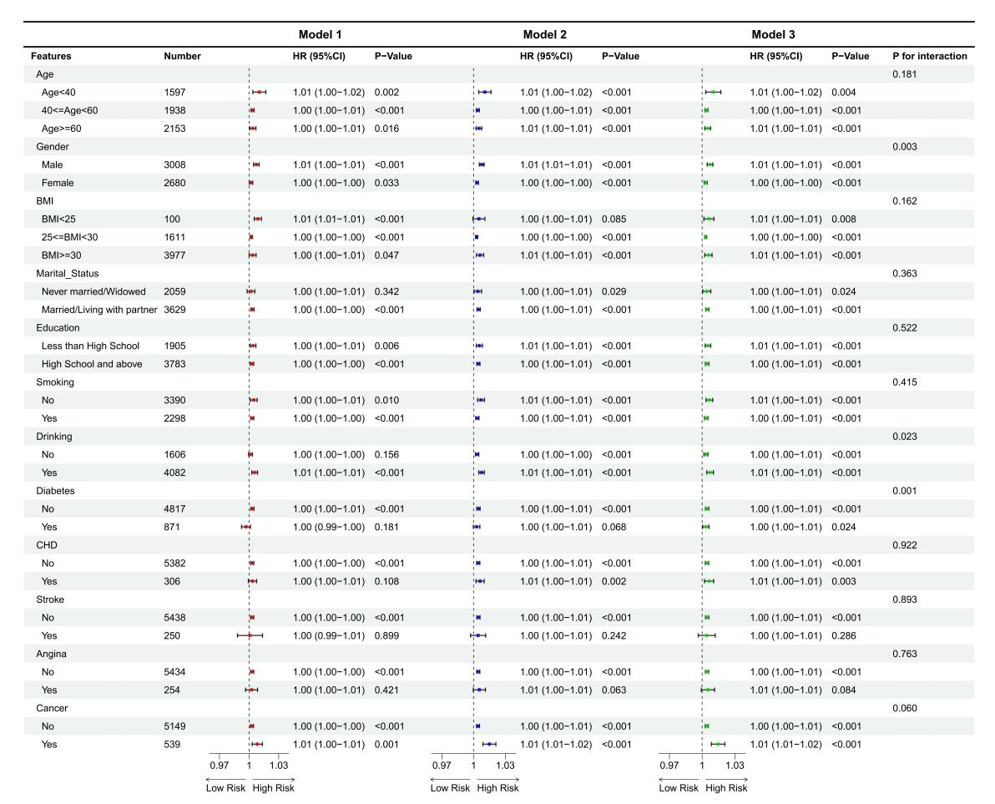
Figure S2. Subgroup analysis of the association between RCII and all-cause mortality risk in patients with MAFLD. RCII, Residual cholesterol-inflammation index; MAFLD, Metabolic dysfunction-associated fatty liver disease
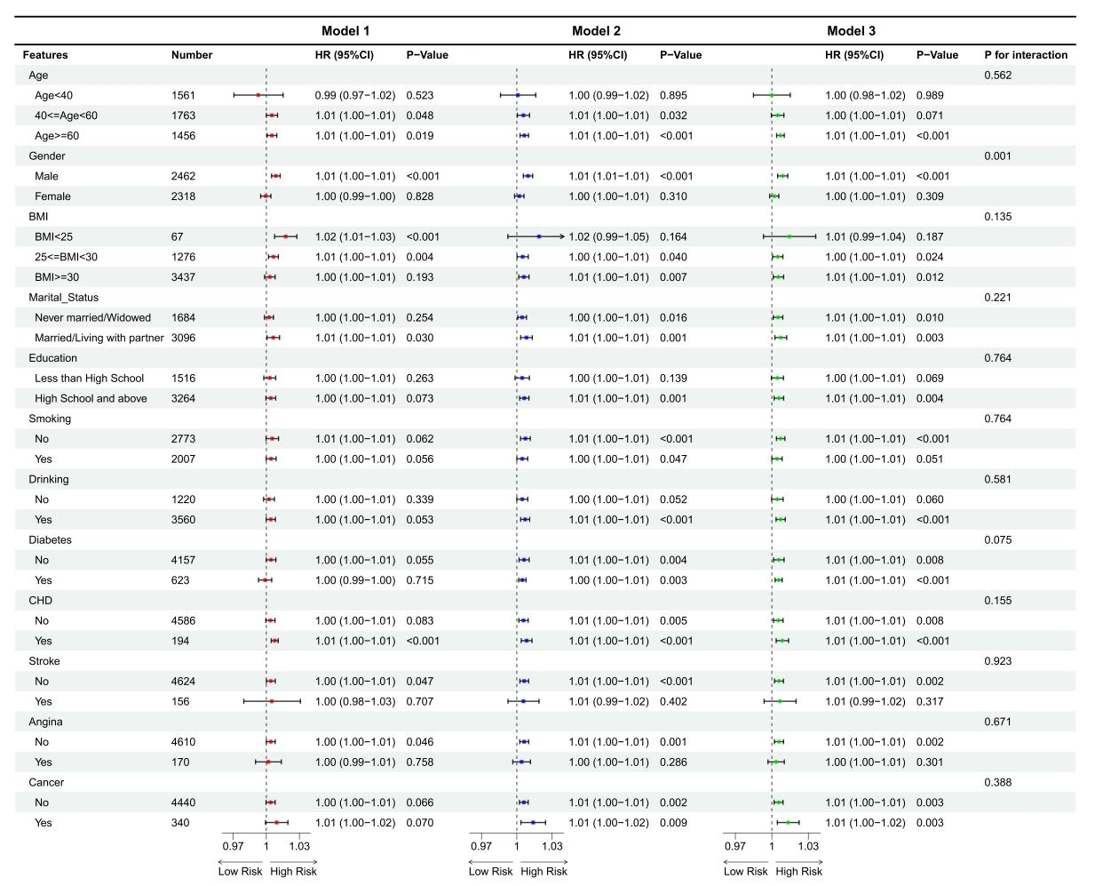
Figure S3. Subgroup analysis of the association between RCII and cardiovascular mortality risk in patients with MAFLD. RCII, Residual cholesterol-inflammation index; MAFLD, Metabolic dysfunction-associated fatty liver disease
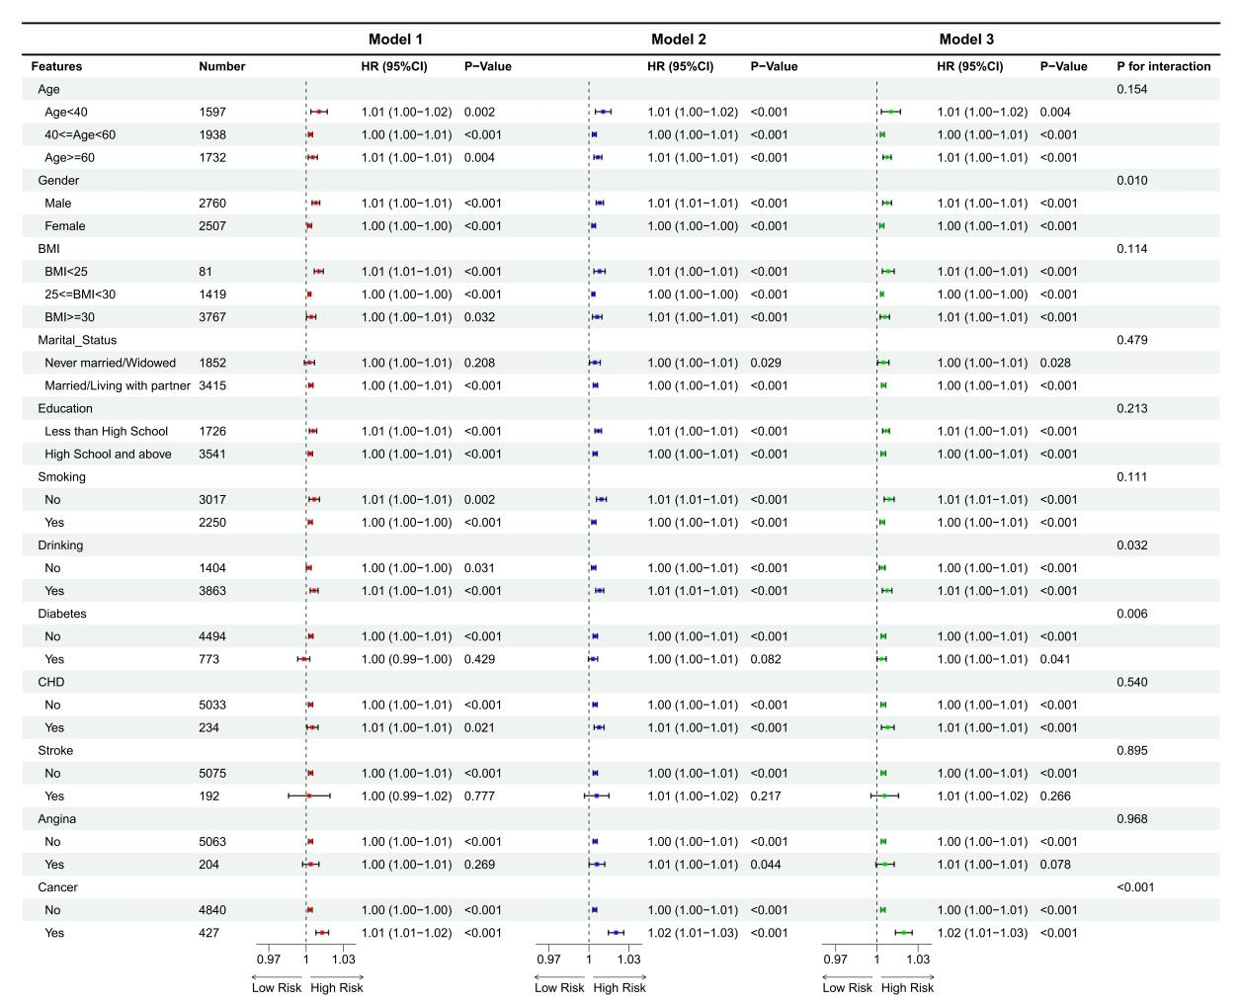
Figure S4. Subgroup analysis of the association between RCII and premature mortality risk in patients with MAFLD. RCII, Residual cholesterol-inflammation index; MAFLD, Metabolic dysfunction-associated fatty liver disease

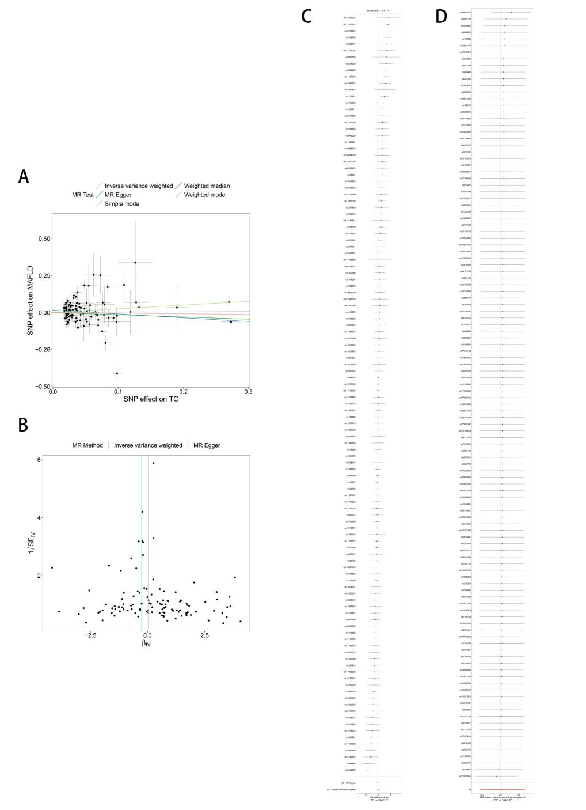
Figure S5. Mendelian randomization analysis of the causal association between total cholesterol and MAFLD. (A) Scatter plot of SNP effects on total cholesterol and MAFLD using multiple MR methods; (B) Funnel plot showing the distribution of instrumental variables; (C) Forest plot of single-SNP MR estimates; (D) Leave-one-out sensitivity analysis. MAFLD, Metabolic dysfunction-associated fatty liver disease; MR, Mendelian randomization; SNP, Single nucleotide polymorphisms.
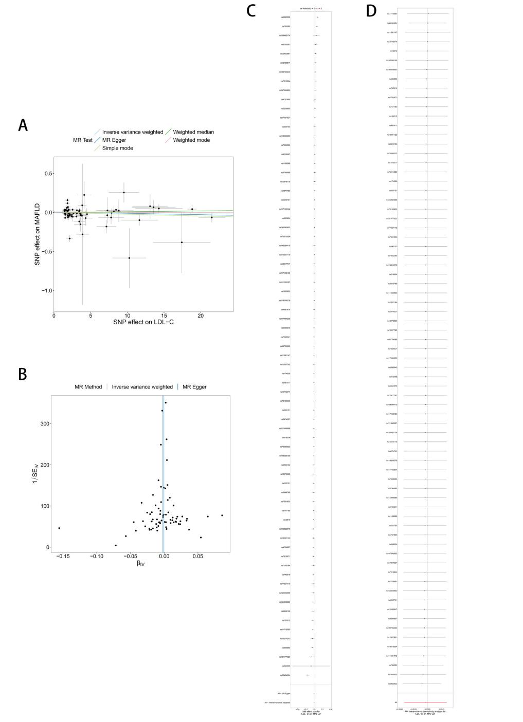

Figure S6. Mendelian randomization analysis of the causal association between LDL-C and MAFLD. (A) Scatter plot of SNP effects on LDL-C and MAFLD using multiple MR methods; (B) Funnel plot showing the distribution of instrumental variables; (C) Forest plot of single-SNP MR estimates; (D) Leave-one-out sensitivity analysis. MAFLD, Metabolic dysfunction-associated fatty liver disease; LDL-C, Low-density lipoprotein cholesterol; MR, Mendelian randomization; SNP, Single nucleotide polymorphisms.
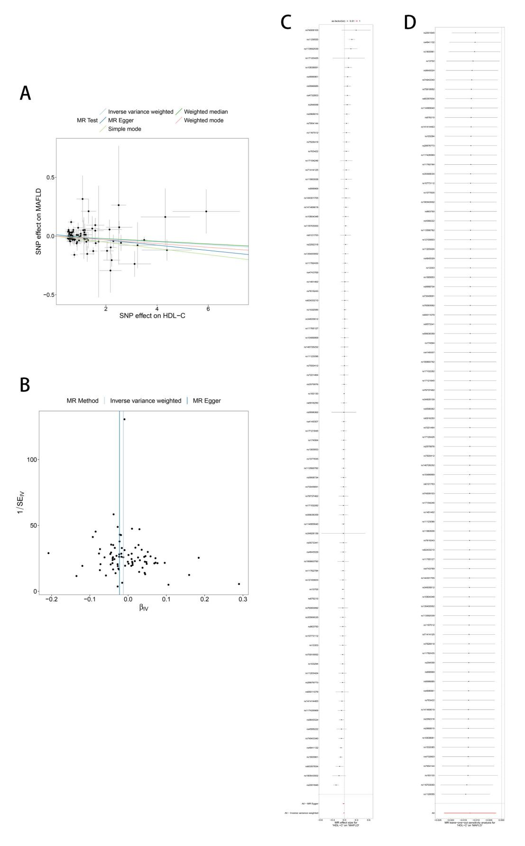
Figure S7. Mendelian randomization analysis of the causal association between HDL-C and MAFLD. (A) Scatter plot of SNP effects on HDL-C and MAFLD using multiple MR methods; (B) Funnel plot showing the distribution of instrumental variables; (C) Forest plot of single-SNP MR estimates; (D) Leave-one-out sensitivity analysis. MAFLD, Metabolic dysfunction-associated fatty liver disease; HDL-C, Hight-density lipoprotein cholesterol; MR, Mendelian randomization; SNP, Single nucleotide polymorphisms.
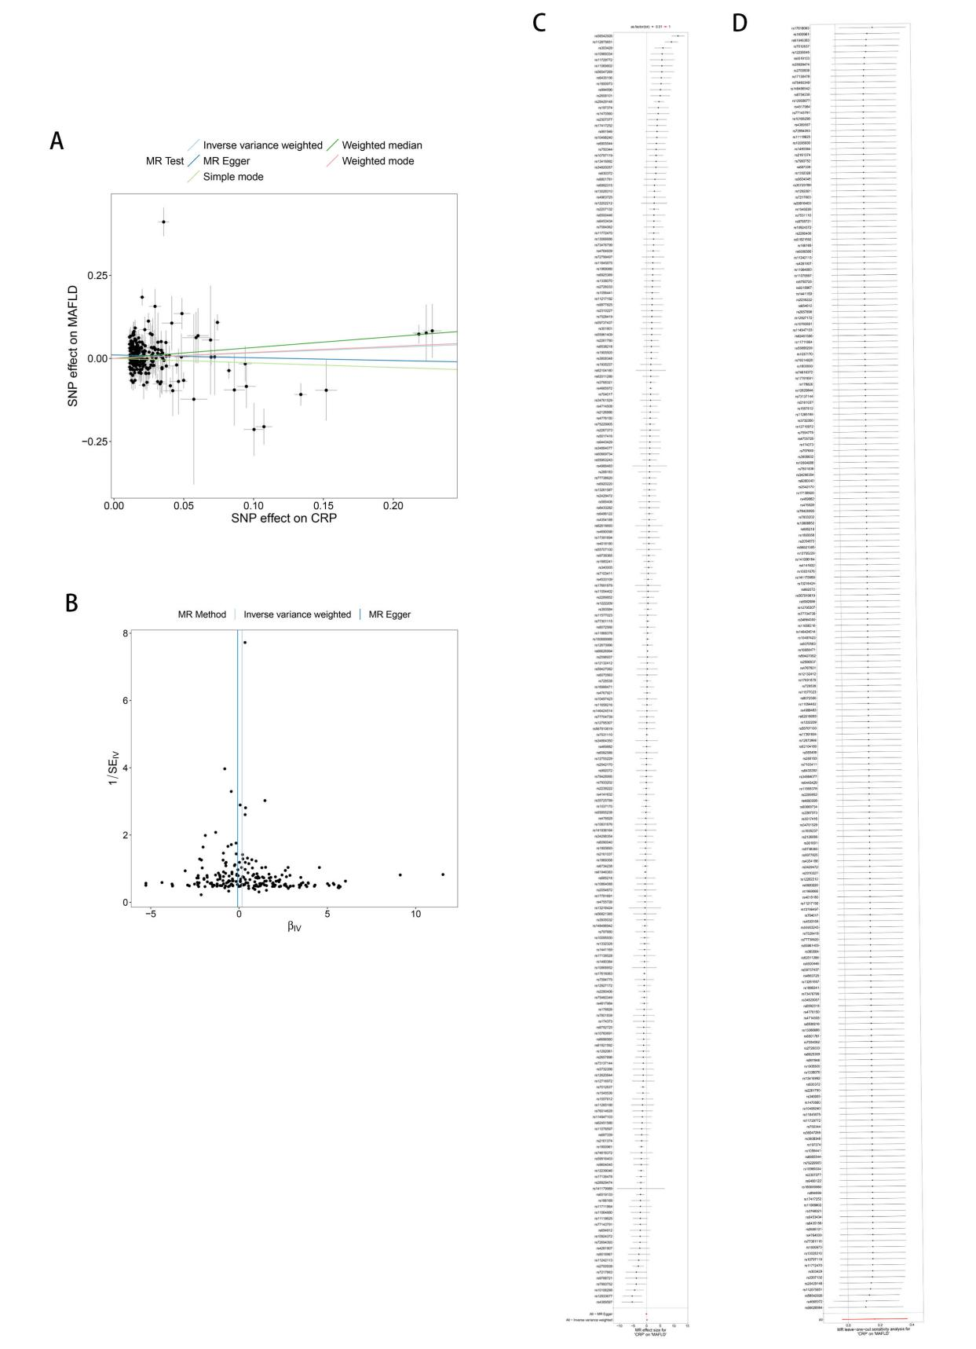
Figure S8. Mendelian randomization analysis of the causal association between CRP and MAFLD. (A) Scatter plot of SNP effects on CRP and MAFLD using multiple MR methods; (B) Funnel plot showing the distribution of instrumental variables; (C) Forest plot of single-SNP MR estimates; (D) Leave-one-out sensitivity analysis. CRP, C-reaction protein; MAFLD, Metabolic dysfunction-associated fatty liver disease; SNP, Single nucleotide polymorphisms; MR, Mendelian randomization.

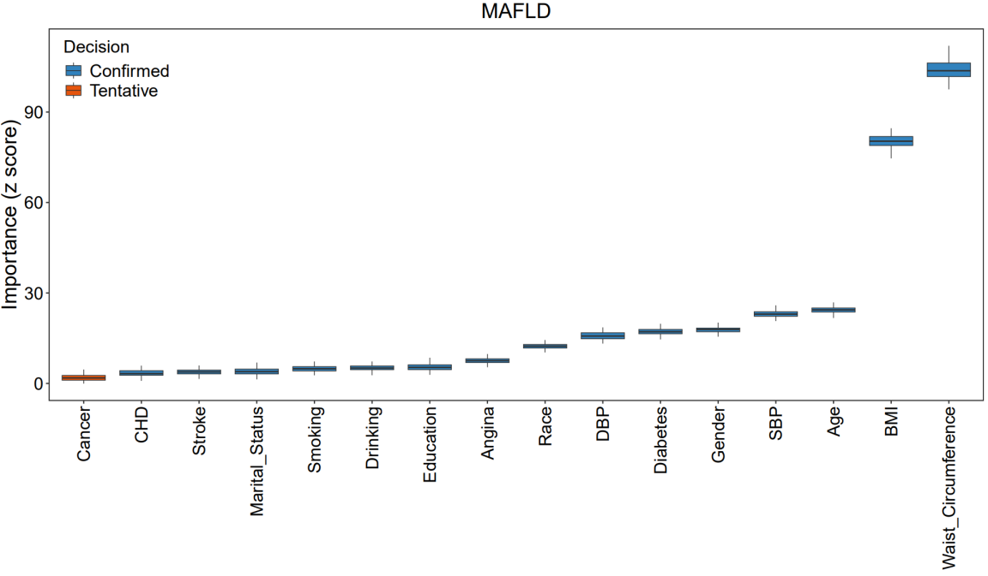
Figure S9. Key variables associated with MAFLD identified by the Boruta algorithm. MAFLD, Metabolic dysfunction-associated fatty liver disease

Table S1. Estimated mediation effects of FPG on the associations between RCII and MAFLD or related mortality outcomes
Exposure | Mediator | Outcome | ADE | ADE P-Value | ACME | ACME P-Value | Total Effect | Total Effect P-Value | Proportion Mediated (%) | Proportion P-Value
RCII | FPG | MAFLD | 0 | <0.001 | 0 | <0.001 | 0.001 | <0.001 | 2.02 | <0.001
RCII | FPG | All-cause mortality | -2.83 | <0.001 | -0.21 | <0.001 | -3.03 | <0.001 | 6.76 | <0.001
RCII | FPG | CVD mortality | -14.81 | <0.001 | -1.32 | <0.001 | -16.13 | <0.001 | 8.06 | <0.001
RCII | FPG | Premature death | -2.31 | <0.001 | -0.18 | <0.001 | -2.5 | <0.001 | 7.33 | <0.001
FPG, Fasting plasma glucose; RCII, Residual cholesterol-inflammation index; MAFLD, Metabolic dysfunction-associated fatty liver disease; CVD, Cardiovascular disease; ADE, Average direct effect; ACME, Average causal mediation effect

