Supplementary Information

Bioadhesion of plant heteropolysaccharides to animal glycocalyx by polymer-typical chain entanglement

Irene Wacker*, Willi Wagner*, Ronald Curticean, Endre Majorovits, Jennifer M. Pan, Steven J. Mentzer, Rasmus R. Schröder

I. Wacker, R. Curticean, R. R. Schröder
BioQuant, Universität Heidelberg, Im Neuenheimer Feld 267, 69120 Heidelberg, Germany and 3DMM2O, Cluster of Excellence (EXC-2082/1 – 390761711)

W. Wagner
Department of Diagnostic and Interventional Radiology, University Hospital of Heidelberg, Heidelberg, Germany and Translational Lung Research Center Heidelberg (TLRC), German Center for Lung Research (DZL), University of Heidelberg, Heidelberg, Germany.
Current address: Diagnostic Radiology and Neuroradiology, Greifswald University Hospital, Ferdinand-Sauerbruch-Strasse 1, Greifswald, Germany.

E. Majorovits
Carl Zeiss Microscopy GmbH, Carl-Zeiss Str. 22, D-73447 Oberkochen, Germany

J. M. Pan, S. J. Mentzer
Laboratory of Adaptive and Regenerative Biology, Brigham & Women’s Hospital, Harvard Medical School, Boston, MA 02115, USA

*These authors contributed equally

To whom further correspondence may be addressed. E-mail: irene.wacker@bioquant.uni-heidelberg.de; willi.wagner@med.uni-greifswald.de
smentzer@bwh.harvard.edu; rasmus.schroeder@bioquant.uni-heidelberg.de

Contents:

Stabilizing pectin page 3

Table S1 Hydration factors page 3
Figure S1 Dehydration kinetics page 4
Figure S2 Hydration gradient lemon pectin page 5
Figure S3 Ultrastructural signatures of different polysaccharides page 6

Quality of tissue preservation page 7
Figure S4 Lung surface/mesothelium page 7
Figure S5 Type 2 alveolar cells page 8
Figure S6 Membrane-bound organelles page 9

Adhesion of pectin film to lung mesothelium page 10
Figure S7 Judging of trimmed blockface with light microscopy page 10
Figure S8 Targeting for 3D analysis with FIBSEM nanotomography page 11

List of Movies page 12
Movie_1 Hydration gradient of lemon pectin – fly-in: overview to detail
Movie_2 Preservation of lung tissue - fly-in: overview to details
Movie_3 FIBSEM nanotomography data - fly-through
Movie_4a-c Annotated data – 3D visualization from different angles

Stabilizing pectin

To avoid the inevitable dissolution in aqueous media of the pure pectin films used in our study, we systematically analyzed how the different solutions utilized in a typical embedding procedure for ultrastructural analysis influenced film quality. Apart from morphological characteristics we derived a hydration factor by gravimetric analysis of small pieces of film before and after incubation with the respective solution, cf Table 1 main text.
The influence of different ethanol concentrations, alone or in combination with one or more components of the fixatives, on the hydration factors of lemon and orange pectin was also determined (Table S1)

Table S1 – Hydration factors of lemon and orange pectin in different concentrations of ethanol, combined with components of aqueous solutions used during a typical preparation protocol for EM imaging.

Solvent | Lemon  15% EtOH | Orange  15% EtOH | Lemon  25% EtOH | Orange  25% EtOH
EtOH | 10.8/14.1 | 11.8 | 4.0/3.4 | 4.2
Pipes & EtOH | 21.5/15.4* | 17.0* | 6.2 | 12.9*
GA & EtOH | 13.3/12.9 | 10.7 | 4.1 | 5.2
GA & Pipes & EtOH | 17.0/21.2* | 13.7* | 6.6 | 8.4
GA & Pipes & RR & EtOH | 10.0/13.0 | 10.2 | 8.6 (20%) | 6.4

* These samples were no longer opaque, manageable and intact films but had disintegrated into several small, transparent pieces of material.
Hydration factor = weight(after incubation)/weight(initial) with incubation times of typically 15min - 30min.
EtOH = ethanol, concentration as given in column header
Pipes = 0.1M Pipes buffer
GA = 2.5% glutaraldehyde
RR = 0.15% Ruthenium red

Based on the finding that films with hydration factors >15 after fixation were no longer manageable, and tended to dissolve completely during the course of EM preparation we aimed for initial hydration factors around 10 for ultrastructural analyses. During the subsequent dehydration necessary for infiltration with the hydrophobic embedding resin hydration factor dropped to around 5 (Fig. S1) which then led to cross sections exhibiting clearly distinguishable filamentous networks (Fig. S2). Initial hydration factors below 5 decreased to around 2 after dehydration and resulted in very compact material without any structural detail (cf Fig. 2 main text).

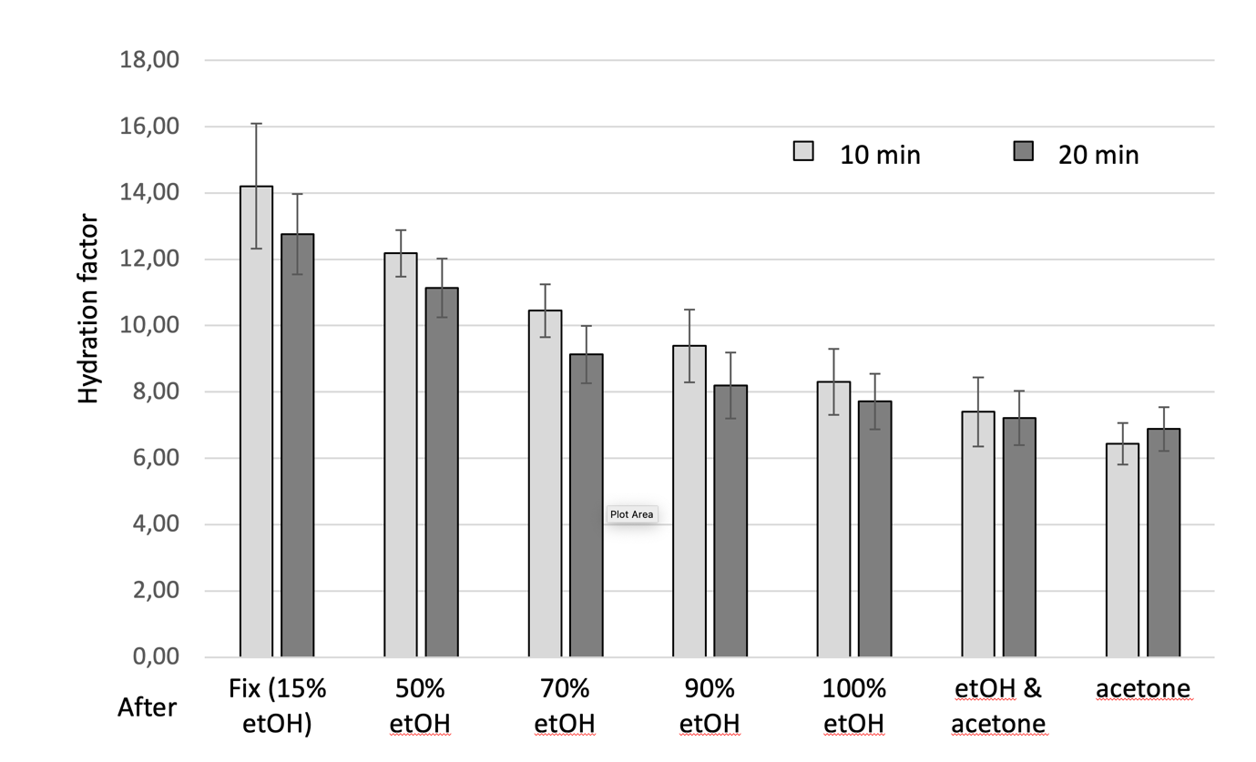
Fig. S1 Dehydration kinetics of lemon pectin films with 10 min or 20 min incubation time during dehydration steps. For each experiment three pieces of film were weighed initially as dry material, then after exposition to different aqueous fixatives with 15% ethanol added for 2h in total (Fix) and subsequently after each dehydration step. All values were normalized to dry weight and are plotted as average ± SD.

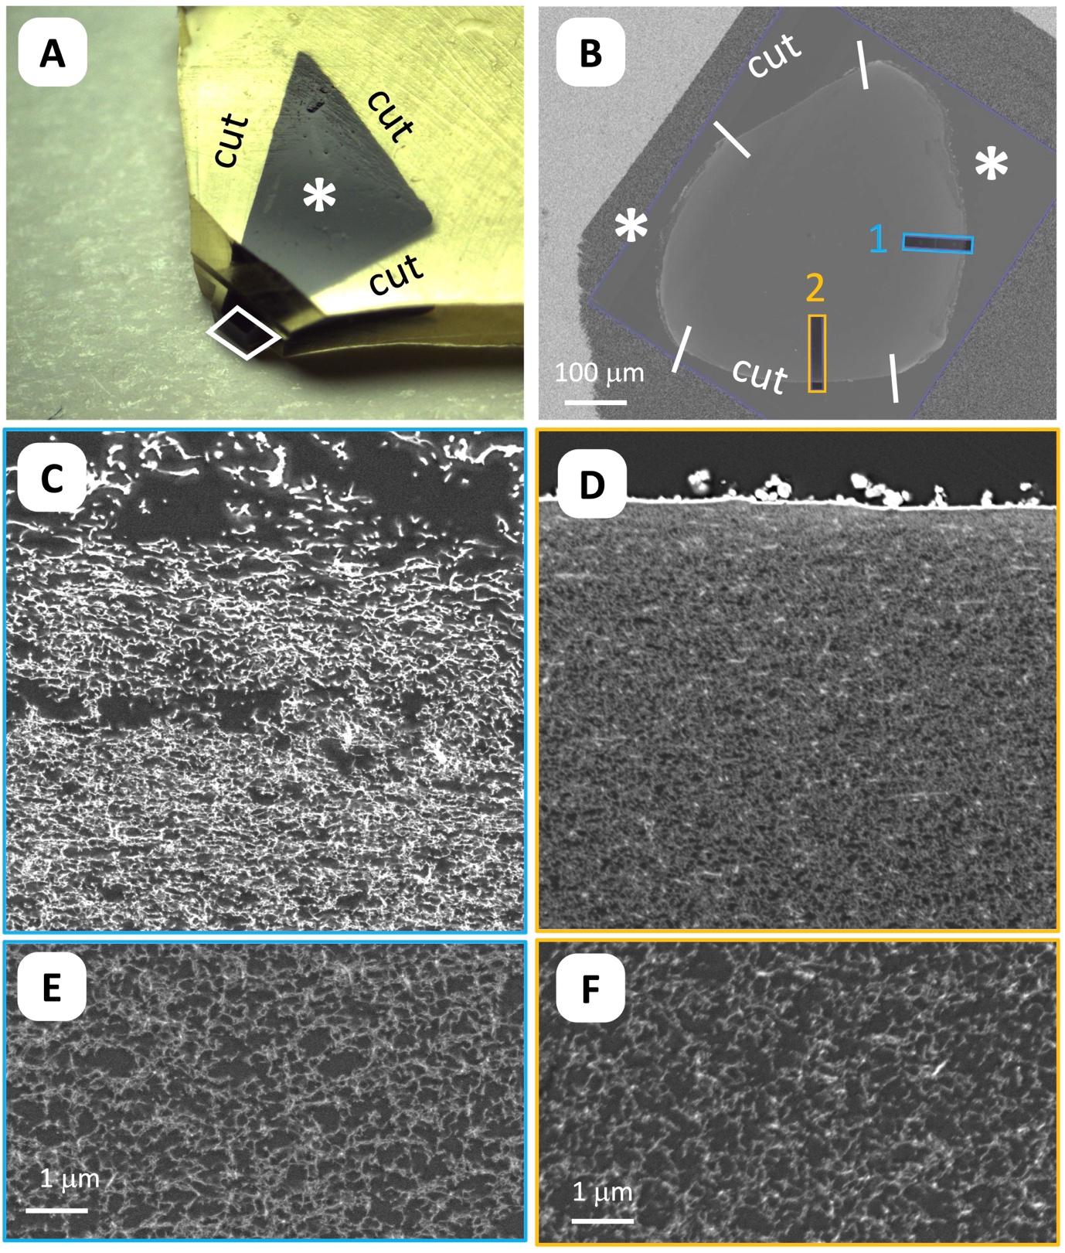

Fig. S2 The different faces of a lemon pectin film: (A) Small piece cut from a larger film, hydrated in the presence of 15% ethanol, embedded in epoxide resin, and trimmed for ultrathin sectioning (blockface indicated by white parallelogram). Stars indicate the original surface (interface of pectin to air or dish). Overview (B) of cross section with different faces separated by white lines (c.f. brackets fig. 2 Bi). Radial profiles with high spatial resolution were recorded at the positions indicated. Profile 1 extends from the original surface of the film (C) towards the centre (E) of the embedded sample, profile 2 from a cut edge (D) towards the center (F). C-F are screenshots from different positions within the radial profile, see also movie_2.

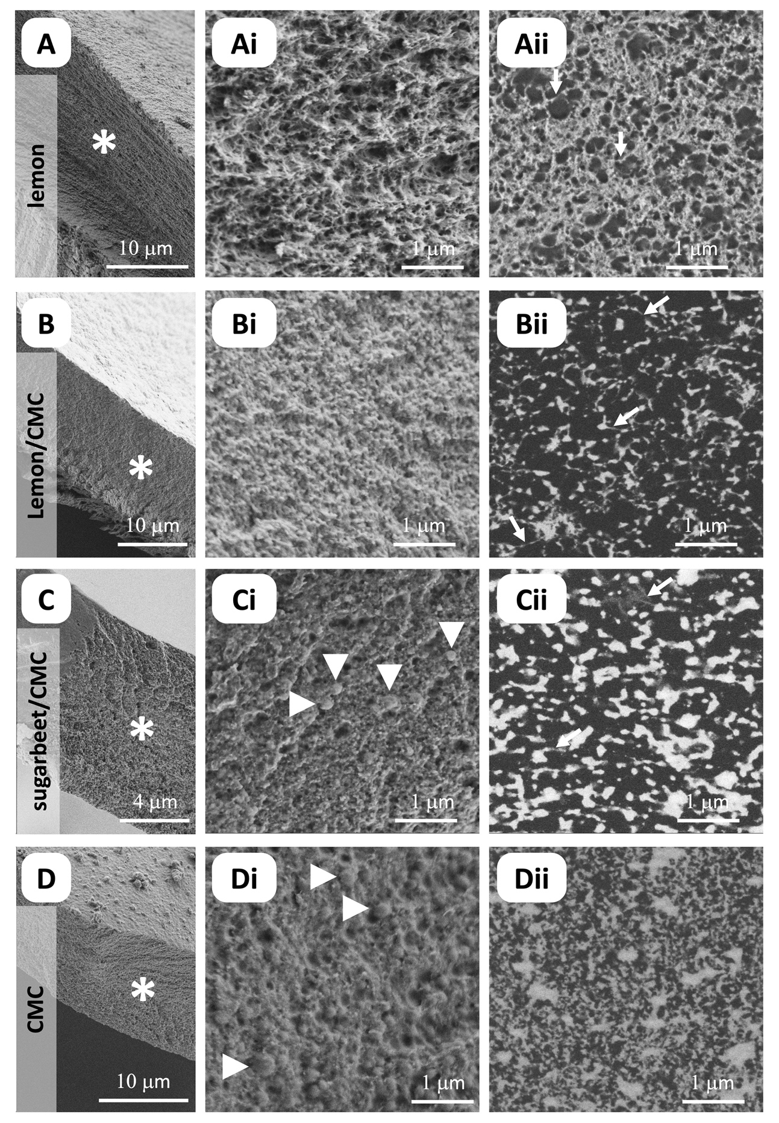
Fig. S3 Ultrastructural signatures of different polysaccharides: (A) lemon pectin, (B) lemon pectin + carboxymethylcellulose (CMC), (C) sugar beet pectin + CMC, (D) CMC. Overviews (A, B, C, D) of fracture faces (asteriscs) from air-dried films stained with ruthenium red and OsO₄ and high magnification images (Ai, Bi, Ci, Di) were recorded using secondary electrons. Ultrathin cross sections from films embedded in epoxide resin after staining as above (Aii, Bii, Cii, Dii) were imaged with backscattered electrons.
Quality of tissue preservation

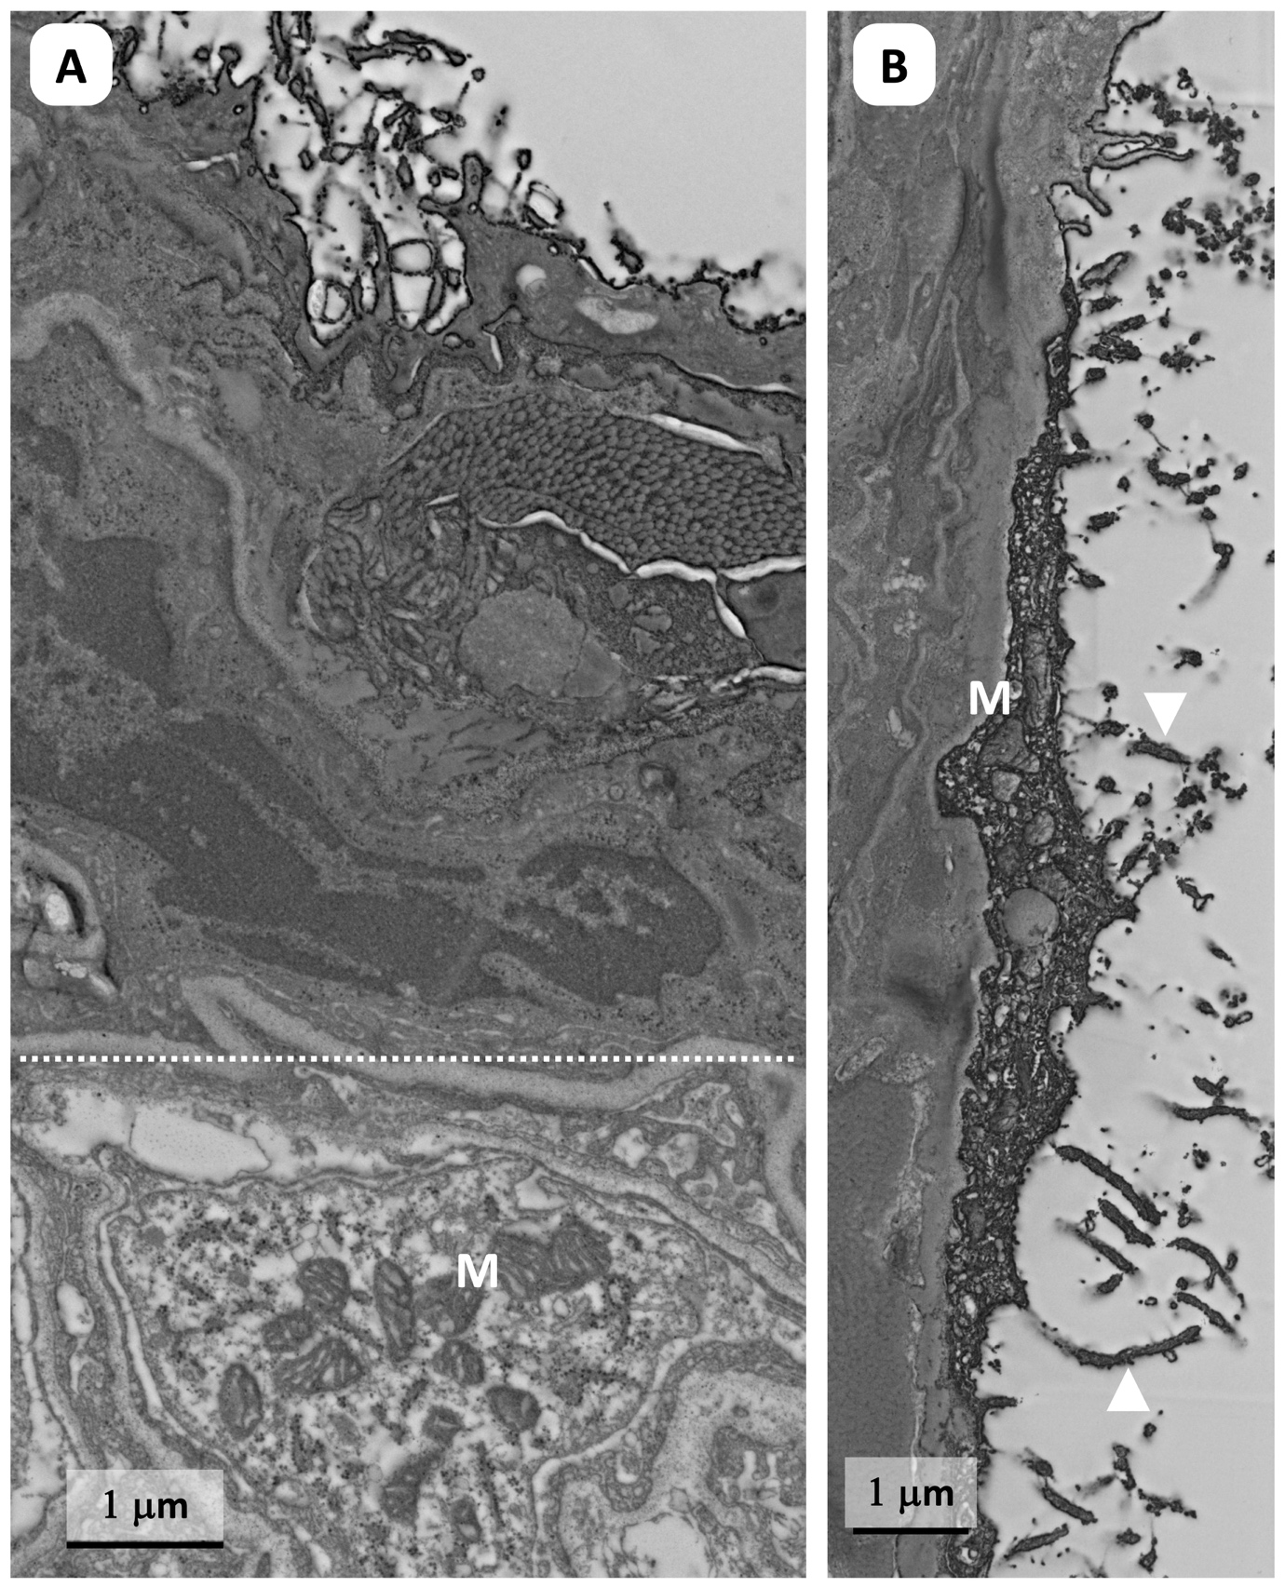Fig. S4 Quality of tissue prepared with 15% ethanol in primary fixative: Lung surface (A) with strongly stained mesothelial layer and submesothelial tissue, presumably caused by ruthenium red in the fixatives. In deeper tissue layers (below dashed line) the cytoplasm is less densely stained and mitochondria (M) appear dark. (B) mesothelial cell with microvilli (arrowheads) and dark, granular cytoplasm containing mitochondria which appear less dense than their surroundings. Note also fine fibrillar strands of the glycocalyx in both.

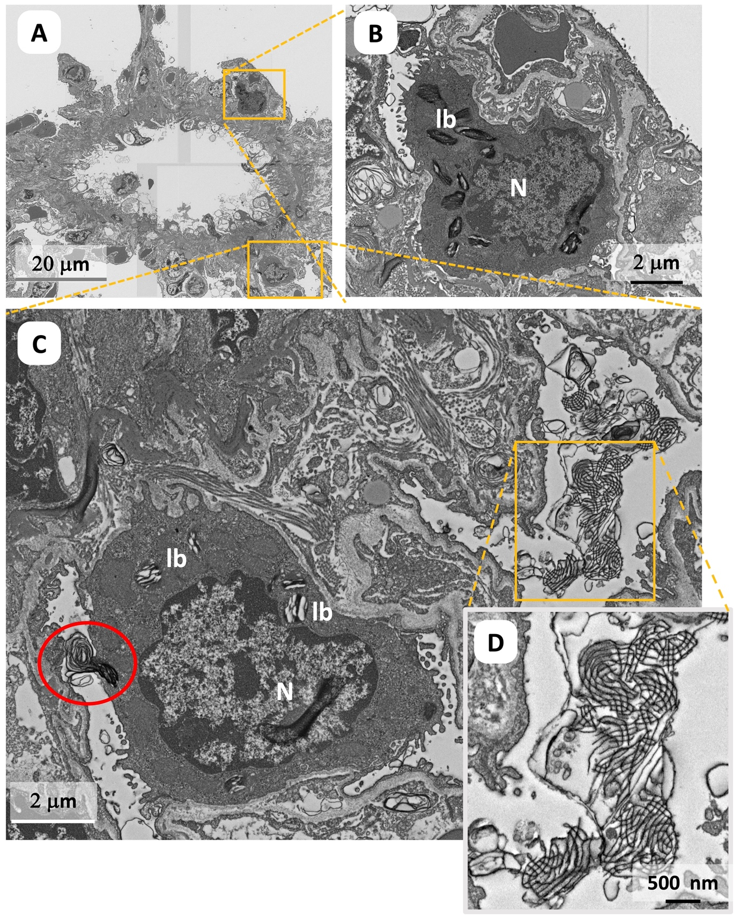

Fig. S5 Quality of tissue prepared with 15% ethanol in primary fixative: Type 2 alveolar cells. (A) Overview of a broncheolus with surrounding alveoli with alveolar epithelial cells type 2 (B, C) with lamellar bodies (lb). Cell in (C) is secreting surfactant (red circle in C), (D) extracellular surfactant (tubular myelin). N = nucleus

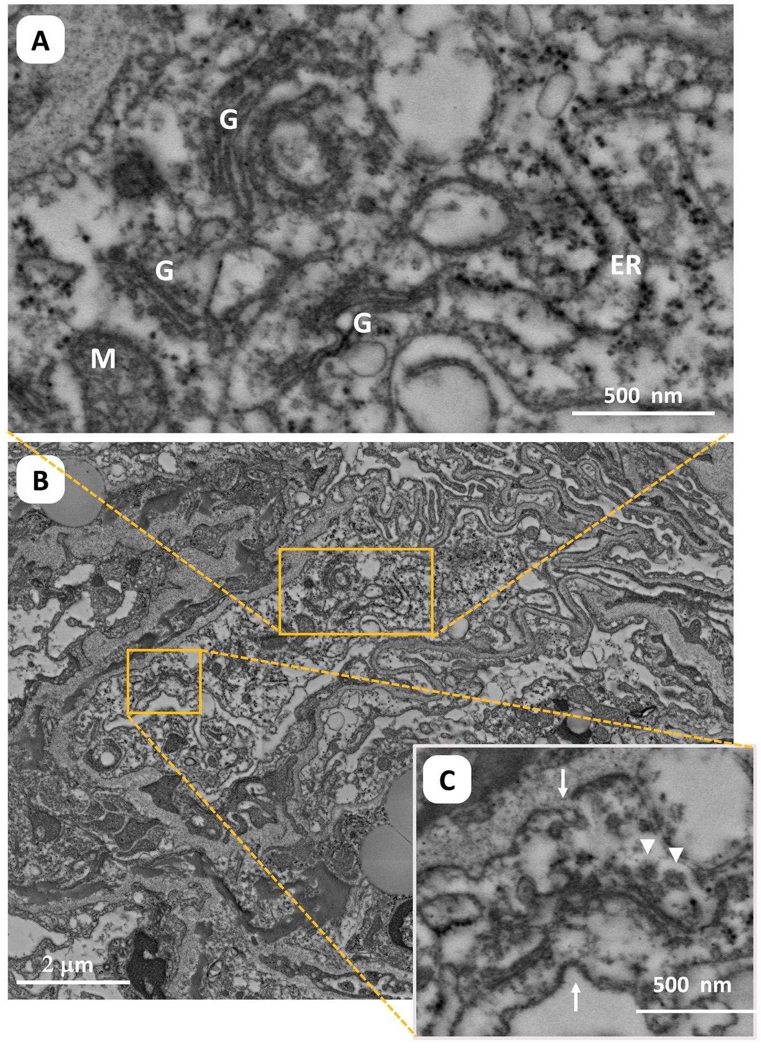
Fig. S6 Quality of tissue prepared with 15% ethanol in primary fixative: Membrane-bound organelles (A) such as Golgi apparatus (G), endoplasmic reticulum with ribosomes (ER) in the cell shown in (B). (C) Clathrin-coated pits (arrows) and vesicles (arrowheads) are also visible. M = mitochondrium
Adhesion of pectin film to lung mesothelium

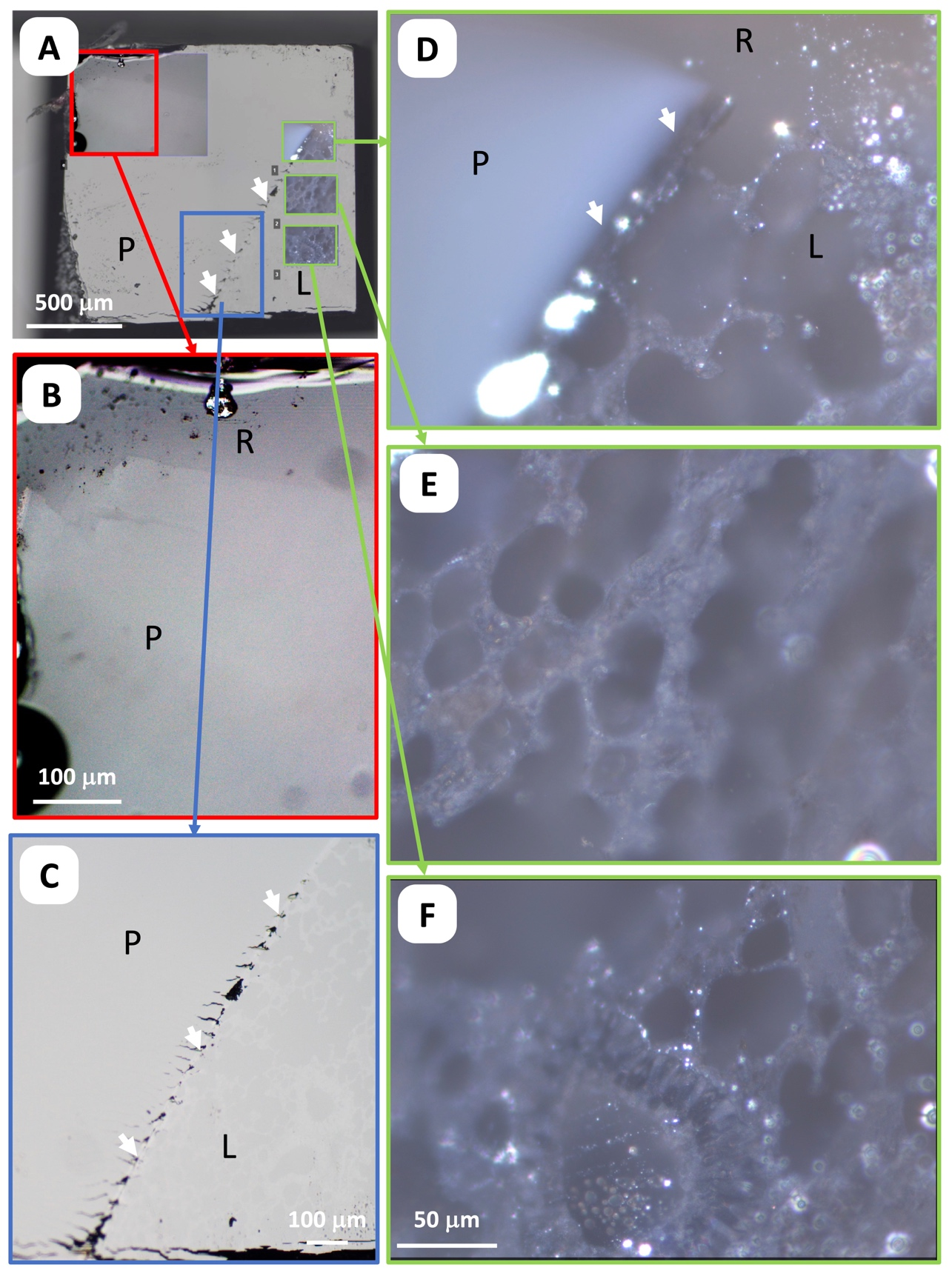
Fig. S7 Assessment of trimmed blockface with epi-illumination light microscopy.
(A) position on the surface of the trimmed block (blockface) of the different ROIs shown: (B) corner of pectin patch, P = pectin, R = embedding resin. (C) interface (arrowheads) between pectin and lung tissue (L), (A-C) visualized in brightfield mode. Darkfield mode (D-F) allows a much clearer visualization of the pectin-lung interface (D) with pectin appearing as a milky material and the lung tissue with much more structural detail (see also E, F), visible in the resin block without further staining.

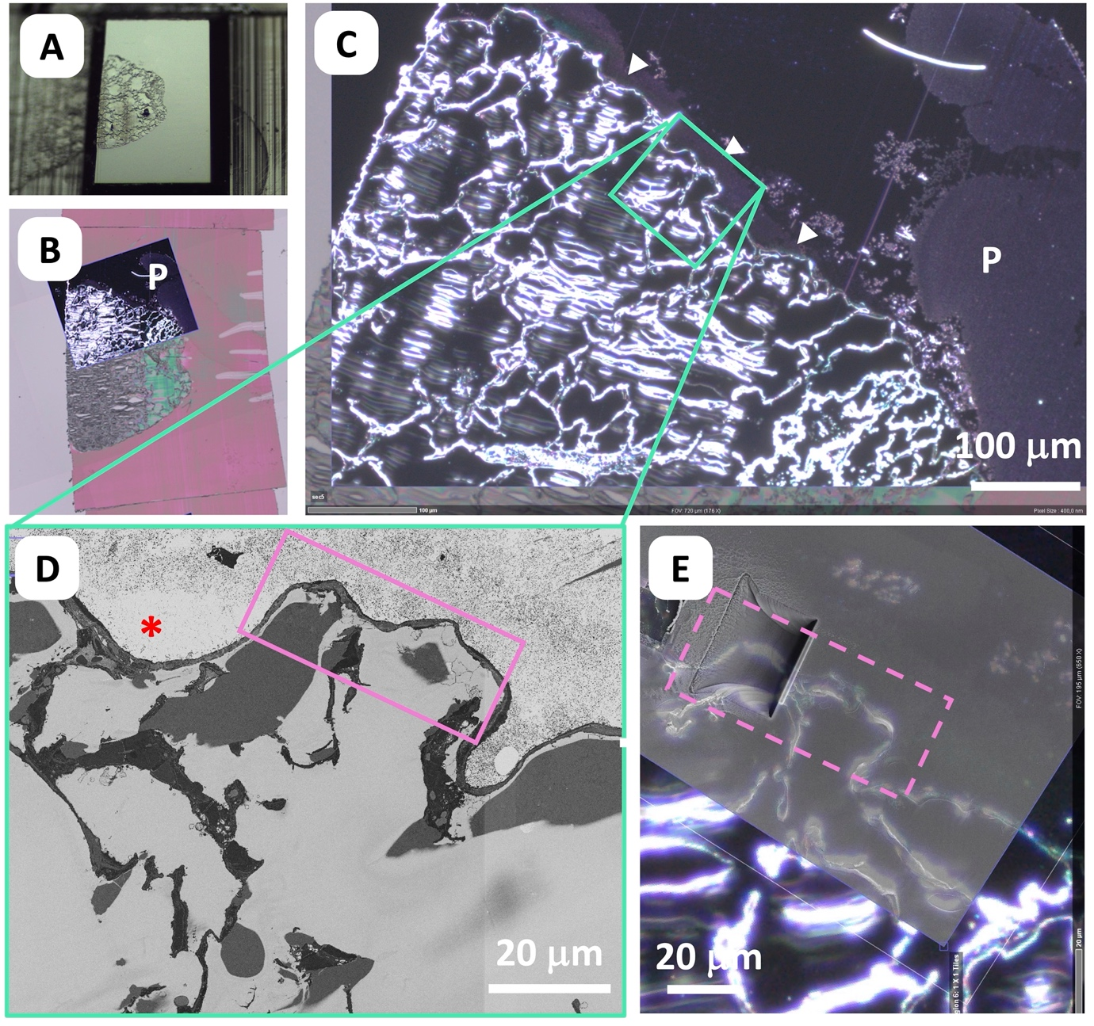

Fig. S8 Targeting for 3D analysis with FIBSEM nanotomography: A common coordinate system established by the software packages ZENconnect, Atlas AT and Atlas 3D was used for defining and checking ROIs and for setting up the FIBSEM runs.
(A) Blockface with lung tissue (B) 500nm thick section with overlay of darkfield image showing large pectin patch (P) which is partially delaminated from the tissue surface. (C) At higher magnification pectin - appearing as milky material – is also detected close to the lung surface (arrowheads) in certain areas. (D) 80nm thick section imaged with SEM to confirm suitable ROIs with pectin really attached to the lung surface (area devoid of pectin indicated by red star). The ROI marked by the pink rectangle was identified as target ROI for the 3D analysis. (E) shows the FIB-milling trench superimposed on the corresponding area of the darkfield image.

List of movies

Movie_1 Hydration gradient of lemon pectin – fly-in: Overview to details for two regions of interest in one section. One region extends from the original material surface towards the center, the other from a cut face of the pectin film towards the center (cf figure S2)

Movie_2 Preservation of lung tissue – fly-in: Overview to details for three regions of interest, located at different positions within the section (cf figure S4, S5, S6).

Movie_3 FIBSEM nanotomography data – fly-through

Movie_4 a-c Annotated data – 3D visualization from different angles

