Supplementary File

Quantum dots coupled streptavidin and its application in lipid rafts protein characterization
Shiying Zhai ^{a, 1}, Hao Chi ^{a, 1}, Sheng Tian^{a, 1}, Michael Adu-Frimpong^{b}, Xia Caoª, Qilong Wangª, Shanshan Tong^{a,}*
¹These authors contributed equally to the work
*Corresponding author: Shanshan Tong, E-mail: tongss_han@163.com
ªSchool of Pharmacy, Jiangsu University, Zhenjiang, Jiangsu, 212000, PR China
^{b}School of Chemical and Biochemical Sciences, C. K. Tedam University of Technology and Applied Sciences (CKT-UTAS), Navrongo, UK-0215-5321, Ghana

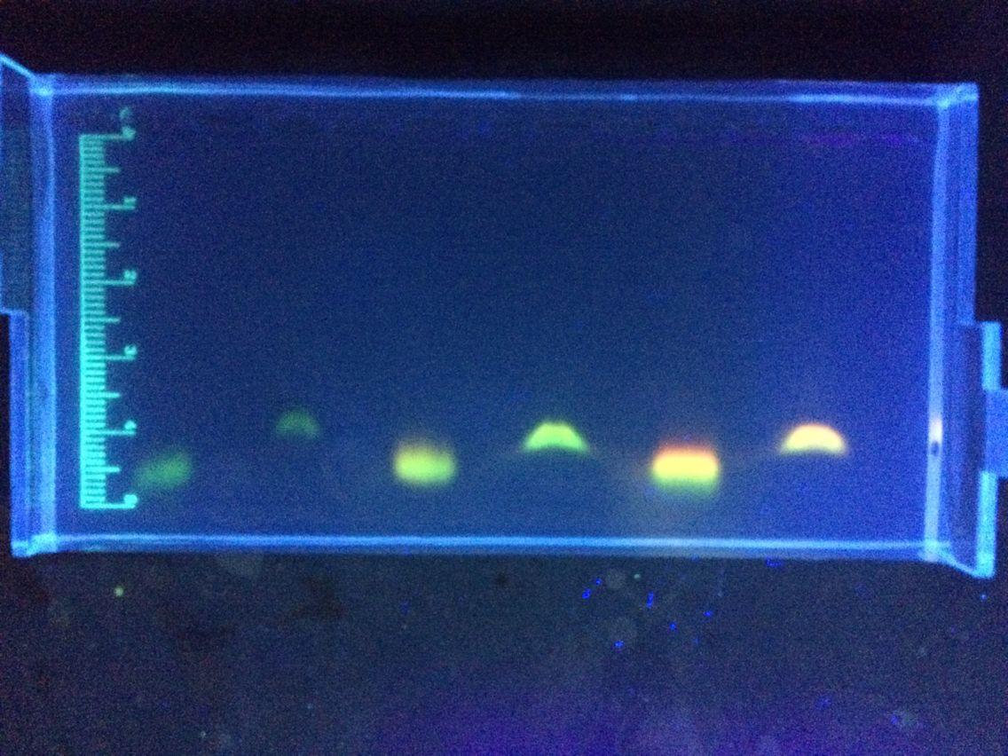
Figure S1 full uncropped Gels and Blots image

