Supplementary Table 1 Changes in comedication with glucocorticoids and methotrexate during the first year in cohorts C1–C4
Glucocorticoids (GCs) | C1 | C2 | C3 | C4
Change in comedication with GCs in M1–M5 (yes → no or no → yes) | 17.0% | 11.2% | 7.1% | 7.2%
Change in comedication with GCs in M6–M12  (yes →no or no → yes) | 9.1% | 8.5% | 17.1% | 5.7%
No change in M1–M12  (yes → yes or no → no) | 73.9% | 80.3% | 75.8% | 87.1%
Methotrexate (MTX) | C1 | C2 | C3 | C4
Change in comedication with MTX in M1–M5  (yes → no or no → yes) | 15.4% | 5.0% | 2.7% | 2.9%
Change in comedication with MTX in M6–M12  (yes →no or no → yes) | 4.5% | 2.8% | 7.3% | 3.2%
No change in M1–M12  (yes → yes or no → no) | 80.1% | 92.1% | 90.1% | 93.8%
GCs glucocorticoids; M month; MTX methotrexate
Percentages of patients changing the comedication with GCs and MTX (in the sense of starting or discontinuing the comedication compared to the situation at baseline) within the studied period are presented in the table.

Supplementary Table 2 Comparison of differences in parameters from month 6 to 12 between cohort C3 and C4
 | C3 (n=124) | P-value* | C4 (n=491) | P-value* | P-value†
DAS28-ESR | -1.60 (-2.81; -0.49) | <0.001 | -0.35 (-1.00; 0.28) | <0.001 | <0.001
TJC (28 joints) | -5.00 (-10.00; -1.00) | <0.001 | -1.00 (-2.00; 1.00) | <0.001 | <0.001
SJC (28 joints) | -3.00 (-7.00; 0.00) | <0.001 | 0.00 (-1.00; 0.00) | <0.001 | <0.001
ESR (mm/h) | -9.50 (-22.00; 0.00) | <0.001 | -1.00 (-10.00; 6.00) | 0.015 | <0.001
CRP (mg/l) | -7.31 (-16.15; 1.39) | <0.001 | -0.20 (-3.50; 3.00) | 0.052 | <0.001
SDAI (0–86) | -15.34 (-25.13; -4.85) | <0.001 | -2.23 (-5.83; 1.93) | <0.001 | <0.001
PTGA (0–100)d | -16.00 (-41.50; 0.00) | <0.001 | -5.00 (-15.00; 7.00) | <0.001 | <0.001
MDGA (0–100) | -26.00 (-45.00; -3.50) | <0.001 | -3.00 (-15.00; 6.00) | <0.001 | <0.001
HAQ-DI (0–3)^{d} | -0.24 (-0.38; 0.00) | <0.001 | 0.00 (-0.25; 0.13) | 0.059 | <0.001
EQ-5D (-0.59–1) | 0.04 (0.00; 0.53) | <0.001 | 0.00 (-0.05; 0.07) | 0.032 | <0.001
DAS28-ESR 28-joint disease activity score with ESR; TJC tender joint count; SJC swollen joint count; ESR erythrocyte sedimentation rate; CRP C-reactive protein; SDAI Simplified Disease Activity Index; PTGA patient general assessment of disease activity; MDGA physician general assessment of disease activity; HAQ-DI Health Assessment Questionnaire; EQ-5D EuroQol 5 Dimension for measuring the quality of life
Medians of differences between 6-month and 12-month visit with interquartile ranges are presented.
* We were testing the hypothesis that the differences are equal to zero through Wilcoxon paired test.
† We were testing the hypothesis of equality of medians of differences between groups C3 and C4 (Mann-Whitney test).
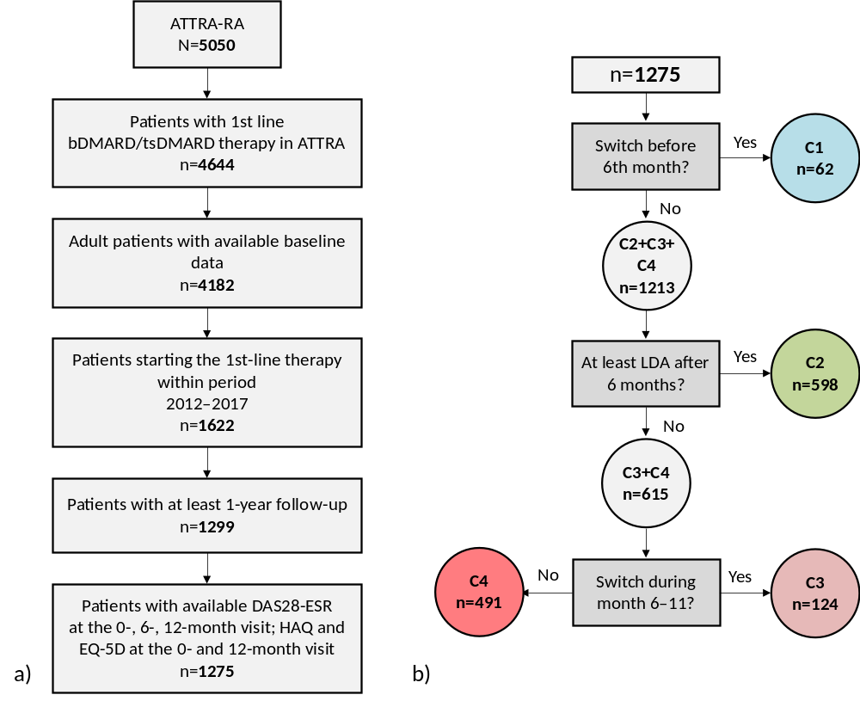
Supplementary Figure 1 Flow chart showing individual steps to final dataset (a) and division into four cohorts (b)

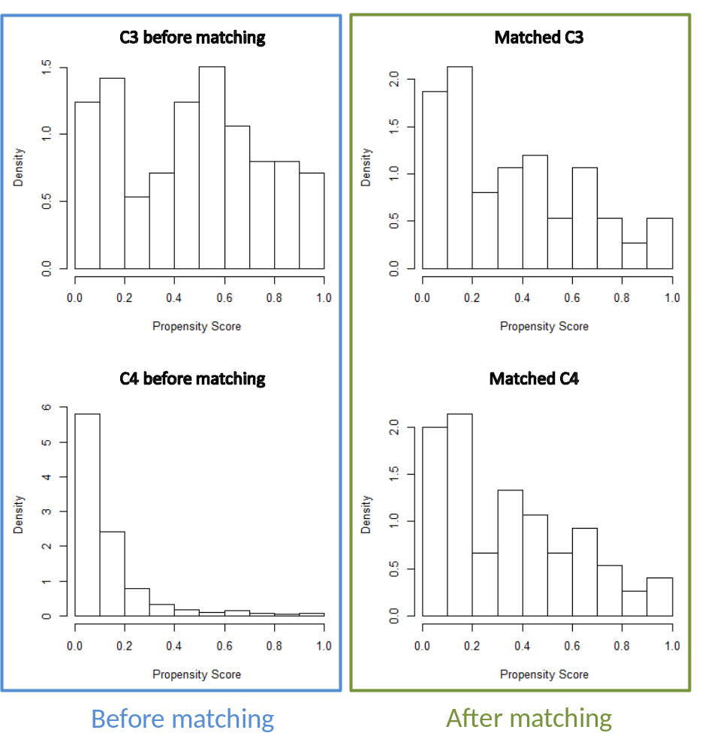
Supplementary Figure 2 Propensity score densities of cohorts C3 and C4 before and after matching

