Supplementary material of
One-Second-Lead Earthquake Warning and Impact Assessment at Campi Flegrei
V. Longobardi ¹, S. Colombelli¹ and A. Zollo¹*
¹ Department of Physics “Ettore Pancini”, University of Naples “Federico II”, Naples, Italy
*corresponding author (email: aldo.zollo@unina.it)

Text S1
In Figure S2, we show the single-station magnitude estimate obtained from the P-peak acceleration, velocity, and displacement within one second from the P-wave arrival. We call this magnitude estimate MPx. The MPx estimate requires the calibration of the attenuation laws Px vs M and R (see Data and Methods) within the area. In Table S1 we report the relationship coefficients for displacement, velocity and acceleration. We observe a higher absolute value for the distance coefficient with respect to the magnitude coefficient, meaning that the area is characterized by strong attenuation effects, coherently to what is expected in the area[1,2] . We notice a slight underestimation of the magnitude within one second from the P-wave arrival (inset histogram Figure S2). The standard deviation is 0.41 magnitude units. The MPx does not rely on any assumption since the magnitude measurement is performed from an amplitude measurement (Pa, Pv, Pd) in a very short time window. However, at each station an average value of the expected hypocentral distance is used (see Figure S1).

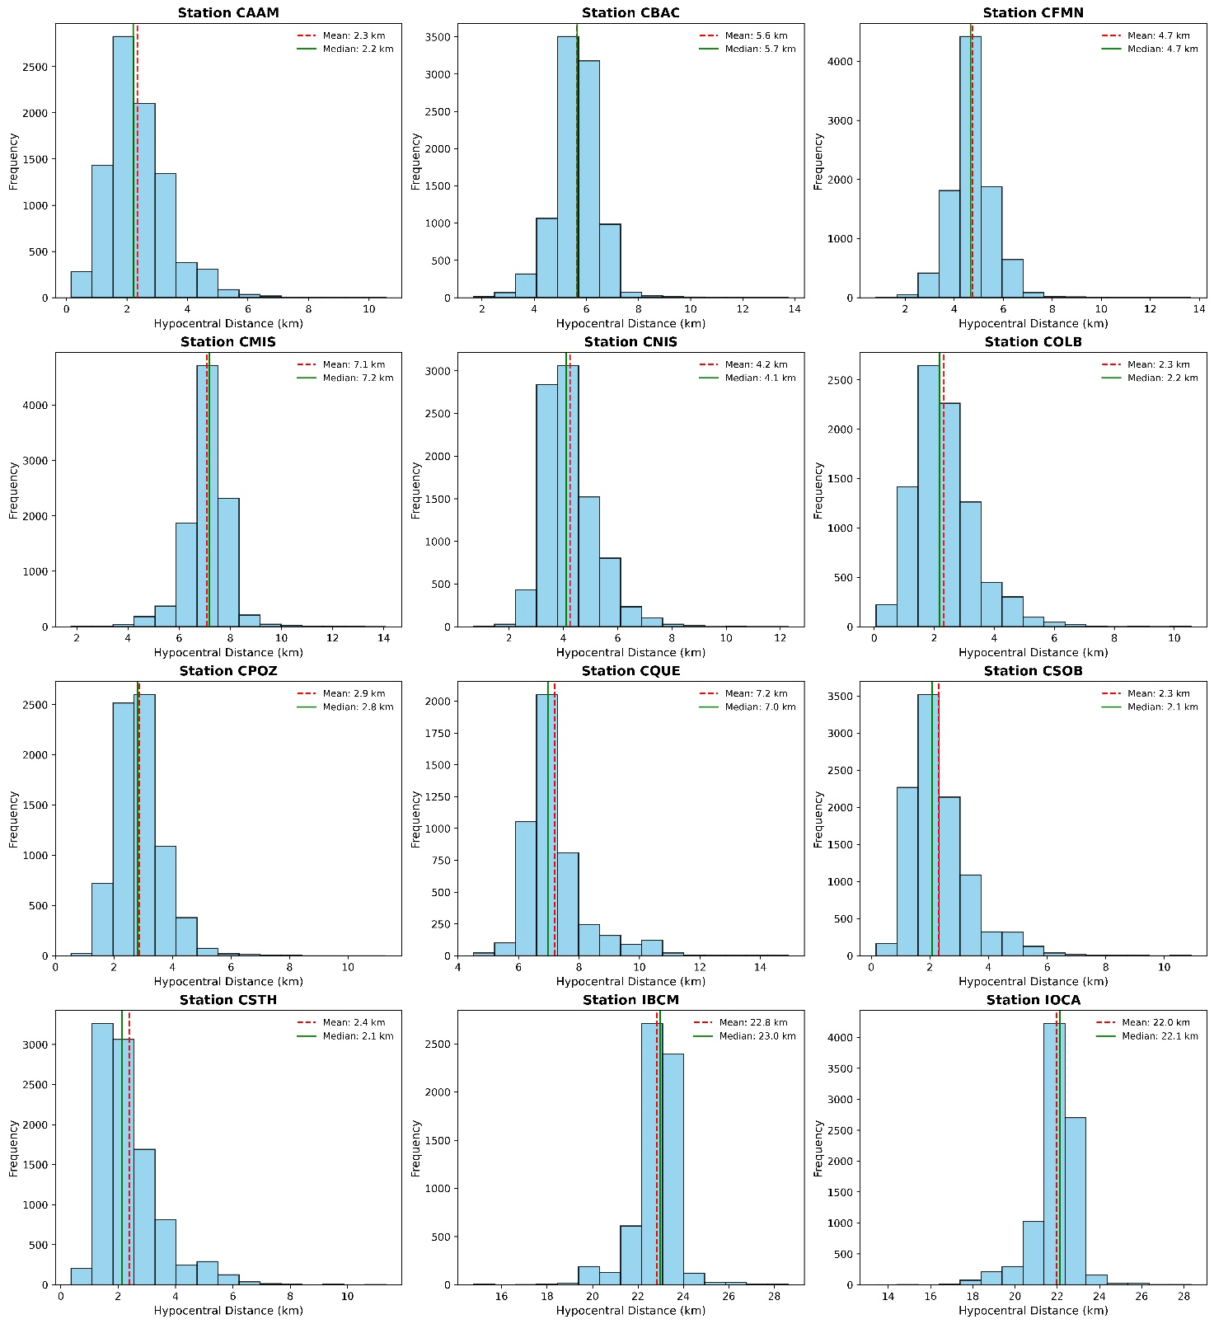

Figure S1: Hypocentral distances distrubutions for stations in the area. Each histogram shows the station code in the title. Mean and median of each distribution are shown with a vertical red dashed line and solid green line respectively.

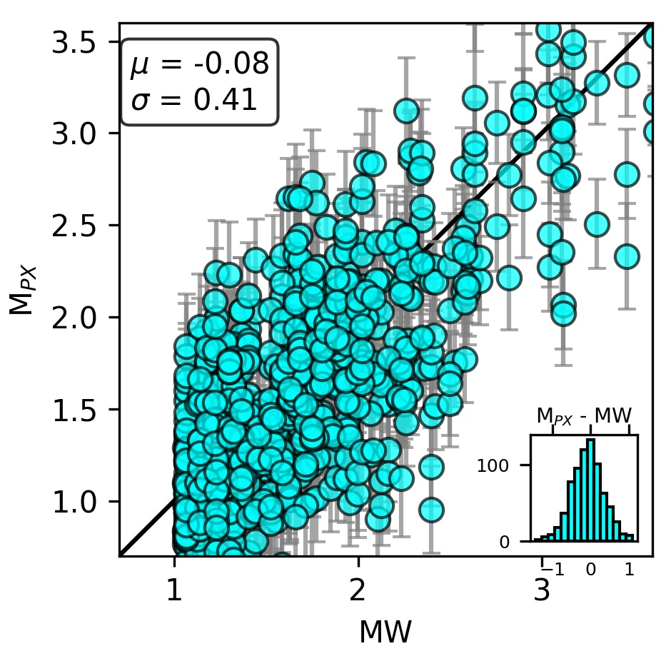

Figure S2 shows the single station magnitude estimate from Pd, Pv, Pa method (MPx) in one-second P-time window versus observed moment magnitude (MW). Black solid line is the one-to-one MW line. Inset shows the histogram of the difference between MPx and MW. Mean and standard deviation of the distribution are reported at top left corner.

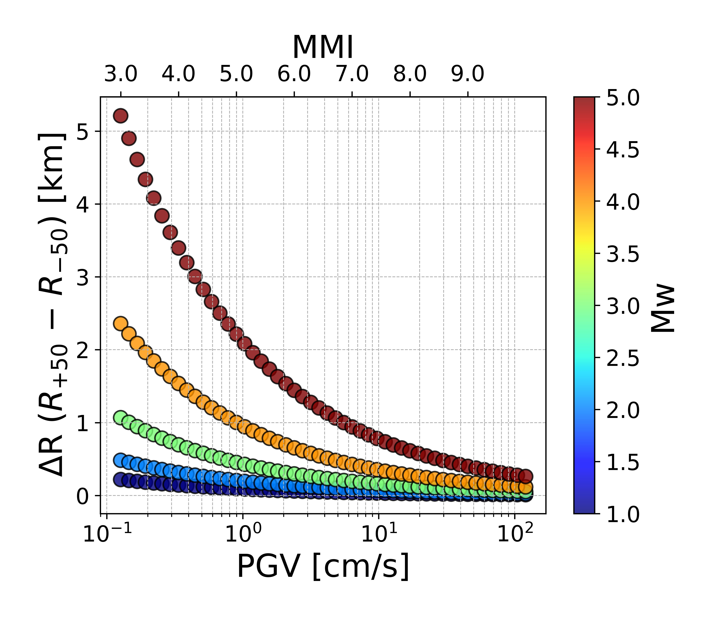
Figure S3 represents the radius ΔR (R_{max}-R_{min}) of the impacted area versus PGV and moment magnitude Mw. Within the impacted area, the PGV is expected to vary within ±50% of its value. On secondary y-axis the corresponding value of intensity is also shown.

Figure S4 shows the scaling of PGV vs PD in a one-second P-time window. Dark grey crosses represent single station measurements on the train dataset. Cyan points represent 2-d binned data (x-bin width = 1 cm and y-bin width = 0.5 cm/s). Dashed lines are the calibrated PGV vs Pd law and its standard error bounds for the 2-d binned data.

Figure S4 shows the predicted PGA of the test dataset with respect to the observed PGA, using the calibrated law of PGA vs Pd in one-second P-time window. Points are colored following the expected potential damage scale. The black solid line is the one-to-one line. In top left corner, the histogram of the prediction error (PGApred – PGAobs) is reported.

Table S1: coefficients for displacement, velocity and acceleration attenuation laws according to the model $logPx=A+B∙M+ClogR$ where M is the magnitude and R is the hypocentral distance.
 | A±σ_{A} | B± σ_{B} | C± σ_{C}
Displacement (Pd) | -3.19 ± 0.12 | 0.99 ± 0.03 | -3.66 ± 0.19
Velocity (Pv) | -0.77 ± 0.18 | 0.85 ± 0.03 | -4.46 ± 0.26
Acceleration (Pa) | 2.55 ± 0.24 | 0.73 ± 0.03 | -5.86 ± 0.36

Supplementary references
1. Scala, A. et al. Ground Motion Prediction Equations for Campi Flegrei (Italy). (2025). doi:10.21203/rs.3.rs-5758860/v1
2. Iervolino, I. et al. Seismic risk mitigation at Campi Flegrei in volcanic unrest. Nat Commun 15, 10474 (2024).

