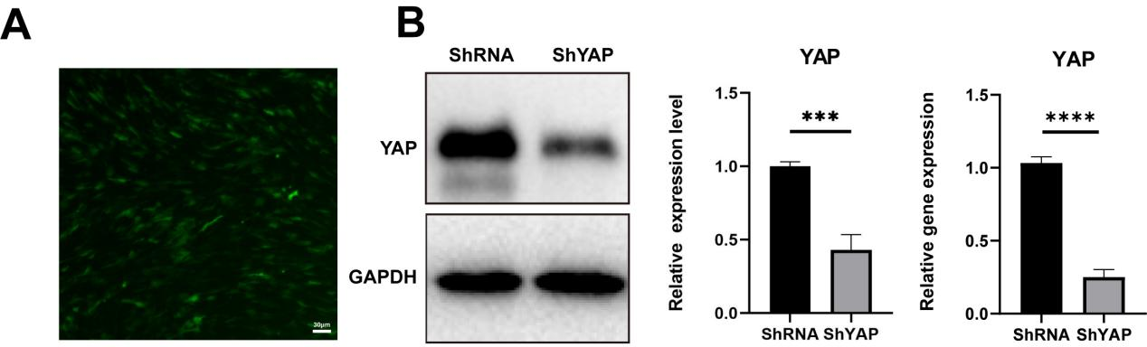

Fig.S1.（A）Representative fluorescence images of BMSCs after lentivirus transfection.（B）
WB and qRT-PCR were used to verify the knockdown of YAP. (n=3 ***P < 0.001，****P < 0.0001).
Runx2

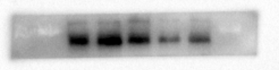

ALP
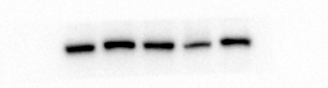

GAPDH
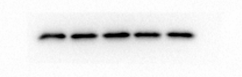

Fig.S2.The original blots generated alternative repeats of Western blotting analysis of Figure 3A.

Nuc-β-catenin
β-catenin
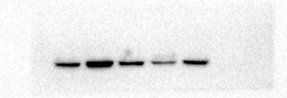
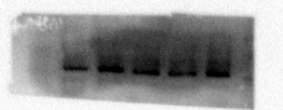

Nuc-YAP

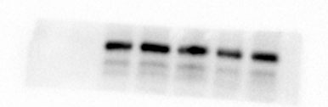
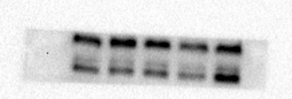

YAP
GAPDH
H3
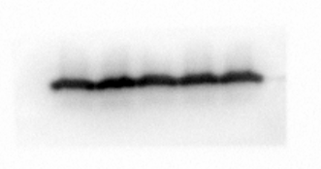
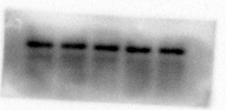

`

Fig.S3.The original blots generated alternative repeats of Western blotting analysis of Figure 3D.

