Supplementary information
Large area infrared wideband flexible extinction film
Zhe Wu¹，Zhongzhu Liang^{*,1}，Xiaoyan Shi¹，Fuming Yang¹，Enzhu Hou¹，Jihui Jiang¹，Xintong Wei¹，Siyu Guo¹，Bing Sun¹，Qingxin Tang¹，David R. Smith²，Haiyang Xu^{*,1}
¹State Key Laboratory of Integrated Optoelectronics and Key Laboratory of ultraviolet Light-Emitting Materials and Technology of Ministry of Education, College of Physics, Northeast Normal University, Changchun 130024, China
²Center for Metamaterials and Integrated Plasmonics, Department of Electrical and Computer Engineering, Duke University, Durham, NC 130024, USA
* e-mail: liangzz@nenu.edu.cn, hyxu@nenu.edu.cn
Section S1: Electromagnetic Field Analysis of the proposed Ti/Al₂O₃/Fe₃O₄/Ti Absorber.
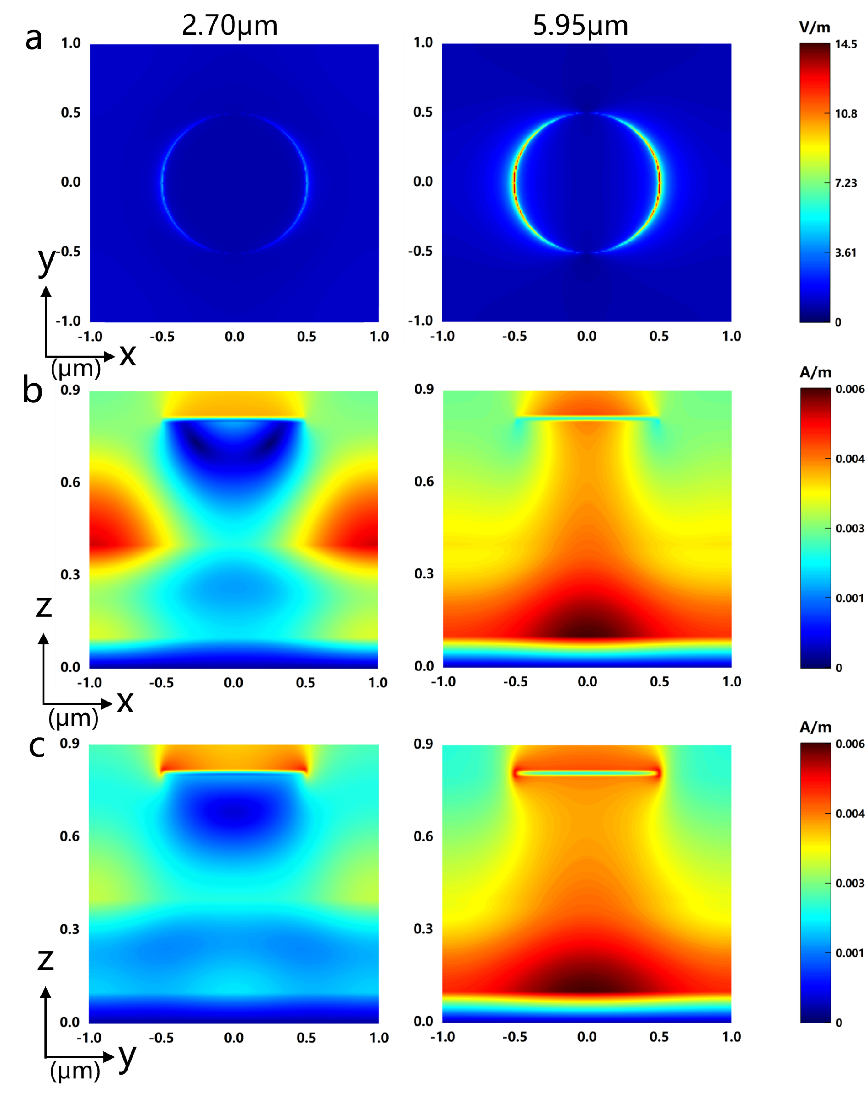
Fig. S1 Electromagnetic field distributions of the proposed Ti/Al₂O₃/Fe₃O₄/Ti absorber at its three resonant wavelengths in the MIR ranges. a Electric field distributions in the top layer (x-y plane). b Magnetic field distribution in the dielectric (x-z plane, y=0). c Magnetic field distribution in the dielectric (y-z plane, x=0).

The electromagnetic field distribution of the Ti/Al₂O₃/Fe₃O₄/Ti four-layer structure is shown in Figs.S1a-c. Compared with the electromagnetic field of the Ti/Al₂O₃/Ti three-layer structure absorber, it can be seen that the electric field of the Ti/Al₂O₃/Fe₃O₄/Ti four-layer structure is still distributed on both sides of the surface pattern. Therefore, light is coupled into the air gap between adjacent crystal cells, which also generates SPP induced light absorption. As shown in Figures 4b and c, the magnetic field at 2.70μm is also mainly concentrated in the dielectric layer below the two adjacent surface patterns. However, the difference is that the magnetic field is mainly localized at the interface of the dielectric layers Fe₃O₄ and Al₂O₃, still the PSPR is mainly excited. Furthermore, The magnetic field at 5.95μm is still mainly concentrated at the interface between the dielectric layer Al₂O₃ below the surface pattern and the bottom Ti layer, indicating that PSPR dominates the absorption of the peak at 5.95μm. Therefore, the broadband absorption of the Ti/Al₂O₃/Fe₃O₄/Ti four-layer structure absorber is caused by the hybrid mode of SPP and PSPR and LSPR localized in different layers.

Section S2: Absorption performance of a flexible roll shaped absorber with a size of 2μm of the proposed Ti/Al₂O₃/Fe₃O₄/Ti Absorber.
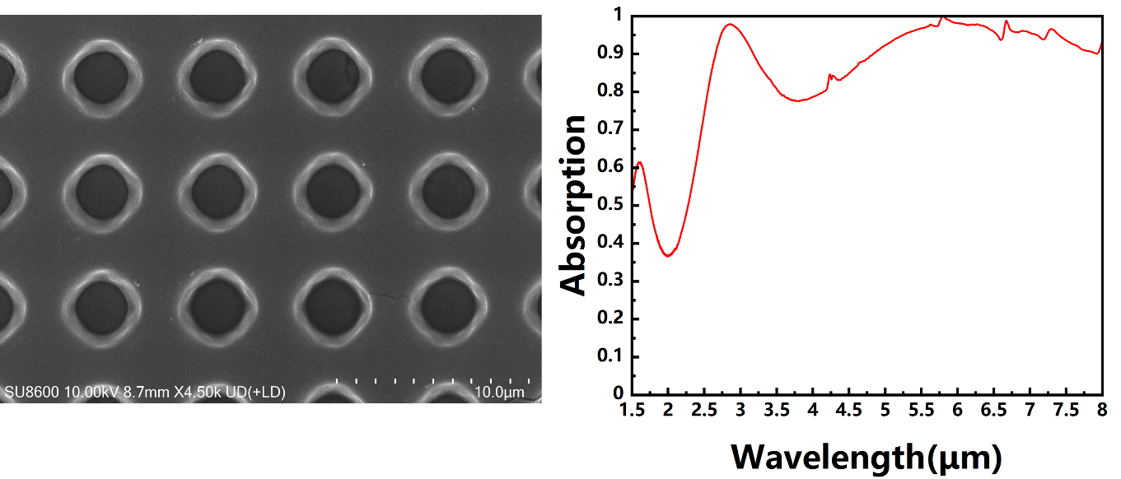
Fig. S2 Experimental results of integrating Ti/Al₂O₃/Fe₃O₄/Ti absorbers with a diameter of 3 μm on flexible substrates. a SEM images of the proposed Ti/Al₂O₃/Fe₃O₄/Ti 4 layers absorbers with a diameter of 3μm. b Experimental absorption spectrum of the proposed Ti/Al₂O₃/Fe₃O₄/Ti 4 lays absorbers integrated on flexible substrates at a size of 2μm.

Figure S2a shows the SEM image of the proposed Ti/Al₂O₃/Fe₃O₄/Ti four-layer absorber with a diameter of 3μm. Due to the fact that the surface pattern actually prepared has a narrow upper and wide lower structure, there will be a white edge around the pattern. The experimental spectrum of a 4-layer absorber with a size of 3μm is shown in Figure S2b. Two absorption peaks can be observed in the MIR band, located at 2.9μm and 6.0μm, with absorption rates of 97.8% and 99.6%, respectively. The average absorption level of 3-5μm is only 84.4%. Overall, compared to the structure with a size of 1μm, the experimental results of the structure with a size of 3μm showed a redshift, but the spectral curve still maintained the same trend as the simulation results. In addition, an absorption peak at a wavelength less than 1.5μm was also displayed due to a certain degree of redshift during simulation.

Section S3: The influence of bending frequency on the absorption performance of the proposed Ti/Al₂O₃/Fe₃O₄/Ti absorber.
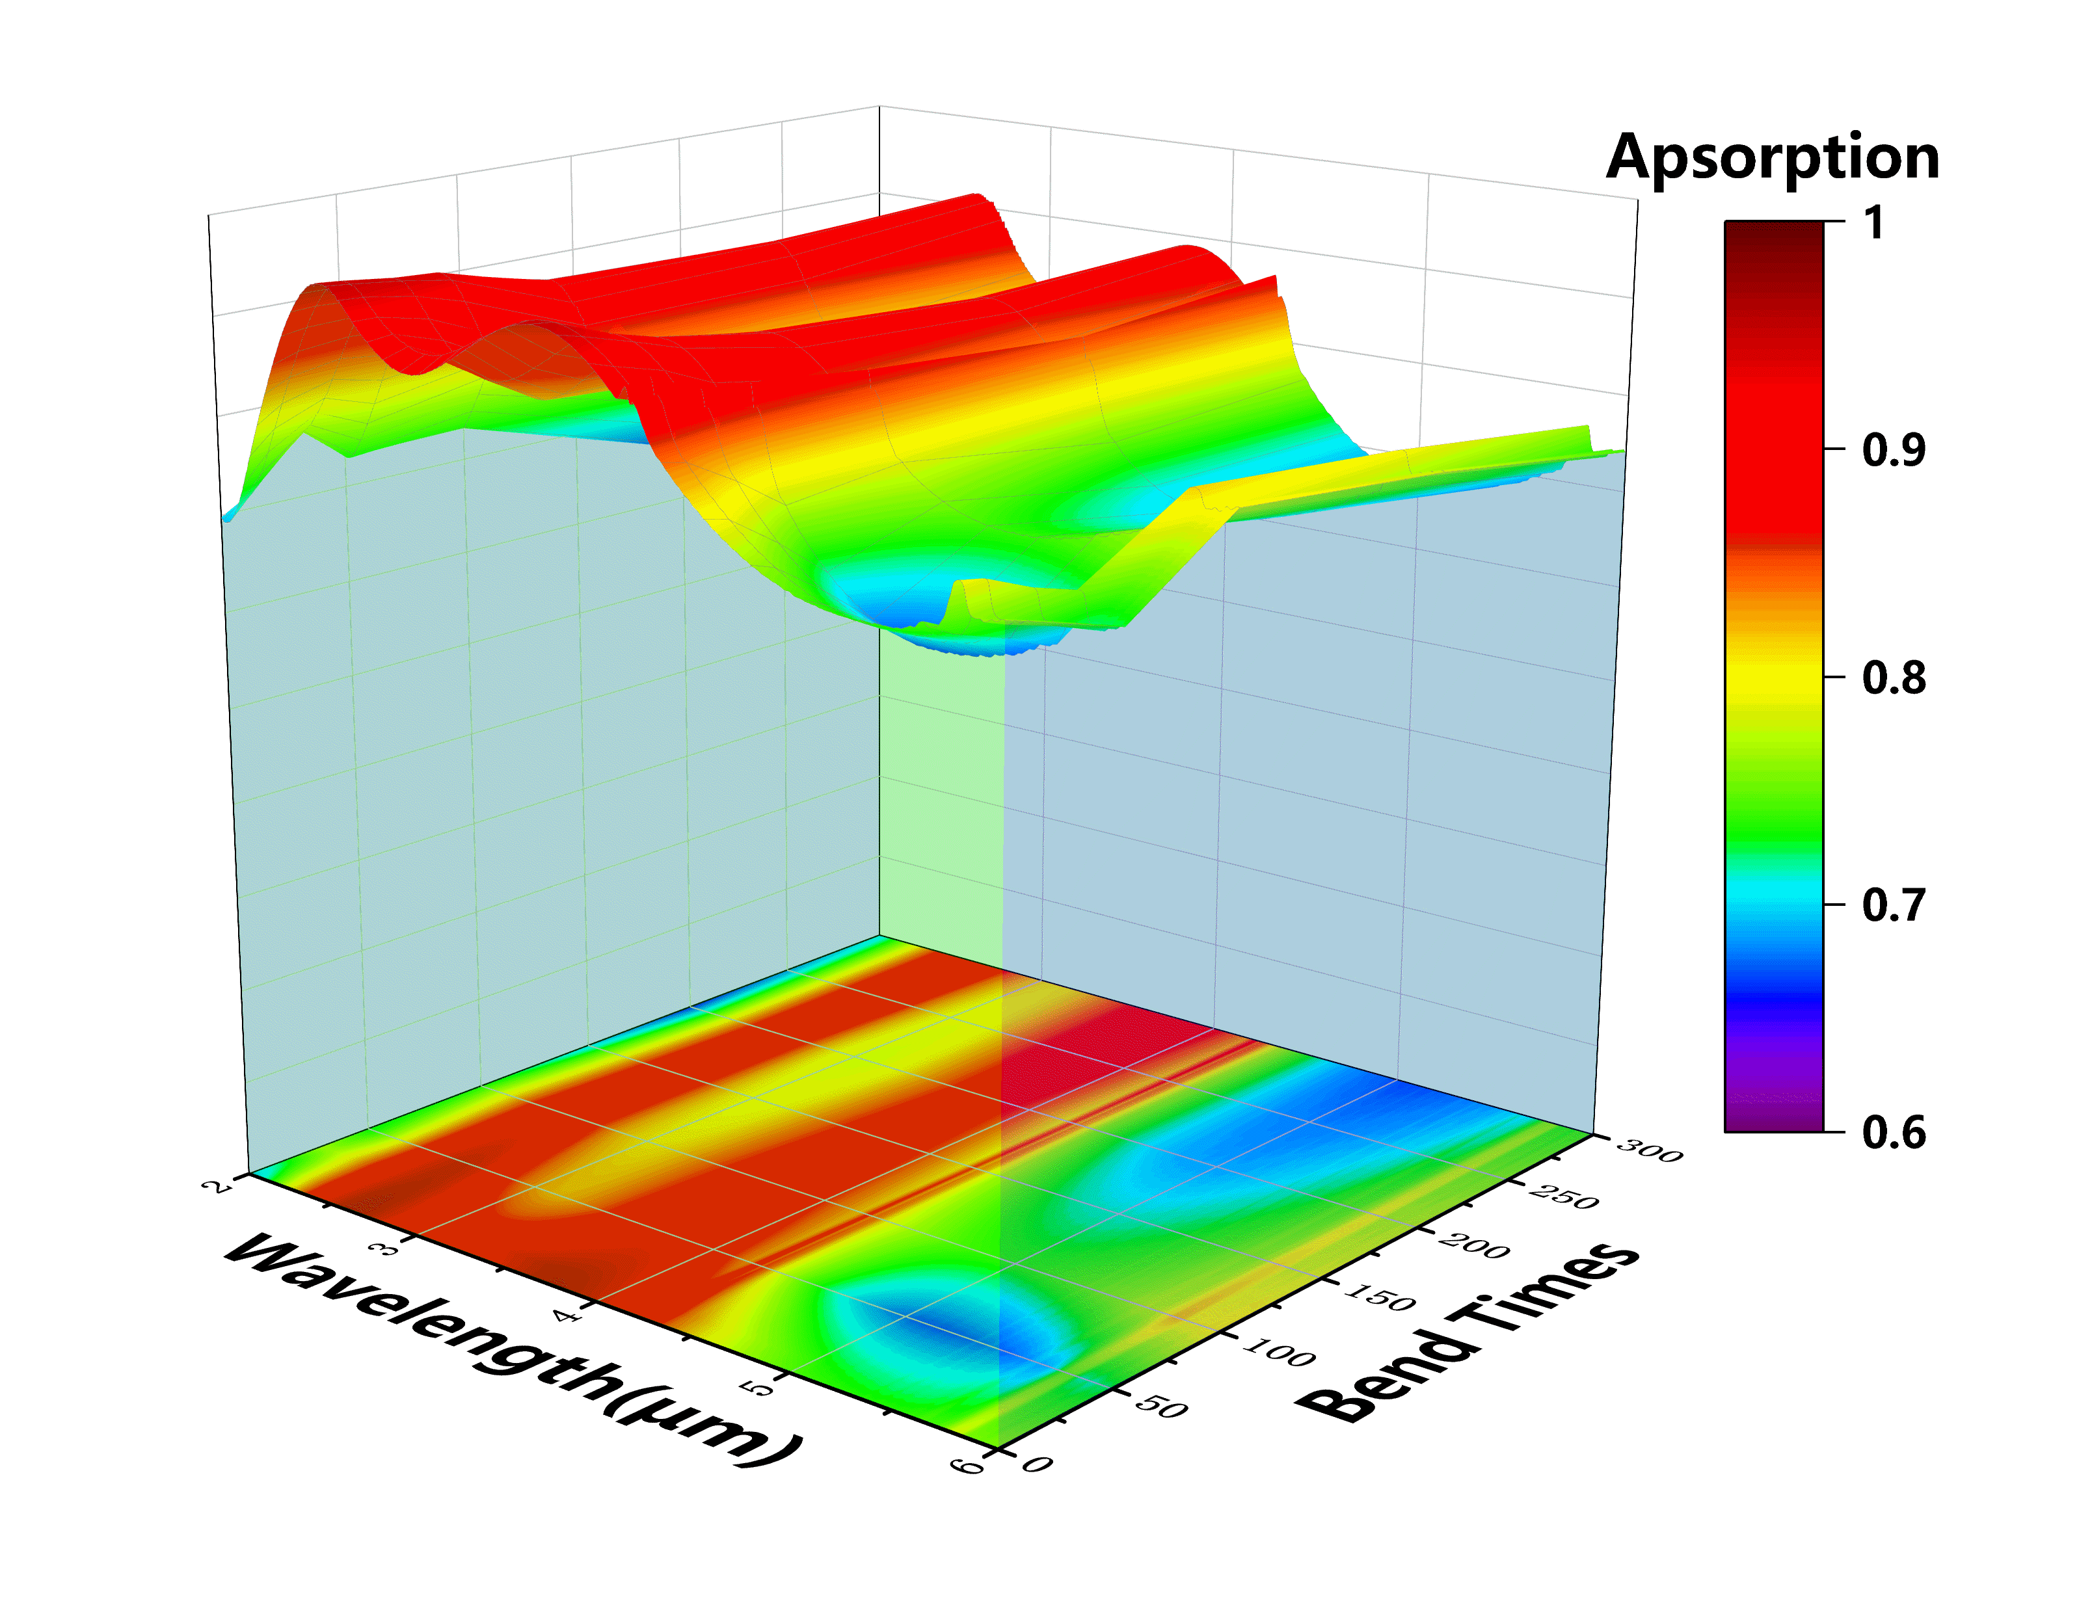
Fig. S3 Experimental results of absorption performance of Ti/Al₂O₃/Fe₃O₄/Ti absorber under different bending frequencies
Figure S3 illustrates the relationship between the absorption performance and the bending frequency of the designed flexible matting film. It can be observed that as the bending frequency increases, the absorption performance of the matting film slightly decreases. However, after 300 bends, the overall absorption rate still exceeds 90%, with a decrease of less than 10%. This demonstrates the good bending resistance and practicality of the flexible matting film, further highlighting its potential in practical applications.

